

Student Name: Mahedy Hasan
Student ID: 2425802

Module Name: Strategic Management
Module Code: LCMB7003

Assignment Title: Assessment component: Individual report
Lecturer’s Name: Andry Rakotovololona

Work Count: 5284

Submission date: 22/12/2025

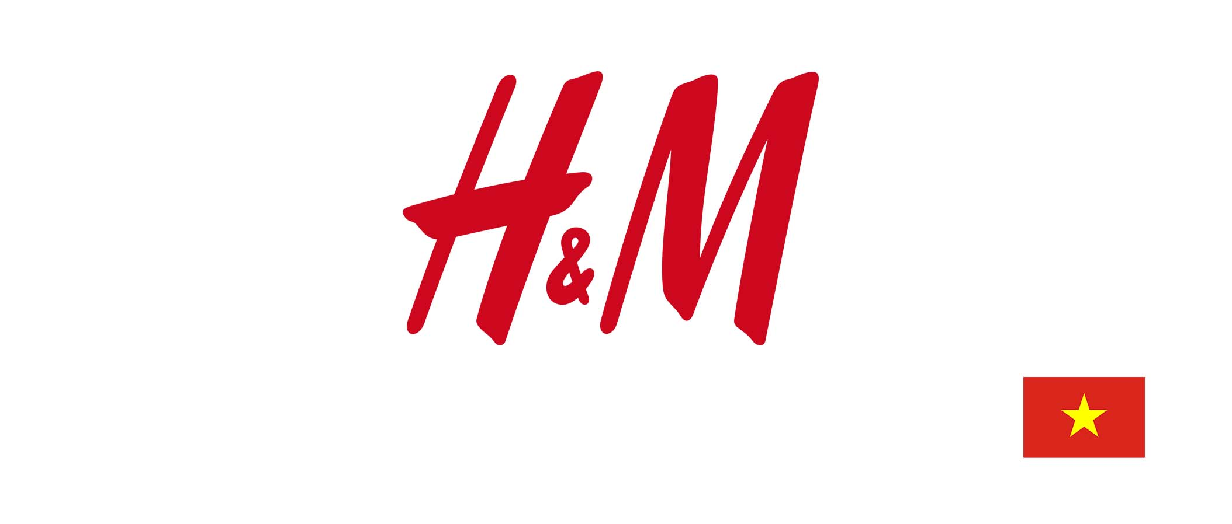

Strategic Expansion of H&M into Vietnam: A Comprehensive Internationalisation and Competitive Analysis

Executive Summary
This report is a detailed strategic analysis and expansion plan to help H&M enter Vietnam, which is an emerging market with high growth of the economy, increasing disposable income and high rates of digital adoption. The analysis appraises the competitive environment of Vietnam, the macro and global fashion industry trends and strategy frameworks. In-house analysis shows that the financial strength, omni-channel retailing model, digital capabilities, and sustainability orientation of H&M give it a good entry point. The process of scenario planning shows both the prospects of quick growth and the threats of regulatory change and ultra-fast fashion rivalry.
The report suggests a hybrid entry approach of flagship stores and digital growth, localisation of supply chains and sustainability-based differentiation. Achieving this will need organisational dexterity, a robust leadership team and a solid governance system.
Table of Contents
1. Introduction and Company Overview 4
1.1 Company Background, Mission and Corporate Values 4
1.2 Products, Services and Business Model 5
1.3 Financial Performance (2019–2024) 6
1.4 Strategic Relevance and Contemporary Challenges (2025) 7
2. External Environment Analysis and Competitive Positioning 8
2.1 Porter’s Five Forces Analysis 8
2.2 Strategic Threats and Opportunities 10
2.3 Tailored PESTEL Analysis 11
2.4 Global Industry Trends and Market Dynamics 12
2.5 Strategic Group Map: Vietnam Fashion Market 13
3. Internal Analysis 14
3.1 Resource-Based View (RBV) and Core Competencies 14
3.2 VRIO Evaluation 15
3.3 Value Chain Analysis 16
3.4 Business-Level Strategy: Porter’s Generic Strategies 17
3.5 Competitive Advantage Compared with Key Rivals 18
4. Strategic Options and Decision-Making 19
4.1 Ansoff’s Matrix and Growth Strategy Evaluation 19
4.2 Corporate-Level Strategies 21
4.3 Portfolio Evaluation: BCG Matrix 22
4.4 Strategic Decisions from the Past Five Years 23
5. Data Analysis, Strategic Implementation, and Recommendations 24
5.1 Financial and Market Data Analysis 24
5.2 Scenario Planning for Future Strategic Paths 25
5.3 Strategic Recommendations 27
5.4 Implementation Challenges 27
Conclusion 29
References 30
Appendices 32

1. Introduction and Company Overview
The strategic preparedness of H&M to expand internationally can only be assessed in terms of understanding the organisational background, business model and financial performance of the company. This section says formally the history of the company, the mission and values, the description of the portfolio and the business model of the company, the analysis of financial performance in the last five years and the discovery of the modern strategic challenges that are associated with global competitiveness.

1.1 Company Background, Mission and Corporate Values
H&M (Hennes & Mauritz AB) was established in 1947 in Vasteras, Sweden, as a women's clothing store named Hennes (H&M Group, 2024). The company product assortment was augmented when it acquired Mauritz Widforss in 1968, and the H&M brand started. During the following decades, H&M grew to become one of the biggest fashion retailers in the world, with its presence in 79 markets and over 4,253 brick-and-mortar stores spread throughout the world (H&M Group, 2024).
Figure 1: Hennes Storefront, Vasteras (1947)
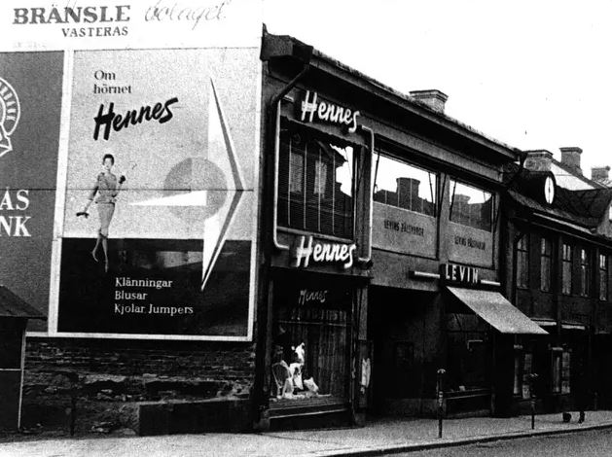
Source: First Versions (2016), H&M Group (2024), Sweden.se (2024).
The mission of the organisation is formulated as offering fashion and quality at the best price in a sustainable manner (H&M Group, 2024), which reflects an inclusiveness and sustainability and commitment to affordability. Teamwork, transparency, cost-consciousness, simplicity and continuous improvement are its corporate values that support an organisational culture of operational efficiency and value creation over the long run. The scholastic writings emphasise the significance of the cultures based on values in facilitating the global retail process and organisational flexibility (Schein, 2017).

1.2 Products, Services and Business Model
The portfolio of H&M Group consists of a number of different brands, including H&M, COS, Monki, Weekday, Arket, and Other Storey, allowing the company to focus on various segments of the population and their tastes and preferences in fashion (H&M Group, 2024). The organisation has an omnichannel retail structure that combines both physical shops and online stores, mobile apps and third-party e-commerce marketplaces. Omni-channel retailing has been highlighted as one of the major contributors to the competitive advantage in academic research because it is able to create customer experience and operational integration (Verhoef, 2015).
Figure 2: H&M Group's Omni-Channel and Fast-Fashion Business Model.
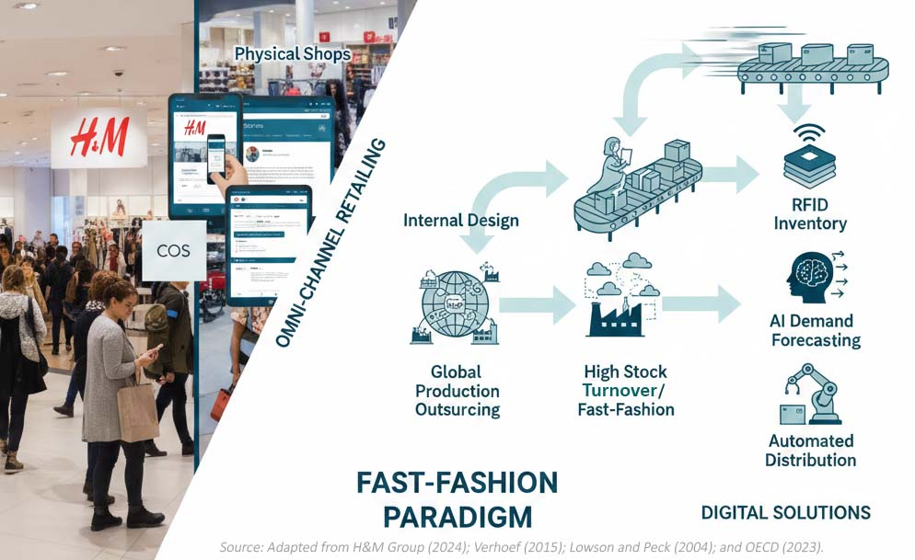
The business model of H&M is defined by an internal design, production outsourcing via a global network of suppliers, and high stock turnover in accordance with the fast-fashion paradigm. This model is consistent with the literature in the industry that recognizes the responsiveness in design and supply-chain agility as major components of the fast-fashion responsiveness (Lowson and Peck, 2004). Its strategic allotments in digital solutions, such as RFID-based inventory control, AI-controlled demand forecasting and automated distribution systems, also enhance operational efficiency (H&M Group, 2024).
Sustainability-targeted companies assist companies to provide a greater range. For instance, Sellpy is a domain in which human beings should buy and sell used goods, which supports the reuse of factors. This fits with international rules that focus on recycling and waste discount (OECD, 2023).

1.3 Financial Performance (2019–2024)
An in-depth examination of the recent financial reports indicates that H&M has been recovering slowly after the COVID-19 shocks and instability in retail market development across the planet. The reported 2024 net sales of the company are SEK 234,478 million, and these were SEK 236,035 million in 2023 (H&M Group, 2024). The operating profit ratio rose between the years 2023 and 2024 by a margin of SEK 14,537 million and SEK 17,306 million, respectively, indicating that the company has enhanced its operational performance and maintained a tight rein over its expenses (H&M Group, 2024).
Figure 3: H&M Group Key Financial Performance Indicators (2019 vs. 2024)
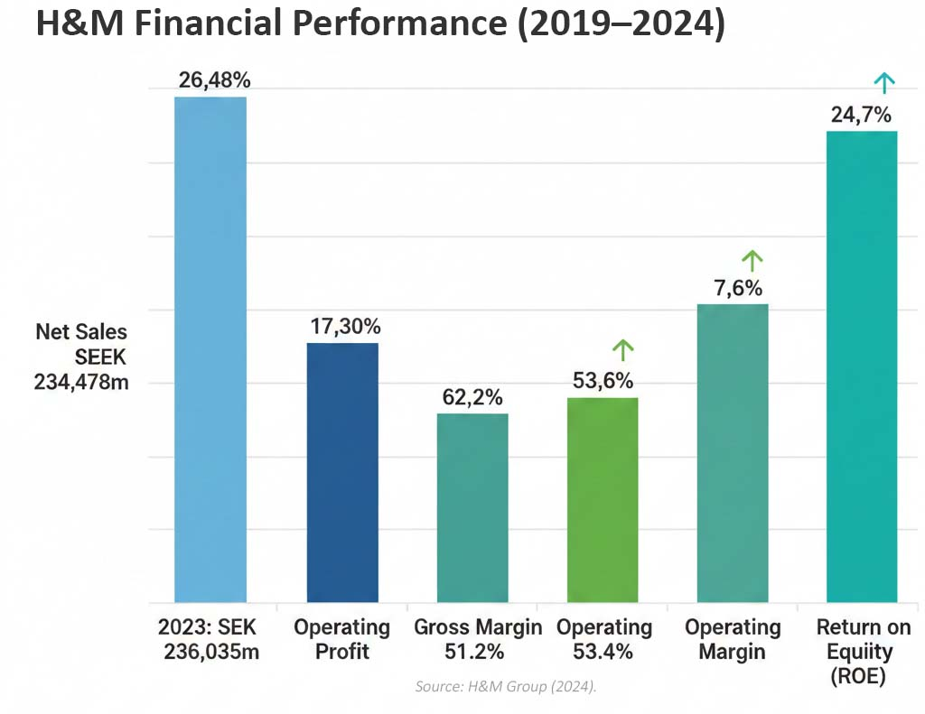
The most crucial financial ratios represent better performance:
- The gross margin increased to 53.4% (up from 51.2% in 2023).
- The operating margin has improved to 7.4% (up from 6.2%).
- Return on equity (ROE) increased to 24.7% (from17.8%).
The operating activities cash flow was SEK 31,756 million, and total cash and cash equivalents were SEK 17,340 million at the end of the year, which shows that the liquidity was good (H&M Group, 2024). In 2024, online sales were 30% of total revenue, which demonstrates the growing strategic value of online channels (H&M Group, 2024).
The rationalization strategy of the store portfolio led to the opening of 88 stores and the closing of 204 stores, with a net change of 116 stores and a stronger profitability (H&M Group, 2024). According to academic literature, retail network optimization is one of the major cost management and digital integration tools of global retail (Brynjolfsson and McAfee, 2014).

1.4 Strategic Relevance and Contemporary Challenges (2025)
H&M has a basis of strategic analysis in the complexity of its operations across the globe and the strategic tension that it experiences in the international fashion industry. The company is in an environment that is highly dynamic in terms of rapid technological change, sustainability demands and stiff competition.
Figure 4: H&M Strategic Challenges (2025): A Model of Competitive and Transformative Pressures
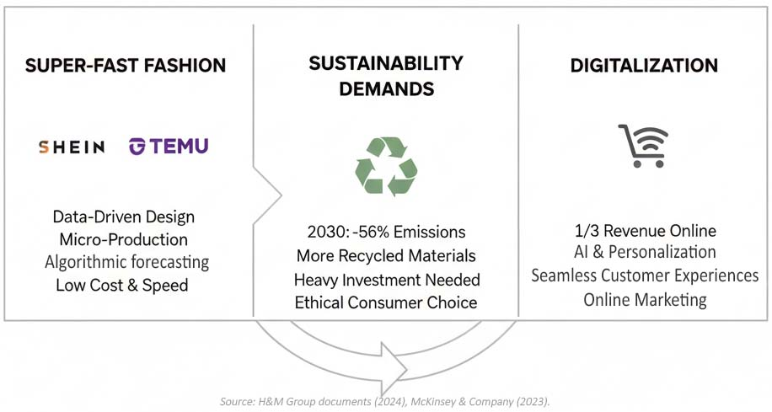
A significant strategic issue is the competition of super-fast fashion sites, including Shein and Tamu, which have adopted data-driven design, micro-production and algorithmic demand forecasting as the means of low cost and rapid trend reactivity (McKinsey and Company, 2023). These competitors are undertaking H&M's fast fashion model through accelerating style trends and growing price competition.
By 2030, H&M plans to cut its greenhouse gas emissions by 56%, and it will use more recycled substances (H&M Group, 2024). Yet, to gain these desires, heavy funding should be made, cooperation with suppliers should be established, and the latest era should be ushered in. To remain aggressive, sustainability has emerged as essential, as more and more customers choose environmentally pleasant practices (Delmas & Toffel, 2008).
Furthermore, digitalization is very essential, as online sales now account for nearly a third of H&M's general revenue. H&M ought to maintain spending money on synthetic intelligence, online advertising and marketing and seamless consumer enjoyment. Digital functionality is a key contributor to long-term competitiveness, particularly in speedy-growing generation sectors (Brynjolfsson and McAfee, 2014). These motives underline the relevance of the strategic control version in the analysis of H&M internationalisation.

2. External Environment Analysis and Competitive Positioning
The intensive external environment analysis is necessary to determine the macro-environmental factors and competition that affect the H&M entry into Vietnam. In this section, I will use Porter's Five Forces, a customized PESTEL analysis, an analysis of the global and local industry trends and a strategic group map as a force to assess the threats and opportunities. It combines both the theoretical and empirical data in the form of industry reports and the Annual and Sustainability Report 2024 released by H&M.

2.1 Porter’s Five Forces Analysis
The Five Forces framework developed by Porter (Porter, 1980) is a systematic way of analysing the competitive pressures but with the assumption that the boundaries of the industry are relatively fixed, which does not work in the fast-changing fashion industry, where digital disruption occurs (Grant, 2021).
Rivalry Among Existing Competitors – High
Aggressive competition between international fast-fashion companies like Zara and Uniqlo, local chains like Giordano, and a high presence of local brands characterize the Vietnamese apparel market (Euromonitor, 2024). Competition is similarly fueled through ultra-speedy style manufacturers, which include Shein and Temu, whose AI-driven designs and mini-production cycles reduce price systems and boost up fashion response (McKinsey, 2023). The cost of switching to other consumers is minimal due to the young demographic profile as well as consumption patterns that are trend-orientated, thus enhancing competition.
Figure 5: Porter's Five Forces Analysis: H&M in the Vietnamese Apparel Market
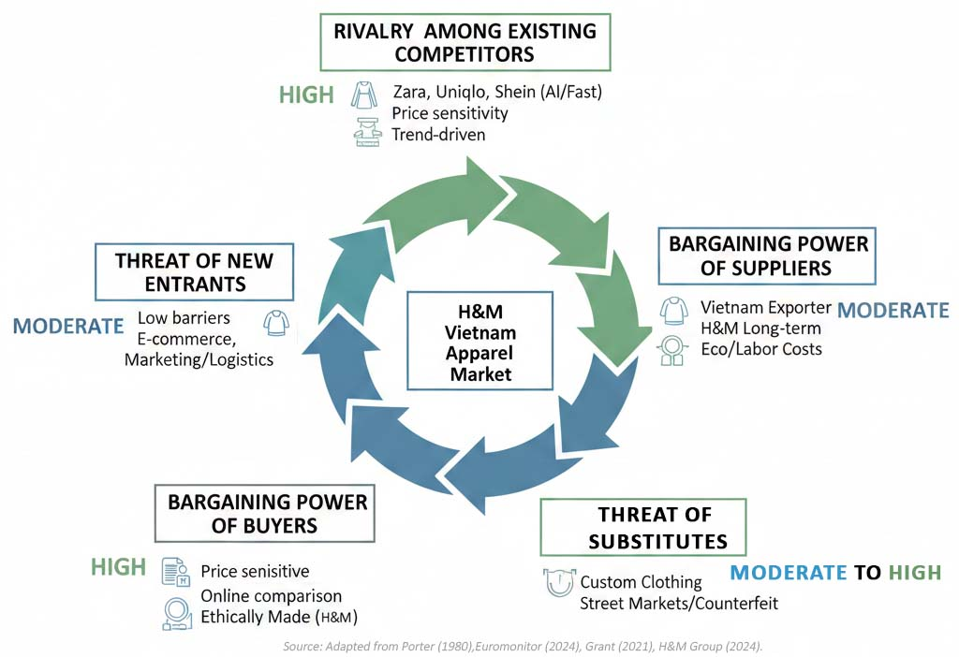
Threat of New Entrants – Moderate
The entry barriers within the fashion industry in Vietnam are relatively low because the retail infrastructure is expanding and there is liberalization of foreign direct investment policies. Nevertheless, it will take a significant investment in marketing, logistics and supply-chain management to build a strong nationwide brand. The rise of the digital-only entrants has lowered the barriers by a considerable amount since companies can expand using the platforms of established e-commerce with no physical presence (Statista, 2024). This increases the competitive threats of H&M in the long run.
Bargaining Power of Buyers – High
The Vietnamese are also very sensitive to price, especially the young generation, which makes up over 60% of the market (World Bank, 2024). Buyer power is enhanced by the fact that an array of apparel choices is available and online price comparison behaviour is high. Nevertheless, the growing demand for ethically made clothes opens an opportunity for H&M, which has its sustainability pledges reported extensively (H&M Group, 2024).
Bargaining Power of Suppliers – Moderate
Availability of suppliers is boosted by the fact that Vietnam is one of the largest exporters of textiles and garments in the world. The long-term supplier relations and regional sourcing approach of H&M minimize the supplier bargaining power (H&M Group, 2024). Nonetheless, heightened environmental regulation and labour requirements can increase the cost of production, which would have an impact on the sustainability of the supply chain in the medium term.
Threat of Substitutes – Moderate to High
Such substitutes as custom-made clothing, often available and culturally favored to wear in the workplace, and used clothing websites, which have witnessed rising sustainability trends, can be mentioned (OECD, 2023). Street markets and counterfeit fashion are also an issue that intensifies substitution.
Critical Evaluation: Although the Porter model is useful in determining the overall competitive forces, it does not encompass the dynamic capabilities, including digital transformation and sustainability commitment, that are both important in determining competitiveness in the contemporary apparel retailing.

2.2 Strategic Threats and Opportunities
Category | Description
Key Threats | - Increasing competition of low-cost, fast-design cycle platforms of ultra-fast fashion (McKinsey, 2023).
Key Threats | - An increase in regulatory pressures in terms of waste and labour rights and emissions in Vietnam and globally.
Key Threats | - Dependence on discretionary consumer spending, which could easily be hit by inflation and economic turbulence.
Key Threats | - Saturation in developed urban centres that have already become major international players.
Key Opportunities | - The rising middle income and the forecasted leap of GDP in Vietnam over 5 per cent every year favor expansion of the apparel market (World Bank, 2024).
Key Opportunities | - An integrated population that is becoming more and more digital and concentrating on mobile commerce is the one that is aligned with the omni-channel capabilities of H&M (H&M Group, 2024).
Key Opportunities | - The increased popularity of the sustainability of H&M among the Vietnamese youth is contributed to by the growth of environmental awareness (Nielsen, 2024).
Key Opportunities | - Existing high local manufacturing capacity offers nearshoring and logistics minimized emissions.

2.3 Tailored PESTEL Analysis
Targeted PESTEL analysis produces factors of the macro-environment that are most pertinent to H&M strategic decision-making.
Figure 6: Tailored PESTEL Analysis of H&M's Macro-Environment in Vietnam
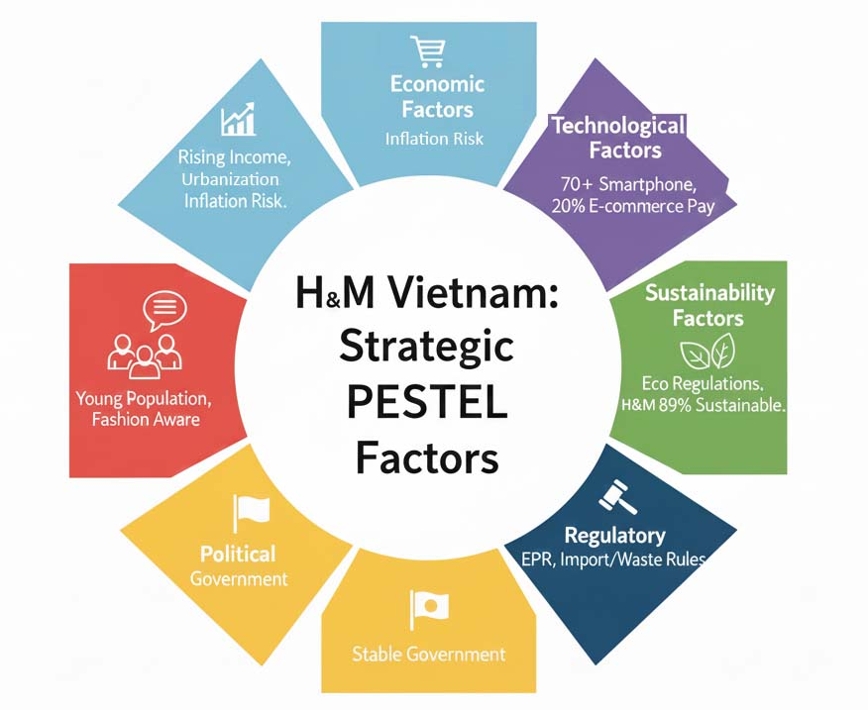
Economic Factors
The economic development of Vietnam has been sustained, and the disposable income is increasing, and the rate of urbanisation poses favorable opportunities to fashion retail (World Bank, 2024). Demographic strengths and the rising fashion awareness have helped its clothing market to expand steadily (Euromonitor, 2024). Prices are, however, a danger to price-sensitive consumers due to inflationary pressures.
Technological Factors
Vietnam has one of the quickest-growing digital ecosystems in Southeast Asia. Smartphone penetration exceeds 70%, and e-commerce is developing at more than 20% per year (Statista, 2024). Mobile payments, stay-stream purchasing and social trade are a number of the technologies which might be ubiquitous. H&M makes the investment in digitalization, such as RFID technology and AI-based planning, which can be successfully used to operate in a digitally enabled retail setting (H&M Group, 2024).
Regulatory Factors and Sustainability Factors.
The growing environmental regulation, such as Extended Producer Responsibility (EPR), impacts apparel imports, waste management and recycling (OECD, 2023). The circularity commitments of H&M, such as its utilization of 89% sustainable materials, contribute to the adherence to the new standards of sustainability (H&M Group, 2024). These forces can act as obstacles against rivals having a less transparent supply chain.
Critical Evaluation: PESTEL is a thorough environmental scan; however, the framework fails to prioritise elements or speak to the relationship among digital and social forces, which can be at the coronary heart of style markets.

2.4 Global Industry Trends and Market Dynamics
The competitive environment of H&M is influenced by a number of global trends:
- Digital commerce, such as AI-based retailing, predictive analytics and personalized marketing, is accelerated (Deloitte, 2023).
- Sustainable shifts where customers are becoming more obsessed with recycled goods, responsible sourcing and openness.
- Introduction of ultra-fast fashion that has seriously shortened the fashion cycle and increased competition.
- Move towards experience retailing whereby the brick-and-mortar stores are complemented by digital presence via aesthetic value and in-store experience (McKinsey, 2023).
Figure 7: Global Industry Trends and Market Dynamics Influencing H&M in Vietnam.
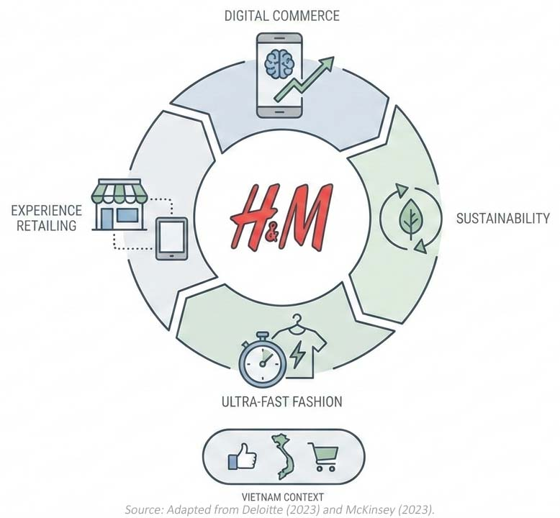
Vietnam is also not an exception to these trends all over the world, and its culture is highly orientated to adopting trends, social media impact, and online shopping.

2.5 Strategic Group Map: Vietnam Fashion Market
A price level and trend responsiveness strategic group map is used as an axis to identify competitive clusters:
Group | Competitors | Features
Cheap / Fast Fashion | Shein, Temu, local copy brands | Very low prices, sold mostly online
Mid-Price / Fast Fashion | H&M, Zara | Trendy clothes, sold all around the world
Mid-Price / Basic Clothes | Uniqlo, Canifa | Simple, good quality clothes, less change
Expensive / Special Fashion | Designer and boutique brands | High price, for a small group of people
Zara and Uniqlo are the nearest rivals of H&M. Zara competes in terms of speed of trends and high-end positioning, and Uniqlo competes in terms of quality basics and practical clothing. The hybrid approach adopted by H&M, which is a combination of affordability, digital strength and sustainability, is used to facilitate competitive differentiation.

3. Internal Analysis
The analysis of internal capabilities is strategic and is done to establish whether H&M has the resources, competencies and structural systems to aid in expansion to Vietnam. The section will use the Resource-Based View (RBV), VRIO framework, Value Chain analysis and Porter's generic strategies to critique the internal environment of H&M. The analysis will be based on academic theory and company-specific evidence provided in the Annual and Sustainability Report 2024 by H&M.

3.1 Resource-Based View (RBV) and Core Competencies
According to the RBV, firms can have a sustained competitive advantage when resources held by them are valuable, rare, imitable, and well organised (Barney, 1991). The resource base of H&M is a mixture of intangible capabilities and operational strengths that have made the company global in scale and performance.
Figure 8: H&M’s Resource-Based View (RBV) and Core Competencies
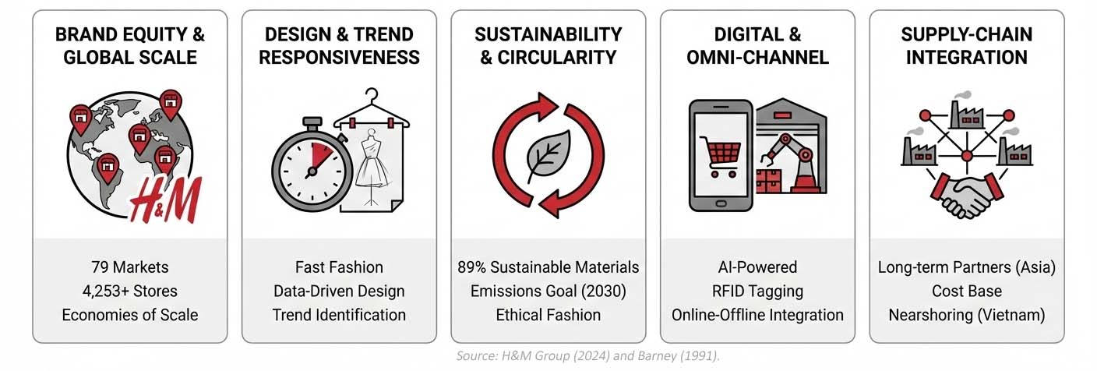
Brand Equity and Global Scale
H&M brand equity is backed up by operating in 79 markets, having a network of more than 4,253 stores, and having a robust digital presence (H&M Group, 2024). This type of global presence strengthens consumer confidence and provides economies of scale in the procurement, marketing and logistics. Brand equity also enhances the potential to enter into the market, especially in the emerging economies like Vietnam.
Design, Trend Responsiveness and Innovation Capacity
H&M is fast at identifying global fashion trends, which is a core competency. Internal design teams work at an international level, and it is backed by information-driven knowledge that guides assortment planning (H&M Group, 2024). These functions facilitate fast-fashion receptiveness, which allows H&M to provide trend-driven products at an affordable cost.
Sustainability and round management
H&M's commitment to sustainability allows it to stay in advance of competitors worldwide. The corporation recycles or makes use of sustainable materials for 89% of its merchandise and plans to reduce greenhouse gas emissions in its delivery chain by 56% via 2030 (H&M Group, 2024). These moves reply to new worldwide guidelines and developing patron calls for a more ethical style.
Digital and Omni-channel Capabilities
H&M has invested a lot in digitalization, such as RFID tagging, AI-powered forecasting, automated distribution centres and online-offline store integration (H&M Group, 2024). These enhanced technologies boost the precision of inventories, boost the flow of stocks and improve the customer experience, which are crucial in a market with high e-commerce adoption like Vietnam.
Supply-chain Integration and Supplier Network
H&M maintains a vast supply chain of long-term partners in Asia, which allows producing products in reasonable production cycles and on a favorable cost base. The sourcing strategy of the company is based on transparency, compliance and sustainability (H&M Group, 2024). The availability of Vietnamese textile manufacturers also creates future opportunities for nearshoring and climate-friendly supply chains.
All these resources and capabilities make a good internal base for international expansion.

3.2 VRIO Evaluation
Using the famous VRIO framework, which resources contribute the maximum to sustainable blessings?
Resource / Capability | Valuable | Rare | Hard to Copy | Organized | Competitive Edge
Global brand power | Yes | Yes | Yes | Yes | Long-term advantage
Digital sales system | Yes | Moderate | Moderate | Yes | Short-term advantage
Focus on sustainability | Yes | Yes | Yes | Yes | Long-term advantage
Ability to follow trends fast | Yes | Yes | No | Yes | Short-term advantage
Worldwide supplier network | Yes | No | No | Yes | No real edge
This discussion shows that the brand equity and sustainability capabilities of H&M are the most long-term strategic benefits of the company. These strengths are also in line with both regulatory and consumer trends in the Southeast Asian market.

3.3 Value Chain Analysis
The Value Chain framework by Porter (Porter, 1985) is what allows assessing the locations and mechanisms of value creation at H&M.
Figure 9: H&M Value Chain Analysis, Highlighting Sustainability and Technology Drivers
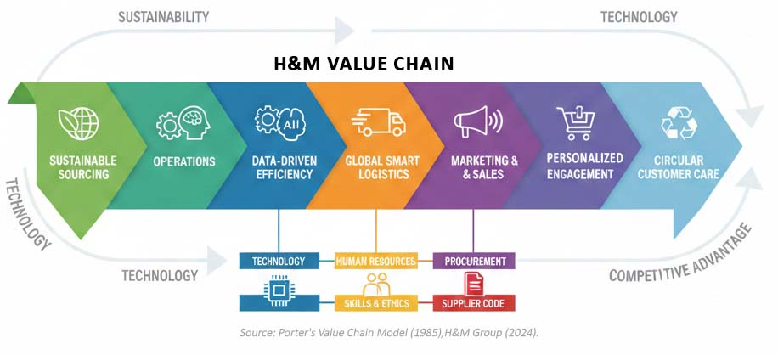
Inbound Logistics: H&M enjoys long-term supplier relationships, a material traceability programme, and excellent regional sourcing. Material procurement is dictated by the principles of sustainability, such as water-efficient production and recycled textiles (H&M Group, 2024). This minimizes the use of non-renewable materials.
Operations: The data-driven technologies are essential to the functioning of the company. Inventory management, artificial intelligence-driven trend forecasting, and automated distribution centres can be found in RFID, which is efficient (H&M Group, 2024). These systems minimize lead times, stockouts and markdowns.
Outbound Logistics: The logistics system at H&M is global and has state-of-the-art distribution centres that are engineered with smart systems to enhance a higher throughput efficiency (H&M Group, 2024). In the case of Vietnam, technological hubs in the region can also reduce transportation charges and carbon emissions.
Marketing and Sales: H&M makes use of online advertising, influencer partnerships and facts for manual advertising. Their loyalty software and multi-channel approach provide a personalized experience and a continuing purchasing manner (H&M Group, 2024). This attempt allows holding the emblem constant across all systems.
Services: The sustainability promise and purchaser loyalty are strengthened via additional offerings together with product restoration, recycling packages and easy return alternatives.
Support Activities
- Technology development: RFID, AI and predictive analytics.
- Human resources: Digital and sustainability competencies training in the workforce.
- Procurement: Supplier Code of Conduct and ethics.

3.4 Business-Level Strategy: Porter’s Generic Strategies
According to Porter (1985), the strategic position is determined as cost leadership, differentiation and focus. H&M uses a hybrid strategy, which is the mixture of cost leadership and differentiation.
Cost Leadership Elements
- Procurement is on a large scale; this lowers the cost of inputs.
- Improved operations speed up production.
- Competitive fees attract fee-sensitive clients.
Differentiation Elements
- Responsiveness to fashion-based fashion and layout.
- Sustainability performance is high compared to the major competitors (H&M Group, 2024).
- Powerful digitalization and omnichannel.
Figure 10: H&M Business-Level Strategy: The Hybrid Approach
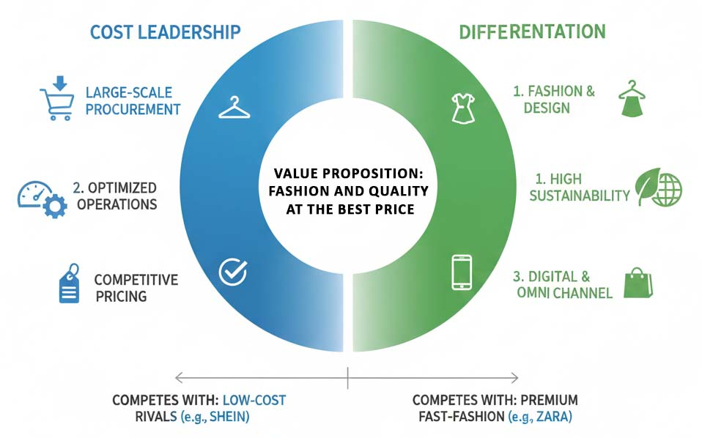
This mixed strategic niche allows H&M to compete with low-end rivals (e.g., Shein) and high-end fast-fashion brands (e.g., Zara) equally.

3.5 Competitive Advantage Compared with Key Rivals
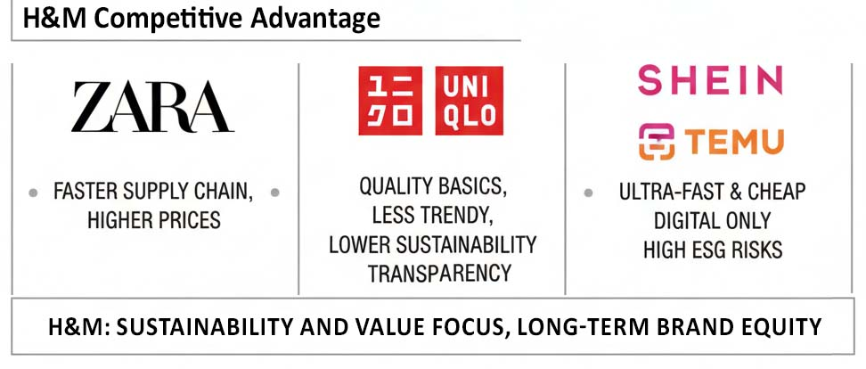
Figure 11: H&M Competitive Landscape and Strategic Differentiators
Comparison with Zara
The advantages that Zara has are vertically integrated supply chains and extremely rapid design cycles (Inditex, 2023). Nevertheless, H&M has been disadvantaged in terms of sustainability and cost leadership. The prices of Zara are generally more expensive, and H&M has an edge in price-sensitive markets like Vietnam.
Comparison with Uniqlo
Uniqlo does not specialize in fast-moving fashion; the products it manufactures are functional and of high quality. The trend-driven products offered by H&M are more attractive to young buyers, whereas its sustainability promises are even greater than those of transparency of Uniqlo at present.
Comparison with Ultra-fast Fashion (Shein, Temu)
The competitors in ultra-fast fashion are faster and cheaper than H&M because of digital-only business models. But these competitors are under greater regulatory pressures and criticism on sustainability. The brand image and ESG practices of H&M give the company competitive advantages in the long run in the market that is more stringent.

4. Strategic Options and Decision-Making
Strategic analysis would be necessary in identifying the most viable expansion pathway that H&M can pursue in the Vietnamese market. In this section, the Ansoff Matrix is used to analyse growth opportunities, the corporate-level strategies are evaluated, the diversification portfolio of the firm is evaluated using the BCG Matrix, and the strategic decisions made in the last five years are critically reviewed. Altogether, these analyses give grounds to determine a consistent and evidence-based approach to international expansion by H&M.

4.1 Ansoff’s Matrix and Growth Strategy Evaluation
The Ansoff Award Matrix is a formal set of evaluations of the organisational growth alternatives of four avenues available to a company: market penetration, market development, product development and diversification (Ansoff, 1957). The two alternatives have different strategic impacts of H&M entering Vietnam.
Figure 12: Ansoff's Growth Matrix Applied to H&M's Strategy in Vietnam
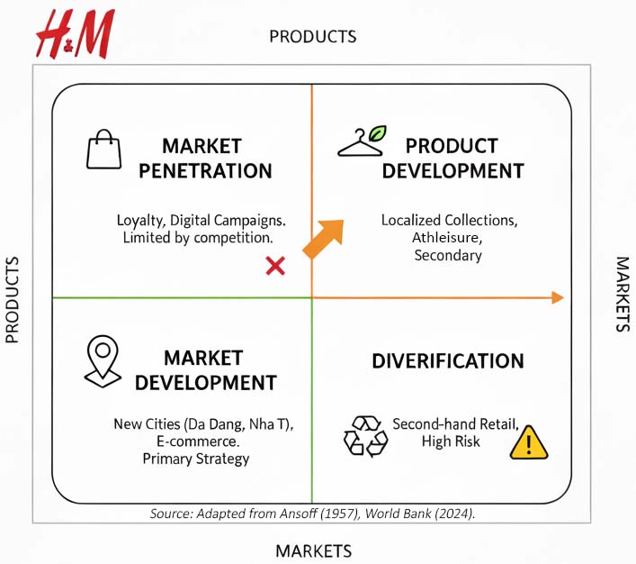
Market Penetration
A market penetration strategy is aimed at the growth of market share in the current markets. Within the framework of the H&M presence in the key Vietnamese cities, such measures as reinforcement of loyalty programmes, specific digital campaigns on such platforms as TikTok and Facebook, and in-store merchandising can be identified as the possible steps. Nonetheless, the stiff competition of Zara, Uniqlo and low-cost digital rivals restricts the long-term viability of this strategy, but it can bring incremental benefits within the circle of loyal consumers.
Market Development (Primary Strategy)
Market development entails access to new geographical areas or segments of customers. It is the most strategic strategy to be employed in the expansion plan of H&M in Vietnam. Demographic factors such as a growing middle income, a mostly young population, rapid urbanisation and high GDP rates offer good opportunities to expand the store outside of Hanoi and Ho Chi Minh City (World Bank, 2024). H&M can capitalize on the business prospects of the secondary cities like Da Nang, Hai Phong and Nha Trang alongside the intensified e-commerce through the local online markets. Market development is thus consistent with the goal of sustainable and long-term international development of H&M.
Product Development
Product development involves the addition of new product lines in the current markets. In the case of Vietnam, H&M can create localized collections based on cultural tastes, weather and the trend of styles in the region. There are further opportunities regarding the expansion of such categories as athleisure (H&M Move) or beauty products. However, product development needs more investment into local design capabilities and market research and, therefore, is secondary to market development.
Diversification
The riskiest strategy is diversification, and the approach includes entering completely new products or industries. The opportunities for H&M to diversify are the incorporation of a second-hand retail business by purchasing Sellpy, as well as investing in Vietnamese textile recycling systems to promote the goals of circularity. Despite the fact that diversification would enhance the sustainability of this firm, it ought to be done in a cautious manner and after gaining a stable market base.

4.2 Corporate-Level Strategies
Corporate-level strategy deals with the overall direction of the organisation, such as acquisitions, alliances and international expansion decisions. H&M is largely dependent on organic growth with an added advantage of selective acquisition that facilitates its sustainability and online agenda. This approach can be illustrated by the fact that the organisation acquired Sellpy, a resale and circular-economy platform (H&M Group, 2024). This supports the long-term strategic focus of sustainability at the firm and competitiveness in the long term.
H&M will be based on strategic alliances in the expansion in Vietnam. Collaborations with established e-commerce platforms (e.g., Shopee, Lazada, and TikTok Shop) may be used to enter the market quickly, whereas partnerships with local textile producers would allow decreasing the lead times and promoting the environment with nearshore production. The partnership with logistics companies may also enhance the fulfilment and the last-mile delivery services, which would increase the customer experience.
Figure 13: H&M Corporate Strategy Overview
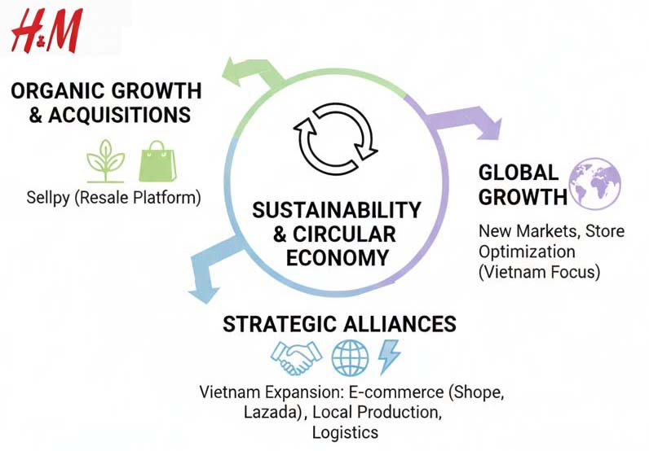
The global growth is one of the key aspects of H&M's corporate strategy. The Annual & Sustainability Report 2024 states that the organisation is still investing in high-growth areas and streamlining its global store base to enhance performance (H&M Group, 2024). Macroeconomic stability, favorable demographics and rising digitalization are key factors that make Vietnam a strategically important location in the future.

4.3 Portfolio Evaluation: BCG Matrix
The BCG matrix classifies business units on the basis of market share and market growth opportunities. The matrix used on the multiple brand portfolio of H&M gives hints into the priorities in resource allocation.
Brand | Market Share | Market Growth | Position
H&M (core) | High | Moderate | Cash Cow
COS | Moderate | High | Star
Sellpy | Low | High | Star
Arket / & Other Stories | Low | Moderate | Question Mark
Weekday | Niche | Moderate | Question Mark
The H&M core brand, a cash cow, provides the financial base to fund the strategic projects, including supply-chain modernization and sustainability revolution. As Stars, Cos and Sellpy are compatible with the trends of premium fashion and circular economy, respectively, with good global expansion potential.
The framework of the BCG, however, makes complex market dynamics simple. As an example, ultra-fast fashion competition by Shein and Temu is also a major factor influencing growth paths that are not readily modelled in the static matrix. Therefore, the BCG Matrix is to be applied together with more dynamic strategy tools.

4.4 Strategic Decisions from the Past Five Years
An overview of the major strategic choices of H&M in 2019-2024 indicates a number of initiatives which have enhanced its preparedness for market expansion.
Figure 14: H&M Group Strategic Decisions and Initiatives (2019-2024)
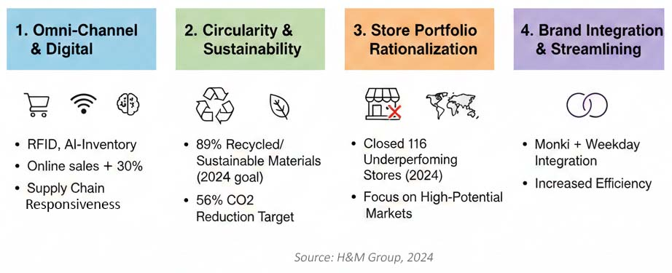
Omni-Channel and Digital Transformation.
H&M has invested a lot of money in innovations such as RFID, AI-powered inventory management, and increased online and offline channel integration (H&M Group, 2024). These have led to better inventory accuracy, lower stockouts and enabled online sales to rise to 30% of the overall revenue. This change has greatly increased the responsiveness of the supply chain and made shopping easier for the customers.
Circularity and Sustainability Promises.
By 2030, H&M will have already recycled or turned to sustainably sourced materials 89% of its materials and aims at cutting its greenhouse emissions by 56% (H&M Group, 2024). Such activities enhance the brand image and assist in compliance with the requirements of regulations, and their cost is extremely high in terms of involving suppliers and sustainable innovation.
Store Portfolio Rationalization
In 2024, H&M closed 116 non-performing stores around the world even as it pursued expansion markets. It is a profit-making strategy that concentrates resources in locations where there is a high potential (H&M Group, 2024). Nonetheless, over contraction will pose a risk of decreasing global presence in the established markets.
Brand Integration and Streamlining
The Monki addition to Weekday streamlined activities and minimized the overhead expenses (H&M Group, 2024). This is efficient, but this has the risk of diluting brand differentiation in the portfolio.

5. Data Analysis, Strategic Implementation, and Recommendations
This part is a synthesis of the above analyses, where the financial performance, stock trends and market data of H&M are analysed in order to make strategic recommendations regarding the expansion of the company into Vietnam. It also uses scenario planning to evaluate what might occur in the future and talks about the issues of implementation concerning organisational structure, leadership, governance and risk management.

5.1 Financial and Market Data Analysis
A financial analysis of the H&M financial status in the last five years shows that it has increased its operational resilience and has ground to expand internationally. In 2024, net sales were SEK 234,478 million, and operating profit was SEK 17,306 million, which shows increased gross margins and cost-effectiveness (H&M Group, 2024). Gross margin increases to 53.4% ​​in 2024 from 51.2% in 2023. This development took place especially due to the fact that H&M managed the inventory better and required fewer rate cuts.
H&M has a strong liquidity position and operating cash flow, and cash and equivalents amount to SEK 31,756 million and 17,340 million, respectively, which allows it to invest capital in new markets (H&M Group, 2024). The ROE of the company was raised to 24.7, indicating a better shareholder value and the efficient allocation of capital.
The performance of the stock market has been moderate, and the share price of H&M has increased in accordance with the recovery in global retail markets after the COVID-19 crisis. Analysts project medium-term growth which is stable with the assistance of digital transformation, cost betterment and revised brand relevance (Bloomberg, 2024). The trends in market shares show that the company performs well in Asian markets, especially the ones where the devices are sold via digital channels, and it is recovering in Europe (Euromonitor, 2024).
Figure 15: Overview of H&M Group’s 2024 Performance
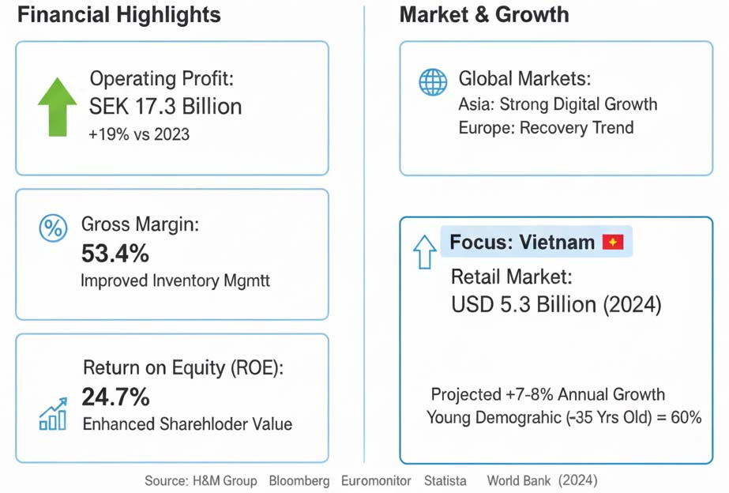
The retail and apparel market in Vietnam is estimated to cost USD 5.3 billion in 2024 but is expected to increase at 7-8%/year because of the increase in disposable income and population increase (Statista, 2024). The young demographic of the country (60% of the population is aged below 35 years old) has significant growth potential for fast-fashion brands (World Bank, 2024). The figures are in line with the strategic imperative of H&M to focus on emerging markets having favorable demographics and growing digital infrastructures.

5.2 Scenario Planning for Future Strategic Paths
Scenario planning aids in the establishment of possible futures and strategic contingencies within uncertain surroundings (Schoemaker, 1995). To enter Vietnam, H&M develops three scenarios according to the macro-environmental conditions, intensity of competition and technological changes.
Figure 16: H&M Vietnam Market Entry: Three-Scenario Framework
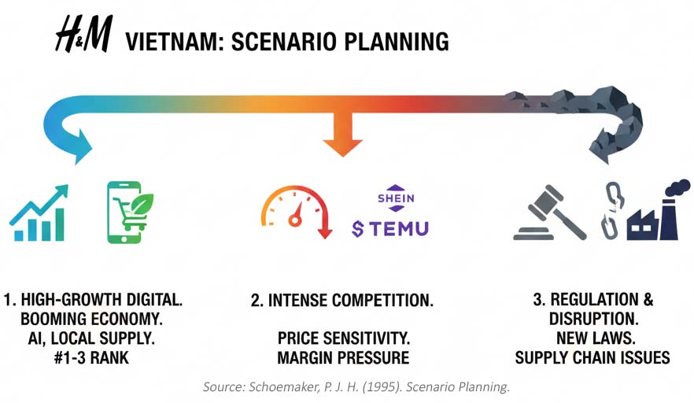
Scenario 1: High-Growth Digital Retail Expansion
In this positive case, Vietnam will have a booming economy, a faster pace of digital adoption and a growing preference among consumers for sustainability-driven fashion. H&M will use AI-based inventory applications and increased local supply-chain relationships to shorten lead times and improve customer experience. The sales increase will be more than projected, and H&M will be ranked among the three leading global apparel brands in Vietnam.
Scenario 2: Intensified Competition and Margin Pressure
In such a moderate situation, ultra-fast fashion competitors like Shein and Temu compete by penetrating the market with algorithmic product design and strong pricing. The consumers are very sensitive to price, and this restricts H&M in its differentiation strategy based on sustainability. The entry into a market is successful but limited by the margin pressures which demand a high level of operational discipline.
Scenario 3: Regulatory and Supply-Chain Disruption
Vietnam is more stringent with environmental regulations, labour laws or duty on importations in the frame of sustainability pledges (OECD, 2023). Interruptions in the supply chain raise the costs of production, and a slow growth in GDP decreases consumer spending. H&M is struggling with tardy roll-outs of stores and increased compliance expenses, which require strategic realignment.
Scenario planning explains why it is necessary to develop flexible strategy formulation, digital and supply-chain capabilities, and risk management systems that are adaptive.

5.3 Strategic Recommendations
According to external, internal and financial analysis, the following strategies should be considered by H&M as potential in expanding to Vietnam:
Strategy | Description
Hybrid Market Entry Strategy | H&M has to open a primary save in large towns like Ho Chi Minh City and Hanoi and also raise awareness of online income. This plan suits Vietnam's growing online purchasing trend (Statista, 2024) and has lower costs than commencing many brick-and-mortar stores.
Optimize Supply Chain and Local Sourcing | Working with nearby suppliers will help H&M reduce delivery incidents, reduce carbon emissions and guide sustainability. This supports the company's environmental aspirations, which include reducing its impact on the world and using more recyclable materials (H&M Group, 2024).
Be Sustainable | H&M needs to identify as sustainable through the use of materials, provision of recycling of clothes and a clear supply chain. These packages can deliver to customers who care that merchandise is made in a fair and environmentally friendly manner (Delmas & Toffel, 2008).
Use AI to Raise Retail Efficiency | H&M can enhance inventory management and efficiency with the help of AI, such as RFID, stock replenishment, and prediction. This will make H&M remain competitive with the fast-fashion brands that exploit advanced technology (McKinsey & Company, 2023).
Localize Marketing | H&M needs to move into the Vietnamese youth market by marketing cheaply using online marketing and influencers on social networks such as TikTok, Facebook, and Instagram (Nielsen, 2024). This is a local strategy that will enable H&M to generate great customer loyalty in Vietnam.

5.4 Implementation Challenges
Although the strategic potential is there, a number of challenges in implementation are to be dealt with.
Figure 17: Key Implementation Challenges for H&M in Emerging Markets (Vietnam)
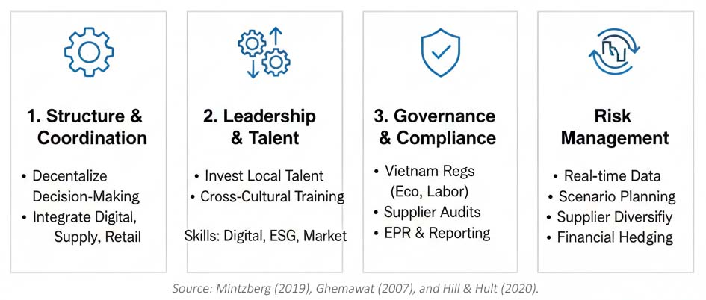
Organisational Structure and Co-ordination.
Expanding into an emerging market with significant growth potential demands the integration of digital, supply-chain and retail units. To enable regional teams, H&M might have to decentralize decision-making in line with structural flexibility research on global retailing (Mintzberg, 2019).
Leadership Skills and Leadership Development.
The company should invest in the local leadership talent and training on cross-cultural management. It should be implemented successfully by leaders who are skilled in digital retail, transition and emerging market dynamics and sustainability. Internationalisation success has a close linkage to leadership capability (Ghemawat, 2007).
Corporate Governance/Compliance.
Governance structures relating to sustainability should be enhanced by making sure that the environmental regulations of Vietnam, labour regulations and transparency demands are followed. This involves auditing of suppliers, EPR compliance and reporting mechanisms.
Risk Management
Some of the major risks are the volatility in supply chain, currency change, competitive pressure and regulatory change. H&M should strengthen the risk management systems by integrating real-time data analytics, scenario planning and supplier diversification. Exchange-rate exposure might necessitate the use of financial hedging strategies (Hill and Hult, 2020).

Conclusion
The report critically assessed the strategic position and growth prospects of H&M in the Vietnamese market based on external, internal and financial analysis. The results demonstrate that Vietnam is a favorable place to grow, as it is characterized by the growing middle population, rapid digitalization and a growing demand for affordable fashion.
H&M has a robust financial base combined with the application of various sales channels and adherence to sustainability, which form a good basis to go global. Nevertheless, the company will have to address such issues as competition with fast-fashion brands, government regulations, and the necessity to have a flexible supply chain. A future strategy reveals that the success of H&M would be based on its ability to adjust to the digital world, establish higher-quality relations with local clients, and localize its business model to fit local tastes.
The strategic suggestions highlight hybrid market introduction, differentiation and better risk management. The implementation will need organisational flexibility, good leadership and good governance to be successful. On the whole, H&M can attain sustainable growth in Vietnam in case these priorities are successfully implemented.

References
- Alvarez, S.A. and Barney, J.B. (2007) ‘Discovery and creation: Alternative theories of entrepreneurial action’, Strategic Entrepreneurship Journal, 1(1–2), pp. 11–26.
- Barney, J. (1991) ‘Firm resources and sustained competitive advantage’, Journal of Management, 17(1), pp. 99–120.
- Barney, J. and Hesterly, W. (2019) Strategic Management and Competitive Advantage. 6th edn. Pearson.
- Bloomberg (2024) H&M Equity Market Performance Overview.
- Brynjolfsson, E. and McAfee, A. (2014) The Second Machine Age. New York: Norton.
- Christopher, M., Lowson, R. and Peck, H. (2004) ‘Creating agile supply chains in the fashion industry’, International Journal of Retail & Distribution Management, 32(8), pp. 367–376.
- Delmas, M. and Toffel, M. (2008) ‘Organizational responses to environmental demands’, Strategic Management Journal, 29(10), pp. 1027–1055.
- Euromonitor (2024) Vietnam Apparel and Footwear Market Report. London: Euromonitor.
- Ferdows, K., Lewis, M. and Machuca, J. (2004) ‘Rapid-fire fulfillment’, Harvard Business Review, 82(11), pp. 104–110.
- Ghemawat, P. (2007) Redefining Global Strategy. Boston: Harvard Business School Press.
- H&M Group (2024) Annual & Sustainability Report 2024. H&M Hennes & Mauritz AB.
- Hill, C. and Hult, G.T.M. (2020) International Business: Competing in the Global Marketplace. 13th edn. McGraw-Hill.
- Hitt, M., Ireland, R. and Huskisson, R. (2020) Strategic Management: Competitiveness and Globalization. 14th edn. Cengage.
- Johnson, G., Whittington, R. and Scholes, K. (2020) Exploring Corporate Strategy. 12th edn. Pearson.
- Kahn, B. (2018) ‘The future of retailing’, Journal of Retailing, 94(4), pp. 309–316.
- Kim, W.C. and Mauborgne, R. (2015) Blue Ocean Strategy. Expanded edn. Harvard Business School Press.
- Kotler, P. and Keller, K. (2016) Marketing Management. 15th edn. Pearson.
- McKinsey & Company (2023) The State of Fashion 2023. McKinsey Global Institute.
- Mintzberg, H. (2019) Structure in Fives: Designing Effective Organizations. Pearson.
- OECD (2023) Textiles and the Environment: Policy Challenges. Paris: OECD Publishing.
- Porter, M.E. (1985) Competitive Advantage: Creating and Sustaining Superior Performance. Free Press.
- Schein, E.H. (2017) Organizational Culture and Leadership. 5th edn. Wiley.
- Schoemaker, P.J.H. (1995) ‘Scenario planning: A tool for strategic thinking’, MIT Sloan Management Review, 36(2), pp. 25–40.
- Verhoef, P., Kannan, P. and Inman, J. (2015) ‘From multi-channel retailing to omni-channel retailing’, Journal of Retailing, 91(2), pp. 174–181.
- World Bank (2024) Vietnam Economic Update. Washington, DC.

Appendices
Appendix A: H&M Financial Performance Data (2019–2024)
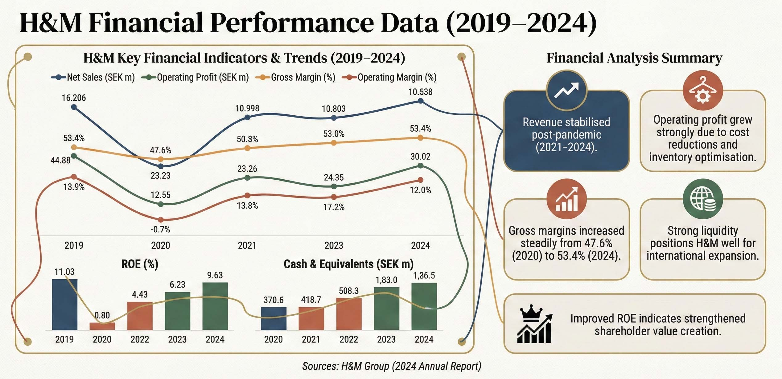
Appendix B: Vietnam Market Data and Demographics
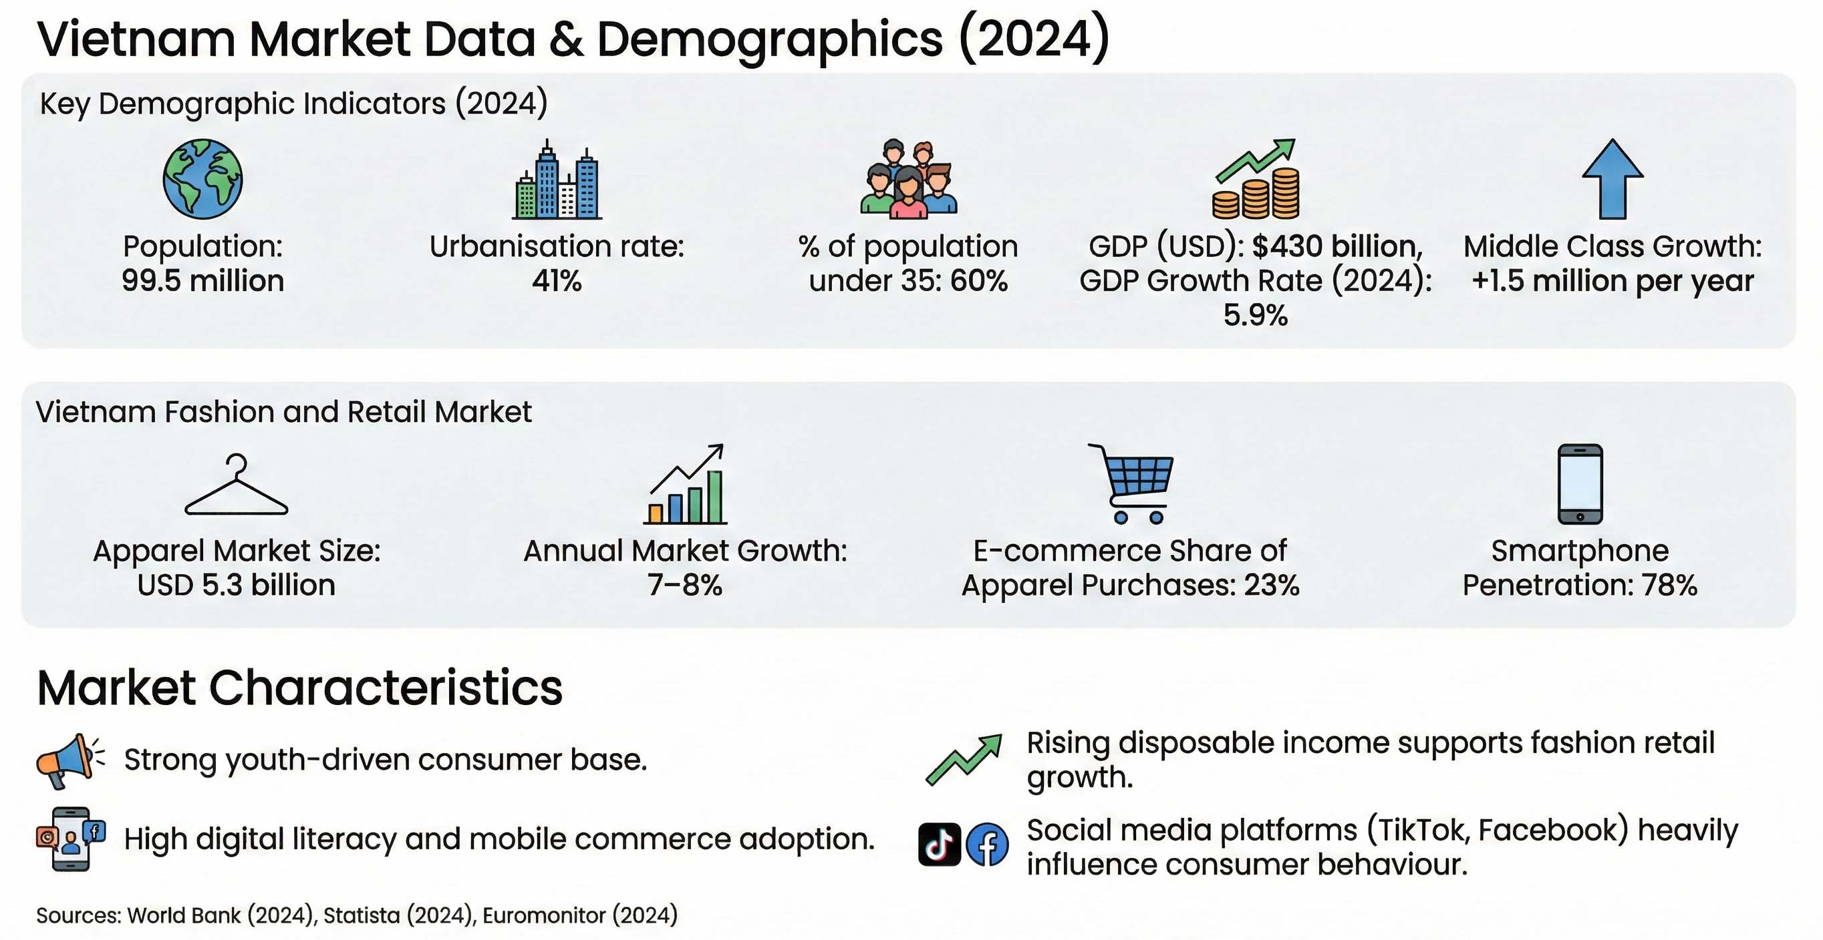
Appendix C: PESTEL Analysis Summary for Vietnam
Factor | Key Points
Political | Stable government; friendly policies for foreign businesses; tax benefits; better trade deals (CPTPP, EVFTA).
Economic | Growing economy (5-7% GDP growth); more middle-class consumers; inflation impacts on fashion demand; strong manufacturing.
Social | Fashion driven by young people; preference for international brands; growing awareness of sustainability; social media’s big role.
Technological | High use of mobile phones and internet; fast growth of online shopping; strong digital payments system; improving logistics tech.
Environmental | More rules on waste, plastic, and emissions; consumers care more about eco-friendly products.
Legal | Better enforcement of labor laws; stricter rules on imports; new rules for managing textile waste.

Appendix D: Porter’s Five Forces Summary
Force | Rating | Justification
Competitive Rivalry | High | Big brands like Zara and Uniqlo are growing fast; people care a lot about prices.
Threat of New Entrants | Moderate | It's easier for new brands to start selling online; foreign brands can sell through websites.
Buyer Power | High | Lots of options to buy clothes; switching brands is easy and cheap; people focus on price.
Supplier Power | Moderate | Many suppliers in Vietnam, but following eco-friendly rules makes things more expensive.
Threat of Substitutes | Moderate-High | Custom clothes, second-hand fashion, and local markets are popular choices.

Appendix E: Competitor Benchmarking and Strategic Group Map
E.1 Competitor Benchmark Table
Competitor | Price Level | Trend Speed | Sustainability | Digital Capability | Market Share (VN)
H&M | Medium | Fast | Strong | High | Growing
Zara | Medium–High | Very Fast | Moderate | High | Strong
Uniqlo | Medium | Slow–Moderate | Strong | High | Strong
Shein | Very Low | Ultra-fast | Weak | Very High | Rapidly increasing
Temu | Very Low | Fast | Weak | High | Emerging

E.2 Strategic Group Map (Description)


