

Module Name: Marketing Management
Module Code: LCMB7024
Program Name: Master of Business Administration
Student Name: Aamir Sohail
Student ID: 2439807
Tutor name: Dian Mayasari
Submission Date:
Wordcount: 2512

Brand Development and Marketing Strategy for Tesla Habitat: A Sustainable Smart-Home Ecosystem for the UK Market

Contents
Introduction 4
Element 1: STDP Analysis 4
Alignment with Evolving UK Consumer Behaviour Trends 5
Segmentation Analysis 5
Primary Target Segment Selection 6
Differentiation Strategy 6
Positioning Statement 6
Element 2: Marketing Mix (7Ps) 7
1. Product 7
2. Price 7
3. Place 8
4. Promotion 8
5. People 8
6. Process 8
7. Physical Evidence 9
Element 3: Pitch 9
Element 4: Reflection 9
Conclusion 11
References 12

Brand Development and Marketing Strategy for Tesla Habitat: A Sustainable Smart-Home Ecosystem for the UK Market

Introduction
The modern marketing landscape is shaped by accelerated technological innovation, shifting consumer demands, and growing global sustainability concerns. Companies are faced with the growing necessity to correlate business development with environmental sustainability and the value addition in the long run. Tesla, known as the world leader in electric mobility and renewable energy systems, provides an excellent foundation for the creation of new brands that cater to sustainability-oriented lifestyles. The proposed brand, Tesla Habitat, builds upon the Tesla ecosystem into the residential built environment, encompassing solar microgeneration, energy storage, smart home automation, and modular sustainable architecture, for the UK market. This marketing portfolio elaborates a strategic plan for Tesla Habitat using the analysis of Segmentation, Targeting, Differentiation, and Positioning (STDP) and then applies the 7Ps marketing mix to establish a consistent market-approach strategy. A critical reflection of the learning process through the brand development process is also incorporated in the portfolio. The broad objective is to show a scholarly and strategy-based methodology for the launch of Tesla Habitat as a unified sustainable living solution to modern consumers in the UK.

Element 1: STDP Analysis
Tesla consists of electric mobility and clean energy solutions, which are global and are celebrated by innovation in electric cars, batteries, and renewable energy systems. Tesla Habitat is a proposed new brand that expands the Tesla ecosystem into the residential built environment by incorporating Tesla Solar Roof technology, Powerwall energy storage, EV charging solutions, and AI-based home optimisation into the modular, low-carbon residential building units. Tesla Habitat will solve the problems of the sustainability of UK housing and energy market, and match new consumer values of environmentally conscious lifestyle and smart digital lifestyle.

Alignment with Evolving UK Consumer Behaviour Trends
The UK has been experiencing significant changes in consumer expectations associated with cost efficiency and sustainability. Energy bills and worries over reliance on fossil fuels in the household have provoked the recent surge of interest in microgeneration and domestic energy resilience (BEIS, 2022). Moreover, the Net Zero 2050 target set out by the government of the UK is a legally binding measure that puts pressure on households to lower carbon emissions (HM Government, 2021). Consumers are becoming more concerned with sustainability, not just as a form of ethical behaviour by choosing sustainability as a lifestyle, which is a financially sound decision (Mintel, 2023). By providing houses that can produce and store renewable electricity, Tesla Habitat takes advantage of these circumstances to eliminate the need to depend on the external supply.
Another significant consumer trend is digital lifestyles. The adoption of smart homes is on the rise, and UK households increasingly demand the incorporation of consumer technologies and data-based personalisation into their homes without problems (Statista, 2024). Tesla Habitat integrates artificial intelligence to automate the decisions related to lighting, heating, EV charging, and energy storage to help with convenience and increase energy efficiency. Thus, Tesla Habitat will be attractive to UK consumers who are driven by sustainability, cost-saving, and smart lifestyles.

Segmentation Analysis
Segmentation may be designed based on the possible market in terms of demographic, geographic, psychographic, and behavioural (Kotler and Keller, 2022).
- Demographic: High to upper-middle income professionals between 30 and 55 years old who have a stable job in technology, finance, healthcare, and creative sectors. Such people will be in a better position to invest in high-end sustainable housing solutions.
- Geographic: The cities and suburbs of the UK that have a high potential for uptake of renewable energy, like the South East, London, Manchester, and Bristol. Such places are more expensive in terms of property and more conscious of sustainability (ONS, 2023).
- Psychographic: Eco-friendly customers who are innovation-driven, independent, and creative in designing their modern lifestyle. These are the same consumers who are technology adopters and will perceive sustainability as inspiring instead of limiting.
- Behavioural: Consumers who are interested in long-term cost savings, carbon minimization, and integration at both personal mobility and home systems. They react favorably to the brands that have a good environmental reputation and technological credibility.

Primary Target Segment Selection
Tesla Habitat has the upper-middle-income professional families in the suburban and peri-urban areas, aged 30 to 50, who are mainly environmentally conscious and are looking to improve their lifestyle and gain control over their energy needs as its main target segment. This segment is very similar to the current EV clients of Tesla, which will allow cross-selling and lower customer acquisition expenses. The studies indicate that families switching to owning EVs are bound to invest in solar and energy storage tools to reduce operating expenses (IEA, 2023). Thus, Tesla Habitat has an opportunity to build a relationship with a consumer, based on both vehicle and home, with the help of Tesla's brand equity.

Differentiation Strategy
Tesla Habitat also stands apart when it comes to the use of renewable microgeneration and home automation technologies in its design, which are not an upgrade option available, but instead a fundamental architectural element of the Tesla Habitat. It is also a contrast of solar providers because Tesla Habitat provides a comprehensive system of home energy, which covers both generation, storage, consumption, and integration of mobility. Compared to smart home companies like Google Nest, Tesla Habitat will incorporate intelligence throughout the physical makeup of the residence with Tesla's proprietary AI energy optimisation framework instead of isolated device connections.
The value proposition created is an integrated, self-renewable living environment that has a lower impact on the environment and a high-quality user experience. This holistic approach enhances the competitiveness of Tesla Habitat as it presents the concept of sustainability as a lifestyle upgrade, opposed to a technical tool.

Positioning Statement
Tesla Habitat is positioned as:
"The premium sustainable smart-home ecosystem that enables UK households to achieve energy independence, intelligent living, and meaningful carbon reduction through fully integrated design and renewable technology."

Element 2: Marketing Mix (7Ps)

1. Product
Tesla Habitat is not a single product, but an entire ecosystem of a smart home. It integrates sustainable housing architecture, which is modular and based on Tesla Solar Roof, Powerwall energy storage, EV home chargers, and AI-based energy optimisation through Habitat OS. The system continually monitors user behaviour to anticipate the patterns of energy consumption, and charging and storage are done based on real-time electricity prices and weather predictions. This is in line with the concept of service-dominant logic that values are built over time by using systems (Vargo and Lusch, 2016). Tesla Habitat is thus functional utility and lifestyle improvement, which is based on sustainability and digital convenience.

2. Price
The strategy of Tesla Habitat pricing is in the form of premium pricing based on its technological and brand reputation. Nevertheless, the pricing should consider the UK's affordability issues. Tesla Habitat will provide flexible financial arrangements, such as:
- Long-term payment plans
- Green mortgage partnerships
- Renewable energy tax incentives support
- EV-owner loyalty discount schemes
To increase transparency and support customer decision-making, Tesla Habitat will introduce a clear price range for its ecosystem components:
• Full Tesla Habitat Home Ecosystem (solar + battery storage + EV charger + AI home automation): £18,000 – £28,000 depending on home size and energy needs.
• Solar Panel System Only: £5,000 – £8,000 for a standard 4–6 kW system.
• Battery Storage Unit (Powerwall-type): £6,000 – £9,000.
• Smart EV Charger: £900 – £1,500.
• AI Home Efficiency Suite: £1,200 – £2,500.
Value-based pricing is suitable because people would consider other benefits like decreased lifetime energy expenses and environmental impact, and not merely the initial costs (Nagle and Müller, 2018). Such a price structure will put Tesla Habitat in an aspirational but financially logical position.

3. Place
A hybrid model will be used in distribution. The Internet platform of Tesla will allow interactivity with customization, as well as the virtual simulation of energy savings. Face-to-face consultation will be provided at selected Tesla showrooms that will be modified to have Habitat demonstration areas. The major rollout areas will be London, Manchester, Bristol, Oxford, and Edinburgh, which were chosen because of the increased rate of sustainability adoption and EV use. The long-term scalability will rely on the partnerships with sustainable land developers and local planning councils.

4. Promotion
The promotion aims at a sustainability narrative, user experience, and digital-first communication. Core methods include:
● Social media campaigns on real-life energy independence stories.
● Working with eco-influencers and architectural thought leaders.
● Demonstration homes in which the visitors can test the Habitat OS system.
● Specific marketing to current Tesla EV clients.
It is in line with the principles of relationship marketing when brand community increases long-term loyalty (Grönroos, 2020).

5. People
Individuals constitute an important part because Tesla Habitat is consultative and long-term in support. The most important staff members are Tesla engineers, installation experts, customer advisors, and digital support teams. Employee development is aimed at sustainability, communication, empathy, and customer empowerment. Tesla will also develop a community of Habitat residents to establish peer advocacy and exchange of knowledge.

6. Process
The service process has several steps:
1. Online consultation and appraisal.
2. Systems and architectural customisation.
3. Planning assistance Regulatory.
4. On-site installation and system integration.
5. Continuous system monitoring and optimisation with Tesla Cloud.
This is a personalised but standardised process that ensures the reliability of the operations and customer confidence.

7. Physical Evidence
Physical evidence can be seen in the architectural look of Tesla Habitat houses, the design of Tesla showrooms, Habitat OS online interfaces, and demonstration properties. Minimalism, clean lines, and high-quality materials feature the visual identity that supports the innovative and high-quality brand image of Tesla. Physical consistency helps to enhance brand consistency and the feeling of reliability (Zeithaml et al., 2020).

Element 3: Pitch
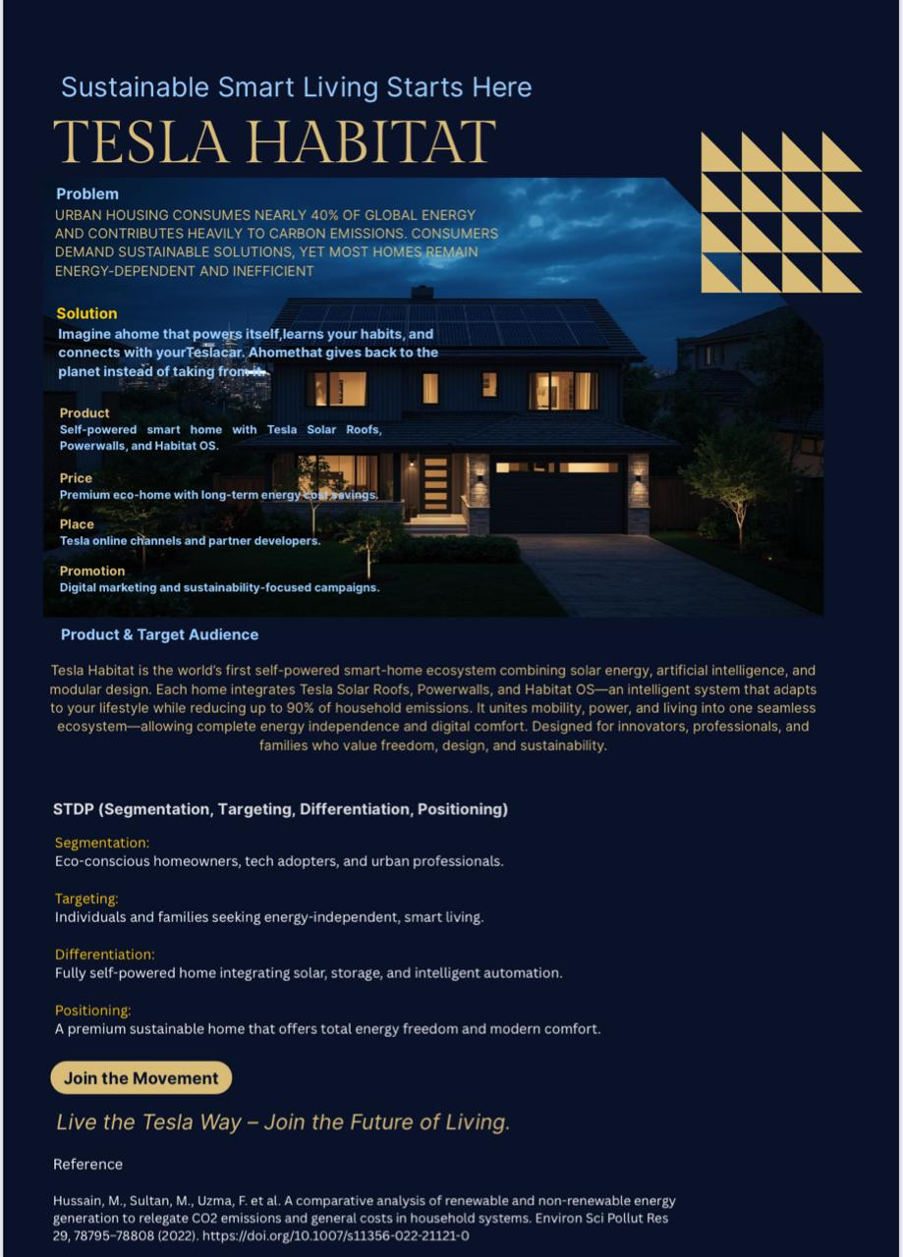
The poster features the Tesla Habitat, an idea of a fully sustainable smart-home system that aims at minimizing the use of energy around the world and family emissions. It starts with determining the principal issue: city housing consumes nearly 40 percent of the world's energy and makes significant carbon emissions. Although the demand for green solutions is on the increase, the majority of houses continue to rely on traditional and inefficient energy systems.
The marketing mix accentuates the product as a high-end smart home, which operates using solar energy and offers Tesla support. Its target customers are environmentally conscious people living at home, tech adopters, workers, and families who desire energy self-sufficiency and energy savings.
The STDP section describes the way the brand will divide the market, appeal to people interested in sustainable living, how the brand will distinguish itself by being fully solar-powered, with storage and intelligent automation, and how the home will be presented as a well-designed and comfortable eco-luxury.
In general, the poster conveys Tesla Habitat as a combination of sustainability, intelligent technology, and lifestyle design to introduce the future-oriented lifestyle that provides the freedom of energy and environmental awareness.

Element 4: Reflection
The Tesla Habitat brand concept was developed by me, which gave me an opportunity to learn more about strategic brand development in the modern marketing practice. I have come to know that brand creation does not simply involve offering a new product or service, but also developing a narrative that is well-linked and acceptable to consumer values, market situations, and long-term organisational identity. In the process, I realised that it is necessary to base brand strategy on real market understanding and not assumptions. As an example, the choice to locate Tesla Habitat on the principles of sustainability and digital life integration was preconditioned by the research, which revealed the increasing interest in smart houses and low-carbon living in the UK (Mintel, 2023; Statista, 2024).
My exposure to Tesla Habitat helped me increase my awareness of the importance of sustainability as a driver of modern marketing responsibility. I had to consider marketing as something more than an instrument of persuasion, but a way of making lifestyle changes more environmentally responsible. According to Peattie and Belz (2021), sustainability marketing needs to build the value that will be beneficial to consumers and the entire environment, and this model helped influence my decision-making. Instead of having sustainability appear as a sacrifice, I tried to make it inspirational and empowering. This change affected my perspective of thinking about messaging, value propositions, and the emotional tone of the brand. It made me remember that consumers are becoming more and more demanding of companies acting genuinely, rather than acting in a manner that is shown as environmentally friendly.
Another skill that was built during the preparation of ideas to be pitched is communication and professional presentation skills. To render a complex concept into a convincing story, it had to be clear with structure and the presentation of functional and emotional worth. I also came to know that strategic pitching does not just involve outlining features but also an explanation of why the offering is important to people. According to Gronroos (2020), relationship-building in marketing is anchored on the communicated value in a manner that the audience can relate to on an individual level. When creating my pitch, I guided the concept of energy independence and future-proof living due to the fact that the messages are emotional and socially relevant to the target audience.
One of my strengths in my approach was that I used research to justify decisions, especially when segmenting and positioning the brand. I made sure that every strategic decision, like focusing on professional families that were conscious of the environment, was backed up with sound industry statistics. I also think that I was coherent in ensuring that the marketing mix was in line with the brand identity. Nonetheless, I have identified areas in which I can improve. One of the spheres is the necessity of using a greater amount of quantitative prediction and financial feasibility analysis. Although I rationalized the pricing conceptually based on the value-based pricing theory (Nagle and Muller, 2018), I could have reinforced the strategy by modeling the concept of affordability in various payment conditions. I can also continue to delve into how to make the brand inclusive to more than upper-middle-income consumers, as sustainable products easily lead to socioeconomic exclusivity.
Altogether, this project expanded my skills in bridging theory and practice and showed how marketing strategy could contribute to the development of innovations that would be sustainability-oriented. I am now in a better position to come up with brand strategies that are not only commercially viable but also socially relevant.

Conclusion
Tesla Habitat development example shows that strategic marketing can incorporate sustainability, technology, and lifestyle aspirations into a logical value proposition. The STDP analysis proved that the primary target segment to be taken is the environmentally conscious and digitally oriented professional households in the UK, especially where the consumers are driven by both carbon reduction and the management of energy costs. Tesla Habitat differentiation and positioning are based on Tesla's current brand equity, with a focus not on individual smart appliances and renewable upgrades, but on a holistic energy independence and smart living approach. The operationalisations of the 7Ps marketing mix realised the strategy so as to make sure that there was fit between the product ecosystem, value-based pricing, multi-channel distribution, digital promotion communication, trained service staff, organised installation procedures, and regular physical brand indicators. The reflection has revealed the significance of responsible marketing practice, strategic narrative building, and professional communication in the development of sustainable innovation. Comprehensively, Tesla Habitat is a brand idea that can make a significant contribution to the evolution of the UK into a low-carbon lifestyle and provide customers with high-quality and prospective living in the country.

References
BEIS. (2022) Energy Consumption in the UK. UK Government.
Belz, F.M., Peattie, K. and Onel, N., 2025. Sustainability marketing: A global perspective. John Wiley & Sons.
Grönroos, C., 2020. Service marketing research priorities. Journal of Services Marketing, 34(3), pp.291-298.
HM Government. (2021) Net Zero Strategy: Build Back Greener. London: UK Government.
Hussain, M., Sultan, M., Uzma, F., Longsheng, C., Malik, M.Y., Butt, A.R., Sajjad, A., Younis, I., and Imran, M., 2022. A comparative analysis of renewable and non-renewable energy generation to reduce CO2 emissions and general costs in household systems. Environmental Science and Pollution Research, 29(52), pp.78795-78808.
IEA. (2023) Global EV Outlook 2023. International Energy Agency.
Kotler, P. and Keller, K. (2022) Marketing Management. 16th ed. Pearson.
Mintel. (2023) Sustainable Lifestyles UK. Mintel Market Report.
Nagle, T.T. and Muller, G., 2018. The strategy and tactics of pricing. Routledge.
ONS. (2023) Energy and Housing Statistics. Office for National Statistics.
Statista. (2024) Smart Home Market in the United Kingdom. Statista Research Service.
Vargo, S.L., Lusch, R.F., AKAKA, M.A. and HE, Y., 2016. Service-dominant logic. Marketing Theory: A Student Text, Sage Publications, Thousand Oaks, CA, pp.458-475.
Wilson, A., Zeithaml, V., Bitner, M.J. and Gremler, D., 2020. EBK: Services marketing: Integrating customer service across the firm 4e. McGraw Hill.

