
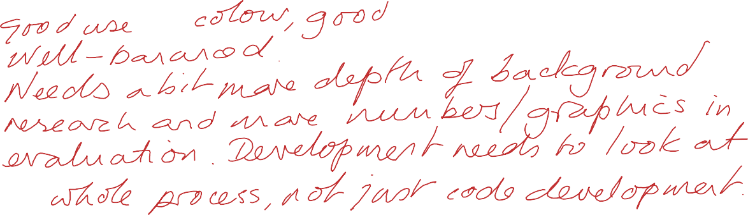

INDEPENDENT PROJECT - Exhibition – 10%
Comments:

Student Name: | Charlie Kierl
Title of Project: | Social Skills Educational Game
Supervisor: | Dr Nik Whitehead
2nd marker: | Mark Huntly
Course: | ☒ Applied Computing  - CNC  - DIS  - Software Dev  - Games Dev  - Web Dev  - Electrical and Electronic

Exhibition
1. Poster: Clarity of Technical  Description |  /40
2. Poster: Quality of Visual Display | /40
3. Questionnaire/other materials
TOTAL |  /80 - 79%

