
Perceptions Of Bias Mitigation in Ai-Driven Hr Recruitment Tools: An Investigation into HR Professionals' Trust, Concerns, And Priorities

By Kate Davies
2316342

Dissertation submitted as part of the requirements for the award MBA

Supervised by James Moore
September 2024

EXAMINATION OF TAUGHT MASTER'S DEGREE DISSERTATION:
NOTICE OF CANDIDATURE FORM

Please complete this form when your dissertation is ready to be submitted for examination.

Surname/Family Name: Davies Date of Birth: 01.03.1986
Forenames (in full): Katherine Cerys Jane Title: Mrs
Institution Number (if known): 2316342
Title of Degree (eg MA, MSc, MBA etc): MBA
Title of Taught Master's degree scheme followed (eg Equine Studies): Master of Business Administration
Department/School in which study pursued: Swansea Business School
Name of your Supervisor: James Moore
Full Title of dissertation submitted: Perceptions Of Bias Mitigation in Ai-Driven Hr Recruitment Tools: An Investigation into HR Professionals' Trust, Concerns, And Priorities
Please indicate that the following will all be submitted along with this form:

two permanently bound copies of your dissertation plus 1 electronic copy submitted via Turnitin;

SUBMISISION OF DISSERTATIONS

Final Dissertation submission
Dissertations to be submitted via Turnitin, together with
2 paper copies (Heat bound).
Paper copies to be forwarded to :

Faculty Office
Swansea Business Campus
Faculty of Business and Management
University of Wales Trinity St David
Powell Street
SA1 1NE.

Declaration/Statements page

DECLARATION

This work has not previously been accepted in substance for any degree and is not being concurrently submitted in candidature for any degree.

Signed  (candidate)

Date 14/09/2024

STATEMENT 1

This work is the result of my own investigations, except where otherwise stated.

Other sources are acknowledged by footnotes giving explicit references. A bibliography is appended.
Signed (candidate)

Date 14/09/2024

STATEMENT 2

I hereby give consent for my work, if accepted, to be available for photocopying and for inter-library loan, and for the title and summary to be made available to outside organisations.
Signed (candidate)

Date 14/09/2024

NB: Candidates on whose behalf a bar on access has been approved by the University (see Note 1), should use the following version of Statement 2:

I hereby give consent for my work, if accepted, to be available for photocopying and for inter-library loans after expiry of a bar on access approved by the University.

Signed (candidate)

Date 14/09/2024

Candidate’s signature . (candidate)

Date 14/09/2024

Abstract
This dissertation explores the perceptions of HR professionals regarding bias mitigation in AI-driven recruitment tools. The central research question investigates how AI technologies impact recruitment practices, particularly concerning bias mitigation, trust, and the balance between operational efficiency and fairness. The study is significant because it addresses the paradox of AI adoption in recruitment while offering improved efficiency and the potential to reduce human biases, AI also presents significant ethical concerns and risks of perpetuating and exacerbating bias.
A survey of 100 HR professionals forms the basis of this research, with the data analysed using theoretical frameworks such as the Technology Acceptance Model (TAM), the Diffusion of Innovations (DOI) theory, and Wilful Blindness. The results highlight a mixed level of trust in AI tools, with seasoned HR professionals expressing reservations about the effectiveness of bias mitigation strategies. Efficiency was a primary motivation for AI adoption, with 70% of respondents prioritising this factor. However, only a small proportion of organisations had implemented concrete bias mitigation strategies, suggesting a significant gap between the perceived benefits and actual effectiveness of AI tools in reducing bias.
The findings suggest that while AI is seen as a tool for operational efficiency, its adoption is hindered by a lack of trust and awareness regarding bias prevention measures. The study concludes that for AI to be more widely accepted and effective in recruitment, HR professionals require better education on AI's limitations and its ethical implications. The results also point towards the need for more robust regulatory frameworks to ensure fairness and transparency in AI-driven recruitment.

Contents
Abstract 3
Chapter 1.0 Introduction 7
1.1 Background 7
1.2 Research Rationale 8
1.3 Statement of the Problem 9
1.4 Research Aims & Objectives 10
1.5 Purpose of this Study 11
1.6 Research Design 12
1.7 Assumptions, Limitations, and Scope 13
Chapter 2.0 Literature Review 14
2.1 Introduction 14
2.2 Evolution of AI in HR: 14
2.3 Legal and Ethical Frameworks 15
2.4 Perceived Benefits and Critical Evaluation of AI in Recruitment and HR Practices 16
2.5 Theoretical Framework and Models 18
2.5.1 Technology Acceptance Model (TAM) 18
2.5.2 Diffusion of Innovation Theory and AI in Recruitment 19
2.5.3 Wilful Blindness in AI Adoption 19
2.6 Research Questions and Hypotheses 20
2.7 HR Professional Bodies' Views on AI in Recruitment 21
2.7.1 Chartered Institute of Personnel and Development (CIPD) 21
2.7.2 Society for Human Resource Management (SHRM) 22
2.7.3 The HR Digest 23
2.8 Algorithmic Hiring in Practice: 23
2.8.1 Recruiter and HR Professional’s Perspectives on AI Use in Hiring 23
2.8.2 Research Into Candidates’ Perceptions 24
2.9 Research Gaps 24
2.10 Conclusion 26
Chapter 3.0 Methodology 27
3.1 Introduction 27
3.2 Research Rationale 28
3.3 Research Aims and Objectives 28
3.4 Research Design 29
3.5 Participants 31
3.6 Data Collection Instrument 32
3.7 Questionnaire Design and Relation to Research Objectives 32
3.8 Data Analysis 34
3.9 Ethical Considerations 34
3.10 Validity and Reliability 35
3.11 Pilot Testing and Adjustments 35
3.12 Limitations 37
3.13 Challenges 38
Chapter 4.0 Analysis of Results 39
4.1 Introduction 39
4.2 Demographic Information of Participants 40
4.3 Awareness of AI Bias and Concerns in Recruitment 41
4.3.2 Concerns Regarding AI in Recruitment 41
4.4 Perceptions of Anti-Bias Measures in AI Tools 42
4.4.2 Effectiveness of Anti-Bias Measures 44
4.5 Factors Influencing Trust and Adoption of AI Recruitment Tools 45
4.5.1 Motivations for AI Adoption 45
4.5.2 Trust in AI Technologies 46
4.6 Efficiency vs Fairness in AI-Driven Recruitment 47
4.6.1 Efficiency as a Priority 47
4.6.2 Fairness in Recruitment 47
4.7 Impact of AI on Organisational Culture 48
4.8 Awareness and Compliance with Legal and Ethical Standards in AI-Driven Recruitment 50
4.9 Future Role of AI in Recruitment 50
Chapter 5.0 Discussion 51
5.1 Introduction 51
5.2 Addressing Research Questions 51
5.3 Application of Theoretical Frameworks: DOI, TAM, and Wilful Blindness 53
5.3.1 Diffusion of Innovations (DOI) Theory 53
5.3.2 Technology Acceptance Model (TAM) 53
5.3.3 Wilful Blindness 54
5.4 Implications for Practice and Further Research 54
Chapter 6.0 Conclusion 56
6.1 Awareness of AI Bias and Mitigation Strategies 56
6.2 Trust in AI Recruitment Tools 57
6.3 Efficiency vs. Fairness in AI Recruitment 57
6.4 Impact on Organisational Culture and Future Role of AI 58
6.5 Ethical and Regulatory Implications 58
6.6 Recommendations for Future Research 59
6.7 Final Thoughts 59
Reference list 60
Appendices 70
Questionnaire 70

Tables and Graph Contents
Number | Type | Title
2.1 | Figure | Research onion
2.2 | Figure | Social media poll
4.0 | Table | Demographic
4.1 | Graph | Experience V Understanding
4.2 | Graph | AI Concerns
4.3 | Graph | Anti-bias Measures
4.4 | Graph | Anti-bias Understanding
4.5 | Table | Motivating Factors
4.6 | Graph | Experience V Trust
4.7 | Graph | Size V Culture

Word Count
Chapter 1 Introduction | 2,222
Chapter 2 Literature | 4,406
Chapter 3 Methodology | 3,364
Chapter 4 Findings | 2,409
Chapter 5 Discussion | 1,326
Chapter 6 Conclusion | 1,265
Total | 15,092

Chapter 1.0 Introduction

1.1 Background
Artificial Intelligence has been progressively integrated into various aspects of HR, namely recruitment and selection, promising to streamline processes, enhance decision-making, and reduce costs (Brookings Institution, 2018). Initially, AI tools were used primarily for automating repetitive tasks, such as resume screening and interview scheduling as observed by Strategic Human Resource Management (SHRM) (SHRM, 2024). Over time, the capabilities of AI in recruitment have expanded to include sophisticated algorithms that can assess candidate skills, predict job performance, and even analyse cultural fit (McKinsey, 2018). Despite these advancements, the journey of AI in recruitment has been marked by significant challenges, particularly around bias and fairness as reported in the HBR (Bogen, 2019).
Historically, there has been considerable apprehension about AI and robotics taking over human jobs, fuelled by fears of losing control and the ethical implications of automated decision-making (West, 2018). Despite these concerns, AI-driven recruitment tools have been swiftly and widely adopted worldwide. Intelion Systems (2023) report that 35% to 45% of companies utilise AI recruitment tools, with 99% of Fortune 500 companies incorporating AI practices. Looking ahead, over 73% of companies plan to invest in recruitment automation in 2023. The adoption of AI in recruitment aligns with broader trends seen in the UK, where AI's impact on various sectors, including job creation and economic contribution, has been profound. Adebisi, (2023) reports in 2022, AI contributed £3.7 billion to the UK economy, and it is predicted to generate £232 billion in additional revenue by 2030.
The primary motivations behind this adoption include the promise of cost savings, enhanced efficiency, and the perceived ability of AI to reduce human biases. Notably, 44% of recruiters emphasise time saving as a key reason for implementing AI in their hiring processes, with 67% of hiring decision makers appreciating AI’s time-saving capabilities. However, significant concerns persist. For instance, 35% of recruiters worry that AI might exclude candidates with unique skills and experiences, and 26% fear that AI could negatively disrupt the HR industry (Intelion Systems, 2023).
Transparency issues also arise because many AI recruitment tools are protected by intellectual property laws, and software companies have no legal obligation to disclose how their bias mitigation methods work. This lack of transparency makes it difficult to assess how decisions are made and potentially leads to mistrust among users and the existence of discrimination within recruitment software (TechUK Reports, 2023). The AI Barometer Part 3 - Recruitment and Workforce Management by GOV.UK, (2021) highlights that while AI can standardise hiring processes and increase transparency, it also poses risks such as disproportionate workplace monitoring and the perpetuation of human biases. furthermore, the lack of clear governance frameworks complicates the responsible adoption of AI technologies, increasing costs for developers and employers and creating an uneven playing field for SMEs (GOV.UK, 2021) This duality potentially leaves organisations to determine their own compass on ethical stance on self-governance and accountability, as a result of a severely lagging legal framework to govern AI usage.
Currently, the UK relies on the Equality Act 2010 (GOV.UK, 2010) and data protection laws to regulate AI in recruitment. Meanwhile, the European Parliament (2024) is enacting comprehensive regulations to ensure the ethical use of AI. The new Artificial Intelligence Act by the European Parliament aims to position the EU as a global leader in AI adoption while addressing regulatory and ethical challenges. However, the rapid adoption of AI has outpaced regulatory measures, with these new regulations not expected to commence until late 2024 and finalising by 2027, posing challenges in governance and accountability (TechUK Reports, 2023).

1.2 Research Rationale
The rapid adoption of AI in recruitment presents a paradox: while AI offers significant benefits in terms of efficiency and cost-effectiveness, it also poses ethical implications and risks related to bias and fairness. Historical data used to train AI systems can perpetuate existing biases, leading to discriminatory outcomes. Additionally, the lack of transparency in AI algorithms complicates efforts to identify and address these biases as explored by Lavanchy et al. (2023). Despite these challenges, AI-driven recruitment tools have been embraced by organisations at an unprecedented rate.
It is crucial to investigate whether HR professionals and decisionmakers fully understand AI's weaknesses and biases. This study will examine if these decision-makers prioritise efficiency over fairness, their understanding of AI capabilities and limitations, and their regulatory practices regarding AI usage.

1.3 Statement of the Problem
The integration of AI in recruitment processes has been widely adopted, promising enhanced efficiency, cost savings, and the potential to reduce human biases. However, this technological advancement is accompanied by significant challenges, particularly regarding bias and fairness. Despite the rapid adoption of AI-driven recruitment tools, there are unresolved issues that necessitate a thorough examination.
Firstly, AI systems, which rely on historical data for training, can perpetuate and even amplify existing biases (Lee, Resnick, & Barton, 2019). This results in discriminatory outcomes that undermine the goals of equality and diversity within the workplace (Dattner et al., 2019), Rashid (2023) further warns of broader implications that AI tools not only perpetuate existing biases but also pose risks if bias decision making is present the outcome is potentially undermining democratic laws and exacerbating societal wealth inequality, along with creating demographic and geographical disparities. Reuters (Dastin, 2018) reports on the notable incident of the failure of Amazon’s AI recruiting tool due to inherent biases that could not be neutralised, exemplifying the difficulties in mitigating these biases, even for technologically advanced organisations.
Secondly, as reported by Vultus Inc., (2024) there is a pronounced lack of transparency in AI algorithms used for recruitment and selection. Many of these algorithms are protected by intellectual property laws, and software companies are not legally required to disclose how their bias mitigation strategies operate. This opacity means the existence of bias within these tools could be prevalent with users unaware of their existence. The concealment of these algorithms makes it challenging for users to understand how decisions are made, leading to potential mistrust, and questioning the fairness of these systems (TechUK Reports, 2023).
The rapid pace of AI adoption in recruitment outstrips the development of comprehensive regulatory frameworks leaving a fragmented landscape to navigate. In the UK, current regulations, such as the Equality Act 2010 (GOV.UK, 2010) and data protection laws (GOV.UK, 2018), are insufficient to fully address the complexities introduced by AI in recruitment. The European Parliament (2024) upcoming Artificial Intelligence Act aims to establish more robust regulations, but these measures will not be fully implemented until 2027. Additionally, there is a lack of standardised best practices for implementing and auditing AI tools, making it difficult for organisations to measure and improve fairness consistently. leaving a significant governance gap in the interim
This study aims to investigate whether HR professionals are fully aware of AI’s weaknesses and potential biases in recruitment. It will explore if decision makers prioritise efficiency over fairness, their understanding of AI capabilities and limitations, and their practices regarding the regulatory and ethical use of AI. Addressing these issues is crucial for developing fair, transparent, and effective AI-driven recruitment systems that align with broader societal goals of equality and diversity.
This study aims to address the following research questions:
- How aware are HR professionals of the potential biases in AI-driven recruitment tools?
- What are HR professionals’ perceptions of the effectiveness of anti-bias measures in these tools?
- Do HR professionals prioritise efficiency over fairness in AI-driven recruitment?

1.4 Research Aims & Objectives
The primary aim is to critically examine the motivations and perceptions of HR professionals regarding the use and effectiveness of bias mitigation in AI-driven HR recruitment tools. This exploration is crucial as it seeks to understand their trust in these technologies, concerns about potential biases, and how they prioritise these concerns against the operational efficiencies that AI promises. This research is pivotal as it aims to provide empirical evidence on how AI tools are used in real-world HR settings and their impact on recruitment practices.
Research Objectives:
Assess Awareness and Concerns of HR Professionals: This objective involves evaluating HR professionals' awareness of potential biases present in AI-driven recruitment tools and their concerns regarding these biases. Understanding their level of awareness will help identify knowledge gaps and the need for further education or modifications in AI tool functionalities.
Examine Perceptions of Anti-Bias Measures: Investigate HR professionals’ beliefs about the effectiveness of implemented anti-bias measures within AI recruitment tools. This will involve assessing whether these professionals believe that the anti-bias technologies integrated into AI systems are effective at mitigating biases, and if so, in what ways.
Analyse Trust and Adoption Factors: Identify factors that influence HR professionals’ trust in and adoption of AI recruitment technologies. This includes exploring both positive and negative aspects that affect their willingness to rely on these tools for hiring purposes.
Prioritisation of Efficiency vs. Fairness: Determine whether HR professionals prioritise efficiency and resource time-saving benefits offered by AI tools over fairness and bias prevention. This will help understand if there's a trade-off being made between efficiency and ethical considerations in the use of AI in recruitment.

1.5 Purpose of this Study
The purpose of this study is to investigate the use and impact of AI-driven recruitment tools from the perspective of HR professionals. It aims to provide a detailed understanding of how AI technologies are currently employed and motivations in real world HR settings and their implications for recruitment practices.
Study Seeks To:
- Identify Knowledge Gaps: Highlight areas needing further education or training by examining existing research and HR professionals' awareness of AI capabilities and limitations.
- Assess Bias Mitigation: Evaluate the effectiveness of anti-bias measures in AI recruitment tools to determine if current technologies meet their goals.
- Explore Trust and Adoption: Understand factors influencing trust and adoption of AI recruitment technologies, both positive and negative.
- Evaluate Ethical and Regulatory Practices: Examine how organisations ensure compliance with ethical and regulatory standards in AI recruitment.
- Inform Future Research and Development: Provide feedback for developing more effective and unbiased AI tools, laying the groundwork for future research.
Broader Purpose
The findings of this study will be valuable to various stakeholders:
- Policymakers: Offer insights into the regulatory needs for AI in recruitment, helping to shape policies that ensure fair and ethical AI usage.
- HR Professionals: Guide HR practitioners in making informed decisions about adopting and integrating AI technologies into their recruitment processes, leveraging AI effectively while mitigating risks.
- AI Developers: Inform developers about practical challenges and concerns faced by HR professionals, helping improve the design and functionality of AI recruitment tools.
Long-term Vision
In the long term, this study aims to influence the development and deployment of AI in recruitment by promoting the adoption of ethical AI tools that prioritise fairness, transparency, and accountability, fostering diversity and inclusion within organisations. It also seeks to shape future research and guide technological advancements, ensuring AI tools are robust in mitigating biases and compliant with evolving regulatory standards, thus paving the way for innovative and equitable AI systems.

1.6 Research Design
This research is both descriptive and exploratory, aiming to provide a comprehensive understanding of the use and impact of AI-driven recruitment tools in HR. A quantitative research method was chosen following research into methodology as studied from Cameron and Price, (2009), utilising a structured questionnaire distributed to a targeted group of 120 HR professionals. The questionnaire consists of multiple-choice and Likert scale questions (Mcleod, 2023), designed to gather detailed data on the participants' experiences, perceptions, and attitudes towards AI in recruitment.
A cross-sectional time horizon is adopted, collecting data over several weeks but focusing on capturing the current views and practices of HR professionals at a single point in time for each participant (Saunders, Lewis and Thornhill, 2019). This approach allows for the analysis of contemporary issues related to AI in recruitment, offering a snapshot of the current state of adoption and its associated challenges and benefits.
The survey was designed using Microsoft Forms, with responses securely stored through the university's cloud storage systems to ensure GDPR compliance.
Ethical clearance for this research was obtained from the university’s ethics committee, ensuring that the study complies with ethical standards and protects the rights and privacy of all participants.

1.7 Assumptions, Limitations, and Scope
Assumptions:
- HR professionals’ responses accurately reflect their perceptions and experiences regarding AI recruitment tools.
- Respondents are aware of the AI tools used within their organisations and understand their technical and ethical implications.
Limitations:
- Survey-based research may not capture the full depth of respondents’ experiences.
- Findings may not be generalisable to all HR professionals or global organisations.
- Response biases such as social desirability might influence the data.
- Rapidly evolving AI tools could affect the study's long-term relevance.
Scope:
This research focuses on HR professionals in the UK, examining their motivations and perceptions of AI-driven recruitment tools, particularly regarding bias mitigation, transparency, and regulatory practices. The study aims to provide insights that can inform policy and practice in HR management, ensuring ethical and effective AI deployment.

The following sections of this report will cover the literature review, methodology, data analysis, findings, discussion, and conclusion. The literature review will provide an in-depth analysis of existing research on AI in recruitment. The methodology will outline the research design and data collection methods. Data analysis will present the results of the study, followed by a discussion of the findings. Finally, the conclusion will summarise the key insights and suggest implications for practice and future research.

Chapter 2.0 Literature Review

2.1 Introduction
The use of Artificial Intelligence (AI) in recruitment has revolutionised traditional hiring methods, introducing greater efficiency and precision. At its core recruitment and selection is fundamentally a discriminatory act (Kroll, Veit and Ziegler, 2021), recruitment involves making choices between candidates, decisions that are by nature selective. From how job roles are advertised to whom is ultimately hired. Historically, these processes have relied on human judgment, which is vulnerable to both bias and inefficiency. AI offers the potential to reduce these limitations by automating various stages of recruitment, from sourcing candidates to making final selections. However, this raises an important question: does AI effectively eliminate human biases or does it risk introducing new forms of bias. This literature review examines the evolution of AI in recruitment and selection, its advantages, the challenges it poses, and the ethical and legal concerns surrounding its use.

2.2 Evolution of AI in HR:
The evolution of AI in recruitment and selection showcases both advancements and challenges. AI can have a significant impact on both recruitment—attracting and identifying a pool of appropriate candidates—and selection—choosing the best fit from that pool. Initially, AI automated repetitive tasks like CV screening, improving efficiency in recruitment (LinkedIn, 2024). However, early systems often overlooked qualified candidates due to their reliance on keyword matching, limiting their effectiveness in both recruitment and selection (Indeed, 2023). By refining algorithms and using data-driven approaches, AI tools can better match candidates to roles while also mitigating some biases, though concerns remain about potential new biases introduced during the selection process
As AI developed, advanced algorithms enabled complex assessments of candidate skills and cultural fit, leading to data-driven hiring decisions (Naik, 2023). Big data analytics further enhanced accuracy by identifying patterns in extensive datasets (SHRM, 2024). Natural language processing (NLP) improved candidate engagement through AI-powered chatbots and virtual assistants, like HireVue (McKinsey, 2018) Generative AI now helps create accurate job postings, enhancing the recruitment experience (Jones, 2024).
Despite these benefits, challenges remain in mitigating biases and ensuring fair assessments. Ongoing refinement and ethical oversight are crucial as AI continues to evolve.

2.3 Legal and Ethical Frameworks
Despite the majority of AI technology emerging from the U.S., there are no specific federal laws in place that directly regulate AI. In contrast, the UK and the broader EU have taken proactive steps, such as the proposed AI Act in the EU, to regulate the use of AI and mitigate potential risks (U.S. Department of Labor, 2023). The regulation of AI in the UK and Europe presents varying approaches and significant challenges. The UK framework is interlaced with 3 separate regulations consisting of the AI act (UK Government, 2023), Data protection laws (GOV.UK, 2018), and the equality act (GOV.UK, 2010). The Cambridge Handbook of Artificial Intelligence (Banteka, 2024) notes the contrasts of the regulatory heavy European frameworks with the UK's more flexible, principle-based approach. This flexibility aims to foster innovation while ensuring safety and accountability through ethical compliance but highlights the need for new regulatory norms to address AI's unique challenges, such as autonomy and legal personality. The Ada Lovelace Institute (Davies and Birtwistle, 2023) examines the UK's pro-innovation regulatory framework, emphasising broad principles like safety, fairness, and transparency. However, concerns about inconsistent enforcement and inadequate safeguards against biases remain, essentially critiquing the framework as inadequate.
In contrast, the European Parliament's (2024) AI Act, finalised in 2024, introduces a more stringent regulatory framework. This Act categorises AI applications by risk levels and imposes strict requirements on high-risk systems, mandating comprehensive risk assessments, transparency obligations, and prohibiting certain AI systems that violate fundamental rights (Carter, Hyman and Silver, 2024) The EU's approach appears to be a reaction to the rapid adoption of AI technologies and the perceived inadequacies of earlier frameworks, such as that of the UK, which focused primarily on fostering innovation, potentially at the expense of robust regulatory oversight. This cautious, more structured approach by the EU aims to protect fundamental rights and ensure trustworthy AI use and development, reflecting lessons learned from the UK's earlier, more permissive stance.
A key consideration is that the new EU regulations will not begin to take effect until late 2024, with full implementation expected by 2027. This delay raises questions about how AI will shape the workforce in the interim and what measures will be necessary to manage the transition period effectively.
Acuity Law (2024) provides insight from legal practitioners and discusses practical and legal risks of AI in the workplace, such as discrimination, data breaches, and the complexities of AI vulnerabilities. Acknowledging the frameworks open to interpretation they emphasise the importance of human oversight, thorough risk assessments, and compliance with data protection laws to mitigate these risks.
In summary, while the UK's flexible regulatory framework aims to balance innovation with ethics over strict governance, the European AI Act provides a rigid model focusing on stringent compliance. This shift reflects a growing recognition of the need for robust standards to govern AI effectively. Effective AI governance will require coordinated international efforts, robust regulatory standards, and ongoing critical analysis to address the ethical and legal complexities of AI technology.

2.4 Perceived Benefits and Critical Evaluation of AI in Recruitment and HR Practices
AI has become integral to modern recruitment and HR, offering multiple advantages but also raising important concerns. One of the main benefits is its ability to enhance efficiency by processing large volumes of applications rapidly, significantly reducing the time required for initial screening, as theorised by Thakur, Hinge, and Adhegaonkar (2023). Similarly, Köchling and Wehner (2020) highlight how AI can streamline CV evaluations and candidate ranking. However, early systems that relied heavily on keyword matching often led to the oversight of qualified candidates, as noted by Islam et al. (2022), suggesting that while AI enhances productivity, careful monitoring is essential to avoid reducing complex candidate profiles to simple keyword filters, as observed by Indeed (2023).
Another significant benefit of AI is its potential to reduce human error and improve accuracy in candidate selection by using objective, data-driven algorithms. As Köchling and Wehner (2020) explain, AI can help mitigate biases inherent in human judgement. Thakur, Hinge, and Adhegaonkar (2023) further argue that AI tools evaluate candidates more objectively than human recruiters. However, as Dastin (2018) notes in the case of Amazon’s AI recruiting tool, biases present in the training data can still lead to discriminatory outcomes, such as the downgrading of women’s CVs. Zliobaite (2017) also cautions that training data must be carefully selected to prevent AI systems from perpetuating past biases.
AI promises to enhance the candidate experience by providing faster feedback and consistent engagement through tools like chatbots and automated systems, as observed by the University of Southern California (2023). These tools can keep candidates updated on their application status and answer common questions. However, as Ore and Sposato (2022) point out, automated interactions can sometimes feel impersonal, making the experience more transactional. Therefore, while AI improves communication efficiency, it may compromise the personal touch that some candidates value.
Cost savings are another important motivation for AI adoption in HR. Nyathani (2022) notes that by automating repetitive tasks, AI reduces the need for extensive HR staff involvement, leading to lower operational costs. However, Schmitz (2024) cautions that initial investments in AI can be substantial, and these tools are not without risks. If AI systems produce biased outcomes or fail to perform effectively, companies may face legal challenges or reputational damage, as argued by Fancher et al. (2021). This raises concerns about whether the long-term benefits truly outweigh the risks, as posed by Walker and Ramirez (2024).
AI’s potential to improve diversity and inclusion is one of its most promising aspects. Nazer et al. (2023) suggest that AI systems can focus on objective criteria, reducing the influence of irrelevant factors like gender or race, which fosters a more inclusive hiring process. However, Thakur, Hinge, and Adhegaonkar (2023) warn that AI systems must be carefully monitored to prevent them from embedding biases present in historical data. As Köchling and Wehner (2020) highlight, AI can only promote diversity effectively with rigorous oversight and regular updates to the system’s training data.
Finally, AI offers HR professionals valuable data-driven insights that can help refine recruitment strategies. Walker and Ramirez (2024) highlight the strategic advantages of AI in identifying patterns and trends in recruitment data. However, Binns (2018) argues that the "black box" nature of AI systems complicates efforts to ensure transparency and accountability, which can erode trust in AI-driven decisions. Al-Alawi et al. (2021) further support this, suggesting that without clear insights into how AI makes decisions, it is difficult for organisations to evaluate the fairness of outcomes

2.5 Theoretical Framework and Models
The theoretical frameworks discussed in this literature review provide a foundation for the proposed research, guiding the formulation of research questions and hypotheses. The Technology Acceptance Model (TAM), the Diffusion of Innovation (DoI) Theory, and the concept of wilful blindness are particularly pertinent to understanding the rapid adoption and implications of AI in recruitment.

2.5.1 Technology Acceptance Model (TAM)
The Technology Acceptance Model (TAM), developed by Davis, (1989), is a widely recognised framework for understanding user behaviour towards technology adoption. Rooted in the Theory of Reasoned Action (TRA) (Staats, 2016), TAM hinges on the theory that two key factors, perceived usefulness, and perceived ease of use, significantly influence an individual's attitude towards using a technology, which in turn affects their behavioural intention to use it and actual usage. In modern recruitment, TAM helps understand how HR professionals and recruiters perceive and adopt AI technologies.
Tanantong & Wongras, (2024) detail how L'Oréal has implemented AI chatbots like Mya to optimise their recruitment process, resulting in a significant reduction of the average time spent per applicant and considerable cost savings in recruiter wages. Laurim et al. (2021) reports that Unilever has automated its recruitment process using AI tools, saving about 70,000 hours of work by evaluating CVs, conducting online assessments, and analysing video interviews to shortlist candidates. These practical applications directly evidence the efficiency, usefulness and time saving potential that AI can provide, corelating with the notion of the technology acceptance model explaining the rapid adoption AI has undergone in recruitment.
However, the adoption of AI in recruitment presents several challenges. The lack of a robust legal and ethical framework, combined with the "black box" nature of AI software, means that many actual issues may go undetected. Since HR professionals are not required to understand or regulate the algorithmic workings, they may not fully comprehend the downsides, which could lead to an overestimation of the benefits. This scenario, viewed through the TAM model, helps explain why the rapid adoption of AI in recruitment has occurred despite its potential drawbacks.

2.5.2 Diffusion of Innovation Theory and AI in Recruitment
The Diffusion of Innovation (DoI) Theory, proposed by Rogers (1962) explained by Lundblad, (2023), is a foundational framework for understanding how innovations are adopted within organisations. It identifies five key attributes that influence the adoption of new technologies: relative advantage, compatibility, complexity, trialability, and observability.
Relative Advantage describes how an innovation is perceived as better than its predecessor. Studies have shown that AI tools, such as automated CV screening and AI-driven interview analysis, significantly enhance the efficiency and accuracy of hiring processes. Deloitte (2021) highlights that AI technologies can streamline recruitment, reducing time-to-hire and improving candidate matching. Laurim et al. (2021) similarly emphasise the efficiency gains from AI tools in recruitment, noting improvements in speed and precision.
The characteristics of AI adoption in recruitment are evident in its implementation. Compatibility is crucial, as AI tools need to fit seamlessly with existing HR practices and organisational cultures to ensure successful adoption, as emphasised by Khalil and Köster (2024). Complexity is addressed by simplifying user interfaces and providing effective training programs, which help users become comfortable with AI technologies (Khalil and Köster, 2024). Trialability is demonstrated through pilot programs that allow organisations to test AI tools in controlled environments, thereby building confidence in their effectiveness and reliability (Laurim et al., 2021). Observability is shown by the successful use of AI in companies such as L'Oréal, where significant improvements in efficiency and diversity have made the benefits of AI clear, promoting wider adoption (Trziszka, 2023).
These attributes, as discussed by Khalil and Köster (2024) in the context of blockchain technology, are equally applicable to AI in recruitment. Their study underscores the importance of compatibility, trialability, and relative advantage in the adoption of new technologies in HR practices.

2.5.3 Wilful Blindness in AI Adoption
Heffernan, (2011) explains that Wilful blindness refers to situations where individuals or organisations deliberately ignore information that could lead to undesirable outcomes, often to avoid liability or to pursue a particular agenda without confronting potential negative consequences. The rapid adoption of AI in recruitment, despite its numerous challenges and widespread fears, can be understood through the lens of wilful blindness. Historically, there has been a pervasive fear amongst humanity of new technologies, including AI, potentially leading to detrimental societal impacts. Despite these fears, Cave & Dihal, (2020) argue that the rapid adoption of AI suggests a cognitive dissonance where the recognition of these risks does not translate into cautious or delayed adoption. Instead, there is a selective focus on the positive aspects of AI, driven by technological optimism and the belief in its potential to solve problems and drive progress.
Many organisations adopt AI technologies rapidly, focusing on the immediate benefits such as increased efficiency and cost savings, while overlooking long-term ethical and legal implications. This can be seen as wilful blindness, where the advantages of AI overshadow potential risks. The absence of competent legal frameworks further exacerbates this issue, allowing companies to implement AI without facing immediate regulatory scrutiny (Binns, 2018). Cath et al. (2017) believe this fosters a sense of complacency and wilful ignorance about potential ethical implications, self-regulation, and internal guidelines, which may not be strong or transparent, create an illusion of responsible adoption.
Vallas & Schor, (2020) explores innovation-driven cultures, and theorises there may be a tendency to overlook or minimise risks associated with new technologies. This cultural bias towards progress has strong characteristics to contribute to wilful blindness, where the pursuit of innovation overshadows the consideration of potential ethical and legal issues.
Looking forward, this research applies TAM to explore HR professionals' perceptions of AI tools in recruitment, aiming to understand factors that encourage or hinder their adoption. The Diffusion of Innovation Theory identifies key attributes like relative advantage and compatibility that influence technology adoption. This study uses DoI to assess how HR professionals perceive AI's benefits, compatibility, and complexity in recruitment. The concept of wilful blindness, where potential negative outcomes are ignored, is also crucial. The research examines whether organisations overlook long-term ethical and legal implications of AI for short-term efficiency gains, highlighting the need for comprehensive ethical guidelines and robust regulatory frameworks.

2.6 Research Questions and Hypotheses
The theoretical frameworks guide the development of the following research questions and hypotheses:
Research Question: How do HR professionals perceive the effectiveness of anti-bias mitigation strategies in AI?
Hypothesis: HR professionals with positive perceptions of AI's usefulness and ease of use are more likely to trust and adopt anti-bias strategies.
Research Question: What are the primary motivations behind the adoption of AI in recruitment?
Hypothesis: The adoption of AI in recruitment is primarily driven by upper management's emphasis on efficiency and cost savings, rather than ethical considerations.
Research Question: How effective are current regulatory and ethical frameworks in governing the use of AI in recruitment?
Hypothesis: Existing regulatory and ethical frameworks are insufficient to ensure fairness, transparency, and accountability in AI-driven recruitment processes.

By linking these theoretical frameworks to the research objectives, the study aims to provide a comprehensive understanding of the adoption and impact of AI in recruitment, addressing the identified gaps and contributing to the academic discourse on this topic.

2.7 HR Professional Bodies' Views on AI in Recruitment
Human Resource professional bodies such as the Chartered Institute of Personnel and Development (CIPD), the Society for Human Resource Management (SHRM), and The HR Digest have provided valuable insights into the use of AI in recruitment. Their perspectives highlight both the potential benefits and the inherent challenges of integrating AI into hiring processes.

2.7.1 Chartered Institute of Personnel and Development (CIPD)
CIPD (2023a) is a professional body for HR and people development, headquartered in the UK, which sets professional standards for HR and provides the expertise to drive the HR and L&D professions forward. CIPD provides comprehensive guidance on the ethical use of AI in recruitment through its Code of Conduct & Ethics, Profession Map, and dedicated viewpoints on AI in the workplace.
Code of Conduct & Ethics:
The CIPD's Code of Conduct & Ethics (CIPD, 2023d) emphasises principles such as integrity, transparency, and accountability. These principles are crucial for the ethical implementation of AI in recruitment. HR professionals are encouraged to ensure that AI systems are used responsibly, maintaining fairness and avoiding discrimination.
Profession Map:
The CIPD Profession Map (CIPD, 2023c) outlines the standards for the people profession, emphasising core behaviours and knowledge areas relevant to AI in recruitment. It stresses the importance of continuous professional development, ethical practice, and the strategic use of technology to enhance HR functions.
- Ensuring transparency in AI decision-making processes.
- Maintaining human oversight to complement AI systems.
- Providing clear communication to candidates about how AI is used in recruitment.
- Regularly reviewing and auditing AI tools to ensure they comply with ethical and legal standards.
The CIPD emphasises that while AI offers significant efficiencies, it also poses ethical challenges, particularly around fairness and transparency (CIPD, 2018). They recommend a hybrid approach that combines AI and human inputs in the recruitment process. This approach leverages the objectivity and data processing capabilities of AI while retaining human judgment to address complex decisions that AI might not handle effectively. Research by CIPD (2023a) indicates that candidates perceive the recruitment process as fairer when there is a balance of AI and human involvement. They stress the importance of transparency, advocating for clear communication with candidates about how AI tools are used and how decisions are made. This can enhance trust and acceptance among candidates, thereby improving the overall recruitment experience (CIPD, 2023b).

2.7.2 Society for Human Resource Management (SHRM)
The SHRM acknowledges the ability of AI to streamline recruitment processes, enhance candidate matching, and reduce biases (SHRM, 2023). AI tools can automate routine tasks such as CV screening and initial candidate assessments, allowing HR professionals to focus on strategic decision-making and personalised candidate interactions. These efficiencies can lead to significant time and cost savings. However, SHRM also highlights potential pitfalls, such as the risk of algorithmic bias, where AI systems might unintentionally perpetuate existing biases present in the data they are trained on. To mitigate these risks, SHRM stresses to their members of the importance of maintaining transparency and ethical standards, advocating for regular audits of AI systems and the inclusion of diverse data sets to ensure fairness and accuracy in AI-driven decisions (SHRM, 2024).

2.7.3 The HR Digest
An article from The HR Digest highlights the dual potential of AI in recruitment to either enhance diversity or perpetuate existing biases if not carefully managed (Martinez, 2023) AI systems, if properly designed and monitored, can help reduce certain biases by focusing on objective criteria. However, without careful oversight, these systems can also amplify biases present in the training data. The HR Digest recommends thorough testing of AI systems for biases, ongoing monitoring, and incorporating human oversight to ensure ethical use. They suggest regular audits of AI systems and provide training for HR professionals on the ethical implications of AI, as well as clear communication with candidates about the use of AI in the recruitment process to maintain transparency and trust (Martinez, 2023).
While all three bodies recognise the efficiencies AI brings, they also highlight the importance of transparency, ethical standards, and human oversight to mitigate biases and enhance fairness. CIPD's recommendation of a hybrid approach offers a balanced perspective that leverages the strengths of both AI and human judgment, potentially serving as a model for ethical and effective AI integration in recruitment.

2.8 Algorithmic Hiring in Practice:

2.8.1 Recruiter and HR Professional’s Perspectives on AI Use in Hiring
Li et al. (2021) conducted a study that provides additional insights into how AI-enabled hiring software is used in practice and its impact on recruiters and HR professionals. The study involved interviews with 15 recruiters and HR professionals who used AI for sourcing and assessment. In the sourcing phase, AI-enabled software was found to efficiently process candidate data, allowing recruiters to introduce or advance candidates from broader and more diverse pools. However, a lack of trust in data accuracy and inadequate control over algorithmic matches created reluctance among some HR professionals to fully embrace the technology. For assessment, the implementation of AI varied across companies depending on the industry and hiring scenarios.
Interestingly adding weight to the Li et al (2021) study is A recent study reported by HRD America (2023) revealed mixed feelings among HR professionals about the use of AI in hiring. While 62% believe AI can help hire the best candidates, 37% disagree that AI will reduce bias, and 27% of candidates feel AI leads to more bias in the hiring process. This study emphasises the importance of transparency and human oversight to build trust and ensure ethical use of AI in recruitment. It also highlights the need for ongoing monitoring and clear communication with candidates about AI's role in the hiring process.
Research highlights significant concerns from HR professionals, which contrast sharply with the high rates of AI adoption by organisations. This disparity raises the question of whether HR professionals are the ones making the decisions to adopt this technology or if these decisions are driven by upper management.

2.8.2 Research Into Candidates’ Perceptions
Lavanchy et al. (2023) examine the impact of algorithms in hiring on candidates' perceptions of fairness. Their study reveals that candidates view AI-only recruitment as less fair than human-only processes, but AI-assisted human recruitment is seen more favourably. Transparency and human judgment are crucial for maintaining trust and perceived fairness. Additionally, the Pew Research Centre (Raine et al., 2023) finds that 66% of Americans are reluctant to apply for jobs with AI-driven hiring, citing concerns about bias and lack of human touch. This highlights the need for clear communication and transparency in AI's role in recruitment.

HR professionals and candidates share significant concerns about AI in recruitment, contrasting with high adoption rates by organisations, suggesting that AI adoption decisions may be driven more by upper management than those directly impacted.

2.9 Research Gaps
Despite significant strides in integrating AI into recruitment, several gaps persist. One notable gap is understanding HR professionals' perceptions of anti-bias mitigation strategies. Studies like those by Bornstein (2018) discuss technical approaches to reducing bias but lack insights into HR professionals' confidence in these methods.
Another gap is the disparity between documented concerns about AI's fairness and the high adoption rates of these technologies. Research should investigate whether AI adoption decisions are driven more by upper management focusing on efficiency and cost savings, as suggested by Laurim et al. (2021) and HRD America (2023), than by HR professionals' ethical considerations.
Furthermore, there is limited research on whether HR professionals fully understand their legal and ethical responsibilities regarding AI use. Studies like those by Balasubramaniam et al. (2022) and Binns (2018) highlight concerns about the "black box" nature of AI, but more research is needed to determine if HR professionals are adequately trained and informed about these systems.
Despite the rapid integration of AI in recruitment, there is limited empirical research on its long-term impact. The adoption of AI has been described as "game-changing" for HR, yet the academic literature points to a significant gap in understanding how these technologies will shape workforce dynamics over time. The swift uptake of AI tools often prioritises immediate benefits such as efficiency and cost savings, potentially overlooking the deeper, systemic issues that may arise.
The literature review has identified several gaps and critiques in the current research on AI in recruitment and HR practices. To address these, the following research objectives are proposed:
- HR Professionals' Perceptions of Anti-Bias Strategies: Explore HR professionals' confidence in and experiences with anti-bias methods in AI.
- Motivations Behind AI Adoption: Investigate whether AI adoption is driven by upper management's focus on efficiency and cost savings over ethical considerations.
- Long-Term Implications of AI: Evaluate how AI impacts workforce dynamics, including diversity, employee satisfaction, and organisational culture.
- Effectiveness of Regulatory Frameworks: Assess current regulatory and ethical frameworks' ability to ensure fairness, transparency, and accountability.
These objectives aim to directly address the identified gaps, advancing the academic discourse on AI in recruitment and HR practices by answering the question of- Perceptions Of Bias Mitigation in Ai-Driven Hr Recruitment Tools: An Investigation into HR Professionals' Trust, Concerns, And Priorities.

2.10 Conclusion
The integration of AI in recruitment has revolutionised hiring practices, offering efficiency and precision while aiming to reduce human biases. Initially, AI automated repetitive tasks like CV screening but faced limitations, such as keyword reliance. Advancements enabled complex assessments and better engagement through tools like NLP-powered chatbots. Despite these benefits, challenges persist in mitigating biases and ensuring fair assessments. The UK’s flexible regulatory framework contrasts with the robust European Parliament AI Act, which mandates strict requirements on high-risk systems. While AI offers significant efficiency gains, improved accuracy, and cost savings, it can incorporate biases from training data, leading to discriminatory practices. Transparency issues arise from the "black box" nature of AI, complicating fairness evaluations.
Theoretical frameworks like TAM and DoI explain AI adoption, emphasising perceived usefulness and compatibility. However, organisations might overlook long-term implications for immediate benefits. HR bodies like CIPD advocate for a hybrid approach combining AI and human oversight to ensure fairness and address complex decisions. Research gaps include understanding HR professionals' perceptions of anti-bias strategies and the motivations behind AI adoption, often driven by upper management prioritising efficiency over ethical considerations.
The literature review has undoubtedly revealed that the adoption of AI in recruitment and selection is still in its infancy. While the immediate benefits, such as enhanced efficiency and accuracy, are clear, the review highlights significant shortcomings, particularly in terms of bias, transparency, and accountability. The overwhelming majority of research highlights the lack of understanding of the long-term implications of AI in recruitment. This tool is being widely used without comprehensive insights into its future impact on workforce dynamics and organisational practices.
The importance of this research is accentuated by the fact that regulatory bodies currently lack the necessary information to fully understand AI's effects. Consequently, the only way to gauge the broader implications of AI on the workforce and organisations is through the insights of first-hand users, particularly HR professionals. This adds weight to the need for continuous monitoring, transparency, and the development of robust ethical guidelines and regulatory frameworks to ensure AI is used responsibly and equitably in recruitment practices.

Chapter 3.0 Methodology

3.1 Introduction
This chapter outlines the research methodology employed to answer the overall research objective of this study- to investigate HR professionals' trust, concerns, and priorities regarding AI-driven recruitment tools, with a particular focus on the effectiveness of bias mitigation strategies.
This study adopts a descriptive research approach, which aims to systematically describe the current perceptions and attitudes of HR professionals towards AI-driven recruitment tools. Unlike exploratory research that seeks to discover new insights, or causal research that aims to determine cause-and-effect relationships, descriptive research provides a detailed account of the current state of affairs (Horn, 2012). The focus is on understanding what these professionals think and feel about the trustworthiness, fairness, and bias mitigation of AI tools in recruitment processes. The study leverages a quantitative approach as studied (Saunders, Lewis, and Thornhill, 2019), utilising a structured online questionnaire to gather data from HR professionals to attempt to bridge the gap in secondary research identified in the previous chapter.
The methodology will be grounded in the theoretical framework of this study, based on TAM, developed by Davis (1989), theorises that perceived usefulness and perceived ease of use are primary factors influencing technology acceptance. This model is pertinent to understanding HR professionals' acceptance of AI-driven recruitment tools. DoI Theory, proposed by (Lundblad, 2023) explains how innovations are adopted and diffused within a social system. Applying DoI Theory helps analyse the factors influencing the adoption of AI tools among HR professionals and the organisational context in which this adoption occurs. Additionally, the concept of wilful blindness, popularised by Heffernan (2011), is integrated to gauge the level of understanding of AI consequences among HR professionals and how concerned they are about these implications. Wilful blindness refers to situations where individuals or organisations choose to ignore undesirable facts or fail to act on critical information. In the context of AI in recruitment, this concept will be tested by crafting questions capable of assessing HR professionals' awareness of potential biases and ethical issues associated with AI tools, and their willingness to address these concerns.
These three theoretical frameworks provide a solid foundation to craft survey questions that test assumptions and offer insights. This comprehensive approach ensures the survey effectively tests hypotheses derived from these frameworks, providing valuable data on the adoption of AI-driven recruitment tools.

3.2 Research Rationale
This study aims to address the critical gap in understanding HR professionals' and decision-makers' perceptions, motivation and knowledge of AI's limitations and biases. Given that AI algorithms can perpetuate and exacerbate historical biases through training data, resulting in discriminatory outcomes (Li et al., 2021). It is imperative to explore whether these key stakeholders are prioritising efficiency over fairness. Additionally, the lack of transparency in AI decision-making processes raises concerns about accountability and ethical governance (Lee, Resnick and Barton, 2019). By examining HR professionals' and decision-makers' awareness and regulatory practices, this research seeks to provide empirical insights into the adoption of AI in recruitment. The findings will contribute to developing more robust ethical guidelines and regulatory frameworks, ensuring that AI enhances recruitment practices without compromising fairness and accountability whilst adding to the discourse of AI in recruitment and selection.

3.3 Research Aims and Objectives
The primary aim of this research is to answer the question addressing the research gap by critically examining the motivations, perceptions and level of understanding and trust of HR professionals regarding the use and effectiveness of bias mitigation in AI-driven HR recruitment tools. This exploration is crucial as it seeks to understand their trust in these technologies, concerns about potential biases, and how they prioritise these concerns against the operational efficiencies that AI promises.
Research Objectives:
Trust: How much do HR professionals trust AI-driven recruitment tools?
Concerns: What concerns do HR professionals have regarding the use of AI in recruitment, particularly in terms of bias and fairness?
Bias Mitigation: How effective do HR professionals believe current bias mitigation strategies within AI recruitment tools are?
Priorities: How do HR professionals prioritise operational efficiencies offered by AI against concerns about fairness and bias mitigation?
These objectives aim to guide the survey questions that will be able to provide a detailed understanding of the current state of AI adoption in HR recruitment. The insights gained from this research will contribute to the development of more transparent, fair, and effective AI-driven recruitment practices.

3.4 Research Design
Building on the foundations of the theoretical concepts of DOI, TAM and wilful blindness as previously identified, the Research Onion Framework by Saunders, Lewis, and Thornhill (2019). Will provide a structured methodical approach to research design, ensuring methodological rigor and clarity. The study is underpinned by a positivist philosophy, which focuses on collecting objective, quantifiable data to test hypotheses and generalise about HR professionals' perceptions of AI-driven recruitment tools. Positivism is chosen because it emphasises empirical evidence and statistical analysis, which are essential for producing reliable and generalisable findings, particularly in understanding biases in AI recruitment tools (Cameron and Price, 2009).
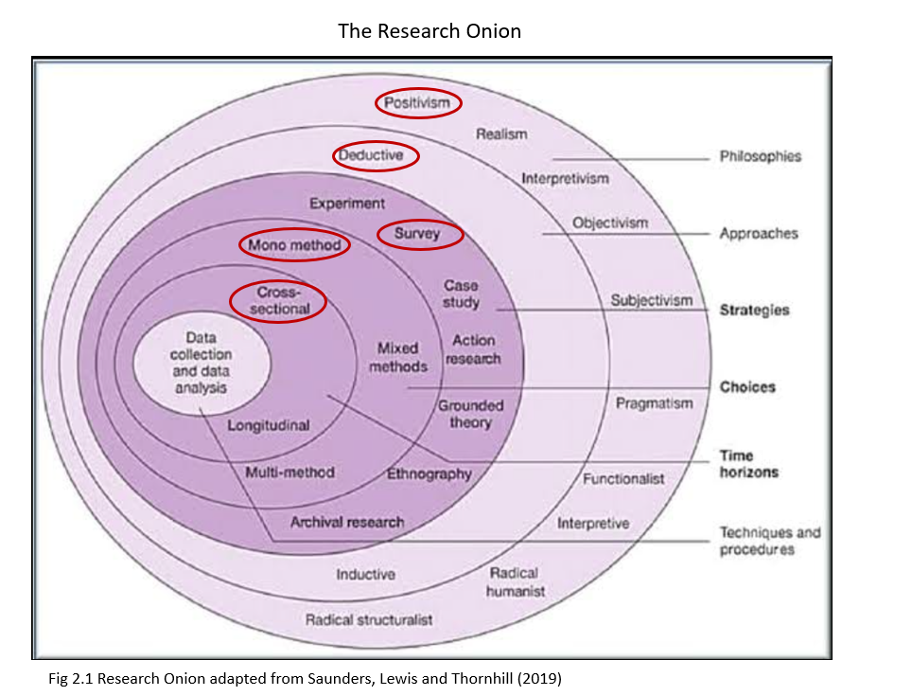

Utilising a deductive approach, the research begins with existing theories observed in the secondary research of the literature review related to bias in AI recruitment tools and tests them through empirical data collection and analysis. This approach, supported by Rajat Acharyya and Bhattacharya (2019) allows for the systematic testing of hypotheses derived from the literatures secondary research, ensuring that the study's conclusions are based on robust and replicable evidence. Deductive reasoning enhances the research’s scientific rigor, providing a clear and structured methodology (Bell, Bryman and Harley, 2019).
Deduction will be in performed by examining explanations for the rapid adoption of AI despite its known vulnerabilities. By investigating whether HR professionals prioritise efficiency over fairness, understand AI’s weaknesses or not, and believe that anti-bias mechanisms are effective. Through deducting hypotheses these inquiries will test if the quick uptake of AI can be attributed to a perceived operational advantage or if there are gaps in understanding the ethical implications and limitations of AI technologies.
The research strategy employs a survey, The most effective primary research method for gathering large amounts of data from a broad population, This mass volume attainment is required to effectively answer the research question as opposed to a small focus group or interviews. According to Collis and Hussey (2013) surveys enable the efficient collection of standardised data from a significant number of HR professionals, thus enhancing the external validity of the findings. Surveys are particularly suited to quantitative research as they allow for the collection of data from diverse demographics, providing a comprehensive view of the population under study.
The use of a mono-method quantitative approach, involving structured online questionnaires, ensures consistency and comparability across responses, which is crucial for statistical analysis (Rajat Acharyya and Bhattacharya, 2019). This approach simplifies data collection and analysis, reducing the potential for errors and increasing the reliability of the results. Structured questionnaires standardise data collection, making it easier to identify trends and draw meaningful conclusions (Saunders, Lewis, and Thornhill, 2019).
Adopting a cross-sectional time horizon, the study captures the current perceptions and attitudes of HR professionals at a single point in time. Levin (2006) points out that Cross-sectional studies are valuable for their ability to provide immediate insights into current trends and issues, making them highly relevant for policy and decision-making rendering this approach as pertinent for providing a snapshot of the current contemporary state of AI-driven recruitment tools and their perceived biases as the technology landscape is fast paced.

3.5 Participants
The target population comprises HR professionals engaged in recruitment within organisations that have adopted AI technologies. This demographic is pivotal, given their direct interaction with AI tools and their role in shaping recruitment strategies. Participants will be sought through LinkedIn, industry forums, social network forums, and professional HR networks. This approach aims to capture valuable insights into the outcomes of AI use in recruitment, especially since organisations and software companies often do not disclose detailed data on AI usage.
While this study primarily focuses on the UK, it is challenging to ensure that all respondents are based in the UK. Due to globalisation, many divisions of large organisations are dispersed globally.
To capture a comprehensive spectrum of perspectives, stratified random sampling will be utilised (Bickman and Rog, 2009). This technique involves dividing the population into subgroups based on relevant criteria such as organisation size, seniority, and experience. Such stratification ensures the inclusion of diverse viewpoints, enriching the study's findings with insights from various organisational contexts. By including HR professionals with varying levels of experience with AI tools, the study ensures a diverse and comprehensive understanding of the issue.
Aiming for a minimum sample size of 100 respondents, determined through power analysis, ensures the reliability and representativeness of the data (Collis and Hussey, 2014). This analysis considers the expected variability in perceptions of AI tool bias, aiming to balance the depth of analysis with the practical aspects of survey distribution (Bickman and Rog, 2009).

3.6 Data Collection Instrument
The primary data collection instrument is an online questionnaire developed using Microsoft Forms. The questionnaire includes multiple-choice (Bell, Bryman and Harley, 2019) and Likert scale questions (Mcleod, 2023), designed to capture various aspects of AI adoption and its perceived impact on recruitment practices. Online questionnaires are advantageous for their accessibility, efficiency, and rapid data collection (Horn, 2012) They can reach a broad and diverse audience quickly, which is essential for obtaining a representative sample of HR professionals.

3.7 Questionnaire Design and Relation to Research Objectives
The questionnaire is informed by best practices in questionnaire methodology as studied from Bradburn, Sudman, & Wansink, (2004) to minimise common errors such as leading questions and bias, ensuring clarity and relevance the questionnaire is divided into sections. Multiple-choice questions (MCQs) provide clear, quantifiable data that is easy to analyse (Krosnick & Presser, 2010). They reduce respondent burden by offering predefined answers, which can improve response rates and data reliability. MCQs standardise responses, making it easier to compare and identify trends (Bickman and Rog, 2009). They are also effective for capturing specific information relevant to the study's objectives, such as awareness of AI biases and perceptions of anti-bias measures (Bradburn, Sudman, & Wansink, 2004).
The design of the questionnaire is informed by best practices in survey methodology to minimize common errors such as leading questions and bias, ensuring clarity and relevance as studied from Krosnick & Presser, (2010)
Demographic Information
Q1-6 will provide basic demographic information and establish use of AI.
Assess Awareness and Concerns of HR Professionals
These questions aim to evaluate HR professionals' awareness of AI and its implications in recruitment. Q7 assesses self-reported understanding, which provides insight into perceived knowledge levels. Q11 gauges collective understanding within the organisation, while Q12 focuses on specific knowledge about anti-bias features, crucial for identifying knowledge gaps. Q13 highlights concerns, directly addressing awareness of potential risks and biases.
Examine Perceptions of Anti-Bias Measures
These questions are designed to evaluate HR professionals’ beliefs about the effectiveness of anti-bias measures in AI recruitment tools. Q12 provides a baseline understanding of knowledge regarding anti-bias features. Q14 explores the strategies employed to mitigate biases, and Q24 and 17 assesses perceptions of the effectiveness of these measures. Together, these questions help understand the confidence HR professionals have in the current anti-bias practices.
Analyse Trust and Adoption Factors
These questions explore the factors influencing trust and adoption of AI recruitment technologies. Q8 identifies the motivations behind adopting AI, while Q9 examines the decision-making process, highlighting organisational influences. Q10 evaluates perceived benefits, crucial for understanding positive impacts that may drive adoption. Q25 directly measures trust in AI’s ability to operate without bias, linking perceptions to actual trust levels.
Prioritisation of Efficiency vs. Fairness
These questions investigate whether HR professionals prioritise efficiency over fairness in AI recruitment. Q8 reveals if efficiency was a key motivator for AI adoption. Q10 identifies efficiency-related benefits experienced. Q15 and 16 assess the HR department's control over AI tools and the final decision-making process, indicating the balance of power between human oversight and AI, reflecting the prioritisation between efficiency and ethical considerations.
The inclusion of specific questions on anti-bias measures and decision-making processes provides valuable insights into the practical and ethical considerations of AI adoption in HR practices.

3.8 Data Analysis
The data will be analysed using a combination of descriptive and inferential statistical techniques studied from Byrne (2002). Descriptive statistics will provide an overview of the sample characteristics and response distributions. Inferential statistics, such as chi-square tests and Excel, will test relationships between variables and compare group means. SPSS will be used for efficient data management and complex analyses, ensuring validity and reliability.
These techniques are suitable for identifying patterns and testing hypotheses related to bias mitigation and trust in AI recruitment tools. However, limitations include potential response bias, sampling bias, and the cross-sectional nature of the study, which may not capture changes over time. Additionally, the structured nature of the questionnaire may limit the depth of insights Byrne (2002).

3.9 Ethical Considerations
This study applies Seedhouse's (Seedhouse and Lovett, 1992) ethical framework, which emphasises the importance of respect, autonomy, and beneficence in research. Seedhouse's framework guides the ethical considerations by ensuring that participants' autonomy is respected through informed consent and voluntary participation. The principle of beneficence is adhered to by designing the study to minimise any potential harm and maximise the benefits of the research findings. The commitment to confidentiality and data protection aligns with Seedhouse's emphasis on respecting participants' privacy and maintaining trust. By integrating these ethical principles. This study adheres to rigorous ethical standards to ensure research integrity and protect participants' rights. Ethical approval has been obtained from UWTSD Research Ethics Committee. Participants will receive detailed information about the study's purpose, procedures, and their rights, including voluntary participation and the ability to withdraw at any time. Informed consent will be obtained electronically before participants begin the survey. Confidentiality and anonymity are ensured by not collecting personal identifiers and securely storing data. The study complies with GDPR (GOV.UK, 2018), data is stored on the secure cloud of the university with restricted access. Participants can skip any uncomfortable questions, and the research does not involve sensitive or distressing topics.

3.10 Validity and Reliability
To ensure validity and reliability, the questionnaire was pre-tested with a small sample of HR professionals. Feedback from this phase informed revisions to enhance clarity, relevance, and reliability. The study design aims to minimise biases and errors, ensuring the results accurately reflect HR professionals' perceptions and experiences (Bashir, Afzal and Azeem, 2008)

3.11 Pilot Testing and Adjustments
Before the full deployment of the questionnaire, a pilot test was conducted as part of the guidance from Saunders, Lewis and Thornhill (2019). on troubleshooting potential issues. This pilot involved a small sample of HR professionals who provided valuable feedback on the questionnaire's clarity and functionality.
Several issues were identified during the pilot phase:
Wording Issues: One question was not worded correctly, causing confusion among respondents. This question needed to be rephrased to ensure it was easily understood.
Question Design: A multiple-choice question initially allowed respondents to select only one answer. This was corrected to enable multiple selections.
Irrelevant Question: A question asking if respondents used AI was found to be irrelevant as completing the survey required the use of AI. This question was subsequently removed.
Response Challenges: After posting the revised questionnaire on LinkedIn, industry forums, social network forums, and professional HR networks, it became apparent that securing responses was challenging. Feedback indicated that many HR professionals did not perceive themselves as users of AI in recruitment, which conflicted with the literature review's statistics.
To investigate this discrepancy, a poll was conducted in a social media group for HR professionals (Davies, 2024). Out of 50 votes, 88% stated they did not use AI in recruitment. This stark contrast suggested either a misunderstanding of what constitutes AI or an overestimation in the literature.
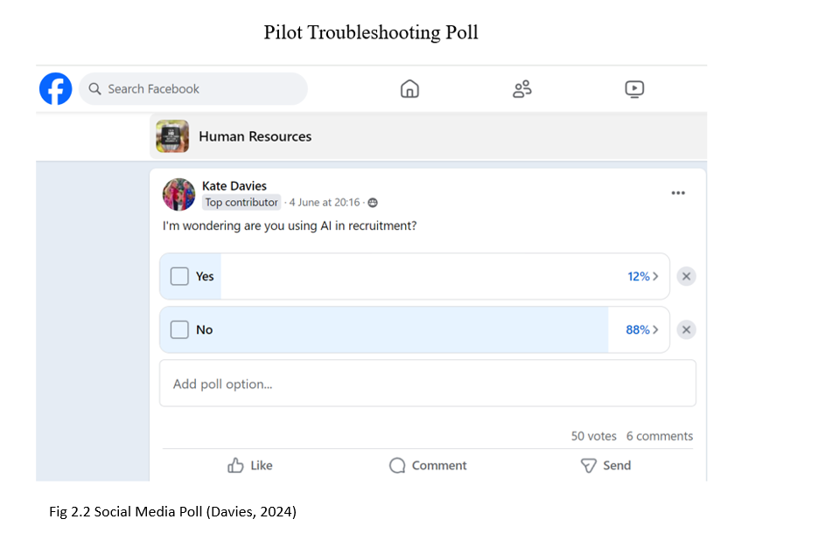
Following a discussion during a supervisor meeting of the low response rate and the discrepancy between feedback and existing statistics. It became clear that many HR professionals had a narrow understanding of AI. They did not recognise tools like Indeed and LinkedIn, which use AI to match candidates, as AI-driven recruitment tools.
Based on this insight, the questionnaire was revised to clarify that using platforms like Indeed and LinkedIn constitutes the use of AI in recruitment. This change significantly improved the response rate, as HR professionals began to acknowledge their use of AI technologies.
The pilot phase was instrumental in refining the questionnaire, ensuring its questions were relevant and correctly interpreted by the target audience. This process highlighted the importance of clear communication and accurate representation of AI technologies in HR practices, leading to more reliable and valid data collection.

3.12 Limitations
To ensure the robustness and credibility of the chosen methodology, a deeper critical evaluation is necessary, following claims made by Bashir, Afzal and Azeem (2008) the following limitations can be identified with mitigation tactics detailed where possible.
Response Bias: One significant limitation is response bias, where participants might provide socially desirable answers or not fully disclose their true perceptions due to confidentiality concerns. To mitigate this, the study will ensure strict anonymity and confidentiality of responses (Bradburn, Sudman and Wansink, 2004). Using anonymous surveys and assuring participants that their responses cannot be traced back to them can reduce this bias. Additionally, framing questions in a neutral manner and avoiding leading questions will help obtain more honest responses.
Sampling Bias: Despite employing stratified random sampling to capture a diverse range of perspectives, there remains a risk of sampling bias. Self-selecting participants might differ systematically from those who do not participate, potentially skewing results. To address this, the study will aim for a large and diverse sample size to ensure broader representation. Outreach efforts will be expanded to include various professional networks, forums, and social media platforms to reach a wider audience. Regular reminders and follow-ups will be sent to encourage participation and reduce non-response rates as advised by Bradburn, Sudman and Wansink (2004).
Limited Depth of Responses: The structured nature of multiple-choice and Likert scale questions can limit the depth of responses, potentially overlooking complex views and insights (Collis and Hussey, 2014).
Cross-Sectional Design: The cross-sectional design captures a snapshot of perceptions and attitudes at a single point in time, limiting the ability to understand how these may evolve (Levin, 2006).
Generalisability: While the study aims to capture a broad spectrum of HR professionals, the findings may not fully generalise to all HR professionals globally, especially those in different cultural or regulatory environments. To enhance generalisability, the study will ensure that the sample includes HR professionals from various regions, industries, and organisational sizes (Bashir, Afzal and Azeem, 2008).
Self-Reported Data Accuracy: Relying on self-reported data can lead to inaccuracies due to memory recall issues, misunderstandings of questions, or personal biases (Bashir, Afzal and Azeem, 2008). To improve data accuracy, the survey questions will be carefully pre-tested to ensure clarity and relevance. The use of clear, simple language and providing examples where necessary can help minimise misunderstandings.
By recognising these limitations and taking proactive steps to address them, this study aims to provide a more accurate and reliable understanding of HR professionals' perceptions of AI-driven recruitment tools. These enhancements will contribute to the overall validity and robustness of the research findings, ensuring they are both credible and valuable for informing future practices and policies.

3.13 Challenges
The final sample size of 100 respondents was not predetermined but was the number reached when it became necessary to proceed with data analysis. Although the target was initially set at 120 respondents to enhance the robustness of the findings, this proved challenging. Despite extensive efforts to recruit participants through LinkedIn, social media outreach, and HR community platforms, these avenues were eventually exhausted. In an attempt to reach the target, repeated outreach to the same groups led to negative responses, with some group members expressing displeasure towards the frequent posts.
Given these challenges and the need to move forward with data analysis, 100 respondents became the practical stopping point. While a larger sample might have provided more generalisable findings, the final sample size is still considered sufficient to generate meaningful insights and identify key trends. The decision to conclude at this point reflects the balance between time constraints, participant engagement, and the need for timely analysis

Chapter 4.0 Analysis of Results

4.1 Introduction
This chapter presents the findings from the primary research of a survey sampling 100 HR professionals, conducted to explore HR professionals’ perceptions of AI-driven recruitment and selection tools. The data is analysed to understand key concerns around bias mitigation, trust, and the trade-off between operational efficiency and fairness. The analysis integrates the theoretical frameworks outlined in the methodology chapter, including the Technology Acceptance Model (TAM) (Davis, 1989), the Diffusion of Innovations (DOI) theory (Lundblad, 2023) and the concept of Wilful Blindness (Heffernan, 2011). The findings are structured according to the key research objectives: assessing trust in AI-driven recruitment tools, evaluating bias mitigation strategies, and understanding the motivations for AI adoption. The data is presented through tables and graphs, offering a clear illustration of the survey results and their implications.

Category | Frequency
Respondent Demographic
Role | Respondents
HR Manager | 47
Recruiter | 23
HR Team Member | 24
Management | 6
Experience in HR
Less than 1 year | 4
1-3 years | 12
3-5 years | 18
More than 5 years | 66
Organisation Size
Small (1-50 employees) | 18
Medium (51-250 employees) | 28
Large (over 250 employees) | 54
Duration of AI Use
Less than 1 year | 32
1-3 years | 42
More than 3 years | 26
Table 4.0 Demographic

4.2 Demographic Information of Participants

Notably, 66% of respondents have more than five years of HR experience, indicating that the data primarily reflects the views of seasoned professionals this is positive as data will be gathered from professionals who are likely familiar with both traditional and AI-driven recruitment methods.
Regarding organisational size, 54% of respondents work in large organisations with over 250 employees, while 28% are from medium-sized organisations, and 18% are from smaller organisations. This spread suggests that the insights gathered come from diverse organisational settings, which is significant for understanding the adoption of AI tools. As larger organisations tend to adopt innovations earlier (as posited by DOI theory (Lundblad, 2023)), It was expected for the majority of respondents to represent this group, as early adopters their perspectives on AI may differ from smaller organisations.

4.3 Awareness of AI Bias and Concerns in Recruitment
4.3.1 Self-Reported Understanding of AI Tools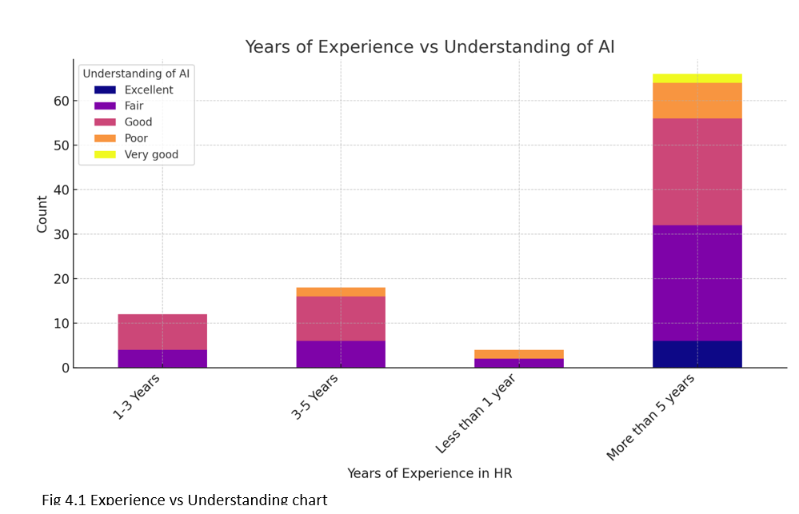
Figure 4.1 shows that 42% of respondents rated their understanding of AI in recruitment as "Good," while 38% rated it as "Fair." Only a small minority 6% reported an "Excellent" understanding of AI. This suggests that while there is familiarity with AI tools, there is considerable level of low understanding. Interestingly, HR professionals with over five years of experience were more likely to rate their understanding as "Fair" 45%, implying that despite extensive experience in HR, AI remains a relatively new and evolving tool for many in the field supporting Köchling and Wehner (2020) views.
4.3.2 Concerns Regarding AI in Recruitment
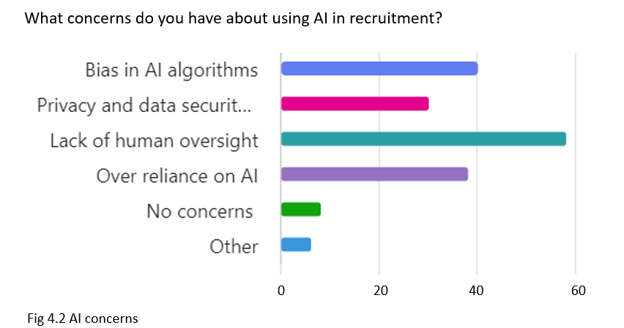
Table 4.2 presents the key concerns raised by respondents; this was a multiple choice giving the option to select all that apply. with the most frequently cited being "Lack of human oversight" 58 respondents, "Bias in AI algorithms" 40 respondents, and "Over-reliance on AI" 38 respondents. These concerns mirror much of the academic discourse on AI ethics from Köchling and Wehner (2020), which often highlights how AI can inadvertently reinforce biases in recruitment rather than mitigate them as cautioned by Binns (2017).
Notably, larger organisations (those with over 250 employees) expressed higher levels of concern regarding "Over-reliance on AI" compared to smaller organisations.
The Chi-square tests (Glen, 2013) confirmed a statistically significant association between organisation size and concerns about "Over-reliance on AI" (p < 0.05). This means that the size of an organisation plays a crucial role in shaping its views on the potential risks of depending too much on AI tools in recruitment. Larger organisations are more likely to view AI as a double-edged sword: while they benefit from the operational efficiency AI brings such as reduced hiring time and streamlined processes they also recognise the ethical risks associated with over-reliance on automated systems.
This suggests that as larger organisations adopt AI at a faster rate, they may also have more awareness of the potential pitfalls associated with over-reliance on technology.

4.4 Perceptions of Anti-Bias Measures in AI Tools
4.4.1 Awareness of Anti-Bias Features
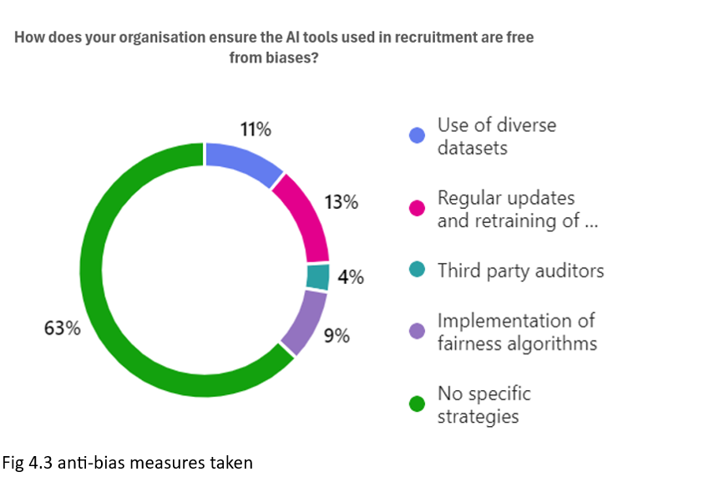

A critical insight from the survey was the significant gap in organisations strategies for mitigating bias in AI-driven recruitment. An overwhelming 63% of respondents indicated that their organisations had no specific bias mitigation strategies in place. Of those that did report using strategies, 13% cited “regular updates and retraining of AI models,” 11% referenced the “use of diverse datasets,” 9% mentioned the “implementation of fairness algorithms,” and only 4% reported employing “third-party auditors” Strategies studied from (Nazer et al., 2023).
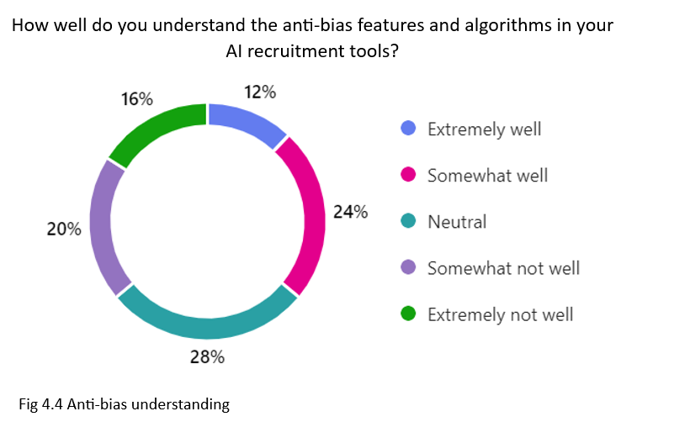
This lack of action aligns poorly with respondents' self-reported understanding of anti-bias features in AI tools. Only 12% claimed to understand these features "extremely well," while 36% felt their understanding was poor or neutral. This suggests as previously stated by Köchling & Wehner, (2020) a strong correlation between the lack of bias mitigation strategies and the knowledge gap among HR professionals. The fact that organisations are not employing concrete strategies could be attributed to this lack of understanding, indicating that many HR professionals are not fully equipped to leverage AI tools effectively for bias prevention in recruitment processes.
Given that bias mitigation is often cited as a primary reason for adopting AI in recruitment, the disconnect between understanding and action is particularly concerning (Binns, 2017). Without proper knowledge, even organisations that adopt AI for its anti-bias potential may fail to implement it in a meaningful or effective way.

4.4.2 Effectiveness of Anti-Bias Measures
When asked about the perceived effectiveness of anti-bias measures in AI tools, respondents expressed mixed views. Some HR professionals rated these measures as "Moderately effective," while others were more sceptical of their ability to fully mitigate bias. Cross-tabulations revealed that respondents who cited "Bias in AI algorithms" as a key concern were also less likely to trust AI-driven recruitment tools.
Furthermore, there was a notable correlation between respondents' understanding of AI and their perceptions of the effectiveness of anti-bias features. Among those who rated their understanding of AI as "Excellent," 4 respondents found the anti-bias measures effective, while 6 found them moderately effective. None rated these features as ineffective. In contrast, respondents with lower levels of understanding were less confident in the effectiveness of anti-bias measures, reinforcing the link between knowledge gaps and scepticism around AI's ability to reduce bias.

4.5 Factors Influencing Trust and Adoption of AI Recruitment Tools

4.5.1 Motivations for AI Adoption
Motivating factors for implementing AI
Cost Savings | 40
Efficiency and speed | 70
Improved quality of hires | 30
Reduction of human bias | 20
Competitive Advantage | 12
Other | 16
Table 4.5 Motivating factors

In a 'select all that apply' question, 70 respondents chose 'Efficiency and speed' as a primary motivation for AI adoption, while 40 selected 'Cost savings. This data reinforces the idea that perceived usefulness, particularly in improving operational efficiency, is a key driver of technology adoption as argued by Davis, (1989) and Laurim et al., (2021). However, adding weight to the theories of Mujtaba & Mahapatra, (2019) that while efficiency gains were widely acknowledged, respondents expressed reservations about AI’s ability to improve the quality of hires and reduce human bias.
Cross-tabulations between motivations for AI adoption and diversity outcomes reveal that in organisations that adopted AI specifically to reduce bias, 14 respondents reported that AI had led to a more diverse candidate pool, while only 6 respondents indicated no such change. Conversely, in organisations that adopted AI for reasons other than bias reduction, only 8 respondents reported seeing an increase in diversity, while 16 respondents saw no such outcome.
This tension is also supported by concerns that organisations may choose to overlook potential ethical issues in favour of short-term efficiency gains.

4.5.2 Trust in AI Technologies
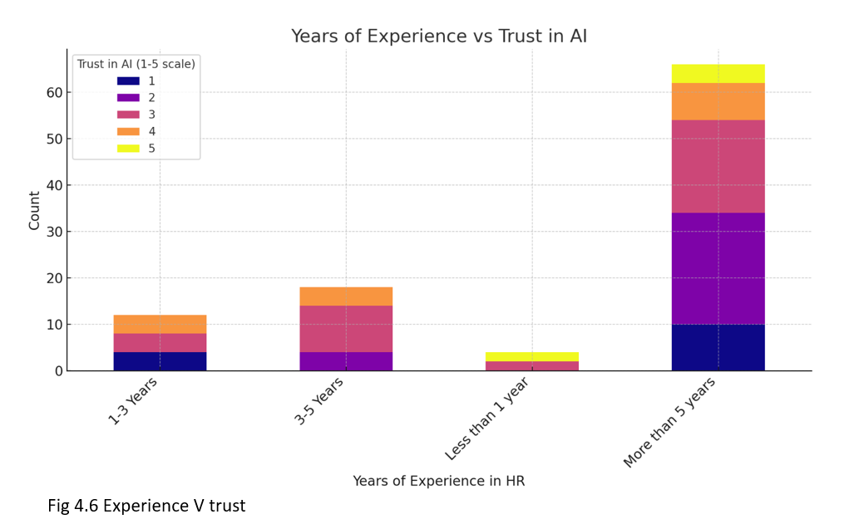

Trust in AI was relatively low, with many respondents expressing moderate to low levels of trust in AI systems' ability to operate without bias. This is a critical finding, as trust is essential for widespread AI adoption. Respondents were particularly sceptical about AI’s ability to deliver unbiased outcomes, which correlates directly with the concerns raised about bias in the earlier sections.
The analysis of years of experience versus trust in AI reveals that HR professionals with more than five years of experience display varied levels of trust in AI, with many showing moderate trust (rating it 2 or 3 out of 5). In contrast, professionals with less than five years of experience tend to exhibit either lower or moderate trust. This suggests that even seasoned HR professionals remain skeptical or cautious about the reliability of AI in recruitment, despite their expertise. Less experienced professionals also show caution, though they represent a smaller portion of the sample. Overall, the mixed trust levels, especially among those with significant experience, highlight that while AI tools may provide operational efficiencies, the lack of trust in these systems remains a key barrier to wider adoption.
The ANOVA (Analysis of Variance) (Laurim et al., 2021) test is a statistical method used to compare the means of three or more groups to determine if there are any statistically significant differences between them. The ANOVA test was performed to determine whether there are statistically significant differences in the levels of trust in AI technologies among respondents from small, medium, and large organisations. The ANOVA test results show an F-statistic of approximately 1.56 and a p-value of 0.214. Since the p-value is greater than the common significance level of 0.05, we fail to reject the null hypothesis. This indicates that there is no statistically significant difference in the trust in AI technologies across different organisation sizes (small, medium, large).
In summary, organisation size does not appear to have a significant impact on the level of trust in AI recruitment tools based on this data.

4.6 Efficiency vs Fairness in AI-Driven Recruitment

4.6.1 Efficiency as a Priority
Efficiency was clearly a priority for 70 respondents the majority of respondents, with many highlighting the operational benefits of AI-driven recruitment tools, such as reducing time-to-hire and streamlining the recruitment process. These operational efficiencies were frequently cited as primary drivers for AI adoption.

4.6.2 Fairness in Recruitment
Despite the emphasis on efficiency, fairness remains a key concern for HR professionals. The data shows that many respondents believe that AI tools require more human oversight to ensure fairness in recruitment processes. Cross-tabulations between levels of concern about bias and the degree of human oversight suggest that those most concerned about bias are also the most likely to advocate for greater human involvement in decision-making.
The level of influence the HR department has over AI recruitment systems also affects who ultimately has the final say in candidate selection. In organisations where HR had complete control over AI tools, 8 respondents indicated that the HR team has the final say, while 16 respondents reported that senior management retains the final decision. In organisations where HR had high influence, 6 respondents reported that the HR team had the final say, while 14 respondents indicated that senior management made the final decision. In organisations where HR's influence was moderate, 10 respondents reported that the HR team had the final say, while 18 respondents reported that senior management retained control.
This finding highlights the trade-off between efficiency and fairness in AI adoption, as many HR professionals appear unwilling to sacrifice fairness for operational efficiency.

4.7 Impact of AI on Organisational Culture
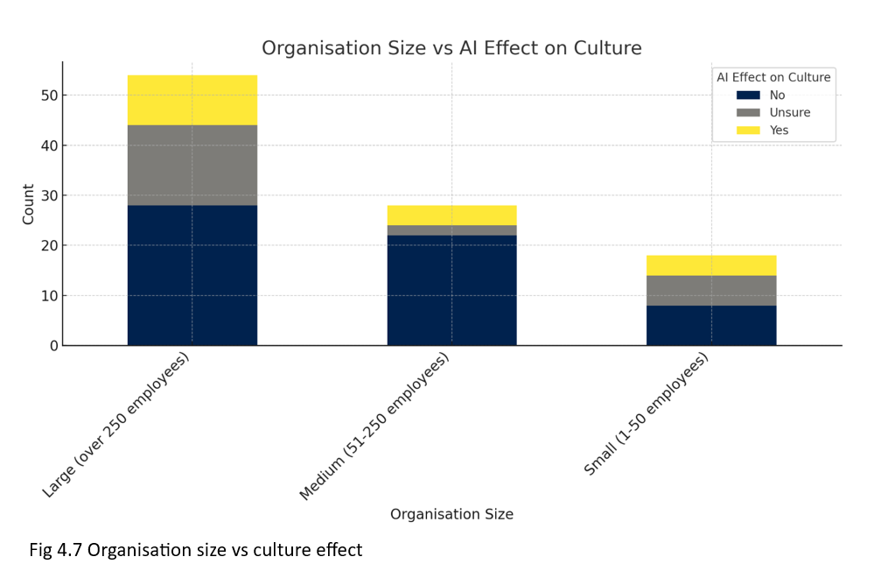
The survey sought to understand how AI recruitment tools have affected the culture within organisations. When asked if AI had affected their organisation's culture, the responses were varied. 48% stated that AI had an impact on their organisation's culture, while 34% were unsure and 18% did not perceive any cultural changes.
Interestingly, organisations that reported frequent use of AI in recruitment were more likely to perceive cultural shifts. Among respondents from large organisations, 55% believed that AI had affected the workplace culture, whereas only 40% of respondents from small and medium-sized organisations shared this view. This could be due to the more extensive integration of AI in larger organisations as studied by West, (2018), where automation and data-driven processes are more prevalent, potentially leading to shifts in workplace dynamics.
One of the key areas where AI appeared to influence organisational culture was diversity. Respondents from organisations that reported an increase in diversity of hires were more likely to say that AI had positively impacted workplace culture. In contrast, those who did not observe changes in diversity were less likely to report any significant cultural shifts. This correlation highlights how the perceived success of AI in achieving diversity goals can shape broader perceptions of its impact on organisational culture.
Despite these insights, the data also revealed a notable level of uncertainty about AI's influence on culture, with 34% of respondents unsure of its effects. This suggests that AI's impact on organisational culture may not yet be fully understood or may vary significantly across different organisational contexts.
The Chi-square test (Glen, 2013) is a statistical method used to determine whether there is a significant association between two categorical variables conducted to explore the relationship between organisation size and the perception that AI affects culture. It compares the observed frequencies in a contingency table to the expected frequencies, which are calculated under the assumption that there is no association between the variables. The test helps to assess whether the differences between the observed and expected frequencies are due to chance or reflect a real relationship.
- Chi-Square Value (χ²): 8.05
- p-value: 0.0898
- Degrees of Freedom (dof): 4
- Expected Frequencies:
  - Small Organisations: [3.24, 10.44, 4.32]
  - Medium Organisations: [5.04, 16.24, 6.72]
  - Large Organisations: [9.72, 31.32, 12.96]
Interpretation:
- The p-value of 0.0898 suggests that there is no statistically significant relationship between organisation size and the effect of AI on culture at a 5% significance level. However, the p-value is close to 0.05, indicating that there might be some relationship that could be explored further with a larger sample size.

4.8 Awareness and Compliance with Legal and Ethical Standards in AI-Driven Recruitment
The data reveals a significant gap in HR professionals' awareness and understanding of the legal and ethical standards governing AI in recruitment. Only 24% of respondents are fully aware of these rules, while a substantial 36% have no knowledge, and 40% have only partial awareness. This lack of clarity is reflected in their perceptions of the adequacy of these regulations, with just 10% believing the current rules are sufficient, 28% finding them inadequate, and a concerning 62% unsure. This uncertainty extends to compliance practices, where 46% of respondents are unaware of the legal requirements, and only 26% report that their organisations meet the necessary standards. Even fewer 12% are proactively exceeding these requirements, while just 16% collaborate with legal and ethical experts.

4.9 Future Role of AI in Recruitment
The survey asked respondents to predict the future role of AI in HR and recruitment over the next five years. The results were largely optimistic about AI's growth, with 62% of respondents predicting that AI’s role would increase significantly. A further 26% believed that AI's influence would increase slightly, while only 4% anticipated no significant changes, and 8% foresaw a slight decrease in AI's role.
Respondents who currently use AI frequently were more likely to anticipate a significant increase in AI usage. Of those who use AI very frequently, 78% predicted a significant rise in the use of AI-driven recruitment tools. In contrast, organisations that rarely use AI were less enthusiastic about its future role, with only 22% expecting a significant increase.

Chapter 5.0 Discussion

5.1 Introduction
This chapter reflects on the findings presented in Chapter 4, relating them to the research objectives and theoretical frameworks discussed in earlier chapters. The discussion explores how HR professionals perceive AI recruitment tools, with specific attention to their awareness of AI biases, the effectiveness of anti-bias measures, and the prioritisation of efficiency over fairness. This chapter also evaluates the implications of these findings for both theory and practice.

5.2 Addressing Research Questions
Research Question 1: How aware are HR professionals of the potential biases in AI-driven recruitment tools?
The findings indicate that while there is some awareness of AI biases, it is often insufficient, with only 6% of respondents rating their understanding as "Excellent." Many professionals lack a comprehensive understanding of bias mitigation features and legal frameworks (Köchling & Wehner, 2020). For instance, 63% of respondents reported no specific strategies to address bias, and only 12% reported having a deep understanding of anti-bias features. These results suggest a strong need for further education and training on AI biases and the legal and ethical obligations related to recruitment. The lack of bias mitigation strategies may be directly linked to this knowledge gap, highlighting the importance of raising awareness and enhancing expertise within HR departments.
Research Question 2: What are HR professionals’ perceptions of the effectiveness of anti-bias measures in these tools?
HR professionals expressed mixed perceptions of the effectiveness of anti-bias measures in AI-driven recruitment tools. While some respondents rated the measures as "Moderately effective," many remained sceptical about their ability to fully mitigate bias (Binns, 2017). This scepticism highlights a gap between the potential of AI to reduce bias and the reality of how it is being implemented. Those with higher levels of understanding of AI were more likely to perceive the anti-bias features as effective, suggesting that building confidence in these measures is contingent upon improving knowledge and transparency (Laurim et al., 2021). These findings reinforce the need for organisations to adopt structured bias mitigation strategies and ensure HR professionals are adequately trained to leverage AI technology ethically.
The self-governance aspect also plays a role here: with no clear external standards to adhere to, organisations may be implementing piecemeal solutions based on their own understanding of fairness and bias, rather than relying on established best practices (Heffernan, 2011). This might explain why many HR professionals remain sceptical about AI's ability to fully mitigate bias. Without a unified legal framework, perceptions of anti-bias measures may continue to vary widely across organisations.
Research Question 3: Do HR professionals prioritise efficiency over fairness in AI-driven recruitment?
The study revealed that HR professionals tend to prioritise efficiency, with 70% of respondents citing it as a primary motivation for adopting AI in recruitment. However, this focus on efficiency often comes at the expense of fairness (Davis,1989). Many respondents acknowledged the trade-off between the two, with those most concerned about bias advocating for more human oversight in recruitment decisions. This suggests that while AI provides clear operational advantages, ethical considerations regarding fairness remain a key concern (Mujtaba & Mahapatra, 2019). The challenge lies in finding the right balance, ensuring that efficiency gains do not overshadow the need for ethical recruitment practices that promote diversity and inclusivity.
Additionally, the lack of regulatory pressure means that many organisations feel free to prioritise efficiency over fairness, knowing they are unlikely to face legal consequences for doing so (Heffernan, 2011). This environment of self-regulation leaves organisations to decide their own ethical stance, potentially leading to a greater focus on operational benefits at the expense of fairness and inclusivity.

5.3 Application of Theoretical Frameworks: DOI, TAM, and Wilful Blindness
The findings of this study can be further understood through the lenses of the Diffusion of Innovations (DOI) theory, the Technology Acceptance Model (TAM), and the concept of Wilful Blindness. Each of these frameworks provides a unique perspective on how AI-driven recruitment tools are perceived and adopted by HR professionals, particularly in terms of bias mitigation, efficiency, and fairness.

5.3.1 Diffusion of Innovations (DOI) Theory
DOI theory, developed by Everett Rogers (Lundblad, 2023), explains how innovations are adopted within organisations, based on factors such as relative advantage, compatibility with existing systems, and complexity. The findings show that larger organisations, which are generally early adopters of new technology, were more likely to have implemented AI recruitment tools. However, these same organisations also reported higher concerns about over-reliance on AI, which aligns with DOI’s prediction that later adopters become more cautious about the downsides of an innovation.
Efficiency and cost-saving potential were key motivators for AI adoption, with 65% of respondents citing these factors (Laurim et al., 2021). However, the complexity of AI tools and concerns about bias present barriers to broader acceptance. The fact that only 6% of respondents rated their understanding of AI as "Excellent" underscores the need for education and training, reducing the perceived difficulty of using AI and encouraging wider adoption within the HR field (Köchling & Wehner, 2020).

5.3.2 Technology Acceptance Model (TAM)
The Technology Acceptance Model developed by Davis, (1989) explains how perceived usefulness and ease of use influence technology adoption. In this study, the perceived usefulness of AI in recruitment, particularly in terms of efficiency and speed, was a primary driver of adoption, with 65% of respondents citing these factors. However, concerns about the ease of use were also prominent, with 42% of respondents rating their understanding of AI as only "Good," and 38% rating it as "Fair."
This gap in understanding directly impacts HR professionals’ trust in AI technologies. Lower levels of trust in AI’s ability to deliver unbiased outcomes reflect a lack of transparency and confidence in how these tools function. Without better education on how AI mitigates bias and improves recruitment fairness, many HR professionals may hesitate to fully embrace the technology, despite its operational advantages.

5.3.3 Wilful Blindness
The concept of Wilful Blindness, as explored by Margaret Heffernan (2011), refers to situations where individuals or organisations choose to ignore inconvenient truths or ethical dilemmas in favour of efficiency or ease. In this study, wilful blindness is relevant in the context of balancing efficiency and fairness. While many HR professionals recognised the ethical concerns around bias and lack of human oversight in AI recruitment, they often downplayed these issues in favour of the operational benefits AI provides.
For example, 70% of respondents prioritised efficiency in their decision to adopt AI, despite being aware of its potential to reinforce bias Laurim et al, (2021). This tendency to overlook ethical risks in pursuit of short-term gains reflects wilful blindness, particularly in the way that organisations may adopt AI without fully understanding its limitations or implementing robust bias mitigation strategies. Addressing this requires a shift towards greater accountability, with organisations ensuring that AI adoption is aligned with both operational goals and ethical standards, reinforced by Hefferman, (2011) theories.
The absence of legal frameworks regulating AI in recruitment also contributes to this phenomenon. Since there are no immediate legal repercussions for prioritising efficiency over fairness, many organisations may feel comfortable making this trade-off. The lack of external oversight means that HR professionals are often left to self-regulate, potentially leading to wilful blindness in how AI tools are implemented and governed.

5.4 Implications for Practice and Further Research
The findings highlight significant gaps in HR professionals' understanding of AI tools and their bias mitigation capabilities, as well as the trade-offs between efficiency and fairness in recruitment processes (Köchling & Wehner, 2020). Addressing these gaps will require targeted training, increased transparency from AI vendors, and more rigorous oversight to ensure that AI technologies are implemented in a way that supports both operational efficiency and ethical recruitment practices.
For future research, there is a need to explore how AI bias can be better addressed through more advanced algorithms and stronger governance frameworks. Additionally, further studies could investigate the long-term cultural impact of AI adoption in organisations and whether it leads to more equitable recruitment outcomes over time (Laurim et al., 2021).

Chapter 6.0 Conclusion
This study set out to critically examine HR professionals' perceptions, awareness, and trust in AI-driven recruitment tools, particularly focusing on bias mitigation, trust, and the balance between operational efficiency and fairness. Based on the survey of 100 HR professionals, the study has shed light on how AI is being used in recruitment and the challenges it faces in delivering on its potential. While the research successfully addresses the study’s objectives, it also brings to the forefront significant issues in the understanding, trust, and ethical use of AI in HR practices.

6.1 Awareness of AI Bias and Mitigation Strategies
A key finding of this study is the generally low level of awareness among HR professionals regarding the potential biases in AI-driven recruitment tools. Many respondents rated their understanding of AI’s functionalities as moderate to fair, with only a small percentage reporting an excellent understanding. This knowledge gap is particularly problematic because HR professionals are expected to show leadership and influence people management practices, especially in recruitment. As theorised by Binns (2018) and supported by Barocas and Selbst (2016), AI is often viewed as a solution to reduce human biases in hiring. However, without a strong grasp of AI’s capabilities and limitations, HR professionals may fail to fully assess and mitigate the risks of bias effectively, as highlighted by Kim (2017).
Furthermore, 62% of organisations surveyed did not have formal bias mitigation strategies for their AI tools, underscoring a significant issue. Without such strategies, AI cannot be fully leveraged to address bias and may even perpetuate existing inequalities (Binns, 2018). As Barocas et al. (2019) and Kim (2017) emphasise, the lack of tools and knowledge among HR professionals to monitor and correct biases exacerbates the problem. Given the influential role of HR in shaping recruitment practices, this lack of awareness and understanding poses a critical challenge for organisations, potentially undermining the fairness and inclusivity of their hiring processes.

6.2 Trust in AI Recruitment Tools
Trust in AI recruitment tools emerged as a recurring issue in this study. Despite recognising the operational benefits of AI—such as reducing the time-to-hire and increasing efficiency—there remains significant scepticism among HR professionals regarding AI’s ability to deliver unbiased results. Mittelstadt et al. (2016) argue that trust in AI is closely linked to transparency and understanding, and the findings of this study support this notion. Respondents who had more concerns about bias in AI were less likely to trust these systems, reinforcing the need for clearer insights into AI decision-making processes.
The statistical analysis also revealed that trust in AI was not significantly influenced by the size of the organisation, meaning that concerns about bias and transparency cut across both small and large organisations, a finding supported by Kim (2017). However, larger organisations were more likely to express concerns about over-reliance on AI, indicating that while they may adopt AI tools more quickly, they remain cautious about its potential risks, as theorised by Binns (2018).

6.3 Efficiency vs. Fairness in AI Recruitment
The tension between efficiency and fairness is central to the adoption of AI recruitment tools. The study found that HR professionals tend to prioritise efficiency, with 70% of respondents citing it as the primary motivation for adopting AI, a finding that aligns with the work of Taddeo and Floridi (2018) However, this focus on efficiency often overshadows concerns about fairness. Many respondents noted that while AI can streamline recruitment processes, they still require human oversight to ensure that decisions remain fair and inclusive (Binns, 2018). This reluctance to fully delegate decision-making to AI reflects broader ethical concerns, as Barocas et al. (2019) have also observed.
Interestingly, organisations that adopted AI with the explicit goal of improving diversity reported better outcomes in this regard compared to those that implemented AI solely for efficiency gains. This finding reinforces the idea that AI can enhance fairness, but only if fairness is a core objective in its implementation. If AI is adopted purely for operational reasons, ethical considerations may be sidelined, as Kim (2017) argues.

6.4 Impact on Organisational Culture and Future Role of AI
The study produced mixed findings on the impact of AI on organisational culture. While some respondents noted positive changes, particularly in terms of diversity, others reported uncertainty or no significant shifts. Calo (2017) argue that this ambiguity may reflect a broader lack of understanding about how AI influences workplace dynamics and practices. Larger organisations, which are more likely to integrate AI into their operations, were also more likely to report cultural shifts, supporting the work of Binns (2018), who suggests that larger organisations may experience more noticeable changes due to the wider use of automation and data-driven processes. Despite these mixed views, there was general optimism about the future role of AI in recruitment. A significant majority of respondents predicted that AI’s influence would increase in the next five years, particularly among those already using AI tools regularly. However, as Barocas et al. (2019) note, this optimism was tempered by concerns over the ethical and legal challenges AI presents, indicating that while HR professionals see the potential of AI, they are also wary of the regulatory landscape.

6.5 Ethical and Regulatory Implications
One of the most concerning findings of this study was the widespread lack of awareness among HR professionals about the legal and ethical standards governing AI in recruitment. Only 24% of respondents reported being fully aware of these rules, with a significant proportion 36% indicating no knowledge at all. Mittelstadt et al. (2016) suggest that this gap in understanding extends to compliance practices, and this study confirms that less than half of the organisations surveyed were aware of the legal requirements regarding AI use in recruitment. The lack of preparation to ensure compliance with current and future regulations, such as the European Artificial Intelligence Act, (2024) emphasises the need for better governance and education in this area, as argued by Binns (2018).
Without clear external guidelines or regulatory frameworks, organisations are largely left to self-regulate, which increases the risk of unethical AI use in recruitment. Kim (2017) highlights that this lack of oversight may lead to AI tools being misused or misunderstood, further perpetuating bias.

6.6 Recommendations for Future Research
This study has highlighted several key areas that warrant further investigation. Future research should explore how AI algorithms can be improved to better detect and mitigate bias, particularly as AI systems evolve and become more integrated into recruitment processes (Barocas et al., 2019). Additionally, longitudinal studies could offer deeper insights into how AI impacts organisational culture and recruitment outcomes over time Calo (2017). Research should also focus on the intersection of efficiency and fairness, examining how organisations can balance these competing priorities more effectively, as suggested by Taddeo and Floridi (2018).

6.7 Final Thoughts
In conclusion, while AI holds great potential to transform recruitment by improving efficiency and reducing human biases, its current use by HR professionals is often marked by misunderstanding and mistrust. AI is a tool that requires careful oversight, particularly because it has the potential to perpetuate existing inequalities when poorly implemented or left unsupervised. As Kim (2017) argues, the risk is that AI could exacerbate the very biases it was designed to eliminate, especially in contexts where recruitment processes have historically been fraught with bias. Therefore, to fully realise the benefits of AI, HR professionals must become better equipped with the knowledge, skills, and strategies to use these technologies responsibly. Only then can AI fulfil its promise of enhancing both efficiency and fairness in recruitment, as Binns (2018) and Barocas et al. (2019) have theorised.

Reference list
Acuity Law (2024) AI: An automated workforce or… a very complicated calculator?, Acuity Law. Available at: https://acuitylaw.com/ai-in-the-workplace/ (Accessed: 10 June 2024).
Adebisi, A. (2023) The State of AI in the UK 2023: Trends, Data, Statistics, and Insight, Investingstrategy.co.uk. Available at: https://investingstrategy.co.uk/financial-news/the-state-of-ai-in-the-uk-2023-trends-data-statistics-and-insight/ (Accessed: 13 May 2024).
Al-Alawi et al. (2021) The Role of Artificial Intelligence in Recruitment Process Decision-Making. Research Article. Available at: https://www.researchgate.net/publication/358086638_The_Role_of_Artificial_Intelligence_in_Recruitment_Process_Decision-Making.
Albaroudi, E., Mansouri, T. and Alameer, A. (2024) ‘A Comprehensive Review of AI Techniques for Addressing Algorithmic Bias in Job Hiring’, AI, 5(1), pp. 383–404. Available at: https://doi.org/10.3390/ai5010019.
Balasubramaniam, N. et al. (2022) ‘Transparency and Explainability of AI Systems: Ethical Guidelines in Practice’, Requirements Engineering: Foundation for Software Quality, pp. 3–18. Available at: https://doi.org/10.1007/978-3-030-98464-9_1.
Banteka, N. (2024) ‘Legal Personhood and AI’, Cambridge University Press eBooks, pp. 618–635. Available at: https://doi.org/10.1017/9781108980197.033.
Barocas, S., Hardt, M. and Narayanan, A. (2018) Fairness and Machine Learning Limitations and Opportunities, www.semanticscholar.org. Available at: https://www.semanticscholar.org/paper/Fairness-and-Machine-Learning-Limitations-and-Barocas-Hardt/bae7f0b3448a3eac77886f2a683c0cf9256bb8bf (Accessed: 8 September 2024).
Barocas, S. and Selbst, A.D. (2016) ‘Big Data’s Disparate Impact’, California Law Review, 104(3), pp. 671–732. Available at: https://doi.org/10.2139/ssrn.2477899.
Bashir, M., Afzal, M.T. and Azeem, M. (2008) ‘Reliability and Validity of Qualitative and Operational Research Paradigm’, Pakistan Journal of Statistics and Operation Research, 4(1), p. 35. Available at: https://doi.org/10.18187/pjsor.v4i1.59.
Bell, E., Bryman, A. and Harley, B. (2019) Business Research Methods. 5th edn. Oxford: Oxford University Press.
Bickman, L. and Rog, D. (2009) The SAGE Handbook of Applied Social Research Methods. 2455 Teller Road, Thousand Oaks California 91320 United States : SAGE Publications, Inc. Available at: https://doi.org/10.4135/9781483348858.
Binns, R. (2017) Fairness in Machine Learning: Lessons from Political Philosophy, papers.ssrn.com. Rochester, NY. Available at: https://papers.ssrn.com/sol3/papers.cfm?abstract_id=3086546.
Bogen, M. (2019) All the ways hiring algorithms can introduce bias, Harvard Business Review. Available at: https://hbr.org/2019/05/all-the-ways-hiring-algorithms-can-introduce-bias (Accessed: 3 April 2024).
Bornstein, S. (2018) Antidiscriminatory Algorithms, papers.ssrn.com. Rochester, NY. Available at: https://papers.ssrn.com/sol3/papers.cfm?abstract_id=3307893 (Accessed: 1 June 2024).
Bradburn, N.M., Sudman, S. and Wansink, B. (2004) Asking questions : the definitive guide to questionnaire design : for market research, political polls, and social and health questionnaires. San Francisco: Jossey-Bass.
Brookings (2018) The future of work: Robots, AI, and automation, Brookings. Available at: https://www.brookings.edu/events/the-future-of-work-robots-ai-and-automation/ (Accessed: 14 May 2024).
Byrne, D. (2002) Interpreting quantitative data. London: Sage.
Calo, R. (2017) ‘Artificial Intelligence Policy: a Roadmap’, SSRN Electronic Journal [Preprint]. Available at: https://doi.org/10.2139/ssrn.3015350.
Cameron, S. and Price, D. (2009) Business research methods: a practical approach. London: Chartered Institute of Personnel and Development.
Carter, Hyman and Silver (2024) The EU Artificial Intelligence (Al) Act: A Pioneering Framework for AI Governance | Womble Bond Dickinson, www.womblebonddickinson.com. Available at: https://www.womblebonddickinson.com/us/insights/alerts/eu-artificial-intelligence-al-act-pioneering-framework-ai-governance (Accessed: 10 June 2024).
Cath, C. et al. (2017) ‘Artificial Intelligence and the “Good Society”: the US, EU, and UK approach’, Science and Engineering Ethics, 24(1). Available at: https://doi.org/10.1007/s11948-017-9901-7.
Cave, S. and Dihal, K. (2019) ‘Hopes and fears for intelligent machines in fiction and reality’, Nature Machine Intelligence, 1(2), pp. 74–78. Available at: https://doi.org/10.1038/s42256-019-0020-9.
CIPD (2018) CIPD | AI can be used to free up staff to focus on the softer skills that machines can’t replicate, CIPD. Available at: https://www.cipd.org/en/views-and-insights/thought-leadership/the-world-of-work/ai-frees-staff-softer-skills-focus/ (Accessed: 1 June 2024).
CIPD (2023a) CIPD | Preparing Your Organisation for AI Use, CIPD. Available at: https://www.cipd.org/uk/knowledge/guides/preparing-organisation-ai-use/ (Accessed: 4 April 2024).
CIPD (2023b) Code of Conduct and Ethics, CIPD. CIPD. Available at: https://www.cipd.org/globalassets/media/comms/code-of-conduct/2023-cipd-code-of-conduct-and-ethics.pdf (Accessed: 10 June 2024).
Collis, J. and Hussey, R. (2014) Business Research : a Practical Guide for Undergraduate and Postgraduate Students. 4th edn. Basingstoke: Hampshire.
Dastin, J. (2018) Amazon scraps secret AI recruiting tool that showed bias against women, Reuters.com. Available at: https://www.reuters.com/article/idUSKCN1MK0AG/ (Accessed: 3 April 2024).
Dattner, B. et al. (2019) The Legal and Ethical Implications of Using AI in Hiring, Harvard Business Review. Available at: https://hbr.org/2019/04/the-legal-and-ethical-implications-of-using-ai-in-hiring?autocomplete=true (Accessed: 1 April 2024).
Davies and Birtwistle (2023) Regulating AI in the UK. Available at: https://www.adalovelaceinstitute.org/wp-content/uploads/2023/09/ALI_Regulating-AI-in-the-UK_2023.pdf.
Davies, K. (2024) Facebook, www.facebook.com. Available at: https://www.facebook.com/groups/HRUnited/posts/10160946925026141/?comment_id=10160949929121141&notif_id=1717602863640119&notif_t=feedback_reaction_generic&ref=notif&locale=en_GB (Accessed: 15 June 2024).
Davis, F.D. (1989) The Technology Acceptance Model. Springer Nature.
Deloitte (2021) The future of enterprise demands a new future of HR | Deloitte Belgium | Human Capital, www.deloitte.com. Available at: https://www.deloitte.com/be/en/services/consulting/perspectives/future-of-hr.html (Accessed: 1 June 2024).
European Parliament (2024) Artificial Intelligence Act: MEPs adopt landmark law | News | European Parliament, www.europarl.europa.eu. Available at: https://www.europarl.europa.eu/news/en/press-room/20240308IPR19015/artificial-intelligence-act-meps-adopt-landmark-law (Accessed: 9 April 2024).
Fancher, D. et al. (2021) AI model bias can damage trust more than you may know. But it doesn’t have to., Deloitte Insights. Available at: https://www2.deloitte.com/us/en/insights/focus/cognitive-technologies/ai-model-bias.html.
Glen, S. (2013) Chi-Square Statistic: How to Calculate It / Distribution - Statistics How To, Statistics How To. Available at: https://www.statisticshowto.com/probability-and-statistics/chi-square/ (Accessed: 6 April 2024).
GOV.UK (2010) Equality Act 2010, GOV.UK. Gov.uk. Available at: https://www.gov.uk/guidance/equality-act-2010-guidance (Accessed: 3 April 2024).
GOV.UK (2018) Data Protection Act, Gov.uk. Gov.uk. Available at: https://www.gov.uk/data-protection (Accessed: 4 April 2024).
GOV.UK (2021) ‘AI Barometer Part 3 - Recruitment and workforce management’, Department of Health, 17 December. Available at: https://www.gov.uk/government/publications/ai-barometer-2021/ai-barometer-part-3-recruitment-and-workforce-management (Accessed: 13 May 2024).
GOV.UK (2022) AI activity in UK businesses: Executive Summary, GOV.UK. Available at: https://www.gov.uk/government/publications/ai-activity-in-uk-businesses/ai-activity-in-uk-businesses-executive-summary (Accessed: 13 May 2024).
Heffernan, M. (2011) Wilful Blindness. Simon and Schuster.
HireVue (2016) HireVue, Hirevue.com. Available at: https://www.hirevue.com/ (Accessed: 28 May 2024).
Horn, R. (2012) Researching and writing dissertations : a complete guide for business and management students. London: Chartered Institute Of Personnel And Development.
HRD (2023) Mixed feelings: HR unsure of merits of AI in recruitment, www.hcamag.com. Available at: https://www.hcamag.com/us/specialization/hr-technology/mixed-feelings-hr-unsure-of-merits-of-ai-in-recruitment/453238#:~:text=Among%20HR%20professionals%2C%2037%25%20strongly (Accessed: 3 June 2024).
Hunkenschroer and Lutge (2021) How To Improve Fairness Perceptions of AI in Hiring: The Crucial Role of Positioning and Sensitization, AI Ethics Journal. Available at: https://www.aiethicsjournal.org/10-47289-aiej20210716-3 (Accessed: 3 June 2024).
Indeed (2023) Artificial intelligence in recruitment: types and benefits, Indeed Career Guide. Available at: https://uk.indeed.com/career-advice/career-development/artificial-intelligence-in-recruitment (Accessed: 27 May 2024).
Intelion Systems (2023) AI Recruitment Statistics, www.linkedin.com. Available at: https://www.linkedin.com/pulse/ai-recruitment-statistics-intelion-systems/ (Accessed: 1 April 2024).
Jansen and Searle (2021) Diverse effects of team diversity: a review and framework of surface and deep-level diversity . Research Article. Available at: https://www.emerald.com/insight/content/doi/10.1108/PR-12-2019-0664/full/html.
Jones (2024) Top AI recruiting tools and software of 2022, SearchHRSoftware. Available at: https://www.techtarget.com/searchhrsoftware/tip/Top-AI-recruiting-tools-and-software-of-2022 (Accessed: 27 May 2024).
Khalil, S. and Köster, A. (2024) ‘Blockchain Technology Adoption in the Recruitment Industry: An Examination Through the Lens of the Diffusion of Innovation Theory’, ECIS 2024 Proceedings [Preprint]. Available at: https://aisel.aisnet.org/ecis2024/track20_adoption/track20_adoption/8/ (Accessed: 1 June 2024).
Kim, P. (2017) DATA-DRIVEN DISCRIMINATION AT WORK. Available at: https://wmlawreview.org/sites/default/files/Kim.pdf (Accessed: 8 September 2024).
Kroll, E., Veit, S. and Ziegler, M. (2021) ‘The Discriminatory Potential of Modern Recruitment Trends—A Mixed-Method Study From Germany’, Frontiers in Psychology, 12(12). Available at: https://doi.org/10.3389/fpsyg.2021.634376.
Krosnick, J. and Presser, S. (2010) Question and Questionnaire Design, pp. 1–37. Available at: https://web.stanford.edu/dept/communication/faculty/krosnick/docs/2010/2010%20Handbook%20of%20Survey%20Research.pdf.
Kruger, F. and Mitchell, B. (2021) Research methodology. Oxford: Oxford University Press.
Laurim, V. et al. (2021) ‘Computer, Whom Should I Hire? – Acceptance Criteria for Artificial Intelligence in the Recruitment Process’, Proceedings of the ... Annual Hawaii International Conference on System Sciences [Preprint]. Available at: https://doi.org/10.24251/hicss.2021.668.
Lavanchy, M. et al. (2023) ‘Applicants’ Fairness Perceptions of Algorithm-Driven Hiring Procedures’, Journal of Business Ethics, 188. Available at: https://doi.org/10.1007/s10551-022-05320-w.
Lee, N.T., Resnick, P. and Barton, G. (2019) Algorithmic bias detection and mitigation: Best practices and policies to reduce consumer harms, Brookings. Available at: https://www.brookings.edu/articles/algorithmic-bias-detection-and-mitigation-best-practices-and-policies-to-reduce-consumer-harms/ (Accessed: 2 April 2024).
Levin, K.A. (2006) ‘Study Design III: Cross-sectional Studies’, Evidence-Based Dentistry, 7(1), pp. 24–25. Available at: https://doi.org/10.1038/sj.ebd.6400375.
Li, L. et al. (2021) ‘Algorithmic Hiring in Practice’, Proceedings of the 2021 AAAI/ACM Conference on AI, Ethics, and Society [Preprint]. Available at: https://doi.org/10.1145/3461702.3462531.
Lunblad (2023) A Review and Critique of Rogers’ Diffusion of - ProQuest, www.proquest.com. Available at: https://www.proquest.com/docview/197971687?pq-origsite=gscholar&fromopenview=true&sourcetype=Scholarly%20Journals (Accessed: 1 June 2024).
Martinez, A. (2023) Coexisting with AI in HR—Here’s How You Do It, The HR Digest. Available at: https://www.thehrdigest.com/coexisting-with-ai-in-hr-heres-how-you-do-it/ (Accessed: 1 June 2024).
McKinsey (2018) Smartening up with Artificial Intelligence (AI). Available at: https://deepsense.ai/wp-content/uploads/2018/04/170419_mckinsey_ki_final_m.pdf (Accessed: 2 May 2024).
Mcleod, S. (2023) Likert scale definition, examples and analysis, Simply Psychology. Available at: https://www.simplypsychology.org/likert-scale.html (Accessed: 6 April 2024).
Mittelstadt, B.D. et al. (2016) ‘The Ethics of algorithms: Mapping the Debate’, Big Data & Society, 3(2), pp. 1–21.
Mujtaba, D. and Mahapatra, N. (2019) Ethical Considerations in AI-Based Recruitment, IEEE Xplore. Available at: https://doi.org/10.1109/ISTAS48451.2019.8937920.
Nadeem, R. (2023) AI in Hiring and Evaluating Workers: What Americans Think, Pew Research Center: Internet, Science & Tech. Available at: https://www.pewresearch.org/internet/2023/04/20/ai-in-hiring-and-evaluating-workers-what-americans-think/ (Accessed: 3 June 2024).
Naik, N. (2023) Council Post: How Artificial Intelligence Benefits Recruiting, Forbes. Available at: https://www.forbes.com/sites/forbesbusinesscouncil/2023/06/01/how-artificial-intelligence-benefits-recruiting/?sh=3657a13f7f22 (Accessed: 27 May 2024).
Nawaz, N. et al. (2024) ‘The adoption of artificial intelligence in human resources management practices’, International Journal of Information Management Data Insights, 4(1), pp. 100208–100208. Available at: https://doi.org/10.1016/j.jjimei.2023.100208.
Nazer, L. et al. (2023) ‘Bias in artificial intelligence algorithms and recommendations for mitigation’, PLOS Digital Health, 2(6), pp. e0000278–e0000278. Available at: https://doi.org/10.1371/journal.pdig.0000278.
Nyathani, R. (2022) ‘AI-Powered Recruitment The Future of HR Digital Transformation’, Journal of Artificial Intelligence & Cloud Computing, 1(4), pp. 1–5. Available at: https://doi.org/10.47363/jaicc/2022(1)133.
O’neil, C. (2016) Weapons of math destruction: How big data increases inequality and threatens democracy. London: Penguin Books.
Office For National Statistics (2023) Diversity in the labour market, England and Wales - Office for National Statistics, www.ons.gov.uk. Available at: https://www.ons.gov.uk/employmentandlabourmarket/peopleinwork/employmentandemployeetypes/articles/diversityinthelabourmarketenglandandwales/census2021 (Accessed: 1 April 2024).
Ore and Sposato (2022) Opportunities and Risks of Artificial Intelligence in Recruitment and Selection. Research Article. Available at: https://www.researchgate.net/publication/352464056_Opportunities_and_risks_of_artificial_intelligence_in_recruitment_and_selection.
Rajat Acharyya and Bhattacharya, N. (2019) Research Methodology for Social Sciences. Taylor & Francis.
Rashid, O. (2023) If we’re not careful, AI hiring could institutionalise discrimination, euronews. Available at: https://www.euronews.com/2023/05/29/if-were-not-careful-ai-recruitment-could-institutionalise-discrimination (Accessed: 5 April 2024).
Rock, D. and Grant, H. (2016) Why Diverse Teams Are Smarter, Harvard Business Review. Available at: https://hbr.org/2016/11/why-diverse-teams-are-smarter.
Saunders, M., Lewis, P. and Thornhill, A. (2019) Research Methods for Business Students. 8th edn. Harlow: Pearson.
Schmitz (2024) How Automation and AI are Redefining Cost Reduction, ExO Insight. Available at: https://insight.openexo.com/how-automation-and-ai-are-redefining-cost-reduction/.
Seedhouse, D. and Lisetta Lovett (1992) Practical medical ethics. Chichester ; New York: Wiley.
SHRM (2023) Debunking the Myths: Conversational AI in Recruiting, www.shrm.org. Available at: https://www.shrm.org/topics-tools/news/debunking-the-myths-conversational-ai-in-recruiting (Accessed: 1 June 2024).
SHRM (2024) HR Adopts AI, www.shrm.org. Available at: https://www.shrm.org/topics-tools/news/all-things-work/ai-hr-challenges-opportunities (Accessed: 12 May 2024).
Staats, H. (2016) Theory of Reasoned Action - an overview | ScienceDirect Topics, Sciencedirect.com. Available at: https://www.sciencedirect.com/topics/medicine-and-dentistry/theory-of-reasoned-action (Accessed: 1 June 2024).
Taddeo, M. and Floridi, L. (2018) ‘How AI can be a force for good’, Science, 361(6404), pp. 751–752. Available at: https://doi.org/10.1126/science.aat5991.
Tanantong, T. and Wongras, P. (2024) ‘A UTAUT-Based Framework for Analyzing Users’ Intention to Adopt Artificial Intelligence in Human Resource Recruitment: A Case Study of Thailand’, Systems, 12(1), p. 28. Available at: https://doi.org/10.3390/systems12010028.
TechUK Reports (2023) AI Adoption in the UK: Putting AI into Action, www.techuk.org. Available at: https://www.techuk.org/resource/ai-adoption-in-the-uk-putting-ai-into-action.html (Accessed: 13 May 2024).
Thakur, Hinge and Adhegaonkar (2023) Use of Artificial Intelligence (AI) in Recruitment and Selection. Research Article. Available at: https://www.semanticscholar.org/paper/Use-of-Artificial-Intelligence-(AI)-in-Recruitment-Thakur-Hinge/26cd8b12d9cd9cd67bb3c3cf835395e9294fe9bd.
Trziszka, M. (2023) ‘Artificial intelligence in employee recruitment’, European Conference on Knowledge Management, 24(2), pp. 1729–1731. Available at: https://doi.org/10.34190/eckm.24.2.1782.
U.S. Department of Labor (2023) Summary of the Major Laws of the Department of Labor, U.S. Department of Labor. Available at: https://www.dol.gov/general/aboutdol/majorlaws (Accessed: 8 July 2024).
University of Southern California (2023) Artificial Intelligence in HR: How AI Is Changing Hiring | USC Online Communication Degree, communicationmgmt.usc.edu. Available at: https://communicationmgmt.usc.edu/blog/ai-in-hr-how-artificial-intelligence-is-changing-hiring.
Vallas, S. and Schor, J.B. (2020) ‘What Do Platforms Do? Understanding the Gig Economy’, Annual Review of Sociology, 46(1), pp. 273–294. Available at: https://doi.org/10.1146/annurev-soc-121919-054857.
Vultus Inc. (2024) The Ethics of AI Hiring: Bias, Transparency, and Human Touch, www.linkedin.com. Available at: https://www.linkedin.com/pulse/ethics-ai-hiring-bias-transparency-human-touch-vultus-inc--yesle/ (Accessed: 11 June 2024).
Walker and Ramirez (2024) AI in HR 2024: Unveiling the Future. Research Article. Available at: https://www.proquest.com/docview/2913712984?accountid=130472&parentSessionId=Dc14uk1VcTBitLZc9ELGTWKOZe1rEKLDDJ5FmS2vlaA%3D&pq-origsite=primo&sourcetype=Trade%20Journals.
West, D. (2018) Will robots and AI take your job? The economic and political consequences of automation, Brookings. Available at: https://www.brookings.edu/articles/will-robots-and-ai-take-your-job-the-economic-and-political-consequences-of-automation/ (Accessed: 18 May 2024).
Žliobaitė, I. (2017) ‘Measuring discrimination in algorithmic decision making’, Data Mining and Knowledge Discovery, 31(4), pp. 1060–1089. Available at: https://doi.org/10.1007/s10618-017-0506-1.

Appendices

Questionnaire
1.Do you agree to participate in this study, knowing your answers will be anonymous and you can withdraw at any time? Required to answer. Single choice.
Yes
No
2.What is your current role within the organisation? Required to answer. Single choice.
HR Manager
Recruiter
HR team member
Management
3.How many years of experience do you have in HR? Required to answer. Single choice.
Less than 1 year
1-3 Years
3-5 Years
More than 5 years
4.How large is your organisation? Required to answer. Single choice.
Small (1-50 employees)
Medium (51-250 employees)
Large (over 250 employees)
5.How long has your organisation been using AI in recruitment? Required to answer. Single choice.
Less than 1 year
1-3 years
3+ years
6.Which parts of the recruitment process does your AI tool assist with? (select all that apply) Required to answer. Multiple choice.
Sourcing candidates
Screening resumes
Assessing candidate skills
Interview scheduling
Background checks
7.How would you rate your understanding of AI and its use in HR recruitment? Required to answer. Single choice.
Excellent
Good
Fair
Poor
Very good
8.Why did your organisation decide to use AI in recruitment? (Select all that apply)Required to answer. Multiple choice.
Cost savings
Efficiency and speed
Improved quality of hires
Reduction of human bias
Competitive advantage
9.Who made the decision to use AI in your organisation? Required to answer. Single choice.
CEO/ Top management
HR department
IT department
Joint decision by multiple departments
10.What benefits have you seen from using AI in recruitment? (Select all that apply) Required to answer. Multiple choice.
Reduced time to hire
Improved quality of hires
Decreased recruitment costs
Enhanced candidate experience
increased diversity of hires
11.How much do you agree with this statement: HR professionals in my organisation fully understand the capabilities and limitations of AI recruitment tools. Required to answer. Single choice.
Extremely true
Somewhat true
Slightly true
Not true at all
12.How well do you understand the anti-bias features and algorithms in your AI recruitment tools? Required to answer. Single choice.
Extremely well
Somewhat well
Neutral
Somewhat not well
Extremely not well
13.What concerns do you have about using AI in recruitment? (Select all that apply) Required to answer. Multiple choice.
Bias in AI algorithms
Privacy and data security issues
Lack of human oversight
Over reliance on AI
No concerns
14.How does your organisation ensure the AI tools used in recruitment are free from biases? (Select all that apply) Required to answer. Multiple choice.
Use of diverse datasets
Regular updates and retraining of AI models
Third party auditors
Implementation of fairness algorithms
No specific strategies
15.How much influence does the HR department have on the input and output of AI recruitment tools? Required to answer. Single choice.
Low influence
Moderate influence
High influence
Complete control
16.Who has the final say on candidate selection in your organisation? Required to answer. Single choice.
AI systems alone
HR team
Combination of AI and HR team
Senior management
17.Has using AI in recruitment led to a more diverse candidate pool? Required to answer. Single choice.
Yes
No
Unsure
18.How often does your organisation use AI for recruitment? Required to answer. Single choice.
Very frequently
Frequently
Occasionally
Rarely
Very rarely
19.Do you believe AI has created a more diverse and inclusive workplace culture in your organisation? Required to answer. Single choice.
Strongly agree
Agree
Neutral
Disagree
Strongly disagree
20.Has AI in recruitment affected your organisation's culture? Required to answer. Single choice.
Yes
No
Unsure
21.Are you aware of the legal and ethical rules that govern the use of AI? Required to answer. Single choice.
Yes
No
Some
22.Do you believe the legal and ethical rules are adequate? Required to answer. Single choice.
Yes
No
Unsure
23.How does your organisation ensure compliance with legal and ethical standards when using AI in recruitment? Required to answer. Single choice.
Meet legal requirements
Exceed legal requirements
Collaborate with legal and ethical experts
Unaware of requirements
24.How effective are the anti-bias measures in your organisation's AI recruitment tools? Required to answer. Single choice.
Effective
Moderately effective
Not effective
Unsure
25.On a scale of 1-5, how much do you trust AI to be free of biases and not discriminate against candidates? Required to answer. Likert.
26.
How do you see the role of AI in HR and recruitment changing in the next 5 years?Required to answer. Single choice.
Increase significantly
Increase slightly
Remain the same
Decrease slightly
Decrease significantly



