

Title: Embedding Person-Centred Care, Partnership Working, and Ethical Practice in UK Health and Social Care:

Student name: Molly Ndoya
Student Number:2423296

Module code: BMHP5016
Module Title: Principles of Health and Social Care Practice

Assignment name: Component 1: Written Assignment (Reflective Report)

Word count: 2000

TABLE OF CONTENTS
Introduction 3
Task 1: Reflection on the Importance of Principles of Health and Social Care 3
1.1 Definition of each principle (person-centred care, partnership working, ethics) 3
1.2 Explanation of their significance to health and social care practice 3
1.3 Discussion of the benefits and challenges of implementation 3
1.4 Referencing how the principles align with relevant theory (e.g., Maslow, Bronfenbrenner) and policies (e.g., Care Act 2014) 4
Task 2: Practical Examples of Concepts in Practice 5
2.1 Using one of the real-world case studies from a UK setting 5
2.2 Explanation of the impact these three principals have on service users and professionals 5
2.3 Considering the challenges and how they were overcome 5
2.4 Evidence from policies/guidelines 5
Task 3: Self-Reflection as a Health and Social Care Professional 6
3.1 Reflection on how to apply or plan to apply the principle in practice 6
3.2 Identifying the strengths and areas for improvement 6
3.3 Reflection on personal or work-based experiences 6
3.4 Structuring the reflection using Gibbs Model 7
3.5 Plans for future development 7
Conclusion 8
Reference List 9

Introduction
In this report, the principles of health and social care practise will be considered as applied to the UK system that guarantees safe, effective, and ethical service delivery. This report will critically analyse how these principles influence professional practise and enable better outcomes for service users. It will discuss the use of person-centred care, partnership working and ethical practise in the real-life context in health and social care settings to show the relevance of these practises to modern-day service delivery. To reinforce this exploration, the report shall use the NHS England case study Joan Storey to illustrate how such principles are put into practise and made to work.

Task 1: Reflection on the Importance of Principles of Health and Social Care

1.1 Definition of each principle (person-centred care, partnership working, ethics)
Person-centred care is a practise where people play an active role in making a choice about their care with services being customised to their own needs, values and their life objectives instead of just the clinical conditions (Ahmed et al., 2022). Partnership working entails the collaborative interaction of health professionals, social care providers, voluntary organisations, service users, and families in order to provide smooth care. Health and social care ethics are associated with morality that directs professional conduct, such as respect for autonomy, equality in distribution of resources, protection, confidentiality, and accountability in the process of making complicated choices in care (Martins et al., 2022).

1.2 Explanation of their significance to health and social care practice
Effective delivery of health and social care in the UK relies on these principles as they have a direct impact on the quality of care, its safety, and its results. Person-centred care enhances engagement and compliance, especially for those with chronic illnesses who need long-term monitoring (Nkhoma et al., 2022). The joint practise is a necessity in the complex needs management, including the case when older adults might need GP consultation, community nursing, housing assistance, and joint social services. Ethical practise makes certain that practise is legal and ethical as well as fair, which safeguards both service users and professionals in systems which are under even greater strain.

1.3 Discussion of the benefits and challenges of implementation
The advantages are that they enhance continuity of care, reduce duplication of services and better utilisation of resources. To illustrate, through coordinated community care, there will be avoidance of unnecessary hospitalisations, as well as a lot of saved bed days in the NHS Trusts in a year (Cantrell et al., 2024). Nevertheless, obstacles remain, such as a shortage of workforce in more than tens of thousands of positions, a disjointed IT structure, and appointments limited in time, preventing actual engagement (Chit, 2024). Tension in ethics also occurs where practitioners need to weigh individual decisions in the interests of the duties or the lack of services, and then exercise professional judgement.

1.4 Referencing how the principles align with relevant theory (e.g., Maslow, Bronfenbrenner) and policies (e.g., Care Act 2014)
The principles can be highly associated with Maslow's hierarchy of needs, which underlines the fact that without focusing on the topics of psychological health, belonging, and self-esteem, physical health cannot be maintained (Lorber et al., 2025). Person-centred care is responsive to these layers, as it examines housing stability, social connection, and emotional well-being in addition to treatment. The ecological systems theory created by Bronfenbrenner, another argument in favour of partnership working, acknowledges that individuals are touched upon interrelationships of systems such as family, the community services, and broader social structures, all of which should collaborate to facilitate wellbeing (Stanley and Kuo, 2022).
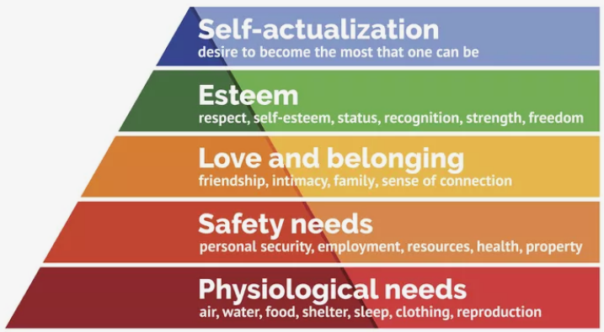
Figure 1: Maslow's Hierarchy of Needs
(Source: Hopper, 2024)
The Care Act 2014 codifies an obligation to encourage individual wellbeing, prevention and integration, putting person-centred and partnership models into the statute and thus embedding local authorities with a responsibility on policy to promote these elements of health care provision (Bell-James et al., 2023). On the same note, national integration agendas necessitate health and social care organisations to liaise in assessment, budgeting, and care planning. Combined, theory and policy support the fact that ethical, collaborative, and person-centred practise is not a frivolous but a core element in sustainable and high-quality delivery of health and social care in the UK (O’Donnell et al., 2022).

Task 2: Practical Examples of Concepts in Practice

2.1 Using one of the real-world case studies from a UK setting
The case study of Joan in NHS England exemplifies the examples of how person-centred care, partnership working, and ethics could successfully be applied to community-based services (NHS England, 2022). Joan is an elderly patient with various chronic illnesses, who used to visit the GPs often with unplanned trips to the hospital, more than 12 visits annually. By using personalised care planning, professionals examined the issues that were of greatest importance to her, and did not only examine the medical symptoms (McCann et al., 2024). The primary care with the additional support of social and voluntary services was a multidisciplinary strategy that allowed a personalised intervention based on the life objectives of Joan.

2.2 Explanation of the impact these three principals have on service users and professionals
In the case of Joan, the principles were applied and led to the adverse outcome of better independence, confidence, and well-being, as well as less dependence on acute services (Julià et al., 2025). She became an active decision-maker and not a passive recipient of care. The effects on the professionals included better clarity in determining the roles as professionals, responsibility in sharing across the service sectors and ensuring that duplication of assessments and referrals is minimised (Thomson, 2024). The care coordinators had efficient caseload management, and the GPs mentioned fewer repeat consultations. Such a holistic method improved the satisfaction of the professionals, as it provided a chance to deliver meaningful, outcome-driven care.

2.3 Considering the challenges and how they were overcome
The major obstacles were disjointed communication channels, inadequate appointment schedules, and, first, unwillingness to abandon old-fashioned models of care. Joan received more than one type of service, which worked through various organisational structures, which put a greater risk of information failure (midandsouthessex.ics.nhs.uk, 2025). These issues were resolved by conducting frequent multidisciplinary meetings, shared care records and appointment of a special care coordinator. Ethical issues pertaining to autonomy and risk were aligned through organised decision-making procedures, with the decision of Joan being honoured without violating the roles which were mandated under the scope of professionalism.

2.4 Evidence from policies/guidelines
The Health and Care Act 2022 facilitates integrated care systems by formally establishing the linkage between NHS organisations and local authorities, as seen in Joan with his pathway to coordinated care (Main et al., 2022). The NICE guideline on personalised care and management of long-term conditions focuses on shared decision-making and holistic assessment, which are the priorities of the given case (Raaijmakers et al., 2023). The Person-Centred Care Framework also supports the emphasis on personal strengths, objectives, and self-control, shifting away from the episodic, condition-based interventions.
Moreover, the domains of care, responsiveness, and leadership by the CQC can be noted within the active organisation of the support for Joan (Bradbury, 2022). Ethical decision-making, communication, and professional accountability are traced in the 6C: care, compassion, competence, communication, courage, and commitment that ensure the safe delivery of care across the continuum of services.

Task 3: Self-Reflection as a Health and Social Care Professional

3.1 Reflection on how to apply or plan to apply the principle in practice
My current practise would involve the use of person-centred care, whereby people are included in the process of making decisions that would influence their day-to-day activities, the priorities of care and their future objectives. In the case of assisting adults with complex needs, as an example, I made sure that care plans were based on individual preferences, i.e. preferred meal times, cultural aspects and communication styles as opposed to routine care plans. I would also meet a minimum of five professionals (nurses, social workers, support, etc.) every day to encourage partnership working and continuity of care. The ethics of my practise is the foundation of my actions, especially when dealing with confidential record keeping, consent discussions, and concerns, and making sure that I make all decisions in a lawful, respectful and responsible way.

3.2 Identifying the strengths and areas for improvement
Effective communication is one of my strengths, especially at multidisciplinary reviews with up to seven professionals, where I effectively state the perspectives of service users and represent their preferences. I have also proven to be good at keeping proper records and reporting issues accordingly. Nevertheless, I understand what I may have done better, particularly managing intricate ethical issues of risk-taking behaviours that include advocating for those who prefer being left alone, regardless of the level of risk of falls. I must also build more confidence in questioning senior colleagues on decision-making processes that might be required to align with the efficiency of the organisation, rather than towards the person-centred outcomes, especially in times when there is a shortage of staff or when organisations are under more pressure to follow up on the caseload.

3.3 Reflection on personal or work-based experiences
I have exhibited person-centred care by changing the ways of supporting individuals with anxiety to ensure continuity by ensuring the support of fewer staff members who might attend the support of these individuals, at times, from six to three personnel paid per week. The practise of partnership working was observed when I worked with occupational therapists, district nurses and housing officers in order to ease safe discharge planning after the hospital admissions that took more than ten days. Ethical practise played a critical role in helping people with clear, inconsistent mental capacity, since in this case I made sure that best-interest decisions were explained with family members and professionals, put in writing, and reviewed frequently to uphold autonomy up to the responsibility of protection.

3.4 Structuring the reflection using Gibbs Model
In each case, I describe the circumstances in which collaborative planning improved health outcomes and minimised instances requiring escalated care using the reflective cycle as introduced by Gibbs. The first had been confusion and responsibility when ethical issues arose, especially in balancing independence and safety (Stahl and Eke, 2024). Some of the positive outcomes were also reported during the assessment. These include higher engagement and incident reduction. Based on the analysis, I identified that communication, mutual documentation, and multidisciplinary team engagement in time were essential. To sum up, our experiences prove that reflective practice is essential. I would base my action plan on building up my ethical judgment skills, boosting my self-confidence in decision-making, and behaving in similar scenarios in the future with reference to what I have learned.
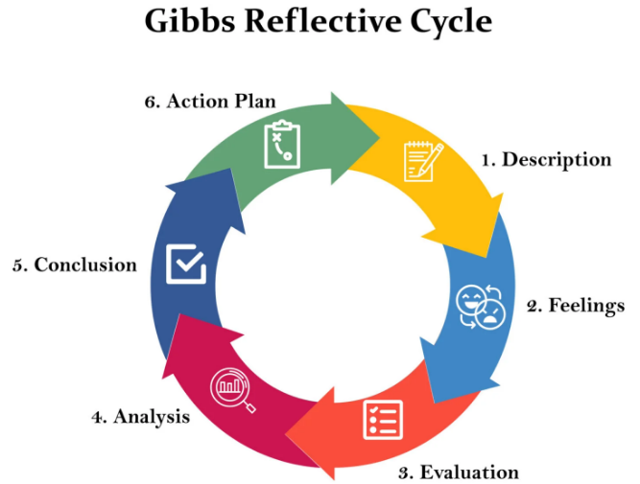
Figure 2: Gibbs reflective Model
(Source: McLeod, 2025)

3.5 Plans for future development
- I plan to engage in the process of continuous professional development by undertaking a minimum of five CPD courses in the next 18 months in the areas of person-centred care, safeguarding, ethical decisions, and integrated care in the context of the United Kingdom’s health and social care system.
- I would like to gain more practical experience by volunteering for at least 4 hours a week with any organisation that works with older adults with long-term conditions and social isolation.
- I would seek formal arrangements for mentorship with an experienced health or social care practitioner. I hope to derive benefits from the reflective supervision sessions, which will help me boost my confidence in resolving ethical dilemmas.
- I intend to participate in multidisciplinary meetings to improve partnership working and communication skills, and I aim to achieve the target of contributing to a minimum of 12 case discussions in a year.

Conclusion
The underlying beliefs of providing high-quality health and social care in the UK are person-centred care, partnership working and the practise of ethics. These combined principles guarantee a responsive care given to the needs of individuals, and conditions of effective cooperation and professional accountability. Their use further enhances service user outcomes, besides allowing the professionals to operate within legal and moral provisions with certainty. The consideration of these values facilitates life-long professional learning through fostering critical self-reflection, moral consciousness, and working practise, which provides the ultimate application to long-term, caring, and individual-centred health and social care provision.

Reference List
Ahmed, A., Muijsenbergh, M.E.T.C. van den and Vrijhoef, H.J.M. (2022) ‘Person‐centred Care in Primary care: What Works for whom, How and in What circumstances?’, Health & Social Care in the Community, 30(6). Available at: https://onlinelibrary.wiley.com/doi/full/10.1111/hsc.13913.
Bell-James, J., Foster, R. and Lovelock, C.E. (2023) ‘Identifying priorities for reform to integrate coastal wetland ecosystem services into law and policy’, Environmental Science & Policy, 142, pp. 164–172. Available at: https://doi.org/10.1016/j.envsci.2023.02.013.
Bradbury, B. (2022) ‘Strategic leadership behaviours that develop organisational resilience in NHS Trusts in England: A multiple-case study - ePrints Soton’, Soton.ac.uk [Preprint]. Available at: https://eprints.soton.ac.uk/470730/1/Thesis_for_deposit_Oct_2022.pdf.
Cantrell, A., Chambers, D. and Booth, A. (2024) ‘Interventions to minimise hospital winter pressures related to discharge planning and integrated care: a rapid mapping review of UK evidence’, Health and Social Care Delivery Research, 12(31), pp. 1–116. Available at: https://doi.org/10.3310/krwh4301.
Chit, T. (2024) Back To The Office: US Employee Reluctance And Re-Engagement Strategies, CUNY Academic Works. Available at: https://academicworks.cuny.edu/bb_etds/192/ (Accessed: 4 November 2024).
Hopper, E. (2024) Maslow’s Hierarchy of Needs Explained, ThoughtCo. Available at: https://www.thoughtco.com/maslows-hierarchy-of-needs-4582571.
Julià, A., Gallo, P., Marga Marí-Klose and Escapa, S. (2025) ‘Examining the matching of care preferences and care modalities for older dependents, and its association with satisfaction and wellbeing’, BMC Geriatrics, 25(1). Available at: https://doi.org/10.1186/s12877-025-05749-4.
Lorber, M., Mlinar Reljić, N., McCormack, B. and Kmetec, S. (2025) ‘Person-Centred Care in Association with Psychological Well-Being of Older Adults’, Healthcare, 13(12), p. 1379. Available at: https://doi.org/10.3390/healthcare13121379.
Main, C., Haig, M. and Kanavos, P. (2022) ‘The Promise of Population Health Management in England: From Theory to Implementation’. Available at: https://doi.org/10.21953/lse.dujyxzlb3juw.
Martins, M.F., Murry, L.T., Telford, L. and Moriarty, F. (2022) ‘Direct-to-consumer genetic testing: an updated systematic review of healthcare professionals’ knowledge and views, and ethical and legal concerns’, European Journal of Human Genetics, 30(12), pp. 1–13. Available at: https://doi.org/10.1038/s41431-022-01205-8.
McCann, S., McCann, S., McCann, S., McCann, S., McCann, S. and McCann, S. (2024) ‘Telephone consulting for “Personalised Care and Support Planning” with people with long-term conditions: a qualitative study of healthcare professionals’ experiences during COVID-19 restrictions and beyond’, BMC primary care, 25(1). Available at: https://doi.org/10.1186/s12875-024-02443-z.
McLeod, S. (2025) Gibbs Reflective Cycle, Simply Psychology. Available at: https://www.simplypsychology.org/gibbs-reflective-cycle.html.
midandsouthessex.ics.nhs.uk (2025) Joan’s story: Monitoring my blood pressure at home helps me manage my health, Mid and South Essex Integrated Care System. Available at: https://www.midandsouthessex.ics.nhs.uk/local-stories/joans-story-monitoring-my-blood-pressure-at-home-helps-me-manage-my-health/ (Accessed: 10 February 2026).
NHS England (2022) NHS England» Joan’s Story, www.england.nhs.uk. Available at: https://www.england.nhs.uk/personalisedcare/comprehensive-model/case-studies/joans-story/.
Nkhoma, K.B., Cook, A., Giusti, A., Farrant, L., Petrus, R., Petersen, I., Gwyther, L., Venkatapuram, S. and Harding, R. (2022) ‘A systematic review of impact of person-centred interventions for serious physical illness in terms of outcomes and costs’, BMJ Open, 12(7), p. e054386. Available at: https://doi.org/10.1136/bmjopen-2021-054386.
O’Donnell, D., Dickson, C., Phelan, A., Brown, D., Byrne, G., Cardiff, S., Cook, N.F., Dunleavy, S., Kmetec, S. and McCormack, B. (2022) ‘A mixed methods approach to the development of a Person-centred Curriculum Framework: surfacing person-centred principles and practices’, International Practice Development Journal, 12(3), pp. 1–14. Available at: https://doi.org/10.19043/ipdj.12Suppl.003.
Raaijmakers, L.H.A., Schermer, T.R., Wijnen, M., van Bommel, H.E., Michielsen, L., Boone, F., Vercoulen, J.H. and Bischoff, E.W.M.A. (2023) ‘Development of a Person-Centred Integrated Care Approach for Chronic Disease Management in Dutch Primary Care: A Mixed-Method Study’, International Journal of Environmental Research and Public Health, 20(5), p. 3824. Available at: https://doi.org/10.3390/ijerph20053824.
Stahl, B.C. and Eke, D. (2024) ‘The Ethics of ChatGPT – Exploring the Ethical Issues of an Emerging Technology’, International Journal of Information Management, 74(74), pp. 102700–102700. Available at: https://doi.org/10.1016/j.ijinfomgt.2023.102700.
Stanley, K. and Kuo, N.-C. (2022) ‘“It Takes a Village”: Approaching the Development of School-Family-Community Partnerships through Bronfenbrenner’s Socio-Ecological Perspectives’, Journal of Human Sciences and Extension, 10(1), pp. 1–14. Available at: https://doi.org/10.54718/cqbw6379.
Thomson, L. (2024) ‘Barriers and Enablers of Integrated Care in the UK: a Rapid Evidence Review of Review Articles and Grey Literature 2018–2022’, Frontiers in Public Health, 11(1). Available at: https://doi.org/10.3389/fpubh.2023.1286479.

