Name | Student Number | Date | Lecturer’s Name | Your score
ZAIRE ARIF | 2432765 | 29/06/2025 | SIMON | To be filled by the marker  ___/40
You will have 90 minutes to complete this assessment. It is divided into three sections: note-taking, paraphrasing and writing a paragraph.
---------------------------------------------------------------------------------------------------------------------
1. Take diagrammatic notes from the passage below using the space provided:

The university experience is not just about subject knowledge, but also about developing skills that will equip you for your future life. For starters, it's impossible to graduate without a range of people skills under your belt. You'll meet new people from different backgrounds. You'll also interact with lecturers, tutors and university staff almost daily. Another life lesson that university teaches you is taking responsibility for yourself, your own schedule and learning. A lot of university study is self-directed - it's up to you to plan and organise your work, juggle multiple projects and manage deadlines – you will need to develop self-motivation if you want to succeed. Let’s not forget learning how to overcome obstacles; whether academic, work-related or personal, you'll face your fair share of hurdles as a student, but you will develop resourcefulness and resilience in the process. If you were a bit unorganised before you went to university, you won't be by the time you leave. To successfully navigate student life you'll need to handle a variety of study, work, social and personal commitments and the only way to do this is with organisation and time management. Finally, university provides plenty of opportunities to work on and boost your confidence: you'll work in groups, deliver presentations, complete assessments and maybe even become a class representative.
Adapted from: https://www.prospects.ac.uk/applying-for-university/university-life/7-life-skills-youll-learn-at-university

Space for your notes (max 12 marks):
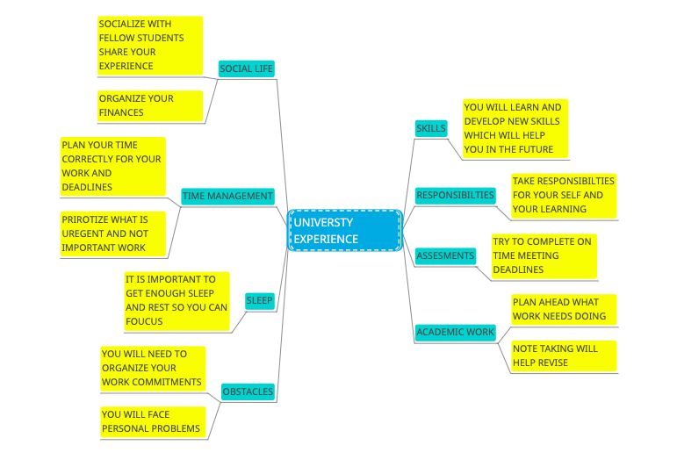

2. Paraphrase the following sentences (max 3 marks for each, max 12 marks in total):

a) To successfully navigate student life you will need to handle a variety commitments.
____________________________________________________________________________________________To correctly understand student life experience you will need to handle many different obstacles and multiple commitments.____________________________________________________________________________________________________________________________________________________________________________________________________________________________________________________________________________________________

b) You will need to develop self-motivation if you want to succeed at university. ____________________________________________________________________________________________
If you want to progress and achieve your goals at a university you will need to improve your self-motivation and discipline yourself.
_____________________________________________________________________________________________________________________________________________________________________________________________________________________________________________________________________________________________

c) Many students find it challenging to manage stress during assessment periods. ____________________________________________________________________________________________Assesment periods can be stress full and difficult and make many students feel anxious at times._____________________________________________________________________________________________________________________________________________________________________________________________________________________________________________________________________________________________

d) Frequent reading can help you become a more effective communicator.

_To become more successful in communicating reading regular is very important.________________________________________________________________________________________________________________________________________________________________________________________________________________________________________________________________________________________________________________________________________________________________________________________

3. Write a well-structured paragraph (8 sentences) on the following topic:

Effective time management techniques for university students

Your paragraph must be written in full sentences (no bullet points) and in an academic style.

(max 16 marks in total)

_______________________________________________________________________________________________
Time management techniques for university students involve many obstacles prioritising what is important. These can be organizing your time, and meeting deadlines priortize what is important. Doing too much work at once will give more stress and you will not be able to achieve your goals. Using a planner note taking allocate time correctly. Using the Smart goal, Specific, Measurable, Achievable, Realistic and Time-bound method. Also using the 4d strategy identify thing which are not important ,delaying the work, ask help to understand things better. Also avoiding multi-tasking can help putting too much pressure on yourself it is better to concentrate on one thing at a time. Student should stay focused on what is important by using the Eisenhower Matrix method and get done important work first, Going back regular check on their work going and your progress. ____________________________________________________________________________________________________________________________________________________________________________________________________________________________________________________________________________________________________________________________________________________________________________________________________________________________________________________________________________________________________________________________________________________________________________________________________________________________________________________________________________________________________________________________________________________________________________________________________________________________________________________________________________________________________________________________________________________________________________________________________________________________________________________________________________________________________________________________________________________________________________________________________________________________________________________________________________________________________________________________________________________________________________________________________________________________________________________________________________________________________________________________________________________________________________________________________________________________________________________________________________________________________________________________________________________________________________________________________________________________________________________________________________________________________________________________________________________________________________________________________________________________________________________________________________________________________________________________________________________________

