The importance of effective communication for young children’s learning and development during transitions
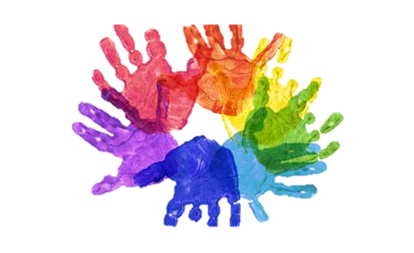


http://www.siagain.com/the-early-years/ [accessed[18/11/17]
Solentmaths (2016)https://solentmathshub.org.uk/early-years-mathematics/[access 13/11/17]
http://www3.northamptonshire.gov.uk/learning-disability-partnership-board/easy-read-info/Pages/EarlyYearsandTransitions.aspx

Content page

- Introduction

- Transition

- Ways to a smooth transition

- Communication

- Working together
-staff
Parents

- Theories

-Lev Vygotsky
-Abraham Maslow
-John Bowlby

- References

Introduction

The purpose of this handbook is to highlight the importance of effective transitions during transition phases, this handbook is aimed to benefit early years workers, foundation stage children and parents. Throughout this handbook it will be focusing on key elements of transitioning and how it can be made smooth and more effective. Communication is key during transitions to enable the child is happy and comfortable during unsettling times. Throughout this handbook key theories will be drawn in to help understand the development of children and the key attachments children build within early years education.

Transition

What are transitions?
Research suggests that transitions are central to young children’s development and emotional wellbeing, and the way in which the first transitions are handled could have a significant impact on the child’s capacity to cope with change in the short and long term. Early years practitioners should ensure children are fully supported through these key transitions and plan for them appropriately, writes Elizabeth Walker. (https://app.croneri.co.uk/feature-articles/managing-transitions-early-years-provisions accessed on 17/11/17 )

Transitions should be seen as a journey from one setting to another, it should be an exciting time for the child.

Ways to a smooth transition
- Transition times are opportunities for learning - Transitions hold many opportunities for cooperation, problem-solving, skill-building, listening and following directions

- Make transitions fun and enjoyable – As transitions can be a daunting procedure by making the situation fun and enjoyable creates positive memories for the child in the new environment.

- One key worker/ teacher to go with the majority of the children that are moving onto the new setting – The key worker is an invaluable tool during transitions. A familiar face and a person who a child has built an attachment to can make the transition smooth, along with making the child feel secure in the new environment.

- Give children time to prepare for transitions - We need to respect children’s choices. They need to mentally prepare for changes, and feel that they have some control within their environment and their day. Children respond to structure and routines, and consistency enables them to feel safe, secure, and more in control and competent. (https://app.croneri.co.uk/feature-articles/managing-transitions-early-years-provisions accessed on 17/11/17)

- Positive reinforcement - Children generally want to please people they have built a relationship with. Reward appropriate behaviour with positive reinforcement, praise and recognition. Be specific and concrete with your comments, it indicates that you are really looking and paying attention.

- Try to stay away from always relying on external rewards like stickers - This can often lead to children doing only what is expected for something in return.

- Know upon whom you need to keep an extra close eye – some children don’t react well to change so keeping a special eye on them to ensure they are coping, again using positive reinforcement when they display appropriate behaviours.

- Plan visits – plan visits to the new settings so the children have the opportunity to get used to the new settings and see where everything is ready for the first day.

- Know your children - Know what they like and what they respond to, what works, and what doesn't this can be done through an ‘all about me book’.
(https://app.croneri.co.uk/feature-articles/managing-transitions-early-years-provisions accessed on 17/11/17 )

The ability to communicate effectively is crucial for developing positive relationships with children, young people and their families, colleagues and other professionals. It paves the way for an enjoyable and happy environment which is vital for young children’s development. If a parent or staff member feels they have a strong relationship/ communication with you it will benefit the way in which the child will learn and develop, if there are any problems the child is struggling with, the parent / guardian will have no problem than to communicate and ultimately benefit the child. These are some ways in which can benefit your communication skills:
- Practitioners and parents/ guardians must give each other full attention when communicating to ensure all information is received.

- You need to be aware on non- verbal communication such as body language, to ensure you are relaying the correct and appropriate message.

- Practitioners and parents/guardians must listen correctly to one another without interruptions. Listen with sympathy and understanding.

- Everyone is different, so the practitioner and parents need to be understanding of this when communicating, be flexible in the way you communicate.

- Sensitivity is key when dealing with cultural differences such as touching, curtain gestures and eye contact can be seen as disrespectful in some cultures

- Personal space needs to be maintained when communicating

- Be wary of your environment when communication and the nature of the topic, for example if the topic is more of a serious matter then a private environment will be more beneficial

- Use of photographs or visual aids can be a great way to communicate with a parent/ guardian or practitioner that may speak a different language or hearing impediment

communication

Parents
It is important that parents relay information to staff especially when the child is going through transitions because the new teachers or key workers don’t know the child’s personality, this can be done by: Verbal communication: It is vital that the parents/ guardians communicate if there are any specific topics or areas that the child is sensitive about i.e. if a parent is not around they may be sensitive around the family topic. It is also important that parents/ guardians relay information about who has child access to the child and who does not.
Non- verbal communication: This can also be done through the medium of a journal, this is and easy and effective way to communicate any concerns parents may have. https://www.nurseryworld.co.uk/nursery-world/news/1080194/transition-settings (Accessed on 18/11/17)

Staff

Staff play a major role in a smooth transition between settings. It is the staff’s responsibility to pass on key information about children to ensure a happy and enjoyable transition. It is essential that both parents and staff work together and communicate efficiently, so the needs of the child/children are met. One way the staff can relay information is by:
Verbal communication: this could simply be talking to parents/ guardians at the beginning or end of the day letting the parents know what their child will be doing that day. It is also important that the new setting staff and parents/guardians have efficient communication so the parents know if their child is settling in to their new setting or if there are any areas in which the child is struggling with. Staff should give children opportunities to talk about their concerns and to ask questions. Often children's fears will be around practical issues, but adults shouldn't underestimate the emotional wrench for a child of leaving a key worker in which they have built a relationship with.
Non- verbal communication: there are many ways in which staff and parents/ guardians and new staff can communicate non-verbally, one way is an ‘all about me book’ this is a book which is all about the specific child and what the enjoy and what they don’t. this is just a simple way to get to know each individual child before you meet them. Another way is a journal which can be sent home every week which is an effective way for staff and parents to communicate easily. Photographs or visual aids can benefit if the parents/ guardians speak a different language of suffer from hearing impediment, this is an easy way to show them how their child is playing or working in class.

Working together

Lev Vygotsky (1934)
Theories

Vygotsky believes Children at play are making sense of the world through a process of "inner speech" – this is why they are often talking out loud to themselves. As adults, we lose this capacity because it is not socially accepted
Vygotsky argued that development first takes place socially. He believes children observe parental behaviour by listen to parents' speech and body language, then trying to imitate them. As children practice through imitation, parents will guide children, correct them, and provide challenges. Through play, children take on different roles, all of which help them on the journey. Through play, children become more competent in their language use and begin to regulate their own thought processes. This overall helps children communicate with not just peers and their parents but key workers within their settings.

Zone of Proximal Development

This is an important concept that relates to the difference between what a child can achieve independently and what a child can achieve with guidance and encouragement from a skilled partner. Saul McLeod (published 2007) ‘zone of proximal development’ (https://www.simplypsychology.org/bowlby.html)[access 14/14/17]
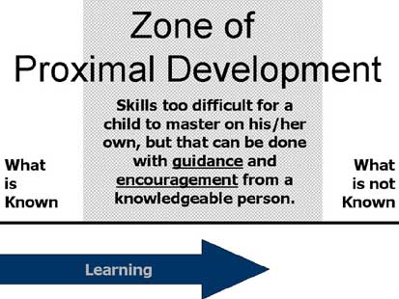
Lev Vygotsky views interaction as an effective way of developing skills and strategies. He suggests that teachers use cooperative learning exercises where less competent children develop with help from more skilful peers providing the appropriate assistance will give the student enough of a "boost" to achieve the task.- within the zone of proximal development.
Simply phycology (2012)(https://www.simplypsychology.org/Zone-of-Proximal-Development.html)[access 13/11/17]

Abraham Maslow (1908-1970)

Hierarchy of needs

Maslow developed a theory that a specific series of needs must be met before any child could learn he called this the ‘hierarchy of needs’
D.E. Campbell (2014) believes that this hierarchy explains important components of behaviour, including school behaviour. In many school’s teachers often assume that the physical security and safety needs of their students are ensured, but they are not. When physical security and safety, including sleep, are challenged, students will use most of their time, energy, and creativity simply trying to survive. This struggle interferes with learning.
In the book ‘Pearson Allyn Bacon Prentice Hall’ it states that belonging needs are often strong in school. Children need to know they are a welcome part of the class meaning inclusion plays a massive role in children having a positive education. The teacher cannot allow derogatory name-calling and other forms of bullying and exclusion to dominate the classroom.
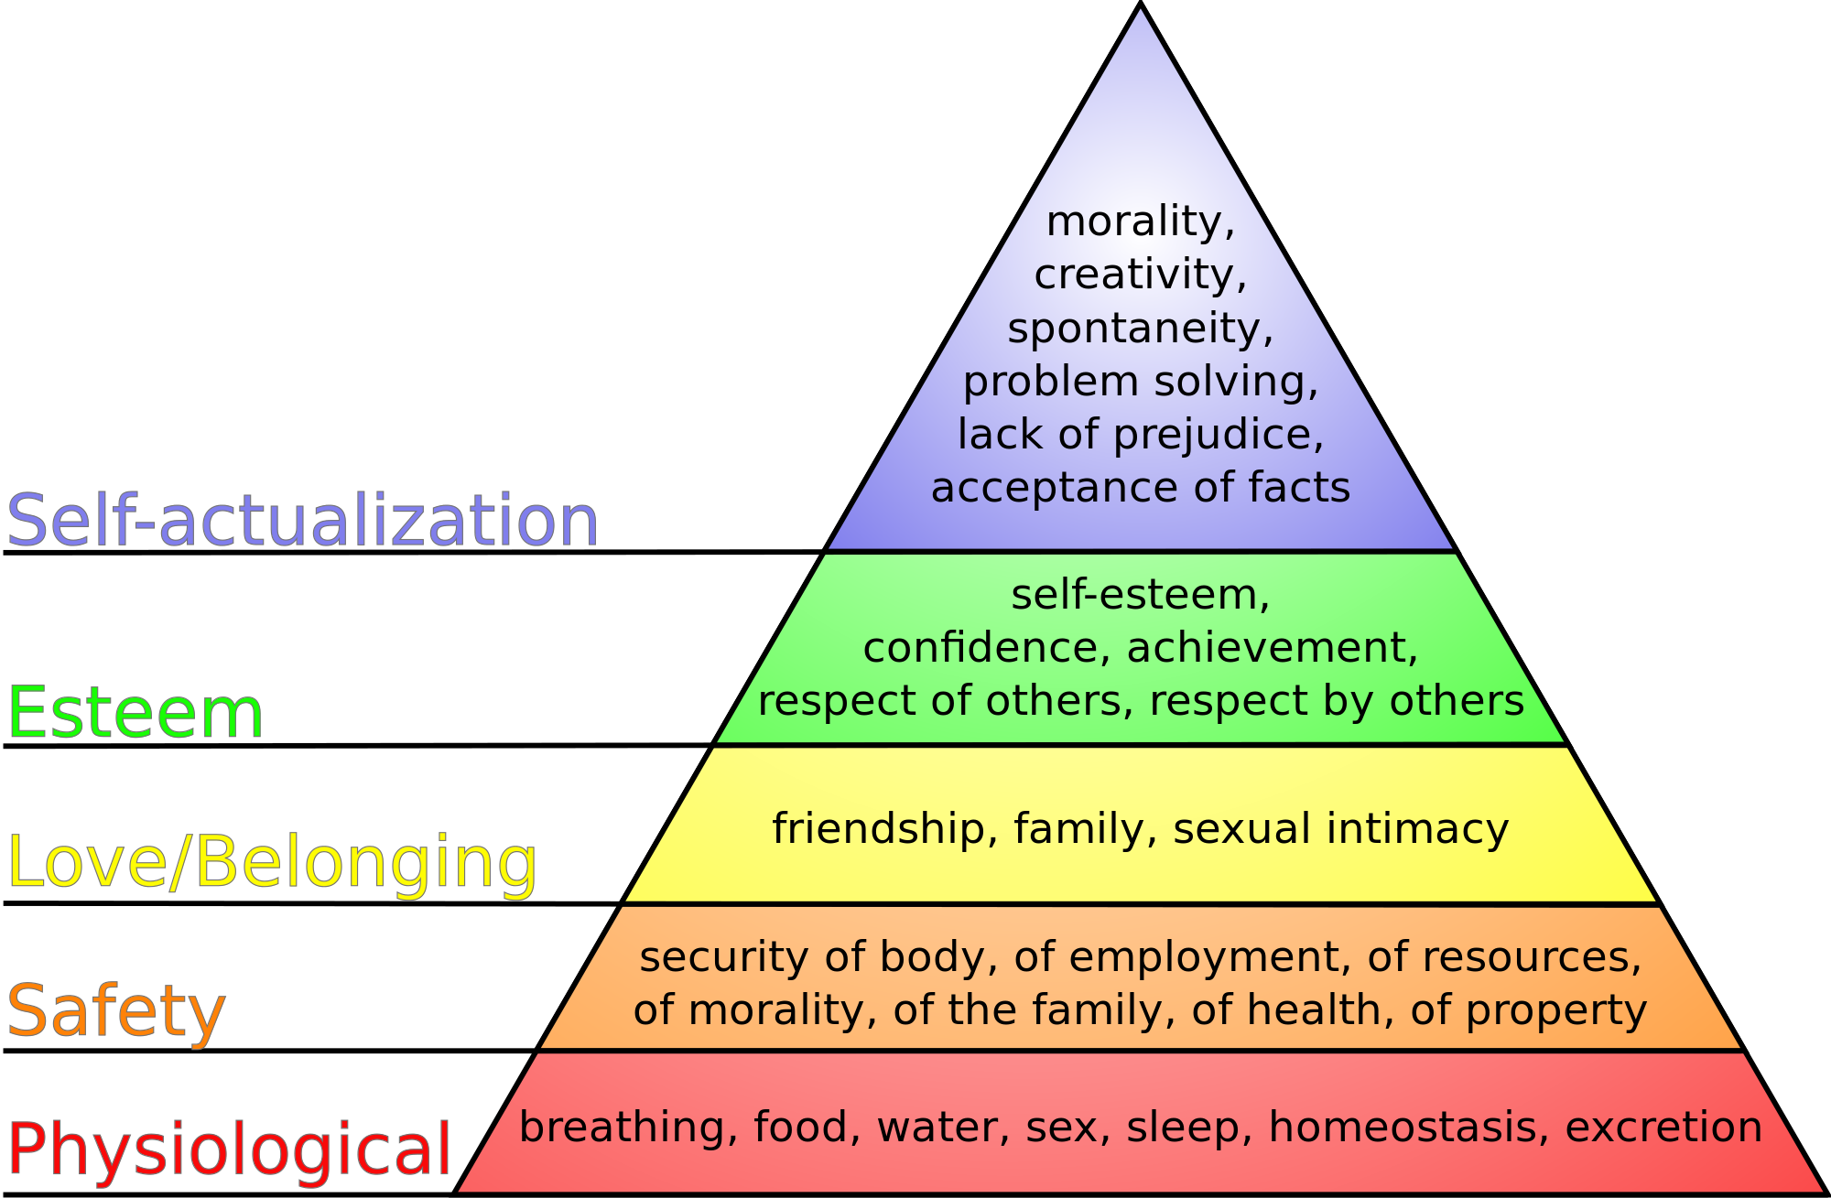

The hierarchy can only work if all the foundations are solid, without one the hierarchy can work, and the child will not benefit from it. This is very important when a child is going through a transition, so they are able to build new relationships with their new key workers. This also links to Bowlby’s theory of attachment

John Bowlby (1907-1990)

John Bowlby was a psychoanalyst and believed that mental health and behavioural problems could be attributed to early childhood. He developed a theory that every child is born with and innate need to attach to one main attachment figure.

Saul Mcleod states that Bowlby did not rule out the possibility of other attachment figures for a child, he did believe that there should be a primary bond which was much more important than any other (usually the mother). Bowlby argues that the relationship with the mother is somehow different altogether from other relationships. Saul McLeod (published 2007) ‘Bowlby's Attachment Theory’ (https://www.simplypsychology.org/bowlby.html)[access 14/14/17]

Bowlby felt that existing theories on attachment from psychoanalytic and behavioural fields were detached from reality and not up to date, thus he began reading into and corresponding with current researchers in the fields of biology and ethology. One study which was particularly influential on attachment theory was conducted by Harlow & Zimmerman in 1959 they studied attachment on young monkeys that were separated from their mothers and put into cages with “surrogate mothers”. One ‘mother’ was built out of cloth but unable to feed the young monkey. The other ‘mother’ was built out of wire but attached with a bottle. The results showed that the young monkey only desire the wire ‘mother’ when the need for food was greater then the need for emotional bond. Bowlby based his theory on the bases of these results, meaning the attachment for intrinsic need for an emotional bond with a mother is greater than the need to be fed. David L, "Attachment Theory (Bowlby)," in Learning Theories, January 24, 2016, https://www.learning-theories.com/attachment-theory-bowlby.html.
This theory shows that the attachment with a key worker is an essential bond, to feel safe and build strong, secure environment for the child to develop without unnecessary stress. Transition from one key worker to another can be upsetting for a child that has made strong bonds with them, if the key workers make the environment feel safe and secure will make the child feel safe enough to move on from the key worker that they have built a relationship with.

- Reattachment (newborn-6 weeks): Newborn infants know to act in such a way that attracts adults, such as crying, cooing, smiling, and making eye contact. Although not attached to their mothers yet, they are soothed by the presence of others. David L, "Attachment Theory (Bowlby)," in Learning Theories, January 24, 2016, https://www.learning-theories.com/attachment-theory-bowlby.html.

Bowlby’s Stages of attachment
- Attachment in making (6 weeks- 6 to 8 months): Infants begins to develop a sense of trust in their mothers, in that they can depend on her in times of need. They are soothed more quickly by their mother, and smile more often next to her. David L, "Attachment Theory (Bowlby)," in Learning Theories, January 24, 2016, https://www.learning-theories.com/attachment-theory-bowlby.html.
- Clear cut attachment (6 to 8 months- 18 months to 2 years): Attachment is established. The infant prefers his mother over anyone else, and experiences separation anxiety when she leaves. The intensity of separation anxiety is influenced by the infant’s temperament and the way in which caregivers respond and soothe the infant. David L, "Attachment Theory (Bowlby)," in Learning Theories, January 24, 2016, https://www.learning-theories.com/attachment-theory-bowlby.html.
- Formation of reciprocal relationship (18 months- to years +): As language develops, separation anxiety declines. The infant can now understand when his mother is leaving and when she will be coming back. In addition, a sense of security has developed, in that even when his mother is not physically there, he knows she is always there for him. Bowlby called this sense of security an internal working model. David L, "Attachment Theory (Bowlby)," in Learning Theories, January 24, 2016, https://www.learning-theories.com/attachment-theory-bowlby.html.
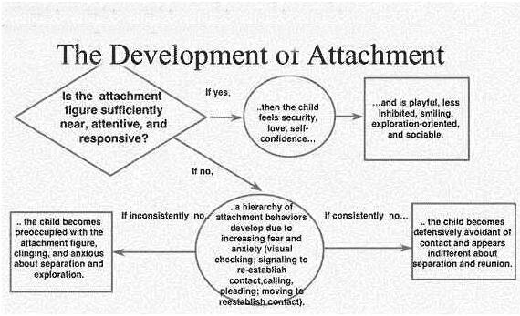
Studio guys (not dated)(https://studiousguy.com/john-bowlby-attachment-theory/)[access13/11/17]

Strategies
Transition activities give children and parents/ guardians opportunities to find out information about the new school and become familiar with new routines and people.

One strategy to help children settle in to a new setting could be making a treasure hunt to help children find where places are, for example the toilets, sinks, coat room ect. This could be a great way for children to work together and learn a bit more about each other and build those key relationships that will be needed throughout their time in the new class/ group.

Drawing members of the family, Do they have siblings and what are their names and ages? Or maybe they live with extended family or have lots of pets that the child may talk about. The grandparents may be collecting the child from school on certain days of the week. This is a simple and easy way to build a connection and find out more about each individual child.
Another great strategy is ‘Simon says’, this could also help with finding out where places are in the new settings, i.e. ‘Simon says find where the coats are hung’ it just makes finding new places fun and enjoyable.

Nurseryworld(2009) https://www.nurseryworld.co.uk/nursery-world/news/1080194/transition-settings (Accessed on 18/11/17)
Saul McLeod (published 2007) ‘Bowlby's Attachment Theory’ (https://www.simplypsychology.org/bowlby.html)[access 14/14/17]
Simply phycology (2012)(https://www.simplypsychology.org/Zone-of-Proximal-Development.html)[access 13/11/17]
Solentmaths (2016)https://solentmathshub.org.uk/early-years-mathematics/[access 13/11/17]
Studio guys (not dated)(https://studiousguy.com/john-bowlby-attachment-theory/)[access13/11/17]
The speech centre for language processing disorders (Not dated) (http://www.siagain.com/the-early-years/.) [access 18/11/17]
Wikipedia(2006)(https://commons.wikimedia.org/wiki/File:Maslow%27s_hierarchy_of_needs.svg)[access13/11/17]
Elizabeth Walker. (2006) (https://app.croneri.co.uk/feature-articles/managing-transitions-early-years-provisions accessed on 17/11/17 )
David L, "Attachment Theory (Bowlby)," in Learning Theories, January 24, 2016, https://www.learning-theories.com/attachment-theory-bowlby.html.
D. E. Campbell (2014) ‘Pearson Allyn Bacon Prentice Hall’ (https://www.education.com/reference/article/work-Abraham-Maslow/)[14/11/17]

How young people learn (https://hycl.wordpress.com/educational-foundations/maslows-hierarchy-of-needs/)[access 14/11/17]
References

