Work Plan/Method Statement
Before starting my work, I am going to make sure that the workspace is safe to work in without any obstructions, I am going to make sure that I am wearing the current PPE which includes steel toed boots, thick workers trousers and jacket. Once I am happy with my workspace, I am going to gather the required tools to carry out my work, this includes a flat head and Phillips screwdrivers, small hammer, side cutters, needle nosed pliers, small ladder. I am also going to need materials which would include around 10m of 2.5mm² of twin and earth, around 2m of 1.5mm² twin and earth, 2m of 1.5mm² three core and earth, cables clips for 2.5mm² and 1.5mm² cable, 8 one-gang back boxes, 2 ceiling roses, 1 junction box, 1 ccu, 4 single socket outlets, 1 fused spur, 2 three-way switches and 1 four-way switch.
I am going to start with the eight back boxes and place these on my board in similar areas specified on my drawing, I have found it easier to start with items you have most of as it makes it easier working out the spacing required to get it to all fit on the board. Next, I will put on the junction box, ceiling roses and ccu as putting all the base plates on first give you something to wire to which makes cutting your cable a lot easier. Then I am going to put on the bottom most socket as this is the one with the most cables coming in/out of it so will be the most difficult to get neat. When terminating my cables, I am going to try where possible to loop the end of the cable so it looks like a doughnut, this means that the termination should be more secure as the screw should sit in the hole and hold the termination firm rather than if you were to just leave it straight. I am going to continue around to the junction box and add the two three single sockets and then the fused spur. All these cables I have so far put in will be 2.5mm² and will form my ring. Off from my fused spur I will go to my two ceiling roses, 1.5mm² will be used. Then from the ceiling rose I will still use 1.5mm² to the three-way switch but the neutral will have a brown sleeving as it’s the switched live, then will use 1.5mm² three core and earth to go to the four-way switch, and the same cable from the four way switch to the last three way switch. When using the 1.5mm² on the grey and black cables I will use brown sleeving as these are like conductors. Finally, I will connect my two remaining 2.5mm² cables into the ccu.
Once I have completed building my circuit, I will need to test to make sure all my connections are correct and there are no faults. First before conducting any electrical test, I will visually go around the circuit looking for cuts/nicks in the cable, any exposed conductors where the sleeving has been cut back too far, earth conductors are correctly sleeved and live, neutral and earth are in the correct terminations. I am also going to go around and double check that all terminations are tights and not terminated on sleeving. The first electrical test I am going to do is to test the continuity of the earth conductor if the resistance of this is too high or open circuit it will mean that our protection wont trip under fault conditions. To test this, we need to test the resistance of our leads as we need to take this away from our final value. To conduct the R1+R2 test I need to link the earth and live together, I am going to do this at the furthest point as if there is a fault it will make it easier to locate. Once I have them connected together, I then go back to the CCU and perform a resistance test between live and earth, the result I had was 0.2Ω, if this was high I would expect to find a break somewhere in the circuit which would need to be investigated. Next, I am going to carry out an insulation resistance test, this tests the resistance between two conductors when voltage is applied; in my tests I am going to test between live and earth, live and neutral, neutral and earth. On a brand-new circuit like this one I would expect results of over >500MΩ but our minimum accepted result is 1MΩ. In my opinion If I had any results below 50MΩ I would conduct some investigation into my circuit to try and get the value higher. Its also important to note that when carrying out insulation resistance tests that you must remove any sensitive electronics from the circuit as we are applying over double the normal voltage that the circuit would normal see which could damage equipment connected. The next test I am going to do is the RCD test, this is a test which checks the trip times of the RDC installed. I am going to perform the tests at ½ times, 1x, and 5x the trip time of the RCD, the times that I achieved were >2000ms, 18.9ms and 19.2ms. When recording the results, I take the highest time so 19.2 ms.
Test Results
Lead Resistance = 0Ω
R1+R2 = 0.2Ω
IR Line to Neutral = >500mΩ
IR Line to CPC = >500mΩ
IR Line to CPC = >500mΩ
RCD:
½ = >2000ms
1 = 18.9ms
5 = 19.2ms
Part B
a)
i) Discrimination is important in electric circuits as it prevents unwanted tripping of circuits which don’t have a fault on, in the case of the fuses A and B if A was to trip before B due to a fault being on A’s circuit, this would also cause a loss of feed to the other circuit that is being fed. To prevent this, we use a higher rated fuse upstream. In the case of a fault, the current drawn by the circuit is infinite (under perfect conducting conditions), as this is the case its not just the current rating of the fuses which matter but the trip time as in the case of a fault, we would be exceeding the current limits of both fuses. As can been seen in the image below the trip times for a 32-amp fuse is shorter than a 64 amp, this means although each fuse has more than its rated current flowing through it the 32 amp will trip first and remove the fault before the upstream fuse blows.

ii)

Its important to consider the current-time characteristics of fuses as if not taken into account it can lead to the disconnection of circuits which are not under fault. For example if we had a 32 amp fuse in fuse A and a 40 amp fuse in fuse B and there was a fault on circuit B, this would cause the upstream fuse to blow first taking out circuits B and C. In reality we don’t need this to happen as circuit C doesn’t have any faults so it doesn’t need to be disconnected. What should happen is that fuse B should blow before fuse A. If you look at the table below you can see the current-time characteristics for a wide range of fuses at different currents, so if we were using a 40 and 32 amp fuse and we had an overcurrent of 300 amps, it would take the 32 amp fuse 0.03 seconds to blow and it would take an 40 amp fuse 0.2 seconds; so if the 32 amp is upstream it’s going to blow before the 40 amp. Lower currents its takes longer for the fuse to blow, the area under the curve is where the fuse won’t blow.
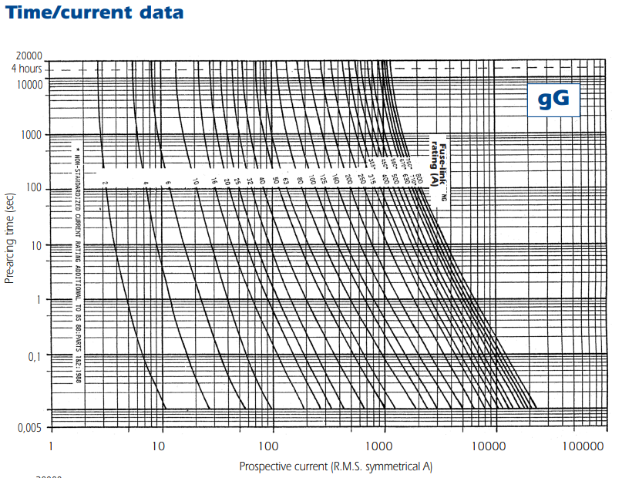
Figure 1 Current-time characteristics of Gg fuses

b)
Tripping devices such as MCB’s typically use two different types of tripping method, heat and magnetism. These two different types of ways of sensing current are used for two different types of trips, the first being overload. Overload is when a circuit draws more current than it is designed for, an example of this could be a motors bearing have started to fail and to keep the rotor turning at the same speed more current is drawn. This isn’t usually a spike of current but more a gradual increase, the more current drawn by the circuit the hotter the cable gets. So, inside a MCB is a bi metallic strip which when more current is applied, more heat is applied, and the bimetallic strip will bend more. The strip will be calibrated so at a certain heat (or current) it will contact either an electrical contact or a mechanical contact and trip the MCB. The other type of trip we are protecting against is faults, wherever this is earth faults or short circuits. These types of faults generate lots of current, over 20x the rated current for the circuit so if are not isolated quick enough can cause damage to the whole circuit. For this reason, we need to use magnetism to trip our MCB. When a large current is induced almost instantly a large magnetic field is produced around the conductor, the MCB has a magnetic coil inside it so when a large enough current is produced there will be enough magnetic flux to overcome a spring and trip the MCB. We can’t use the bi metallic strip for earth faults and short circuits as it takes too much time to transfer the heat to the bimetallic strip, and for the bi metallic strip to bend.

2.
A)
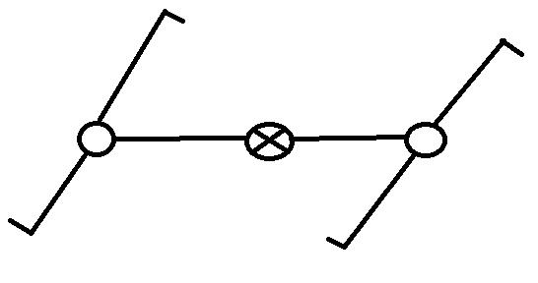
B)
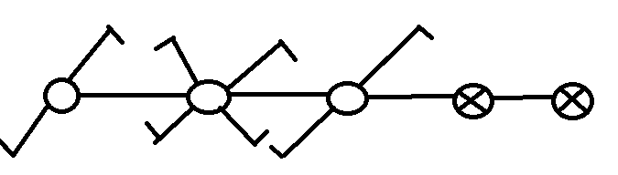
C)
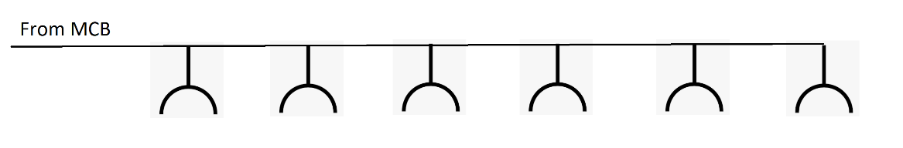
D)
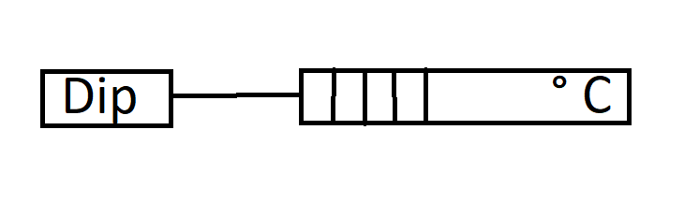
Marking Comments
Jack, all of your diagrams are missing from the assignment.
Your answers do not read well. While I understand what you are trying to say, your answers are not entirely accurate and lack structure. If you break your answers into several parts, it will make them easier to write and to understand.
You must try to move away from ‘site-speak’ and use professional technical terms. This can be difficult to adjust to doing but is necessary at this level.

Steven Evans

