The woods at Llanachaeron (SN4798160177) are as good an example of British woodland as can be found in the modern landscape, as close to Oliver Rackham’s definition of ancient woodland that can still be seen (Rackham, 2003) It is formed mainly of Oak, Ash, and Beech, with an understory of Hazel and other smaller trees, along with less authentic invaders such as London Plane and coniferous Larch. This varied woodland supports a complex ecosystem of trees, bushes and other flora, fungi and small animals, more complex than purely coniferous woodland which has led to it being granted SSSI status (Tir Coed, 2017).
For their part, the National Trust takes a somewhat lassaiz-faire attitude to the maintenance of the woodland. Trees are felled mainly when they form a danger to the public or block paths, for instance through tilting, and are otherwise allowed to grow wildly. Cuttings are left almost in situ, cleared only from the paths and left on the forest floor allowing a wealth of other species to thrive. The trees are regularly surveyed to look at their condition – are they diseased? Are they in danger of falling onto the pathways? Are they continuing to grow? Metal tags are left on the trunks to provide information about these surveys for further management.
This style of management has strengths and weaknesses. On one hand, many of the trees are broadleaf species, in one of the few areas where they are in abundance, left unsold past their profitable period, as opposed to being planted in a conservation effort. But these trees are an aging population, coming to the end of their expected lives, rotting from the inside and falling down, sampling of some oak trees after felling have found them to be over 220 years old (Bale, 2005, p.49). I couldn’t observe any efforts to replant any species, though this may be explained by gap dynamics – trees such as oak do not likely growing in established woodland, because of lack of light (De Chant et. al. 2007 p.1). New tree growth would therefore be better focused on the edges of the area rather than the centre we were walking through.
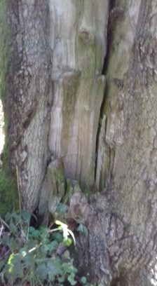
(Oak tree rotting whilst in situ, my photograph)
There is also evidence of maintenance in the form of coppicing, creating new tree shoots for growth, observed for example on the hazel understory. This coppicing may indeed have predated the National Trust involvement in the woodland but is still evident in some trees. There is also evidence of pollarding, perhaps carried out to increase safety by removing upper branches likely to fall onto paths, Current cuttings from these trees are stacked on the woodland floor in order to promote wildlife.
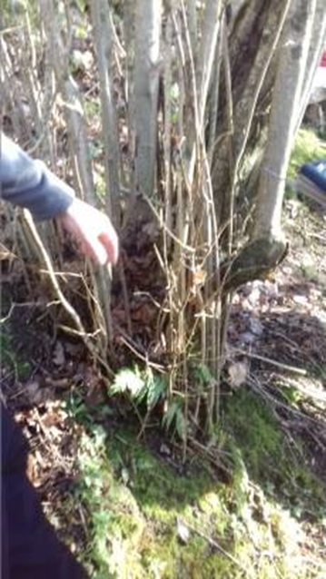
(Coppiced hazel at Llanachaeron, my photograph)
The woodland at Llanachaeron is not ancient, having been planted for sale use only a couple of hundred years ago, but more closely resembles it than is found elsewhere. However as these trees die of old age and disease they need to be replaced in order to maintain the balance.
References
Bale, R. (2005). A 223 year (AD 1779-2001) modern oak tree ring chronology from Allt Lanlas, Llanerchaeron, Ceredigion. Swansea Geographer, 40.
De Chant, T., Kelly, M. and Allen-Diaz, B. (n.d.). Gap Dynamics in Oak Woodlands Across a Gradient of Disturbance. US Forestry Service. https://www.fs.fed.us/psw/publications/documents/psw_gtr217/psw_gtr217_251.pdf (Accessed 21/1/19)
Rackham, O. (2003). Ancient Woodland: Its History, Vegetation and Uses in England. Dalbeattie: Castlepoint Press.

