Gobbet.
Daniel Gwilliam – 1603402.

Introduction:
For this gobbet I will be critiquing a video on BBC iPlayer. The video is entitled, ‘when will we stop stereotyping people?’ it is part in a collection of short films on the BBC iPlayer called ‘the A-Z of isms’, the ‘ism’ this film is focussing on is ‘orientalism’. It was made as part of a collection of information and educational videos created by the BBC.
The film is narrated by professor Evelyn Asultany, she is an expert on the history of the representation of Arabs and Muslims in the United States of America, including the media and anti-Arab and Muslim racism. She is also the associate professor at the University of Southern California in the Department of American Studies and Ethnicity.
The short film focuses on ‘orientalism’, a term first created by Edward Said (1978). Orientalism is used to describe the typical ‘Eastern’ world in the way that it is seen by the ‘Western’ world. It is often seen from a colonial and almost racist viewpoint and used to view the Eastern world in a way where the West are patronizing the East.
Content:
The content of the video appears to be very biased; in favour of Middle Eastern people being scapegoated by the West, whether they live in the Middle East, or in the Western world. This could be because the narrator is of Middle Eastern descent, yet has grown up in the Western world, and has experienced the kind of racism that orientalism is talking about. She has become an expert on racism towards Eastern people in the West as a result of her experiences (Asultany, 2013).
Despite Asultany appearing to be biased in what she presents in this film, she does seem to be giving us a fair representation of what Said discusses in relation to orientalism.
Orientalism is the theory coined by Edward Said in 1978, seen in his book by the same name. the theory is defined as the ‘west patronizing representations of the East’, meaning the people, races, cultures and ethnicities that live there. There being Africa, Asia, the middle East, China and Japan and everything in between. The idea that the ‘Arab’ elites have romanticised the Arab culture which was created by colonial and imperialistic influenced orientalists.
Said’s origins are similar to Asultany, he was of Palestinian decent and of the united states by his father who was a war veteran he was educated in British and American schools, and was professor of literature at Columbia university, he applied his cultural experiences and learnings to help give light to the political and cultural gaps between the West and East, especially the conflict between Israel and Palestine. This shows us a equal diversity and knowledge of the differences between the east and west within the two, Said and Sultany.
The film tends to use the term ‘the middle east’ quite a lot, this makes us naturally think of the geographic middle east, Syria, Iraq etc. thus disregarding the rest of ‘the East’. Does she mean to do this? Or is it just her cultural background and that is what she is used to saying to describe the east.
Asultany says in the film that the middle East is in the middle of the East, but it rally seems to be close to the Western world so is perhaps getting more reaction from a Western viewpoint because of this, particularly related to the ‘fanatical and hateful’ ways that are listed in the film. In comparison, the more distant Eastern cultures perhaps gain more of the romantic, exotic views, which were briefly talked about in the film.
The film was heavily weighted towards the negative results of orientalism and hardly mentioned the potential positive elements, in fact even the ‘romantic and exotic’ was stated in a very negative way.

It is worth thinking about why the BBC have put forward this film as part of their A-Z of -isms. This film was only made last year and so clearly is dealing with a very current issue, ISIS and there war of terror on the world, including attacks in Manchester and London, this will naturally give rise to negativity towards people from the east, perhaps the BBC is trying to give the public a better view of this issue.

In political anthropology, orientalism is important because it is a certain part of the world’s and certain culture’s way of seeing another part of the world and other cultures. Ultimately understanding these differences are important, especially at this time of globalisation, when trade and political interaction is ongoing, because otherwise misunderstanding and disagreements would be happening all the time. Political anthropology is particularly interested in such issues as it informs politicians on how to act appropriately (Clemens and Cook, 1999).
It is also important for political anthropologists to consider, because it is a very outdated and stereotyped way of viewing the Eastern world. This means that the researcher can consider how slowly cultures change their beliefs, and it could be said that such ways of seeing people with views different to our own has always been the case for most human beings (Green, 1994).
in one way having different cultures, eastern people living in Britain for example, it brings diversity to the nation, which can bring better understanding, from such simple things like Chinese or Indian take ways, or living near a mosque and suffering a death in the family, perhaps a different religion can bring comfort in those times.

References:
Asultany, E. 2013. Untapped Stereotypes, TEDxUofM. [Available at: https://www.youtube.com/watch?v=r4J1Gaz3ByU] (accessed: 25/02/19)
Clemens, E.J. and Cook, J.M. 1999. Politics and Institutionalism: Explaining Durability and Change. Annual Review of Sociology, 25:441-466
Green, L. 1994. Fear as a Way of Life. Cultural Anthropology, 9:2, pp. 227-256
Said, E. W. 1978. Orientalism. New York: Pantheon Book
Somethin' Else. 2018. ‘When will we stop stereotyping people?’ BBC. [online] Available at: https://www.bbc.com/ideas/videos/when-will-we-stop-stereotyping-people/p06p97cr?playlist=the-a-z-of-isms (accessed: 1st March 2019)

Blog post.
What is justice?
Cultural views on the use of cannabis (worldwide):
Introduction:

The Chemical Structure of Cannabis (Mattei, in Flynn, 2018).
This blog will look at how cannabis laws and cultures are looked at in different ways by different cultures, as cannabis is used all over the world everyday by people from all walks of life and it is used for many different reasons; some medical, some religious and some just for recreational use (to enhance everyday life). I will split this blog into the eastern and western views on the use of cannabis, but in both cases there are exceptions to the ‘norm’ and these ‘norms’ will be explored, along with the politics of the plant and the laws that come with it.
The eastern view: 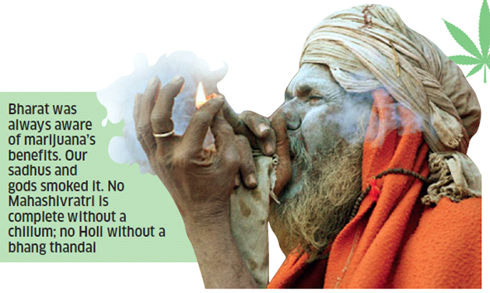
India’s culturally accepted use of cannabis (Mehrotra, 2018)
The Eastern cultures generally speaking have an accepted view of cannabis use, however many countries have laws against its production, use and possession, but these laws often go un enforced, why is this? Perhaps it’s because of religious reasons (will cover more, later in the blog). There are some exceptions to this in the East, for example Ethiopia and North Korea don’t have any laws what so ever on the cannabis plant, so production, sale, possession and use go un-checked and people are free to use it how they see fit without fear of prosecution, imprisonment or even in some cases such as in Saudi Arabia you can be executed!
On a cheerier note, if the governments of poor countries legalized cannabis for medical and recreational use, they could benefit greatly from the money it will bring in. (Mehrotra, 2018).

The Western view.
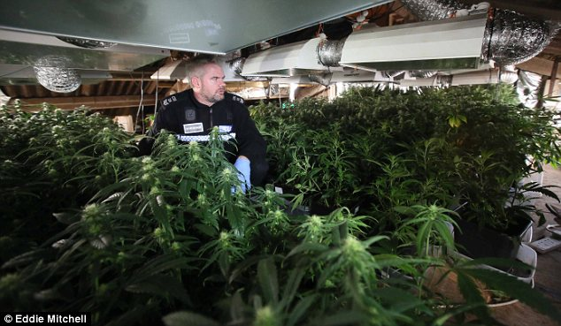
A police raid In on a cannabis farm, Devon UK, with an estimated value of half a million pounds. (Daily Mail, 2013)
Generally speaking the western world has a very different approach to the cannabis plant, in many different countries It is seen as a ‘drug’ and is classified within the law accordingly. The level of punishment can vary slightly from country to country. People are prosecuted an often imprisoned for simple possession, with production of the plant or ‘drug’ carrying in some cases long prison sentences. For example, in the Uk cannabis is a class B drug meaning that possession of a small amount for a first offence will carry a street caution, next time you get caught it’s a fine and then imprisonment, production can land you in prison for a long time. (HM Government, 2017)
People who use cannabis medically and recreationally often have to use it in there own homes or places were they feel safe to do so, under a bridge, in the woods or maybe even somewhere less savoury; living in fear of going to prison for the simple fact of wanting to relax and/or help relieve pain and suffering. People have lost jobs, families and even their kids because they choose to consume a plant that make their life better.
As with the east there are exceptions to this, in December 2013 Uruguay became the first country in the world to completely legalize recreational use of cannabis, they have lead the charge in other countries at he very least changing there laws for medical use and possession. The people of Canada have had been legally allowed to posses and consume cannabis recreationally since October 2018.
The back door paradox – many of us know (and for those who don’t) in the Netherlands they have their coffeeshop culture, the unique system of people being allowed to buy and carry up to five grams of cannabis or hash and to consume it in a coffeeshop or in there own home, the misconception is that it is legal, it however is not it is in a legal ‘grey area’ it is not legal but it is also not illegal, its ‘tolerated’. This has brought about what is know as the ‘back door paradox’ in which it is illegal for the coffeeshop to buy in their supply of cannabis and hash but its ok to sell it. Illegal through the back door and not illegal out of the front door, to be frank it is a silly and stupid system, in which the coffeeshop owners suffer with long sentences in prison, which does not make sense in an already accepting system and culture such as the Dutch.
Medical reasons for change in the West:
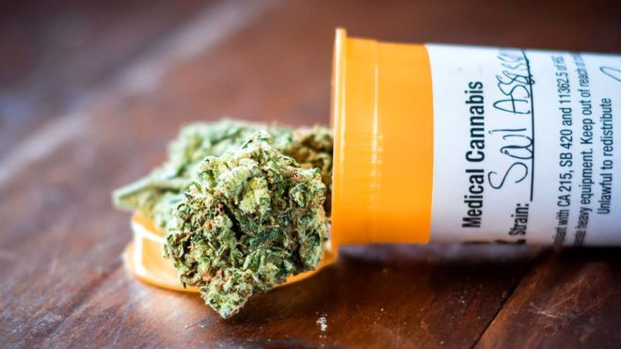
Medical cannabis now available in the UK – if it contains the right kind of natural chemicals. (BBC, 2019)
In the past year or so they have been a lot of change in medical cannabis laws in the west. This is in part due to the ever-demanding public call for its medical use to be legalised or at least de-criminalized. This had led to the previously mentioned laws changing in Canada, but also in the USA there are many states that are passing legislation, even here in the UK laws have changed (but still very restricted). This is due to the overwhelming evidence of the medical benefits of the cannabis plant, from healing cancer to helping ease the symptoms caused by cancer, insomnia, back and arthritic pain, and can even treat depression.
Religious and cultural reasons for acceptance in the East.
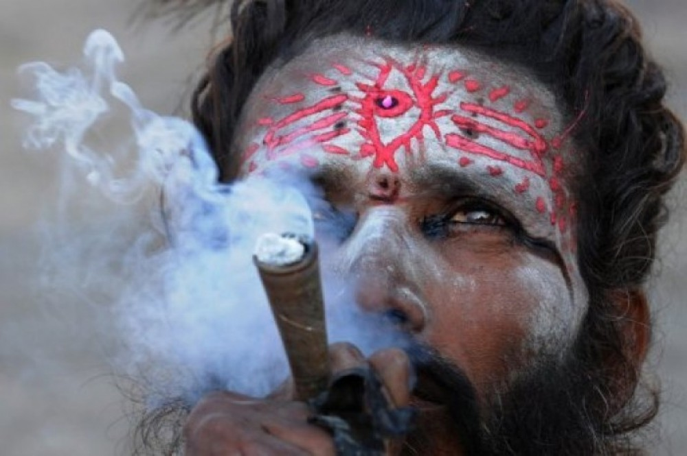
A Hindu smoking cannabis. (Hindu human rights, 2012)
In the east there are many different religions and many different sects of those religions who use cannabis as part of there religion, weather its to feel closer to there god or to achieve a higher plain of existence only they know. What we do know is that there millions upon millions of people who use cannabis culturally an religiously in the east.
Conclusion:
In conclusion I think its time we end the imprisonment and persecution of people from both the east and west, regardless of weather its there medical of recreational use of cannabis. Its time the politicians and law makers open their eyes to the evidence and start making a change.

Reference list:
https://www.bbc.co.uk/news/health-47241787 (accessed: 4th March 2019)
https://www.dailymail.co.uk/news/article-2271751/Now-drug-barons-going-green-police-raid-solar-powered-cannabis-factory-growing-500-000-worth-plants.html (accessed: 4th March 2019)
Flynn, P. 2018. Why we need to legalise cannabis for medical use in the UK. The Pharmaceutical Journal. Available at: https://www.pharmaceutical-journal.com/opinion/comment/why-we-need-to-legalise-cannabis-for-medical-use-in-the-uk/20204287.article?firstPass=false (accessed: 5th March 2019)
http://www.hinduhumanrights.info/a-hindu-view-on-drug-use-and-abuse/ (accessed: 5th March 2019)
HM Government. 2017 drug strategy. July 2017. Available at: www.gov.uk/government/uploads/system/uploads/attachment_data/file/628148/Drug_strategy_2017.PDF (accessed: 4th March 2019)
Hasin DS, Wall M, Keyes KM et al. Medical marijuana laws and adolescent marijuana use in the USA from 1991 to 2014: results from annual, repeated cross-sectional surveys. Lancet Psychiatry 2015;2: 601–08
Mehrotra, P.K. 2018. Is India losing out on a ready-to-boom cannabis market by not legalising its use? The Economic Times. Available at: https://economictimes.indiatimes.com/industry/cons-products/tobacco/is-india-losing-out-on-a-ready-to-boom-cannabis-market-by-not-legalising-its-use/articleshow/66101561.cms (accessed: 3rd March 2019)

