
APPENDIX GA36a

LEVEL 4 ASSESSMENT SPECIFICATION

Student name: | Gruff Williams | Student ID number: | 143348
Programme: | HNC Mechanical Engineering
Module: | Materials
Module code: | PSDM4003 | Contribution to Overall Module Assessment (%): | 20%
Lecturer: | P R Taylor | Internal Verifier: | L Rutherford
Assignment Title: | Ductile and Brittle Fracture | Word count (or equivalent): | 1500
Submission deadline: | April 29th, 2021. | Return date of provisional marks & written feedback: | May 20th, 2021
Submission method: | All written assessments, where practical and possible, must be submitted via Turnitin unless otherwise instructed by the Lecturer. (Please DO NOT put this assessment specification into Turnitin or it will match many similarities with other students’ submissions.)  Alternative submission method (if applicable):  Late submission of the assessment will result in a late penalty mark. Penalties for late submission: Up to one week late, maximum mark of 40%. Over one week late, 0%. Only the Extenuating Circumstances Panel may approve a change to submission dates.
Academic honesty / referencing: | Academic honesty is required. In the main body of your submission you must give credit to authors on whose research and ideas your work is based. Append to your submission a reference list that indicates the books, articles, etc. that you have used, cited or quoted in order to complete this assessment.

Module Learning Outcomes
(from module syllabus)
Analyse and understand the cause of materials failures

TASK DESCRIPTION

Introduction.

Fracture is a common cause of failure in metals. Whilst it will occur when a metal is stressed
beyond its tensile strength under certain conditions it will also occur at stresses below the elastic limit.
Some metals may creep over long periods of time (particularly at high temperatures) until fracture
occurs, whilst fracture which is the result of repeated cyclic stress is termed fatigue failure. Furthermore,
some metals may fail by a form of brittle fracture (which is influenced by low temperatures) and other will
fail due to ductile failure.

Object:

To investigate notched bar impact tests on metals over a range of temperatures to determine their susceptibility to brittle fracture.

Impact testing can be used to the investigate fracture characteristics of metals. Typically samples will
tested through a range of temperatures and the energy absorbed during testing used to determine the
fracture toughness of the material. Using a Hounsfield balanced impact tester the following data was
gathered.

Temperature of sample during testing ( C ) | Impact value (J)  Aluminium | Impact value (J)  Copper | Impact value (J)  Mild Steel (0.1% C)
-200 | 6.1 | 17.6 | 1.1
-100 |  |  | 4.1
-50 |  |  | 6.8
-20 |  |  | 54.9
0 |  |  | 55.3
21 | 7.1 | 18.0 | 58.3
50 |  |  | 54.2
100 | 6.6 | 15.9 | 54.5

GUIDANCE FOR Students IN THE COMPLETION OF TASKS

Plot a graph of Impact value against temperature for each metal.

Identify with metal(s) that exhibit a ductile/brittle transition temperature. Explain the importance of the
ductile/brittle transition temperature and discuss what factors affect the result at which the temperature
occurs.

Using the graphs estimate the per cent crystalline fracture appearance at each test temperature as well as
the level of plastic deformation.

Discussion of results.
Explain the important differences between ductile and brittle impact failures.
Identify the type of fractures which occur in the metal tested and co-relate that to the testing temperature.
Discuss the significance of your results.
What other factors may influence the transition temperature in the affected metal? Heat treatment and mechanical working?
Illustrate your report with relevant examples.

Programme – HNC/D Mechanical Engineering

Module – Materials

Module Code – PSDM4003

Lecturer – Peter Taylor

Student – Gruff Williams

Contents Page

Introduction – Page 7

Brittle Fracture Report 8 – 12

Reference Page – Page 13

Introduction

This assignment will investigate the different types of fracture that occur, when the temperature of the material is changed also the amount of energy needed to fracture the material at different temperatures. Explain the catastrophic effect of the brittle to ductile transition temperature. What different factors effect the properties of materials and the heat treatments available to change the crystalline structure of metals to suite its purpose.

Brittle Fracture Report.

The Hounsfield balanced impact tester is a machine that strikes a piece of material with two pendulum arms. The energy produced by the falling pendulums breaks the material into two pieces and data is recorded. After the material has been fractured the pendulums momentum is stopped by finely geared teeth that look the pendulums to stop them from swinging back and forth. A lever is then used to turn the gears and re position the pendulums in the neutral position. This makes sure that no body parts get caught in the direction of the swinging pendulum by being able to stop the pendulums immediately after the material has been fractured irradiated the risk to the user. This tester is compact and lightweight compared to other test rigs. The size of material used for the Hounsfield balanced impact tester are a rounded specimen machined to 44.5mm long with an 8mm diameter. A small indent is made into the centre of the specimen, this indent acts is a stress concentrator for the pendulums to break the sample. To determine what stresses the materials can withstand at different temperatures, the materials must be cooled and tested at negative temperatures and positive temperatures to receive enough data. To cool the materials, substances such as dry ice (Solid carbon dioxide) or liquid Nitrogen are used to decrease the temperature of the material. Hot or boiling water is used to increase the temperature of the material. With the results gathered at different temperatures with the three different materials, the information can be compared with the creation of a brittle ductile temperature graph. The materials used were aluminium, copper and (0.1%) mild steel. With the conclusion of the experiment these graphs were constructed.
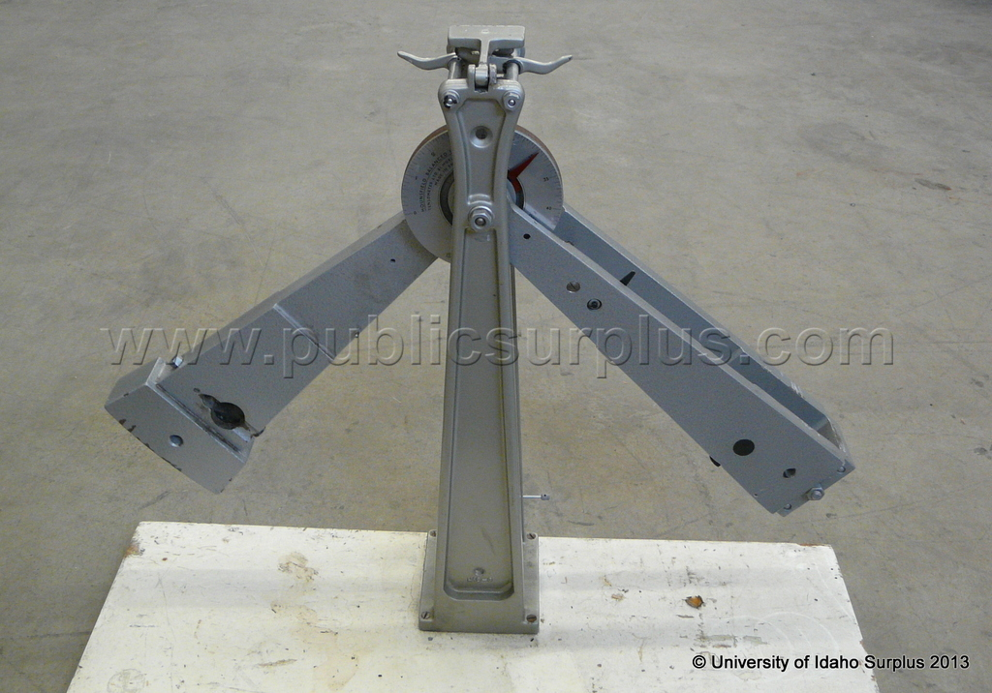

Public Surplus: Auction #940303
20/04/21

It is clear that with the elements copper and aluminium, the temperature does not affect the impact energy on the material. At the different temperatures the elements went through, the impact value remained consistent. Less impact energy was needed to break the aluminium compared with the copper. Aluminium took on average 7KJ to break the materials compared with copper that took an average 18KJ to break. As the energy required to break the copper is higher, this gives copper a larger area underneath the graph, making copper the tougher and more ductile material. Both aluminium and copper are excellent conductors of electricity because they have free valance electrons on the outer shell of there atoms. The electrons can easily travel from one atom to the next when a electrical current is induced in the material. Copper is widely used as the primary element for electrical wiring. With copper having a larger ductile capacity, more lengths of wires can be drawn from copper. Copper and aluminium have a face centred cubic structure. With this type of structure, the stress needed to move dislocations isn’t dependant on the temperature. Meaning that failure happens with Face centred cubic structures by plastic flow and not of crack propagation. There is only one exemption that a face centred cubic structure break by brittle fracture, and that is in fatigue failure, where the material begins to fail after a prolonged period of repeated stress.

In the second world war there was a great demand for shipbuilding to transport American soldiers and supplies to Europe. The United States manufactured 2710 ships between the years 1941 - 1945. These were known as Liberty ships. The first batch of ships that travelled in the cold icy water of the Atlantic Ocean, had broken in half without any warning. Tests were conducted to determine why the ships split in half, they concluded that it was due to brittle fracture. As the water was around or below the 4-degree mark, this made the cheap steel become extremely brittle. Due to the high demand and need of these vessels, they were also built quickly. The metal used to make these ships would have had impurities in them, leaving many sharp corners without chambers to save time in the manufacturing process. These sharp corners would have acted as stress concentrators at would have been the catalyst to form cracks on the ships. Once the cracks started, they continued to travel the width of the ship until they broke into two pieces.
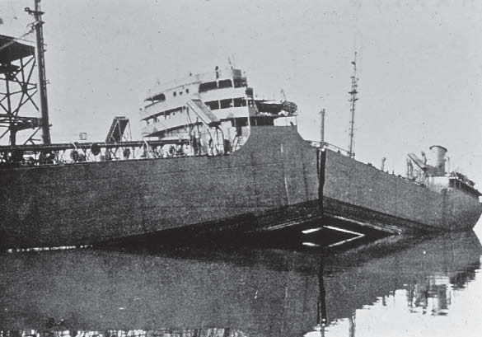
Liberty Ship Failures | Metallurgy & Materials Engineering (wordpress.com)

22/04/21

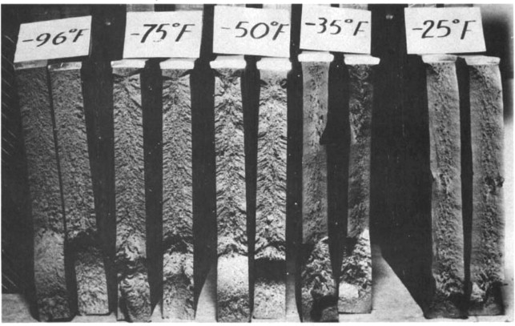

Image of the different crystalline structures of steel at different temperatures.

Liberty Ship - an overview | ScienceDirect Topics
22/04/21

The (0.1%) mild steel has a brittle ductile transition temperature. When the material is cold the energy needed to fracture is low. As the temperature of the mild steel increases so does the energy required to fracture the material. The Brittle Ductile Transition Temperature for the (0.1%) mild steel. The graph above is approximately -20 degrees. If the temperature is below -20 degrees the material will be more brittle, we know this since the area underneath the curve of the graph is high that indicates the material has high toughness. At the lower temperatures the area underneath the graph decreases the toughness will be low meaning the material is brittle. Brittle fracture surfaces can happen in two ways. Intergranular fracture and transgranular fracture. If a metal has a fine grain structure the crack propagation will happen through the grain boundaries of the material. these grain boundaries have regions of high energy. With transgranular fracture, the cracks travel through the grains of the metal. the cracks propagate through the grains making it difficult for it to change direction making the grains course. If the (0.1%) mild steel would fracture at the extremely brittle temperatures such as -200 – 50 degrees. The material would fracture with a flat, smooth and sparkling surface; with no trace of any plastic deformation. Above -20 degrees the area underneath the graph begins to increase meaning the material is becoming tough. With the material being tough, it will be able to absorb more energy and will go through plastic deformation, giving warning that is going to fracture. When fracture occurs the ends of the fractured material will look like a cup and cone and leaving a sombre and fibrous surface. The cup and cone is evidence of plastic deformation with the material being in the ductile region. It has the capability of elongating before fracturing. From the graph above, at 25 degrees Is the temperature that the highest amount of energy is needed to fracture the (0.1%) mild steel. At this point plastic deformation would be the most visible.
As time has progressed, different techniques have been mastered to stop materials from transitioning from ductile to brittle. Heat treatment is a way of changing the properties of metals. It involves the process of heating metals to appropriate temperatures so that the crystalline structures in the metal change to that of what the manufacturer needs. Heat treatment is primarily done to harden or soften the metal. Softening a material will decrease its strength and hardness meaning it will indent easily and bend easily. However, it will increase the materials toughness and ductility meaning if it is hit by a force it will not break easily and will elongate when under a tensile force. The softening process is known as conditioning. there are two heat treatments to soften metals, these are called annealing and normalising. The hardening process gives the opposite properties of softening. It increases the strength and hardness whilst decreases the toughness and ductility. The processes for hardening metals are called, quenching, tempering and age hardening. The specific heat treatment needed will fall on the metal’s molecular chemistry and the size of the metal. The three main molecular structures that can be created through heat treatment are pearlite, Bainite and Martensite. The metal must be heated to the austenitic temperature, this is the temperature where all the metal has returned to its original solution. Once this temperature us achieved the rate at which the metal is cooled will determine the new molecular structure of the metal and thus its properties. To form pearlite, the soft structure. It must be cooled slowly in air. For martensite to be formed, the hardest of the metals. the metal must be cooled quickly. For normalising and annealing, the metal is heated to the austenitic range and to cool down process is different for these applications. For normalising cooling is done in still air and for annealing it cooled in a furnace. A normalised structure can be tempered to change the properties of the metal. Because normalising gets cooled in air the strength and hardness of the metal will be greater compared with the metal that was annealed. Stainless steel and nickel alloys can be added to the metal to turn into a compound with much better corrosion resistance.

Reference Page.

Images.

Public Surplus: Auction #940303
20/04/21

Liberty Ship Failures | Metallurgy & Materials Engineering (wordpress.com)
22/04/21

Liberty Ship - an overview | ScienceDirect Topics
22/04/21

books

Stephen W. Freiman (2018). The Fracture of Brittle Materials: Testing and Analysis. 2nd ed. .: Wiley-American Ceramic Society

G. P. Cherepanov (1980). Mechanics of Brttle Fracture. .: McGraw Hill Higher.

G. M. Boyd (2016 ). Brittle Fracture in Steel Structures. .: Butterworth-Heinemann

Websites

Properties and Grain Structure - YouTube

Heat Treatment -The Science of Forging (feat. Alec Steele) - YouTube

GUIDANCE FOR Students IN THE COMPLETION OF TASKS

NOTE: The guidance offered below is linked to the five generic assessment criteria overleaf.

- Engagement with Literature Skills
Your work must be informed and supported by scholarly material that is relevant to and focused on the task(s) set. You should provide evidence that you have accessed an appropriate range of sources, which may be academic, governmental and industrial; these sources may include academic journal articles, textbooks, current news articles, organisational documents, and websites. You should consider the credibility of your sources; academic journals are normally highly credible sources while websites require careful consideration/selection and should be used sparingly. Any sources you use should be current and up-to-date, mostly published within the last five years or so, though seminal/important works in the field may be older. You must provide evidence of your research/own reading throughout your work, using a suitable referencing system, including in-text citations in the main body of your work and a reference list at the end of your work.

Guidance specific to this assessment:

- Knowledge and Understanding Skills
At level 4, you should be able to demonstrate knowledge of the underlying concepts and principles associated with your area(s) of study. Knowledge relates to the facts, information and skills you have acquired through your learning. You demonstrate your understanding by interpreting the meaning of the facts and information (knowledge). This means that you need to select and include in your work the concepts, techniques, models, theories, etc. appropriate to the task(s) set. You should be able to explain the theories, concepts, etc. to show your understanding. Your mark/grade will also depend upon the extent to which you demonstrate your knowledge and understanding.

Guidance specific to this assessment:

- Cognitive and Intellectual Skills
You should be able to present, evaluate and interpret qualitative and quantitative data, in order to develop lines of argument and make sound judgements in accordance with basic theories and concepts of your subject(s) of study. You should be able to evaluate the appropriateness of different approaches to solving problems related to your area(s) of study and/or work. Your work must contain evidence of logical, analytical thinking. For example, to examine and break information down into parts, make inferences, compile, compare and contrast information. This means not just describing what! But also justifying: Why? How? When? Who? Where? At what cost? You should provide justification for your arguments and judgements using evidence that you have reflected upon the ideas of others within the subject area and that you are able to make sound judgements and arguments using data and concepts. Where relevant, alternative solutions and recommendations may be proposed.

Guidance specific to this assessment:

- Practical Skills
At level 4, you should be able to apply the basic underlying concepts and principles to evaluate and interpret these within the context of your area of study. You should be able to demonstrate how the subject-related concepts and ideas relate to real world situations and/or a particular context. How do they work in practice? You will deploy models, methods, techniques, and/or theories, in that context, to assess current situations, perhaps to formulate plans or solutions to solve problems, or to create artefacts. This is likely to involve, for instance, the use of real world artefacts, examples and cases, the application of a model within an organisation and/or benchmarking one theory or organisation against others based on stated criteria.

Guidance specific to this assessment:

- Transferable Skills for Life and Professional Practice
Your work must provide evidence of the qualities and transferable skills necessary for employment requiring the exercise of some personal responsibility. This includes demonstrating: that you can communicate the results of your study/work accurately and reliably, and with structured and coherent arguments; that you can initiate and complete tasks and procedures, whether individually and/or collaboratively; fluency of expression; clarity and effectiveness in presentation and organisation. Work should be coherent and well-structured in presentation and organisation.

Guidance specific to this assessment:

Student FEEDBACK FORM

This section details the extent to which the assessment criteria are demonstrated by you, which in turn determines your mark. The marks available for each category of skill are shown. Lecturers will use the space provided to comment on the achievement of the task(s), including those areas in which you have performed well and areas that would benefit from development/improvement.

Generic Assessment Criteria | Marks available | Marks  awarded
1. Engagement with Literature Skills
.
A bibliography is attaced but there is no evidence of further reading or referencing within the body of the assessment. |  | 4
 | 10 | 4
2. Knowledge and Understanding Skills

The assessment shows an excellent knowledge and understanding of the concepts involved in brittle fracture. There is informed discussion throughout the report. |  | 30
 | 40 | 30
3. Cognitive and Intellectual Skills

Shows excellent evaluation of the reults and data. There is clear evidence of insight and the ability to analyse. |  | 16
 | 20 | 16
4. Practical Application Skills

A very good application of various tools and techniques. Very good use of graphics. |  | 14
 | 20 | 14
5. Transferable Skills for Life and Professional Practice

The work is well structured and well written. Shows a good ability to work largely unsupervised. |  | 6
 | 10 | 6

Assessment Mark (Assessment marks are subject to ratification at the Exam Board. These comments and marks are to give feedback on module work and are for guidance only until they are confirmed. ) | Late Submission Penalties (tick if appropriate) |  | 70%
 | Up to 1 week late (40% Max) |  | 70%
 | Over 1 week late (0%) |  | 70%

GENERIC ASSESSMENT CRITERIA

Level 4
In accordance with the Framework for Higher Education Qualifications, at the end of Level 4 students will be expected to have demonstrated knowledge of the basic underlying concepts and principles of a subject, and an ability to evaluate and interpret these within the context of that area of study. They should be able to present, evaluate and interpret qualitative and quantitative data in order to develop lines of argument and make sound judgements in accordance with basic theories and concepts of their subject(s) of study. They will have learned how to evaluate different approaches to solving problems, and will be able to communicate the results of their study/work accurately and reliably, and with structured and coherent arguments. They will be able to undertake further training and develop new skills within a structured and managed environment and will have the qualities and transferable skills necessary for employment requiring the exercise of some personal responsibility.

Level 4 | FAIL | MARGINAL FAIL | SATISFACTORY  (3rd / Pass) | GOOD  (2.2 / Pass) | VERY GOOD  (2.1 / Merit) | EXCELLENT  (1st / Distinction) | EXCEPTIONAL  (1st / Distinction)
Category | 0-29% | 30-39% | 40-49% | 50-59% | 60-69% | 70-84% | 85-100%
Engagement with literature (including reading, referencing,  academic conventions and  academic honesty) | Little or no evidence of reading and/or reliance on inappropriate sources.  Views and findings mostly unsupported and non-authoritative.  Referencing conventions used incoherently or largely absent. | Poor engagement with essential reading. No evidence of wider reading. Reliance on inappropriate sources, and/or indiscriminate use of sources. Heavily reliant on information gained through class contact. Inconsistent and weak use of referencing. | Engagement with a limited range of mostly relevant and credible sources but with some reliance on information gained through class contact. Some omissions and minor errors.  Referencing conventions evident though not always applied accurately or consistently. | Engagement with an appropriate range of literature, including sources retrieved independently. Some over-reliance on texts rather than other sources. Referencing may show minor inaccuracies or inconsistencies. | Engagement with a wide range of literature, including sources retrieved independently.  Selection of relevant and credible sources. Generally sound referencing, with no/very few inaccuracies or inconsistencies. | Engagement with an extensive range of relevant and credible literature. Consistently accurate application of referencing. | Exceptional engagement with an extensive range of relevant and credible literature. High-level referencing skills consistently applied.
Knowledge and understanding (Knowledge of the basic underlying concepts and principles of a subject.) | Major gaps in knowledge and understanding of the basic underlying concepts and principles of the subject matter. Inclusion of irrelevant material. Substantial inaccuracies. | Gaps in knowledge of the basic underlying concepts and principles, with flawed or superficial understanding. Some significant inaccuracies and/or irrelevant material. | Limited knowledge and understanding of the basic underlying concepts and principles within the subject area. Some elements may be missing. | Knowledge of the basic underlying concepts and principles is accurate with a good understanding of the field of study but lacks depth and/or breadth. | Competent knowledge of the basic underlying concepts and principles. Exhibits very good understanding. | Excellent knowledge and understanding of the basic underlying concepts and principles of the subject. | Exceptional, detailed knowledge and understanding of the basic underlying concepts and principles
Cognitive and intellectual skills  (Evaluate underlying concepts and principles of a subject and interpret qualitative and quantitative data in order to develop lines of argument and make sound judgements.) | Wholly or almost wholly descriptive work. Little or no evaluation of the underlying concepts and principles.  Failure to develop arguments, leading to illogical or invalid judgements. Minimal or no use of  evidence to back up views. | Largely descriptive work, with superficial evaluation of the underlying concepts and principles. Weak interpretation of data, flawed development of arguments and judgements. Information accepted uncritically, uses generalised statements made with scant evidence and unsubstantiated opinions. Ideas sometimes illogical and contradictory. | Limited attempt at evaluation of the underlying concepts and principles, tending towards description.  Can interpret qualitative and quantitative data but with some errors. Some evidence to support emerging arguments and judgements but these may be underdeveloped or with a little inconsistency / mis-interpretation. | Good evaluation of the underlying concepts and principles. Can interpret qualitative and quantitative data, with minor errors.  An emerging ability to use evidence to support the argument.  Mostly valid arguments and logical judgements. | Sound evaluation of the underlying concepts and principles. Can interpret qualitative and quantitative data accurately. Ability to devise arguments using evidence to make mostly appropriate and valid judgements. | Excellent evaluation of the underlying concepts and principles. Can interpret qualitative and quantitative data accurately and with some insight. Excellent ability to devise arguments using evidence and make appropriate and valid judgements. | Exceptional evaluation of the underlying concepts and principles based evidence. Outstanding interpretation of qualitative and quantitative data.  Exceptional ability to devise arguments using evidence and make wholly appropriate and valid judgements.
Practical skills  (Different approaches to solving problems in particular contexts.) | Limited or no use of taught, basic methods, materials, tools and/or techniques.  Little or no appreciation of the context of the application.  Very weak evidence of different approaches to problem-solving in particular contexts. | Rudimentary application of taught, basic methods, materials, tools and/or techniques but without consideration and competence. Flawed appreciation of the context of the application.  Weak evidence of different approaches to problem-solving in particular contexts. | An adequate awareness and mostly appropriate application of basic methods, materials, tools and/or techniques.  Basic appreciation of the context of the application.  Can identify problems in particular contexts and propose basic alternative approaches or solutions though there may be errors. | A good and appropriate application of basic methods, materials, tools and/or techniques.  Clear appreciation of the context of the application.  Good evidence of different approaches to problem-solving in particular contexts and proposes mostly appropriate solutions. | A very good application of a range of basic methods, materials, tools and/or techniques.  Very good consideration of the context of the application. Very good evidence of different approaches to problem-solving in particular contexts and proposes appropriate solutions. | An advanced application of a range of taught, basic methods, materials, tools and/or techniques.  The context of the application is well considered, and insightful.  Excellent evidence of different approaches to problem-solving in particular contexts and proposes appropriate solutions. | Exceptional levels of application and deployment skills in particular practical contexts. Outstanding identification of problems in particular contexts and formulation of wholly appropriate, thoughtful solutions / different approaches.
Transferable skills for life and professional practice  (Communicate the results of their study/work accurately and reliably, and with structured and coherent arguments; the qualities needed for employment requiring the exercise of some personal responsibility within a structured and managed environment.) | Work is poorly structured, disorganised, inaccurate and/or confusingly expressed. Very weak use of language and/or very inappropriate style. Failure to work effectively individual or as part of a group. Little or no evidence of the skills for employment requiring the exercise of some personal responsibility. | Work is poorly presented in a disjointed manner. It is loosely, and at times incoherently, structured, with information and ideas often poorly expressed. Weak use of language and/or inappropriate style. Flawed approach to individual or group work, meeting only partial obligations to others. Limited evidence of the skills for employment requiring the exercise of some personal responsibility. | Mostly ordered presentation and structure in which relevant ideas / concepts are reasonably expressed. Work may lack coherence and/or accuracy in places. Can work as part of a group, meeting most obligations to others but perhaps with limited involvement in group activities.  Demonstrates the basic skills for employment requiring the exercise of some personal responsibility, with some areas of minor weakness. | Mostly coherent, organised and accurate work, in a suitable structure and is for the most part clearly expressed. Can work effectively independently and/or as part of a team, with clear contribution to group activities.  Demonstrates the skills for employment requiring the exercise of some personal responsibility, with some areas of strength and some of minor weakness. | Work is accurate, coherent, fluent, well-structured and organised.  Can work effectively independently and/or as part of a team, with very good contribution to group activities. Demonstrates very good skills for employment requiring the exercise of some personal responsibility, with just occasional minor weakness. | Work is coherent, very fluent and is presented professionally. Can work effectively independently and/or as part of a team, with an excellent contribution to group activities. Demonstrates excellent skills for employment requiring the exercise of some personal responsibility with an appetite for further development. | Work is accurate, exceptionally coherent, very fluent and presented well. Can work effectively independently and/or as part of a team, with an exceptional contribution to group activities. Demonstrates exceptional skills for employment requiring the exercise of some personal responsibility with an appetite for further development.

THIS DOCUMENT IS ALSO AVAILABLE IN WELSH

