Case Study – Indonesia

Introduction
This case study is going to be looking at Islam in the nation of Indonesia. The aspects that will be discussed are the State and Religion of Indonesia, laws impacting Islam in Indonesia and social media on Islam in Indonesia. The Case study will be finishing with a discussion on the mystical order of Islam found in Indonesia called Sufism.
Demographic Information
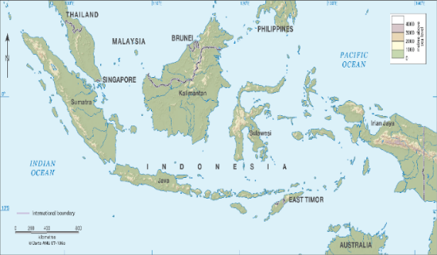
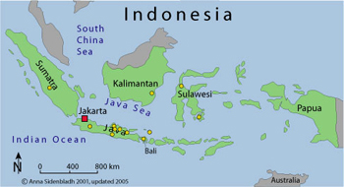
Indonesia is a South East Asian nation that is made up with a variety of different volcanic islands such as Bali, Medan and Lombok surrounded by the South China Sea and Indian Ocean. Indonesia has a demographic of 268,343,998, this information was gathered on the 23rd of January 2019, and therefore this figure may vary with the population growing continuously. The two map images, show how Indonesia is one country although it situated in different parts. The image on the right hand side of the page displays Indonesia countries with colour green and the surrounding other countries are in a purple colour. This shows that Indonesia is liked with other countries closely and this may impact the values and ‘the way of life’ of the Muslims in Indonesia.

The population of just over 268 million, it is important to discover other demographic information such as gender and religion as these aspects would affect the way a Muslim practices their religion in Indonesia. In 2019 the population is divided equally with only one percent difference between the two genders. The pie chart displays the percentages of the two gender, however does not demonstrate the religion of the population. Indonesia holds the largest Muslim population in the world, therefore the nation holds majority Islam values. The Bar Chart displays the percentages of the different faiths in the nation of Indonesia. Islam holds 87.2% of the population, following by the 6.9% of Protestants and the less prominent religions in Indonesia are Hinduism, Buddhism and Confucian. With Indonesia being an Islamic majority, this will inevitably have positive impact on Muslims in Indonesia as the communities hold the same religious beliefs and can practice together, minimising conversion that may be occurring in the Western countries.

State and Religion in Indonesia
Islam is one of many religions in Indonesia although it may be the majority of the population, the state is separate from these religions. Islam is not the state religion and the Islamic law (Shari’a) is not nationwide practiced, except in a few locations. The Islands in Indonesia where most people are Muslim is the people of Java, Sumatra, Kalimantan and Sulawesi. Religion is argued to be the most important aspect in Indonesia culture as it is illegal to not belong to a religion. Every person in Indonesia has an ID card where their basic information is stated such as address, date birth and religion, showing religiosity is permitted. Those who do not observe their religious practices still would claim to be Muslims, Christian etc. according to their family’s religions that is stated on their ID card.
Although Indonesia’s state makes religion a requirement it does not mean that Indonesian government stand firmly against radical groups, this indicates that the state has a weak monopoly on violence. An online article by the Indonesian investments comments on this,
“Some radical Muslim groups such as the Front Pembela Islam (Islamic Defenders Front) use violence (or the threat of violence) to achieve their ideals; also against the Muslim community itself, for example by attacking Muslims that sell food at daytime during the holy fasting month Ramadan.”
This is only a minority of Indonesia Muslim community that commit to radical thinking and actions but however this quote shows that state of Indonesia struggles to retain these radical Muslims. The majority of Indonesian Muslims are highly supportive of pluralism and living in harmony with religious freedom, the radicals are only a small minority.
Movements
There is two main Islamic movements that promote state ideas while remaining the Islamic tradition, although some Muslims in Indonesia do reject these movements. These movements are called Muhammadiyah and Nahlatul Ulama, they focus on the concept of jihad and improving the social and educational struggles. The Muhammadiyah was an Islamic party created by Ahmad Dahlan who is a devoted Muslim who focuses on being united with Allah. Dahlan was a reform character wanting to improve Islamic life in Indonesia and hold influence in modern Indonesia.
The Muhammadiyah party is similar to the Muslim brotherhood found usually in the Middle Eastern countries as they use propagation, education, health and social services to support the Islamic communities. Muhammad Fuad comments on this in his article,
“Reflecting the movement's objective of drawing from Western and Islamic reformist ideas, Muhammadiyah schools and hospitals combine modern methods with the teaching of religious subjects. These Muhammadiyah institutions spread throughout the major islands of Indonesia. Today, Muhammadiyah mission is still the same but despite substantial improvements, facilities in its schools, hospitals, and clinics are far from adequate.”
This demonstrates that the Muhammadiyah is using the modern reform ideas just like the western and Islamic reformist groups while combining the teachings of the Islamic religion. Although the Muhammadiyah mission is beneficial for the Muslim communities in teaching and spreading the word of Islam. It is also being a supportive network in all aspects of the community the facilities are described as far from adequate.
Nahdlatul Ulama is another Islamic movement in Indonesia, they are also known as the ‘awakening of Islamic scholars’ this is because the party was created in response to the issues in Turkey and the rise in Saudi Arabia of the Wahhabi movement and this is their way of battling these issues. Education for both parties is key with a modern approach to Islam and the way Indonesian people should practice Islam. Khoirun Niam states in his article,
“Both of the NU intellectuals and Muhammadiyah intellectuals are using modernism as their method of thought. In addition, in expressing and defending Muslim interests during the process of social transformation, both of the NU intellectuals and Muhammadiyah intellectuals use the structural focuses on religious practice including loud recitation of the intention of prayer and cultural strategy.”
This illustrates that for both of the parties and their intellectuals both mainly focus on the religious practice while they defend Muslim and interests of social transformations for Muslims in Indonesia. The Nahdlatul Ulama focuses on the Indonesian identity for Islam and how the two aspects can work, the party allows plurality and celebrates this.

Laws effecting Islam in Indonesia
Although the majority of Indonesia is Islamic, the laws are however not Islamic laws (Shari’a). One of the most important law in Indonesia that will impact the Islamic communities if the freedom of religion law, allowing all recognisable religions to be practiced. Although, some local regulations in some islands do not allow religious freedom occasionally. In Indonesia there is a law called ‘Pancasila’ this term means The Five Pillars. In the international Religious Freedom Report for Indonesia in 2012, the U.S Department states “All persons the right to worship according to their own religion or belief… The nation is based upon a belief in one supreme God” Under the law of Pancasila every person is required to believe in only one God but this can be any chosen religion that is recognised, as Atheism is forbidden in Indonesia. Other laws can be found that restrict certain types of religious activity particularly among unrecognisable religious groups and deviant orders of recognised religious groups.
Another substantial law found in the U.S report that impacts religion. This law is under the Child protection act 2002, where conversion to minors to a religion other than their own, through tricks or lies, these terms are applied loosely. This crime is punishable up to 5 years in prison. This can be beneficial for the Muslims in Indonesia as conversion too their youth cannot occur but also allows people to voluntarily come to Allah and become one with Allah.

Social Media on Islam in Indonesia
Social Media in Indonesia has impacts on the way Muslims can practice and convey their message and devotion to Allah. With 95.38% of Indonesian people being literate this allows the majority of the public to be able to read the social media and news and be educated on Islam. Indonesia is also continuously becoming more urbanised, as in 2017 54.66% of the population of Indonesia live in an urban areas, this is a large increase. Two pie charts created show the rise of urbanisation in Indonesia that is taking place, meaning more people are accessing the internet and therefore using social media to practice their faith.
In the U.S report that is previously mentioned states that Televised religious programming is unrestricted for any recognised religious groups, allowing Islam programmes to be played to educate or inform Indonesia on Muslim news. However, the government can ban any discriminatory and negative material dismissing a religious group. Just like the organisations Muhammadiyah and the NU who have a reform interest and use modern technology to promote the meaning of Islam in the contemporary context, therefore these laws supporting religions being televised supports this aim of spreading the word.
Social media is becoming more prominent in most societies, this is the case for Indonesia also. Social Media like Facebook is used as their internet search as Facebook can provide all answers. Therefore Muslims in Indonesia are faced with this too, using Facebook as their means to find information out about their culture, news and modern politics for example. Martin Slama states in his article on Indonesia in 2018,
“In recent years, one of the most significant shifts in the field of Islam in Indonesia is the increasing reliance of Muslims on social media when practicing faith.”
This shows that Islam in Indonesia is also reliant on social media when practicing faith such as through online fatwas and educational articles on how to practice Islam etc. Social media is embedded in culture and Muslims in Indonesia are adapting to modern world.
An example of Indonesia on social media is the Facebook page called ‘IslamIndonesia’ and this is accessible for all and it has a large following of over 10,000 people. There are many Facebook pages like this for Muslims in Indonesia, below an image showing the page and the typical posts that are updated daily, there is also suggested pages on the side of the image for farther information on Allah and Islam in Indonesia.
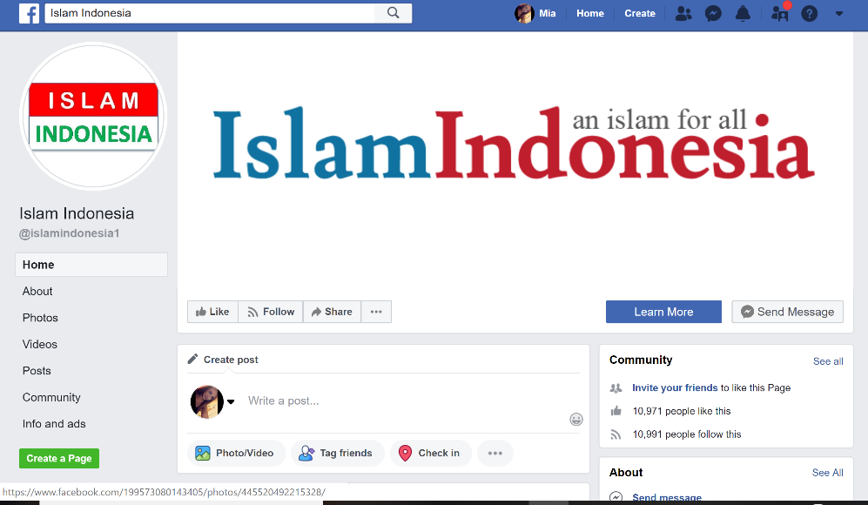

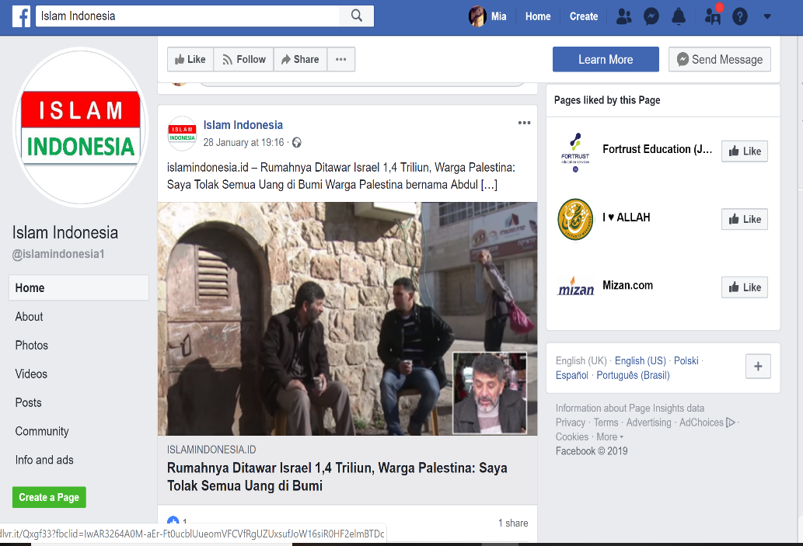

The Sufi Muslims in Indonesia
Sufism is the order of Islam that uses mysticism and spirituality to reach their goal of closeness with God. Although the country is Sunni majority, there are a small amount of Shia and Sufi Muslims also. Indonesia has a population of Sufi Muslim, said to be around 5% of the Muslims are Sufism. However, Islam in Indonesia has a very mystical essence and uses spirituality although most Muslims would not declare themselves as a Sufi. Most Muslims in Indonesia are interested in Ijtihad, this being the interpretations of the Qur’an and this results in many Muslims celebrating Islam mystically. When Sufis moved to Indonesia their easy framework to follow may have attracted many followers, leading to more conversion to Islam.
Sufism has been around for many centuries, however an influential Islamic figure is called Abdullah Gymnastiar (1962- ) who is significant for the Sufi in modern times. Dhume Sadanand describes Gymnastiar as, “his upbeat sermons and handy self-help tips strike a chord with a people increasingly drawn to religion. And in an era where militant Islam has achieved new prominence, Gymnastiar's non- confrontational message towards other faiths offers the comfort of simpler, happier times.” This description illustrates the influential figure as upbeat and a positive person drawing people to this religion. With Gymnastiar having a non- confrontational attitude towards other faiths unlike some militant Islam orders allows Sufism to be viewed as having a positive outlook on interfaith dialogue. Overall, Sufism therefore has a significant impact on Islam in Indonesia when working with the laws of religious freedom law.
Indonesia has a spiritual theme in communities and Gymnastiar ideas work well along with the existing spirituality, Marcia Hermansen in Kenney and Moosa’s book Islam in the modern world states,
“Gyms style is reminiscent of the “self-help” and “how to succeed” genres in the West, for example, one of his slogans describes three “beginnings” – “begin with yourself, begin with small things, and begin now.” He also drew inspiration from Sufi tales and dream spirituality, which resonate with the Indonesian Muslim culture.”
This demonstrates that Gymnastiar style brings western genres of self-help and inspiration to succeed in to the Indonesian Muslim culture. This development in Indonesia allows Muslims to practice similar rituals to the Sufi order with dreams of spirituality and personal relationship with God.

Julia Howell writes in-depth on the subject of Sufism in Indonesia, Howell believes that Gymnastiar is a significant reason why Islam in Indonesia is on the silver screen. Howell believes that Islam in Indonesia is inevitably impacted by the Sufi order which she describes as, “The theme of closeness to a loving God, which is so prominent in Sufi literature and poetry, has great contemporary appeal and can be projected through emotive voice quality in commentaries accompanying rituals and in popular styles of religious songs.” This theme of being close with God can be found through poetry, literature and can be projected through emotive voice quality in commentaries. The variety of ways one can learn and practice this closeness with God, makes Sufism and Islam an accessible faith in Indonesia that teaches love and harmony.
Overall, this case study provides a basic over view of Islam in Indonesia in many different aspects such as how social media has adapted the way Muslims practice their faith in this nation and how Mystical Islam is predominate in Indonesia. However, this case study does fail to provide an overview of all aspects such as women’s rights movements and politics. For further reading on these topics, the list bellow provides good quality information on these topics.
Further reading list:
- Janet McIntyre-Mills ‘Prostitution and Human rights in Indonesia: a critical system review of policy discourses and scenarios’ Systemic practice and action research. Vol.30 (2017)
- Ali Syamsuri ‘Discusses of women political rights based on al ’Qur’an; empirical study on women’s political participation in Jakarta, Indonesia. ’Journal of economic development. Vol.7 (2018)
- Anonymous ‘Military Politics, Islam and the state of Indonesia: from turbulent transition to democratic consolidation’ (Institute of Southeast Asian Studies, 2009)
- C.van Dijk ‘Islam, politics and change: the Indonesian experience after the fall of Suharto’ (Netherlands: Leiden University Press, 2016)

Bibliography
- Anonymous ‘Military Politics, Islam and the state of Indonesia: from turbulent transition to democratic consolidation’ (Institute of Southeast Asian Studies, 2009)
- Australian National University ‘Indonesia’ http://asiapacific.anu.edu.au/mapsonline/base-maps/indonesia 25th January 2019.
- Bureau of Democracy, Human rights and labor ‘International Religious freedom report for 2017’ https://www.state.gov/j/drl/rls/irf/religiousfreedom/index.htm#wrapper -30th January
- C.van Dijk ‘Islam, politics and change: the Indonesian experience after the fall of Suharto’ (Netherlands: Leiden University Press, 2016)
- Countryeconomy ‘Indonesia- literacy rate’ https://countryeconomy.com/demography/literacy-rate/indonesia -30th January 2019.
- Fuad, Muhammad, ‘Civil Society in Indonesia: The potential and limits of Muhammadiyah’ SOJOURN: Journal of Social issues in Southeast Asia. Vol.17 (2002) p. 135
- Hays, Jeffery, ‘Religion of Indonesia’http://factsanddetails.com/indonesia/History_and_Religion/sub6_1f/entry-3975.html -30th January 2019
- Howell, Julia, ‘Sufism on the silver screen: Indonesian innovations in Islamic televangelism’ Journal of Indonesia Islam. Vol 2 (2008) p.228
- ‘Indonesia’ https://sites.google.com/site/sdjjindonesia/physical-geo- 25th January 2019
- Indonesia Investments ‘Islam in Indonesia’ https://www.indonesia-investments.com/culture/religion/islam/item248 - 29th January 2019.
- Knoema ‘Indonesia Male to female ratio of total population’ https://knoema.com/atlas/Indonesia/topics/Demographics/Population/Male-to-female-ratio 25th January 2019.
- Kenney, Jeffery and Ebrahim Moosa ‘Islam in the Modern World’(London and New York: Routledge, Taylor& Francis Group, 2014) p.312
- Ministry of Tourism, Republic of Indonesia ‘Wonderful Indonesia ‘https://www.indonesia.travel/gb/en/home 23rd January 2019.
- McIntyre-Mills, Janet, ‘Prostitution and Human rights in Indonesia: a critical system review of policy discourses and scenarios’ Systemic practice and action research. Vol.30 (2017)
- Niam, Khoriun, ‘Nahdlatul Ulama and the production of Muslim intellectuals in the beginning of the 21st century Indonesia’ Journal of Indonesia Islam. Vol.11 (2017) p.353
- Sadanand, Dhume, ‘Islam with a smile’ Far Eastern Economic Review. Vol.166 (2003) p.53
- Syamsuri, Ali, ‘Discusses of women political rights based on al ’Qur’an; empirical study on women’s political participation in Jakarta, Indonesia. ’Journal of economic development. Vol.7 (2018)
- Slama, Martin, ‘Practising Islam through social media in Indonesia’ Indonesia and the Malay world 2018. Vol.46 (2018) p.134.
- Statista ‘Indonesia- Urbanisation from 2007- 2017’ https://www.statista.com/statistics/455835/urbanization-in-indonesia/ - 30th January 2019.
- WorldMeters ‘Indonesia population’ http://www.worldometers.info/world-population/indonesia-population/- 23rd January 2019.

Ministry of Tourism, Republic of Indonesia ‘Wonderful Indonesia ‘https://www.indonesia.travel/gb/en/home 23rd January 2019.
WorldMeters ‘Indonesia population’ http://www.worldometers.info/world-population/indonesia-population/- 23rd January 2019.
‘Indonesia’ https://sites.google.com/site/sdjjindonesia/physical-geo- 25th January 2019
Australian National University ‘Indonesia’ http://asiapacific.anu.edu.au/mapsonline/base-maps/indonesia 25th January 2019.
Knoema ‘Indonesia Male to female ratio of total population’ https://knoema.com/atlas/Indonesia/topics/Demographics/Population/Male-to-female-ratio 25th January 2019.
‘Indonesia Religions’ https://www.indonesia-investments.com/culture/religion/item69- 26th January 2019.
Jeffery Hays ‘Religion of Indonesia’http://factsanddetails.com/indonesia/History_and_Religion/sub6_1f/entry-3975.html -30th January 2019
Jeffery Hays ‘Religion of Indonesia’http://factsanddetails.com/indonesia/History_and_Religion/sub6_1f/entry-3975.html -30th January 2019
Indonesia Investments ‘Islam in Indonesia’ https://www.indonesia-investments.com/culture/religion/islam/item248 - 29th January 2019.
Muhammad Fuad ‘Civil Society in Indonesia: The potential and limits of Muhammadiyah’ SOJOURN: Journal of Social issues in Southeast Asia. Vol.17 (2002) p. 135
Khoirun Niam ‘Nahdlatul Ulama and the production of Muslim intellectuals in the beginning of the 21st century Indonesia’ Journal of Indonesia Islam. Vol.11 (2017) p.353
Bureau of Democracy, Human rights and labor ‘International Religious freedom report for 2017’ https://www.state.gov/j/drl/rls/irf/religiousfreedom/index.htm#wrapper -30th January
Jeffery Hays ‘Religion of Indonesia’http://factsanddetails.com/indonesia/History_and_Religion/sub6_1f/entry-3975.html -30th January 2019
Bureau of Democracy, Human rights and labor ‘International Religious freedom report for 2017’ https://www.state.gov/j/drl/rls/irf/religiousfreedom/index.htm#wrapper -30th January
Countryeconomy ‘Indonesia- literacy rate’ https://countryeconomy.com/demography/literacy-rate/indonesia -30th January 2019.
Statista ‘Indonesia- Urbanisation from 2007- 2017’ https://www.statista.com/statistics/455835/urbanization-in-indonesia/ - 30th January 2019.
Bureau of Democracy, Human rights and labor ‘International Religious freedom report for 2017’ https://www.state.gov/j/drl/rls/irf/religiousfreedom/index.htm#wrapper -30th January
Martin Slama ‘Practising Islam through social media in Indonesia’ Indonesia and the Malay world 2018. Vol.46 (2018) p.134.
Dhume Sadanand ‘Islam with a smile’ Far Eastern Economic Review. Vol.166 (2003) p.53
Jeffery Kenney and Ebrahim Moosa ‘Islam in the Modern World’(London and New York: Routledge, Taylor& Francis Group, 2014) p.312
Julia Howell ‘Sufism on the silver screen: Indonesian innovations in Islamic televangelism’ Journal of Indonesia Islam. Vol 2 (2008) p.228.

