Foreign Languages & Cultural Awareness

Student Name: Rekha Begum
Module Title: Foreign Languages & Cultural Awareness
Module code: BMIH003
Lecturer: Giulia Chifari

Table of Contents
Professional reflection 3
Training Plan for Cultural Awareness 4
Language Training 4
Scenario-Based Training 5
Guest Feedback Analysis 5
Cultural Sensitivity Workshops 5
Self-Reflection 6
Enhances Customer Satisfaction 6
Creates Authentic Experiences 6
Builds Positive Cross-Cultural Interactions 7
Preserves Cultural Heritage 7
References 8

Professional reflection
In my job as a Food and Beverage (F&B) worker at the Mercure Hotel, I've seen an example of how cultural mistakes can happen in the hotel business. A Japanese guest named Mr. Tanaka came up to me during dinner service at the hotel restaurant and asked about the ingredients in a certain dish on the menu. As I tried to explain the dish's parts in English, Mr. Tanaka looked confused and unwilling to go ahead with his order. When I could tell he was uncomfortable, I knew that language and cultural hurdles were making it hard for us to talk to each other. There are many ways that cultural confusion can happen, and language barriers and different cultural standards can make them worse (Holliday and Sheffield, 2020). Both Mr. Tanaka's poor English skills and my failure to speak clearly in Japanese added to the mistake in this case. Regional differences in how to eat and what to eat made the encounter even more difficult. So Mr. Tanaka wasn't sure about the food and ended up choosing something else, which changed his total eating experience. As I think back on this, I realize how important it is to learn certain skills to avoid future cultural mistakes. To begin, being able to speak and understand the language is essential for communicating well with foreign people. Improving my language skills, like Japanese, would help me get my point across clearly and remove language obstacles. Enhancing my cross-cultural conversation skills, such as active listening and nonverbal communication, is also important for getting to know my friends better and understanding their needs more naturally (Walker, 2020).

Training in cultural literacy can help you understand the habits, customs, and food tastes of people from different cultures. Understanding Japanese eating manners, like how to bow and use chopsticks correctly, will help me make the dining room a friendlier and more comfortable place for guests like Mr. Tanaka. Also, learning about the typical dietary rules and tastes in Japanese food can help people get along better with each other and make guests happier. Taking a responsible approach to cultural awareness also means accepting differences and making the hotel a welcoming place for everyone (Baum, 2019). A culture of respect and love for different cultures can be built by letting staff members share their cultures, holding workshops on cultural awareness, and giving people the tools they need to keep learning. By training its employees to be culturally aware, the Mercure Hotel can ensure that its contacts with people from other countries go smoothly and keep up its image of great service. The conversation with Mr. Tanaka showed how hard it can be to communicate with people from other cultures in the hotel business. By improving my language skills, ability to communicate across cultures and cultural competence, I can better handle cultural differences and avoid mistakes when I talk to people in the future. Embracing variety and raising cultural understanding at work are important ways to make the workplace a place where people from all over the world feel welcome (Mahesh Chandra Singh, 2022).

Training Plan for Cultural Awareness
Cultural understanding means that a person, a group, or an organization can understand and respect cultural differences so that they can work well with people from different backgrounds. Like handling payments, cultural understanding training is important for a business (Baum, 2018). Training in cultural understanding makes the workforce more diverse and makes everyone feel welcome. Cultural awareness training teaches people about differences between cultures so they can work better with others on a team. With this kind of training, the staff may be able to work together better. Most of these trainings take place in workshops, and the company sets the time and level of difficulty of the courses (Szende, 2017).
Language Training
When you communicate well, you make sure that your guests' wants and standards are met. When hotel workers can talk to guests clearly, they can give them personalized services, address their concerns, and make the stay enjoyable, which makes customers happier and more faithful. Staff members who can talk to each other are better able to provide smooth and effective services. Communication at the front desk and with housekeepers is important for making sure that jobs are done correctly and on time, which leads to better service (P Christopher Earley, Ang and Joo-Seng Tan, 2019). The hotel business has become more international, so employees deal with people from a wide range of cultures. Language obstacles and cultural differences can be overcome with good communication skills, which lead to exchanges that are polite and open to everyone.
Scenario-Based Training
A scenario-based learning setting changes how employees act in the real world and helps them reach their goals (Ruth Colvin Clark and Mayer, 2018). That's why scenario-based learning needs to be well thought out and take into account all the factors that might happen in the real life of the employee. Scenario-based learning helps employees learn basic and useful things. It also helps kids learn important skills like how to communicate, work as a team, solve problems, and think critically. An excellent way to keep employees interested in their learning is to use a scenario-based learning setting. It makes real encounters possible.

Guest Feedback Analysis
I believe that training our staff to ask guests for reviews is crucial to boosting the number of reviews and feedback we receive. I believe that training our staff members on how and when to ask for reviews is crucial. It allows us to receive valuable customer feedback that will ultimately help us improve our services and offerings (Cannon, Gustafson and American, 2019). I've found that politely and appreciatively asking for reviews can make a difference in receiving more positive feedback and reviews from our guests. I find that the best time to ask for a review is at checkout or other staff-guest touchpoints when the interaction has been positive. I believe it is important for staff to receive training on using language that conveys appreciation for the guest's stay and emphasises the importance of their feedback.

Cultural Sensitivity Workshops
I believe that cultural diversity training is essential in reducing miscommunications in the workplace. It is important to teach employees the appropriate ways to communicate with each other so that everyone can work together effectively (Cannon, Gustafson and American, 2019). I believe that by implementing a programme that focuses on fostering sensitivity and respect for cultural differences, we can effectively train our employees to successfully collaborate with individuals from diverse cultures. It'll also lessen the number of conflicts among employees. I've noticed that companies with diverse workforces often face challenges related to harassment and discrimination when they don't prioritise training their employees in cultural sensitivity. With cultural diversity training, I can proactively identify situations that may result in conflict, such as language barriers or different working styles.

Self-Reflection
I love how our interconnected world allows us to constantly be on the move, exploring new destinations, and experiencing diverse cultures. It's amazing to see people from different backgrounds and countries coming together in this way. I have noticed that cultural awareness has become a crucial element for achieving success in the hospitality and tourism industry in Tobago. Fostering a sense of identity and being sensitive to cultural differences and similarities is crucial. It enables us to be aware and communicate effectively with others (Fitzgerald, 2020).
Enhances Customer Satisfaction
I believe that Most of the time, being sensitive to different cultures makes customer service better. Staff can give better, more personalised service when they know and follow the cultural rules and standards of their guests. It makes people feel like they are respected and understood, which makes them happier and more faithful.

Creates Authentic Experiences
I often seek authentic experiences that allow me to immerse myself in the local culture. Embracing cultural diversity adds immense value and enriches the overall travel experience (Reisinger and Turner, 2017). Whether it's through offering traditional cuisine, organising cultural events, or providing opportunities for me to interact with locals, I truly appreciate the chance to immerse myself in different cultures.

Builds Positive Cross-Cultural Interactions
I believe that a lot of the time, people from different countries have unique skills, experiences, and points of view. Members of the team have to be more open-minded about problems and how to fix them because of these differences. So, work settings with people from different cultures tend to encourage more imagination and new ideas. These changes are good for businesses because more new ideas mean more money (Reisinger and Turner, 2017).

Preserves Cultural Heritage
I believe that the appearance of people from various cultural groups in a certain setting is known as cultural variety. Cultural variety is very important in the tourist and leisure business. It helps us understand the different cultures in the workplace better, which leads to better work and new ideas Both workers and guests in the business deal with people from a wide range of ethnic groups [2]. Managing ethnic variety in this field is a big task, but it also gives companies chances to give their customers better services and experiences (Kozak and Kozak, 2016).

References
Walker, J.R. (2020). Introduction to hospitality management. Boston: Pearson.
Holliday, S.J. and Sheffield (2020). Hospitality management. Sheffield: Sheffield Hallam University, School Of Leisure And Food Management.
Baum, T. (2019). Hospitality management. Los Angeles: Sage.
Mahesh Chandra Singh (2022). Hospitality management. New Delhi Centrum Press.
Baum, T. (2018). Hospitality management. 2 The hospitality industry - structures, strategies and markets. Los Angeles, Calif. Sage Publ. Ltd.
Szende, P. (2017). Hospitality Management. Delmar Pub.
P Christopher Earley, Ang, S. and Joo-Seng Tan (2019). CQ: developing cultural intelligence at work. Stanford, Calif: Stanford Business Books.
Ruth Colvin Clark and Mayer, R.E. (2018). Scenario-based learning: evidence-based guidelines for online workforce learning. Hoboken, N.J.: Wiley.
Cannon, D.F., Gustafson, C.M. and American (2019). Training and Development for the Hospitality Industry (AHLEI). Pearson Higher Ed.
Fitzgerald, H. (2020b). Cross-cultural communication for the tourism and hospitality industry. Frenchs Forest, N.S.W.: Pearson Education Australia.
Reisinger, Y. and Turner, L. (2017). Cross-Cultural Behaviour in Tourism. Routledge.
Kozak, M. and Kozak, N. (2016). Tourism and Hospitality Management. Bingley: Emerald Group Publishing Limited.

PowerPoint
Slide 1
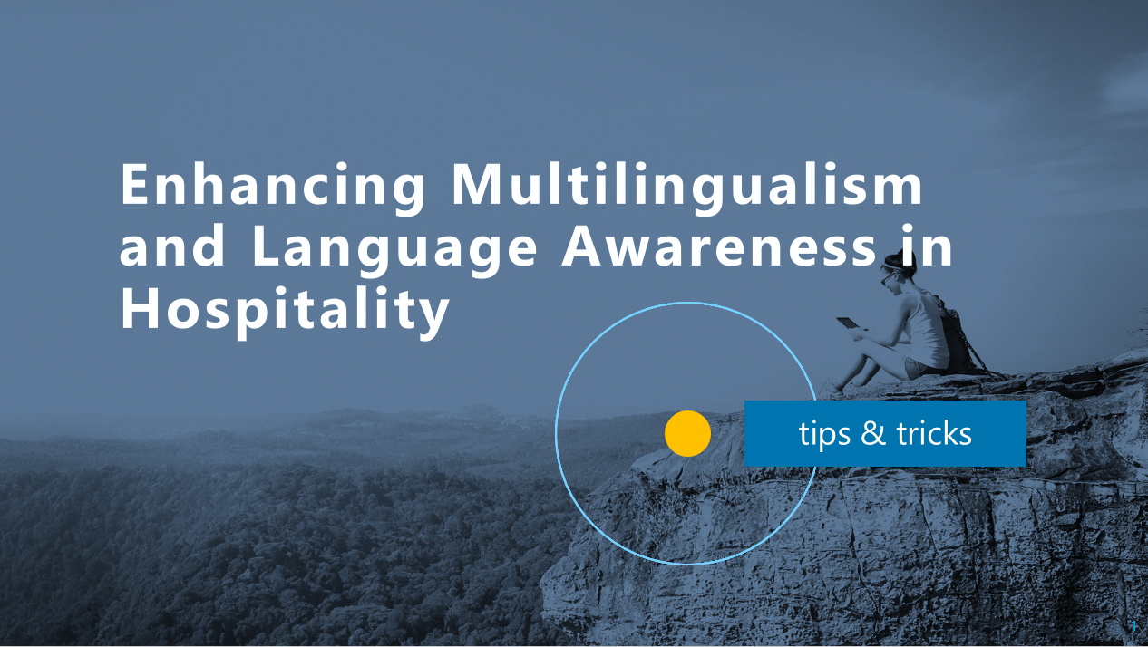

Slide 2
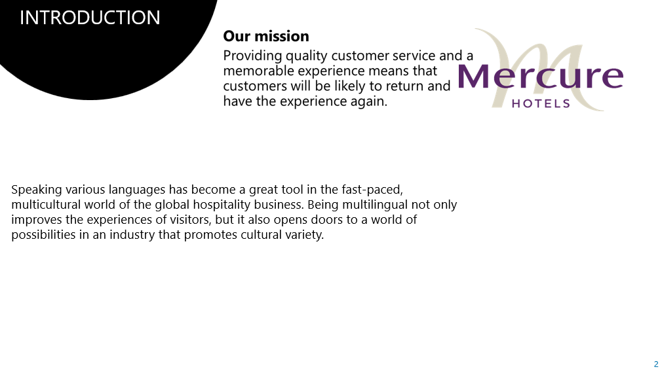
Speaking various languages has become a great tool in the fast-paced, multicultural world of the global hospitality business. Being multilingual not only improves the experiences of visitors, but also opens doors to a world of possibilities in an industry that promotes cultural variety (Holliday and Sheffield, 2020). Here we explore the value of multilingualism in the hospitality sector and how being multilingual may help people advance their careers internationally and improve cross-cultural relationships.

Slide 3
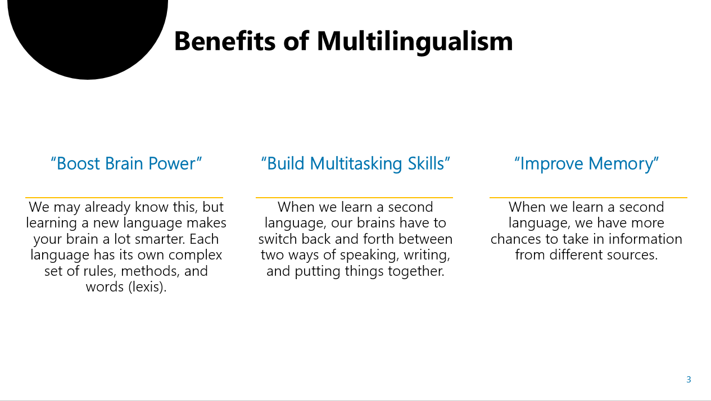
We may already know this, but learning a new language makes your brain a lot smarter. Each language has its own complex set of rules, methods, and words (lexis). Our brain learns to deal with complexity and pick up new patterns as we move through these systems (Pfurtscheller, 2020).
When we learn a second language, our brain has to switch back and forth between two ways of speaking, writing, and putting things together. According to a study from Pennsylvania State University, this "juggling" skill makes bilingual people great at doing many things at once because they can easily switch between forms (Jiang, 2022). We might find that we can do more than one thing at once as we learn a new language.
The more we use our brains, the stronger it gets. Not only do we have to learn rules and words, but learning a language also makes us work harder to remember them and use them when we need to. This may be why bilingual people remember names, shopping lists, and routes better (Chumbow, 2018). When we work out our brains, our memories get better too.

Slide 4
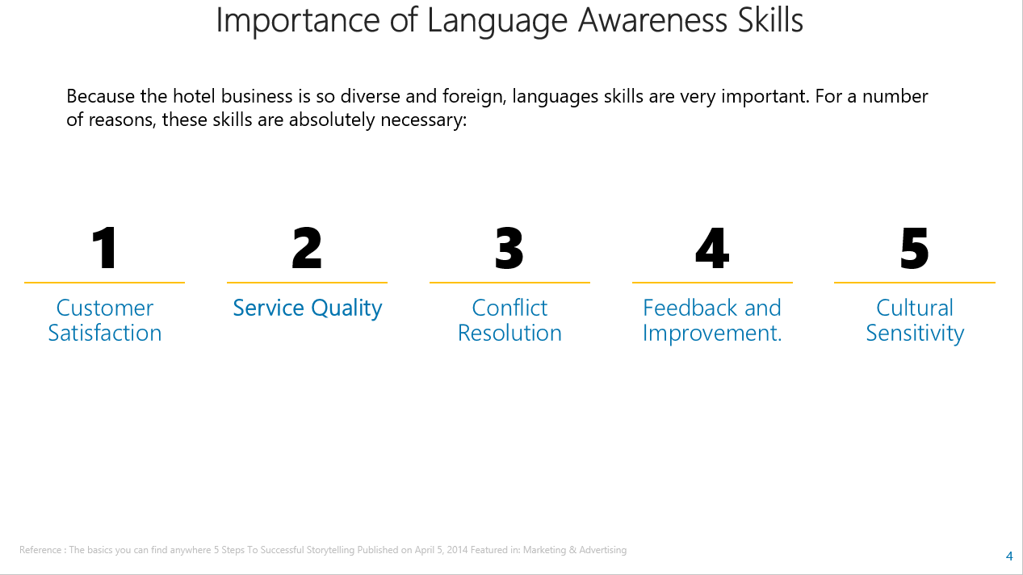
When we communicate well, we make sure that our guests' wants and standards are met. When hotel staff can talk to guests clearly, they can give them personalised services, address their concerns, and make the stay enjoyable, which makes customers happier and more faithful.
Staff members who can talk to each other are better able to provide smooth and effective services (Chumbow, 2018). Communication at the front desk and with housekeepers is important for making sure that jobs are done correctly and on time, which leads to better service.
There can be disagreements and mistakes in any job that deals with customers. When workers have good communication skills, they can handle these situations politely, lowering stress and finding solutions that work for both the guest and the hotel.
Guests can help a hotel improve its services by giving it useful comments (Curtin, Mary Grantham O'Brien and Naqvi, 2015). Staff with good communication skills can actively listen to what guests have to say, learn from it, and make the changes that are needed to improve the guests' experience.
Slide 5
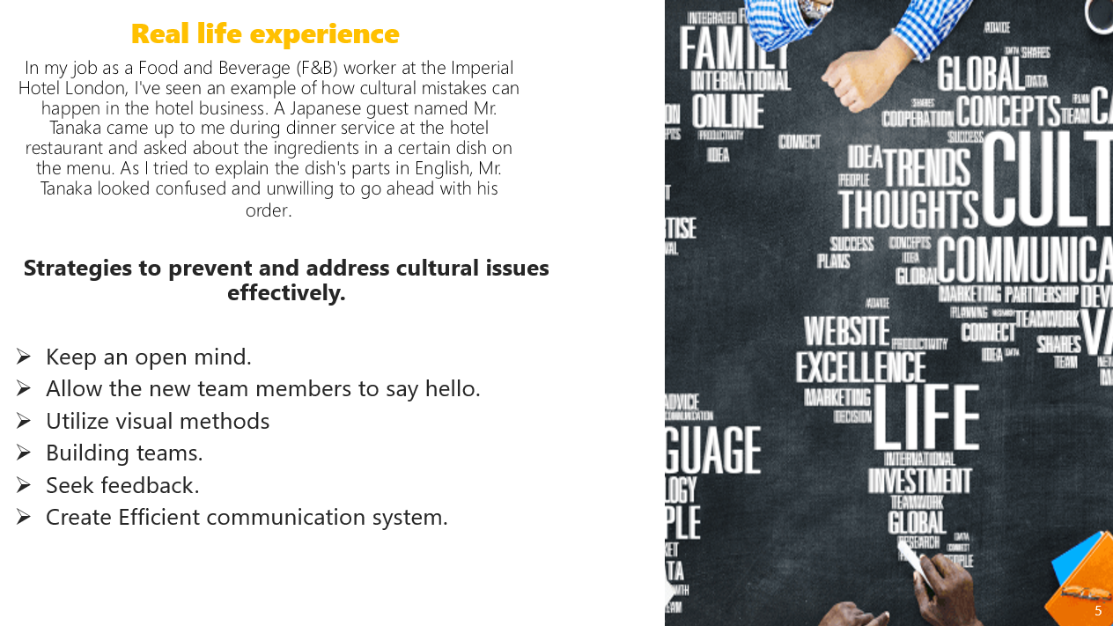
In my job as a Food and Beverage (F&B) worker at the Mercure Hotel, I've seen an example of how cultural mistakes can happen in the hotel business. A Japanese guest named Mr. Tanaka came up to me during dinner service at the hotel restaurant and asked about the ingredients in a certain dish on the menu. As I tried to explain the dish's parts in English, Mr. Tanaka looked confused and unwilling to go ahead with his order.

Strategies to prevent and address cultural issues effectively.
Keep an open mind.
Allow the new team members to say hello (Koc, 2020).
Utilize visual methods
Building teams.
Seek feedback.
Create an Efficient communication system (Koc, 2020).

Slide 6
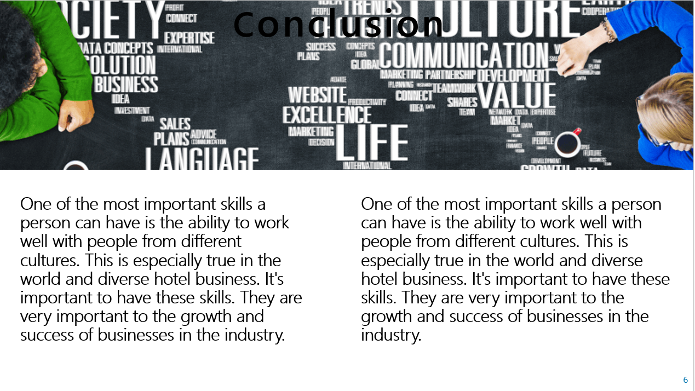
One of the most important skills a person can have is the ability to work well with people from different cultures. This is especially true in the world and diverse hotel business. It's important to have these skills. They are very important to the growth and success of businesses in the industry.
One of the most important skills a person can have is the ability to work well with people from different cultures (Fitzgerald, 2022). This is especially true in the world and diverse hotel business. It's important to have these skills. They are very important to the growth and success of businesses in the industry.

Reference
Holliday, S.J. and Sheffield (2020). Hospitality management. Sheffield: Sheffield Hallam University, School Of Leisure And Food Management.
Pfurtscheller, R. (2020). Cognitive Consequences of Bi-/Multilingualism. Cognitive Benefits of Growing up within a Multilingual Environment. GRIN Verlag.
Jiang, X. (2022). Multilingualism : interdisciplinary topics. London: Intechopen.
Chumbow, S.B. (2018). Multilingualism and bilingualism. London, United Kingdom: Intechopen.
Curtin, S., Mary Grantham O'Brien and Naqvi, R. (2015). Interdisciplinary Approaches to Multilingualism. Frontiers Media SA.
Koc, E. (2020). Cross-Cultural Aspects of Tourism and Hospitality A Services Marketing and Management Perspective. Milton: Taylor & Francis Group.
Fitzgerald, H. (2022). Cross-cultural communication for the tourism and hospitality industry. Frenchs Forest, N.S.W.: Pearson Education Australia.

