ASSESSMENT COMPONENT 2;
A successful business start –up : what does it take?

STUDENT NAME: MAURA PONTES
STUDENT NUMBER: 1809187
MODULE NUMBER: BMSK4003
LECTURE NAME: BALAN KANDASAMY

TABLE OF CONTENTS
Executive Summary 3
Introduction 4
Literature Review 4
Secondary research 5
Methodology 5
Results 6
Conclusion 7
References 7

Executive Summary

In this research highlights the steps that will need to be taken to turn your idea into a business, such as ; personal skills set , marketing strategy, what is a business plan and furthermore some recommendations. The concepts that I describe in this research paper comes from experts in this area, they share knowledge gain from their past experience. While I progress this research I realise that the most important concept was the business plan if you want to become successful in your business , you must create a good business plan ,also marketing strategy is the key to attractive customers you must be creative relative your idea, if being creative is not your case try to find someone specific in this area to help you gain some knowledge and be prepared not all the time you going to win the competition .

INTRODUCTION
This assignment aims to describe how does it takes to create your own business, includes some beneficial information for those who plan to run their own business .The research method is based knowledge gain from experts in the area .In order to analyse the case study I read books from different authors ,they talking about the same thing but in different perspective .
I recommend to use a swot analyses by following the mean below to see some relevant factors and review them if eventually you running a business .

SWOT ANALYSIS TABLE
STRENGTHS  . Why should you succeed?  . What do you do well?  . Why do customers say they enjoy doing business with you?  . What distinct advantages does your company offer?  . What are you USPs?  S | Weaknesses  . What could be improved about the business?  . Is the market strong enough?  . Do you have enough/good enough staff on board?  . Are your management skills up to scratch?  . Do you have enough finance to make it work?  . What stumbling blocks do you continue to encounter?  . What does your company do that can be improved?  . What do your competitors do better than you?  W
OPPORTUNITIES O  . Where are the openings for your business?  . Has the market significantly changed recently? | T THREATS  . What is your competition doing that could take business away from you or stunt your company is growth?  . How might your competitors react to any moves you make?  . What trends in the market do you see that could wipe you out or make your business obsolete?  . Might technology changes threaten your products or services? Or your job?  .Do you have a stable relationship with supplies?

IS YOUR BUSINESS IDEA FEASIBLE

You have an idea that looks good but you want know if there is a demand for it? Or better still, to know if a demand can be created? The first step to take is to analyse your marketplace and a good way to start is by asking yourself the following questions:
. Is there any individual or company currently exploiting your idea?
. Is there a market for your idea?
. Is the competition stiff or non existent?
. If there is a market for your idea, then who are your customers?
It is crucial that you conduct a market analyses to as to determine the potential demand for your idea and the level of competition you will face. However, if after doing your market research and you discover that the market is already saturated with similar product ideas and customers are not in need for additional option, the best thing to do is to pass on such idea and move on . Dip up all industry information about your business idea ,if you scale trough the step one and you have ascertained that a market exist for your product idea ,the next step to take is to research the industry you will be operating in . It is of so much important for you to research everything about the product and business itself by going trough trade publications, searching online, reading the news papers, talking to others in the industry and contacting your local chamber of commerce. Also, it is important you ask yourself the following questions:
. Who is the market leader in your industry?
. What percentage market share does the market leader hold?
. What is the success rate or failure rate of start ups in that industry?
. Is the industry strictly regulated by the government?

WHAT DATA SHOULD BE OBTAINED ?
According to Carl Reader (2015) it is important to decide what information is required to help you formulate your business plan also important that you understand the difference between the two main types of data.
Firstly you would need at least three different sources of each type of the research, to help you construct your action plan for market research from the list below.
Desk research (directories, forums, websites ,etc. )
Trade journals and magazines (include mailing lists and subscription website)
Local street research (note specific areas to visit)
Industry associations and key individuals

THE DIFFERENCE BETWEEN THE TWO MAIN TYPES OF DATA:
Qualitative data is based on descriptions and perception of service. It is based on observations, but cannot be accurately measured . It may include sensory experiences such as the look , feel , smell and taste of an item. | Quantitative data
  Qualitative data
  Quantitative data is based on numbers, and can always be measured exactly. It may include number, total, time, ages, height, etc.-in fact anything that can be measured.
Example 1 – Data for a coffee from a coffee shop
. Friendly barista  . Calm atmosphere  . Cold coffee  . Frothy but too milky  .Served in a brown mug | . 1 minute 35 seconds queuing  . Noise level 71 dB  . Price 2.95 pounds  .14 choices on the menu  . 2 upsell opportunities

Example 2- Data for a bank or building society
. Old –fashioned building  . Polite and professional staff  . Dated décor  . Strong brand image  . Staff seem happy to work there | .2,000 square foot building  . Counter protector by XYZ glass  . 3% interest rate on savings  .8.4% interest rate on loans  . Established since 1932
Qualitative data focused on qualities | Quantitative data focused on quantitative

BUSINESS PLAN
A business plan is the compass that guides your business trough its journey to growth and success. A good business plan usually contains the executive summary of the business, an overview of the industry the business will be a part of , the problems identified that needs solving , its services or products , how the business intends to achieve its goals and how it will distinguish itself from its potential competitors .The most important component of your business plans are your business goals and objectives .Well chosen goals and objectives keep a new business on track.
The business objectives section reveals how you are going to execute your vision and mission and bring them to reality. This is where setting goals and objectives must be SMART. That is , they must be specific, measurable ,actionable , realistic, and time based.
Business goals: goals tend to be more qualitative , while objectives are usually quantitative. Also, goals usually revolve around achieving big picture business intentions that are entered around market position, customer service, growth , and company culture among other key things .Goals are the ultimate successes that you plan to achieve after some activity or practice. For example, one of your business goal could be “ to expand your business from small scale to medium scale by the next 5 years.”
Business objectives: objectives ,on the other hand ,focus more on practical ,day –in day out metrics that revolve around revenue, number of customers, and product –related metrics. Objectives are specific procedures for achieving a goal. They are the steps that you need to take in order to achieve your desired goals. For instance, if your goal is to expand your business from small scale to medium scale in the 5years,you are likely to have the following as your objectives.
. To marker your business aggressively in order to attract more customers
. To reward loyal customers as away of retaining them
. To develop an online marketing strategy
. To research and analyse possible growth opportunities such as acquisitions, merges , etc .
. To introduce new products and services
. To open more offices in various locations
The business plan should contain details like ; financial projections, target market and exit strategy . Even though a business plan has to contain a lot of business specifics so as to provide great detail for investors, but it should be noted that the plan should never be voluminous as you risk losing it to the trash can. Try as much possible to fit in the detail in most 20 pages or less so that it can be readable because investors are always very busy people who have no time to pore over irrelevant words. Even if you are not soliciting funding from an investor, you still need to write a business plan for your business because a business plan allows you to identify potential problems and opportunities your business might encounter, it would help you avoid penalties, fines or other legal problems, help you adapt to changes in the marketplace and let you expand or contract from a position of objectivity.
Others benefits of a business plan include;
. Aids in obtaining funding: A thorough business plan will increase your chances of obtaining venture capital and bank loans.
. Aids in managing cash flow: Outlining a cash flow plan is a great way to make educated guesses on sales , costs , expenses, assets you need to buy and debts you have to pay . It would also help you manage your available cash effectively .
. Sets Milestones: Good business planning helps the business to sets milestones it can work towards achieving at a particularly time frame.
. Minimize Legal Problems: you will definitely need to procure certain licenses or permits to operate your business. You would need to arrange for taxes, incorporate the business .All these modalities are listed in the business plan so you do not forget any one of them and incur penalties for yourself.
. Set priorities: a good business plan would help you to keep track of the most important things . It would help you allocated your time, effort , and resources strategically and effectively .
. Provide exit strategy: In addition to providing benchmarks for success, a good business plan sets realistic criteria for shutting down the business to prevent you losing at both ends.
Above all you have to keep in mind, that you are not the only one who needs funding for a business. Because of the sheer number of people seeking funding, bankers and professional investors do receive so many business plans. In order to be able to go trough all of them, they sometimes go right to the executive summary for an overall view of what your plan is all about . You have to make sure that your executive summary contains all the details of your business from the executive summary.

EFFECTIVE MARKETING STRATEGY
Once you got your business idea, it is crucial to identify your target market to avoid loss even you thing your brand is affordable for everyone. As you can see the chart below is an example of segmentation to help you identify the best market for your brand .

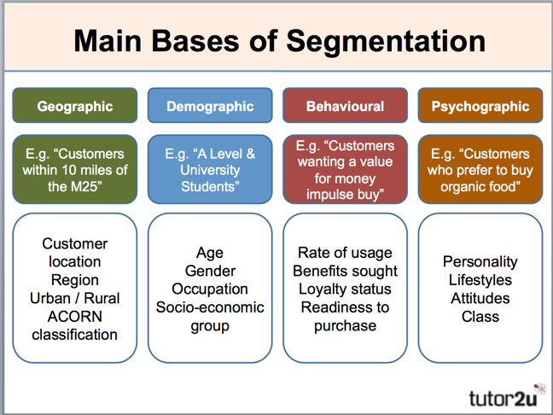
figure 1; segmentation
(source:tutor2u.net)

MARKET RESEARCH
The number one reason why start up companies fail because there is no market need for what they offer. Marketing strategy is important before start up launches with them you would be able to find out early on during the market research phase whether your venture is worth pursuing.

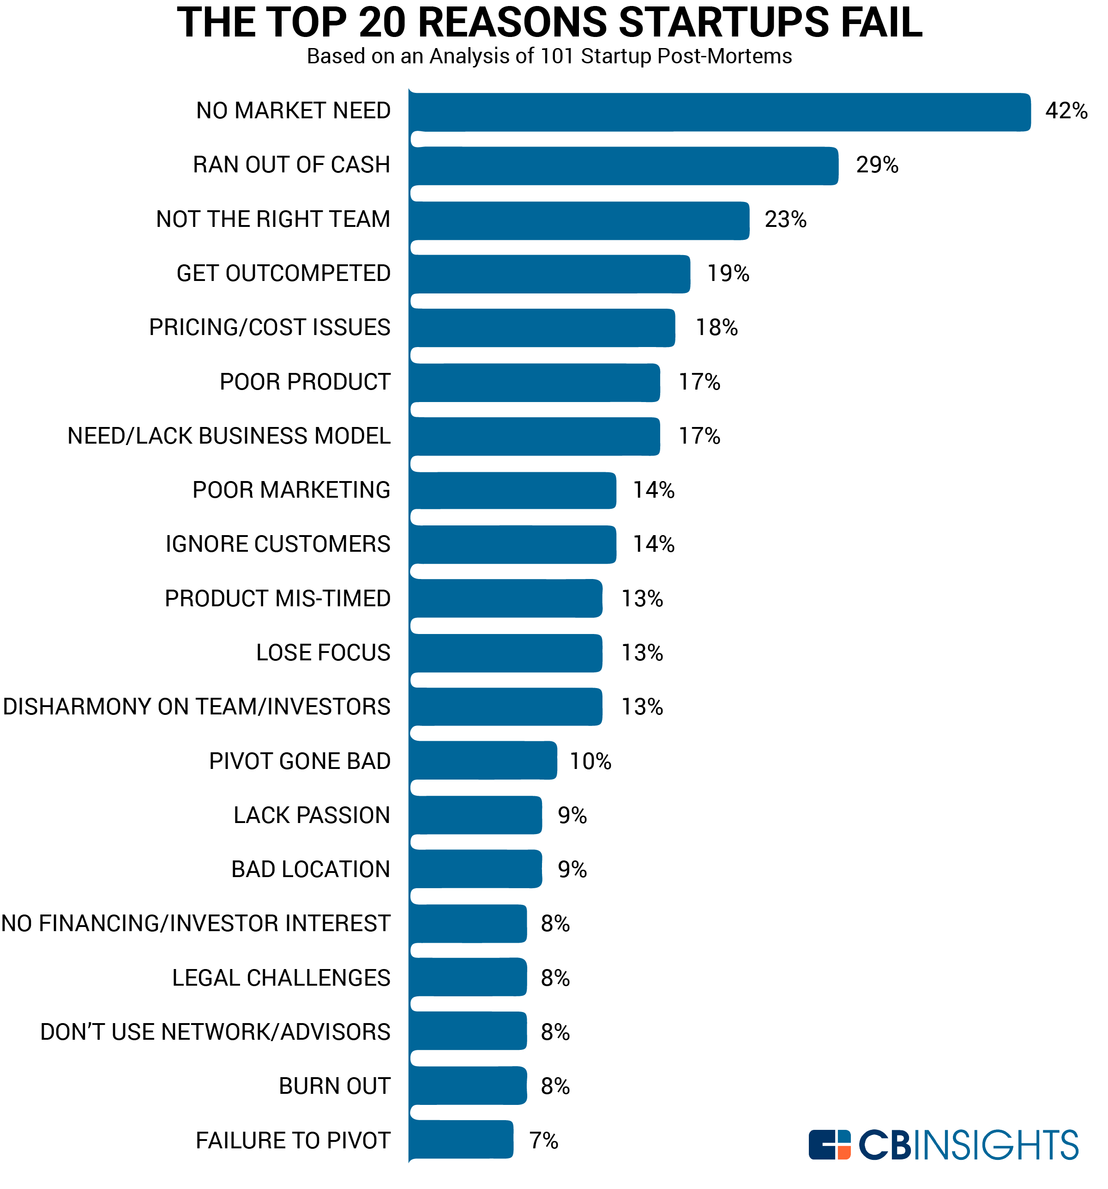
figure 2;reasons start up fail
(source:entrepreneur.com)

COMPETITION
Is one of the most crucial parts of the marketing strategy. A simple chart can be a useful tool when it comes to for the competitive analysis process .

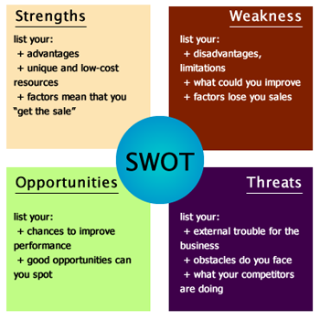
figure 3; swot analysis
(source; canvanizer.com)

COME UP WITH A REALISTIC BUDGET
Appropriate budgeting is important for all businesses. But its even more important for start ups. That is because when you first launch, you don’t have a steady income yet.

PROMOTING YOUR BUSINESS
Start by creating a website. Everything you do should focus on driving traffic to that website and getting visitors to convert.
Create a profile on as many social media channels as possible
. Facebook
. Instagram
. Twitter
. Snap chat
. You tube

YOUR EMAIL LIST
A email list subscriber list serve as one of the most important distribution for channels.

Conclusion
Starting a business is no easy task. I consider to setting up and running my own business after my graduation but after some research to do this assignment I quite admit that there is a long road ahead and you must love what you do to become successful is a key, but if you start with the right foundation, this road can be very rewarding.

References
Major ,M.(2014) Grosvenor Press London
Reader , C. (2015) published in Great Britain Hodder and Stoughton UK COMPANY
Williams , S. (2016)Great Britain .
Ashford colour Press

