Esther Anderson
1803142
19.2.19
Tom Duxberry
ACBA4001

Introduction
The purpose of this assignment is to demonstrate an understanding of appropriate site evaluation and site and soil investigation techniques, types of substructure available for a variety of low-rise building systems and their production and to show an understanding of the main forms of superstructure applicable to a range of buildings. This will be carried out by the use of both primary and secondary data.
The process will consist of a desktop study of the site, which will include a complete walkover inspection. The preliminary observations will be written up and developed within the assignment. The use of neat, annotated sketches will be used to aid the site investigation. This will therefore help in the description and foundation choice for the building. Sketches will also be used to illustrate the materials and methods for a number of building elements and construction interfaces.
Project description
The proposed development will involve the construction and development of a two-storey commercial build.
Project location
City and county of Swansea have selected a joint agreement with Marriot hotels to create a new restaurant, ice-cream parlour and manager’s apartment on Swansea foreshore. This new building will be located between county hall and the Marriott hotel. The building is to be located on existing shared carpark; the ground level will have a gross internal area of approximately 300square meters. This area will consist of the restaurant, café-bar, ice-cream parlour, kitchen and food stores. The second floor will consist of the manager’s apartment and staff welfare facilities. These both having a GIA of 150 square meters.
Desktop study
A desktop study (DTS) discusses the available data obtained for the specific site and the surrounding area in regards to its physical, historic and environmental setting. The DTS provides a better understanding of the site and its surroundings. Potential issues can be identified within the site, a conceptual site model can be initially developed for the geo/environmental considerations and geotechnical assessments can be developed, during this stage and other ground hazards can be early identified that can have any effect on the development. There are a number of collective requirements undertaken by investors and regulatory authorities.
Desktop studies should be carried out for every development, regardless to any previous invasive site investigations. A DTS is conducted prior to starting any work on site including ground investigations. This is the first stage of the site investigation, which aids in the development of ground investigations. Research into the site is recorded during this stage and as much information is obtained during the stage of the process. The uses of previous site investigations are very useful to current investigations during a DTS. For example an UTX survey will identify if the site was ever used as a bombsite or had contact with bombing (Doherty, 2019)
It is beneficial if previous service report is obtained during this stage. This can aid in the progression of locating hidden services, this includes electricity cables, telephone wires and sewers. This information can be attained from the service provider, which is normally free of charge. The service providers being: - British gas, welsh water companies, electricity board, and British telecom. A major yet forgotten check, which is essential, is to check for former mining work, if detected this can have detrimental consequences on both the construction and cost of the development.
The desktop study for this project was limited and as little information was obtain a walk over inspection was more suitable, this being due to the fact that there are restricted access to information and the cost aspect to view data and information. However putting these limitations aside the information that was obtained for this project was accessed via general free information such as search engines, a visual walkover, surveys and apparatus (Doherty, 2019).
Walk over inspection
A walk over inspection has the potential to provide vast amount of information of the site. It is at this stage that ground condition complications can be identified, these including contamination issues, shallow groundwater and the slope of the land. Not every site need an initial site walk over but for this instance it is required. There is a number of main factors that need to be included within this stage. These being: -
- Access- this is to identify that there is suitable access to the site and there are no obstructions such as watercourses and overhead cables.
- Mining- when previous mining is identified within an area there are normally signs of subsidence.
- Slope of the land – this will be identified by displaced fences and drains, bent trees, and movement in the land
- Hydrogeology – this can detect any wet grounds, wet soil and clay, marshland, ponds and streams, seepage or springs.
- Drainage/services – to locate if there any manholes and if so to determine the drainage system, other services include gas, electricity, and water.
- Overhead lines- to access if there are any electricity lines overhead and if so determines how to work around them or arrange a process to get them moved to a different location (company database, 2019).
It is vital that both the DTS and walk over investigation are completed as the first stage; this is very cost effective and has a major effect on the whole development. Problems and complications such as ecology and archaeology can be early identified, which allows a base line for the development that can then progress to further investigations of the site.
From the walk over it was observed that there was a number of draining systems, made evident by the manholes and drainage covers. There is a public right of way within the boundaries of the development, there are a number of ways to overcome this issue, firstly can be left and incorporated into the development as planning will have respected the right of way and the decision to design around it has been proposed, secondly planning can be applied to the council to have the right of way moved. There are steps with access to the beach front via a public right of way. The land is relatively flat and does not slope as such. From observation there are not overhead cables. There was a mixture of ground surface both tarmac and grass/greenery. There is a water tank located within the boundaries, which was approved planning in 2003 (Property.swansea.gov.uk, 2019). There are steps with access to the beach front via a public right of way. The access to the site needs to be segregated with plant and pedestrians. The carpark for both businesses needs to remain open for business but cordoned off for the development to progress. Access to the site will remain from the main road via the remaining carpark.
Site investigation
According to Clayton & Smith (2013) the main investigation consists of detailed investigations such as trial pits and bore holes, these include the preparation of site investigation reports with a number of plans and sections to outline different recommendations for the design and development of the project. There is a number of subjects to the investigation these being: -
- Soil investigation- The soil type for the development is clay.
- Geologic survey maps
- Preliminary investigations
- Detailed site investigation
- Supplementary investigation and construction control
The aim of a site investigation is to obtain the required information in order to conduct risk assessments and to be at a requirement to assess the land for any contamination. A major objective of the main site investigation is to determine as accurately as is possible. There are four indication that are followed at this stage, these are to observe the following
- The nature and sequence of strata
- The ground water conditions are the site
- The physical properties of soil and rock underlying the site
- The mechanical properties such as soil strength and rock strata
Geological data
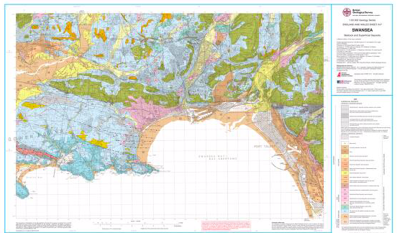
The published geological information covering the site in Swansea can be obtained from the British Geological Survey (BGS) sheet 247 (2011) and the BGS website. This indicated the downward succession of strata at the site, in relation to strata it has originated from numurian age recognised by millstone grit that has initiated from the Marros groups. The Marros group millstone grit primarily makes up a proportion of material from Swansea bay to Llanrhidian (Rees and Williams, 1941).
The site indicates that the underlying geology consists of Grovesend formation of Carboniferous age, dipping at approximately 10 degrees in the northerly direction. The Grovesend formation characteristically is made from mudstone and siltstone, with the well-developed coals and sandstones. Sedimentary bedrock was formed on the site approximately 310 to 318 million years ago. Prior to the use of the site the Local environment previously consisted of swampland, estuaries and deltas. The superficial geological indicates that blown sand formed the superficial deposits approximately 3 million years ago, as a result of this it is believed that the site was subject during the quaternary period therefore this process was a result from windblown deposits.
From secondary data of previous existing buildings of the proposed site the following data has been obtained in relation to the strata of the land and previous planning (SwanseaGov, 2019).
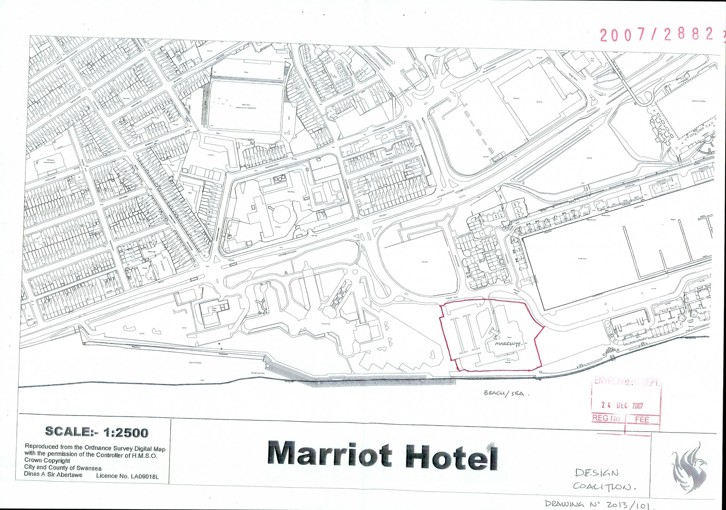
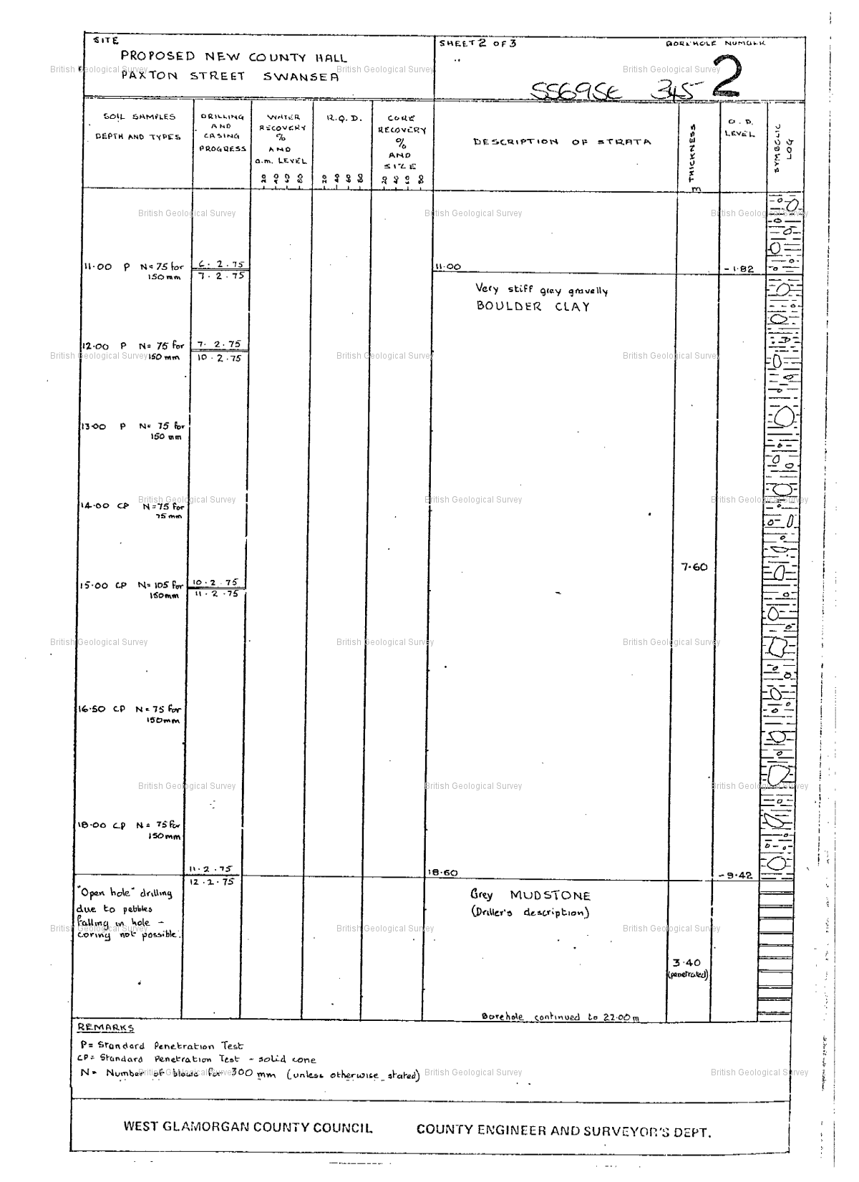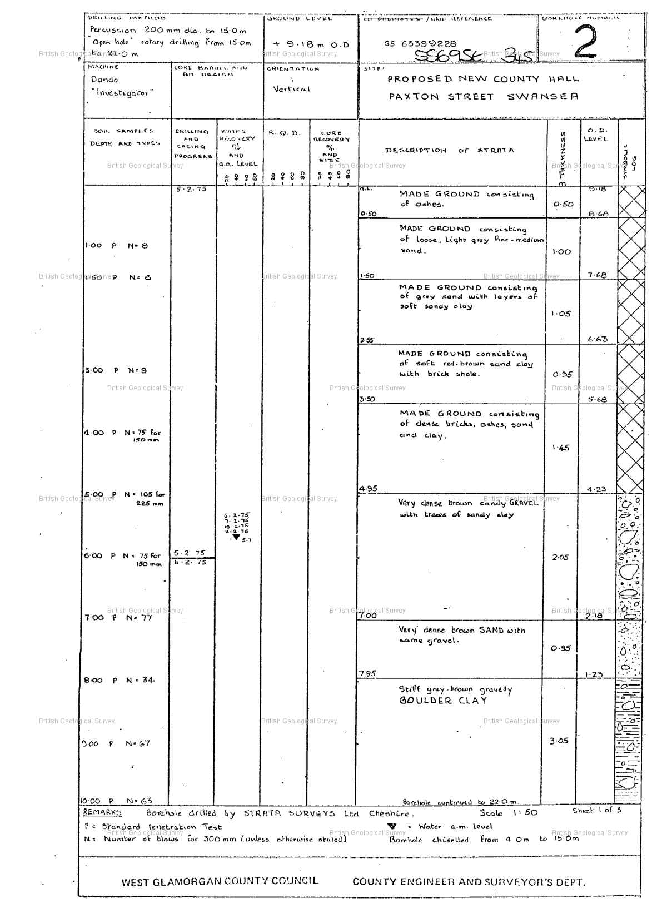
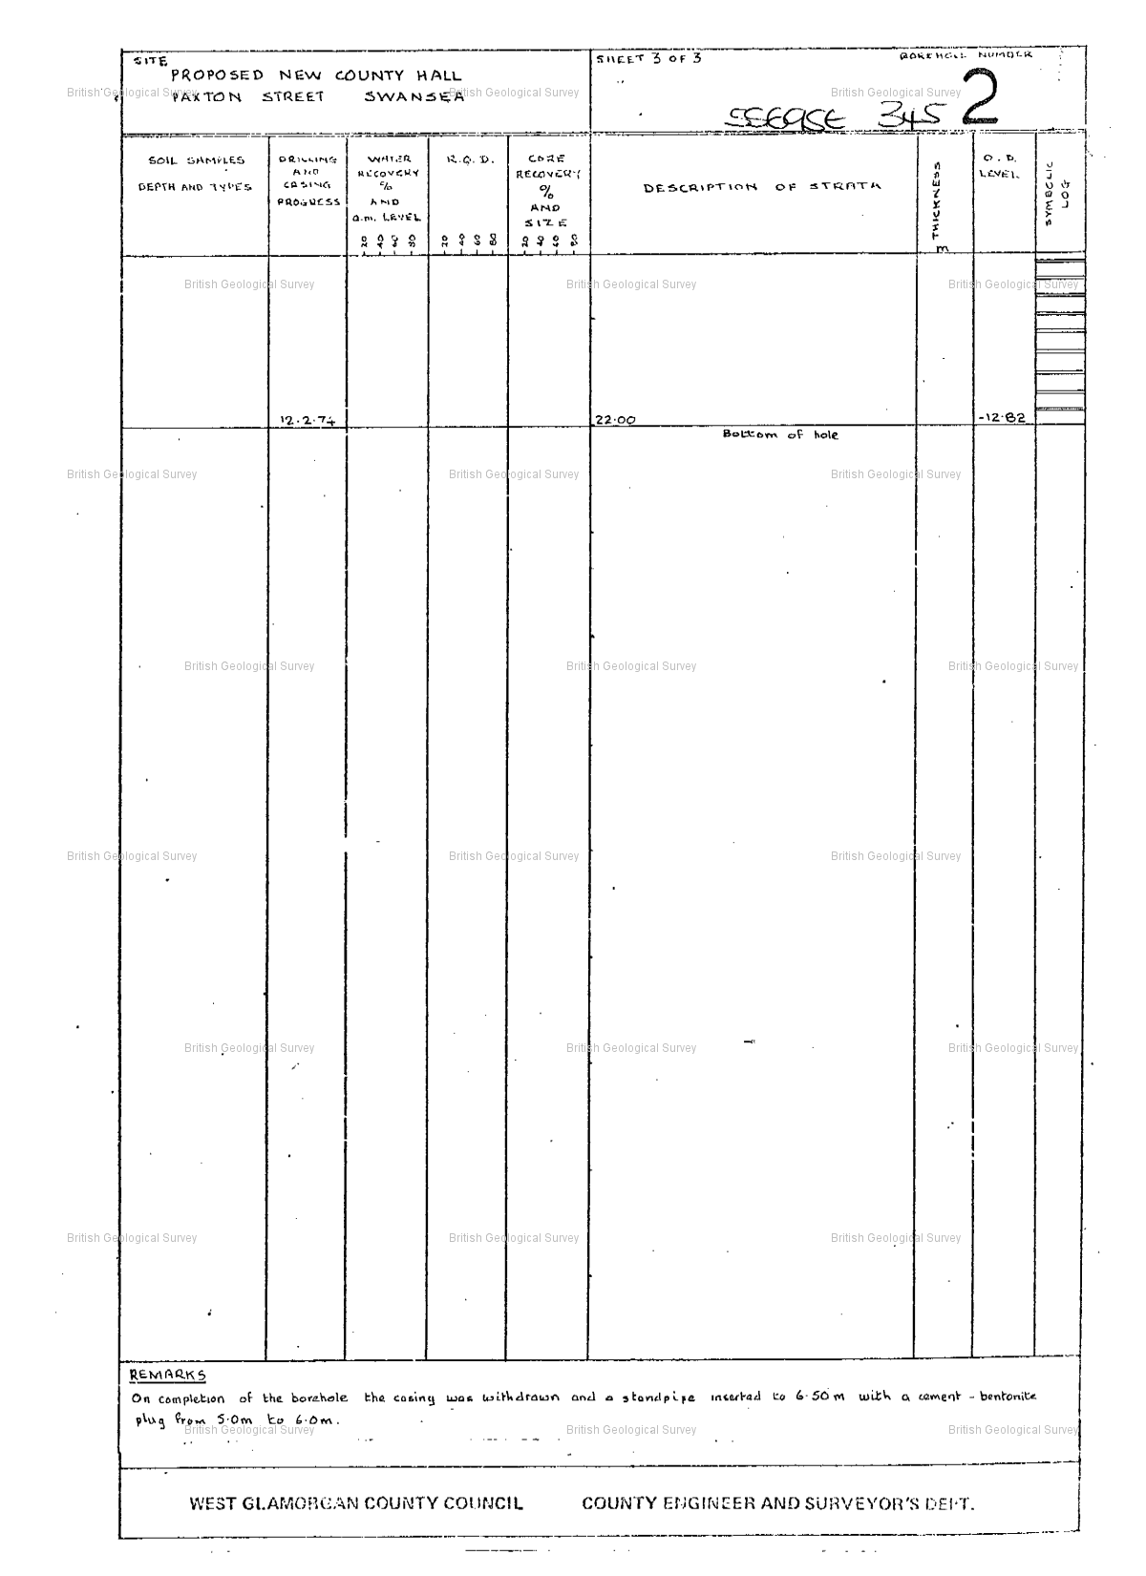

Mining
The coal authorities (2019), allow limited access to the location of previous mining and coal land. Which is illustrated in the image below.
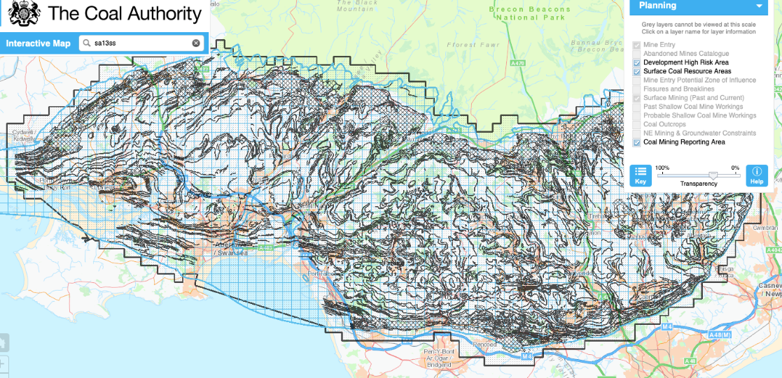

There are a variety of techniques that can be adapted for ground investigations. This can be done as a sole investigation or used as a combined method. This is dependent on the level of detail needed, the nature of the ground and the scope of the investigation. Given these results, it can have a major impact on the risks of the project not just the cost implications of the investigations themselves. As stated there are a number of techniques to investigate the ground, for the purpose of this project the following will be adapted (Lyons, 2014).
Boreholes
There are a variety of borehole investigations that can be carried out these being
- Window sampling
- Windowless sampling
- Light cable percussive
- Rotary
Window and windowless sampling boreholes are both economical and are both a relatively quick process. This process is achieved by inserting tubes into the ground to obtain soil samples. Both processes are limited to shallow soil depth, however they are useful when a site has restricted or little access or have a slope to the land need to be tested.
Light cable percussive boreholes are used for limited headroom. This process is beneficial for testing high quality samples of weaker soils.
Rotary boreholes are used for a more heavy-duty ground surface, such as dense gravel. It is possible for depths of up to 100meters deep to be achieved. This is a processed used to obtain bedrock samples that can then be laboratory tested for further investigation. This can help to identify any underlying rock, by the use of a core barrel. Rotary boreholes are suitable when voids have been identified they are primarily used for mining areas.

Trial pits
Trial pits are used in relation to shallow ground conditions; this can therefore give an indication to the soil profile in the ground being tested. This is beneficial when investigating land for any contamination or buried structures. Trial pits can be excavated by hand or by the use of plant such as a backhoe. The approximate depth of a trial pit is 3.5-4.5 meters deep. Trial pits are more finically beneficial that boreholes however they due present with issues in regards to the depth they are capable over reaching. The location of the trial pits will be located on a map and assisted with a sketch of the process.
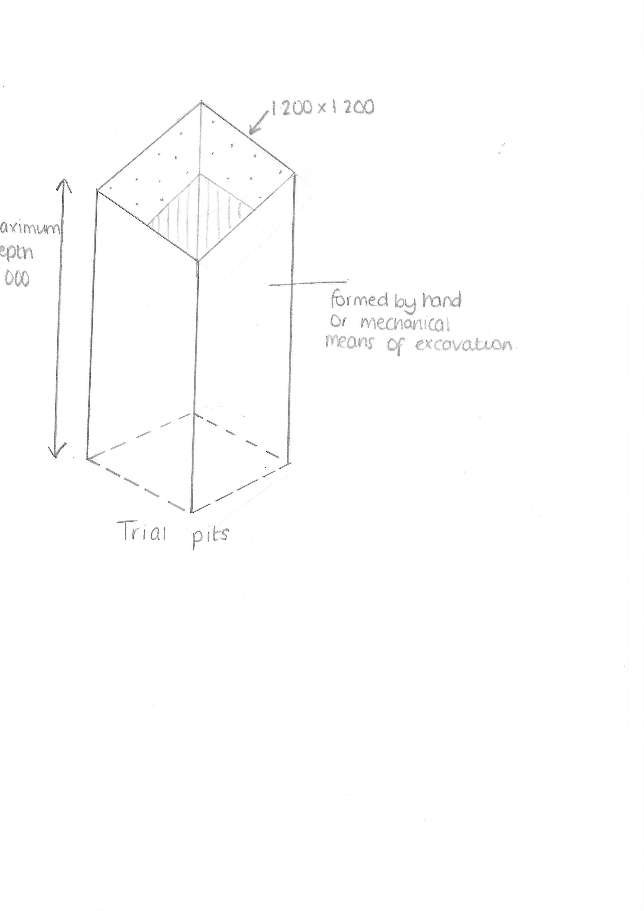
WAC testing
A waste acceptance criteria (WAC) test is used to give the exact level of contamination. A WAC test will give guidance on how the waste will behave once it is buried. This process is achieved during laboratory testing by analysing leachate derived from the waste. However this test does not indicate whether the waste is hazardous or non-hazardous in relation to an inert landfill. Inert waste is neither chemically or biologically reactive an example of this material is sand. In order to carry out a WAC test 3 WAC tests must be conducted within 1 trial pit.
Soak away test/percolation test
This test is carried out by a hole being excavated approximately 300mm square and 300mm depth. This test is required in relation to any septic tank or sewage treatment area. It is used to test the absorption rate of soil of a selected amount of water. This is to access whether the soil has the ability to adapt a soak away process. The percolation test comes under 1.33 to 1.38 part H2 of the building regulations 2000- drainage and waste disposal. This trial is conducted by repeating the test at 3 separate times within 1 trial pit.
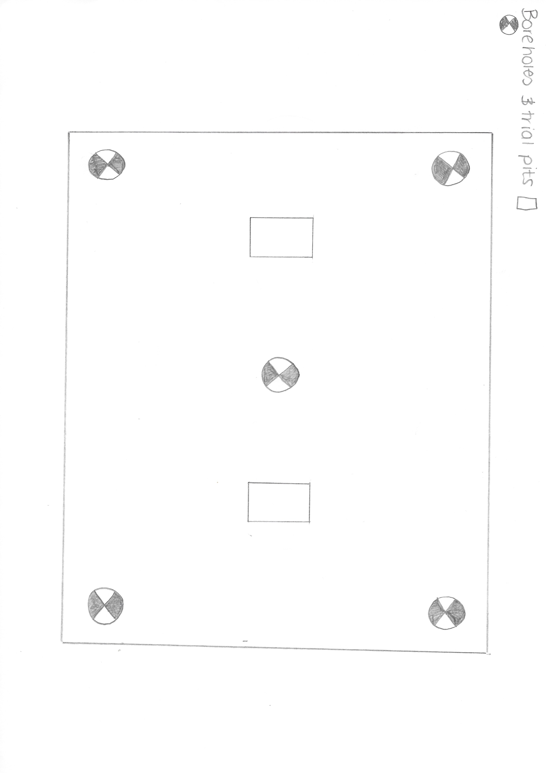
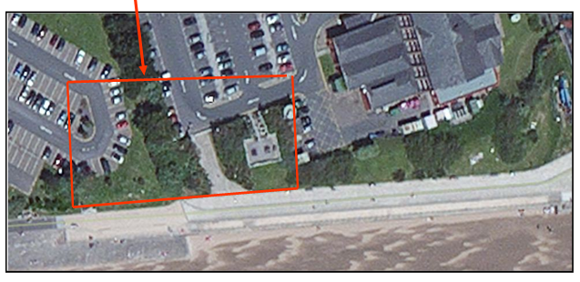

Foundations
It is believed by Henry (1986), that the purpose of a foundation is to provide support to a structure. It also need to be able to transfer the load to soil and rock that needs to have a suitable bearing capacity and have the correct and most efficient settlement characteristics for the job purpose. There are two characteristics of foundations these being shallow foundations and deep foundations. Shallow foundations are used when the weight-bearing load imposed by a structure is low in comparison to the bearing capacity of the surface materials. However deep foundations are primarily used when the bearing surface materials is not suitable to support the load, therefore the load needs to transferred to deep layers that will increase the bearing capacity.
There are a number of shallow foundations that are used within construction these include strip foundations, pad foundations and raft foundations. For the purpose of this assignment the most suitable foundation to use for the project is a raft foundation. A raft foundation is a concrete slab of uniform thickness, this ranging from 150mm to 300mm. The raft foundation can be created at a large-scale area, typically covering the footprint of the development. This will therefore support multiple walls and columns (Hemsley, 2009). The raft foundation has the ability to float as a raft floats on water. There is a number of compatible uses for this foundation these varying from: - If the floor area is minimal and there is low structural loading for e.g. a two storey domestic build. It is suitable if a basement is being included within the development. The ground conditions are poor for example soft clay and compressible fill, therefore strip foundations would not be suitable for this and on review raft foundation would be more suitable. This theory would be applied also if there were settlement of the development (Cooke, 2011).
Raft foundations are relatively cheap and quick to construct, this is due to the excavations being shallow compared to strip or pad foundations. Another benefit is that they use less material as ground slab is combined with the foundation. However there are a number of disadvantages to using raft foundations these being that they have the potential to erode at the edges also the efficiency of the foundation is less when the structural load are higher in concentrated areas (Hemsley, 2009).
According to Cooke (2011), the formation of a raft foundations is constructed on a compacted hard-core base approximately 100mm deep. Blinding concrete is then used to assist with the formation of the raft this being approximately 50mm deep. It is then covered with a waterproof membrane on top.
Steel reinforcement and incorporated stiffening beams are often included within a raft foundation. This helps to prevent any cracking and will aid to the support in certain areas that will endure more load, for example below walls and columns. Beams can either be hidden within the foundation or stand proud of the raft. This is beneficial when the ground quality is poor (Steelconstruction, 2019).
According to Doherty (2018) is it essential that the building regulation be adhered to in relation to insulation of the foundations. This is calculated by a number of u-values that aim to hit heat loss targets. Therefore Insulation should be put on top of the raft foundation. There are a number of disciplines within the design of raft foundations. It is vital that the structure is not wholly considered but that the walls, insulation, DPM, and ground conditions are also taking into consideration.
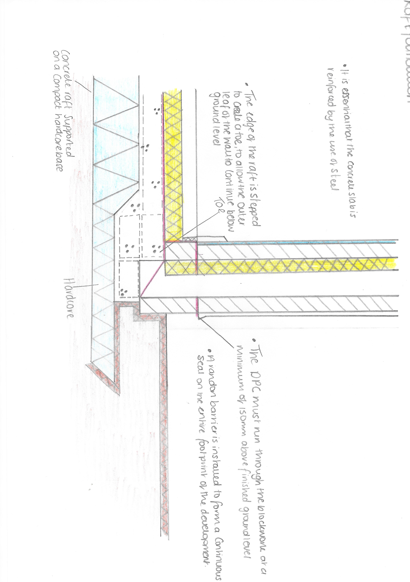
The materials used with the development need to meet all requirements, this is essential due to the development being build in a marine environment. Therefore certain materials will need to be a priority, this will make sure the materials are more suitable to the weathering and corrosion they could be subject to (Lyons, 2014).
Site Set Up (Armitt, 2016).
Site fully secured with solid timber / steel hoarding with temporary works design to suit location
- 6-meter wide site gates for plant and materials.
- 1-meter wide site pedestrian gate.
- Low-level pedestrian barriers to segregate plant and materials from pedestrian routes.
A gate man to ensure the site is secured and deliveries controlled as they enter site.
I have estimated that during the construction programmes busiest period there will be at least 24 operatives including site staff so the accommodation required will be as follows
- 1no 32x10 Open Plan Office
- 1no 32x10 Meeting Room / Office
- 1no 32x10 Canteen
- 1no 32x10 Drying Room
- 1No 3+1 Toilet Block and Tank if no mains drainage available.
- 2 Steel Storage Containers
Segregated skips for waste
Waste skip for concrete washout
Silt fencing to control any run off of site spoil during the works
Timber stakes and timber for setting out purposes.
Water connection for site temporaries
Electrical Connection for site temporaries
Telephone Connection for site temporaries
Foul connection for site toilets
External and Internal Fire Points Wireless linked
Temporary surfacing to site compound and vehicle access to avoid mud being taken out of site.

Proposed Staff
- Full time Site Manager
- Full time site labourer / gateman
- Building supervisor for internal works only
- Visiting Contracts Manger
- Visiting Quantity Surveyor
- Visiting Design Manager

Plant
Cat Scan for tracing existing services
Dumpy Level / Total Station
Scaffolding internal and external
MEWPS if required.
8 Ton 360 Excavator
5 Ton Dumper
120 Bomac Roller
Wacker Plate
Fuel Bowser for the plant
Spill kits for the plant
35 Ton Mobile Crane for Steel Erecting
Safety nets for the roof and metal decking installation
Concrete Pump for ground and upper floor slabs
Generator for site set / site up if mains power not available.
Small portable generator during Sub Structure Works
Mobile road sweeper if required during Sub Structure Works
7M Telehandler
50mm Pump
Still Saw
Compressor and Tools if Required
Power floats
Vibrating Poker
Trench Supports / Trench Boxes
Kerb Lifter (Lyons, 2014)

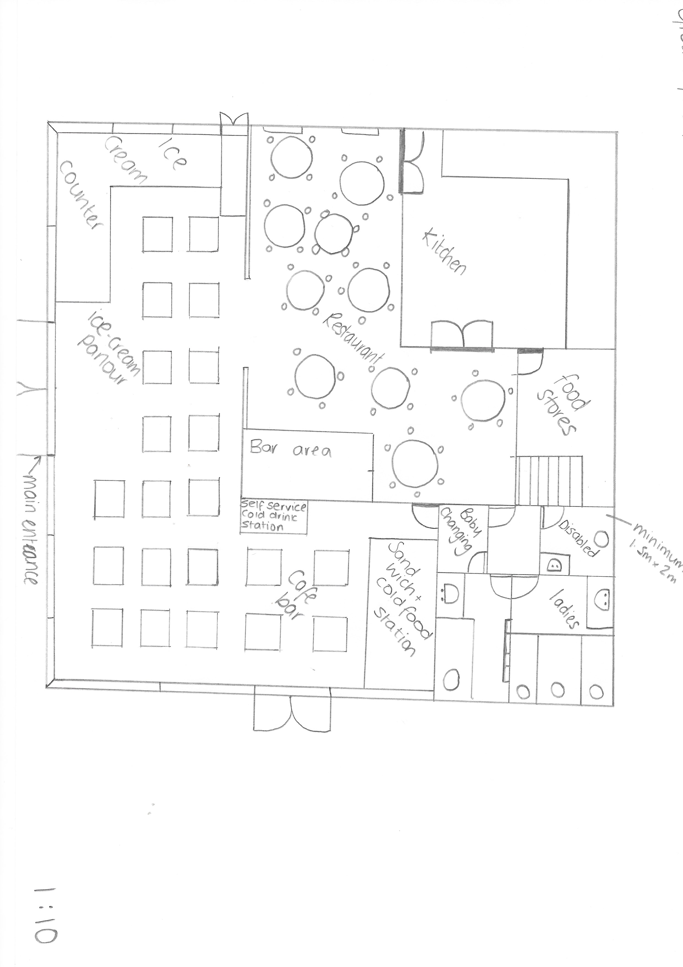

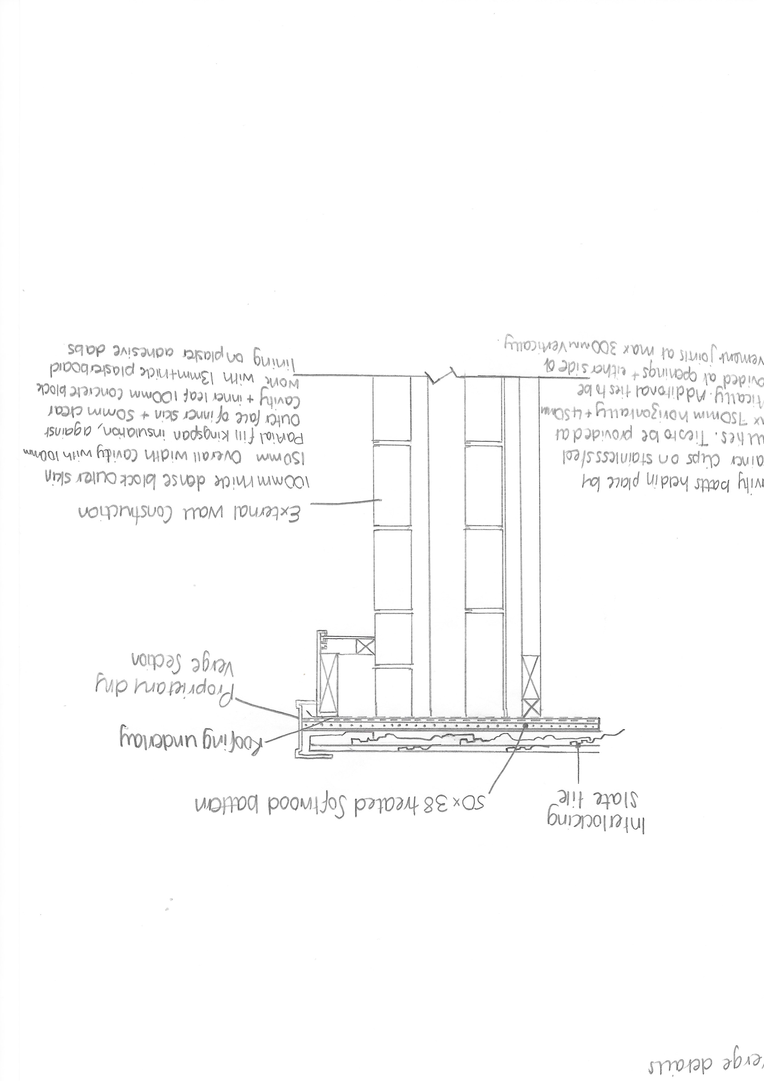
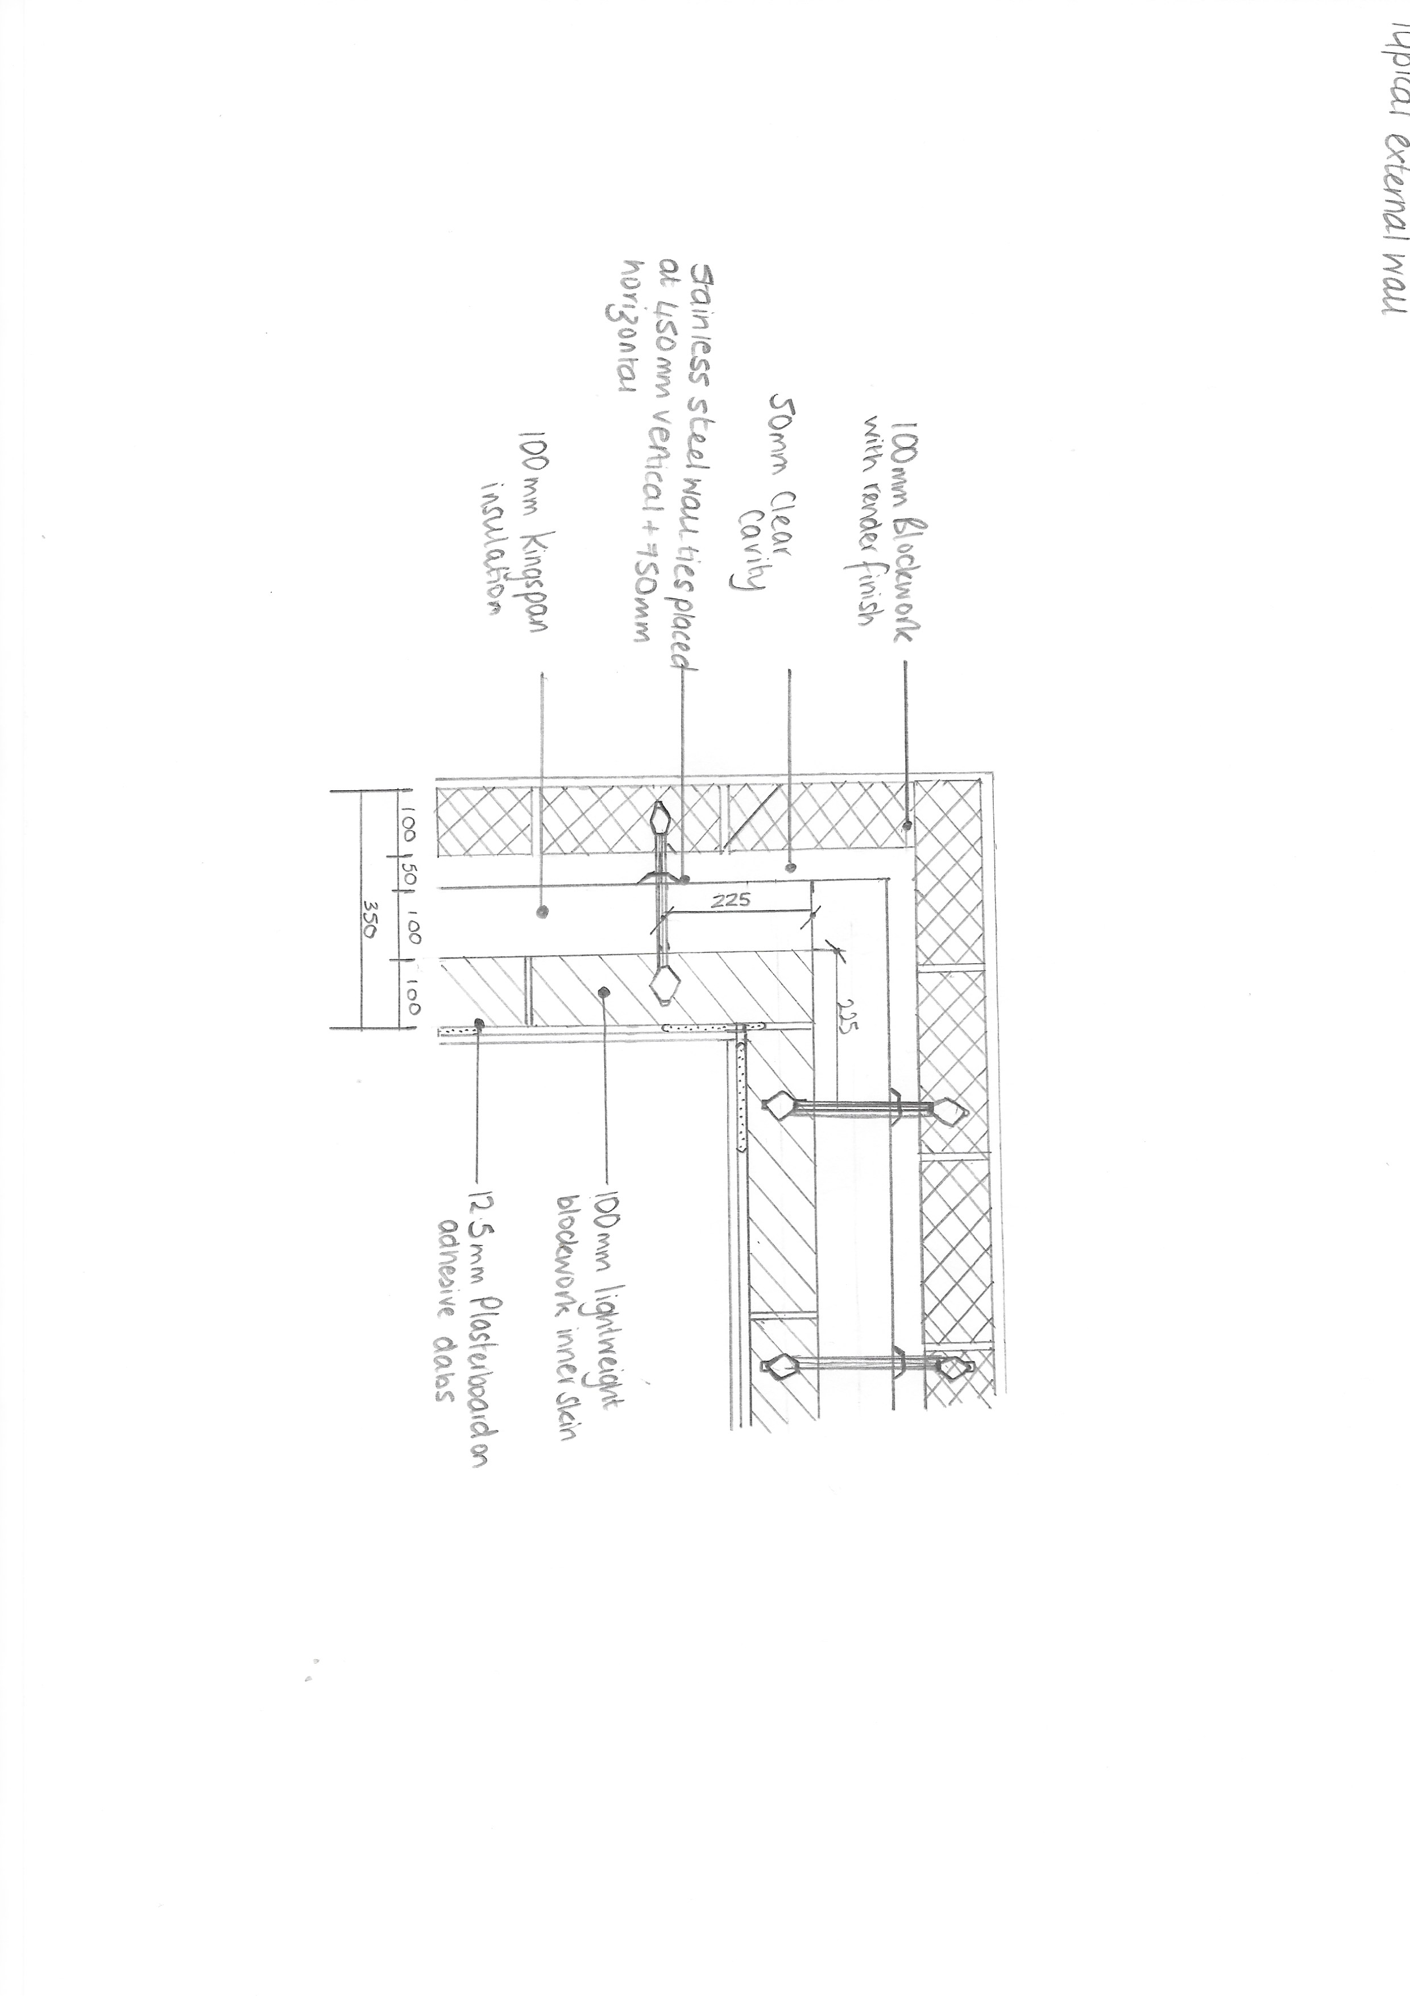
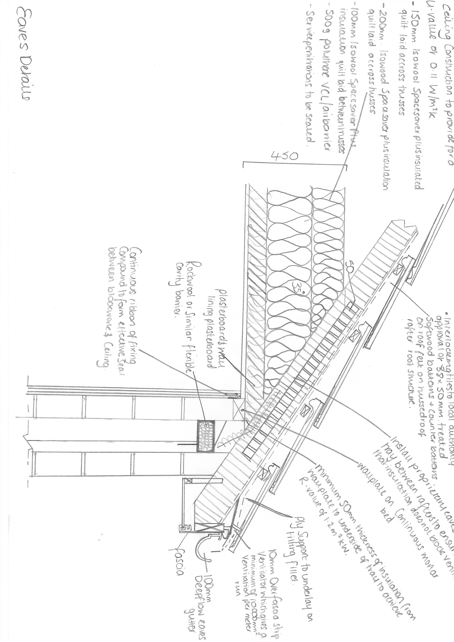
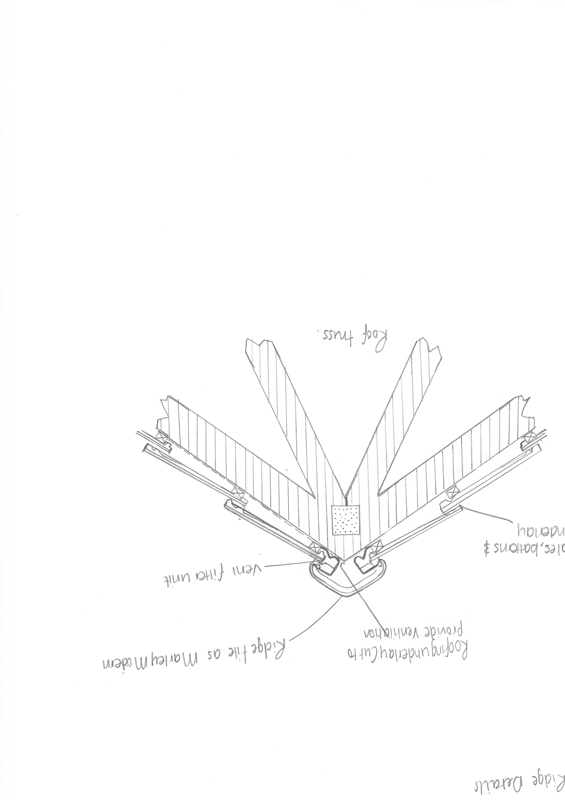

Reference
Armitt, J. (2016). Civil engineers: shaping ourselves and our world. Proceedings of the Institution of Civil Engineers - Civil Engineering, 169(1), pp.3-8.

Cooke, B n. D., Constrcution Practice: Oxford Wiley-Blackwell 2011, CIOB Reference Library Catalogue, Retrieved 14.2.19
Chudley, R. and Greeno, R. (2014) Building Construction Handbook 10th Edition, Routledge
Chudley, R. and Greeno, R. (2006). Advanced Construction Technology , Pearson Education
Clayton,C. and Smith,D. (2013). Effective site investigation. ICE publishing.
Company database – Swansea county council
Company database – Dawnus
Doherty, T.(2019). Hoe to insulate foundations- buildit. Available at http://self-build.co.uk/how-to-insulte-foundation/ accessed 14/2/19.
Henry, F. (1986). The design and construction of engineering foundations. London: Chapman and Hall.
Hemsley, J. (2009). Design applications of raft foundations. London: Thomas Telford Ltd.

Lyons, A. (2014). Materials for Architects and Builders. Hoboken: Taylor and Francis.
Lyons . (2010). Materials for Architects & Builders Third Edition, Published by Elsevier.
Property.swansea.gov.uk. (2019). 2003/1584 | Erection of pump house and water tank south of existing car park | Swansea Marriot Hotel, Maritime Quarter, Swansea, West Glamorgan, SA1 3SS. [online] Available at: https://property.swansea.gov.uk/online-applications/applicationDetails.do?previousCaseType=Property&keyVal=ZZZZSDEVXB170&previousCaseNumber=OANW6V00DT014&previousCaseUprn=010010057365&activeTab=summary&previousKeyVal=OANW6V00DT018 [Accessed 18 Feb. 2019].
Rees, J. and Williams, D. (1941). The Economic Development of Swansea and of the Swansea District to 1921. Economica, 8(29), p.107.
Site investigation in construction. (2009). London: Thomas Telford Ltd.

Steel Construction info, The free encyclopedia for UK steel construction information, retrieved 12.2.19 from http://www.steelconstruction.info

