Database Analysis and Design

A

Table of Contents
Table of Figures 2
Introduction 4
Task Description 4
Design 5
Documentation 9
Tables 9
Relationships 17
Lookups 18
Input Masks 23
Forms 25
User Guide 30
Database Navigation Interface 30
Record Forms 30
Event Query Form 31
Invoice Form 32
Record of Transactions 33
Conclusion 33
References 33

Table of Figures

Figure 1 - Task Description 4
Figure 2 - Data Flow Diagram 5
Figure 3 - Entity Relationship Diagram 6
Figure 4 - Customer Table in Design View 9
Figure 5 – Customer Table Datasheet View 10
Figure 6 - Order Table in Design View 10
Figure 7 - Order Table Datasheet View 11
Figure 8 - OrderItem Table in Design View 11
Figure 9 - OrderItem Table Datasheet View 12
Figure 10 - FoodItem Table Design View 12
Figure 11 - FoodItem Table Datasheet View 13
Figure 12 - Supplier Table Design View 13
Figure 13 - Supplier Table Datasheet View 14
Figure 14 - SupplierOrder Table Design View 14
Figure 15 - SupplierOrder Table Datasheet View 15
Figure 16 - SupplierOrderItem Table Design View 15
Figure 17 - SupplierOrderItem Table Datasheet View 16
Figure 18 - StockItem Table Design View 16
Figure 19 - StockItem Table Datasheet View 17
Figure 20 - Table Relationships in Database 17
Figure 21 - Evidence of Working Relationships 18
Figure 22 - CustomerID Lookup 19
Figure 23 - OrderID Lookup 19
Figure 24 - FoodID Lookup 20
Figure 25 - SupplierID Lookup 20
Figure 26 - Supplier OrderID Lookup 21
Figure 27 - StockID Lookup 21
Figure 28 - OrderID List Box 22
Figure 29 - StockID List Box 22
Figure 30 - OrderBranch Lookup 23
Figure 31 - OrderBranch Combo Box 23
Figure 32 - Customer Postcode Input Mask 24
Figure 33 - Customer Telephone Input Mask 24
Figure 34 - Postcode Input Mask 25
Figure 35 - Phone Number Input Mask 25
Figure 36 - Customer Form 26
Figure 37 - Order Form 26
Figure 38 - Order Item Form 27
Figure 39 - Food Item Form 27
Figure 40 - Supplier Form 28
Figure 41 - Supplier Order Form 28
Figure 42 - Supplier Order Item Form 29
Figure 43 - Stock Item Form 29
Figure 44 - Database Navigation Form 30
Figure 45 - Record Form 30
Figure 46 - Record Form Buttons 31
Figure 47 - Event Query Form 31
Figure 48 - Event Query Navigation Bar 32
Figure 49 - Invoice Form 32
Figure 50 - Record of Transactions 33

Table 1 - Customer Entity Data Types 6
Table 2 - Order Entity Data Types 7
Table 3 OrderItem Entity Data Types 7
Table 4 - Supplier Entity Data Types 8
Table 5 - Order Entity Data Types 8
Table 6 - SupplierOrderItem Entity Data Types 8
Table 7 - StockItem Data Types 9

Introduction
This document will go through details of the Celtic Caterers database, including the design stages, and a full user guide to aid employees who are new to the system. The database has been designed for Celtic Caterers. Overall, this database was created with their needs as a business in mind. The database should be sufficient enough for use. However, there has been some guesswork and assumptions made within the designing process due to lack of information provided. Alterations can be made if the database doesn’t quite meet the specification and should be done before the database is put to use.

Task Description
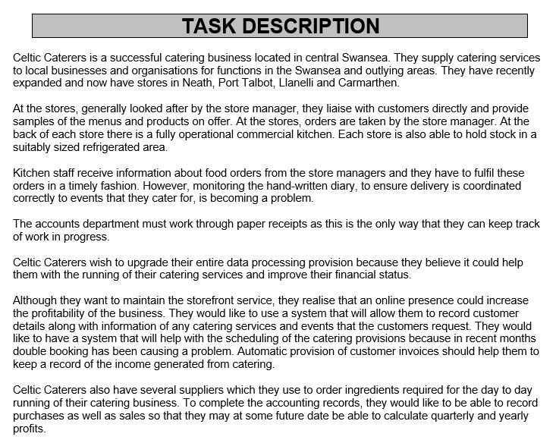
Figure 1 - Task Description
Figure 1 shows the task description for the desired system. This is the information which was provided to the system designer for them to create the database. The information covers the current situation of Celtic Caterers without the database system.

Design
This is the design section of the document, which contains diagrams of the designed system. These diagrams can be seen in Figures 2 and 3. The diagrams consist of a data flow diagram and an entity relationship diagram. They were designed using “Lucidchart”. Overall, the system designer thinks that Lucidchart has been extremely helpful in designing the system. From the vast amount of shape presets to the slick design, it’s been invaluable to the system designer. [1]

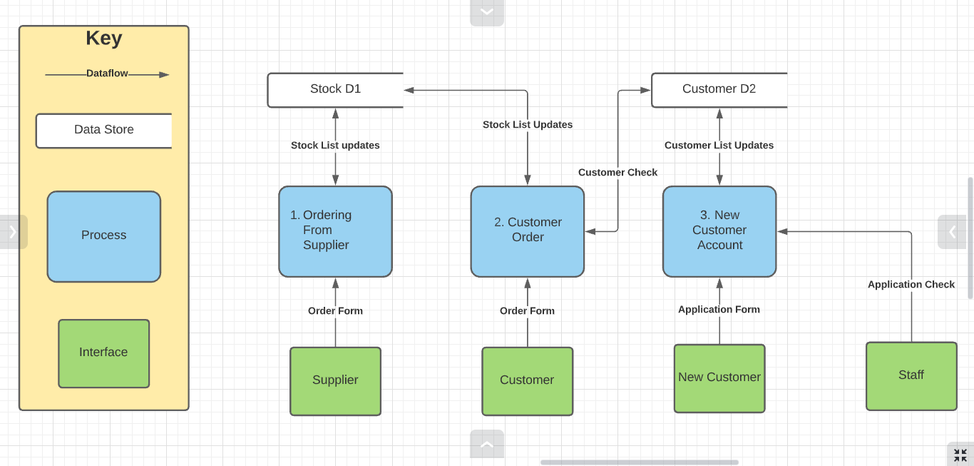
Figure 2 - Data Flow Diagram
Figure 2 shows the created data flow diagram, which is a level 0 diagram. The system designer has made this diagram based on the “Gane-Sarson notation” This is a diagram of how the system designer believes data will move as the business carries out normal business processes. The database will be made up around the first two processes, the new customer account process will likely just be a form in the database. The stock datastore represents the individual storages of each branch of the business, it won’t be a part of the database as the system designer thinks stock would likely be recorded per branch separately, as appose to all of the stock of all of the branches being merged together, the system designer doesn’t think that’s realistic. The customer data store will be a part of the database as the database should store the information of customer’s online orders. All of the data flows in the diagram could relate to forms or processes within the database. [2]

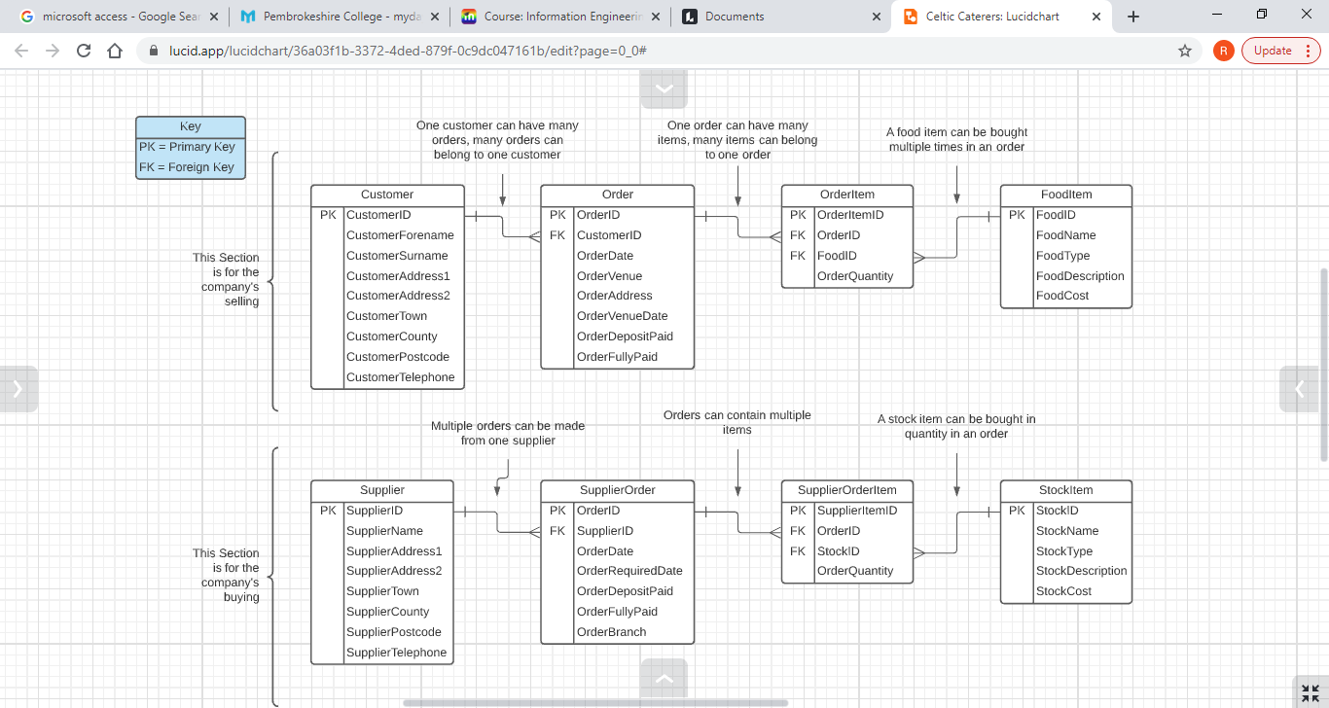
Figure 3 - Entity Relationship Diagram
Figure 3 shows the system designer’s entity relationship diagram. This entity relationship diagram uses the “Crow’s Foot Notion”. [3] This isn’t a traditional crow’s foot diagram as the system designer has decided to exclude the file types of the fields from the entities to reduce the overall size of the diagram, a larger diagram making the text harder to read without zooming in to the image. Instead, the system designer has made tables to show the data types in the entities, which can be seen in tables 1 to 7 below. [4]

Table 1 - Customer Entity Data Types
Table 2 - Order Entity Data Types
Table 3 OrderItem Entity Data Types
Table 4 - Supplier Entity Data Types
Table 5 - Order Entity Data Types
Table 6 - SupplierOrderItem Entity Data Types
Table 7 - StockItem Data Types
The system designer has tried to be sensible with the field sizing of these fields. He thinks assigning most of the fields with a short text data type to a size of 25 will make sure that the fields can be properly filled. Fields related to dates are set to 15 and fields related to postcodes are set to 10. He has set description fields to a field size of 100, which will hopefully be large enough to store descriptions of stock and food items. Quantity fields have been set to integers over large integers as food and stock won’t be ordered in ridiculous quantities.

Documentation

Tables
Figures below show the tables and fields of the database. Screenshots will consist of the design and datasheet views. You can see proof that some of the fields have the correct field sizes in the design view figures below. Getting proof for all of those fields would be quite excessive, so you’ll have to view the database itself if you want to check if the field sizes are the same as the ones specified in tables 1 to 7.
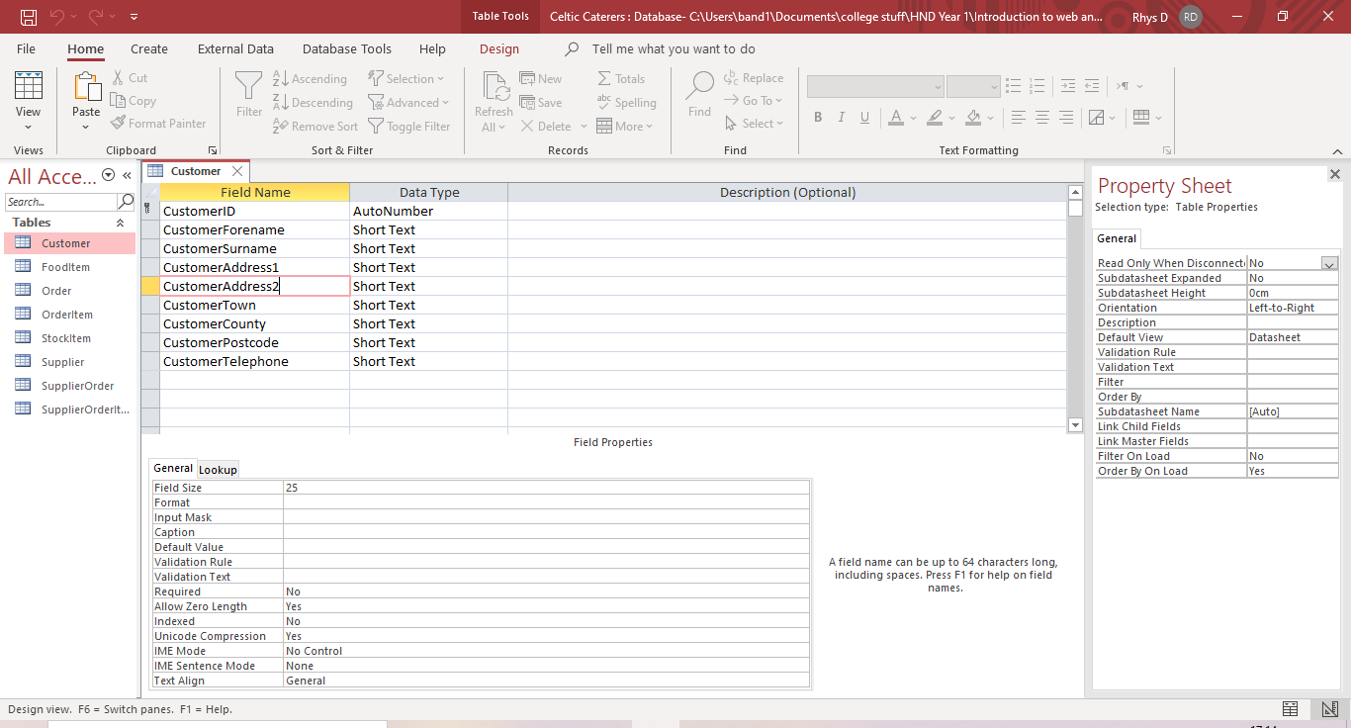
Figure 4 - Customer Table in Design View
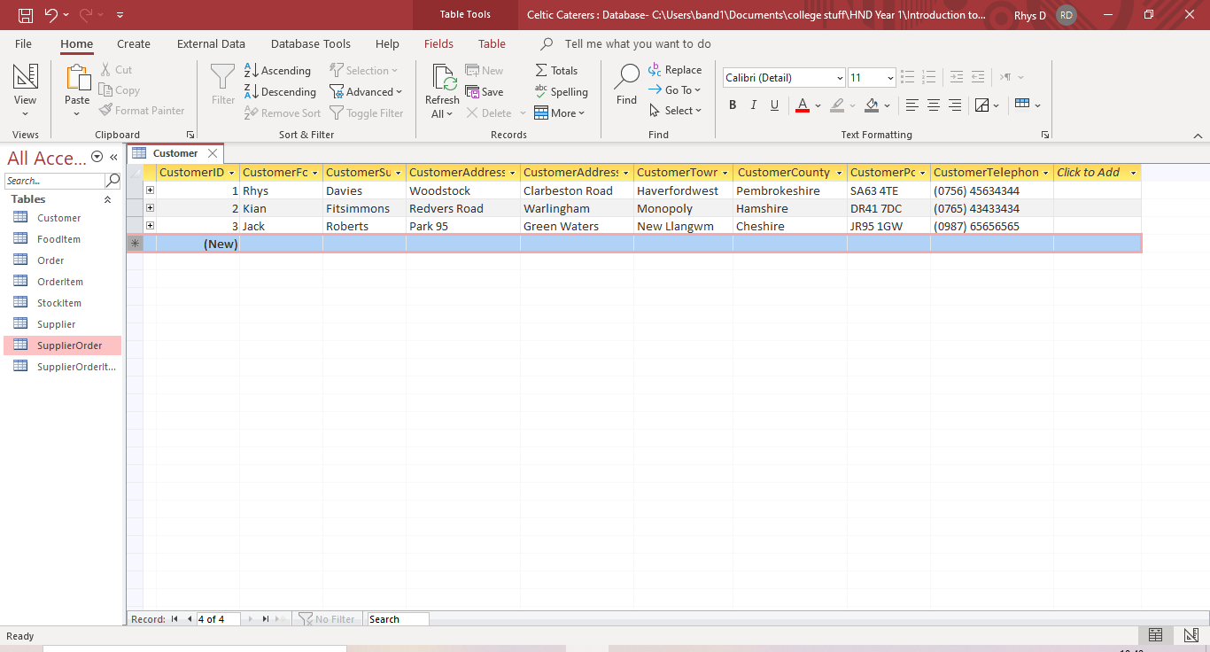
Figure 5 – Customer Table Datasheet View
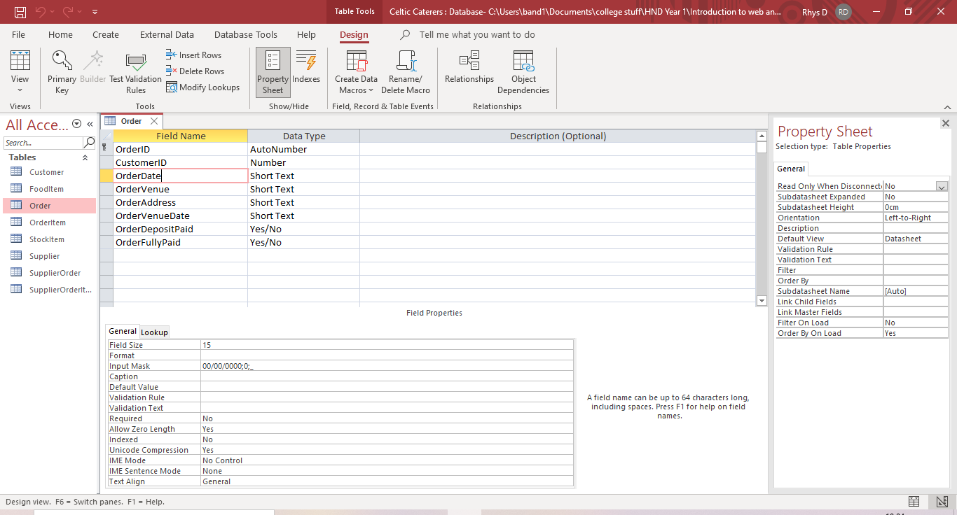
Figure 6 - Order Table in Design View
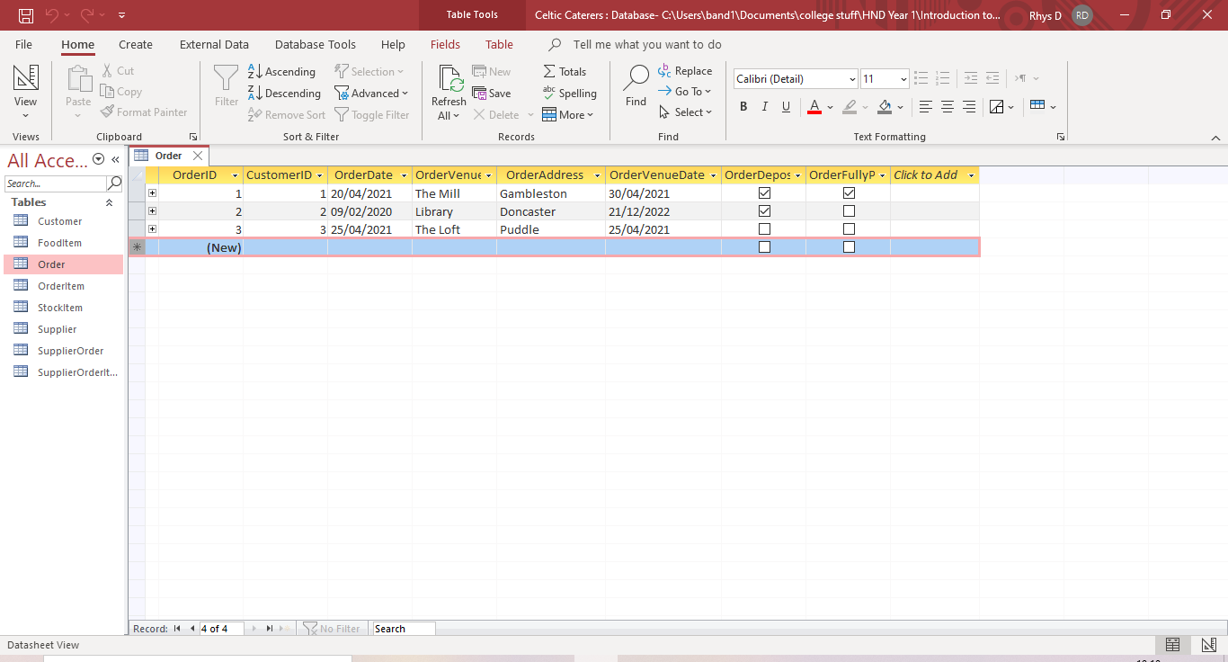
Figure 7 - Order Table Datasheet View
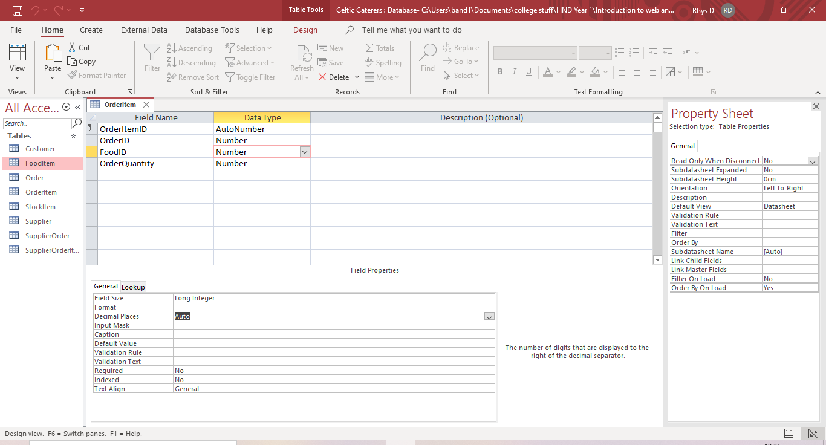
Figure 8 - OrderItem Table in Design View
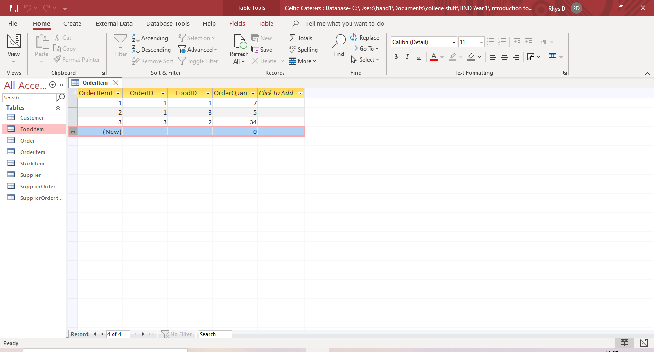
Figure 9 - OrderItem Table Datasheet View
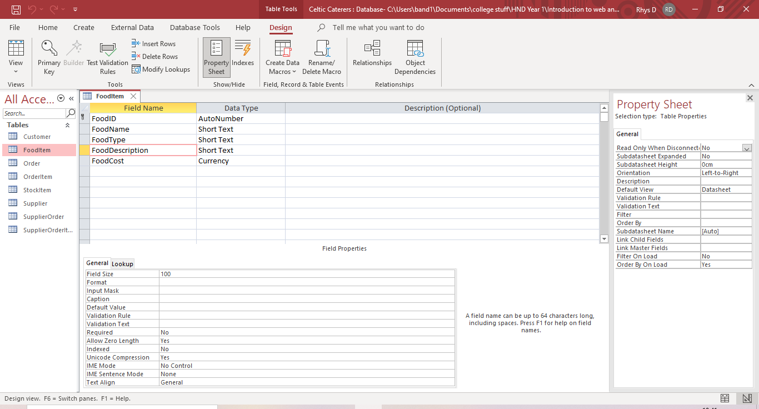
Figure 10 - FoodItem Table Design View
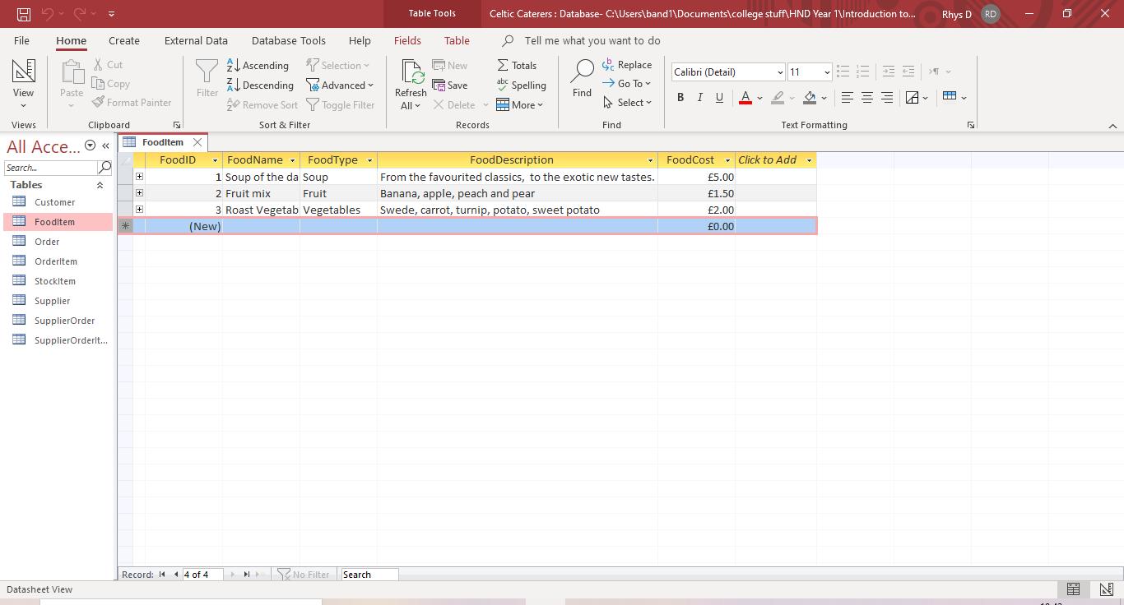
Figure 11 - FoodItem Table Datasheet View
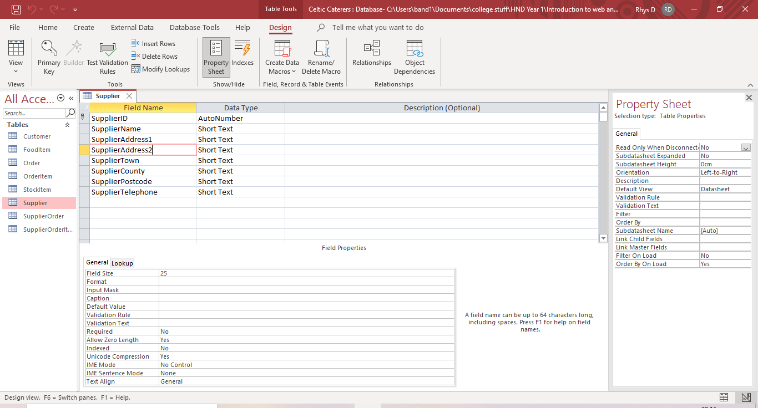
Figure 12 - Supplier Table Design View
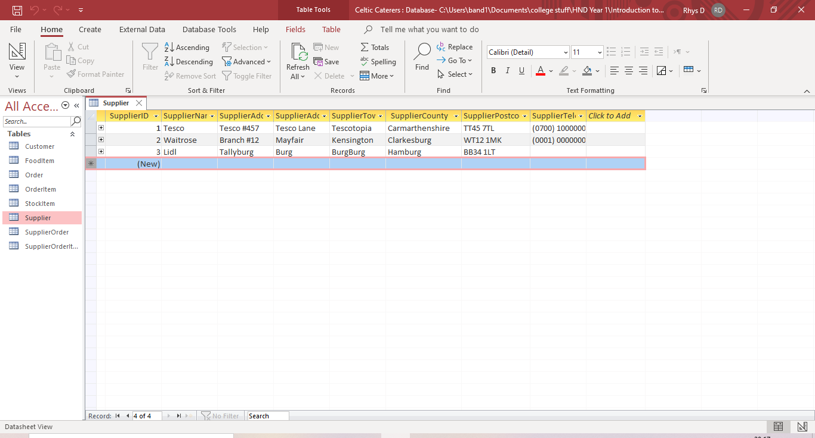
Figure 13 - Supplier Table Datasheet View
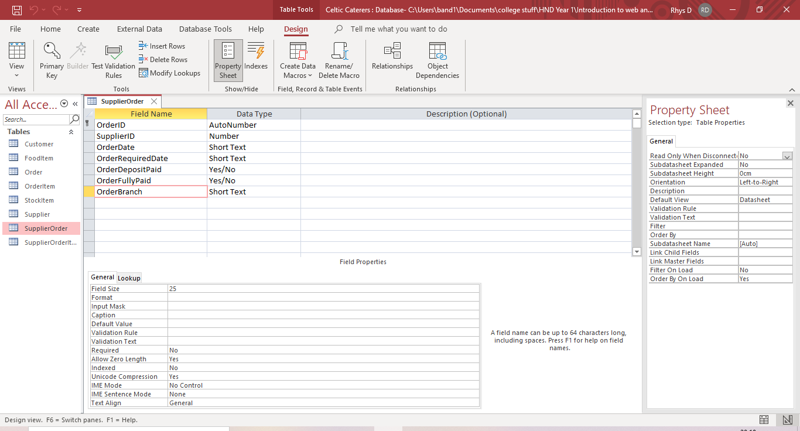
Figure 14 - SupplierOrder Table Design View
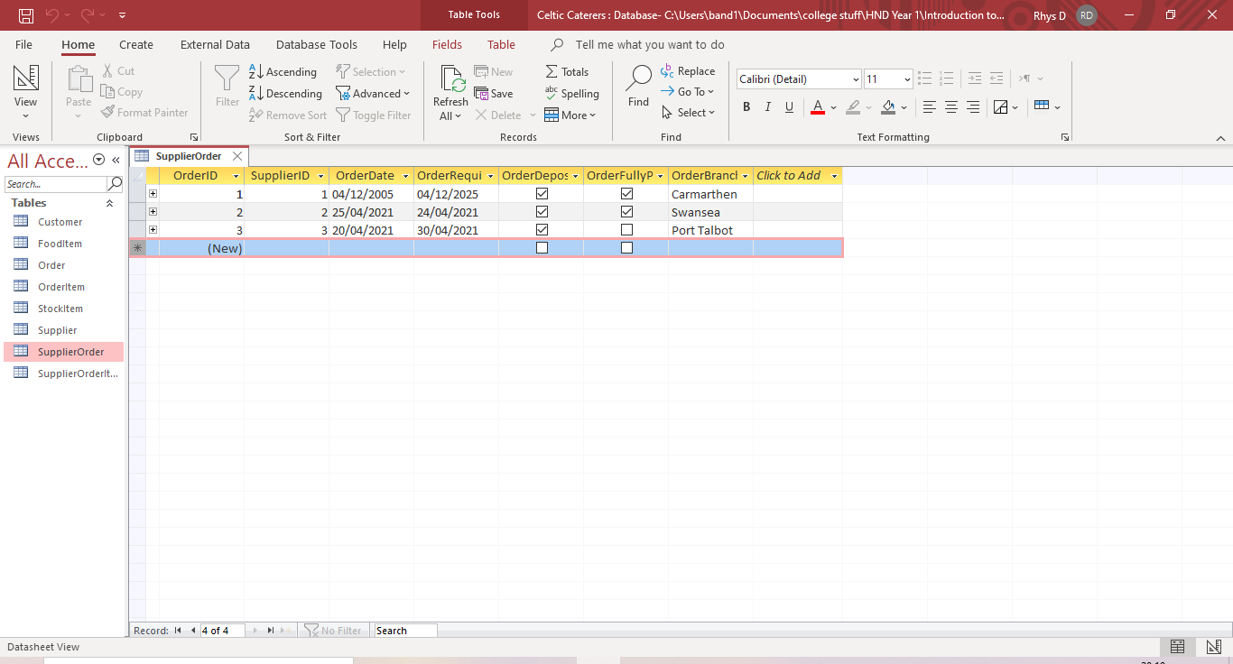
Figure 15 - SupplierOrder Table Datasheet View
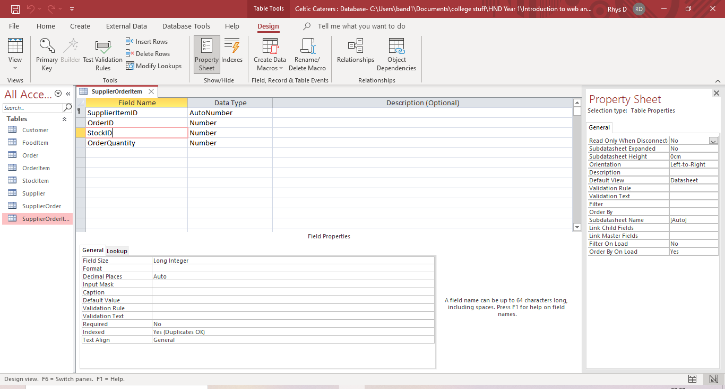
Figure 16 - SupplierOrderItem Table Design View
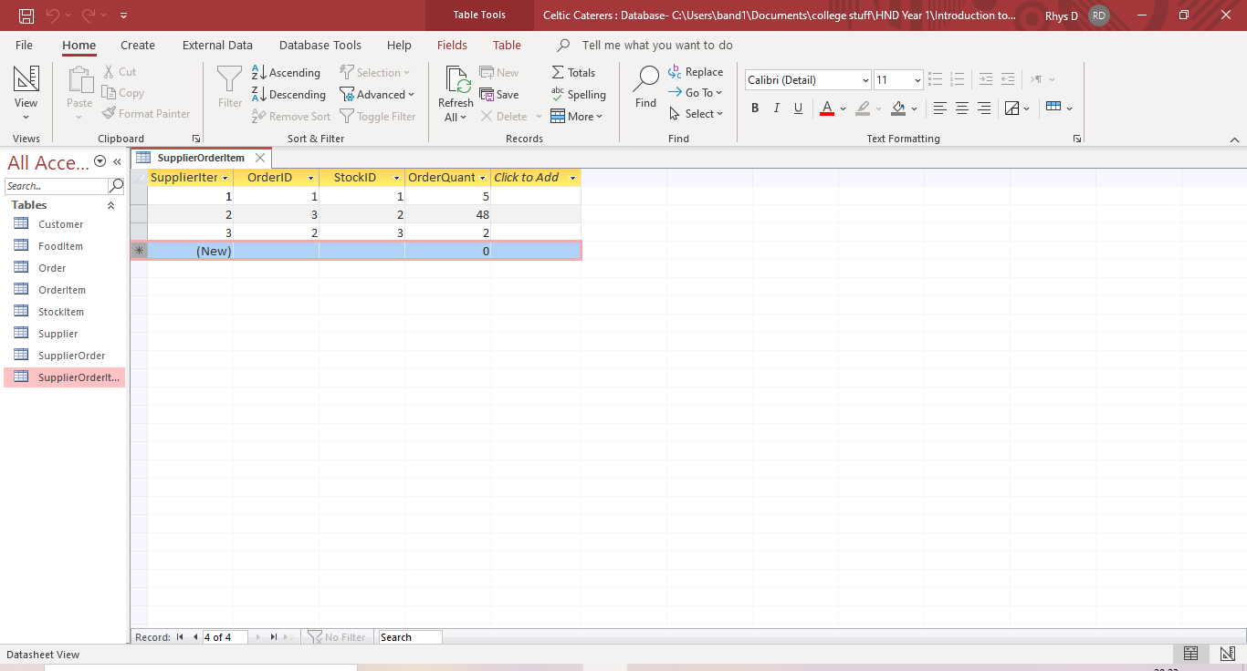
Figure 17 - SupplierOrderItem Table Datasheet View
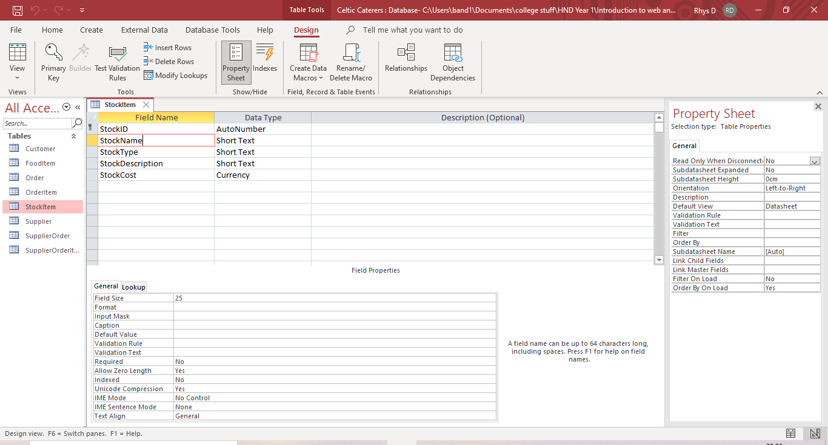
Figure 18 - StockItem Table Design View
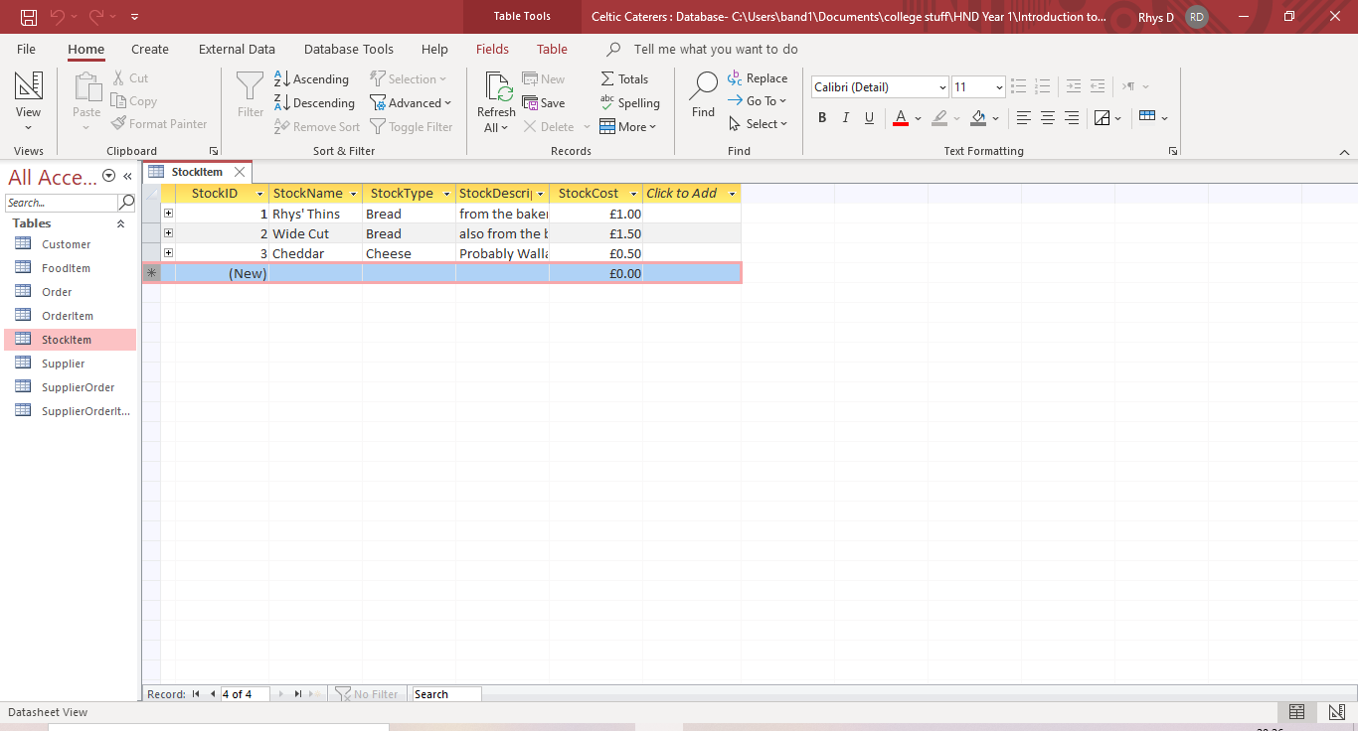
Figure 19 - StockItem Table Datasheet View

Relationships
Figure 20 shows the relationships between the tables in the database. The relationships have been set up exactly how they were planned in the entity relationship diagram seen in figure 3.
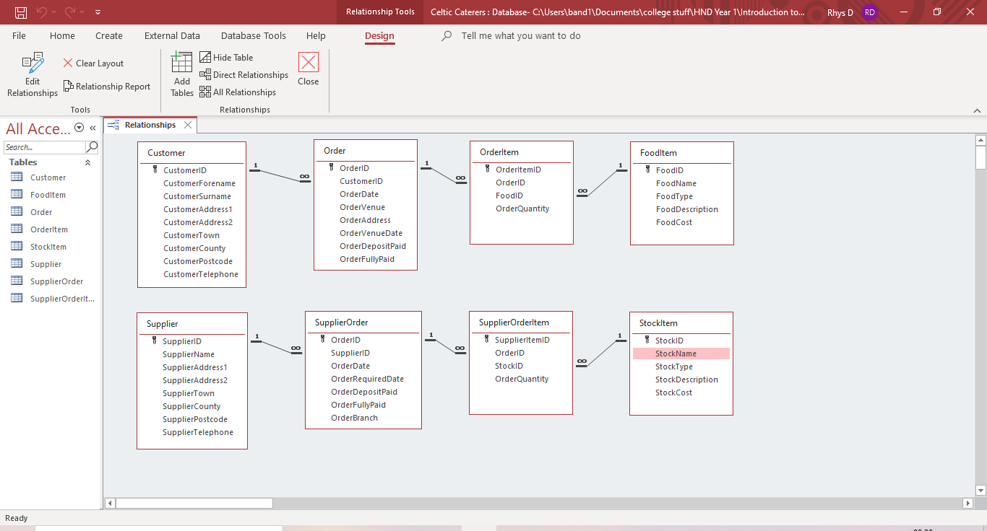
Figure 20 - Table Relationships in Database
The relationships work as intended. This can be seen when you attempt to add a new item to one of the tables with a foreign key. In figure 21, the system designer tried to add a new item to the order table. He tried to assign the order to customer 7. However, there isn’t a customer 7 in the customer table as there aren’t that many customers currently in the table, so an error message occurs. This shows that the CustomerID foreign key field is not allowed to be set to a figure that doesn’t exist in the customer table’s primary key field. The system designer sees that as evidence of the relationships working as intended and the database having levels of referential integrity.
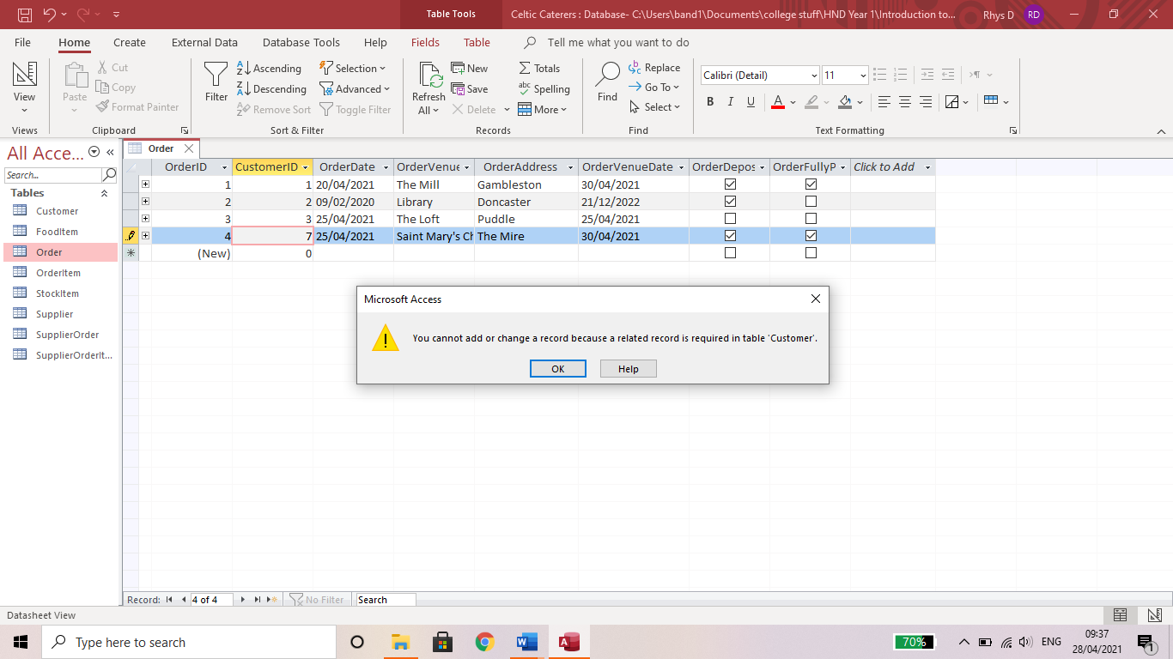
Figure 21 - Evidence of Working Relationships

Lookups
The system designer has decided to utilise list boxes to prevent users of the system from trying to add information to the foreign key fields which doesn’t already exist in the database. So, instead of allowing users to type in data for the foreign key fields, they’ll have to select the data they want from a list box. Figures 22 to 27 show how the list boxes were set up for the foreign key fields. Most have a column count of 2 to allow the names of the items to appear with the identification numbers. Figure 28 shows the supplier OrderID list box, which only shows the ID, and figure 29 shows the StockID list box, which has a column count of 2 so it shows the ID and the name. There is an additional lookup, shown in figure 30. The lookup in figure 30 was made to force the OrderBranch field to only allow the locations of the businesses existing branches. This can be seen in action in figure 32.
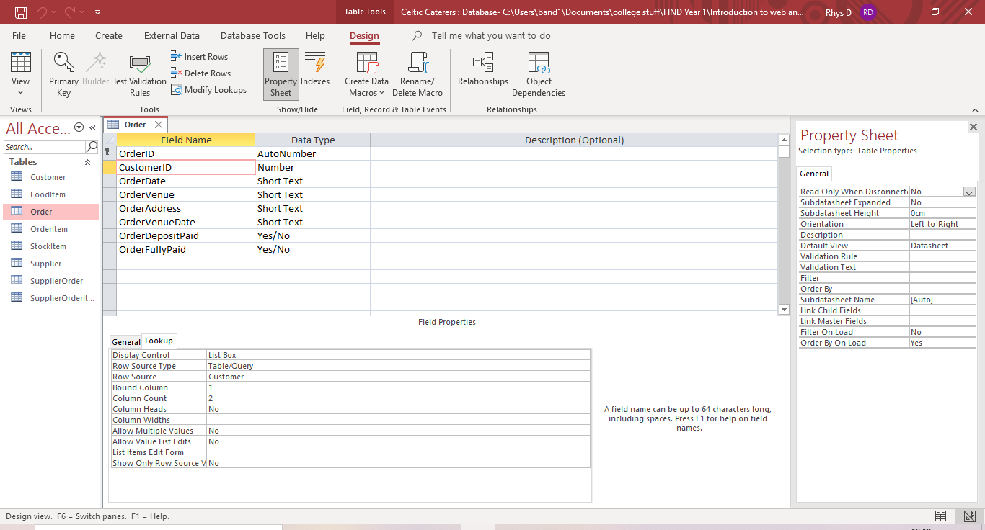
Figure 22 - CustomerID Lookup
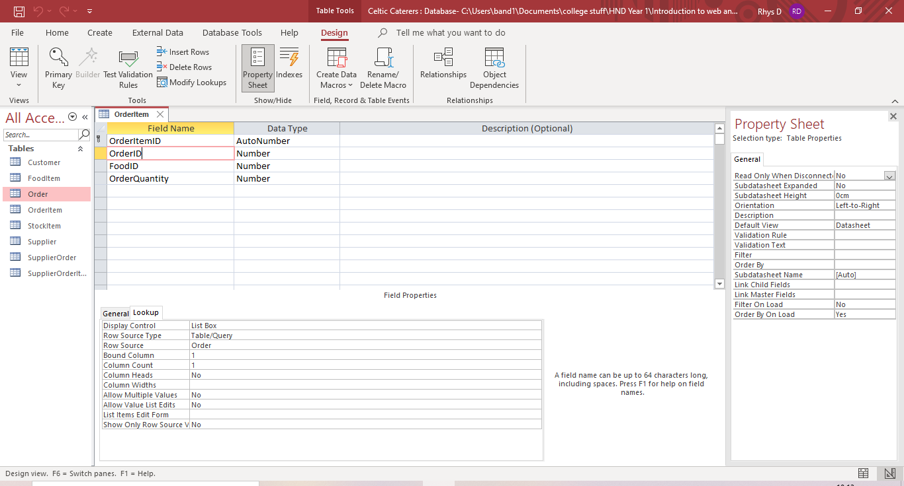
Figure 23 - OrderID Lookup
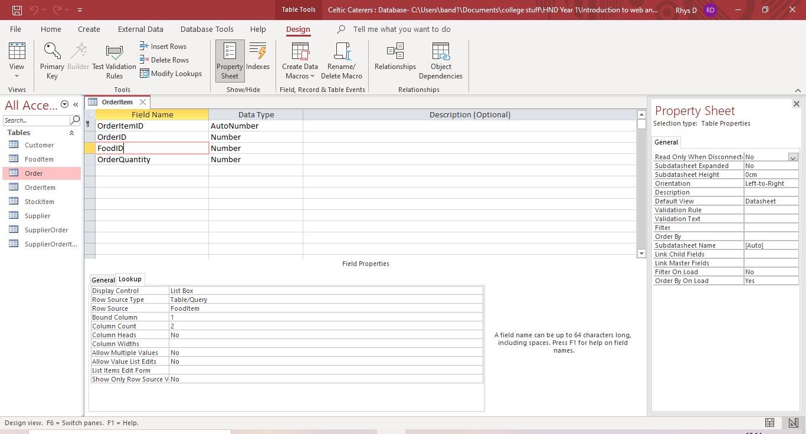
Figure 24 - FoodID Lookup
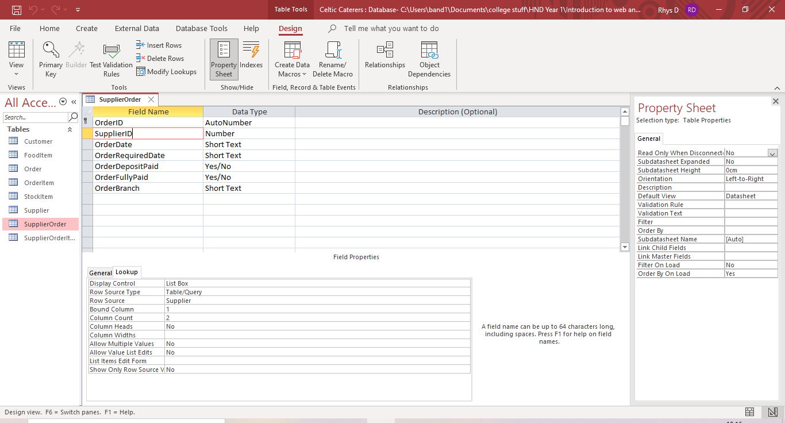
Figure 25 - SupplierID Lookup
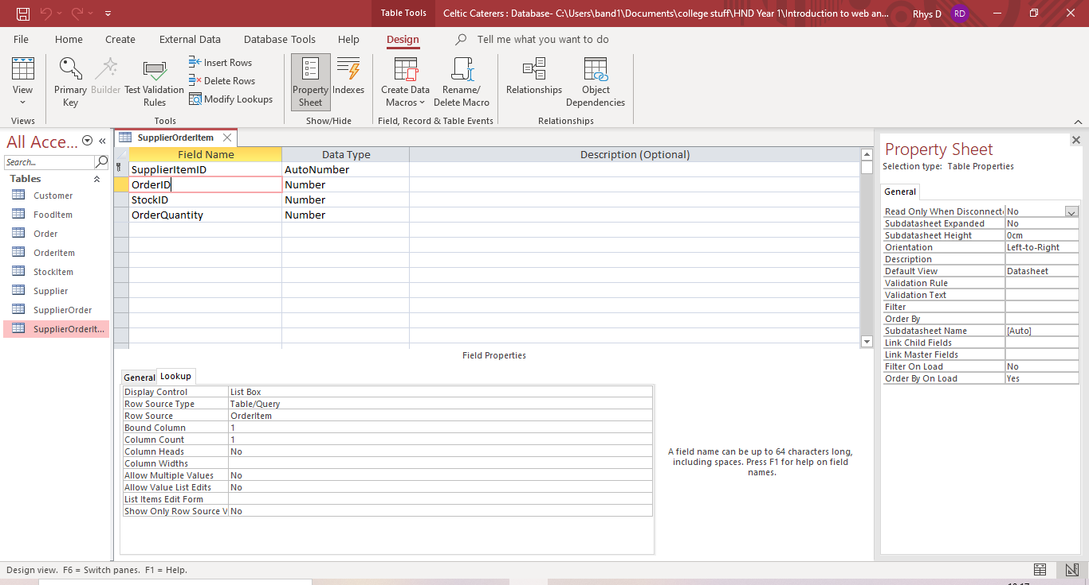
Figure 26 - Supplier OrderID Lookup
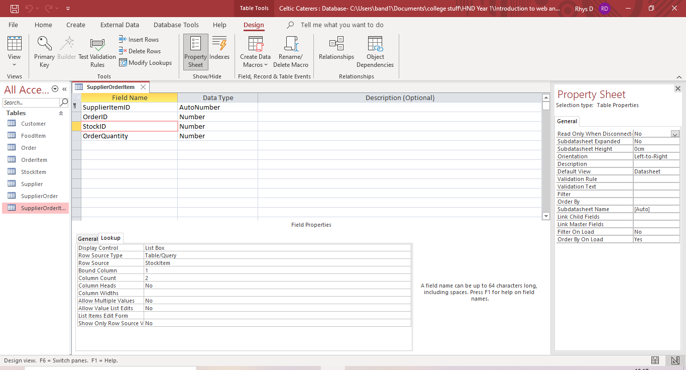
Figure 27 - StockID Lookup
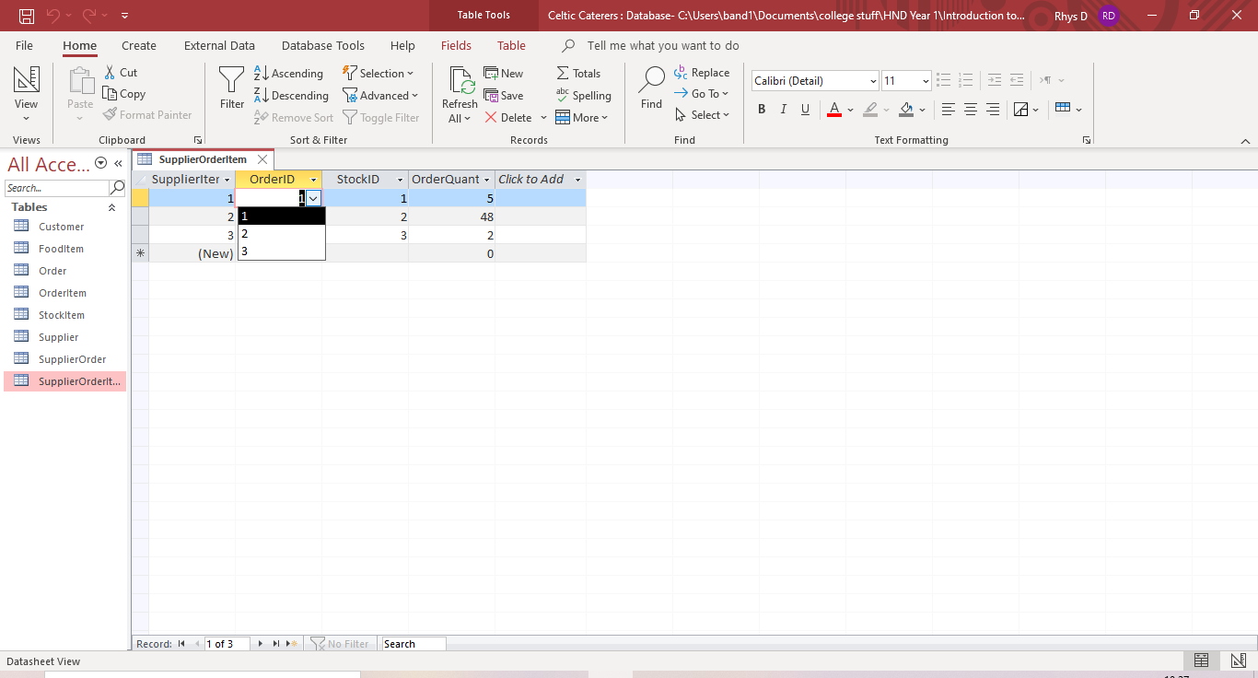
Figure 28 - OrderID List Box
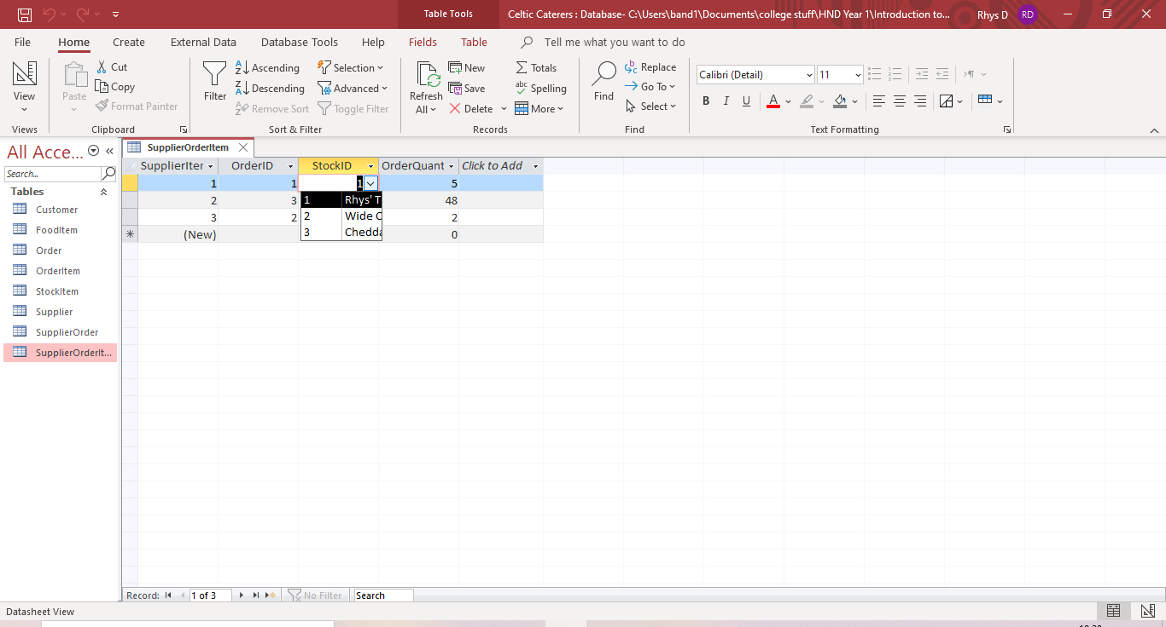
Figure 29 - StockID List Box
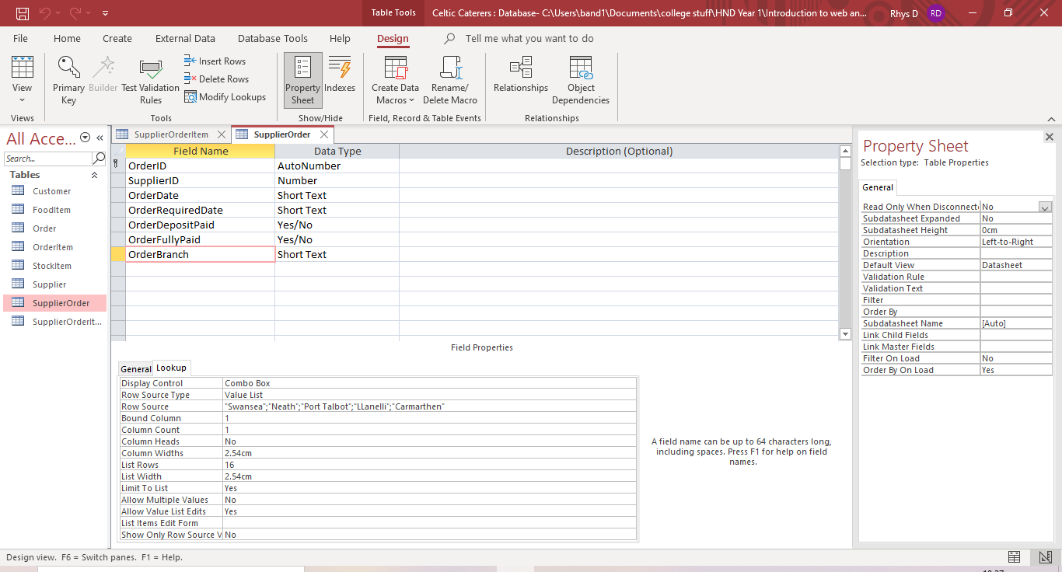
Figure 30 - OrderBranch Lookup
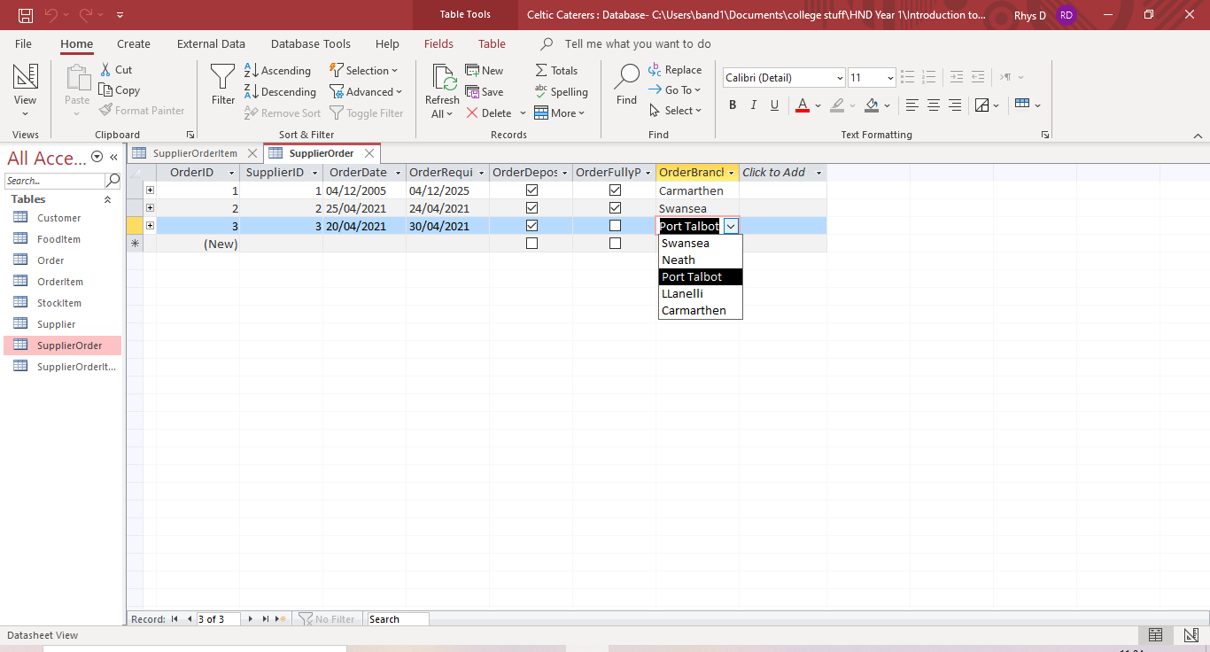
Figure 31 - OrderBranch Combo Box

Input Masks
Input masks are in place to aid users of the system while filling in information. They will only allow the user to input information in the format which has been specified. Figures 32 and 33 show input masks for the CustomerPostcode and CustomerTelephone fields. Input masks have been created for all postcode and phone number fields in the database. Figures 34 and 35 show the input masks working in the datasheet view.
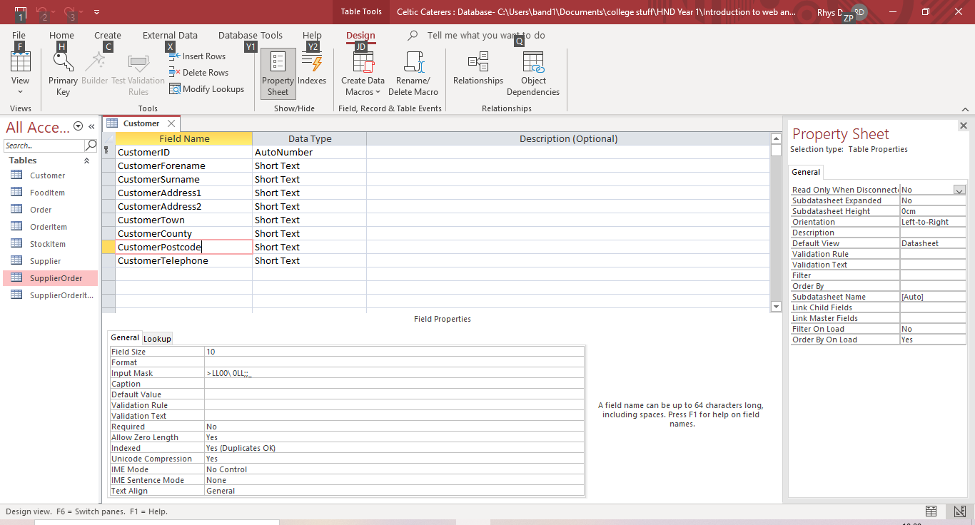
Figure 32 - Customer Postcode Input Mask
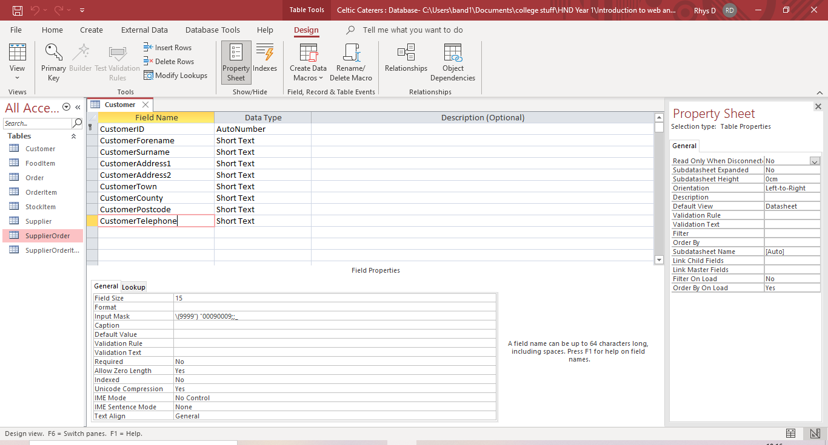
Figure 33 - Customer Telephone Input Mask
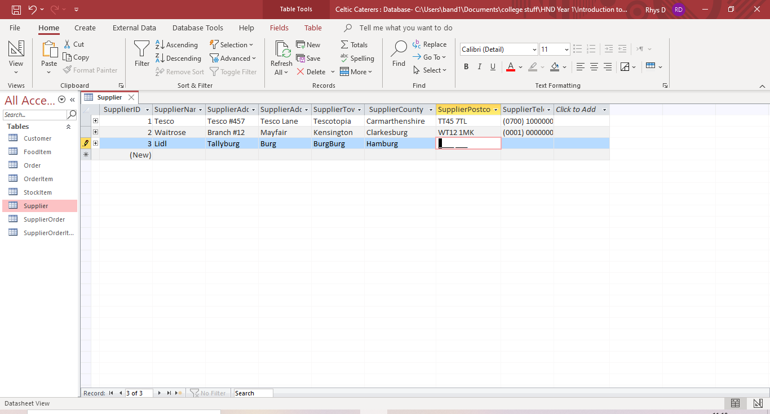
Figure 34 - Postcode Input Mask
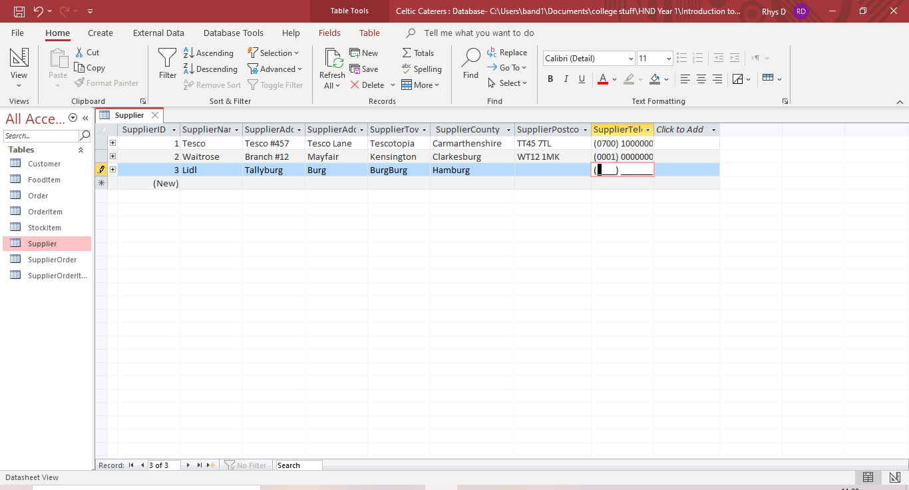
Figure 35 - Phone Number Input Mask

Forms
The system designer has created a form for each of the tables in the database, providing an interface for users to add and edit records into the tables. Figures 36 to 43 show the record forms.
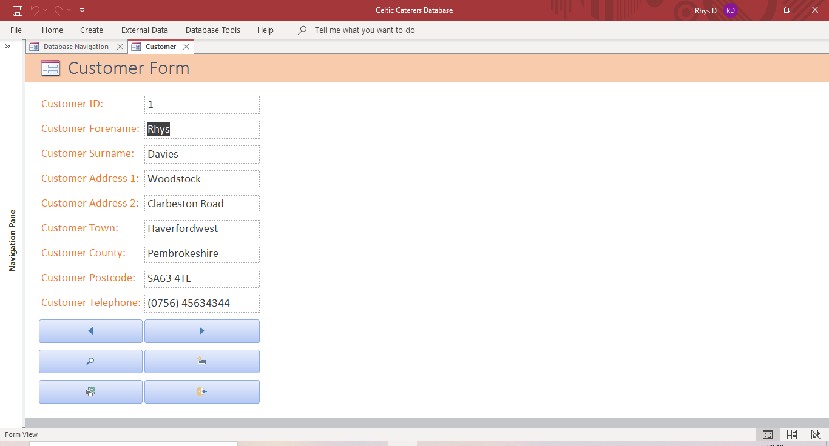
Figure 36 - Customer Form
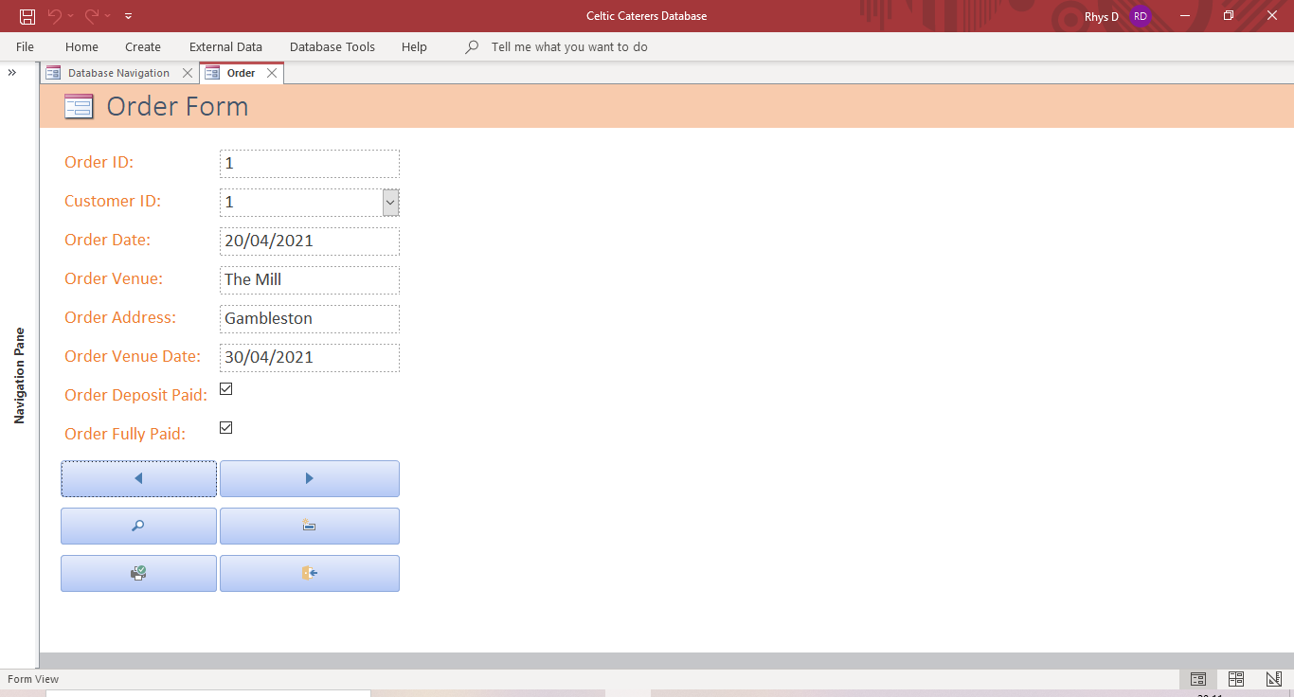
Figure 37 - Order Form
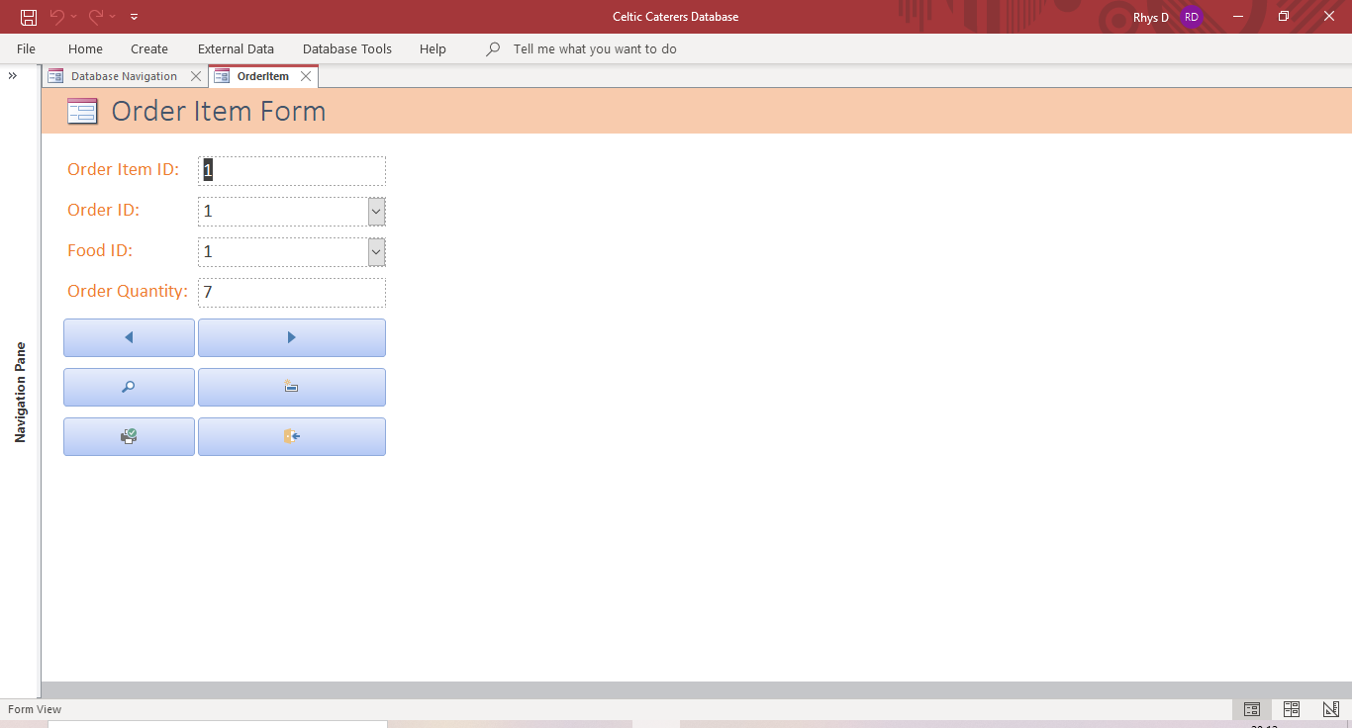
Figure 38 - Order Item Form
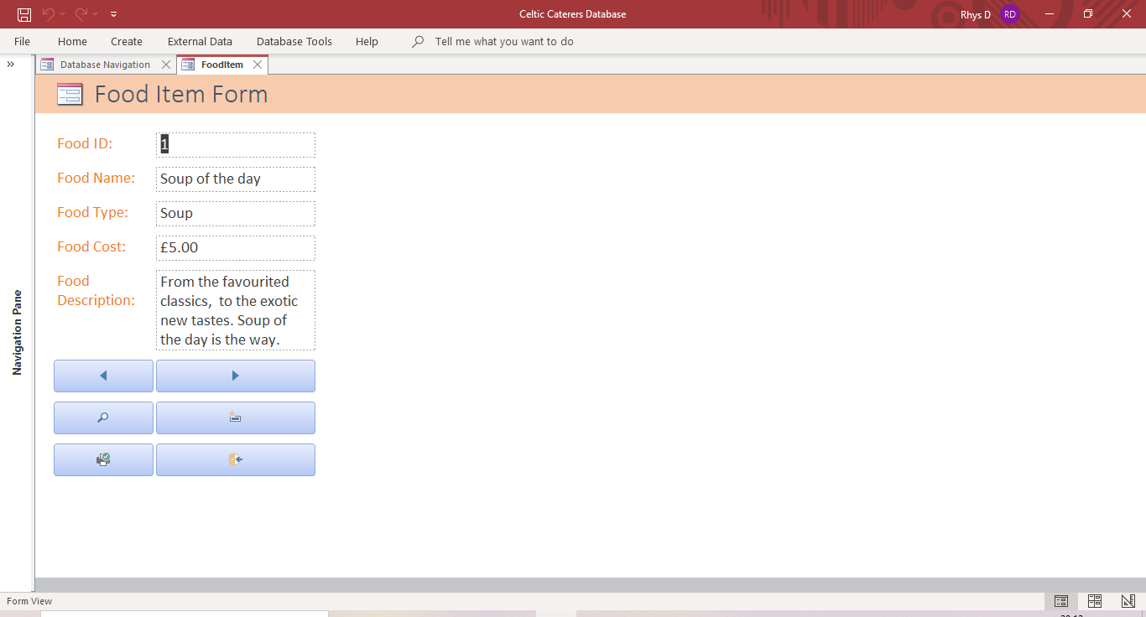
Figure 39 - Food Item Form
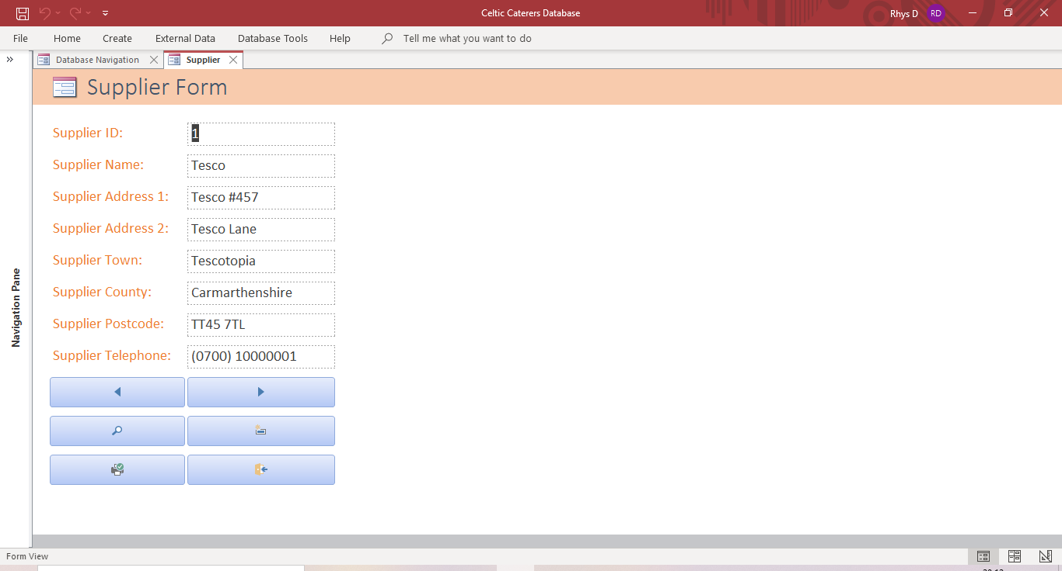
Figure 40 - Supplier Form
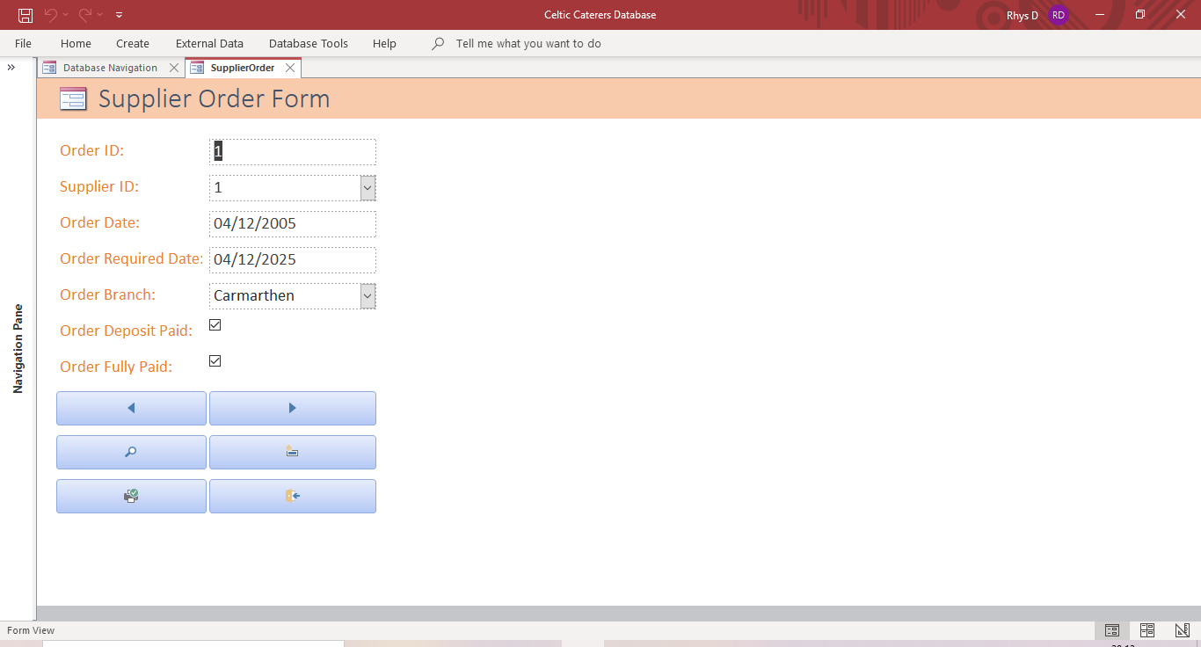
Figure 41 - Supplier Order Form
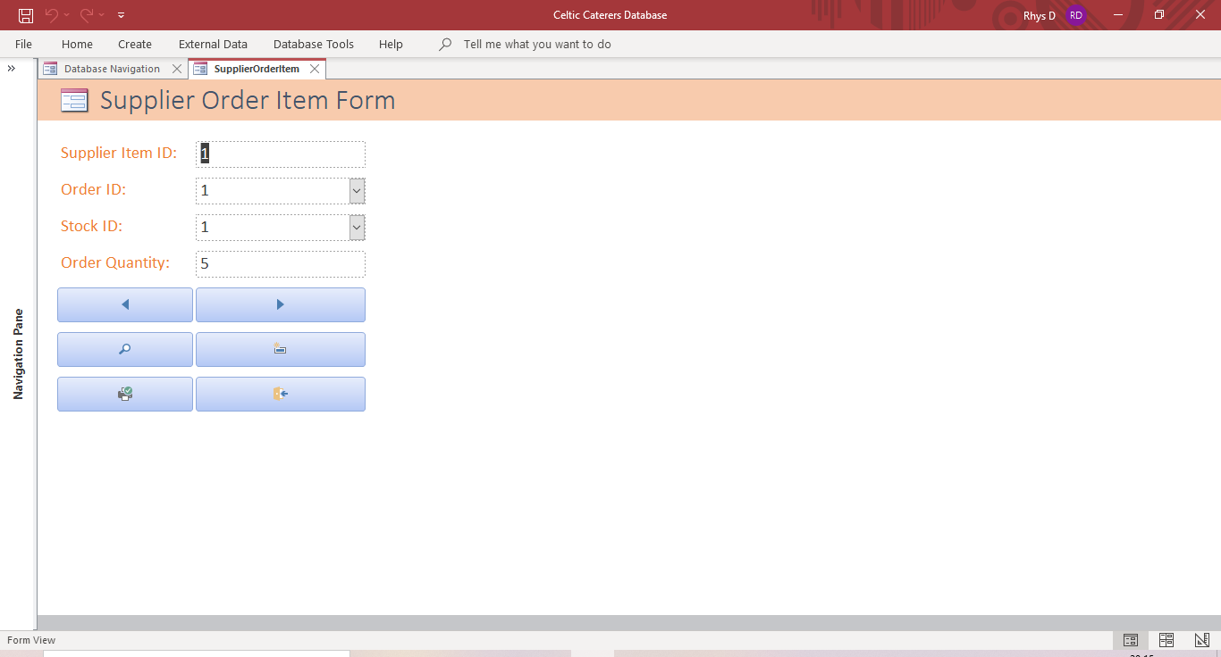
Figure 42 - Supplier Order Item Form
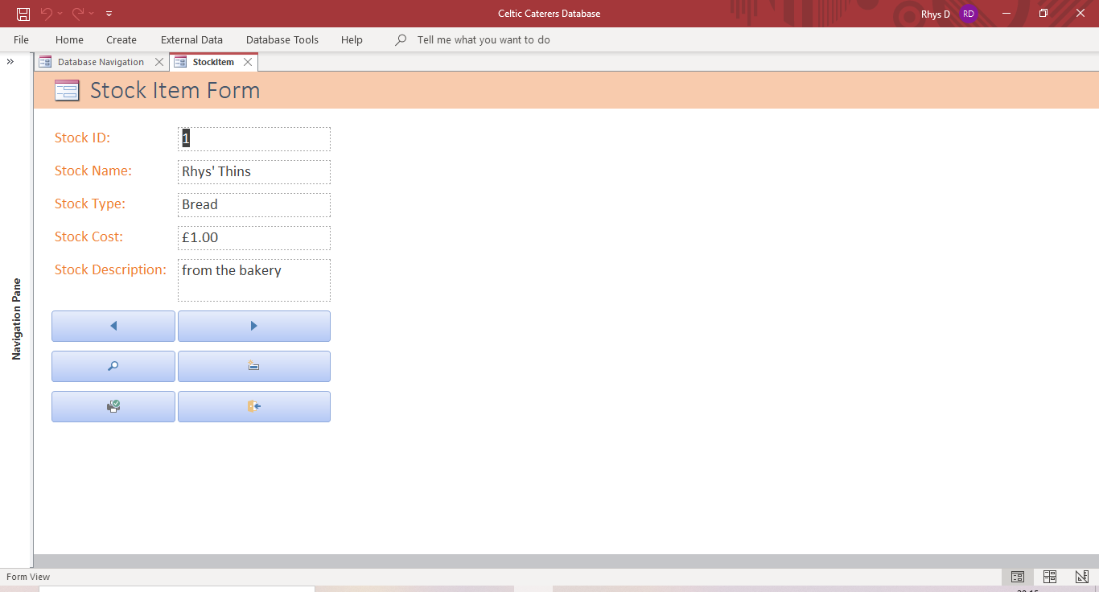
Figure 43 - Stock Item Form

User Guide
This is the user guide for the Celtic Caterers database, which will cover how to navigate and use the database effectively.

Database Navigation Interface
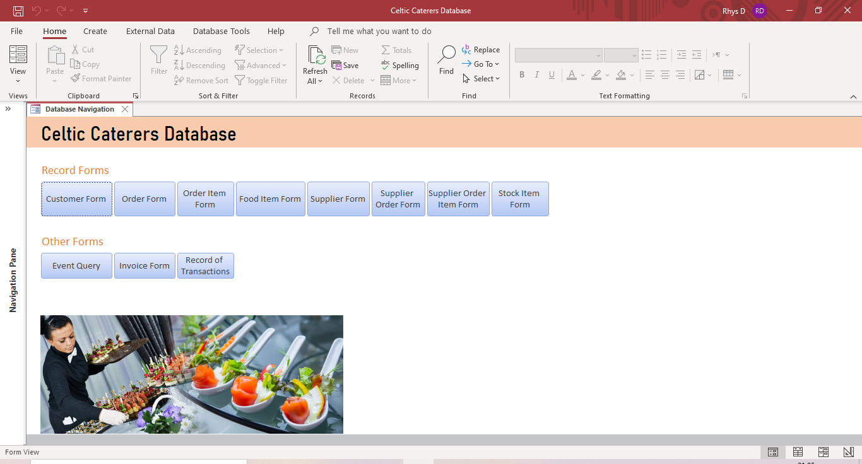
Figure 44 - Database Navigation Form
The database navigation interface is a form which contains links to other forms in the database. Due to the AutoExec macro, this navigation form will open whenever you start the database. Click on a button to open the form labelled on that button.

Record Forms
Figure 45 - Record Form
The record forms allow you to add and alter records in the database. Just click on the textbox that you want to edit. Alternatively, you can use the arrow keys on the keyboard to navigate the textboxes.
Figure 46 - Record Form Buttons
Each record form will include the buttons seen above. The arrow buttons will allow you to switch between records in the form. The button with the magnifying glass will allow you to search for a specific record. The button with the square and light icon located in the right middle will allow you to create a new record. The print button will allow you to print the current form and the exit button will allow you to close down that form.

Event Query Form
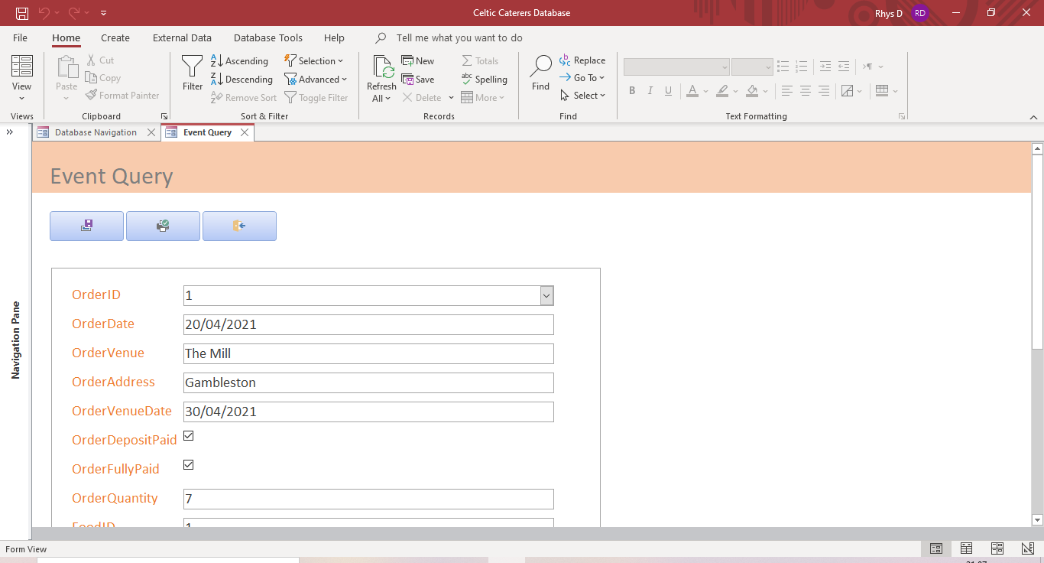
Figure 47 - Event Query Form
The event query form will allow you to look up and alter information related to customer orders and events. The top buttons allow you to save the record, print out the form and close the form. A sub form can be found under the buttons which contains the information regarding the customer orders and events.
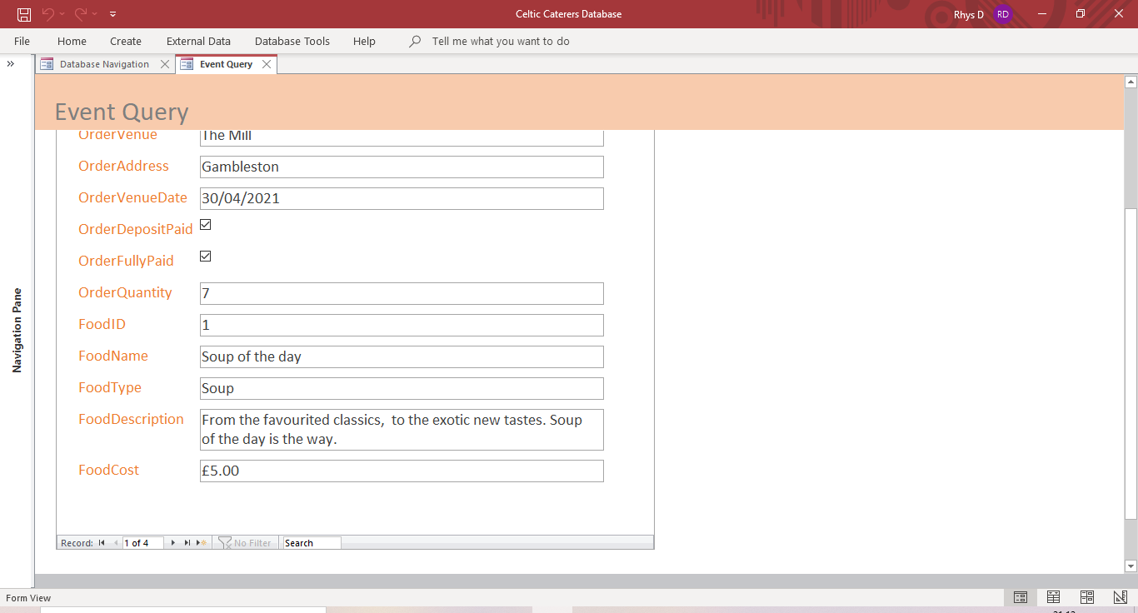
Figure 48 - Event Query Navigation Bar
A navigation bar can be found at the bottom of the sub form to allow you to move between and search records.

Invoice Form
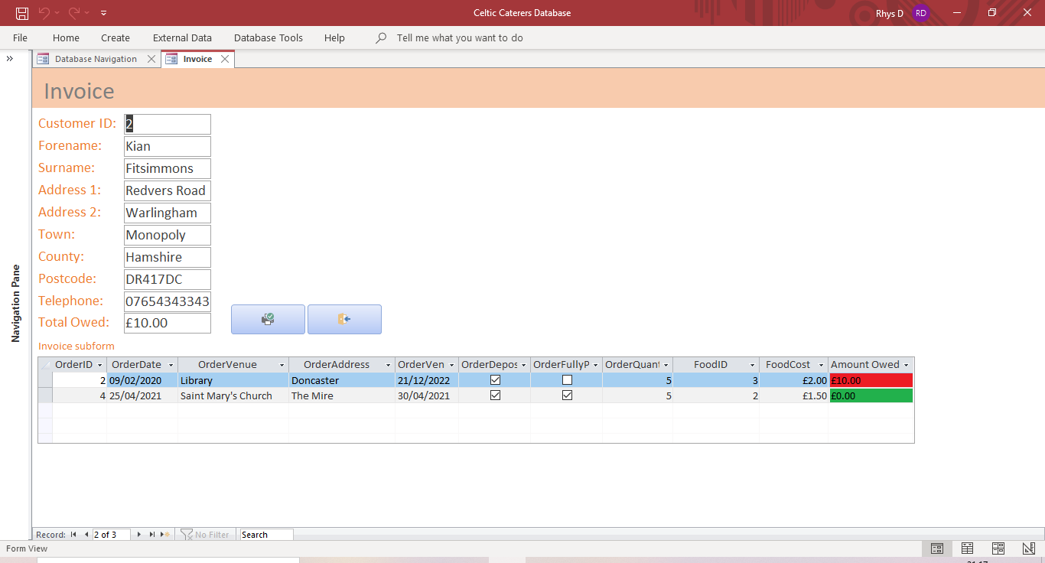
Figure 49 - Invoice Form
The invoice form will allow you to create an invoice for each customer. This would display the customer details, the total amount owed by that customer and all of the orders associated to that customer in a sub form. You can then print the invoice form using the print button, then use the exit button to close down the form when you’re finished. The invoice form also uses a navigation bar.

Record of Transactions
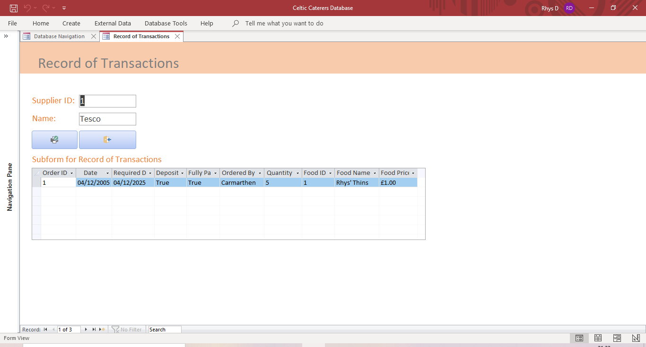
Figure 50 - Record of Transactions
The record of transactions form allows you to sort company orders by the supplier they were purchased from, allowing you to see all of the orders associated to each supplier. You can then print the form and click the exit button when you want to close the form. This form also makes use of a navigation bar to change which supplier is viewed.

Conclusion
The system designer has created a decently complex system but has tried to design it to be simple to use for the staff. He believes that the system will meet the requirements of Celtic Caterers. If more forms and tables will be required, the system designer can add them before the database is populated and utilised by staff. The already existing data in the database can also be deleted before the system is used.

References

[1] | “lucidchart.com,” [Online]. Available: https://www.lucidchart.com/pages/. [Accessed 2021].
[2] | “online.visual-paradigm.com,” [Online]. Available: https://online.visual-paradigm.com/knowledge/software-design/gane-sarson-dfd-tutorial/#:~:text=Gane%20Sarson%20notation%20uses%20straight,be%20altered%20in%20some%20way.. [Accessed 2021].
[3] | “www2.cs.uregina.ca,” [Online]. Available: http://www2.cs.uregina.ca/~bernatja/crowsfoot.html. [Accessed 2021].
[4] | “visual-paradigm.com,” [Online]. Available: https://www.visual-paradigm.com/guide/data-modeling/what-is-entity-relationship-diagram/. [Accessed 2021].

