Lainey Gallo (1900747)
November 2019
ECGE4002P: Academic study skills for students

Table of Contents

Portfolio task 1- Developing your skills: vision of success as a student-teacher
Create a digital mind-map of all the resources available to you as a university student………………………………………………………………………………………………………….. 2
Current skills audit…………………………………………………………………………………………. 3
What success would look like for me……………………………………………………………… 4
- Portfolio Task 2- Developing critical thinking
Summary of chapter 1- Critical thinking skills Stella Cottrell…………………………….. 5/6

- Portfolio Task 3- Developing critical writing
What I think about education in Wales…………………………………………………………….. 7/8

- References
…………………………………………………………………………………………………………………………. 9

Portfolio Task 1- Developing your skills: vision of success as a student-teacher
Create a digital mind-map of all the resources available to you as a university student.
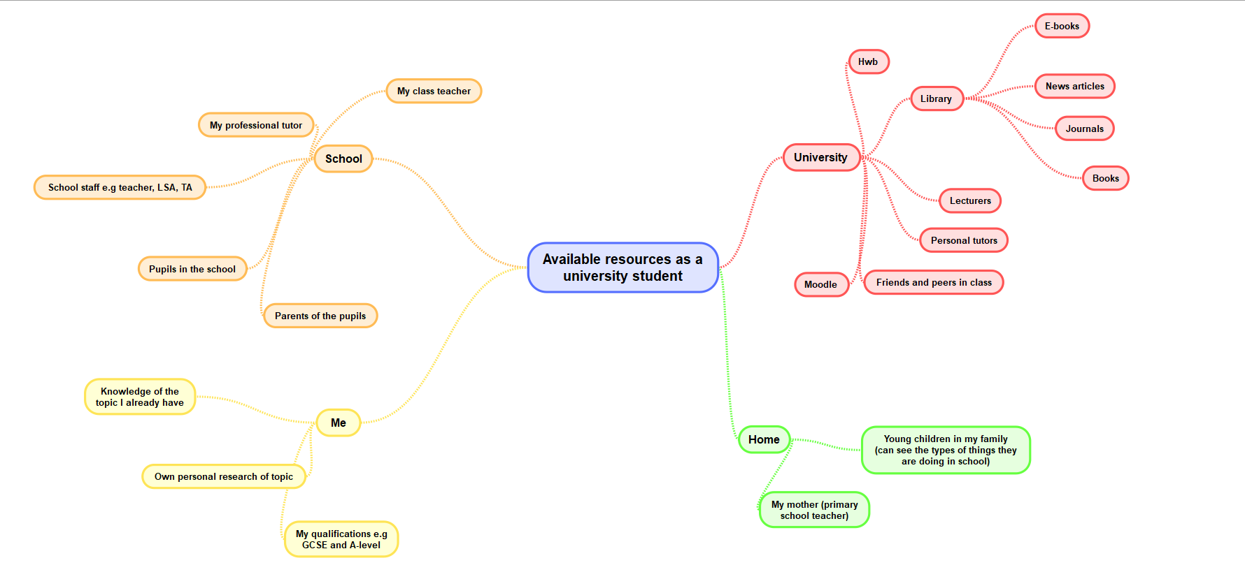

Current skills audit

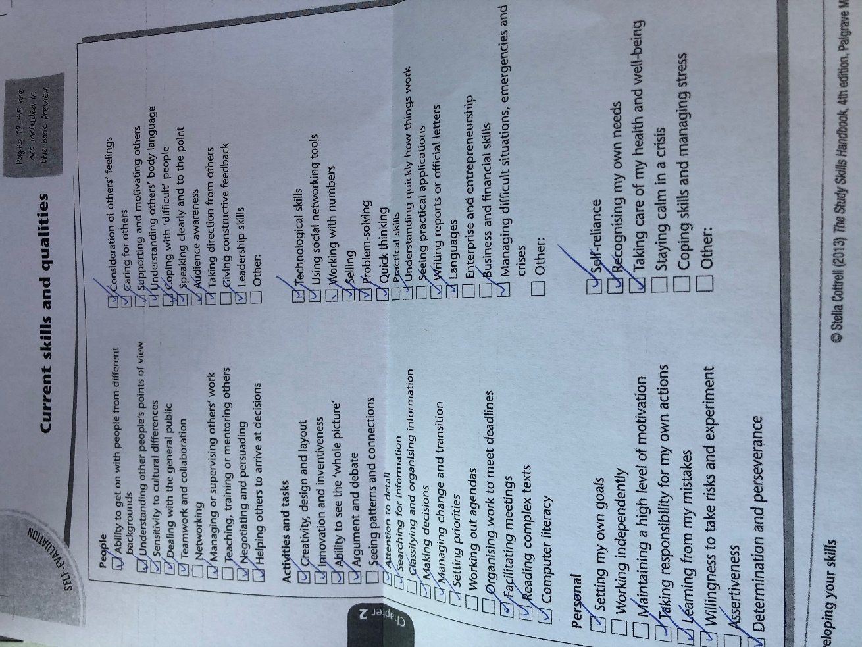

What success would look like for me.
I believe that success is different for every person. For me, success would be to gain my degree with first class honours. Following on from this, I would like to have a successful NQT year of which I secure a permanent teaching position. Being successful means having the ability to understand the mistakes I make in life but using these mistakes to better myself as a person. I also believe that being successful in my own life would mean me being happy in the career path I have chosen. Waking up each day and being excited to start the day in a job I love would truly show me how successful I have become. Ultimately, success would mean having a comfortable life financially, where I can travel the world and eventually have a family of my own. Most people would believe that having a job which has a highly paid income would mean they are successful. However, I believe that having an exaggerated amount of money has nothing to do with my own personal success. Me being happy in my life would prove how successful I really am.” Did you know that a study of the richest Americans revealed that 37% are less happy than the average American? If these people had been pursuing wealth as a means of happiness, that’s what we would call being ‘successfully unsuccessful’.” (Alison and David Price, 2011) I think this quote fits well with my opinion on success and shows that money doesn’t always equate to success.

Portfolio Task 2- Developing Critical Thinking
Summary of chapter 1- Critical Thinking Skills Stella Cottrell
Critical thinking is an activity which relies on the mind. To critically think, you use your mind to decide what is important and relevant, and what is not. However, many people find it difficult to use their critical thinking skills effectively. Personal reasons and emotions often create difficulties when using critical thinking. For example, if someone was angry, their critical thinking would not be the same as when they were calm.
Stella Cottrell’s book on Critical thinking shows the importance and benefits of critical thinking. Reasoning is an important aspect when discussing critical thinking. Reasoning and being rational are linked because when someone is being rational, they have a reason to be. Often, people are questioned about their beliefs and they then realise that they have little to no reason for believing in those things. Being able to present reasoning is also crucial when critically thinking. Cottrell uses the example of being asked why it is cold today. Using evidence, like a thermometer, is an example of presenting someone’s reasoning.
Cottrell notes that being precise in the way you think, and work is a benefit brought from critical thinking. Using this way of thinking helps people be more accurate and specific when they are questioning what is relevant and what is not relevant.
Cottrell claims that there are some skills which are useful when critically thinking. One skill which she thinks is vital is emotional self-management. Having your own opinion on a topic means that there will be opposing opinions on the same topic which may not agree with your own. These different opinions may make people feel extreme emotions such as anger. However, being able to manage these emotions and remaining calm will help get the persons point of view across in a much better way.
Self-awareness seems to be another key point in Stella Cottrell’s book. She claims that people who are good critical thinkers are usually self-aware. This means they can look at themselves and point out their flaws and what they need to improve. This helps them fill gaps in their own knowledge and find out things about themselves that they never knew. She also states that being able to question your own views is quite nerve wrecking and it takes a lot of courage to be able to sit and question your own opinions and thoughts.
Although Cottrell shows there are many benefits to critical thinking, she also shows that there are barriers too. One barrier which Cottrell talks about is over-estimating our own reasoning abilities. Everyday people rely on their own reasoning abilities and usually our brains are on automatic. The example that Cottrell uses for this is that we don’t have to question the safety of our toothbrushes every day and that’s something we don’t have to reason with. However, she claims it is easy for people to believe their reasoning, even if it is poor, because nobody has questioned it. Cottrell goes on to say, “Imprecise, inaccurate and illogical thinking does not help to develop the mental abilities required for higher-level academic and professional work.”
To conclude, critical thinking is a long process, but allows people to make choices and help influence others on their own choices.

Task 3- Developing Critical Writing
What I think about education in Wales
Education differs all over the world and this includes Wales. Wales is a unique country with a rich history and culture. This can be seen within the Welsh education system from the bilingualism of both Welsh and English being used in schools.
It is an exciting time to become a teacher as there is a new curriculum that is being introduced in every school throughout Wales. Professor Graham Donaldson and his team had various meetings throughout Wales to discuss the education system and for those involved in the education system to have their say. They also looked through many different reports and policies to try and find out more about the current education system. Through doing this, Donaldson found out many positive things about education in Wales such as National Literacy and Numeracy Framework and the foundation phase. However, teachers and students both said that the current curriculum was out-dated particularly on the digital side of education. The children also suggested that they, “wanted lessons to be fun, interesting and not something that were there just to pass assessments or get qualifications.” (Welsh Government, 2015). The writer agrees with this and thinks the Welsh curriculum has become somewhat stale and lacking in imagination and modern-day subjects. Technology is an extremely big part in children’s lives today, so having a curriculum which is inclusive of this seems vital to continue grasping the interest of children in school.
From having these meetings, Donaldson created the four purposes of the new curriculum. He created these four purposes to, “guide all future decisions about national and local educational priorities and underpin all teaching and learning in Wales.” (Welsh Government, 2015). The four purposes are ambitious capable learners, ethical informed citizens, enterprising creative contributors and healthy confident individuals. These purposes are embedded in the new curriculum and fit in with the six areas of learning. The six areas of learning (Expressive arts, Humanities, Health and well-being, Language, literacy and communication, Mathematics and numeracy and Science and technology.) all have equal significance in the curriculum and will help children and young people in Wales to have an enriched and exciting education.
The new curriculum has removed key stages and phases and are replaced with progression steps that start from 5 to 16 years of age. This means that learning is continues throughout primary and secondary school. The curriculum has also gotten rid of levels and outcomes which means that learning is individual to each child and the pressures of attainment are diminished.
To conclude, I believe that although the current curriculum does have a few positive point, the new curriculum is much more up to date and education in Wales at this time is innovative and diverse and ultimately it is one that is going to help shape the successful futures of every child in Wales.

References
Price, D and Price A. (2019) Psychology of success. (online) Available at: https://www-dawsonera-com.ezproxy.uwtsd.ac.uk/readonline/9781848313323 (Accessed 15th October 2019)
Stella Cottrell (2005) Critical Thinking Skills. Hampshire: Palgrave Macmillan
Welsh government (2015) ‘Successful futures’, Looking at the curriculum and assessment arrangements in Wales, pp. 2-10. https://gov.wales/sites/default/files/publications/2018-03/succesful-futures-a-summary-of-professor-graham-donaldsons-report.pdf
Evans, G. (2015) ‘The Donaldson Report: An-at-a-glance-guide’, Wales online 25th February. Available at: https://www.walesonline.co.uk/news/wales-news/the-donaldson-report-an-at-a-glance-guide-8713671 (Accessed 25th October 2019)
Lemke M. (2018) Successful futures? New economy business logics, child’s rights, and Welsh educational reform. Available at: https://journals-sagepub-com.ezproxy.uwtsd.ac.uk/doi/full/10.1177/1478210317751269 (Accessed 24th October 2019)

