

Investigates the Strategic Importance of Guest Satisfaction in Achieving Operational
Case Stady of Novotel Milton Keynes

BA Internationa Hotel Management
Module name: Hotel Placement Project
Module code: BMIH6008
Student name: Alina Boestean
Student number: 2207646
Supervisor: Chris Wilkin
Date: 12.06.2025

AI Declaration
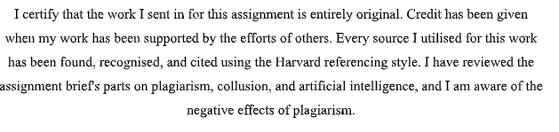

Acknowledgement
I would like to sincerely express my gratitude towards family, supervisor, placement hotel, university, department, friends. My supervisor has provided me their constant guidance and encouragement throughout.

Abstract
The research focuses on why guest satisfaction is important for operational goals by analysing the case of Novotel Milton Keynes. The research looks at the connection between satisfaction and important business metrics, showing how service quality affects the company. When looking at employee opinions and customer satisfaction together, the research gives an even assessment of how happy everyone is. Concentrating on Novotel Milton Keynes, the study develops useful knowledge for local hotel operations. The goal is to show how employee satisfaction helps an organisation run well and stay viable in the future. By using both survey and interview, the researcher collected detailed background information. A majority of guests reported being very happy with the services they received, covering cleanliness, cheque-in and the food. Most people who stayed said they liked their visit. The interviews indicated that essential roles in providing satisfaction are staff training, suitable tools for communication and instant feedback. Employees on the front lines pointed out how short-staffing and managing guest wishes are challenges, yet they still demonstrated they are flexible and able to keep emotions in check.
The satisfaction of guests was found to determine things like occupancy rates, repeat business and the business’s online image. Results from the data suggest that when all departments cooperate, visitors get the same quality of service and improved interactions. Management mentioned that updates, team discussions and using performance dashboards all show employees how important guest opinions are. Because of these systems, all departments can agree on a vision and everyone was made more responsible. Credit for satisfaction in an organisation belongs to its working teams, not just to leaders. The results point out that strong teamwork among various departments is key to keeping a high-performance hotel atmosphere. Improving job satisfaction and making service delivery constant followed a major strategy of training staff. Staff participants in training programmes for both technical skills and soft skills which made them more confident and better able to respond to guest demands. Classes in cultural awareness, empathy and resolving complaints helped people in the company work through many different situations well.
The difficulties managers face were analysed to see what barriers there are to completing tasks. There were regular reports of problems including a lack of employees, language problems and difficult guest demands during interviews. Yet, staff pointed out that good communication, creative ideas and a bit of empathy made it easier to get around these challenges. By planning the workforce and scheduling more efficiently, major steps can be taken to handle these repeated issues. Working to please guests when there is pressure reveals how important it is to adapt operations when following brand guidelines. It is shown by the research that being adaptable and ready helps safeguard the guest experience when things are limited. Using the findings, it is suggest some actions for Novotel Milton Keynes to improve guest satisfaction even more. That means using a system that remembers what customers prefer so they have a better experience each time they come back. At times when many guests arrive or when there is breakfast service, adding staff members may relieve the workers and lower guests’worries. Easier mobile key access and smart TV upgrades would please today’s guests. Also, investing in continuous training and improving the way internal feedback happens would keep improvements going in each area.

Table of Contents
AI Declaration 2
Acknowledgement 3
Abstract 4
1 Chapter 1 Introduction 8
1.1 Context 8
1.2 Overview of Case Study 8
1.2.1 Theme 8
1.3 Research Aim 9
1.1 Research Objectives 9
2 Chapter 2 Literature Review 10
2.1 Introduction 10
2.2 Guest Satisfaction 10
2.3 Importance of Customer Satisfaction in Hospitality 10
2.4 Customer Satisfaction and Operational Goals 11
2.5 Challenges in Aligning Guest Satisfaction with Operational Goals 11
2.6 Theoretical framework 12
2.6.1 Expectancy Disconfirmation Theory 12
2.6.2 Equity Theory 12
2.7 Research gap 12
2.8 Chapter Summary 13
3 Chapter 3 Methods 14
3.1 The Case Study Methodology 14
3.2 Associated Case Study Techniques 14
3.3 Methods Employed 14
3.4 Ethical Considerations 15
4 Chapter 4 Findings and Discussion 16
4.1 Descriptive Analysis 16
4.2 Statistical Analysis 22
4.3 Interview Analysis 24
4.3.1 Service Touchpoints as Key Drivers of Guest Satisfaction 24
4.3.2 Internal Communication and Organisational Alignment 25
4.3.3 Training and Capability Development for Service Excellence 25
4.3.4 Operational Challenges and Adaptive Strategies 25
4.3.5 Staff-Driven Recommendations for Service Improvement 26
4.4 Discussion 26
4.4.1 Survey 26
4.4.2 Interview 28
5 Chapter 5 Conclusion and Recommendations 31
5.1 Conclusion 31
5.2 Recommendations and Practical Strategies 33
6 References 36
7 Appendix 44
7.1 Survey Questionnaire 44
7.2 Interview Questions 47

Chapter 1 Introduction

Context
According to Troung et al., (2022), service novelty is acute for enhancing customer satisfaction. Furthermore, customer perception is driven through innovative service clues. Furthermore, according to Alharbi (2024), transformational leadership helps transport proper alignment (Ali, 2024) between planned supervision and tactical achievement in the hospitality sector. Furthermore, hospitality industry is a customer-driven, hospitality industry is suffering from dilemma in regard to the customers (Cavique et al., 2022). Furthermore, gueest reception operations, rate structuring and revenue models, client engagement and communication techniques, interior ambiance and spatial aesthetics, comprehensive corporate and operational frameworks help to boost employee productivity and fiscal gains (Intiar et al., 2024).

Overview of Case Study
Novotel Milton Keynes is a modern 3-star hotel located within the outskirts of the city centre in Milton Keynes, United Kingdom. Located in a quiet area at the edge of Stanton Wood, the hotel is a family-oriented setting and is approximately a four-minute walk from the town centre. It is also conveniently located near major attractions, with Silverstone motor racing circuit a 25-minute drive away, and Milton Keynes Central station approximately 4 km from the hotel (Accor, 2025). Also, the hotel offers various room types, such as executive and standard rooms, which are equipped.

Theme
Moreover, positive guest experiences increase online ratings and word-of-mouth recommendations (Booking.com, 2025). Operational goals such as occupancy rates and profitability are directly linked to how well guest needs are met (Adanse et al., 2023). The hotel chosen for this study is Novotel Milton Keynes. Hence, this hotel mainly sees guest feedback to improve its daily service quality (Expedia, 2025). For this, it will be studied regarding the operational goals ongoing behind the back in order to provide a proper service to the guests. Hence, this research will keep Novotel Milton Keynes as an example in order to study the impact of guest satisfaction on factors including revenue and loyalty. It will show how the hotel implements guest feedback in shaping its operational practices, including service quality, staff engagement, and customer-oriented practices. Therefore, this study will provide strategies in order to improve the challenges, which the employees and the hotel face to provide better services to the guests.

Research Aim
This study aims to evaluate and see how satisfaction guest strategies contribute to achieving key operational goals at Novotel Milton Keynes.

Research Objectives
- To identify the guest satisfaction strategies currently implemented at Novotel Milton Keynes.
- To evaluate the impact of these strategies on operational goals such as staff performance, guest retention, and online reviews.
- To recommend improvements that enhance guest satisfaction and support ongoing operational development.

Chapter 2 Literature Review

Introduction
This part will study about the previous literature to explore how satisfaction guest. It will see how this influences operational success, particularly within branded mid-scale hotels. Furthermore, there will critically study also about key theories, models, and empirical findings related to service quality, theories and gaps. Additionally, this review will identify gaps in current research related to the current study topic. Therefore, this literature review will provide an overview of other studies and researches to support this study's stance. Literature review will be helpful in order to see about researches published.

Guest Satisfaction
According to Hashem and Ali (2019), guest satisfaction is the extent to which a guest's requirements are met or surpassed during their stay or encounter with a hospitality facility. It encompasses service quality, cleanliness, staff behavior, amenities, and the overall experience (Au-Yong et al., 2024). High guest satisfaction produces repeat business, word-of-mouth promotion, and brand loyalty (Ali et al., 2020), which are key to the achievement of hotels, resorts, and restaurants (Karim and Raibul, 2024). It is usually measured using feedback instruments like surveys or internet reviews.

Importance of Customer Satisfaction in Hospitality
Guest satisfaction is critical to the hospitality industries overall success and longevity. Also, according to Marvay (2014), customer satisfaction is measured by service. Hence, there is a need to enhance customer satisfaction among the hospitality industry to gain customer loyalty and focus on more niches of customers (Thu, 2020). Guest satisfaction in hotels reflects the extent to which a guest's needs are fulfilled or exceeded during visit (Moreno-Peridigon et al., 2021). It is one of the most powerful customer acquisition and loyalty drivers (Chyi and Hee, 2022), and it ultimately determines the reputation and profitability of a hotel (Lai, 2019).
While dissatisfied guests leave bad evaluations and harm the hotel's reputation, delighted guests come back and recommend friends and family (Ramgade et al., 2022). According to Caravalho and Alves (2023), hospitality services typically incorporate the guests' input to the creation of the service value. Inadequate hotel service will lead to disgruntled customers, which will lower demand and hurt hotel performance (Berners and Martin, 2020). To attract new visitors, rely on the sales and marketing division (Demir et al. 2020). Nowadays, offering high-quality services that increase customer satisfaction is crucial for competitive market success (Singh et al., 2023). Thus, customer's evaluation for service quality in hotel sectors is highly significant in business development (Ali et al., 2021). Hotels should offer a satisfaction to guests in order to enhance loyalty among consumers (Abdulla et al. 2017).

Customer Satisfaction and Operational Goals
Since it has a direct impact on loyalty, retention, and overall growth, customer satisfaction is a fundamental operational goal for any firm (Cavaleri et al., 2021). This is a core objective that includes initiatives to improve the entire customer experience, from the first contact to after-sale assistance (Sheth et al., 2023). Customer satisfaction is influenced by operational choices (Izumi et al., 2025). Therefore, the utilisation of technology, resource management, process optimisation, and customer service culture are the main focusses of operating efficiency and customer satisfaction levels in food service operations. Customer satisfaction is influenced by employee attitudes, policies, and product quality, whereas the most important factors are cost and turnaround time (Balondo et al., 2025). According to another study, customer satisfaction and operational performance are positively correlated in a number of service sectors, such as healthcare, retail, and hospitality (Koç & Boz, 2022). Okoth et al. (2024) claim that customer pleasure brought about by operational excellence can increase an organization's profitability (Wynn and Lam, 2023). By incorporating the three core tenets of operational excellence—service quality, lean philosophy, and Six Sigma—into its operations plan, the company may improve customer satisfaction. Therefore, using director surveys, the essential success elements for implementing operational excellence were identified in order to carry out the operations plan (Okoth et al., 2024).

Challenges in Aligning Guest Satisfaction with Operational Goals
Departmental operations also frustrate coordination, making overall improvements difficult (Grafenauer, 2024). Operations goals are usually determined without regard for or even consideration of employees and comments from recent customers (Jiang et al., 2024). Changes in delivery consequently become reactive, particularly to adverse web reviews, and not strategy-driven in the long term (Okeke et al., 2024). Operating systems may resist real-time feedback, producing a faceless or systematic service provision (Akhtar, 2024). Ritualistic procedures in the majority of hotels, regardless of the diverse requirements of different client segments, produce a one-fits-all solution to productivity in the majority of hotels (Karlach, 2023). Ineffective training on a recurring basis renders employees more unable to deal with evolving expectations of today's guests (Maslach and Leiter, 2022). Turnover also impacts continuity of service and erosions the consistency repeat guests expect (Panno et al., 2020).

Theoretical framework

Expectancy Disconfirmation Theory
Expectancy Disconfirmation Theory is defined as how customer satisfaction and dissatisfaction affect the initial stages of expectations (Selwyn, 2025). Therefore, this theory suggests that goods performance are better than anticipated, which leads to proper satisfaction level, whereas its poor performance results in negative disconfirmation and dissatisfaction (Schiebler et al., 2025). Consumers develop expectations before experiencing a product or service based on advertising, word-of-mouth, and prior experiences. The result of the comparison (positive, negative, or confirmed) impacts the consumer's satisfaction level (Bollenbach et al., 2024). This theory informs marketing efforts to effectively communicate product or service benefits and manage customer expectations (Sinha et al., 2020). Expectancy disconfirmation theory is related to cognitive dissonance theory. It states that people experience mental uneasiness when beliefs are inconsistent with their actions (Aubert‐Teillaud et al., 2023).

Equity Theory
According to this theory, which was created by John Stacey Adams in the 1960s (Adams, 2015), employees are motivated by sentiments of justice and equity in the workplace (Polk, 2022). The theory states that individuals balance the percentage of their inputs (strength, talent, etc.) and outputs (rewards, praise, etc.) with those of others (Salman and Olawale, 2021). This study can effectively use this principle. Employees are more likely to feel motivated and content if they believe their input-to-output ratio is on par with or higher than others' (Huu et al., 2022). Workers may feel angry, resentful, or frustrated if they believe their contributions are greater than their outputs in comparison to others (Polk, 2022).

Research gap
Regarding the topic, mainly, there are many studies on hospitality management, but guest satisfaction remains underexplored strategically. However, current studies often overlook operational goals aligned specifically with guest satisfaction metrics. Also, limited focus exists on mid-scale hotels like Novotel in regional urban contexts. Previous research rarely connects satisfaction drivers with long-term performance indicators. Operational strategies at the departmental level often remain disconnected from satisfaction outcomes. Moreover, there is need to study operational goals and guests in order to the hotels, which are not studied mostly. Studies neglect how front-line staff experiences influence guest perceptions and loyalty. However, in regard to this study, mainly, there are many studies done separately on guest satisfaction and operations. As a result, these topics are not studied together.

Chapter Summary
This critically reviewed the previous studies on guest satisfaction and its strategic importance in achieving operational goals within the hospitality industry. The review highlighted various determinants of guest satisfaction, such as service delivery, staff behaviour, and facility quality. It also examined how these factors impact operational performance, including occupancy rates, customer retention, and revenue growth. Gaps in current research were identified, particularly the lack of focus on mid-scale hotel brands like Novotel hotel.

Chapter 3 Methods

The Case Study Methodology
This study will adopt a case study research, in regard to the Novotel Milton Keynes to analyse the guest satisfaction in regard to the operational goals in the hospitality industry. The choice of a single case design is justified by the unique attributes of Novotel Milton Keynes, which operates within the broader Accor group but has specific guest satisfaction practices tailored to its local context. Schoepf and Klimow (2022) define the case study as an intrinsic, instrumental or collective case study. Novotel serves as a means to instrumentalize this study as a proper knowledge on the guest satisfaction in helping larger operational goals in similar midmarket hospitality brands.
Among the case study’s major strengths is the ability to analyze holistically, by using many sources of data. However, case study method might lack external validity, that is, it will be difficult to generalise the results (Egami and Hartman, 2022). In order to deal with these problems, both mixed method data sources and clearly defined analytical procedures used in this study are aimed at achieving objectivity and transparency.

Associated Case Study Techniques
In this research several techniques matched to the case study approach are utilized to gather both qualitative and quantitative data. Several techniques were used such as; semi structured interviews and guest surveys. Insights are collected from Novotel staff through semi structured interviews of front of house personnel, housekeeping and management. These interviews are analysed through themes to generate emerging patterns in responses.
Using guest surveys, this research proposes a way of getting guest feedback regarding service dimensions and how they affect overall satisfaction and repeat intention. Quantitative analysis is possible using structured questionnaires and correlations between service aspects and perceived quality are identified (Nguyen et al., 2021). Physical forms of the survey and delivery of it within the hotel combine with online channels of distribution and which consequently increase accessibility and response rates.

Methods Employed
This research utilises a mixed method; qualitative and quantitative approach. The research produced becomes more credible when numerical data is combined with the personal experiences and contextual richness of someone else. The internal perspective of how guest’s satisfaction is prioritised and operationalised is taken by the qualitative component staff interviews. In most cases, employees are the implementers of a satisfaction strategy and their views offer a window into what proves challenging operationally or a success factor. A purposive sampling is used to select participants represented across key departments in the collective (Nyimbili and Nyimbili, 2024).
Guests ‘surveys on a quantitative level provides measurable numbers where satisfaction levels and service quality are measured. The survey is constructed using Likert scale questions, enabling statistical analysis. This data is critical in identifying which service features most strongly influence satisfaction and loyalty. The analysis focuses on how initiatives (such as staff training or guest feedback systems) correspond with improvements in guest ratings or reductions in complaints (Singalean, 2025). Online feedback analysis complements this by taking spontaneous guest opinions and sentiment, offering a real-time measure of brand image.

Ethical Considerations
This research adheres to strict ethical standards in accordance with institutional guidelines and the British Educational Research Association. All participants are anonymised in the transcripts and reports created during the evaluation. All the information is kept safe and only the specialist can use it. People taking part are told they can leave the study at any stage without being penalised. All feedback assessed for internet safety belongs only to data in the public domain and no personal information is collected or saved.

Chapter 4 Findings and Discussion

Descriptive Analysis
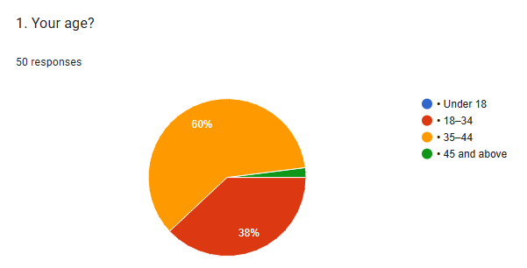
The graph shows that 60% of the respondents are 18 to 34 and 38% are aged 35 to 44 while just 2% were 45 or older and there were no respondents under 18. According to the data, Novotel Milton Keynes is most popular with younger guests because of their offerings.
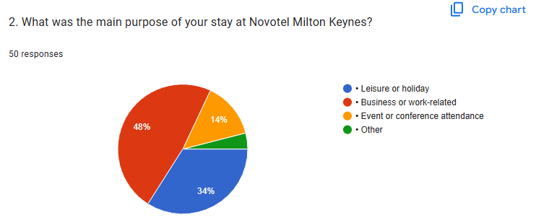
The overview in this graph details the most common reasons guests are staying at the Novotel MK. Just over 48% of trips are for leisure or holidays and around 34% are made for work or business. 14% said they attend events or conferences and the remaining 4% list other reasons. The findings demonstrate that both leisure and business travellers like the hotel, with the biggest influence coming from leisure (Xu et al., 2019; Moreno-Perdigon et al., 2021). Because so few people are coming for events right now, there seem to be opportunities for the sector to grow by forming partnerships or improving its event-holding services.
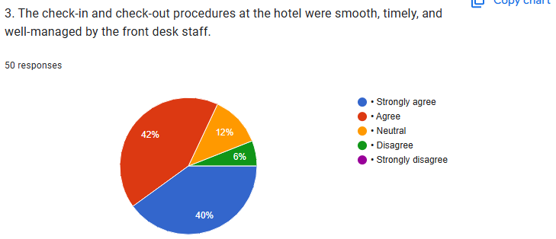
The graph shows that 82% of respondents believe the check-in and check-out processes were smooth, timely, and well-managed. 12% of people showed neutral response and 6% disagreed. The presence of unavoidable setbacks for guests shows that the front desk staff keeps guests very satisfied. By decreasing wait times and higher levels of communication during busy times, many issues from a small number of cases can be fixed, raising satisfaction even further (Godley and Jenkins, 2022; Grocutt et al., 2020).
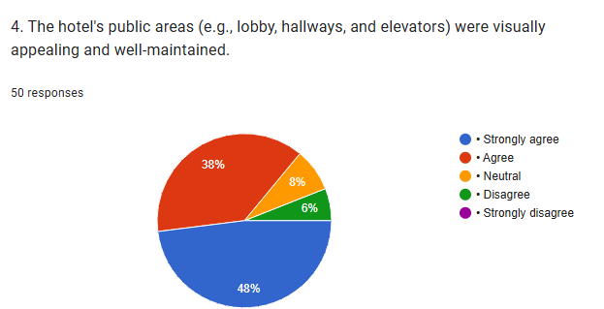
The graph reveals that 86% of respondents found the hotel’s public areas visually appealing and well-maintained. There were 8% who showed neutral response and 6% said that they were unsatisfied. As a result, cleanliness and design in common areas are important to making guests satisfied.
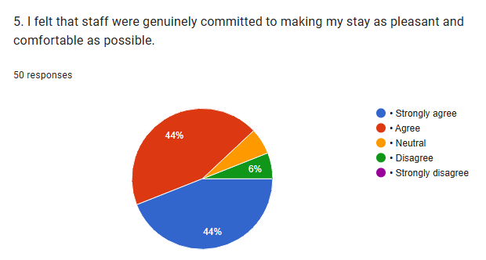
The graph shows that 88% of respondents felt that staff were genuinely committed to making their stay pleasant and comfortable. While 6% gave neutral answer and 6% disagreed. Since a minor dissatisfaction is recorded, it is clear that while most guests are satisfied, a small number of guests are unsatisfied which suggests that the staff engagement should be improved further.
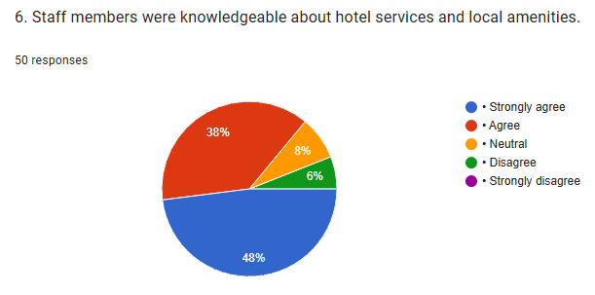
The graph shows that 86% of respondents found staff knowledgeable about hotel services and local amenities. However, 8% of respondents were neutral and over 6% disagreed completely. Therefore, it shows that all the needed training and information are satisfying the guests ‘expectations. The small number of dissatisfied guests indicates a chance to build more staff knowledge which will increase client satisfaction (Kim et al., 2021).
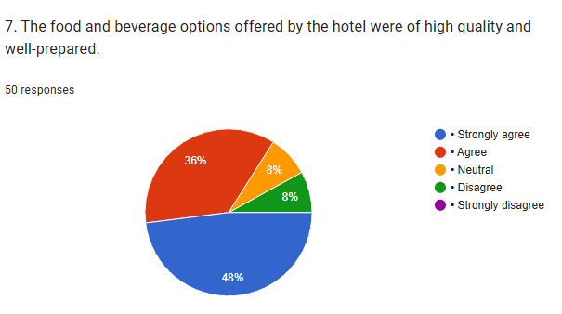
The graph reveals that 84% of respondents rated the food and beverage options as high quality and well-prepared. 8% of the respondents were neutral and 8% totally disagreed. The strong results show that the hotel is doing very well in food and beverage. Just a few guests said they would like to see other menu items or special meals for those with certain dietary needs (Zarezadeh et al., 2022).
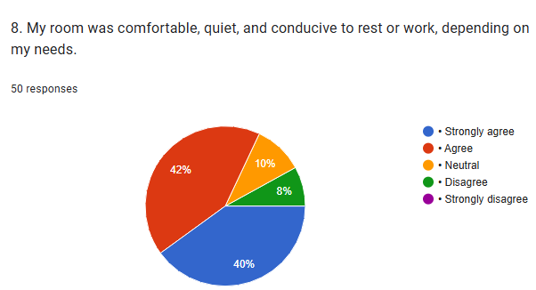
The graph indicates that 82% of respondents found their rooms comfortable, quiet, and conducive to rest or work. 10% gave a neutral opinion and 8% said they were not pleased. It appears that how well guest rooms are designed and maintained affects how content guests feel (Bonfanti et al., 2021). Only a small portion of complaints shows that updating room services or controlling noise can keep all guests satisfied.
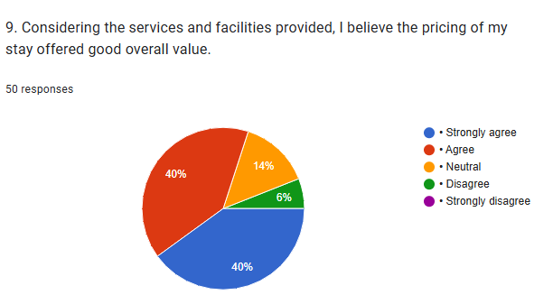
The graph shows that 80% of respondents believe the pricing of their stay offered good overall value. However, 14% showed neutral response and 6% disagreed. It means that guests think the hotel is affordable. The fact that just a small number of guests are unhappy means some may think the pricing is not right for them (Boto-Garcia et al., 2021), so the hotel can look at those opportunities to give more value through promotions, package deals or extra benefits (Fakfare, 2021).
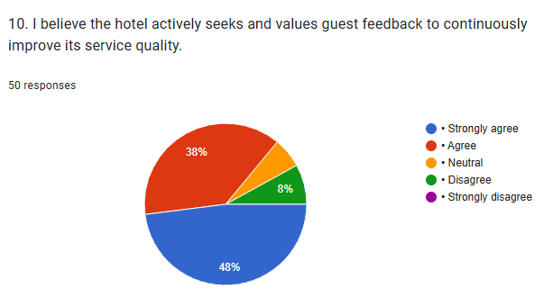
The graph showed that 86% of respondents believe the hotel actively seeks and values guest feedback to improve service quality. While 8% of the respondents were neutral and 6% of them disagreed. A limited number of guests mentioning bad experiences shows that most visitors feel their opinions matter. However, there can be more effort to follow up or make those opinions clearly visible to guests, like by acting on the given feedbacks.

Statistical Analysis
Regression
ANOVAª
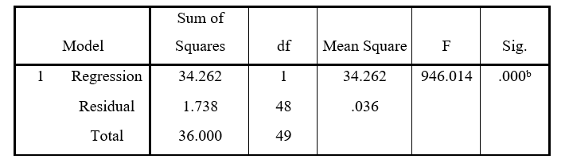
a. Dependent Variable: Operational_Goals_Achievement
b. Predictors: (Constant), Guest_Satisfaction

Coefficientsª
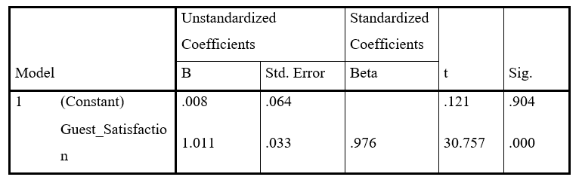
a. Dependent Variable: Operational_Goals_Achievement
Guest Satisfaction (independent variable) is strongly related to Operational Goals Achievement (dependent variable) at Novotel Milton Keynes based on the ANOVA model. The ANOVA table gives an F-value of 946.014 and a significance level of .000, the model used for the regression can be considered highly significant. It is expected that the R² (not drawn but can be estimated) would be very high, thanks to the low residual variance (1.738) and high explained variance (34.262). In the coefficients table, Guest Satisfaction is linked to Operational Goals so that when satisfaction increases by one unit, the operational goal also increases by 1.011 units. An analysis of the beta and t-value shows that this relationship is strong and significantly meaningful (beta = .976 and t-value = 30.757, p = .000). It is clear from these results that raising guest satisfaction is important for better business outcomes (Flora, 2020).
Correlations
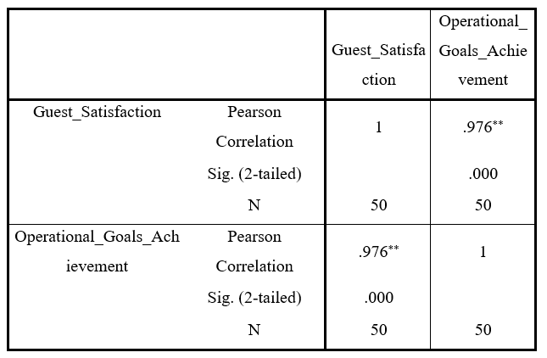
**. Correlation is significant at the 0.01 level (2-tailed).
There is a very strong relationship between the two variables, according to their Pearson correlation coefficient of 0.976. So, improving how guests feel results in greater achievement of operational objectives such as gaining more customers, more business and a loyal client base (Senthilnathan, 2019). There is a very strong positive correlation that is not just random, as the p-value reached 0.000. As 50 respondents were part of the sample, the outcomes show clearly that prioritising guest satisfaction is an important strategy. The result demonstrates that by improving how guests feel, the hotel can meet its goals more effectively, so constant efforts to improve services and involvement with guests are needed.

Reliability

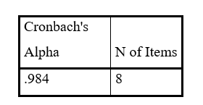
The Reliability Statistics table indicates that the Cronbach’s Alpha for Guest Satisfaction is 0.984. Its value proves that the survey items are reliable and measure the same important thing (Reddy, 2025). Anything with a Cronbach’s Alpha lower than 0 does not pass, while 0.7 is deemed acceptable, 0.8 acceptable to good and 0.9 or above is considered excellent. So, a score of 0.984 means that the guest satisfaction questions are tightly linked and always return similar results. An alpha score of .865 for just 8 items guarantees that the items were strong and that participants answered consistently. Because the data is dependable, we can trust the analysis results and the conclusions concerning how guest satisfaction affects business processes. This increases the quality of the study’s main conclusions.

Interview Analysis

Service Touchpoints as Key Drivers of Guest Satisfaction
One of the respondents shared that “I believe the check-in experience has the greatest impact on guest satisfaction. It is the beginning of the experience and how it starts shapes the whole trip. Alternatively, a long or ignored wait in front of the hotel after check-in can annoy the guest before they have found their room.” Another respondent explained that “In my opinion, room cleanliness is the most critical factor. A friendly service cannot overcome a room that feels or smells dirty or old. Maintaining impeccable hygiene, especially after COVID, has become a key expectation and directly affects overall satisfaction.” A third participant noted that “I have experienced that consistent service across all departments plays a key role in maintaining high guest satisfaction. I feel every department ought to give patients the same high level of care. When your actions are consistent, it gives you more loyal customers. It also shows that the hotel has strong coordination and a shared service culture.”

Internal Communication and Organisational Alignment
One staff member stated that “I receive regular communication about guest feedback through daily briefings and internal reports. Being told feedback directly sometimes encourages us to improve because we remember every step matters. It also helps different departments coordinate better because we are all working towards the same goal.” Another respondent shared that “I have noticed that guest satisfaction is often reinforced during staff meetings and team huddles. I think this way of working builds accountability and teamwork. Appreciative comments give our team hope and useful advice helps us grow. It is also clear that management is serious about this, as they include guest satisfaction KPIs in performance reviews.” A third employee mentioned that “In my experience, Novotel uses visual tools like dashboards and internal newsletters to keep guest satisfaction front of mind. I use it because it links what we do to what our guest’s experience. Viewing real data tells us our situation and allows us to plan improvements. This also leads departments to outdo each other and maintain excellent results.”

Training and Capability Development for Service Excellence
One respondent shared that “I recently attended a customer service training workshop that focused on handling complaints and reading guest emotions. I benefited a lot since we learned with live examples and cases. I think that staff are more confident in their work if they have the right tools. Regular training like this really supports our ability to improve guest satisfaction.” Another staff member explained that “There is an e-learning platform we use for ongoing training, which covers topics like cultural awareness and communication skills. I am happy with these modules because we can study them at our own leisure and when our shifts allow. In my opinion, these small improvements in service delivery make a big difference in how guests perceive us.” A third respondent stated that “I have participated in a new training programme focused on empathy and non-verbal communication. I feel this has helped me communicate differently with guests, most of all when things go wrong during service. I realised that hospitality comprises feelings as well as everyday functions. This kind of soft-skills training is just as important as technical knowledge, in my opinion.”

Operational Challenges and Adaptive Strategies
One staff member shared that “Staff shortages, especially during busy periods, are a major challenge. Talking is extremely important under these circumstances. I have seen that when we stay calm and coordinate well, we can still deliver acceptable service, but it is definitely challenging to maintain the same level of guest satisfaction.” Another respondent mentioned that “I often face language barriers when dealing with guests from different countries. I tend to talk while moving my hands when it helps. To my mind, you need patience and an understanding of cultural differences to deal with this challenge. It is not always easy, but I have found that guests appreciate the effort, even if communication is not perfect.” A third participant noted that “Unrealistic guest expectations are a challenge we encounter frequently. I focus on being sincere and nice and share new options whenever possible. Suppose I am told there is no early check-in. I would suggest you try a coffee in the lounge.”

Staff-Driven Recommendations for Service Improvement
One respondent recommended that “We can implement a guest preference tracking system to personalise stays for repeat visitors. In my opinion, making hospitality personal leads to great results. If a guest realises we know their needs, they are more likely to stick with us. This could be done using the PMS system, and it would improve our ability to deliver consistent, customised service.” Another team member suggested that “In my opinion, increasing staffing during peak times like breakfast service or evening check-in would have a big impact. A lot of people who stay with us during this period often talk about delays. With more support, we could attend to guests more efficiently and prevent these issues from intensifying into formal complaints.” A third participant proposed that “Upgrading the in-room technology could improve the guest experience significantly. People staying in hotels now hope for access to fast internet, smart televisions and digital access for their rooms. Many of our visitors have asked about using mobile key cards. It would also reduce pressure on front-desk staff, as guests would have more control over their environment.”

Discussion

Survey
This research collected over 50 individuals ‘opinions and responses on the topic in regard to the interviews as well also. This research stated that guest perceptions of service quality were largely positive throughout the survey. Most respondents agreed that Novotel Milton Keynes delivered a satisfactory and reliable guest experience overall. Respondents consistently reported high levels of satisfaction across key service areas such as hospitality, cleanliness, and staff behaviour. The survey also revealed that the majority of guests felt their feedback was genuinely valued by the hotel. However, a small percentage of guests expressed dissatisfaction with areas like room noise or wait times. This suggests that while performance is strong, improvements in consistency could further enhance guest perceptions. This research discussed the importance of maintaining high standards across every department during busy periods. Respondents also suggested that additional staffing and clearer communication would improve peak-time operations. Therefore, the survey findings highlight that proactive service planning leads to stronger guest loyalty and trust. Ultimately, the results demonstrate that Novotel can sustain satisfaction by addressing the remaining
Therefore, the research reported that that the hotel possesses two-way clientele. Hence, Novotel Milton Keynes can expand through business event alliances. In regard to the literature review, high guest satisfaction is needed in the industry, which are success in to achieve the guest satisfaction and loyalty (Karim and Raibul, 2024). Another question showed that Novotel Milton Keynes hotel achieved positive feedback for check-in and check-out services. Also, quick check-in, simple-to-follow instructions, and active communication can perhaps avert such delay in the future. Also, it was showed by the visitors that common areas of Novotel Milton Keynes hotel were clean and appealing. Hence, these results corroborated evidence that aesthetic value does affect emotional response and perceived care. This study informed that common areas reflect the personality and maintenance levels of the hotel. If visitors in Novotel Milton Keynes hotel meet with welcoming clean lobbies and tidy lounges, this improves overall impressions. This point is supported by Karim and Raibul (2024) that the quality, cleanliness, staff behavior, amenities, and the overall experience.
Also, respondents showed that in Novotel Milton Keynes hotel that employees were dedicated to satisfaction. Therefore, actual concern for guest needs has been related to perceived value and comfort, the study stated. As a result, the hotel also ensures guest satisfaction through comfort and services. Hospitality services typically entail the visitors’ input to the creation of the service value. Inadequate hotel service will lead to disgruntled customers, which will lower demand and eventually hurt hotel performance. To attract new visitors, rely on the sales and marketing division (Demir et al. 2020). Hence, there were reliability gaps in service, which can be accomplished in enhancing consistency in interactions based on this study and in talking about enhancing consistency in conversations. The sixth question reported that staff were knowledgeable about services and local facilities. Hence, it means training and information exchange between the team have been quite effective. Employees’attitudes, policies, and product quality are drivers of customer satisfaction, while price and service time are areas of utmost concern (Balondo et al., 2025).
Moreover, to another question, the most of the respondents enjoyed their food and beverage as high on quality and taste at the hotel. The study claimed that menu satisfaction is a major factor in overall guest satisfaction. However, in this, few respondents stated they were interested in vegetarian, vegan, or allergen-free options. This point is supported by the point of the utilisation of technology, resource management, process optimisation, and customer service culture are key components of operational efficiency and customer satisfaction levels in food service operations (Zemlina et al., 2023). Another response in regard to Novotel Milton Keynes, respondents shared that rooms were quiet, comfortable, and suitable for work or rest. Personal space and quality sleep are necessities for sustained guest satisfaction. This is supported by the literature review that in addition to meeting guests’needs and wants, a hospitality supplier adds value and provides exceptional, unforgettable experiences.
According to the ninth question, many respondents confirmed that prices were good value for money. This indicates hotel rate structures are quite reasonable when it comes to expected market value and perceived benefit. Nevertheless, the survey indicated that 6% were dissatisfied, and where the areas need to be addressed for improving pricing policies. It explained value addition like bundled services, loyalty discount, or additional benefit for extended stays. Hence, to please guests and win their loyalty, hotels should provide a competitive service (Abdulla et al. 2017). Customer satisfaction is a fundamental operational aim for any firm in regard to loyalty, retention, and overall growth (Cavaleri et al., 2021). The tenth question stated that many respondents believed that the hotel acts and values guest comments. Guests appreciated observing what they recommend implemented, which is establishing trust.

Interview
This research was conducted in regard to multi-method to gain answers from both guests and the hotel employees. Therefore, surveys and interviews were conducted in order to enlarge the scope of this study. Novotel Milton Keynes hotel has strong bases for customer satisfaction. By improving internal communication, training, and allocating resources, the hotel can further improve itself. Guest loyalty is significantly connected to how intentional, individualized, and predictable the service will be. Continuous learning and flexibility programs will be critical in maintaining high satisfaction levels in a dynamic hospitality environment.
Hence, in regard to the interview, the initial theme described how service touchpoints create satisfaction. On the other hand, another explained that cleanliness is a deal-breaker standard that warmth cannot meet. Also, the third participant explained that consistency in service across departments aids retention and builds reliable guest experiences. This is supported by literature review, that Okoth et al. (2024) claim that customer pleasure brought about by operational excellence might increase an organization's profitability. By incorporating the three core tenets of operational excellence, service quality, lean philosophy, and Six Sigma into its operations plan, the company may improve customer satisfaction. While dissatisfied guests leave bad reviews and harm the hotel's image, delighted guests come back and recommend friends and family. According to Solakis et al., (2022), hospitality services typically entail the visitors ‘input to the creation of the service value.
The second question stated that there is an issue of internal communication and alignment. In this research, the employees were kept updated from time to time with feedback and performance indicators, hence gaining a shared purpose. Dashboards, team huddles, and newsletters were identified by the respondents as motivational mechanisms that could drive excellence. The research presented evidence that when real-time information is employed, the employees can compete and innovate in a positive manner. Such practices create the culture of accountability and common standards.
The third theme covered training and capability development. The study indicated that a number of the workers had workshops in service recovery, empathy, and non-verbal skills. One of the respondents mentioned that flexibility was provided through e-learning modules in providing long-term knowledge. This study asserted that soft skills and technical training combined to maximize the service experience for various types of guests. Regular upskilling involves teams responding to changing expectations and develop service resilience. The success of hotels, resorts, and restaurants is largely dependent on the repeat business, word-of-mouth advertising, and brand loyalty that high visitor satisfaction generates (Karim and Raibul, 2024). Feedback tools such as questionnaires or online reviews are typically used to quantify it.
The fourth was operational challenge and strategy issues. Employees reported difficulties such as understaffing during peak hours, language problems, and unrealistic expectation. Yet the respondents showed that peaceful communication and being creative assist in managing such tensions. The study explained how employees managed such problems through the use of gestures or other suggestions to provide input towards satisfaction. Discoveries such as these show high emotional intelligence and problem-solving potential in the workforce. Typically, operations goals are set without taking into account the opinions of recent consumers or even the staff. As a result, delivery changes become reactive rather than long-term strategy-driven, especially in response to negative online evaluations (Lui et al., 2018). Customer satisfaction is influenced by operational choices (Zemlina et al., 2023).
Lastly, the fifth theme was ideas towards service improvement by the staff. Among them, one suggested initiating guest preference tracking to enhance personalisation. Additionally, Marvay (2014) asserts that service is a key indicator of consumer happiness. Therefore, in order to increase customer loyalty and concentrate on new consumer segments, the hotel sector must improve customer happiness. Another claimed that staffing up off-peak hours would avoid delay and complaint. A third suggested technological improvements such as mobile keys and smart TVs to address today's expectations. According to Anwar and Surarchith (2015), hospitality services typically entail the visitors’input to the creation of the service value. This study documented that such interventions would enhance convenience in services and alleviate staff pressure, resulting in improved satisfaction. Nowadays, offering high-quality services that increase customer satisfaction is crucial for competitive market success (Singh et al., 2023).

Chapter 5 Conclusion and Recommendations

Conclusion
This report showed that making guests happy is very important for the operating success of Novotel Milton Keynes. According to the findings, being satisfied largely depends on check-in process, cleanliness of rooms, staff courtesies and what is served for meals. Both service and efficiency were favorites with the guests, making it clear the hotel was running very well. When a guest is satisfied, it helps the company keep loyal customers, grow occupancy numbers, bring back customers again and get recommended online. The research aim was finding how satisfaction affects reaching operational goals. It was discovered by the findings that the way guests are served, technically and emotionally, strongly affects their visit and makes them decide if they will go back. The findings showed how well the staff acted, what they knew and how fast they responded played a major role in people’s sense of comfort and view of value. A wonderfully organised check-in and check-out, colourful public areas and friendly staff kept the atmosphere wonderful. Because of these elements, guests view the brand in a favourable way. That is why satisfaction here is not received by chance, but rather organised to fit with the goals and plans of the hotel.
The importance of feedback and internal communication is essential in shaping operations at hotels. People on the team got updates on dashboards, in team meetings and during performance reviews to show they all play a part in guest satisfaction. Because of these practises, every department knows what it must do to ensure excellent service. Real time results from the feedback system prompt departments to work together and think creatively. When internal communication and guest insights are together, staff feel able to change their behaviours and keep up with new trends. Learning and improving staff identified as major keys to delivering excellent service. Online learning and workshop sessions worked to improve the team member’s skills in empathy, understanding different cultures and clear non-verbal communication. Because of these training programs, the team became better able to serve guests with different needs in various ways. Neither soft skills nor technical expertise determined guest value alone, but using both together made a noticeable impact. Capability development requires continuous attention and links with daily operations to meet changing needs in hospitality.
Company leaders realised that shortages of workers, difficulties communicating in several languages and guests with unrealistic hopes were issues that never went away in the service area. It is evident by the findings that effective hospitality workers need to be emotionally intelligent and good at working with people from many different cultures. In addition, the findings demonstrate that guests are satisfied when hotels fix issues openly and correctly. Using personal preference systems, increasing staff when needed and expanding in-room technology are all considered to follow current patterns in what guests anticipate or hope for. The guests care most about being offered convenience, efficiency and personalised service. The findings indicate that using employee input for strategy planning allows companies to both update their own systems and compete successfully with others. Ideas from staff play an important role in helping organisations get better and stay on track.
The five areas including service points, the way employees are kept informed, training, issues related to the business process and staff opinions are analysed in the study. The findings showed that guest satisfaction involves the whole structure of the service experience. True satisfaction is reached when service, responsiveness and review of performance are all present. This result is consistent with earlier studies showing that continued satisfaction helps hotels maintain customer loyalty, run systems smoothly and expand their operation. Furthermore, this research explored a gap in current studies by analysing a mid-scale hotel in a regional urban area. The majority of existing research is about luxury and big-chain hotels which typically ignores the special conditions found in mid-market establishments such as Novotel Milton Keynes. This analysis allows findings to be transferred and applied to corresponding properties. Concentrating on guests and employees allows a clear view of both building and measuring satisfaction in live operations.
The findings highlighted the importance of Expectancy Disconfirmation Theory and Equity Theory in explaining satisfaction. Satisfaction for guests increases when what they receive matches or exceeds their expectations and staff feel stronger motivation when they believe recognition and their workload are fair. They show how understanding satisfaction can guide a company’s decisions about loyalty and how well a person performs. This means that the next steps for hotels should meet guests’wishes and ensure their staff enjoy good working conditions. The guest satisfaction is both an important marketing target and a key strategy for hotels such as Novotel Milton Keynes. When guests are satisfied, guest retention, a good reputation, greater revenue and running things smoothly all improve. The company supports both its team and operations, decrease blockages to service and prioritises what guests tell the hotel. The findings demonstrate that how guest satisfaction is achieved depends on service systems, training and cooperation within the organisation. Success will be maintained only if satisfaction metrics are used in all decisions made for operations and strategies. As a result of integration, Novotel Milton Keynes and comparable hotels can give both guests and the business significant value over time.

Recommendations and Practical Strategies
- Enhance Personalisation through a Guest Preference Tracking System
For guests to feel more valued at Novotel Milton Keynes, a new strategy should be adding a guest preference tracking system. Having analysed this data, employees can be able to surprise returning guests with choices that fit their preferences. Integrating this with the existing property management system (PMS) will allow all departments to access and act on the data in real time. A returning customer who wants some peace and to check in before noon can be expectedly given these features (Saxena et al., 2024). Being personalised this way helps customers to feel identified and more satisfied. With mid-market hotels facing lots of competition, a technology-based strategy separates Como Hotels from the rest. This strategy matches the current hospitality movement toward personal connection and unique experiences (Campione, 2021). Since millennial and Gen Z travelers want more, systems like these help a business create tailored service without stressing employees. Using data to look for similarities in guest needs helps the hotel improve what it provides over time.
- Strengthen Peak-Time Operations with Targeted Staffing Strategies
Managing the number of employees during busy times, for example at breakfast, evening arrivals and high-occupancy weekends is crucial. According to the data, dissatisfaction due to delays and having too few resources at some places was common but small (Kwon et al., 2022). Using tools that predict customer numbers and scheduling helps managers match the team to customer flow. Lowering the guest-to-staff ratio while the crowd is large will cut wait times, enhance the guest experience and keep employees from exhaustion. Guest pleasure increases while lifting staff morale, as everyone feels backed up when dealing with overwhelms. A simple solution is to have clerks take on food service tasks or vice versa during times when business is at its highest. In addition, having the same staff day to day keeps service high everywhere, not just when there are few customers (Arici et al., 2022). Fewer team members during busy times often results in unsatisfactory service, hurting the company’s popularity, loyalty from customers and bottom line (Rini and Ferdinand, 2021). Having people train in more than one job provides the organisation with extra flexibility and helps cut costs (Kossek et al., 2021). As a result, Novotel Milton Keynes can conduct operations smoothly, provide the same high quality of service every time and retain more customers.
- Proper Interaction through Real-Time Feedback and Alignment Tools
Great internal communication helps link the happiness of guests with how the business runs (Ravina-Ripoll et al., 2022). On the platform, guests can watch their satisfaction levels change live, see areas where steps are needed to improve and receive instant positive remarks. Knowing what guests expect or comment on helps staff from every role to work better together and change their behaviour. Being aware of issues as they happen allows to deal with them sooner and recognise what team has achieved instantly. Also, including guest satisfaction in job performance evaluations shows its significance matters across the organization (Duarte et al., 2022). If everyone realises the effect their work has on the service and aims of the business, they become more responsible. Having regular meetings between departments encourages staff to feel responsible for how guests feel. People working on the front lines should be encouraged to share their views on what is needed to improve services, so solutions can develop together. Using these practises, hotel can improve connections, lose less interest from customers and see improved employee engagement.
- Invest in Ongoing Training to Build Service Resilience and Innovation
Current training efforts are recognised by Novotel Milton Keynes, though further initiatives can help make things systemic and strategic. In their workshops, supervisors should talk about more than standard operations and concentrate on empathy, solving conflicts, how to deal with guests and modern tools used by guests. Assessing these skills matters today in hospitality, given that guests now need understanding as well as skilled service. Offering a training calendar with important and optional classes allows all employees to follow a well-organised learning route. E-learning allows employees to take their training as needed, so it fits well for those who work shifts (Wikström et al., 2023). Using a mentorship program for employees supports their learning from each other, allows beginners to catch up fast and motivates experienced individuals to become better leaders. Data gathered from guests should inform the way training programmes are made so they can improve actual issues with guest interaction. A company culture that promotes learning gives employees reason to propose service improvements and take a stronger interest in how they contribute. With time, this helps the team become stronger and more able to maintain their achievements when things change in the organization (Cavanaugh et al., 2022). At Novotel Milton Keynes, keeping up with training helps the team keep satisfied guests and keep ahead of rival hotels.

References
Accor. (2025). Novotel Milton Keynes. [Online]. Available at: https://all.accor.com/hotel/3272/index.en.shtml [Accessed on May 23, 2025].
Adams, J. S. (2015). Equity theory. In Organizational Behavior 1 (pp. 134-158). Routledge.
Adanse, J., Khayiya, R., and Maranga, V. (2024). Influence of optimal room occupancy strategies on revenue maximisation during slack periods in selected 3-to 5-star hotels in Ghana. Research in Hospitality Management, 14(1), pp. 57-69.
Akhtar, Z. B. (2024). Operating systems (OS): An insight investigative research analysis and future directions. Journal of Technology and Informatics (JoTI), 6(1), pp. 58-69.
Alaameri, A. S., and Jawad, K. A. (2021). The Role of Operations Decisions in Achieving Customer Satisfaction Analytical Study in a Sample of Iraqi Banks. Turkish Online Journal of Qualitative Inquiry, 12(8).
Alharbi, I. B. A. (2024). Strategic Objectives and Control: Optimizing Strategic Success in the Hospitality Setting through Transformational Leadership. Journal of Environmental Management and Tourism (JEMT), 15(2 (74)), pp. 338-356.
Ali, B. (2024). What we know about transformational leadership in tourism and hospitality: a systematic review and future agenda. The Service Industries Journal, 44(1-2), pp. 105-147.
Ali, B. J. (2021). Impact of consumer animosity, boycott participation, boycott motivation, and product judgment on purchase readiness or aversion of Kurdish consumers in Iraq. Journal of Consumer Affairs, 55(2), pp. 504-523.
Ali, M., Puah, C. H., Ayob, N., and Raza, S. A. (2020). Factors influencing tourist’s satisfaction, loyalty and word of mouth in selection of local foods in Pakistan. British Food Journal, 122(6), pp. 2021-2043.
Arici, H.E., Cakmakoglu Arıcı, N. and Altinay, L. (2022). The use of big data analytics to discover customers’ perceptions of and satisfaction with green hotel service quality. Current Issues in Tourism, pp.1–19. https://www.tandfonline.com/doi/abs/10.1080/13683500.2022.2029832
Aubert‐Teillaud, B., Bran, A., and Vaidis, D. C. (2023). Expectation violation and cognitive dissonance theory: Proposal for an epistemic inconsistency management model. European Journal of Social Psychology, 53(7), pp. 1663-1679.
Au-Yong, C. P., Hoh, P. K., and Amos, D. (2024). Enhancing the Maintenance Practice to Improve Guests’Satisfaction in the Hotels Industry. Built Environment Journal, 21(1), 18-29.
Balondo, M. S. C., Du, E. M., and Pitao, D. R. (2023). Food Safety Practices of Home-Based Online Food Sellers During Covid-19 Pandemic in Biliran. Indonesian Journal of Multidisciplinary Science, 2(8), pp. 2896-2907.
Berners, P., and Martin, A. (2022). The practical guide to achieving customer satisfaction in events and hotels. Routledge.
Bollenbach, J., Halbrügge, S., Wederhake, L., Weibelzahl, M., and Wolf, L. (2024). Customer satisfaction at large charging parks: Expectation-disconfirmation theory for fast charging. Applied Energy, 365, p. 122735.
Bonfanti, A., Vigolo, V. and Yfantidou, G. (2021). The impact of the Covid-19 pandemic on customer experience design: The hotel managers’ perspective. International Journal of Hospitality Management, 94(1), p.102871. https://www.sciencedirect.com/science/article/pii/S0278431921000141
Booking.com. (2025). Novotel Milton Keynes. [online]. Available at: https://www.booking.com/hotel/gb/novotel.html [Accessed on May 23, 2025].
Boto-Garcia, D., Escalonilla, M., Zapico, E., & Baños, J. F. (2021). Scale heterogeneity in hotel guests’ satisfaction relative to room rates. Applied economic analysis, 29(87), pp. 208-225.
Campione (2021). HOW DIGITALIZATION IS REVOLUTIONIZING RELATIONSHIPS BETWEEN CUSTOMERS AND SERVICE PROVIDERS IN THE HOSPITALITY INDUSTRY: PERSONALIZATION AND GAMIFICATION - ProQuest. [online] search.proquest.com. Available at: https://search.proquest.com/openview/8138c0c105c0e9bc72a99aa3093589ec/1?pq-origsite=gscholar&cbl=2032142 [Accessed 29 May 2025].
Carvalho, P., and Alves, H. (2023). Customer value co-creation in the hospitality and tourism industry: a systematic literature review. International Journal of Contemporary Hospitality Management, 35(1), 250-273.
Cavaliere, L. P. L., Khan, R., Sundram, S., Jainani, K., Bagale, G., Chakravarthi, M. K., ... and Rajest, S. S. (2021). The Impact of customer relationship management on customer satisfaction and retention: The mediation of service quality. Turkish Journal of Physiotherapy and Rehabilitation, 32(3), pp. 22107-22121.
Cavanaugh, K., Cline, D., Belfer, B., Chang, S., Thoman, E., Pickard, T. and Holladay, C.L. (2022). The positive impact of mentoring on burnout: Organizational research and best practices. Journal of Interprofessional Education & Practice, 28, p.100521. https://www.sciencedirect.com/science/article/pii/S2405452622000283
Cavique, M., Ribeiro, R., Batista, F., and Correia, A. (2022). Examining Airbnb guest satisfaction tendencies: a text mining approach. Current issues in tourism, 25(22), pp. 3607-3622.
Chang, V., Liu, L., Xu, Q., Li, T., & Hsu, C. H. (2023). An improved model for sentiment analysis on luxury hotel review. Expert Systems, 40(2), e12580.
David Ochieng Okoth, Patel, N. and Awuor, E. (2024). Operational Excellence and Customer Satisfaction in the Service Industry in Kenya. International Journal of Research Publication and Reviews, pp.4781–4786. doi:https://doi.org/10.55248/gengpi.5.0624.1576.
Demir, A., Maroof, L., Sabbah Khan, N. U., and Ali, B. J. (2021). The role of E-service quality in shaping online meeting platforms: a case study from higher education sector. Journal of Applied Research in Higher Education, 13(5), pp. 1436-1463.
Duarte, A.P. and Silva, V.H. (2023). Satisfaction with Internal Communication and Hospitality Employees’ Turnover Intention: Exploring the Mediating Role of Organizational Support and Job Satisfaction. Administrative Sciences, [online] 13(10), p.216. https://www.mdpi.com/2076-3387/13/10/216
Egami, N. and Hartman, E. (2022). Elements of external validity: Framework, design, and analysis. American Political Science Review, 117(3), pp.1–19. https://www.cambridge.org/core/journals/american-political-science-review/article/elements-of-external-validity-framework-design-and-analysis/2D0914404C84B3F169732FF1D5E39420
Expedia. (2025). Novotel Milton Keynes. [online]. Available at: https://all.accor.com/hotel/3272/index.en.shtml [Accessed on May 23, 2025].
Fakfare, P. (2021). Influence of service attributes of food delivery application on customers’ satisfaction and their behavioural responses: The IPMA approach. International Journal of Gastronomy and Food Science, 25, p.100392. https://www.sciencedirect.com/science/article/pii/S1878450X21000913
Flora, D. B. (2020). Your coefficient alpha is probably wrong, but which coefficient omega is right? A tutorial on using R to obtain better reliability estimates. Advances in Methods and Practices in Psychological Science, 3(4), 484-501.
Gal, I., Yagil, D., and Luria, G. (2021). Service workers and “difficult customers”: quality challenges at the front line. International Journal of Quality and Service Sciences, 13(2), pp. 321-337.
Grafenauer, B., (2024). Guest books as a reflection of hospitality: The case of the Astoria hotel and Bled Castle Restaurant. Turističko poslovanje, (34).

Godley, M. and Jenkins, J.B. (2020). Decreasing Wait Times and Increasing Patient Satisfaction. Journal of Nursing Care Quality, 34(1), pp.61–65. https://www.mdpi.com/2227-7390/12/23/3743
Grocutt, A., Gulseren, D., Weatherhead, J.G. and Turner, N. (2020). Can mentoring programmes develop leadership? Human Resource Development International, [online] 25(4), pp.1–11. https://www.tandfonline.com/doi/abs/10.1080/13678868.2020.1850090
Huu, T. N., Minh, L. L. T., & Duc, Q. N. (2022). EMPLOYEES’JOB SATISFACTION, JOB PERFORMANCE AND THEIR RELATIONSHIP DURING THE COVID-19 PANDEMIC IN VIETNAM. Организационная психология, 12(2), pp. 38-55.
Izumi, C., Ghaffar, S. A., and Setiawan, W. C. (2025). Enhancing Customer Satisfaction and Product Quality in E-commerce through Post-Purchase Analysis using Text Mining and Sentiment Analysis Techniques in Digital Marketing. Journal of Digital Market and Digital Currency, 2(1), pp. 1-25.
Jiang, Y., Feng, T., and Huang, Y. (2024). Antecedent configurations toward supply chain resilience: the joint impact of supply chain integration and big data analytics capability. Journal of Operations Management, 70(2), pp. 257-284.
Karim, R. A., and Rabiul, M. K. (2024). The relationships of corporate sustainability, customer loyalty, and word of mouth: the mediating role of corporate image and customer satisfaction. Journal of Quality Assurance in Hospitality & Tourism, 25(3), pp. 421-441.
Karlach, J. (2023). Hearths, Mythologies, and Livelihood Choices: Exploring Cultural Change under Poverty Alleviation with the Nuosu-Yi of Liangshan. Modern China, 49(5), pp. 532-563.
Kim, T.J., Almanza, B., Ma, J., Park, H. and Kline, S.F. (2021). The cleanliness of restaurants: ATP tests (reality) vs consumers’ perception. International Journal of Contemporary Hospitality Management, ahead-of-print (ahead-of-print). https://www.emerald.com/insight/content/doi/10.1108/ijchm-08-2020-0822/full/html
Koc, E., and Boz, I. (2022). The impact of operational efficiency on customer satisfaction: Evidence from the hotel industry. Journal of Hospitality and Tourism Management, 49, pp. 10-18.
Kossek, E., Gettings, P. and Misra, K. (2021). The Future of Flexibility at Work You can tailor programs and policies to fit your employees’ needs. [online] Available at: https://www2.mvcc.edu/shn/pdf/presentations/2021-11/Future-of-Flexibility-at-Work.PDF [Accessed 29 May 2025].
Kwon, C., Raman, A. and Tamayo, J.A. (2022). Human-Computer Interactions in Demand Forecasting and Labor Scheduling Decisions. SSRN Electronic Journal. http://www.jorge-tamayo.com/s/Human-Computer-Interactions-in-Demand-Forecasting-and-Labor-Scheduling-Decisions.pdf
Lai, I. K. W. (2019). Hotel image and reputation on building customer loyalty: An empirical study in Macau. Journal of Hospitality and Tourism Management, 38, pp. 111-121.
Maslach, C., and Leiter, M. P. (2022). The burnout challenge: Managing people’s relationships with their jobs. Harvard University Press.
Mercan, R., and Sandıkcı, M. (2024). Bleisure tourism: Business and leisure together. In Future tourism trends volume 1: Tourism in the changing world (pp. 3-15). Emerald Publishing Limited.
Moreno-Perdigon, M. C., Guzman-Perez, B., and Mesa, T. R. (2021). Guest satisfaction in independent and affiliated to chain hotels. International Journal of Hospitality Management, 94, p. 102812.
Moreno-Perdigón, M.C., Guzmán-Pérez, B. and Ravelo Mesa, T. (2021). Guest satisfaction in independent and affiliated to chain hotels. International Journal of Hospitality Management, 94(102812), p.102812. https://www.sciencedirect.com/science/article/pii/S0278431920303649
Nguyen, N.X., Tran, K. and Nguyen, T.A. (2021). Impact of Service Quality on In-Patients’Satisfaction, Perceived Value, and Customer Loyalty: A Mixed-Methods Study from a Developing Country. Patient Preference and Adherence, 15(1), pp.2523–2538. https://www.tandfonline.com/doi/abs/10.2147/PPA.S333586
Nyimbili, F. and Nyimbili, L. (2024). Types of Purposive Sampling Techniques with Their Examples and Application in Qualitative Research Studies. British Journal of Multidisciplinary and Advanced Studies, 5(1), pp.90–99. https://bjmas.org/index.php/bjmas/article/view/808
Okeke, N. I., Alabi, O. A., Igwe, A. N., Ofodile, O. C., and Ewim, C. P. M. (2024). AI in customer feedback integration: A data-driven framework for enhancing business strategy. World J. Advanced Res. Reviews, 24(1), pp. 3207-3220.
Panno, A. (2020). Performance measurement and management in small companies of the service sector; evidence from a sample of Italian hotels. Measuring business excellence, 24(2), pp. 133-160.
Polk, D. M. (2022). Equity theory: Evaluating fairness. Theories in Social Psychology, Second Edition, pp. 217-249.
Selwyn, T., 2025. Host and guest. In Encyclopedia of Tourism (pp. 491-494). Cham: Springer Nature Switzerland.
Ramgade, A., Kumar, A., & Brar, V. (2022). Impact of apologetic responses on guest complaints for creating loyal customer base and the art of restoring repeat business in star rated hotels. International Journal of Food and Nutritional Sciences, 11(8), pp. 1268-1275.
Ravina-Ripoll, R., Galvan-Vela, E., Sorzano-Rodríguez, D.M. and Ruíz-Corrales, M. (2022). Mapping intrapreneurship through the dimensions of happiness at work and internal communication. Corporate Communications: An International Journal. https://www.igi-global.com/chapter/the-importance-of-internal-marketing-in-companies-and-its-relation-with-happiness-at-work/346894
Reddy, C. M. Service Reliability in Hotel Sector and Its Impact on Guest Satisfaction.
Rini, G. P., and Ferdinand, A. T. (2021). Customer Centric in Hospitality Industry: A Systematic Literature Review and Future Research Direction. JDM (Jurnal Dinamika Manajemen), 12(1), 88-101.
Salman, A., and Olawale, Y. A. (2021). Effect of reward system on employees’productivity: A study of Guaranty Trust Bank, Ilorin Metropolis. Journal of Management and Social Sciences, 10(3).
Saxena, S.K., Gupta, V. and Kumar, S. (2024). Enhancing Guest Loyalty in the Hotel Industry Through Artificial Intelligence-Drive Personalization. Advances in hospitality, tourism and the services industry (AHTSI) book series, pp.335–350. https://www.igi-global.com/chapter/enhancing-guest-loyalty-in-the-hotel-industry-through-artificial-intelligence-drive-personalization/353862
Schiebler, T., Lee, N. and Brodbeck, F.C. (2025). Expectancy-disconfirmation and consumer satisfaction: A meta-analysis. Journal of the Academy of Marketing Science. https://link.springer.com/article/10.1007/s11747-024-01078-x
Schoepf, S. and Klimow, N. (2022). Collective Case Study: Making Qualitative Data More Impactful. [online] Conceptual Analyses of Curriculum Inquiry Methodologies. Available at: https://www.igi-global.com/chapter/collective-case-study/292623 [Accessed 24 May 2025].
Senthilnathan, S. (2019). Usefulness of correlation analysis. Available at SSRN 3416918.
Sheth, J. N., Jain, V., and Ambika, A. (2023). The growing importance of customer-centric support services for improving customer experience. Journal of Business Research, 164, p. 113943.
Singh, V., Sharma, M. P., Jayapriya, K., Kumar, B. K., Chander, M. A. R. N., and Kumar, B. R. (2023). Service quality, customer satisfaction and customer loyalty: A comprehensive literature review. Journal of Survey in Fisheries Sciences, 10(4S), pp. 3457-3464.
Sinha, S., Jawahar, I. M., Ghosh, P., and Mishra, A. (2020). Assessing employers’ satisfaction with Indian engineering graduates using expectancy-disconfirmation theory. International Journal of Manpower, 41(4), pp. 473-489.
Solakis, K., Peña-Vinces, J., and Lopez-Bonilla, J. M. (2022). Value co-creation and perceived value: A customer perspective in the hospitality context. European research on management and business economics, 28(1), 100175.
Truong, N., Dang-Pham, D., McClelland, R., & Nkhoma, M. (2020). Exploring the impact of innovativeness of hospitality service operation on customer satisfaction. Operations and Supply Chain Management: An International Journal, 13(3), 307-319.
Thu, H. N. T. (2020). Measuring guest satisfaction from online reviews: Evidence in Vietnam. Cogent Social Sciences, 6(1), 1801117.

Wei, H. C. (2024). A Strategic Evaluation Model for Hotel Investments: A Value Management Approach for Key Stakeholders (Doctoral dissertation, University of Wales Trinity Saint David).
Wikström, E., Arman, R., Dellve, L. and Gillberg, N. (2023). Mentoring programmes – building capacity for learning and retaining workers in the workplace. Journal of Workplace Learning, 35(8), pp.732–751. https://www.emerald.com/insight/content/doi/10.1108/jwl-01-2023-0003/full/html
Wynn, M., and Lam, C. (2023). Digitalisation and IT strategy in the hospitality industry. Systems, 11(10), p. 501.
Xu, n, Li, Y. and Lu, A.C.C. (2019). A comparative study of the determinants of business and leisure travellers’ satisfaction and dissatisfaction. International Journal of Services and Operations Management, 33(1), p.87. https://www.inderscienceonline.com/doi/abs/10.1504/IJSOM.2019.099656
Chyi, C. S., and Hee, O. C. (2022). Linking service quality, guest satisfaction and length of stay to e-WOM: a study in the hotel industry of Singapore. Middle East Journal of Management, 9(1), 44-63.

