UNIVERSITY OF WALES TRINITY SAINT DAVID
LONDON CAMPUS
Assignment 2
Learning in the Digital Era
Video Link:
https://youtu.be/wYrxbp4PLCI

Module Name: Learning in the Digital Era
Module Code: ACCA 4025

Student Name: Dayana Balandra
Student ID: 2442006
Group: 2

Lecturer’s Name: Fehad Koushik

Table of Contents
Introduction 2
Main Body 2
Conclusion 9
References 9

Introduction
This report accompanies the video presentation for Assignment 2 of the module Learning in the Digital Era. The video covers my self-evaluation, professional development plan (PDP) using SMART goals, and a Unit 4 topic summary on Unpacking Experiences. It also applies Gibb’s Reflective Cycle to support reflective practice and personal development.

Main Body
I will discuss my self-evaluation, including my strengths, weaknesses, and traits gained. I will also present my Professional Development Plan (PDP) with a SMART goal and provide a short summary of the Unit 4 topic Unpacking Experiences. Finally, I will explain how Gibbs’ Reflective Cycle supports my personal development. https://youtu.be/wYrxbp4PLCI

Slide 1 COVER PAGE
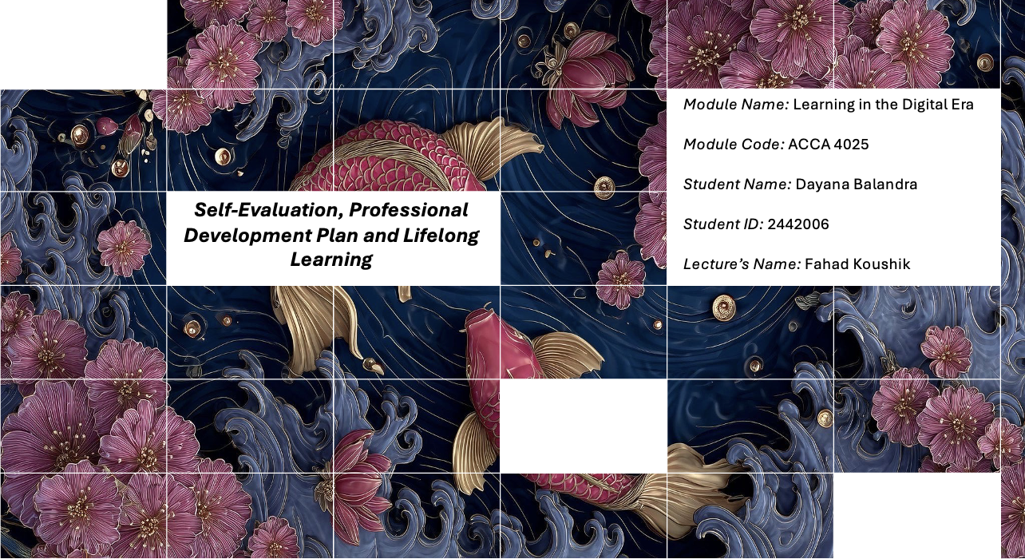
This slide introduces the presentation topic, module details, and student information.

Slide 2 CONTENTS

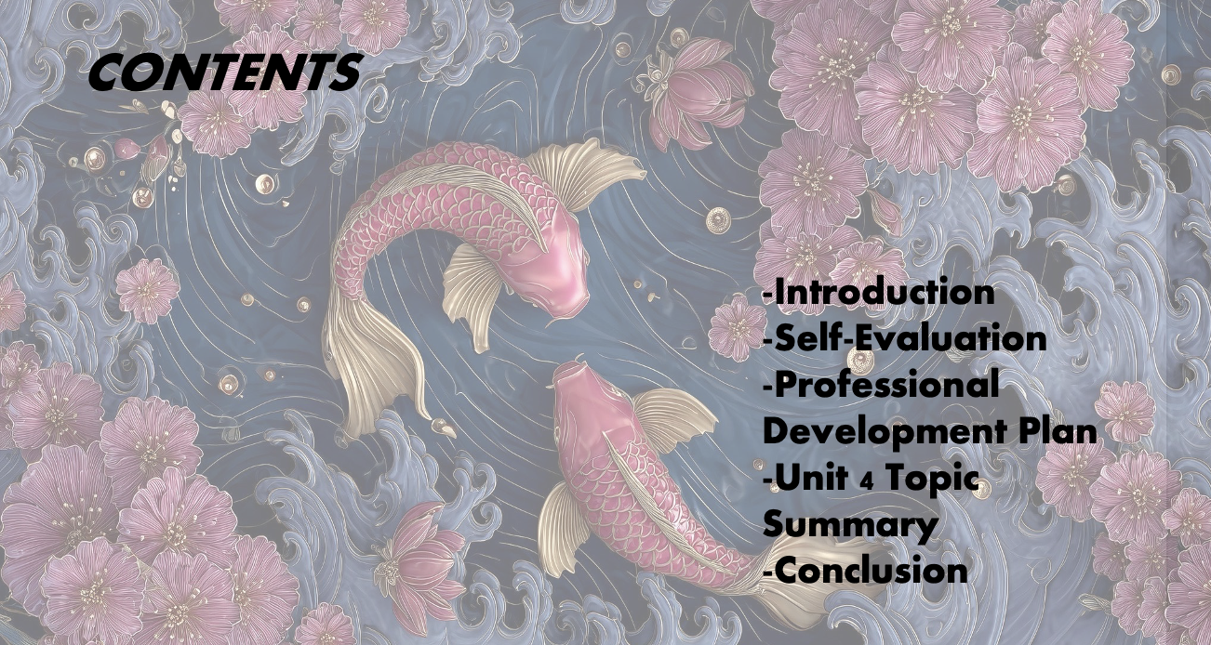
This slide outlines the structure of the presentation, including the introduction, tasks, and conclusion.
Slide 3 INTRODUCTION
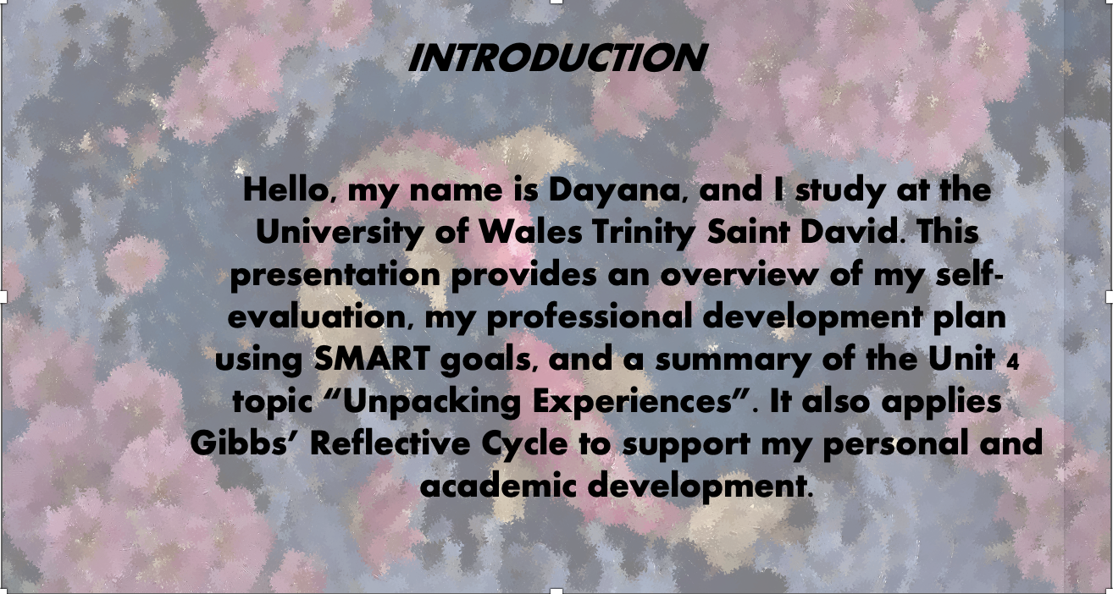
This slide introduces the purpose of the presentation and summarises the key areas: self-evaluation, PDP, Unit 4 topic summary, and reflective practice.
Slide 4 MAIN BODY
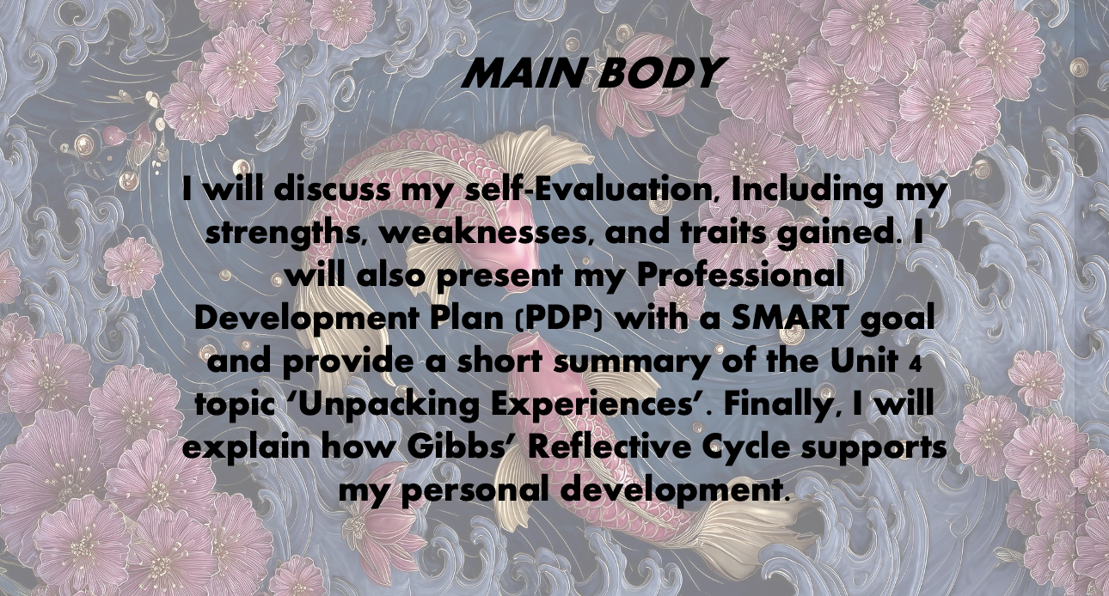
This slide explains that the main body covers Task 1 (self-evaluation), Task 2 (PDP using SMART goals), and Task 3 (Unit 4 topic summary), supported by reflective practice.
Slide 5 GIBB’s REFLECTIVE MODEL
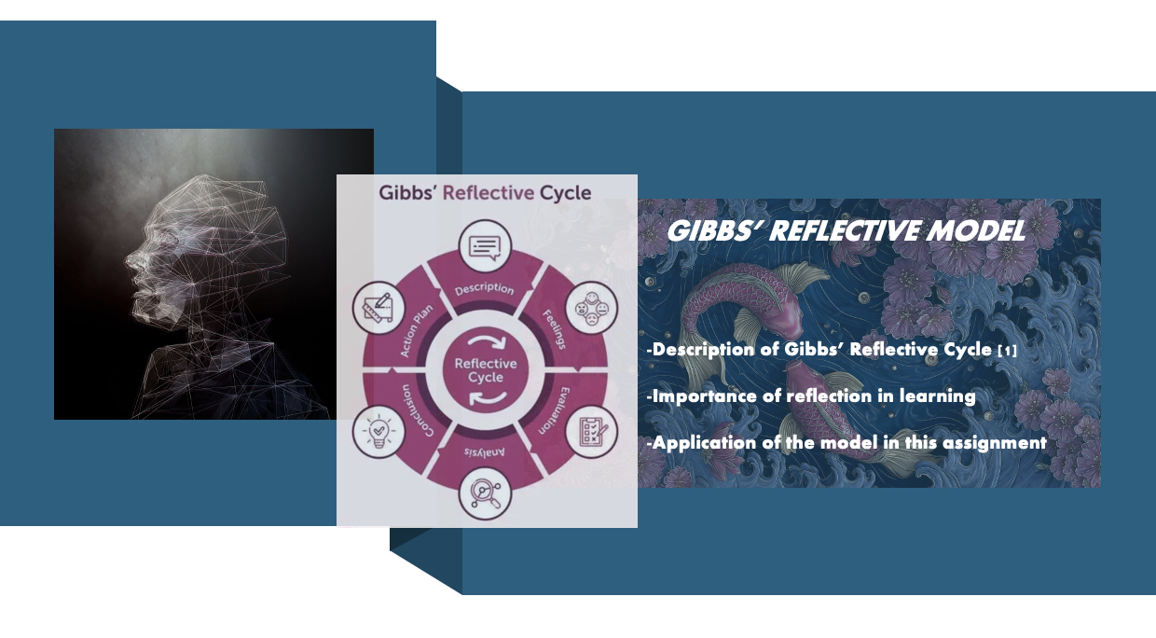
Gibbs’ Reflective Cycle is a structured model for reflective learning that guides individuals through stages such as description, evaluation, analysis, conclusion, and an action plan. [1] In this assignment, I apply Gibbs’ model to reflect on my self-evaluation results and to support the planning of my professional development goals.

Slide 6 TASK 1: SELF EVALUATION
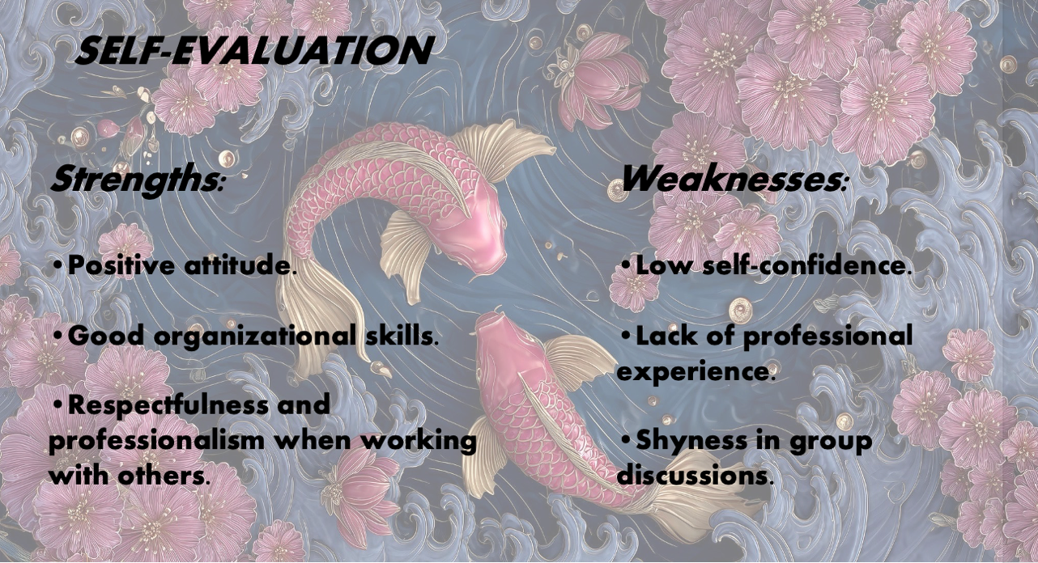
Based on my SWOT self-evaluation, my strengths include a positive attitude, good organisational skills, and respectfulness when working with others. My weaknesses include low self-confidence, lack of experience, and shyness in group discussions.
Slide 7 TRAITS GAINED FROM THE SELF EVALUATION
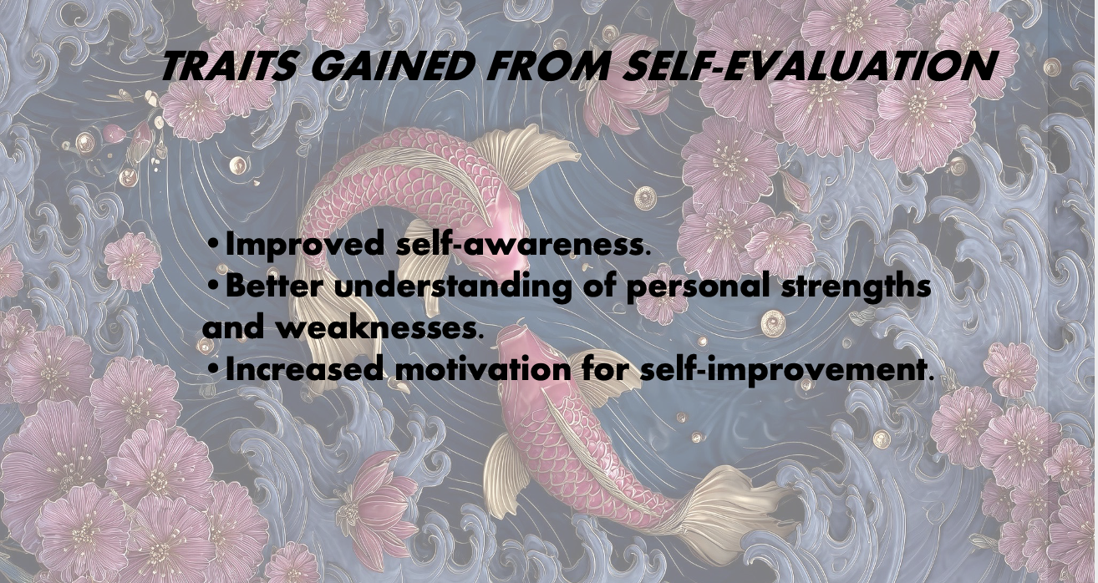
The self-evaluation process increased my self-awareness and helped me better understand areas for improvement. It also improved my motivation for self-development and encouraged me to take greater responsibility for my learning.
Slide 8 PROFESSIONAL DEVELOPMENT PLAN
My professional development plan includes a SMART goal to improve my self-confidence and communication skills within three months. The plan includes actions such as participating in group discussions, practising presentations, and seeking feedback from peers and tutors.
Slide 9 UNIT 4 TOPIC SUMMARY
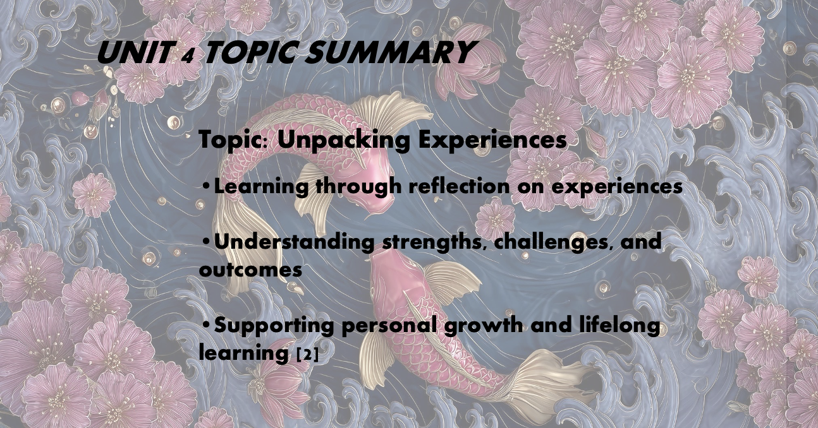
The Unit 4 topic Unpacking Experiences focuses on learning through reflection on personal experiences [2]. By analysing experiences, individuals can identify strengths, challenges, and learning outcomes, supporting continuous personal growth and lifelong learning.
Slide 10 CONCLUSION

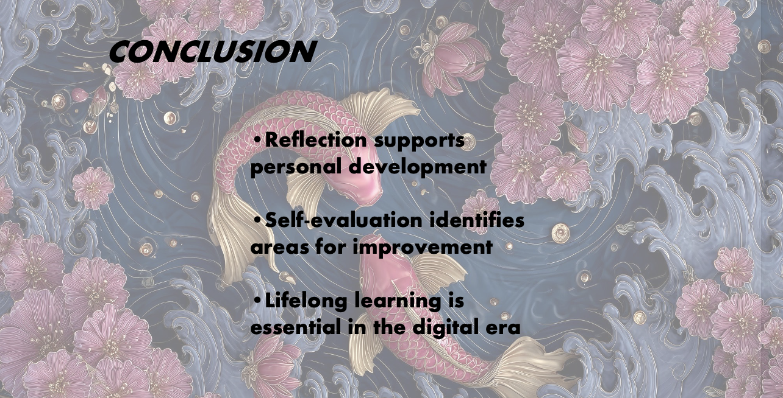
In conclusion, this presentation highlighted my self-evaluation, PDP, and Unit 4 topic summary. Using Gibbs’ Reflective Cycle and reflective learning supports continuous improvement and lifelong learning in the digital era.

Slide 11
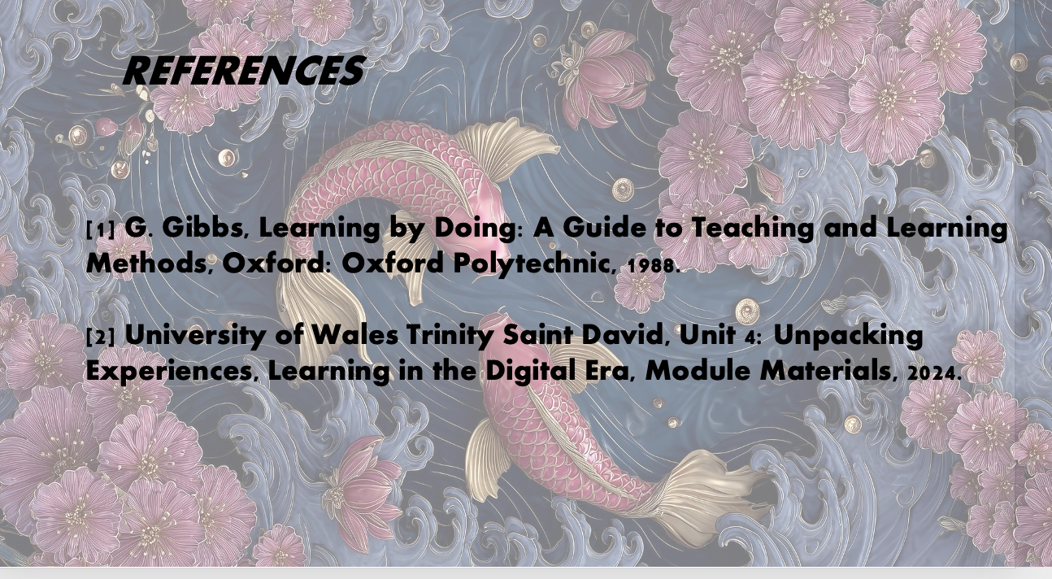

Conclusion
This report summarised the key content included in the video presentation. Overall, the self-evaluation and reflective approach supported the creation of a clear professional development plan and strengthened my understanding of lifelong learning through Unpacking Experiences.

References

[1] | G. Gibbs, Learning by Doing: A Guide to Teaching and Learning Methods, Oxford: Oxford Polytechnic, 1988.
[2] | U. o. W. T. S. David, “Unit 4: Unpacking Experiences,” [Online]. Available: https://moodle.uwtsd.ac.uk/mod/scorm/view.php?id=471946.

