

LEVEL 7 ASSESSMENT SPECIFICATION

Student name: | KUOK Yew Lee | Student ID number: | 2235234
Programme: | DBA
Module: | Quantitative Research Methods
Module code: | HKBM7004 | Contribution to Overall Module Assessment (%): | 100%
Lecturer: | Dr Andrew Chan | Internal Verifier: | Dr Chammy Lau
Assignment Title: | Project Report | Word count (or equivalent): | 7243 words  (excluding References)
Submission deadline: | 27 December 2023 | Return date of provisional marks & written feedback: | 17 January 2024
Submission method: | All written assessments, where practical and possible, must be submitted via Turnitin unless otherwise instructed by the Lecturer. (Please DO NOT put this assessment specification into Turnitin or it will match many similarities with other students’ submissions.)  Alternative submission method (if applicable):  Late submission of the assessment will result in a late penalty mark. Penalties for late submission: Up to one week late, maximum mark of 50%. Over one week late, 0%. Only the Extenuating Circumstances Panel may approve a change to submission dates.
Academic honesty / referencing: | Academic honesty is required. In the main body of your submission, you must give credit to authors on whose research and ideas your work is based. Append to your submission a reference list that indicates the books, articles, etc. that you have used, cited or quoted in order to complete this assessment.

The impact of Corporate Governance on Corporate Social Responsibility Performance: A case study of listed companies in Hong Kong

1 Introduction

1.1 Grounds for the Research

The development of corporate social responsibility (“CSR”) is significantly influenced by the conception development of stakeholder analysis (McDonald, 2007). CSR encompasses the ethical treatment of the firm’s stakeholders and extends its dedication to effective corporate governance (“CG”), sustainability, and ethical business practices that support equality, answerability and transparency disciplines (Hopkins, 2004). Businesses aim to maintain profitability while supporting high governance value internally (Jamali, Safieddine and Rabbath, 2008; Jo and Harjoto, 2011).

Globalisation has played a role in expanding the global economy and creating wealth, while also giving rise to the importance of CSR in conducting business in the 21st century (The Economist, 2008). It can be argued that CSR should primarily be driven by market forces, although regulations amendments are crucial means for this transition. For instance, environmental, social, and governance (refers to CG) (“ESG”) aspects have been included in the rules governing the listing of securities on the main board of The Stock Exchange of Hong Kong Limited (“SEHK”) (“Listing Rules”), as well as corporate laws and regulations, etc. In Hong Kong (“HK”), CSR has become an integral part of mainstream CG and ESG requirements, as it goes beyond moral obligation and is considered a wise business decision. Assessing organisations’ overall performance in terms of their impact on society and the environment has become crucial in evaluating their contribution to sustainable development (“SusDev”) (ISO, 2010).

A collection of United Nations’ (“UN”) 17 SusDev goals endorsed in 2015 under the 2030 Agenda for SusDev (“Global Goals” or “SDGs”) represent a new approach that requires immediate action from all countries. This approach emphasises the need for strong collaborations at all boundaries (global, national and local ranks) for achieving a common vision and goals. It promotes a unified perspective on SusDev that focuses on balancing the interest of all stakeholders for sustainability of environmental, social and economic (United Nations, 2023).

The need for businesses to address social demands and environmental constraints has become a major challenge for fitting comprehensive ESG factors into their strategies. However, it also brings significant opportunities for competition and adaptation in a constantly evolving world, requiring substantial transformations in society, politics, law, technology, culture and behaviour. Consequently, businesses that can succeed in the long-run are those that lead in creating value in their internal and external organisational environments.

1.2 Research Problem Statement

There is minimal research on examining the impact of CG on CSR performance for corporations engaging in CSR orientation in HK, a developed economy and a prominent global financial hub, particularly with sample of corporations listed on the main board of SEHK (“HK Listed Corporations”).

Pursuant to the Listing Rules, the board of directors’ (“Board”) primary focus should be on generating sustainable long-term growth for shareholders and providing enduring value to all stakeholders (HKEx, 2023). Therefore, it is essential to have a viable business strategy that incorporates ESG initiatives, encompassing elements of CG and CSR, to enhance CSR performance.

Carroll (1979) defines a firm’s CSR performance as its capacity to fulfill stakeholders’ expectations regarding economic, environmental and social responsibilities. CSR performance evaluates how a company utilises its resources to address societal issues and attain social objectives. It assesses the actions taken by a corporate entity for the betterment and welfare of society, encompassing areas such as philanthropy, environmental conservation, diverse labour practices, human rights, and selfless services (Nwude and Nwude, 2021).

Despite the significant growth of the literature on CSR concept over the years due to high recognition of the significance of environment and social considerations within the corporate world, the measurement of CSR performance that in line with the notion of stakeholder is still problematic, whereby different scholars have applied different methodology(ies) in measuring CSR performance. For example, Wolfe and Aupperle (1991) states that determining the most effective approach for evaluating corporate social activities is not a straightforward task. Waddock and Graves (1997) similarly acknowledge the challenges associated with measuring corporate social performance and explored various alternative methods, encompassing, inter alia, forced-choice questionnaire, content analysis of hard data, measurement of behaviours and opinions, as well as case studies. These alternative methods have then been classified by Maignan and Ferrell (2000) into three primary methods: expert assessments, indicators focusing on single or multiple issues, and surveys targeting managers. On the other hand, while acknowledging that there is limited literature on how CSR can be measured, Turker (2009) had, based on the CSR theoretical framework with the exclusion of economic component, developed a new scale to measure CSR in terms of the expectations of various stakeholders.

1.3 Research Purpose Statement

The purpose of this study is to develop and pilot test a survey instrument (i.e. questionnaire) to assess the impact of CG characteristics on CSR performance of HK Listed Corporations.

The impact of a company’s established CG on its CSR performance is widely acknowledged. In relation thereto, the objective of this study is to conceptualise CSR as management strategies in voluntarily integration of social and environmental aspects with operations and interactions with the stakeholders by a sample of 31 HK Listed Corporations. Writer has, based on the existing literature, applied the CSR scale developed by Turker (2009) for measuring the CSR performance of HK Listed Corporations in four dimensions (i.e. factors): social stakeholders and non-social stakeholders (including the natural environment and future generations); employees; customers; and government.

Writer has excluded the economic component from the measurement scale of CSR performance because profit achievement is the primary objective and crucial for the survival and continuity of HK Listed Corporation, and financial performance is certainly formed part of key determinants for SusDev. Several studies in sustainable business development suggest that achieving strong CSR performance can lead to positive outcomes, including enhancing financial performance (Waddock and Graves, 1997) and gaining a competitive advantage (McWilliams and Siegel, 2011). Porter and Kramer (2006) linked their value chain model to CSR; and stated that many companies have undertaken efforts to improve the consequences arising from their social and environmental activities.

As mentioned, this study categorised CSR domain into four dimensions, whereby each dimension consists of several indicators, which facilitates the Board to examine the impact of CG (for this study, the writer used close-ended questions to measure CG characteristics which particularly focusing on the size of the Board and the chief executive officer (“CEO”) duality) on each CSR dimension (along with its indicators), thereby adjust the Board structure (where appropriate), and allocate scare and precious resources to the desired CSR activity(ies) appropriately with the objective of enhancing the firm’s performance on CSR activity(ies) in the future within the context of HK listed entities or any form of entities in any jurisdictions. Thus, research findings would contribute to the existing literature. Moreover, the developed questionnaire can be used in multi-context entities to promote and implement CSR activities.

The literature review for this study comprises of CG and CSR literatures, upper echelons theory (Hambrick and Mason 1984), ISO 26000’s international standards (ISO, 2010), ESG agenda in Listing Rules, and the SDGs.

2 LITERATURE REVIEW AND RESOURCES

The main emphasis of this report’s literature review is directed towards the research objectives, research issues, and the examination and interpretation of the research findings.

2.1 CG Literature

The primary focus of this study will centre around the definition of CG as ‘the system by which companies are directed and controlled’ (Cadbury, 2000, p. 8), whereby the control aspect consists of compliance, accountability and transparency concepts (MacMillan et al., 2004), as well as how managers fulfil their duties by adhering to the legal requirement and ethical standards (Cadbury, 2000). According to Hampel Report (1998): ‘The importance of CG lies in its contribution both to business prosperity and to accountability’ (Hampel Committee, 1998, p. 7).

A limited perspective on CG portrays it solely as a regulatory and finance framework, with minimal attention given to socio-environmental concerns (Saravanamuthu, 2004). This concept revolves around the principles of answerability, conformity to regulations and transparency (Keasy and Wright, 1997; MacMillan et al., 2004).

A broader perspective of CG highlights the obligations of businesses towards their diverse stakeholders, who contribute vital resources for their survival, competitiveness and prosperity (MacMillan et al., 2004). This includes cater a well-balanced of various stakeholders’ welfares (Thompson, 1995). Although businesses are primarily accountable to shareholders for the company’s financial performance, they also bear responsibility towards employees, suppliers, customers, and communities, who make substantial investments in different aspects of the company (Kendall, 1999; Page, 2005). A broader CG approach involves considering the interests of all stakeholders and ensuring accountability towards the company’s primary stakeholders (Dunlop, 1998; Kendall, 1999).

In essence, CG primarily centres around a collection of fundamental characteristics, such as establishing an effective corporate leadership, strategy formulation, and strategic management process that integrates stakeholder value and shareholder value (Tricker, 1994; Kendall, 1999; MacMillan et al., 2004); designing reporting systems in a manner that promotes good governance (Kendall, 1999); enhancing accountability to both shareholders and other stakeholders, while improving corporate performance (Keasy and Wright, 1997); generating mechanisms to regulate managerial conduct (Tricker, 1994); emphasising transparency on disclosure (Page, 2005); and operating the companies in compliance with laws and being responsible to all stakeholders (Dunlop, 1998). At the core of robust and efficient CG are essential qualities on leadership, direction, control, transparency and accountability (Huse, 2005; Van den Berghe and Louche, 2005).

2.2 Upper Echelons Theory

The study is underpinned by the upper echelons theory proposed by Hambrick and Mason (1984). According to Hambrick and Mason’s (1984) upper echelons theory, the Board structure significantly shapes the company’s strategic decision-making. Rupley, Brown and Marshall (2012) highlight that a collective attributes of Board members will substantially influence the pattern of a company’s CSR performance as the Board is the ultimate decision-maker. The Board’s decisions encompass resource allocation, engagement in CSR activities, and formulation of strategies concerning the society, as well as establishes and nurtures relationships with various stakeholders (Pucheta-Martínez and Gallego-Álvarez, 2019). The considerable key criterions in Board composition which have impacts on CSR performance are, inter alia, gender diversity (Setó-Pamies, 2015; Hyun et al., 2016), director age (Post, Rahman and Rubow, 2011; Hafsi and Turgut, 2012), the number of outside directors (Jizi et al., 2013; Amran, Lee and Devi, 2014; Liao, Luo and Tang, 2015), board size (Rao and Tilt, 2015), and education (Post, Rahman and Rubow, 2011). Hence, it is essential to examine the connection between the Board structure and the CSR performance of companies.

2.2a Befitting Board Size

The existing literatures have not reached an agreement about the impact of Board size on CSR performance.

Maclagan (1998), and Hermalin and Weisbach (2003) claim that in common perception, Board with a larger size will cause a communication barrier and negative impact on decision-making efficiency for the company, leading to disregard of (or lesser interest on) CSR agenda and unfavourable to CSR implementation.

Additionally, according to Kassinis and Vafeas (2002), there is a suggestion that a larger Board size is associated with a higher likelihood of violating environmental regulations and having a negative effect on environmental performance. Moreover, Olthuis and van den Oever (2020) argue that it also affects the overall CSR performance negatively. However, other scholars such as Cook and Glass (2018) and Endo (2020) present evidence supporting the idea that a larger Board size can have a positive influence on environmental performance. On the other hand, Post, Rahman and Rubow (2011) reported a insignificant relationship between these two factors.

On the other hand, some literatures suggested that larger Board size is linked to better stakeholder representation (i.e. comprises of representative of diverse interests), leading to a higher awareness of stakeholders interests and greater firm’s involvement in CSR investments (Ntim and Soobaroyen, 2013; Chams and García-Blandon, 2019), thus reducing social pressure and demands of stakeholders (Barakat, 2014). More Board members could have advantages of superior news and intelligence (Carter et al., 2010), including environmental knowledge which leads to a positive impact on environmental performance (De Villiers, Naiker and Van Staden, 2011); and greater diversity in education and industry experience (Zahra and Pearce II, 1989), ultimately leading to a well-balanced decision-making and more oriented advice on strategic decisions (Siciliano, 1996). All the above-mentioned factors will enhance CSR performance (Hillman and Keim, 2001).

2.2b CEO Duality (or Board Chairperson and CEO roles are separated)

A variety of studies about the effect of CEO duality with CSR performance have been conducted, especially in developing countries, but the results are not showing consistency (Andanawarih, Restuningdiah and Sidharta, 2021).

CEO duality refers to the situation where an individual holds both the positions of Board leadership and corporate management simultaneously. This arrangement is commonly believed to grant CEOs an increased executive power that potentially leading them to pursue self-serving strategies which may not align with shareholder interests. Consequently, long-term projects such as those in the CSR field may be marginalised in favor of short-term financial performance under the pressure from shareholders. As a result, the presence of CEO duality is negatively associated with CSR performance (Surroca and Tribo, 2008; Paek et al., 2013; Muttakin and Subramaniam, 2015). De Villiers, Naiker and Van Staden (2011) also claim that a dual CEO-chair diminishes CSR performance, as it prioritises short-term financial gains and reduces the chance of investing in the long payback term of environmental strategic project(s). Moreover, Naciti (2019) and Shahbaz et al. (2020) suggest that CEO duality has a detrimental impact on ESG performance.

Previous studies have shown that companies that have a separate CEO and Chairperson exhibit stronger performance in terms of Board oversight concerning climate change (Galbreath, 2010). Moreover, this power separation has a favorable influence on the adoption of environmental and social practices (McKendall, Sánchez and Sicilian, 1999; Lattemann et al., 2009). For instance, McKendall, Sánchez and Sicilian (1999) emphasise that having a non-CEO chairman can alleviate the pressure to deliver immediate positive outcomes and enable them to argue against non-compliance with environmental regulations, highlighting the long-term negative social and financial consequences.

Nevertheless, McGuinness, Vieito and Wang (2017) and Chams and García-Blandon (2019) suggested there is no significant relationship between CEO-duality and CSR performance.

2.3 CSR Literature

The below CSR theories cover the essential responsibilities on economic, societal and environmental aspects (Golja and Pauišić, 2012).

2.3a Davis’s Iron Law of Responsibility

Davis (1960) introduces the concept of the ‘Iron Law of Responsibility’ which posits that business entities shall align their social obligations with their level of societal influence. Failure to prioritise social responsibility will result in a gradual erosion of their societal influence over time. Davis (1960) defined social responsibility as the decisions and actions of businessmen that go beyond the firm’s immediate economic interests. Irrespective of their size, all companies have the capacity to contribute positively to SusDev through responsible conduct (Davis, 1973).

2.3b Friedman’s Shareholder Theory (or Agency theory)

Friedman’s Shareholder Theory (1962) argues that businesses’ primary goal is to maximise profits. According to Friedman (1970a), he does not support the concept of CSR as it undermines the fundamental responsibility of businesses for meeting the interest of their owners in terms of profit generation. Friedman (1970b) underscores the idea that CSR entails harmonising business practices with the interests of shareholders, utilising resources to maximise profits, and simultaneously adhering to societal norms, laws and ethical standards.

2.3c Freeman’s Stakeholder Theory

Stakeholder Theory, often associated with Freeman (1984), suggests that companies should perceive CSR as a natural extension of a high standard of CG. Freeman (1984) asserts that managers bear the responsibility of effectively managing the contradictory and competing interests of stakeholders to fulfill the organisation’s goals. Additionally, Freeman (2002) highlights the significance of acknowledging the rights and interests of all stakeholders recognised by the law, fostering stakeholder democracy and CG. He argues that Stakeholder Theory aligns harmoniously with other ethical frameworks.
2.3d Carroll’s Four-Part Model of CSR (for Corporate Social Performance Theory)

Carroll (1991) proposes that corporations have economic, legal, ethical, and philanthropic responsibilities which collectively form as total CSR that should be upheld concurrently at all times for achieving a harmonious balance of these responsibilities (see Figure 1).

Figure 1 - Carroll’s Four-Part Model of CSR

2.3e Elkington’s Triple Bottom Line (“TBL”) Concept
(also known as Triple P (Profit, Planet, People) Reporting)

Elkington (1997) claims that organisational performance comprises three dimensions: economic prosperity, environmental quality, and social justice/equity. These dimensions encompass the existence purpose of the company and the deliberation of various stakeholders’ desires. Elkington (2006) states that the responsibility for the TBL agenda lies with the Board. A strong CG system enhances the potential for achieving sustainable capitalism. By implementing effective CG practices, sustainable business is attainable.

2.3f Corporate Citizenship (“CC”)

According to Matten, Crane and Chapple (2003), there are narrow perspective of CC that mainly focuses on corporate philanthropy; a broader perspective that equates CC with CSR; and an expanded perspective that recognises the political role of corporations in society. A summary of the three different CC perspectives is presented in Figure 2.

A summary of the corporate provision of these three citizenship rights and the extended view of CC are presented in Figures 3 and 4 respectively. Hence, the extended view of CC can be characterised as the corporate role in overseeing the provision of citizenship rights to individuals (Crane and Matten, 2004). It also recognises that corporations assume responsibility for managing certain aspects of citizenship for various stakeholders, as well as broader constituencies with no direct transactional ties to the corporation (Crane and Matten, 2004).

Figure 2 - Three Views of Corporate Citizenship

Figure 3 - Corporate Provision of Citizenship Rights

Figure 4 - An Extended View of Corporate Citizenship

2.4 Hancock’s (2005) Four Key Pillars of CSR Model

CG is a foundational element within the CSR model (see Figure 5). The model emphasises that an effective CG framework enhances the company’s governance for the benefits all stakeholders involved and contributes to SusDev (Hancock, 2005). This perspective aligns with Elkington’s (2006) viewpoint and the principles outlined in ISO 26000, which recognise the significance of respecting society and the environment for achieving sustainability (ISO, 2010). It suggests that the responsibility of CSR lies with the Board, and strong CG forms a foundation for sustainable CSR practices (Jamali, Safieddine and Rabbath, 2008).

Figure 5 - Four Key Pillars of CSR Model

2.5 Application of ISO 26000

The concept of effective CG being essential for CSR is aligned with ISO 26000. This international standard focuses on seven key areas of social responsibility, including organisational CG, social and environmental responsibilities. These areas encompass the significant economic, environmental and social impacts that necessary for contributing to SusDev (ISO, 2010). Additionally, the seven principles of social responsibility are a useful guide in promoting social equity, healthy ecosystems and sound CG (ISO, 2010; ISO, 2011). Figure 6 provides an illustrative summary of ISO 26000.

Figure 6 - Schematic Overview of ISO 26000

2.6 Application of Listing Rules on ESG Subject Areas

This research is referred to the Listing Rules - Appendix 14 (“CG Code”) and Appendix 27 (“ESG Reporting Guide”) (see Figure 7). The CG Code and ESG Reporting Guide comprise two levels of disclosure obligations: (a) the mandatory requirements for disclosure in an issuer’s CG report and ESG report; and (b) “comply or explain” provisions (HKEx, 2023).

Figure 7 – An Overview of ESG Subject Areas
2.7 Application of UN’s SDGs

The SDGs comprise 17 goals and 169 targets (see Figure 8 with description) with the objective of attaining a more sustainable future by 2030. These goals prioritise the harmonization of environmental, social and economic sustainability. Given their interconnected nature, it is crucial to identify and evaluate a balance among goals which are not attainable at the same time (i.e. trade-offs), and attain synergies (i.e. co-benefits) among the SDGs (see Figure 9) (United Nations, 2023). Mapping the 17 goals to the three overarching categories of ESG is necessary to assess the synergies between them (see Figure 10).

Figure 8 – SDGs

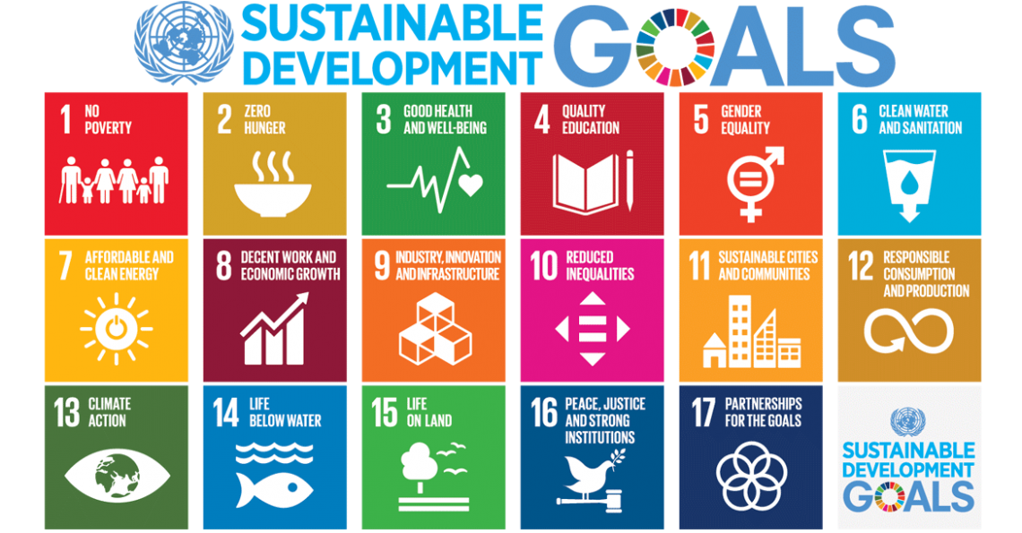
Source: United Nations (2023).

Source: United Nations (2023).

Figure 9 – The Interlinked Nature of the SDGs

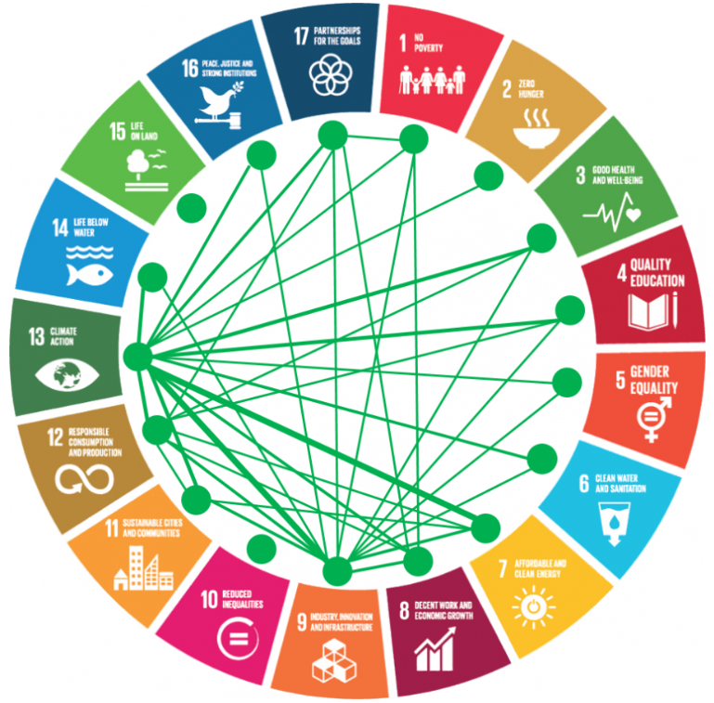

Visualisation of SDG interlinkages based on shares of positive correlations between the goals.

Source: Eurostat (2023).

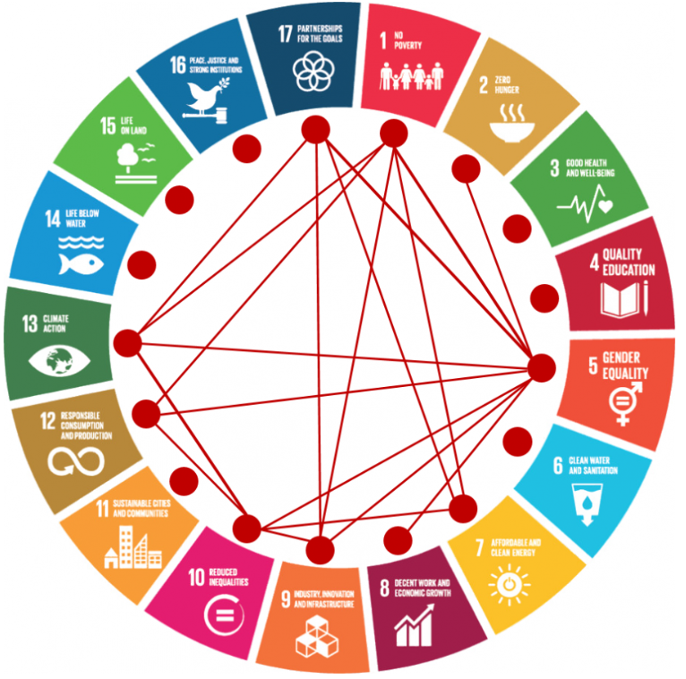

Visualisation of SDG interlinkages based on shares of negative correlations between the goals.

Source: Eurostat (2023).

Figure 10 – SDGs Mapped Against ESG Categories
Source: Ocean Prosperity Company Limited (2023).

2.8 Empirical Literature Review and Hypotheses Development

With reference to the above-mentioned literature review and for the purpose of the design of questionnaire to meet the research objective and purpose, the writer presents the proposed conceptual framework in Figure 11 which synthesise various arguments and findings of prior research. This research focused on the examination of the impact of CG characteristics in respect of the Board size and CEO duality on CSR performance in terms of four dimensions: social stakeholders and non-social stakeholders (including the natural environment and future generations); employees; customers; and government.

This study proposed that the Board size and CEO duality characteristics have significant effects on CSR performance.

Figure 11 – The Proposed Conceptual Framework
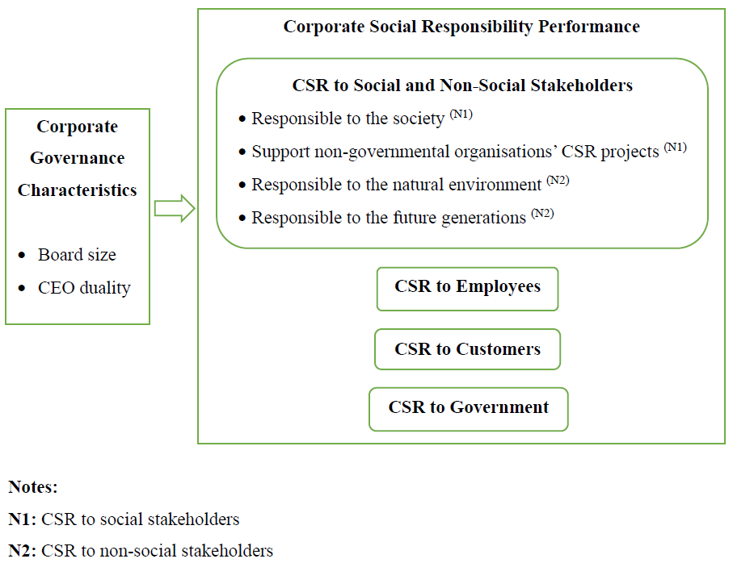

3 Research strategy and Methodologies

3.1 Quantitative Research Design

This study used both induction and deduction research processes which are interconnected throughout the research (Popper, 1972; Strauss, 1987; Richards, 1993; Miles and Huberman, 1994, cited in Perry and Jensen, 2001). According to Parkhe, exclusively relying on pure induction without any pre-existing theory could limit a researcher’s ability to utilise existing theories. Similarly, relying solely on pure deduction might hinder the creation of innovative and valuable theories. Therefore, the progression of theory requires a synergistic approach that combines both approaches (1993, cited in Perry and Jensen, 2001). Writer adopted the positivism paradigm a long with a deductive approach throughout the research.

Coupled with using (a) questionnaire to collect data; and (b) descriptive statistics and inferential statistics to describe and analyse (i.e. through hypotheses testing) the responses respectively, writer has developed a reliable questionnaire and analysed the research issues as demonstrated by the case study towards contributing to the specified research objective and purpose (including the development of a new thinking or knowledge on research field, or generating recommendation), and investigating the identified research problems.

This study was segregated into two phases. Firstly, writer invited experts from the research field to review the initial generated items for questionnaire. Secondly, writer tested the revised items with a sample of 31 HK Listed Corporations, and examined the reliability of each construct scale and questionnaire.

Ethical issues have been addressed throughout the entire research process, such as, inter alia, (a) for experts review, gave credit for inclusion of validation items; (b) for online survey which was anonymous for guarantee the confidentiality of all data collected, informed participants that engagement with this online survey in on a voluntary basis; and informed the objective for the utilisation of research data, and all email contacts and data collected would be deleted 3 months upon the submission of research project to the university of which research data would be presented in anonymous form; and (c) report the comprehensive results honestly with appropriate language, and avoid plagiarize.
3.2 Items Development and Items Revision based on Experts Review Feedback

3.2.1 Figure 12 – Initial Item Pool and Scales for Questionnaire
Notes:
Q: Question.
N1: The 11 close-ended questions used for measuring CG characteristics were referred to the Board practices survey questionnaire (Society of Corporate Secretaries and Governance of Professionals and Deloitte Development LLC, 2014) and the existing literature. Save for Q7 and Q11 whereby respondents have to select one-word answer “yes/no” (nominal scale), for the other 9 questions, respondents have to choose from a pre-defined set of multiple-choice answers.
N2: The 4 factors and 18 indicators (i.e questions) were based on the CSR scale developed by Turker (2009) for measuring the CSR performance and the existing literature. For Q1 to Q18, 5-point Likert scales were used to reflect respondents’ opinions or perceptions, ranging from (1) Strongly disagree; (2) Disagree; (3) Neither agree or disagree (i.e. Uncertain); (4) Agree; (5) Strongly agree. Each value on the scale represents a different level of that attribute (Likert, 1932).

3.2.2 Figure 13 – Items Revision based on Review Feedback of Four (4) Experts

No. | Items  (Before Revision) | Issues identified by Experts | Items  (After Revision)
A  Q7  Q10 | “Chairman” | Replace “Chairman” with “Chairperson” to avoid gender bias in writing as the Chairman of the Board can be woman. | “Chairperson”
B  Q5 | “Our company supports non-governmental organisations working in problematic areas.” | Make the sentence clearer by specifying provides support to non-governmental organisations that “operate in significant challenging projects” instead of “working in problematic areas” which may relate to the legality of such spheres. | “Our company provides support to non-governmental organisations that operate in significant challenging projects.”
B  Q7 | “Our company encourages its employees to participate in voluntarily activities.” | Make the sentence clearer by specifying “volunteer works that enhance their commitment to social and environmental responsibilities and sustainability” instead of “voluntarily activities” which may not relate to social and environmental contribution activities. | “Our company encourages its employees to participate in volunteer works that enhance their commitment to social and environmental responsibilities and sustainability.”
B  Q10 | “The management of our company is primarily concerned with employees’ needs and wants.” | Revise the sentence from a practical aspect for people management context in business environment as follows:  use “has a high concern on understanding” instead of “is primarily concerned with”; replace “wants” with “desires”; and adding “for job satisfaction within the company”, being the ultimate objective of management that focus on this human relation factor. | “The management of our company has a high concern on understanding the employees’ needs and desires for job satisfaction within the company.”
B  Q11 | “Our company implements flexible policies to provide a good work & life balance for its employees.” | Make the sentence clearer by using and focusing on “work arrangements” instead of “policies” which are widely expressed; and revising “provide a good work & life balance” to “promote a healthy work-life balance” which emphasising the promotion of workplace health. | “Our company implements flexible work arrangements to promote a healthy work-life balance for its employees.”
B  Q12 | “The managerial decisions related with the employees are usually fair.” | Add “and equitable” for a comprehensive term, i.e. fair and equitable. | The managerial decisions related with the employees are usually fair and equitable.

Writer has invited four experts from CG and CSR fields to review the initial item pool for questionnaire (see Figure 12) of which two are senior professionals from The Hong Kong Chartered Governance Institute, and the other two are senior practitioners from HK listed corporations. After having a series of discussions between the writer and the relevant experts in respect of their comments or opinions based on both the practical and legal perspectives, the final decision on revision of items are presented in Figure 13. Initial determined scales remain unchanged.

3.3 Research Approach, Research Method, and Sampling

Based on the research design described in the above item 3.1, writer selected case study approach whereby cases could be studied empirically and scientifically through a pre-defined set of responses set out in the newly developed and pilot test questionnaire with objective opinion or perception for the impact of CG (particularly, the Board size and CEO duality characteristics) on CSR performance (particularly, the social and environmental performances). The designed questionnaire has two components: (a) deciding what to measure (see Figure 12 for item pool and scale); and (b) designing questions (see Figures 12 and 13 for item pool and items revision after experts review, respectively) and testing questions that would be good measures (see Figures 14, 15, 16 and 17).

Pilot testing of a questionnaire was crucial for enhancing the quality and effectiveness of the research instrument. Writer could make necessary improvements through (a) identifying potential issues or shortcomings in the questionnaire from the feedback of pilot test respondents (i.e. evaluation of response patterns); (b) refining questionnaire for clarity, comprehensibility, and overall effectiveness; and (c) eliminating measurement errors and increasing the accuracy of data collection. Thus, increase the validity and reliability of the instrument which ultimately enhance the validity of this study. Furthermore, adjustments could be made to ensure the questionnaire was appropriately structured and manageable for participants. In relation thereto, writer could ensure that the questionnaire was well-suited for the research objectives and the subsequent full research in terms of adequately collect the information required to answer the research questions, and instrument items along with scale options were relevant and meaningful for empirical and scientific study.

Data were collected from a sample of 31 HK Listed Corporations, being 31 units of analysis from the SEHK main board listed corporation’s population of interest that meet the minimum sample size as recommended by Johanson and Brooks (2010) for this pilot study with the purpose of preliminary survey and/or scale development.

Writer adopted purposeful sampling (i.e. the samples were HK Listed Corporations and subjects were key informants); convenience sampling for easily approaching sample(s) through writer’s own network; and snowball or chain sampling for gaining access to key informants through the writer’s social network (Creswell and Poth, 2018). Therefore, the sample boundary would not be pre-categorised into the type of industries and the company size.

4 Results

4.1 Figure 14 - Pilot Survey Respondent Profile and CG Characteristics (n = 31)
A total of 31 HK Listed Corporations completed the pilot questionnaire. More than half of the subjects were at management level (54.8%) and subjects from company secretarial department recorded the highest participation rate (67.7%), whereas subject from Board office was only 1 person (3.2%). The second larger subject pool was senior management (35.5%) and subjects from legal/ compliance/ policy department recorded the second highest participation rate (22.6%). Most of the respondents were from consumer discretionary industry (35.5%), followed by industrial (16.1%), properties & construction (12.9%) and utilities (12.9%) industries. The sample pool consisted less participants from financials (6.5%) and healthcare (6.5%) of which the lowest were from conglomerates, energy and information technologies industries (each presented by 3.2%). Responses from large and middle-market capitalisation companies were equal (41.9% for each category), and small market capitalisation companies recorded the lowest response rate (16.1%).

In terms of Board structure, more than half of the respondents have (a) less than 10 directors on Board (i.e. 58.1%, whereas the remaining 41.9% recorded Board with 10 or more members); (b) women directors representing “25% or less” in total headcount at Board (i.e. 77.4%, whereas the remaining 22.6% representing “26% or more” category); (c) independent directors on Board that below majority headcount level (i.e. 71%, whereas the remaining 29% representing the higher side); (d) youngest directors with aged below 50 years (i.e. 77.4%, whereas the remaining 22.6% directors are over 50s); and (e) separation of the roles between Chairperson and CEO (i.e. 71%, whereas the remaining 29% have CEO duality characteristic).

Furthermore, all respondents do not have independent Chairperson, and all their Board and/or Board-level committee have involved in the oversight of the company’s CSR effort and disclosure. For full research instrument, these two questions with 100% same answer (yes / no) could be removed as lack of variability.

4.2 Figure 15 - Final CSR Performance Questionnaire Items (n = 31)

Notes:
n: Sample size
SD: Standard Deviation
Min: Minimum
Max: Maximum

Q11 under EE construct indicating the implementation of good work & life balance flexible policies as stipulated in the initial item pool (see Figure 12) has been removed from this final questionnaire as this construct recorded Cronbach’s α 0.64 which was below 0.7 (representing lower internal consistency) (George and Mallery, 2003). After removing such item, EE construct recorded Cronbach’s α 0.783 which was at acceptable level (George and Mallery, 2003). Apart from this, each construct of SE, CU and GO recorded Cronbach’s α of 0.865, 0.892 and 1.000 respectively (i.e. all more than 0.7). Cronbach’s α 1 indicated perfect internal consistency, thus, GO1 and GO2 were strongly correlated and contributed to a more reliable measurement of GO construct. The results indicated that this instrument was reliable (see Figure 15).

As regards means, SE3 and EE4 with means close to the middle of the scale (i.e. near 3 on a 5-point scale) could claim as good indicators as such questions were well-balanced and not biased towards one extreme or the other (both questions showing responses with minimum value of 2 “disagree” and maximum value of 5 “strongly agree”). This could be desirable because it allows for a more nuanced understanding of the topic being investigated. On the other hand, CU, CU1, CU2, CU3 with means near the extreme end of 5 were considered as less desirable questions which might due to response bias where respondents tended to favour one extreme of the scale with maximum value of 5 “strongly agree” (and minimum value of 3 “neither agree or disagree”) that could limit the variability perspectives, and validity and generalizability of the findings. However, in view of these four items were concerning CSR to customers which was a key criterion in the business environment for financial performance, therefore, such extreme mean scores alone were not sufficient to determine the quality of a research question.

In respect of SD, SE3, SE4, EE4 with SD equal to 1 were considered as large variances spreading from the mean of a data set, and therefore regarded as good indicators (as compared with other values in the data set). These research questions were more variability and powerful as respondents’ responses were quite difference (all showing minimum value of 2 “disagree” and maximum value of 5 “strongly agree”) which was good for survey instrument development. On the other hand, SE7 and CU3 with SD lower than 0.4 might consider as low variances and less variability which could lead to removal from the instrument for full research.

4.3 Hypotheses Testing - Independent Samples T-Test (n = 31)

4.3a Figure 16 - Hypotheses Testing between Board Size characteristic and CSR Performance

Writer used independent samples t-test to compare the means of two independent categories so as to measure if there is a significant impact of Board size characteristic on CSR performance. For analysis purpose, (a) Board size was grouped into two groups: less than 10 members, and 10 or more members; and (b) CSR performance areas were tested individually in terms of social and non-social stakeholders, employees, customers, and government against each group of Board Size.

The P-value of construct “CSR to social and non-social stakeholders” was less than 0.001 (below a chosen threshold of less than 0.05 – for validation of the above-mentioned hypotheses against the collected data) which indicated that this CSR construct (contained 8 indicators) was statistically significant predictions of the performance of CSR on social and non-social stakeholders aspect. This suggested that the collected data was unlikely to have occurred by chance alone under the null hypothesis. Thus, the result supported the idea of a real effect and writer rejected null hypothesis.

Although the means derived from the tests of Board size against the CSR performance areas of employees, customers, and government were near to (or stronger than) the means derived from the tests of Board size against the CSR performance of social and non-social performance (i.e. mean values of 3.972 and 4.596 for Board size “less than 10 members” and “10 or more members” respectively, which considered as having a significant effect between each compared group), but all of the constructs “CSR to employees”, “CSR to customers” and “CSR to government” have P-value higher than a chosen threshold of p-value less than 0.05 which suggested that there were no statistically significant relationship occurred in the research findings.

In summary, Board size characteristic had a significant effect on one of the CSR performance areas, specifically the social and non-social stakeholders aspect.

4.3b Figure 17 - Hypothesis Testing between CEO Duality characteristic and CSR Performance

Writer used independent samples t-test to compare the means of two independent categories so as to measure if there is a significant impact of CEO-duality characteristic on CSR performance. For analysis purpose, (a) CEO-duality was grouped into two groups: Chairperson and CEO roles are separated, and Chairperson and CEO roles are combined; and (b) CSR performance areas were tested individually in terms of social and non-social stakeholders, employees, customers, and government against each group of CEO-duality.

Since all of the constructs “CSR to social and non-social stakeholders”, “CSR to employees”, “CSR to customers” and “CSR to government” generated P-value higher than a chosen threshold of p-value less than 0.05, this suggested that the collected data could reasonably occurred by chance alone under the null hypothesis, and there was no statistically significant relationship occurred in the research findings.

4.3c Presentation of Findings Hypotheses for the Impact of Board Size and CEO Duality Characteristics on CSR Performance of HK Listed Corporations

In conclusion, based on the tested results shown on Figures 16 and 17, only Board size characteristic had a significant effect on one of the CSR performance areas, specifically the social and non-social stakeholders aspect. CEO duality characteristic had no impact on CSR performance.

Figure 18 – Table for Research Finding Hypotheses

 | CG  Characteristics | Support or Unsupported  Existing Literature | CSR Performance
1 | Board size | Support | CSR to social and non-social stakeholders
 |  | Unsupported | CSR to employees
 |  | Unsupported | CSR to customers
 |  | Unsupported | CSR to government
2 | CEO duality | Unsupported | CSR to social and non-social stakeholders
 |  | Unsupported | CSR to employees
 |  | Unsupported | CSR to customers
 |  | Unsupported | CSR to government

5 Discussions

Based on the literature review, larger Board size can have a positive (or negative) significant effect on CSR performance. This research finding shown that Board size has a significant effect on performance of CSR to social and non-social stakeholders. This demonstrated that the opinion or perception about the impact of Board size characteristic on CSR practices provided by samples in HK context was in line with theories and previous research conducted for different populations or contexts.

Additionally, with reference to the existing literature, CEO duality has a negative impact on CSR performance; and separation of CEO and Chairperson roles will have a positive impact on environmental and social practices (i.e. CSR to social and non-social stakeholders). Some researchers suggested that there is no significant relationship between CEO duality and CSR performance. This research finding revealed that there was no significant relationship between CEO duality (and also separation of Chairperson and CEO’s roles) and CSR performance. Hence, the gap occurred between the findings of this research and previous studies might be due to a smaller sample size of this pilot test which might not be a good representative sample.

Among the four CSR constructs, based on the sequential order from the highest to lowest means shown on Figure 15, CSR to customers attained the highest CSR performance level (mean: 4.828), followed by CSR to government (mean: 4.516) and then, CSR to social and non-social stakeholders (mean: 4.234), and the lowest mean of 4.024 was from CSR to employees. Basically, all means were within value 4, no large variance range. Writer opined that, in general, survey samples considered CSR to customers was the utmost essential factor in the business environment for achieving economic (profit) performance, and long-term stability and continuity of business. CSR to government ranked the second important criterion because as public listed corporations, strict compliance with applicable laws and regulations are necessary to protect the company’s reputation (including the liabilities of the Board and key officers) and listing status at SEHK, and avoid reduction of the company’s share price (being an uncontrollable factor) that due to non-compliance of laws and regulations. CSR to social and non-social stakeholders ranked the third key criterion because this construct involved three broad categories of CSR agenda (i.e. natural environment, future generations, and society at large) and consisted of 8 indicators (out of 18 in total), whereby CSR practices on natural environment and society are current hot topics in globalisation context of which company could, inter alia, enhance its reputation in the market, and promote partnership and cooperation with other business entities at the global, national and local levels. For the time being, future generations agenda may be less popular. Due to the resource constraints that faced by all business corporations in HK and even in the global context, companies have no choice but to reduce their available resources or investments in CSR to employees. This argument was supported by the removal of Q11 (under the construct of CSR to employees) from final questionnaire (see description shown in Figure 15).

Writer claimed that the research findings were in line with (a) arguments made by Davis (1960) and Friedman (1962; 1970a; 1970b) where profit maximation is the primary and crucial factor for the survival and continuity of commercial entities, and certainly formed part of key determinants for SusDev; and (b) writer’s decision on exclusion of economic component from the measurement scale of CSR performance (as described in the above item 1.3).

Moreover, as presented in Figure 15, in terms of CSR performance in HK, SE1 (minimum value of 4 “agreed” and maximum value of 5 “strongly agree”) was better than SE2 (minimum value of 2 “disagree” and maximum value of 5 “strongly agree”). Whereas, in terms of survey instrument development, SE2 question (larger variance) was better quality than SE1 question. The above-mentioned scenario was just one of the examples shown on the results in Figure 15.

This research results may cause different implications to CG and CSR researchers, scholars and practitioners. After all, it depends on their specific objective(s) as regards research, academic or commercial (business context) purpose. Different objective may trigger different opinion whether such particularly research question (and scale) is good quality or less desirable.

6 conclusions

When CSR moved from theory to practice, it is considered as an essential actor in terms of corporate strategy. Developing comprehensive measures of multi-dimensional and numerous perspectives of CSR scale and activities for addressing CSR performance is a challenge for this study, and almost all literatures and previous studies have some limitations on CSR measurement. The main limitations of this study are, inter alia, (a) CSR and CG (including formulation of ESG framework) are part of strategic management, but most of the subjects are from management level instead of Board/CEO position (as decision-makers for corporate and business strategies), this may therefore affect the validity of research results due to bias responses; and (b) pilot test sample size may limit the variability and generalizability of the findings as compared to full research.

Due to the changing nature of CSR performance and stakeholder concept, future research shall target perceptions of other stakeholders in HK context, and diverse demographics of respondents are needed to confirm the current scale structure and research findings.

The research results indicated that the pilot test instrument of this study is reliable, and only Board size characteristic has a significant effect on one of the CSR performance areas, specifically the social and non-social stakeholders aspect. CEO duality characteristic has no impact on CSR performance which unsupported the existing literature. Additionally, the findings are in line with some CSR scholars’ arguments (in general context) and writer’s perception (as CG and CSR practitioner in HK listed corporation where comment is referring to HK context) that most of business entities might still prioritise profit performance as main corporate objective as compared to social and environmental performance.

The findings have the potential to generate value (and create signal) to HK’s policy makers, CG/CSR/ESG/SusDev scholars, academicians and practitioners, non-governmental and non-profit organisations on the gap occurred between (a) the research results and (b) existing CG & CSR literatures, and the notion/objective of international standards of ISO 26000 (ISO, 2010) and the Global Goals.

references

Amran, A., Lee, S. and Devi, S. (2014) ‘The influence of governance structure and strategic corporate social responsibility toward sustainability reporting quality’, Business Strategy and the Environment, 23(4), pp. 217-235.
Andanawarih, P, Restuningdiah, N. and Sidharta, E. (2021) ‘The effect of a corporate governance on the corporate social responsibility: Meta-analysis study’, South East Asia Journal of Contemporary Business, Economics and Law, 24(2), pp. 150-162.
Barakat, F., López Pérez, M. and Rodríguez-Ariza, L. (2014) ‘Corporate social responsibility disclosure (CSRD) determinants of listed companies in Palestine (PXE) and Jordan (ASE)’, Review of Managerial Science, 9(4), pp. 681-702.
Cadbury, A. (2000) ‘The corporate governance agenda’, Corporate Governance: An International Review (Practice-Based Papers), 8(1), pp. 7-15.
Carter et al. (2010) ‘The gender and ethnic diversity of US boards and board committees and firm financial performance’, Corporate Governance: An International Review, 18(5), pp. 396-414.
Carroll, A. (1979) ‘A three-dimensional conceptual model of corporate performance’, Academic Management Review,4(4), pp. 497-505.
Carroll, A. (1991) ‘The pyramid of corporate social responsibility: Toward the moral management of organizational stakeholders’, Business Horizons, 34, pp. 39-48.
Chams, N. and García-Blandon, J. (2019). ‘Sustainable or not sustainable? The role of the board of directors’, Journal of Cleaner Production, 226, pp. 1067-1081.
Cook, A. and Glass, C. (2017) ‘Women on corporate boards: Do they advance corporate social responsibility?’, Human Relations, 71(7), pp. 897-924.
Crane, A. and Matten, D. (2004) Business ethics (2nd edition). Oxford: Oxford University Press.
Creswell, J. and Poth, C. (2018) Qualitative Inquiry & Research Design: Choosing among five approaches. United States of America: Saga.
Davis, K. (1960) ‘Can business afford to ignore social responsibilities?’, California Management Review, 2, pp. 70-76.
Davis, K. (1973) ‘The case for and against business assumption of social responsibilities’, Academy of Management Journal, 16(2), pp. 312-322.
De Villiers, C., Naiker, V. and Van Staden, C. (2011) ‘The effect of board characteristics on firm environmental performance’, Journal of Management, 37(6), pp. 1636-1663.
Dunlop, A. (1998) Corporate governance and control. London: CIMA Publishing.
ecgi (2023) Hampel Report (Final): January 1998.
Available at: https://www.ecgi.global/code/hampel-report-final
(Accessed: 2 December 2023).
Eurostat (2022) The interlinked nature of the SDGs.
Available at: https://ec.europa.eu/eurostat/statistics-explained/index.php?title=SDG_cross-cutting_issues_-_interlinkages&oldid=566275
(Accessed: 17 December 2023).
Elkington, J. (1997) Cannibals with forks: The triple bottom line of 21st century business. Oxford: Capstone Publishing.
Elkington, J. (2006) ‘Governance for sustainability’, Corporate Governance: An International Review, 14(6), pp. 522-529.
Endo, K. (2020) ‘Corporate governance beyond the shareholder-stakeholder dichotomy: Lessons from Japanese corporations’ environmental performance’, Business Strategy and the Envionment, 29(4), pp. 1625-1633.
Friedman, M. (1962) Capitalism and freedom. Chicago, IL: University of Chicago Press.
Friedman, M. (1970a) ‘The social responsibility of business is to increase its profits’, The New York Times Magazine, September 13.
Friedman, M. (1970b) ‘Money and income: Comment on tobin’, The Quarterly Journal of Economics, 84(2), pp. 318-327.
Freeman, R. (1984) Strategic management: A stakeholder approach. Boston, MA: Pitman Publishing Inc.
Freeman, R. (2002) ‘Stakeholder theory of the modern corporation’. In: Donaldson, T. and Werhane, P. (eds.) Ethical issues in business: A philosophical approach (7th edition). Englewood Cliffs, New Jersey: Prentice Hall, pp. 38-48.
Galbreath, J. (2010) ‘Corporate governance practices that address climate change: an exploratory study’, Business Strategy and the Environment, 19(5), pp. 335-350.
George, D. and Mallery, P. (2003) SPSS for windows step by step: a simple guide and reference. Boston: Allyn & Bacon.
Golja, T. and Pauišić, M. (2012) ‘New challenges in corporate governance: Linking M&A and social responsibility’, Information Management and Business Review, 4(7), pp. 379-390.
Hafsi, T. and Turgut, G. (2012) ‘Boardroom Diversity and its Effect on Social Performance: Conceptualization and Empirical Evidence’, Journal of Business Ethics, 112, pp. 463-479.
Hambrick, D. and Mason, P. (1984) ‘Upper echelons: The organization as a reflection of its top managers’, Academic Management Review, 9, pp. 193-206.
Hancock J. (ed.) (2005) Investing in corporate social responsibility: A guide to best practice, business planning & the UK’s leading companies. London: Kogan Page Limited.
Hang Seng Indexes Company Limited (2023) ‘Hang Seng Industry Classification System’, Hang Seng Indexes.
Hermalin, B. and Weisbach, M. (2003) ‘Board of directors as endogenously determined institution: A survey of the economic literature’, Economic Policy Review, 9(1), pp. 7-26.
HKEx (2023) Rules and Guidance: Appendices.
Available at: https://en-rules.hkex.com.hk/rulebook/appendices-0
(Accessed: 7 December 2023).
Hillman, A. and Keim, G. (2001) ‘Shareholder value, stakeholder management and social issues: What’s the bottom line?’, Strategic Management Journal, 22(2), pp. 125-139.
Hopkins, M. (2004) ‘Corporate social responsibility: An issues paper’ Working paper no. 27. Geneva: International Labor Organisation.
Huse, M. (2005) ‘Accountability and creating accountability: A framework for exploring behavioural perspectives of corporate governance’, British Journal of Management, 16, pp. 65-79.
Hyun et al. (2016) ‘Women on Boards and Corporate Social Responsibility’, Sustainability, 8(4), pp. 1-26.
ISO 26000 (2010) Guidance on social responsibility. Switzerland: ISO Central Secretariat.
ISO (2011) ‘7 Principles of social responsibility’, ISO Focus +, 2(3), pp. 22-23.
Jamali, D., Safieddine, A. and Rabbath, M. (2008) ‘Corporate governance and corporate social responsibility synergies and interrelationships’, Corporate Governance: An International Review, 16(5), pp. 443-459.
Jizi et al. (2013) ‘Corporate governance and corporate social responsibility disclosure: Evidence from the US banking sector’, Journal of Business Ethics, 125, pp. 601-615.
Jo, H. and Harjoto, M. (2011) ‘Corporate governance and firm value: The impact of corporate social responsibility’, Journal of Business Ethics, 103(3), pp. 351-383.
Johanson, G. and Brooks, G. (2010) ‘Initial cale development: Sample size for pilot studies’, Educational and Psychological Measurement, 70(3), pp. 394-400.
Kassinis, G. and Vafeas, N. (2002) ‘Corporate Boards and Outside Stakeholders as Determinants of Environmental Litigation’, Strategic Management Journal, 23, pp. 399-415.
Keasy, K. and Wright, M. (1997) Corporate governance - Responsibilities, risks and remuneration. New York: John Wiley & Sons.
Kendall, N. (1999) ‘Good corporate governance’, The ICA in England and Wales, Accountants’ Digest, 40.
Lattemann, C. et al. (2009) ‘CSR communication intensity in Chinese and Indian multinational companies’, Corporate Governance: An International Review, 17(4), pp. 426-442.
Liao, L., Luo, L. and Tang, Q. (2015) ‘Gender diversity, board independence, environmental committee and greenhouse gas disclosure’, The British Accounting Review, 47(4), pp. 409-424.
Likert, R. (1932) ‘A technique for the measurement of attitudes’, Archives of Psychology, 22(140), pp. 1-55.
MacMillan et al. (2004) ‘Giving your organisation SPIRIT: An overview and call to action for directors on issues of corporate governance, corporate reputation and corporate responsibility’, Journal of General Management, 30(2), pp. 15-42.
Maclagan, P. (1998) Management and Morality: A Developmental Perspective. London: Sage Publications.
Maignan, I. and Ferrell, O. (2000) ‘Measuring Corporate Citizenship in Two Countries: The Case of the United States and France’, Journal of Business Ethics, 23(3), pp. 283-297.
Matten, D., Crane, A. and Chapple, W. (2003) ‘Behind the mask: Revealing the true face of corporate citizenship’, Journal of Business Ethics, 45(1/2), pp. 109-120.
McDonald, G. (2007) ‘Business ethics and the evolution of corporate responsibility’, Chartered Accountants Journal, March 2007, pp. 12-14.
McGuinness, P., Vieito, J. and Wang, M. (2017) ‘CSR performance in China: The role of board gender and foreign ownership’, Journal of Corporate Finance, 42(2), pp. 75-99.
McKendall, M., Sanchez, C. and Sicilian, P. (1999) ‘Corporate governance and corporate illegality: the effects of board structure on environmental violations’, The International Journal of Organizational Analysis, 7(3), pp. 201-223.
McWilliams, A. and Siegel, D. (2011) ‘Creating and capturing value: Strategic corporate social responsibility, resource-based theory, and sustainable competitive advantage’, Journal of Management, 37, pp. 1480-1495.
Muttakin, M. and Subramaniam, N. (2015) ‘Firm ownership and board characteristics: Do they matter for corporate social responsibility disclosure of Indian companies?’, Sustainability Accounting, Management and Policy Journal, 6(2), pp. 138-165.
Naciti, V. (2019), ‘Corporate governance and board of directors: the effect of a board composition on firm sustainability performance’, Journal of Cleaner Production, 237, pp. 959-6526.
Ntim, C. and Soobaroyen, T. (2013) ‘Corporate Governance and Performance in Socially Responsible Corporations: New Empirical Insights from a Neo-Institutional Framework’, Corporate Governance: An International Review, 21(5), pp. 468-494.
Nwude, E. and Nwude, C. (2021) ‘Board structure and corporate social responsibility: Evidence from developing economy’, SAGE Open, January-March, pp. 1-12.
Ocean Prosperity Company Limited (2023) Sustainable Development: Sustainable Development Goals.
Available at: https://www.oceanpro.com.hk/sustainable-development/
(Accessed: 17 December 2023).
Olthuis, B. and van den Oever, K. (2020) ‘The board of directors and CSR: How does ideological diversity on the board impact CSR?’, Journal of Cleaner Production, 251 (119532).
Paek, S. et al. (2013) ‘Does managerial ownership affect different corporate social responsibility dimensions? An empirical examination of US publicly traded hospitality firms’, International Journal of Hospitality Management, 34, pp. 423-433.
Page, J. (2005) Corporate governance and value creation. University of Sherbrooke, Research Foundation of CFA Institute.
Perry, C. and Jensen, Ø. (2001) ‘Approaches to combining induction and deduction in one research study’, ResearchGate, January 2001.
Porter, M. and Kramer, M. (2006) ‘Strategy and Society: The Link between Competitive Advantage and Corporate Social Responsibility’, Harvard Business Review, 84(12), pp. 78-92.
Post, C., Rahman, N. and Rubow, E. (2011) ‘Green Governance: Boards of Directors’ Composition and Environmental Corporate Social Responsibility’, Business & Society, 50(1), pp. 189-223.
Pucheta-Martínez, M. and Gallego-Álvarez, I. (2019) ‘An international approach of the relationship between board attributes and the disclosure of corporate social responsibility issues’, Corporate Social Responsibility and Environmental Management, 26(3), pp. 612–627.
Rao, K. and Tilt, C. (2015) ‘Board composition and corporate social responsibility: The role of diversity, gender, strategy and decision making’, Journal of Business Ethics, 138(2), pp. 327-347.
Rupley, K., Brown, D. and Marshall, R. (2012) ‘Governance, media and the quality of environmental disclosure’, Journal of Accounting and Public Policy, 31(6), pp. 610-640.
Saravanamuthu, K. (2004) ‘What is measured counts: Harmonized corporate reporting and sustainable economic development’, Critical Perspectives on Accounting, 15(3), pp. 295-302.
Setó-Pamies, D. (2015) ‘The Relationship between Women Directors and Corporate Social Responsibility’, Corporate Social Responsibility Environment Management, 22(6), pp. 334-345.
Shahbaz, M. et al. (2020) ‘Public-private partnerships investment in energy as new determinant of CO2 emissions: the role of technological innovations in China’, Energy Economics, 86.
Siciliano, J. (1996) ‘The relationship of board member diversity to organizational performance’, Journal of Business Ethics, 15(12), pp. 1313-1320.
Society of Corporate Secretaries and Governance of Professionals and Deloitte Development LLC (2014) 2014 Board Practices Report: Perspectives from the boardroom. Hong Kong: Deloitte.
Surroca, J. and Tribo, J. (2008) ‘Managerial entrenchment and corporate social performance’, Journal of Business Finance and Accounting, 35(5-6), pp. 748-789.
The Economist (2008) Do it right: Corporate responsibility is largely a matter of enlightened self-interest.
Available: https://www.economist.com/special-report/2008/01/19/do-it-right
(Accessed: 7 December 2023).
Thompson, J.L. (1995) Strategic management handbook. Oxford: Butterworth-Heinemann Ltd.
Tricker, R. (1994) International corporate governance: Text, readings and cases. New Jersey: Prentice Hall.
Turker, D. (2009) ‘Measuring corporate social responsibility: A scale development study’, Journal of Business Ethics, 85, pp. 411-427.
United Nations (2023) Sustainable Development Goals: Sustainability.
Available at: https://www.un.org/en/academic-impact/sustainability
(Accessed: 7 December 2023).
Van den Berghe, L. and Louche, C. (2005) ‘The link between corporate governance and corporate social responsibility in insurance’, The Geneva Papers on Risk and Insurance, 30, pp. 425-442.
Waddock, S. and Graves, S. (1997) ‘The Corporate Social Performance – Financial Performance Link’, Strategic Management Journal, 18(4), pp. 303-319.
Wolfe, R. and Aupperle, K. (1991) ‘Introduction to Corporate Social Performance: Methods for Evaluating an Elusive Construct’. In: Post, J. (ed.) Research in Corporate Social Performance and Policy (Vol. 12). Greenwich, CT: JAI Press, pp. 265-268.
Zahra, S. and Pearce II, J. (1989) ‘Boards of directors and corporate financial performance: A review and integrative model’, Journal of Management, 15(2), pp. 291-334.

