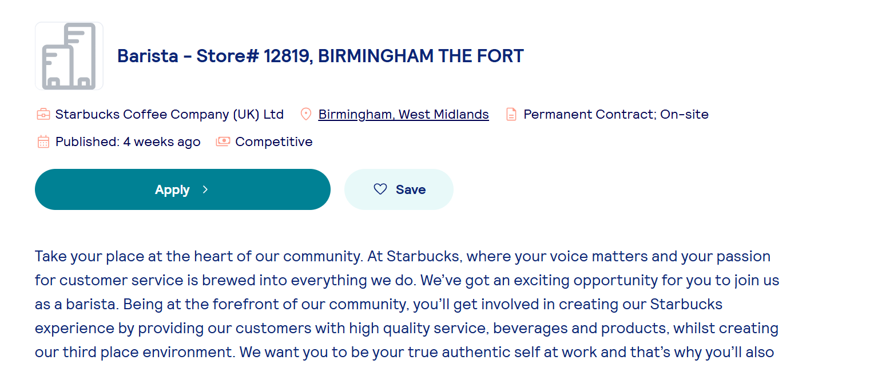
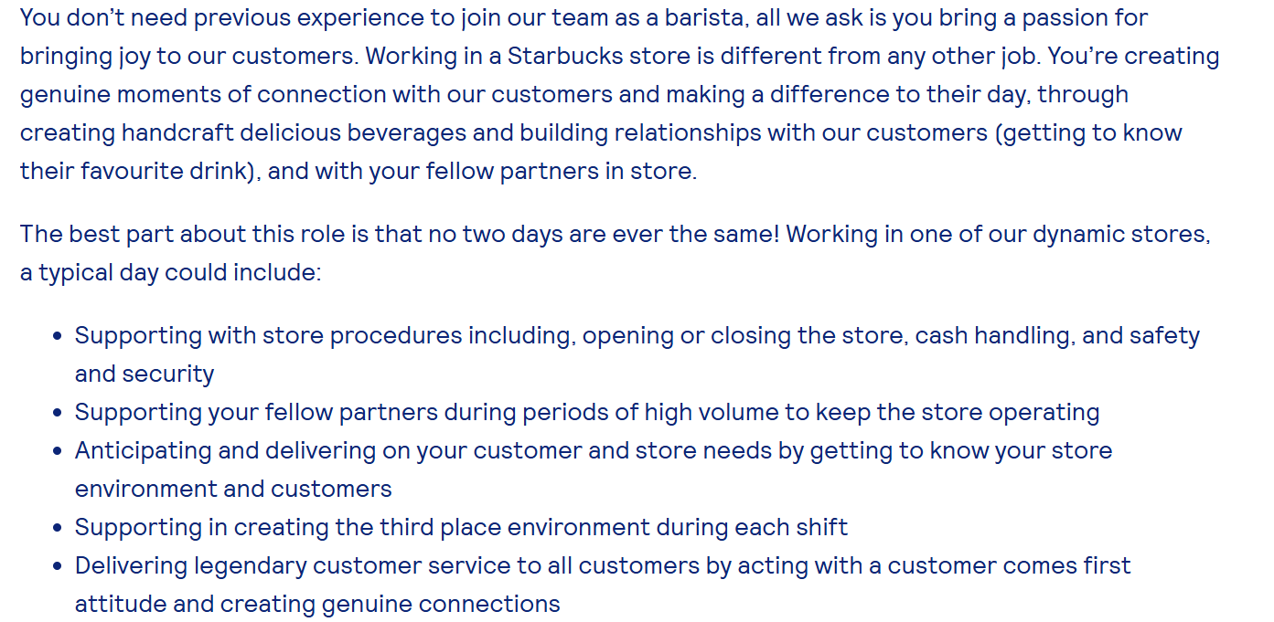
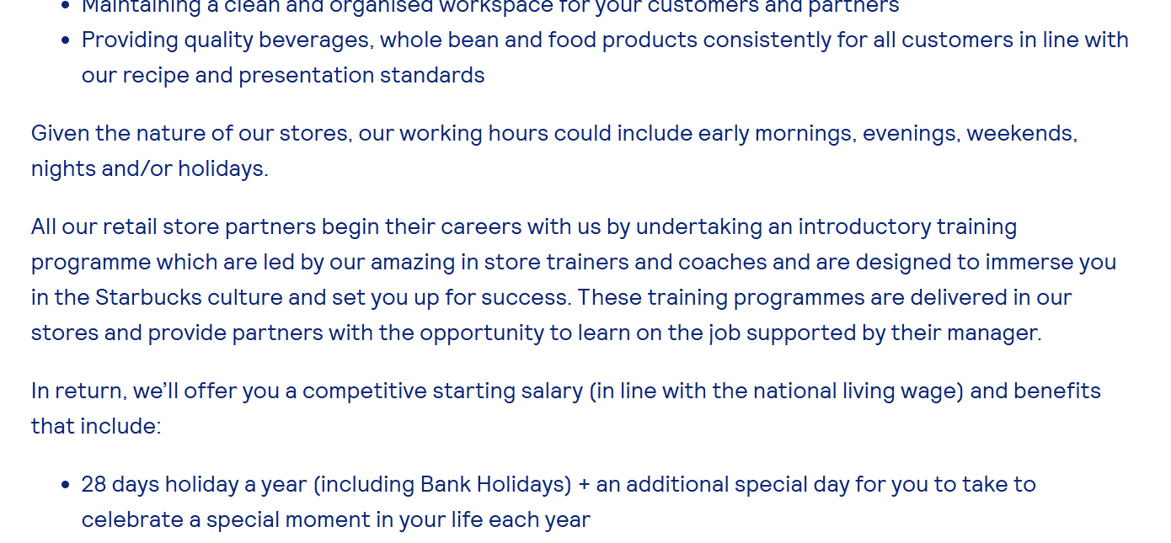

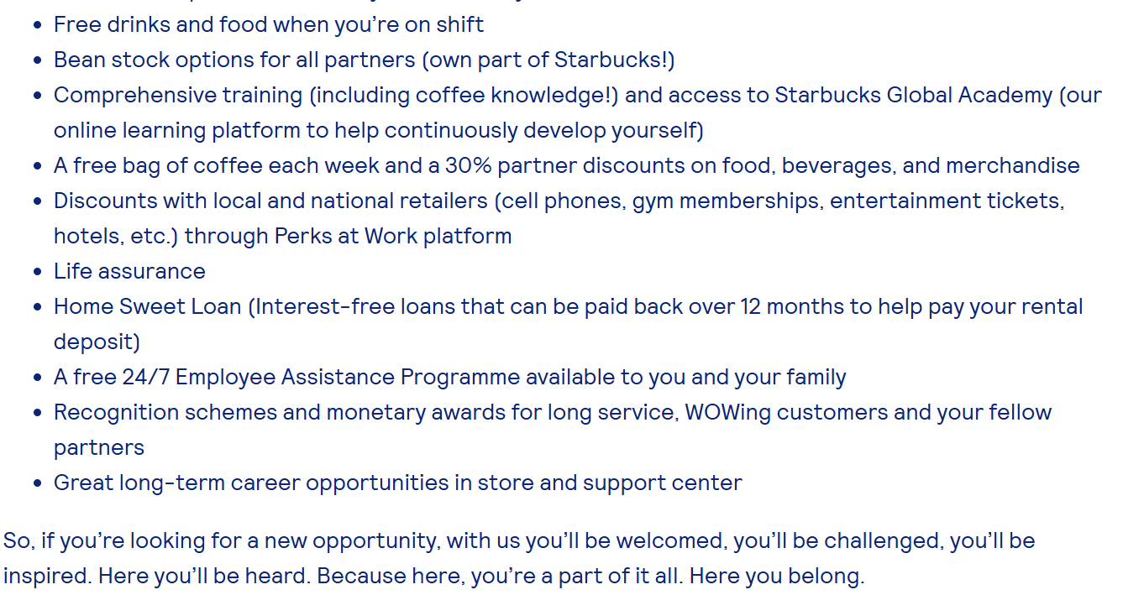
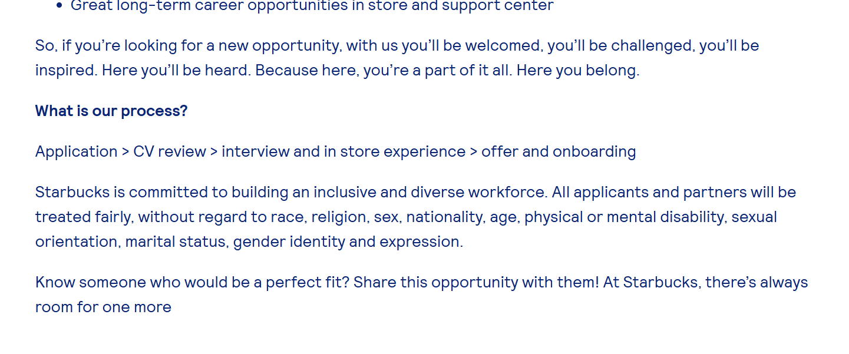

Dharm Kaur
107 New Street, Quarry Bank
Dudley, DY5 2BB
Email: jyotminhas@yahoo.co.in
Phone: 07534 587700
Date: 08 October 2026

Hiring Manager
Starbucks Coffee Company
Birmingham – The Fort
Birmingham
Dear Hiring Manager,
I am writing to apply for the Barista position at Starbucks Birmingham - The Fort, as advertised on Totaljobs. With over five years of customer service experience in the food and beverage industry, I am confident that I have the skills, enthusiasm, and positive attitude needed to make a valuable contribution to your team.

Throughout my career, I have worked in busy customer-facing environments where providing excellent service has always been a priority. As a Customer Service Assistant at Heathrow Airport Terminal 5, working with Starbucks and Costa through Eurest Services, I was responsible for preparing drinks, serving customers, handling cash transactions, and maintaining a clean and welcoming environment. My commitment to delivering outstanding customer service was recognised through a 100% Mystery Shopper customer service score.

In addition, I have worked at Subway in both Egham and Coventry, where I prepared food, assisted customers, handled orders, and maintained high standards of food safety and hygiene. These roles helped me develop strong communication skills, attention to detail, and the ability to remain calm and efficient in demanding environments.

I enjoy working as part of a team and building positive relationships with both customers and colleagues. I am reliable, friendly, and always willing to learn new skills. I take pride in creating a welcoming experience for customers and ensuring they receive excellent service on every visit.

I am excited about the opportunity to join Starbucks and contribute my customer service experience, enthusiasm, and strong work ethic to your team. I am confident that my background and passion for customer service make me a strong candidate for this position.

Thank you for considering my application. I look forward to the opportunity to discuss how my skills and experience would benefit your team.
Yours sincerely,
Dharm Kaur
Dharm Kaur
107 New Street, Quarry Bank, Dudley, DY5 2BB
Mobile: 07534 587700
Email: jyotminhas@yahoo.co.in

Personal Statement
I am a hardworking, reliable, and friendly individual with strong communication skills. I enjoy working with people and supporting my team to achieve shared goals. I am always willing to learn new skill and take on new challenges. Through my experience in customer services roles, I have developed the ability to work effectively in busy environment and provide excellent customer service, which was recognised through a 100% Mystery Shopper customer service score.

Key Skills
Customer Services: Served customer with a smile in a busy place like Heathrow Airport and made sure they had an enjoyable experience.
Communication Skills: As a Student Representative at UWTSD, I shared concerns of classmate with lectures. This helped me become confident in speaking and listening.
Till & Cash Handling: Worked on the till at Subway and Starbucks, took cash and card payments, and gave change.
Teamwork: Collaborated well with team members during rush hours.
Problem Solving: Stayed calm when customer had complaints and solved problems quicky.

Work Experience
Subway – Coventry
Sandwich Artist
May 2015 – Nov 2017
• Prepared fresh food items and sandwiches to customer specifications
• Delivered friendly and efficient customer service
• Maintained hygiene, cleanliness, and food safety standards
Subway – Egham, Surrey
Sept 2013 – Oct 2014 (worked alongside Heathrow roles)
• Prepared sandwiches and served customers politely
• Managed payments and issued receipts
• Maintained a clean and organised workspace
Heathrow Airport (Terminal 5) – London
Customer Service Assistant – Starbucks & Costa Coffee (Eurest Services)
Jan 2012 – April 2015
• Prepared hot drinks and served customers in a high‑traffic airport environment
• Operated tills, handing payments, and issued receipts
• Maintained cleanliness, stock levels, and product displays
• Provided friendly and efficient customer service
• Took customer orders and assisted with product selection
• Achieved a 100% Mystery Shopper customer service score

Education & Qualifications
University of Wales Trinity Saint David (UWTSD)
CERTHE Business Skills for the Workplace – Level 4
2026 – Present
English Course – Level 3 (CERTHE Equivalent)
Local Training Centre
September 2013 (5‑day course)
IELTS – International English Language Testing System
British Council (2011)
Bachelor of Arts (BA)
Guru Nanak Dev University (GNDU)1999 – 2002

Additional Responsibilities & Activities
Student Representative (UWTSD – 2026)
• Helped classmates by sharing their questions or concerns with lecturers.
• Improved my confidence and communication skills.
Group Work – University Assignments
• Collaborated with classmates to complete tasks and presentations.
• Learned teamwork, planning, and how to share ideas clearly.
Personal Development During Career Break(2017-Present)
• Took a career break to focus on my family commitments while continuing to develop my skills.
• Improved my time management, patience, multitasking, and problem-solving skills.

2017 – Present: Career break to raise my daughters.

Hobbies & Interests
I enjoy socialising with friends and family, cooking, shopping, spending time with family and. I also stay active through running, walking, and doing regular exercise, which helps me stay energetic and focused on work.
References
Available on request

