Student name: Patchely Yanga
Student ID: 2010950
Module: BMSW4003
Assignment section: The impact of the student’s academic grit on their academic level.
Lecture’s name: Paul Ranson

Table of contents page number
Title 1
Contents 2
Introduction 3
What is data collection 3
How we collect date using Microsoft from 3,4 and 5
How we collect date using Microsoft from 5
what are Primary data and why are important 5
Examples of Primary Data 5
What are second Data 6
What does Angela say about grits 6
Why are grits important 7
Conclusion 7
References 8-9

Introduction
In this assignment I am going to talk about the DIKW which stand for Data, Information, Knowledge and Wisdom. A lot of people know this model as DIKW Hierarchy or DIKW Pyramid (Brahmachary, 2019). In this assignment we going to see how DIKW model work, how to collect data, and I am going to talk about the impact of the student's academic grit on their academic level and I am also going to explain how does grit impact students according to the UK government academic level and on what Angela Duckworth said on her grit. I am also going to talk about how I collected data using Microsoft form step by step so that the reader will know what I really did to get my work done.

What is date collection
Data collection is methodical method that help us to be able to collect opinions for others, “whether you are performing research for business, governmental or academic purposes” as student or business own before collecting your data you need to make sure that you know your gaols and whatever you want to achieve in your life. This way you will be able to collect the right date and it will help you know the main purpose of the research, type of date you will collect and techniques and systems which you will use to be able to collect your data. (Bhandari, 2020).
Here are the steps that you need to follow steps before start to collect your date.
. Define the aim of your research
. Always choose what method before collecting your data.
. Plan your data collection techniques.
. Make sure you collect all your data.
. Repeatedly asked questions about data collection.

How we collect date using Microsoft from
Firstly, I sign into my Microsoft forms with Microsoft 365 work credentials, when I open my Microsoft 365 than I select forms as there was a lot of apps than I create new form, I choose a name for my form after entering the name I also entered an optional subtitle for it.
Secondly, I select add question so that I could add a new question to my form, I had two questions to ask my first question was about the highest academic level according to the UK government. And second question was about the grit score according to the Duckworth scale.
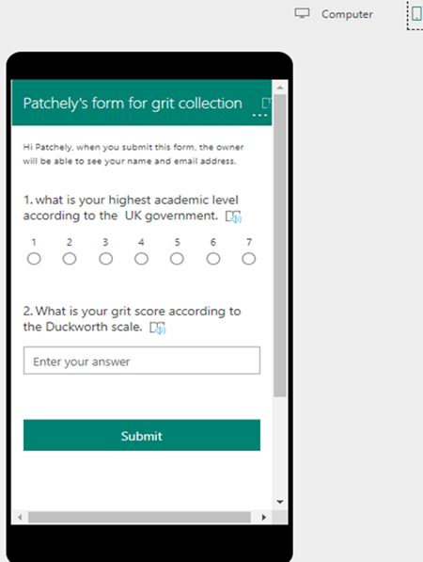
After typing my questions, I had chosen to chaise of text, Rating, or date questions than I checked how my form will look on a computer or mobile device before I send it to my colleagues. To send and collect responses I open the form of where I want to collect responses, I select share, in the share pane under, then after that I select the drop-down list to see what options that I want to collect responses form that I will collect form my colleagues. Before I send it, I make sure that I only select people in my organization as I only wanted people form my organization to respond. (Credentials. et al., 2020)

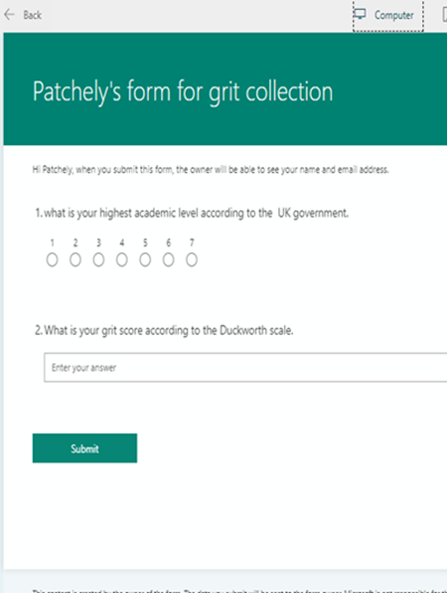

Those is the DIKW pyramid, this pyramid it was established in “1989 by Ackoff,” the pyramid helps students to builds their smart and sensible manufacture methods when it come for the study, but the main benefits that come from the disconnection of concerns, is really “of a problem into sub problems and solving those in turn, focusing on each sub problem separately. many data, information, knowledge, and wisdom DIKW are produced or processed. This article shows how clever manufacturing systems can be created following the DIKW paradigm” (Lobov, A., 2018).
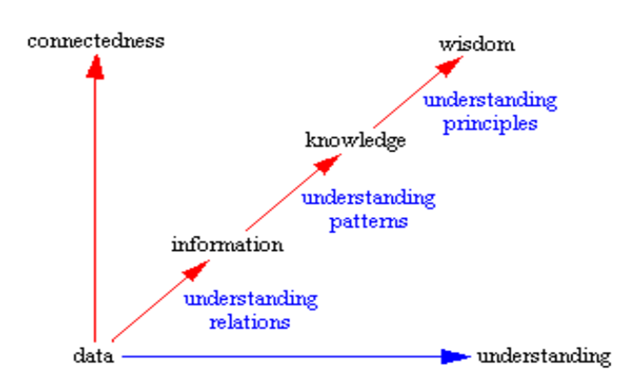
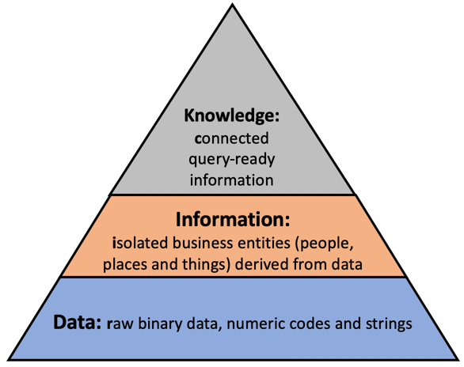
what are Primary data and why are important
“Primary data is a type of data that is collected by researchers directly from main sources through interviews, surveys, experiments, etc. Primary data are usually collected from the source—where the data originally originates from and are regarded as the best kind of data in research”. Interview is the main method that people collection primary data, when you went for an interview the person that is interviewing you, she/he is asking the questions and collecting the data form you at the same time. And you as the interviewee all you need to do is to be able to respond to the question the person who is interviewing you asked (ENONGE et al., 2019).
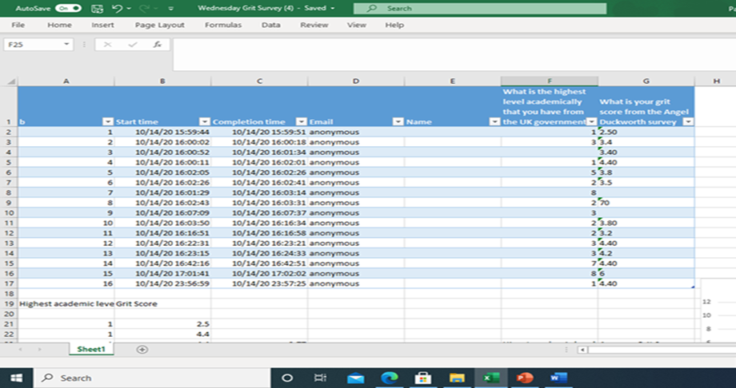
This little table is the date has been collected by people on our group and it shows that what is the highest-level academically that we have from the Uk government, and they grit score that Angel Duckworth survey.

Examples of Primary Data.
Market research- this is so important especially when it comes to people who ruins business as it helps them to know the target of the business and what type of information they need for the company. Data that you collect will help you to be able to meet the business needs. So primary data is important especially for people that ruins their own business as they need to know the process of the business. By collecting primary data your business may be successful so quick (ENONGE et al., 2019).
What are secondary data?
“Secondary date is data that has been collected by a colleague or organizations for a different purpose, and this secondary date is information that already exists (Murich, 2016).
Secondary data help us save time while were collecting data because sometime the information that you are collecting may use before. it is also can give big and better-quality archives that would be impossible for any individual researcher to collect on their own. The only sad thing about secondary data is that some time it can be not helpful in marketing research because some data may be useless or incorrect. Secondary data can be found on several resources like magazines, new paper, internet and from your GP (Secondary data - Wikipedia, 2021).
What does Angela say about grits?
Angela Duckworth is the world’s leading expert on “grit,” the much-hyped ingredient in personal success. As Duckworth defines it, grit is passion and sustained persistence applied toward long-term achievement, with no particular concern for rewards or recognition along the way. I really, I agree with on what Angele says about when its coms to grit, she says that grit is the key to success in life. Grit motivation and gives you self-control in the pursuit of long team goals help your success in life. Angele also said that once she was a professor, she was “teaching math to seventh graders to the university of Pennsylvania psychologist” she understands that the only thing that separating successful students from those who struggled is grit because once your grit scores are lower you are at higher risk of repeating the year over and over. Angele spent many years of teaching, and she knows how lack of grit can affects people’s life e.g., in school, at work and in personal relationships and published her research in grit (Fessler, 2016).
As student we need to stop limiting ourselves by thinking that you are less than another student just because you grit score are lower than your classmate. You do not need to make yourself feel like that because one you start feeling like that this means that you are putting yourself down without knowing, thinking about your goals and what you want to achieve in your life is the most important thing you need to do as student. Working harder to achieve whatever you want to achieve is not bad but as student we need to know that the person who is working smarter chieves they goal faster than the person who typing to work harder, you need to be creative, patient, detailed, the organizer of social gatherings, or comfortable working independently (Derry, Maher, Carter and Team, 2020).

Why is grit important?
Grits is important because its helping a lot of students with their ideas so that thy ideas can make sense. Grits showed show that to be successful in life you do not need to work harder but work smarter because in this world as humans we think that students who are flexible and who work hard tend to do better than students who are not strong and who give up easily, intelligence is not commodity. The more we learn the more you can become more intelligence and have more knowledge about what how you can success in life, and you do not need to force anything because people who ends up being best or the smarter people now, they not always those who stared good or had more intelligence than other people. Your attitudes are the thing that makes you difference (Fitzgerald, 2016)
This shows that to be successful in life you do not need to be cleaver than other people but working hard that makes you successful. For explain the key to becoming the key to turn out to be a successful student is learning how to study smarter but not harder, by learning smarter than typing to learn harder you will be successful quicker. As student we need to make sure that we give ourselves more time of studying even at home when you don’t do anything, giving yourself 2 to 3 hours, a day will help you get higher grades in school, college or even university because the more you we give ourselves time to study is the more we become more and more intelligent. As a student if you do not give yourself enough time to study you won’t know how to work smarter (Loveless, 2020).

Conclusion
In conclusion for people who has replicated the course form multiple time because they have lower grit scores their do not need to worry about it but instead, all they need to do is to make sure that they work smarter not harder as Angela says because on other side “a lack of grit can come from coherent goal structures” not submitting you work on time or not going whatever you lectures wants you to do this is what cause lower grit. Students need to stop feeling less if you cannot do something do not beat or punish yourself, giving up because you have lower level of goals are allowable, work smarter can help you as student to get you grits on the top. Confidence is everything that students needs so that in the life’s because if you have confidence, you have everything, and good things `are accomplished to those people who always think positively about themselves (Duckworth, 2020).

References
Brahmachary, A., 2019. DIKW Model: Explaining the Concept of DIKW Hierarchy in ITIL. [online] CertGuidance. Available at: <https://www.certguidance.com/explaining-dikw-hierarchy/> [Accessed 10 December 2021].
Bhandari, P., 2020. Data Collection | A Step-By-Step Guide with Methods And Examples. [online] Scribbr. Available at: <https://www.scribbr.com/methodology/data-collection/> [Accessed 30 November 2020].
Cooper, P., 2017. Data, information, knowledge, and wisdom. Anaesthesia & Intensive Care Medicine, 18(1), pp.55-56
credentials., Under My Forms, s., it., E., Select Add Question to add a new question to a form. You can choose to add Choice, o. and device., S., 2020. Collect Information With Microsoft Forms. [online] Support.microsoft.com. Available at: <https://support.microsoft.com/en-us/office/collect-information-with-microsoft-forms-a55d6e0d-04f6-45b8-b05f-b141b8ecb4d5> [Accessed 30 November 2020].
Derry, H., Maher, M., Carter, C. and Team, B., 2020. Are You A Student Disrupted By Coronavirus And Feeling Unmotivated? We Have Five Ideas – Center For Academic Innovation. [online] Ai.umich.edu. Available at: <https://ai.umich.edu/blog/are-you-a-student-disrupted-by-coronavirus-and-feeling-unmotivated-we-have-five-ideas/> [Accessed 30 November 2020].
Duckworth, A., 2020. Book Summary: Grit By Angela Duckworth | Sam Thomas Davies. [online] Sam Thomas Davies. Available at: <https://www.samuelthomasdavies.com/book-summaries/psychology/grit/> [Accessed 30 November 2020].
ENONGE, E., Mwangangi, R., Emmanuel, R., Valcheva, S., Media, O., Valcheva, S., macheso, G. and ETIENNE, T., 2019. Primary Data VS Secondary Data: Definition, Sources, Advantages. [online] Blog For Data-Driven Business. Available at: <https://www.intellspot.com/primary-data-vs-secondary-data/> [Accessed 10 December 2021].
En.wikipedia.org. 2021. Secondary data - Wikipedia. [online] Available at: <https://en.wikipedia.org/wiki/Secondary_data#> [Accessed 10 December 2021].
Fitzgerald, C., 2016. Helping students enhance their grit and growth mindsets. Educația Plus, 14(3), pp.52-67.
Fessler, L., 2016. “You’Re No Genius”: Her Father’S Shutdowns Made Angela Duckworth A World Expert On Grit. [online] Quartz at Work. Available at: <https://qz.com/work/1233940/angela-duckworth-explains-grit-is-the-key-to-success-and-self-confidence/#:~:text=Angela%20Duckworth%20is%20the%20world%27s,or%20recognition%20along%20the%20way.> [Accessed 30 November 2020].
Loveless, B., 2020. Study Habits Of Highly Effective Students. [online] Educationcorner.com. Available at: <https://www.educationcorner.com/habits-of-successful-students.html#:~:text=Successful%20students%20typically%20space%20their,%2C%20yet%20shorter%2C%20study%20periods.> [Accessed 30 November 2020].
Lobov, A., 2018, October. Smart Manufacturing Systems: Climbing the DIKW Pyramid. In IECON 2018-44th Annual Conference of the IEEE Industrial Electronics Society (pp. 4730-4735). IEEE
Murich, Z., 2016. Secondary Data — NCVO Knowhow. [online] Knowhow.ncvo.org.uk. Available at: <https://knowhow.ncvo.org.uk/organisation/impact/measuring-your-impact/secondary-data?gclid=CjwKCAiAtK79BRAIEiwA4OskBmA1DFz8VjdcB5ZXFH3QzDU_MWxLYXCndCHFEaWmRzfV8NIv1OV2XBoClaMQAvD_BwE%E2%80%8B> [Accessed 30 November 2020].

