
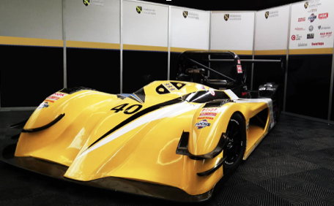
An in-depth study into Kinetic Energy Recovery Systems for Motorsport use.
Module Code: M3X8671
Written by Gavin Owen Stefan Williams

(2017). msport-eng.com
Table of Contents
1.0 Abstracts
1.1 Abstract
1.2 Abstract Technical

2.0 Introduction
2.1Research Questions

3.0 Theory and Research
3.1 Vehicle of choice
3.2 GPS
3.3 Accelerator Pedal Position Sensor
3.4 ECU (Electronic Control Unit)
3.5 Cameras
3.6 Driver Selection
3.7 Track Selection
3.8 Theory behind kinetic energy recovery systems
3.9 Brief History on Regenerative Braking, Kinetic Energy Recovery and Storage Systems

4.0 Data
4.1 Live Testing Data (Archived)
4.2 Race Technology
4.3 Circuit Tools
4.4 Acquiring Simulation Data
4.5 Motec
4.6 Excel Documents

5.0Conclusion
5.1 Future Aims and Objectives

6.0 References

1.0 Abstracts

1.1 Abstract
Due to regulations becoming stricter and race vehicles becoming greener this investigation researches into the possibilities into adding hybrid technologies onto already existing race vehicles. Analysis software and calculations will be used to find out if adding this hybrid technology to an already existing race vehicle will have any benefits.
1.2 Abstract Technical
As engine downsizing, increasing emission strictness due to European laws and stricter regulations within the motorsport industry, more racing series have turned to hybrid technologies to gain competitive advantages from wasted energy through the braking system. As the market grows for more hybrid race cars this report investigates the possibilities of adding a hybrid system to existing racing vehicles. From the use of live data and simulation data several calculations will take place to see if adding a kinetic energy recovery system will increase lap times around Silverstone. Analysis software such as Circuit Tools, Race Technology and Motec will be used along with Excel spreadsheets to work out if it will be a worthy investment for smaller race team.
2.0 Introduction
As energy recovery systems have become more popular within the automotive and motorsport industries throughout the past 10 years, a growing demand for this type of technology to be fitted to racing vehicles without this technology has grown dramatically. Multiple race series have adopted technologies such as kinetic energy recovery to improve the vehicles overall efficiency with benefits which include reduced fuel usage and increased power output for a limited duration of time.
The main purpose of this investigation is to see if it would be a viable option to introduce an energy recovery system to one of the race vehicles found within the UWTSD university workshop. An investigation into to adding this technology onto one of the vehicles then research into which type of technologies are available and which would be suitable to be fitted to the vehicle will be researched.
The main reason why this paper is considering this field is to see if there are any benefits of regaining the wasted kinetic energy from braking, how much energy can be produced from electric motors and which storage option would be best fitted to a lightweight race car if sporting regulations change for the series in the next few years.

2.1 Research questions

Based on previous research into the subject area I have concluded that this investigation will looking into the areas of these points:
- What benefits and problems may occur when introducing a kinetic energy recovery system to a vehicle which doesn’t have that type of system from the factory?

- Will adding a kinetic energy recovery system improve overall performance of the vehicle?

3.0 Theory and Research
3.1 Vehicle of choice
MCR S2 Race Vehicle (Fig 1)
The vehicle that we are looking at implementing these modifications too is a MCR S2 Race Car which is currently being run in the Sports 2000 Duratec Championship. The vehicle itself uses a standard Ford Duratec 2 litre inline 4-cylinder engine which has an approximate power output of 200BHP. Due to regulations of the sports 2000 series engine power is limited. The overall weight of the vehicle with the driver but no fuel is a total of 594kg.
(Fig 1) (2017). msport-eng.com
Fitted to the vehicle are two data logging devices. The first being DL1 which records data from multiple sensors of the vehicle and stores data via an SD card. The second being a Vbox which uses two cameras to record a view from the driver’s perspective and another viewing the feet and pedals. As the vehicle is already being uses for competitive racing a large amount of data has been recorded via the use of these data loggers. This means there`s archive data available to view from multiple different tracks. Some of the main connections to the data logging devices include:
- GPS
- Accelerator Pedal Position Sensor
- ECU (Electronic Control Unit)
- Video Cameras
3.2 GPS
Both the Vbox and the DL1 use separate GPS sensor which are located as centre as possible in the vehicle. The Vbox GPS sensor is located within the car next to the driver`s seat attached to part of the chassis. The DL1 GPS sensor is located on the rear-view mirror of and is attached with industrial strength Velcro. The reason why GPS sensors will be useful for this investigation is for multiple reasons. The first being able to generate an accurate map of the circuit and therefore having a detailed recording of the racing line. The second reason for using a GPS sensor is that it records the lateral and the longitudinal G forces while the vehicle is running. Finally, the GPS sensor can also accurately track the speed of the vehicle.
3.3 Accelerator Pedal Position Sensor
The Accelerator Pedal Position Sensor is attached to the throttle pedal of the vehicle and the chassis. This sensory unit creates a voltage signal depending on how far the pedal is depressed allowing the DL1 data logger to accurately work out the percentage of throttle which is given during its time being recorded. While investigating into deployment of the KERS system it is possible to use this sensor to activate the system.
3.4 ECU (Electronic Control Unit)
The vehicles ECU is connected to the DL1 data logger allowing engine information from multiple sensors that are connected to it. When researching into control units
3.5 Cameras
Connected to the Vbox are two high definition cameras which are located at two different points of the vehicle. The first camera located on the Roll cage behind the driver`s head giving a perspective of the track. The second camera being located near the fire wall positioned to record the pedals and driver`s feet.
3.6 Driver Selection
Due to the nature of the live testing it`s important that the driver which ran during the Silverstone races was also present for the simulation tests. The reason for this was while under simulation testing similar racing lines, braking points and the consistencies of lap times will be important for future calculations.
3.7 Track Selection
For this investigation, a track will be needed to be selected as test data will be collected via simulation and live data. Due to live data being limited to what tracks the Yellow MCR car has run in the Sports 2000 series and what tracks were available in the simulation the track selection was narrowed down to 3 tracks. The first track being Silverstone International which is also known as Silverstone South. The second being Cadwall Park Full circuit and the final circuit being Brands Hatch Indy. Out of these tracks the circuit with the most amount of recorded live data which was available was from Silverstone International. Data collected while at Silverstone included camera via a VBox which recorded 2 camera feeds. Another reason why Silverstone would be picked compared to the other tracks is because of the how the track is laid out. The International circuit itself has sections of low speed, medium speed and high-speed corners in which a large amount of data can be collected along with 2 high speed straights.

3.8 Theory behind kinetic energy recovery systems
The main purpose of the kinetic energy recovery system is to regain the wasted energy into useful energy. This can then either power the electronics or the vehicle of used to accelerate the vehicle via the use of the electronic motors which generated the energy which would have been lost. JANCI RANI, J. (2017).
For a typical GT3 car it will have 2 motors located at the front of the vehicle which while under braking or off throttle will become generators. When under these forces the generator will rotate and generate electricity. This electricity is then sent via electrical cables to a storage system which can be stored either via kinetic energy (flywheel), electro-chemical (battery) or Electrons (supercapacitors).
While in storage there are multiple ways of releasing the energy stored. The two most common ways include boost by throttle which when the throttle is depressed down a certain amount the energy control unit sends the energy stored to the motors giving the vehicle a brief horsepower boost. The other way is a boost by button which allows the driver to activate the KERS system. Heeps, G. (2010).
Below is a brief diagram (Fig 2) which shows how the energy flows within the Kinetic Energy Recovery System:
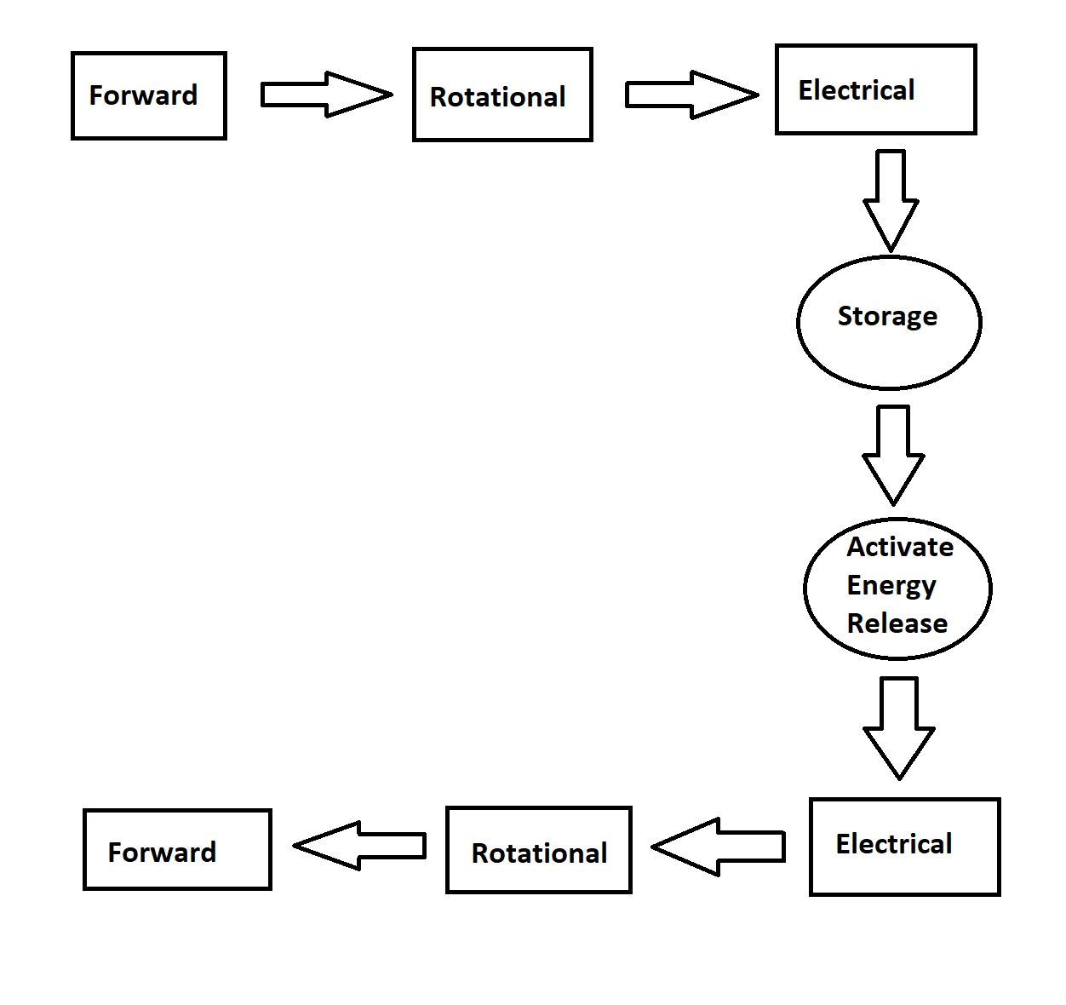
(Fig 2) G Williams (2017)
3.9 Brief History on Regenerative Braking, Kinetic Energy Recovery and Storage Systems
The idea of regenerative braking systems came from the late 1800`s where early attempts of this technology used a spring type storage system fitted to horse-drawn cabs or bicycle to power an auxiliary lamp. From then the technology was then adapted to other forms of transportation such as trams and buses.
First automobile that patented the regenerative braking system was in 1908 by Charles J Paulson`s “a smart car”(Fig 3). This vehicle had a series of mechanisms which could be driven by an electric motor or an “explosive engine” but also had an auxiliary clockwork spring storage system which would recover energy from the momentum of the vehicle and then assist in running the vehicle. Due to the nature of the storage system it was possible to store the energy for a long period of time and released via a release handle. (2017). Manu Garg
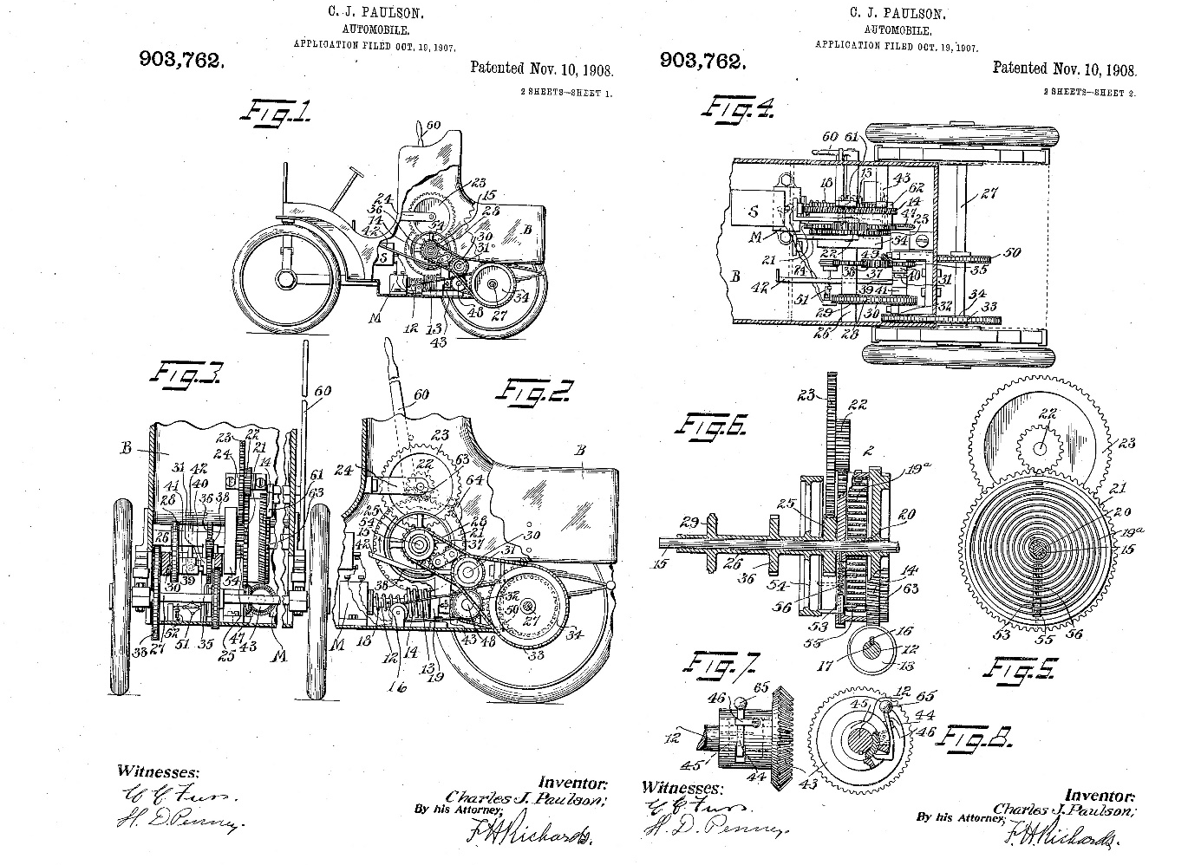
(Fig 3) (2017). Manu Garg
The “energy regeneration braking” system started development by the American Motor Corporation (AMC) in cooperation with Gulton industries. The concept of energy recovery braking was then later commercialized by Japanese automotive Manufactures Toyota and Honda and American Automotive Manufacturers Ford and Chevrolet to be used in domestic hybrid vehicles. One of the most popular hybrid vehicles which uses regenerative braking includes the Toyota Prius which when the brake pedal is depressed or if the accelerator pedal is released the electric motors generate electricity to the hybrid battery.
Multiple auto manufactures during the mid-2000`s started development into kinetic energy recovery systems with Toyota Racing Development and Toyota Team SARD introducing the Supra A80 HV-R Hybrid race car based upon the Supra Super GT car in 2007. This vehicle used a 3UZ-FE 4.4L naturally aspirated V8 with 2 10KW electric motors located at the front wheels and a Mid mounted 150KW electric motor powering the rear wheels of the vehicle. Ultra-capacitors were used in place of batteries with the vehicle producing around 480 BHP@6880rpm without the assistance of the electric motors with an extra 270BHP when the system is engaged. When introduced at the 24 hours of Tokachi International Speedway in Japan the Supra became the first hybrid vehicle to win a race with the car completing 616 Laps being 19 laps ahead of second place being a non-hybrid Nissan Fairlady Z. Deshpande, R. (2015).
The FIA stated in 2008 that they were to “support responsible solutions to the worlds environmental challenges” (2017). FIA. for the 2009 season of Formula 1. The FIA made the use of KERS systems to be optional within the 2009 season. Two Formula 1 teams Williams F1 and Mercedes stated to Race Technology Magazine that “research and development into kinetic energy recovery systems began as early as 2007” with testing of these systems beginning in 2008.
For the 2009 season the FIA allowed teams to use a KERS system to the power of 60 Kw with the energy being stored either electrically via batteries or supercapacitors, or stored via mechanically from the use of a flywheel storage system. During the 2009 season only four teams (BMW Sauber, Ferrari, Renault Sport F1 and McLaren Mercedes) implemented the system with BMW and Renault dropping the system during the season due to reliability issues. On 26th July 2009 at the Hungarian Grand Prix McLaren Mercedes driver Lewis Hamilton won their first race using the KERS system. Later that year Kimi Räikkönen won the Belgian Grand Prix with the KERS system fitted to his Ferrari.
Due to the competitive advantage of the system all teams agreed upon not using the KERS system for the 2010 season due to the manufacturing costs being too expensive even though the FIA rules still stated it was legal to use for that season. For the 2011 season rule changes upon driver weight limits all teams but Lotus, HRT and Marussia started the season with the KERS systems. As the other teams had an extra year of development and testing systems began to be more reliable and cost effective.
Due to packaging problems with flywheel type storage systems Williams F1 suspended development for that type of storage system but then later sold their development to multiple other manufacturers. Audi stated in 2012 that the technology developed by Williams would be used in their Le Mans R18 Hybrid race cars. From 2014 onwards the FIA raised the power capacity of the systems from 60Kw to 120Kw to help balance out the downsizing of engine cubic capacity. (2012). SAE International. All teams are currently using supercapacitors for multiple reasons. The first being the deployment of the storage system, supercapacitors are much smaller in size compared to the flywheel storage systems. Secondly the weight of supercapacitors are also less than the flywheel storage systems. Finally, development into the area of supercapacitors has been researched for longer within the F1 development. (2016). FIA.
Peugeot Sport unveiled their 908 HY LMP-1 Race car after the 1000km of Silverstone in 2008 with it competing the next year setting the standard for LMP-1 Race Cars for the years to come. During the 2013 24 Hours of Le Mans Audi which used a flywheel based energy storage system for their R18 E-tron Quattro and Toyota who used a supercapacitor style system for their TS030 Hybrid. Audi won the race with a single lap ahead of Toyota. In 2014 Porsche introduced the 919 Hybrid which unlike Audi and Toyota used a battery storage system.

4.0 Data
For myself to work out the amount of energy that can be recovered from braking I will need to find out the amount of time the vehicle is spent under braking, the speed of the vehicle and the forces acting upon the vehicle. When trying to get suitable data two methods have been picked. The first being live recorded data which Team MCR provided myself a copy of and simulation data which will take place in university under a testing session. Once the data has been collected the files will then be transferred into CSV file for further analysis in Excel.
4.1 Live Testing Data (Archived)
From receiving archive data from Team MCR`s race at Silverstone International the use of two different analysis software was available to use. The first software which used the data recorded from the DL1 was known Race Technology. The second software used was known as Circuit tools which allowed data from the Vbox to be analysed along with video footage.
4.2 Race Technology Race-technology.com. (2017)
While using Race Technology it was important that the software was correctly set up. When launching race technology multiple options are given before accessing the recorded data. Below shows the starting screen of Race Technology with the option of analysis being selected. (Fig 4)
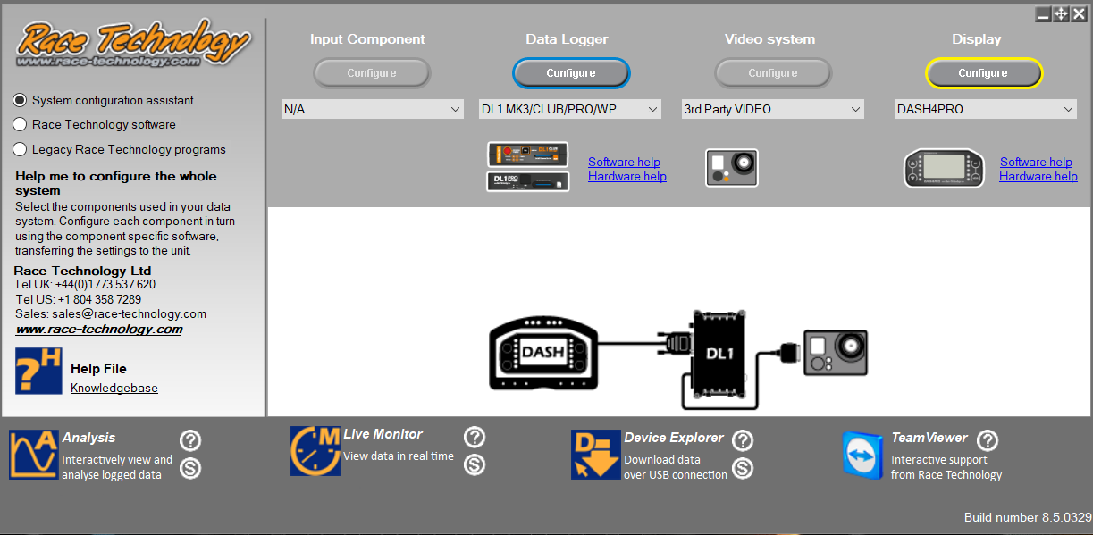
(Fig 4)
When the analysis software has booted up options to loading up the recorded data will then be available. When the data is then selected track map, XY graph, virtual dashboard and lap and sector times are loaded up for the screen layout. For data to be shown per lap a sector marker will then be placed via the track map option allowing data per to be shown in the XY graphs. Below shows an example (Fig 5) of how these options are shown before narrowing data down.
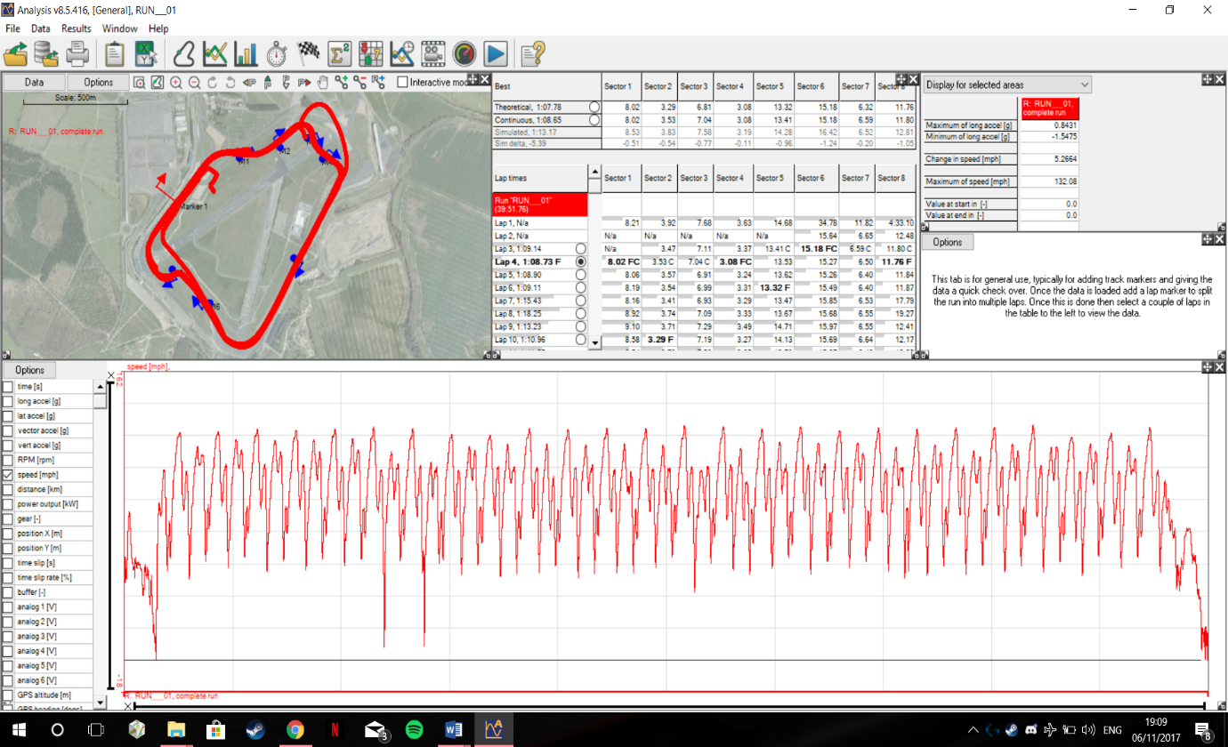
(Fig 5)
As shown above a large amount of data is being shown of the whole session in which the vehicle was run. To narrow down this data even further for the XY graph a setting upon the data tap will be clicked to pick what data is to be shown and what lap you can narrow down too. The data that’s been selected for example purpose`s will be speed over the amount of time. Once these options are selected (Fig 6) it is possible to then see the exact speed in which the vehicle is traveling via the track map.
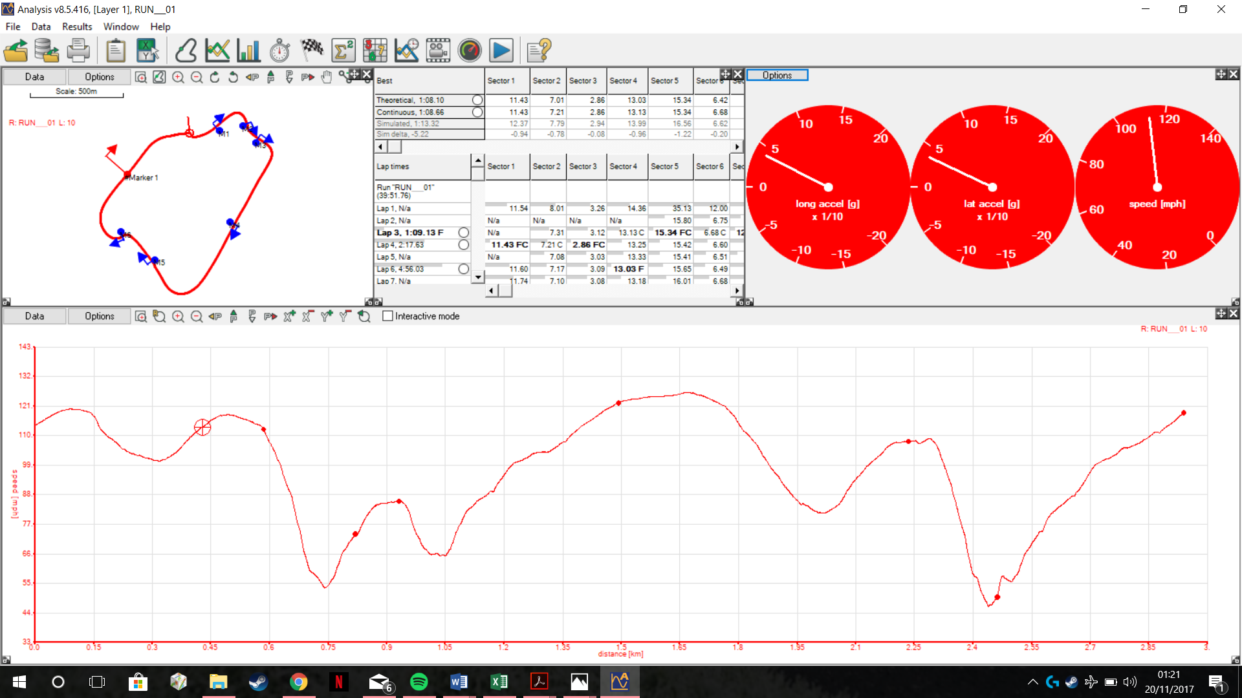
(Fig 6)

The track map analysis has several features that can be used to find out multiple things. One of the more important things in which was used was colouring the map based on certain data. As we are looking at the speed of the vehicle the map is coloured from slower speeds shown in blue to high speeds shown in red. Below shows an example (Fig 7) of the track map feature with satellite view turned on and colour map on.
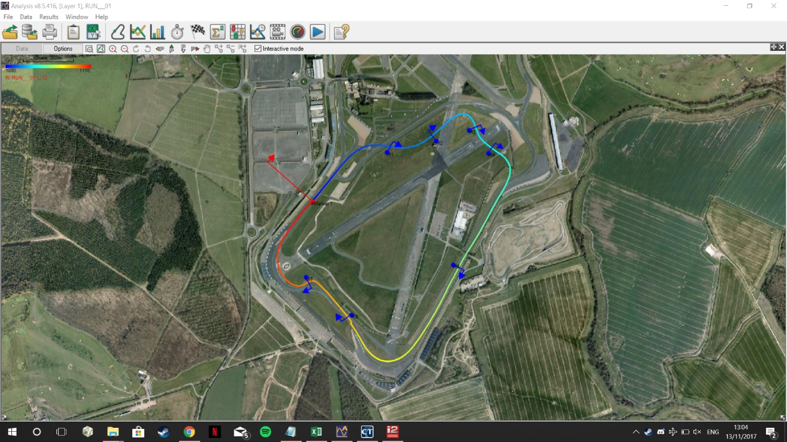
(Fig 7)

4.3 Circuit Tools Drewitz, I. (2017)
The Circuit Tools software uses data from the Vbox. Lap times recorded with the GPS and sensory data from the ECU and DL1 have been recorded with video footage. The software itself is easy to use when the data is loaded up. A suitable lap would be selected and the view all option will then be selected from the home menu to make the software look as so (fig 8):
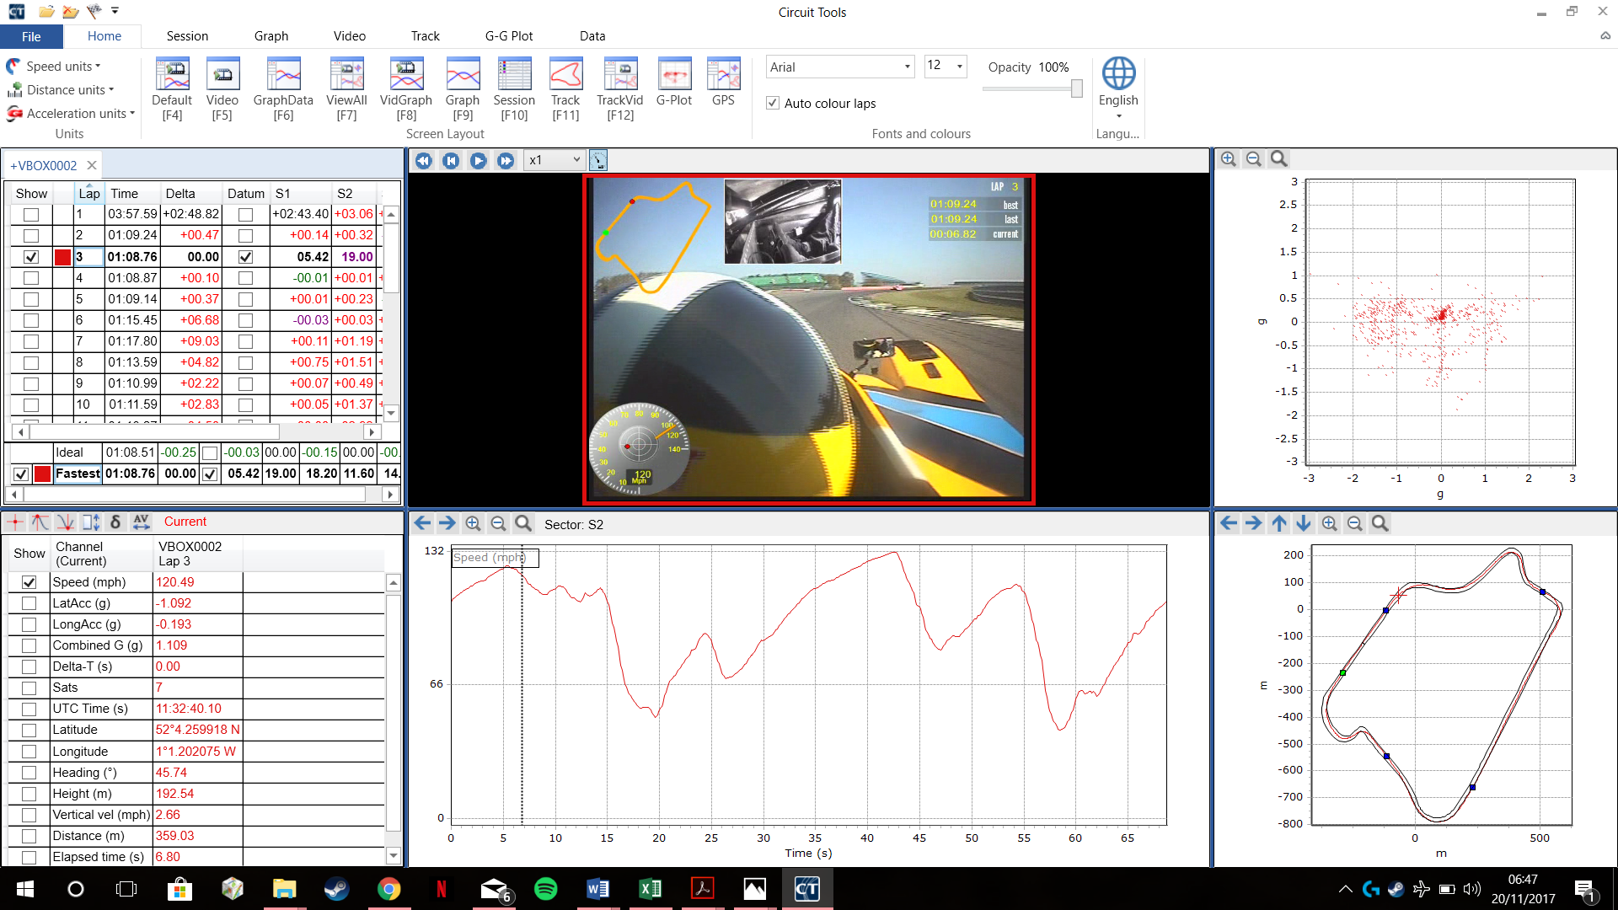
(Fig 8)
With the view, all option selected multiple boxes have filled the screen. The first option in the top left is the session and lap selection. The bottom left is the channels recorded which the graph (Fig 9) at the centre bottom of the screen can adapt to the selection you pick. The top middle box is the footage recorded from the cameras. On the recording, a digital tachometer is showing speed, lateral and longitudinal forces acting upon the vehicle. There`s also a map of the track which uses a green dot to tell you where the start/finish of the recorded lap is but also a red dot to show where the car is along the track. In the opposite corner, a lap counter and lap time recorder is found. In the top centre of the screen shows the secondary camera pointed at the position of the driver`s feet. At the top right corner (Fig 10), a G-Plot graph records the lateral and longitudinal forced. Finally, at the bottom right corner (Fig 11) shows a detailed map of the track with a pin point racing line recorded via the GPS.
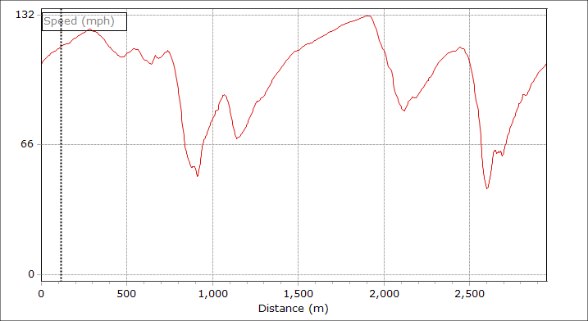
(Fig 9)
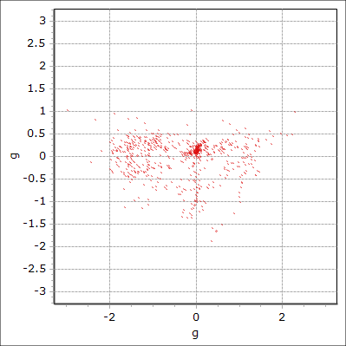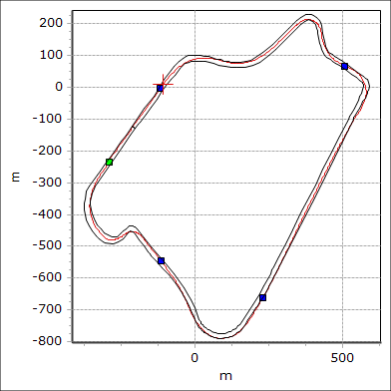
(Fig 10) (Fig 11)
4.4 Acquiring Simulation Data
When acquiring simulation data, a testing session was booked with the same driver as to who raced at Silverstone. Before any testing began it was important that the same vehicle and track was selected. The setup of the vehicle was correct with the same gear ratios and the driver briefed on what he was tasked to do. For this initial simulation session, the driver was tasked to do as many consistent and clean laps around the track as data would then be collected for the Motec Software.
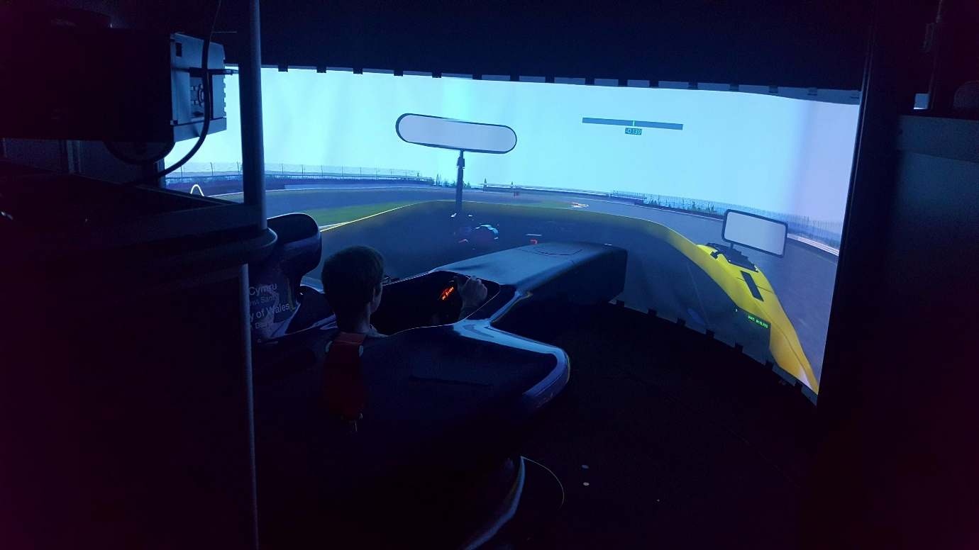
(Fig 12) The simulation software which was used was called Automobilista.
Below shows a table of lap times recorded from the sim:
Lap | Lap time | Total Time (s)
Out Lap | 1:18.146 | 78.146
Lap 1 | 1:11.335 | 149.481
Lap 2 | 1:10.792 | 220.273
Lap 3 | 1:10.892 | 291.114
Lap 4 | 1:09.624 | 360.738
Lap 5 | 1:09.872 | 430.610
Lap 6 | 1:09.754 | 500.364
Lap 7 | 1:09.802 | 570.166
In Lap | 0:11.630 | 582.598
G Williams (2017)
4.5 Motec Motec.com. (2017).
The data recorded from Automobilista created a Motec data file (Fig 13) which would be accessed using the Motec Pro – Sim software. Once loaded into Motec a new project was started under the circuit settings. From then the simulation data acquired could then be analysed. Below shows a full lap in Motec. The channels include Engine RPM, Speed, Throttle Position, Lateral and Longitudinal G forces and Brake Position.
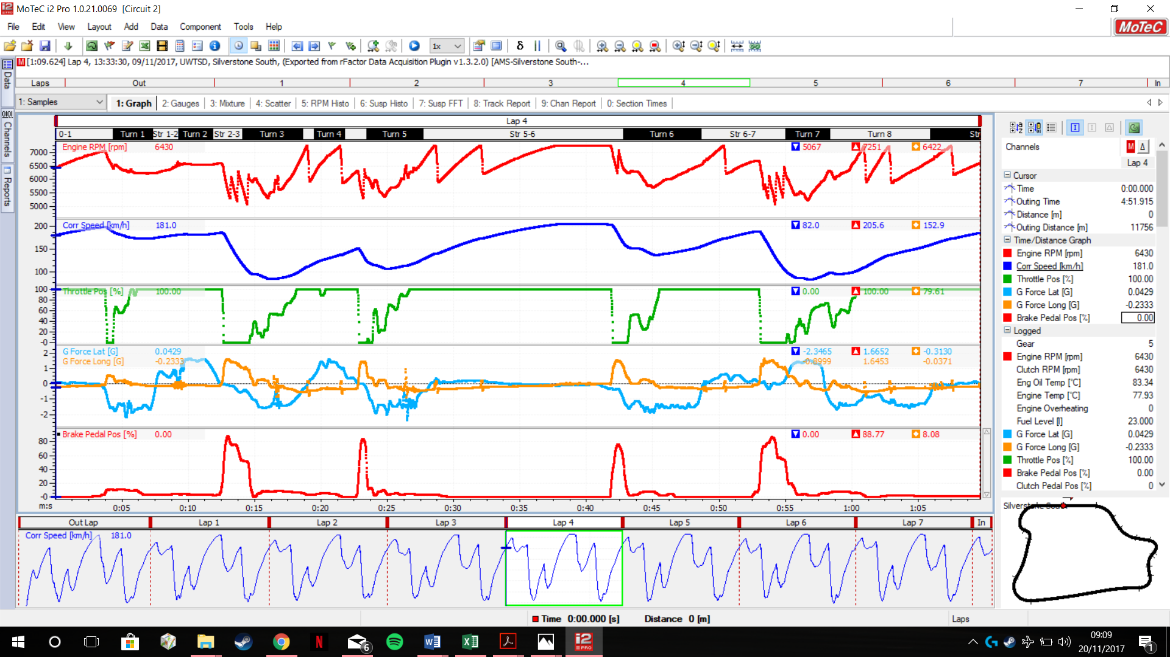
(Fig 13)
Just like race technology and circuit tools there are multiple tools available to use to plot graphs and data. A rainbow track (Fig 14) was then made showing braking points around the track. The darker the colour the colour the higher the braking force which is shown below:
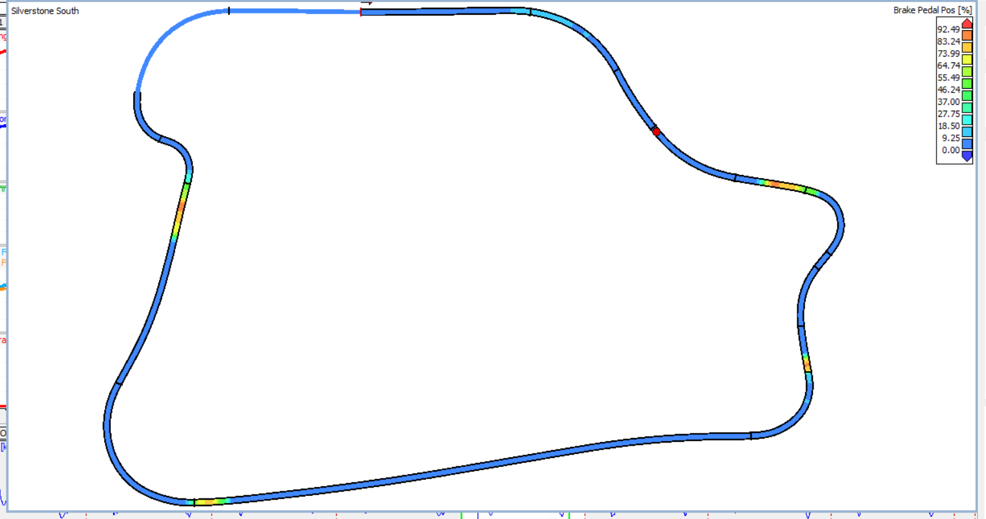
(Fig 14)

Once this was achieved it wold then be possible to plot a scatter graph for lateral and longitudinal G forces against distance of the track. Below show the scatter graphs (Fig 15) which were created:

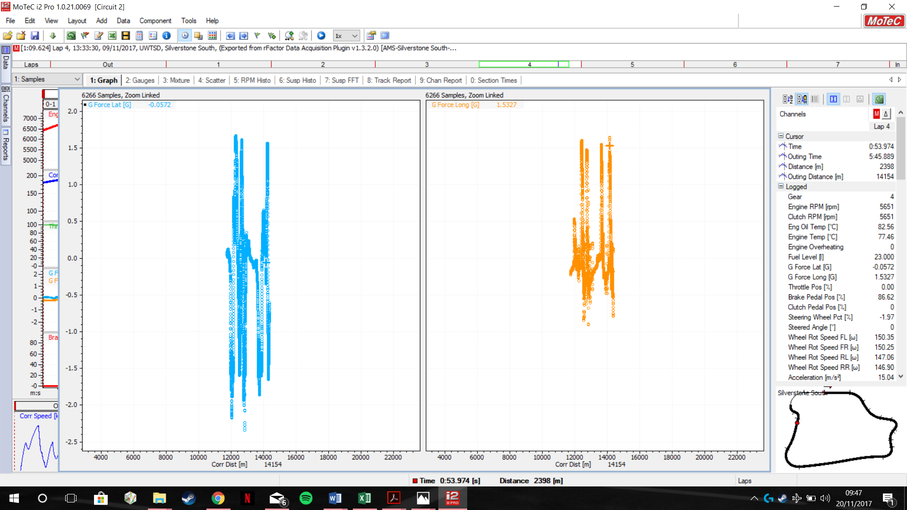
(Fig 15)
4.6 Excel Documents
From the data collected via the simulation and live data a CSV file was then exported at 10hz. As there`s a large amount of data recorded the data was then sectioned off into each lap and any data which won`t be useful will then be deleted. (Fig 16) (Fig 17) Currently this data is still being narrowed down to a manageable size.
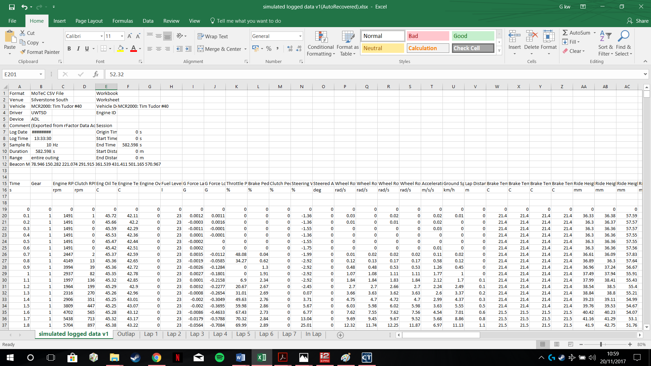
(Fig 16)

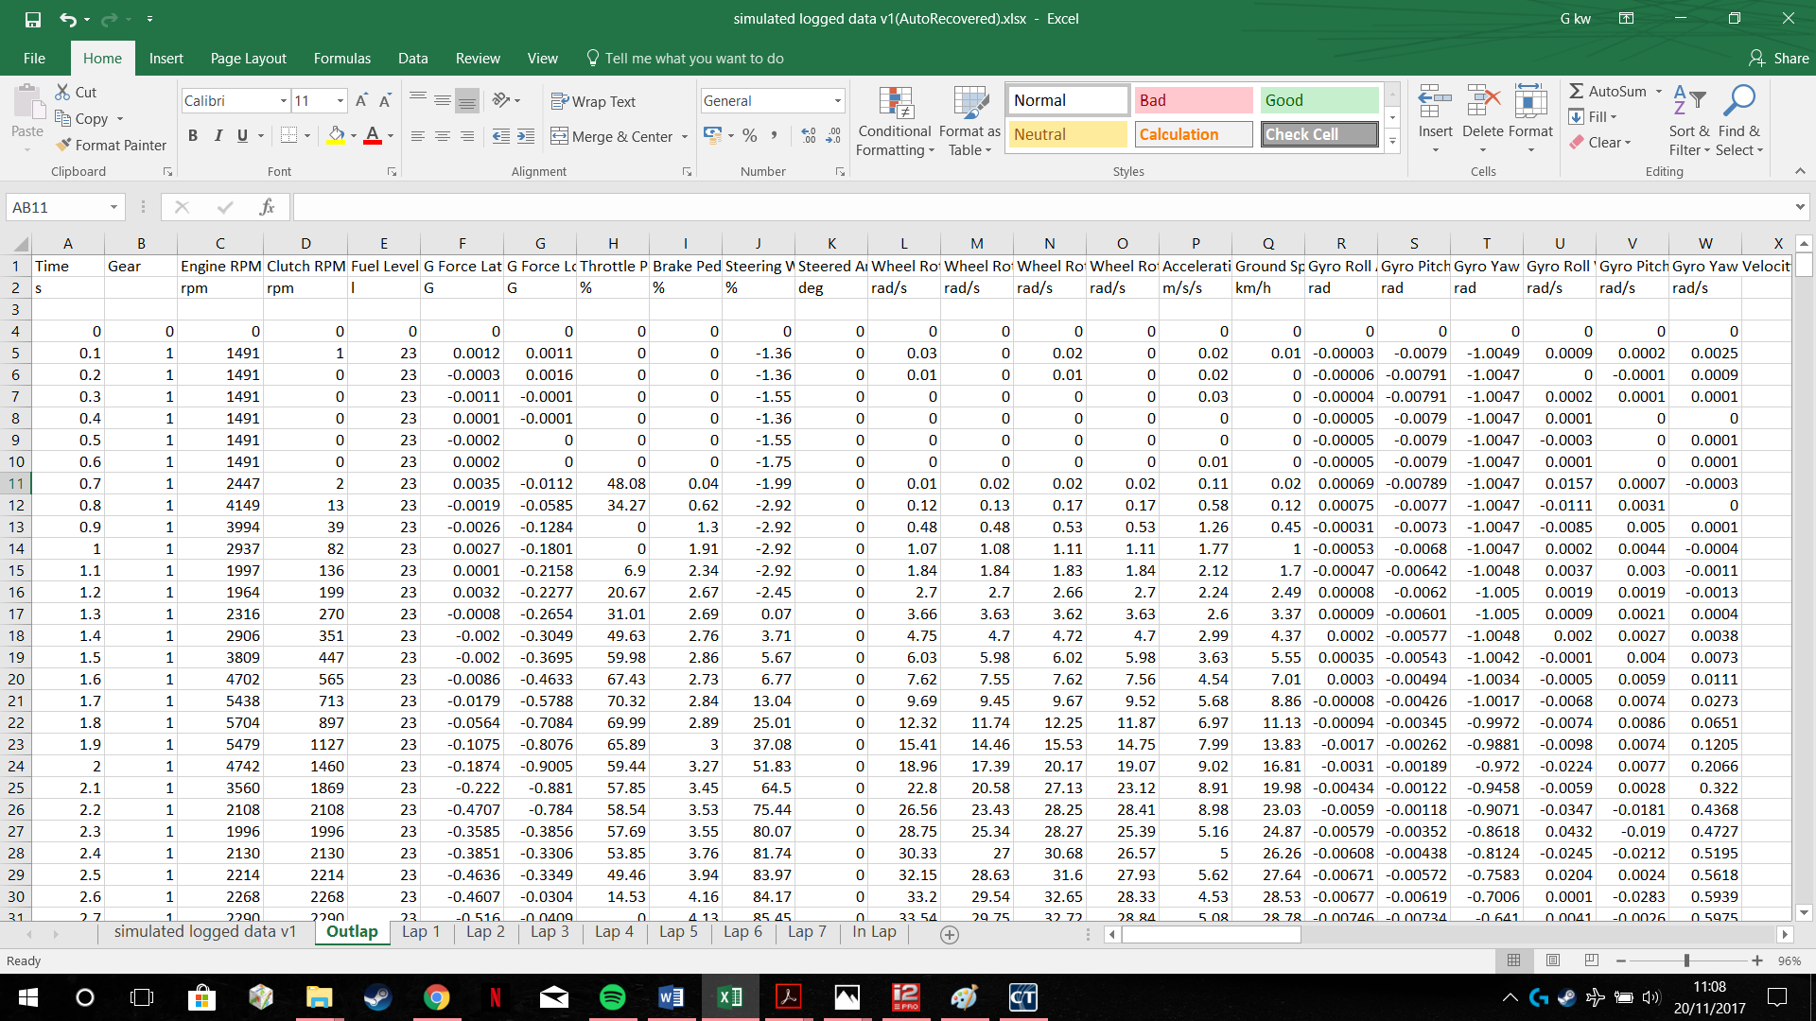
(Fig 17)

5.0Conclusion
5.1 Future aims and objectives
Now that research and data has been gathered the next steps for the investigations is to evaluate the data that’s been found and calculate the amount of time and energy that can possibly be recovered while the vehicle is under braking. From the use of calculations, a suitable set of motors and energy storage options will be able to be priced up and tested upon the simulator. A more in-depth research into energy storage options and motors available on the market will also be looked into with advantages and disadvantages of each part. Power increasing the simulator modal via a torque graph and seeing if adding weight to the vehicle will increase or decrease in lap times.

6.0 References
2017 FORMULA ONE TECHNICAL REGULATIONS. (2017). FIA.
2017 Technical Regulations for LMP1 Prototype Hybrid. (2016). FIA.
2018 FORMULA ONE TECHNICAL REGULATIONS. (2017). FIA.
Amiryar, M. and Pullen, K. (2017). A Review of Flywheel Energy Storage System Technologies and Their Applications. Applied Sciences, 7(3), p.286.
autoevolution. (2017). Team Lotus, Virgin, HRT F1 to Start 2011 Without KERS. [online] Available at: https://www.autoevolution.com/news/team-lotus-virgin-hrt-f1-to-start-2011-without-kers-30389.html [Accessed 9 Nov. 2017].
BALAJI, k., SRIDHAR, k., RAFATH SHERIEF, a. and JANCI RANI, J. (2017). OPTIMIZED REGENERATIVE BRAKING TECHNOLOGY FOR ELECTRIC BIKES. Research Paper.
Bengolea, F. and Samuel, S. (2017). Technology Choices for Optimizing the Performance of Racing Vehicles. SAE International.
Boretti, A. (2014). Kinetic Energy Recovery Systems for Racing Cars. SAE International.
Boretti, A., Masudi, H. and Scalzo, J. (2017). Alternative Crankshaft Mechanisms and Kinetic Energy Recovery Systems for Improved Fuel Economy of Light Duty Vehicles.
Cross, D. (2017). Optimization of Hybrid Kinetic Energy Recovery Systems (KERS) for Different Racing Circuits. SAE Technical Paper.
Deshpande, R. (2015). Ultracapacitors. New York: McGraw-Hill Education.
Federation Internationale de l'Automobile. (2017). Federation Internationale de l'Automobile. [online] Available at: https://www.fia.com/ [Accessed 20 Nov. 2017].
Heeps, G. (2010). wheel of fortune.
Hodkinson, R. and Fenton, J. (n.d.). Lightweight Electric/ Hybrid Vehicle Design. Butterworth Heinemann.
KERS Braking for 2014 F1 Cars. (2012). SAE International.
MCR, U., UWTSD, S., students, A., Engineering, R. and Work, T. (2017). msport-eng.com – Racing @ UWTSD. [online] Msport-eng.com. Available at: http://www.msport-eng.com/ [Accessed 6 Nov. 2017].
Moro, D., Cavina, N., Trivić, I. and Ravaglioli, V. (2017). Guidelines for Integration of Kinetic Energy Recovery System (KERS) based on Mechanical Flywheel in an Automotive Vehicle. SAE international.
Regenerative Braking Mechanism. (2017). Manu Garg, 4(3).
Sun, P., Yu, X., Yi, W., Ding, H. and Liang, J. (2017). Research on Control System of Hybrid Regenerative Braking and Low Speed Energy Recovery.
Templeman, G. (2017). SpeedPro Series - The Competition Car Data Logging Manual. Veloce.
Drewitz, I. (2017). Software. [online] Vboxmotorsport.co.uk. Available at: https://www.vboxmotorsport.co.uk/index.php/en/customer-area/software [Accessed 20 Nov. 2017].
Motec.com. (2017). MoTeC. [online] Available at: http://www.motec.com/ [Accessed 20 Nov. 2017].
Race tech. (n.d.). Race Tech, 14(3).
Race-technology.com. (2017). Select market sector - Race Technology Ltd - Automotive Technical Excellence. [online] Available at: https://www.race-technology.com/ [Accessed 20 Nov. 2017].

