

Module: Changemakers: Creativity and Value Creation

Profession (BMHP5014)

Component 2: Assignment

(Report)

Student name: Juliet Asiedu Boateng

Student number:2335599

Lecturer’s: G1 Laila Surani

G2 Caroline Salami (module

Leader

Task 1: POSTER

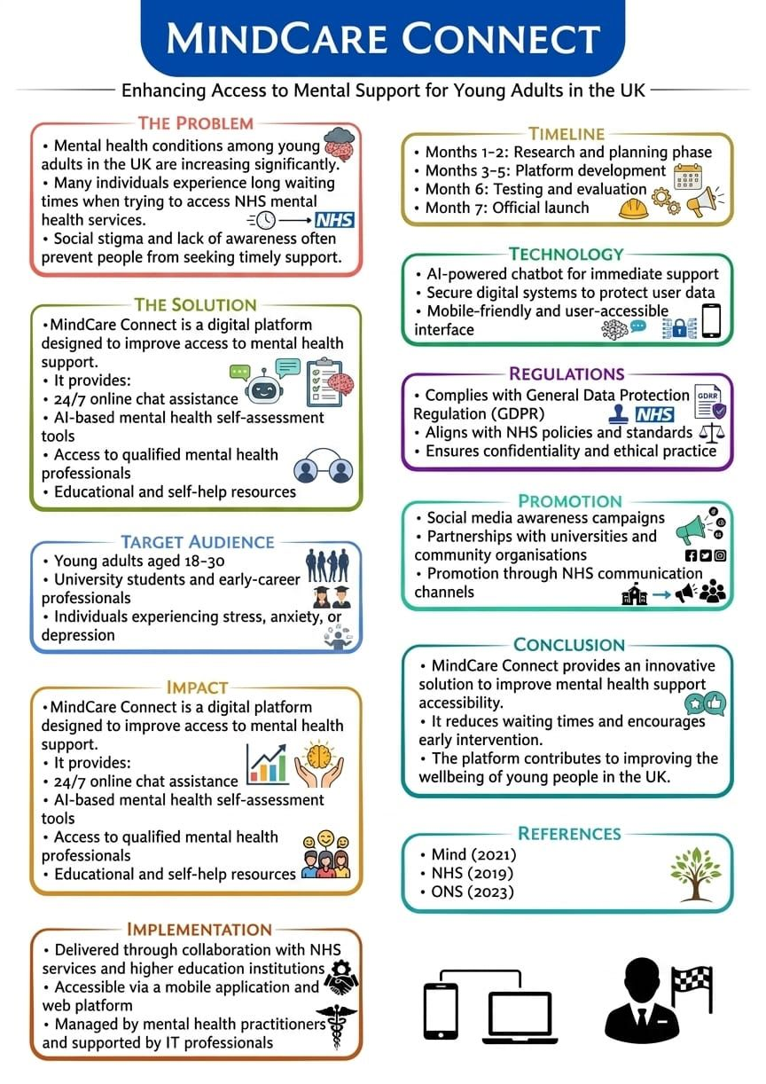

References

Mind (2021) Mental health facts and statistics. Available at: https://www.mind.org.uk

(Accessed: 30 April 2026).

NHS England (2019) The NHS Long Term Plan. Available at: https://www.longtermplan.nhs.uk

(Accessed: 30 April 2026).

Office for National Statistics (2023) Personal well-being in the UK. Available at: https://www.ons.gov.uk

(Accessed: 30 April 2026).

Mental Health Foundation (2021) A right to support: young people’s mental health. Available at: https://www.mentalhealth.org.uk

(Accessed: 30 April 2026).

World Health Organization (2020) Adolescent mental health. Available at: https://www.who.int

(Accessed: 30 April 2026).

NHS Digital (2022) Mental health of children and young people in England. Available at: https://digital.nhs.uk

(Accessed: 30 April 2026).

YoungMinds (2023) Young people’s mental health statistics. Available at: https://www.youngminds.org.uk

(Accessed: 30 April 2026).

The King’s Fund (2022) Access to mental health services in England. Available at: https://www.kingsfund.org.uk

(Accessed: 30 April 2026).

Task 2

PITCH: MindCare Connect: Enhancing Access to Mental Health Support for Young Adults in the UK

🧱 MAIN STRUCTURE
- Introduction
- The Problem
- The Proposed Solution
- Target Audience and Impact
- Implementation and Policy Context
- Regulatory Considerations
- Benefit of MindCare Connect UK
- Role of Technology
- Challenges and Limitations
- Conclusion
- References

🟦 Introduction (expand slightly when rewriting)

In the United Kingdom, mental health is an extremely serious public health concern, especially for the younger generation. With the growing demands from academics, finances, and society at large, more people have developed anxiety disorders and depression problems. Despite the availability of services provided by the NHS, there still aren't enough resources to help everybody.
This proposal introduces MindCare Connect, an innovative digital platform aimed at improving access to mental health support. By combining technology with professional services, the platform seeks to deliver timely, accessible, and user-centred care while contributing to improved wellbeing and social value.

🟥 The Problem
Mental health conditions among young adults have increased significantly in recent years. According to the Office for National Statistics (ONS, 2023), levels of anxiety and depression are particularly high among individuals aged 18–30. Similarly, Mind (2021) reports that a substantial proportion of young people experience mental health difficulties.
Despite this, access to support remains a challenge. NHS services are often overstretched, resulting in long waiting times for therapy and counselling (NHS, 2019). Delays in receiving treatment can worsen mental health conditions and reduce recovery outcomes.
In addition to this, stigma associated with mental illness can be a significant deterrent in seeking treatment. Young people are particularly interested in more convenient forms of therapy such as virtual and remote treatment, which may not be easily accessed through conventional medical facilities.

🟩 The Proposed Solution
MindCare Connect is a digital mental health platform designed to address gaps in accessibility and service delivery. The platform offers 24/7 chat support, enabling users to receive immediate assistance. It also includes AI-based self-assessment tools to help individuals better understand their mental health and identify appropriate support options.
Users can access qualified mental health professionals through the platform, ensuring that expert care is available when needed. In addition, educational materials and self-help resources are provided to promote awareness and encourage proactive mental health management.
This innovation reflects key principles of creativity and value creation, as it applies digital technology to improve health outcomes and address real-world challenges in health and social care.

🟨 Target Audience and Impact
The primary target audience is young adults aged 18–30, including students and early-career professionals. This group is particularly vulnerable due to life transitions and increased social and economic pressures.
The platform is expected to improve access to mental health support and promote early intervention. By providing timely assistance, it can reduce the severity of mental health conditions and improve long-term outcomes.
Furthermore, the initiative contributes to the common good by reducing pressure on NHS services and supporting a healthier population.

🟪 Implementation and Policy Context
The implementation of MindCare Connect would involve collaboration with NHS organisations, universities, and mental health charities. The platform can be integrated into existing healthcare systems to ensure continuity of care.
This initiative aligns with the NHS Long Term Plan (NHS, 2019), which emphasises improving mental health services and expanding the use of digital technologies. It also supports government strategies aimed at prevention and early intervention in mental health care (Department of Health and Social Care, 2021).
By aligning with these policies, the platform ensures compliance with national priorities and professional standards.

Regulatory Considerations

The platform must comply with the Data Protection Act 2018 and UK GDPR to ensure data security (NHS Digital, 2023). It must also meet NHS data protection standards.

Compliance with Care Quality Commission standards ensure safe and effective services (Care Quality Commission, 2023).

Benefit of Mindcare Connect UK

The Mindcare Connect initiative facilitates access to mental health support by providing cost-effective and digitally led mental health services that mitigate obstacles like social stigma and lengthy waiting periods. The service encourages early interventions, which have been shown to yield positive results in terms of building resilience and achieving better long-term effects. The service also facilitates peer support and a sense of community, which positively impacts emotional well-being and help-seeking behaviours (Mental Health Foundation, 2021; NHS England, 2022).

💻 Role of Technology
Technology plays a central role in the effectiveness of MindCare Connect. AI-powered chatbots enable instant responses and support, improving accessibility and efficiency.
The platform uses secure data systems to protect user information and ensure compliance with GDPR regulations. Its mobile-friendly design allows users to access support anytime, making it highly convenient and inclusive.
The integration of technology enhances service delivery, user engagement, and overall effectiveness.

⚖️ Challenges and Limitations
Despite its potential benefits, several challenges may arise. Data privacy and security concerns must be carefully managed to ensure user trust. Financial constraints may also impact development and implementation.
Digital exclusion is another concern, as some individuals may lack access to necessary technology. Addressing these challenges requires strong data protection measures, funding partnerships, and alternative access strategies.

✅ Conclusion
MindCare Connect offers an innovative solution to the growing mental health challenges faced by young adults in the UK. By integrating digital technology with professional care, the platform improves accessibility, reduces waiting times, and promotes early intervention.
The initiative provides value not only to individuals but also to the wider healthcare system, making it a relevant and impactful contribution to health and social care innovation.

REFERENCES

- Department of Health and Social Care (2021) Mental Health Recovery Action Plan.
- Greenhalgh, T. et al. (2017) Beyond adoption: a new framework for theorising and evaluating nonadoption of health technologies.
- Kotter, J. (2012) Leading Change. Harvard Business Review Press.
- Mind (2021) Mental health facts and statistics.
- NHS (2019) The NHS Long Term Plan.
- NHS Digital (2022) Mental Health Services Monthly Statistics.
- Office for National Statistics (ONS) (2023) Adult mental health, UK.
- Rogers, E. (2003) Diffusion of Innovations. 5th ed.
- Topol, E. (2019) The Topol Review.
- World Health Organization (2022) Mental Health Overview.
- Mental Health Foundation (2021). A Right to Support.
- NHS England (2022). Mental Health Services Data

