Reflective Learning Log: Delta Hotels Birmingham

Student name and ID number : 2124188 Cosmin Blaj
Module number: BMIH6004

Table of Contents
1 Introduction 3
2 Role Reflection 4
2.1 Description and Feelings 4
2.2 Evaluation and Analysis 4
2.3 Examples of Skills in Action 4
2.4 Strengths and Weaknesses 4
3 Discussion of Key Hotel Administration Issue 6
4 Future Trends in Hotel Administration 8
5 Conclusion 9
6 References 10

1 Introduction
During my 10-week placement at Delta Hotels Birmingham, I was primarily engaged in the Front Desk Reception department under the supervision of Mr. Kalinauskas Gedas, while also observing operational practices within the Food and Beverage department alongside Ms. Tinika. This reflective log centres on my experience in the Front Desk Reception, widely acknowledged in hospitality literature as the “nerve centre” of hotel operations. The front desk serves as a critical hub for administrative tasks and direct guest interactions, supporting seamless communication between guests and all operational departments.
Throughout my placement, I undertook a variety of responsibilities at the front desk, including managing guest check-ins and check-outs, responding to inquiries and complaints, updating guest profiles and billing through the Opera Property Management System (PMS), and liaising with housekeeping and maintenance teams. These tasks demanded adaptability, strong communication, and problem-solving skills, which align with the core competencies identified by Johnston et al. (2012) as central to maintaining service quality in hospitality environments.
My three learning objectives for this placement were:
- To develop advanced communication and leadership skills within a high-pressure, guest-facing environment, consistent with the leadership competencies identified in the hospitality sector.
- To gain technical proficiency in administrative software systems, particularly Opera PMS, which underpins guest data management, billing, and operational coordination.
- To understand how front office administration contributes to the broader organisational goals of operational efficiency and guest satisfaction, reflecting the interconnectedness of departments within a hotel setting.
These objectives were designed to bridge the gap between theoretical concepts acquired in my academic studies and the practical demands of hospitality operations, consistent with Kolb’s (1984) experiential learning framework. The following reflection will critically examine how my placement experiences contributed to these goals, supported by academic literature and reflective practice models.

2 Role Reflection
2.1 Description and Feelings
I undertook the role of front desk receptionist, a position central to guest satisfaction and administrative excellence. Under the guidance of Mr. Kalinauskas Gedas, I was responsible for greeting guests, processing check-ins and check-outs, responding to guest inquiries and complaints, and maintaining records in the Opera PMS. This role also required close coordination with housekeeping and maintenance teams to ensure that guest expectations and operational standards were consistently met.
Initially, I experienced anxiety and uncertainty due to the high-paced, unpredictable nature of front desk operations. However, Mr. Gedas’ supportive and collaborative leadership style created an environment that fostered open communication and continuous learning, helping me gradually build confidence and adapt to the dynamic demands of the role.
2.2 Evaluation and Analysis
Effective communication emerged as a fundamental competency, as it underpins positive guest experiences and resolution of complaints. In addition, active listening and empathy were crucial for managing emotionally charged situations, highlighting the importance of emotional intelligence in hospitality management.
Adaptability was equally vital. The dynamic nature of front desk operations, characterised by last-minute booking changes, system errors, and overbookings, underscored the need for flexibility in resource management. For instance, when the Opera PMS experienced temporary slowdowns, Mr. Gedas demonstrated proactive leadership by guiding us through manual check-in procedures, illustrating the importance of contingency planning in hotel administration.
2.3 Examples of Skills in Action
One memorable instance involved a guest frustrated by their delayed room readiness. I employed active listening and empathy, offering a complimentary beverage while expediting the room preparation. This proactive service recovery effort transformed a negative experience into a positive one, reinforcing the significance of emotional intelligence in guest satisfaction.
Another example involved managing a corporate group booking with last-minute adjustments, requiring real-time updates in Opera PMS and coordination with housekeeping. This tested and strengthened my technical and organisational skills, highlighting the critical role of precision and teamwork in maintaining operational effectiveness.
2.4 Strengths and Weaknesses
I identified key strengths in my ability to build rapport with guests and remain composed under pressure, aligning with leadership competencies such as effective communication and adaptability. However, my initial unfamiliarity with Opera PMS sometimes led to data entry errors. Additionally, I noticed hesitancy in seeking clarification when unsure, emphasising the need to embrace continuous learning.
2.5 Action Plan
To address these areas for growth, I developed a comprehensive action plan:
- Technical Proficiency: Completing advanced training in Opera PMS and related systems to improve technical confidence and reduce data errors.
- Proactive Communication: Actively seeking clarification and feedback to ensure accuracy and continuous learning, as collaborative knowledge-building is central to professional development.
- Leadership Development: Volunteering for team-based projects to develop supervisory skills, reflecting Lolli’s (2016) emphasis on leadership in hospitality.
- Reflective Practice: Regularly applying reflective practice models like Gibbs’ (1988) cycle to critically assess performance and identify growth areas, supporting lifelong learning in line with Kolb’s (1984) framework.
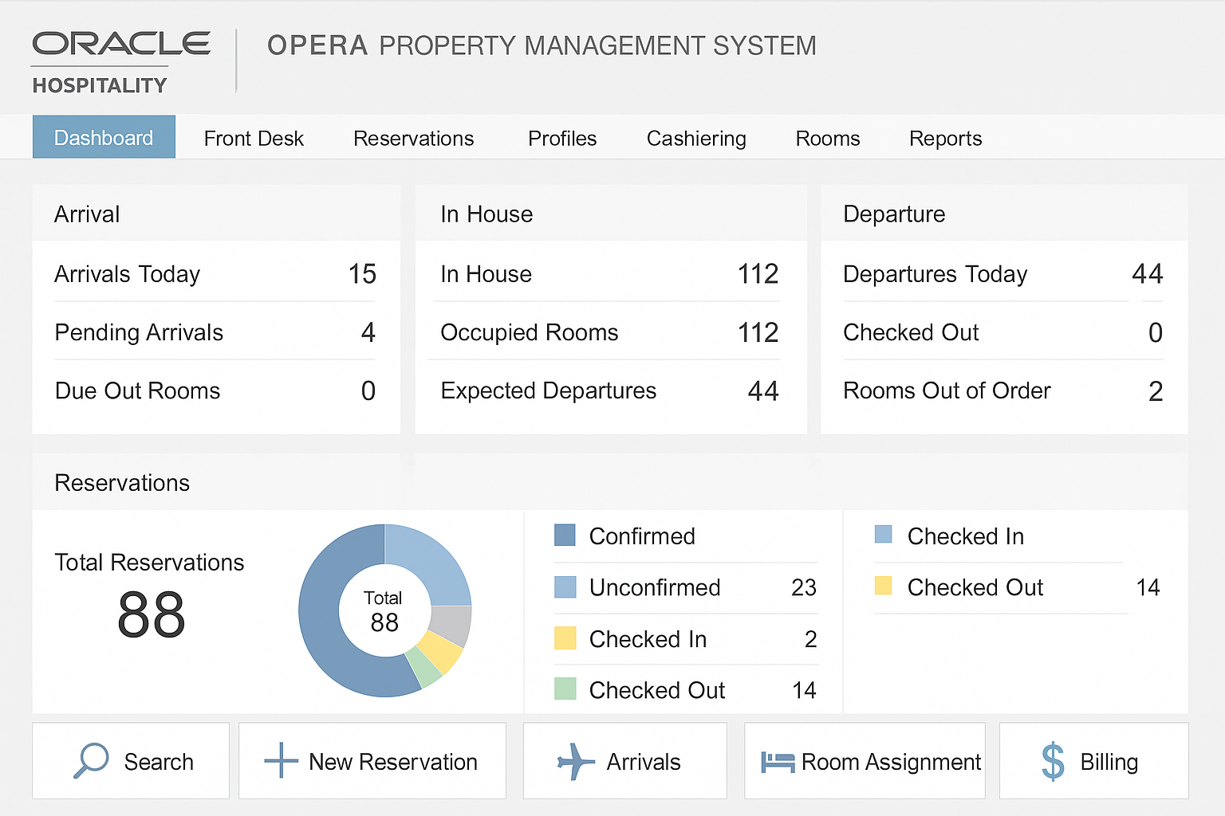
Figure 1: Opera PMS Dashboard Screenshot
(Insert a screenshot or visual representation of the Opera PMS interface, highlighting key features you used during your placement.)

3 Discussion of Key Hotel Administration Issue
A significant issue I observed was resource allocation at the front desk, particularly during peak periods. The front desk’s dynamic environment requires agile resource management to handle unpredictable guest flows. Delta Hotels Birmingham’s fixed staffing schedules, while structured, were sometimes insufficient during sudden surges, leading to longer wait times and increased staff stress.
Literature highlights that effective resource allocation is crucial for sustaining service quality and operational efficiency. Mr. Gedas often reassigned staff from other departments to the front desk, demonstrating adaptive leadership. However, this approach occasionally disrupted workflows in other areas and was not always sustainable.
Insights from the Service Operations Management module reinforced that flexibility and data-driven decision-making are key to addressing such challenges.
Ivanov (2018) advocates incorporating predictive analytics and real-time data to forecast demand and optimise staffing levels proactively. My placement experience supported this, as manual reassignments addressed immediate needs but did not resolve the need for long-term, data-informed resource planning.
Baum (2016) further emphasises the value of cross-training staff to enhance flexibility and reduce errors. I observed that staff unfamiliar with front desk processes faced challenges when reassigned, highlighting the importance of investing in comprehensive cross-training programs to support operational resilience.
Moreover, workplace culture played a pivotal role in addressing resource allocation issues. Mr. Gedas’ supportive leadership fostered collaboration and mutual assistance, which is consistent with Lolli’s (2016) assertion that empowering workplace cultures reduce stress and build team cohesion.
Reflecting on these observations, I recognised that while immediate reallocation strategies provided temporary relief, long-term solutions—such as data-driven staffing and cross-training—are essential for operational sustainability and guest satisfaction.
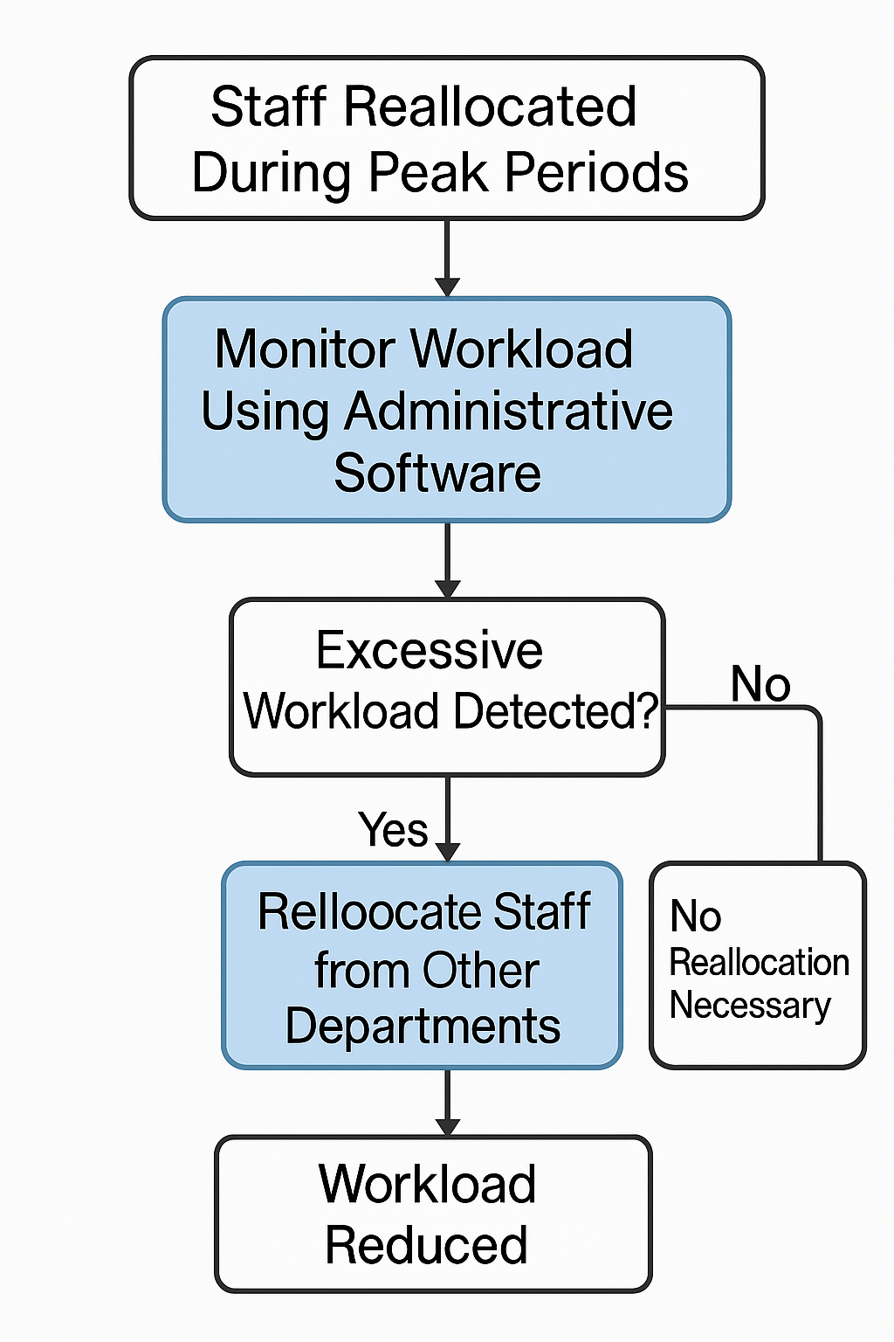
Figure 2: Resource Allocation Flowchart
(Insert a flowchart illustrating how staff were reassigned during peak periods, highlighting the decision-making process and the role of administrative software in monitoring workload.)

4 Future Trends in Hotel Administration
Emerging trends in front office operations include the integration of AI and automation. Verma et al. (2023) argue that AI-powered kiosks and chatbots streamline routine administrative tasks, enhancing operational efficiency and guest satisfaction.
During my placement, I observed that while some guests appreciated digital solutions like contactless check-ins, many still preferred personal, face-to-face interactions, especially for complex or sensitive concerns. This aligns with Gursoy and Chi’s (2020) assertion that the human touch remains central to hospitality, even as technology adoption grows.
These insights suggest that AI and automation should complement, rather than replace, human interactions. AI can handle repetitive tasks, freeing staff to focus on complex guest needs and emotional engagement—skills that remain uniquely human. Furthermore, balancing technological integration with authentic service is critical as guests increasingly value seamless, integrated experiences blending efficiency with personalisation.
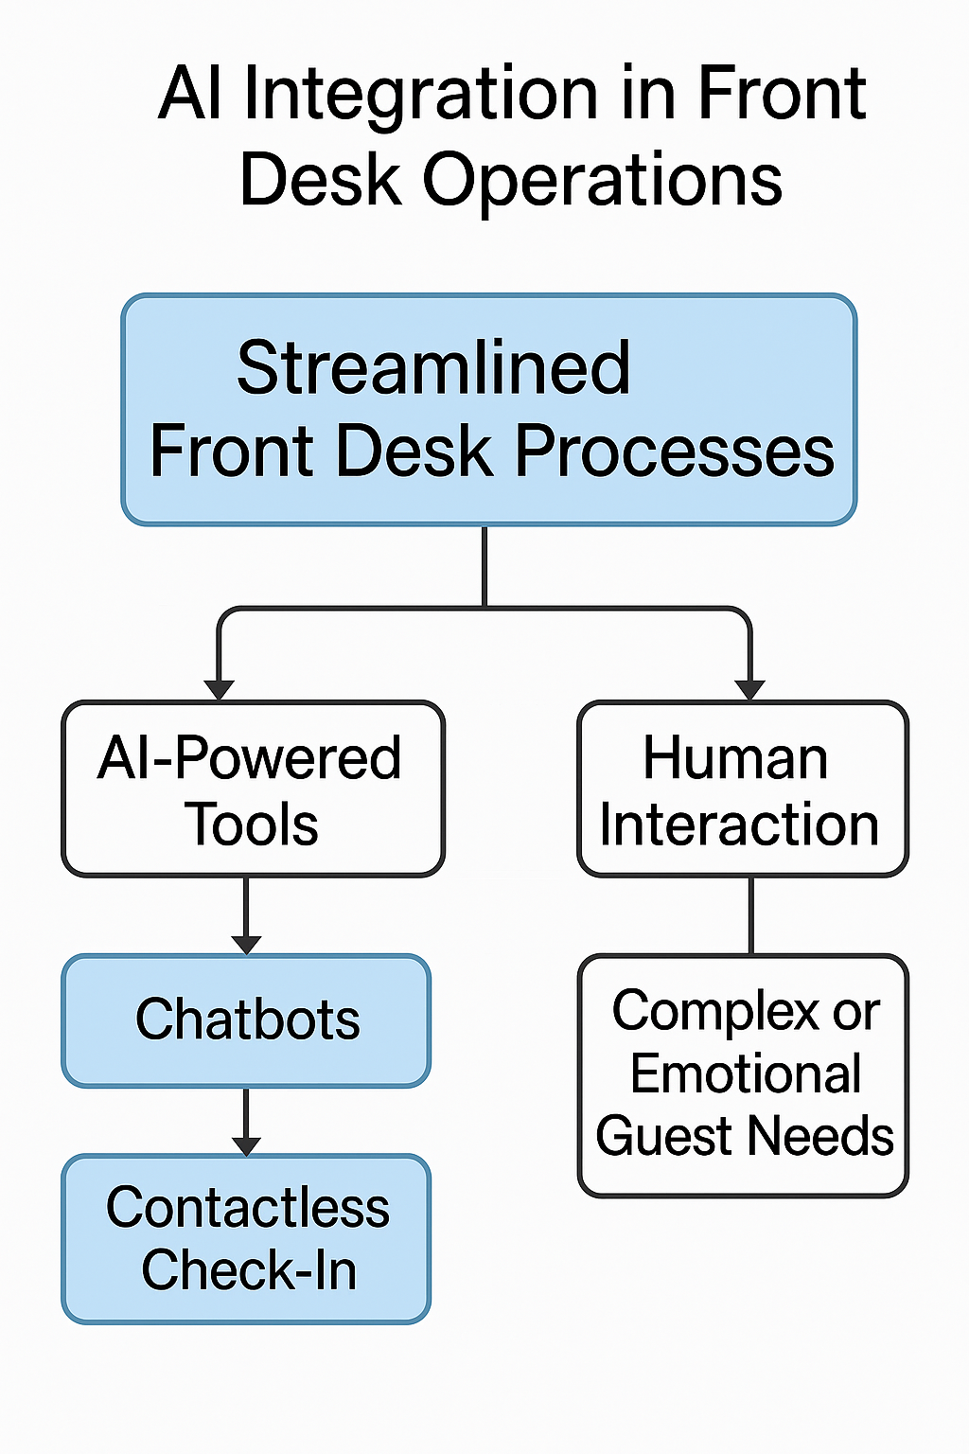
Figure 3: AI Integration in Front Desk Operations
(Insert an infographic or diagram showing how AI (e.g., chatbots, contactless check-in) might streamline future front desk processes, with human roles still central in handling complex or emotional guest needs.)
5 Conclusion
This reflective log demonstrates how my 10-week placement at Delta Hotels Birmingham supported my three learning objectives: developing advanced communication and leadership skills, mastering administrative software, and understanding front office administration’s strategic role. Using Gibbs’ Reflective Cycle (1988), I identified areas of strength—like effective communication—and areas for growth, including technical proficiency and proactive clarification.
My experience underscored the significance of cross-functional collaboration and supportive leadership, consistent with findings by Baum (2016) and Lolli (2016). Furthermore, engagement with contemporary literature on AI and evolving guest expectations broadened my perspective on future trends and the need for balanced, human-centred service delivery.
Overall, this placement has equipped me with theoretical and practical insights, preparing me for future roles in the dynamic hospitality sector. I will continue to apply reflective practices, embrace data-driven decision-making, and foster a commitment to lifelong learning to contribute meaningfully to this ever-evolving industry.

6 References
Baum, T. (2016) Human Resource Management for Tourism, Hospitality and Leisure: An International Perspective. 2nd ed. London: Thomson Learning.
Bardi, J.A. (2010) Hotel Front Office Management. 5th ed. London: Wiley.
Cress, U., Kimmerle, J. & Wodzicki, K. (2013) ‘A systemic and cognitive view on collaborative knowledge building with wikis.’ International Journal of Computer-Supported Collaborative Learning, 8(1), pp. 93–109.
Gursoy, D. & Chi, C.G. (2020) ‘Effects of COVID-19 pandemic on hospitality industry: review of the current situations and a research agenda.’ Journal of Hospitality Marketing & Management, 29(5), pp. 527–529.
Ivanov, S. (2018) ‘Adoption of revenue management practices: A case study of the UK hotel industry.’ Tourism Management, 69, pp. 72–85.
Johnston, R., Clark, G. & Shulver, M. (2012) Service Operations Management: Improving Service Delivery. 4th ed. Harlow: Pearson.
Jones, P., Hillier, D. & Comfort, D. (2016) ‘Sustainability in the hospitality industry.’ International Journal of Contemporary Hospitality Management, 28(3), pp. 424–438.
Kolb, D.A. (1984) Experiential Learning: Experience as the Source of Learning and Development. New Jersey: Prentice Hall.
Lolli, J.C. (2016) ‘Leadership in hospitality: Managerial skills and challenges.’ Worldwide Hospitality and Tourism Themes, 8(2), pp. 166–173.
Maxham, J.G. & Netemeyer, R.G. (2002) ‘Modeling customer perceptions of complaint handling over time: the effects of perceived justice on satisfaction and intent.’ Journal of Retailing, 78(4), pp. 239–252.
Nieves, J. & Quintana, A. (2018) ‘Knowledge-based resources and innovation in the hotel industry.’ International Journal of Hospitality Management, 70, pp. 218–226.
Pizam, A. (2010) International Encyclopedia of Hospitality Management. 2nd ed. Oxford: Elsevier.
Verma, S., Mishra, A. & Rani, A. (2023) ‘Artificial intelligence in hospitality: Opportunities and challenges.’ Journal of Tourism Futures, 9(1), pp. 45–58.
Yukl, G. (2013) Leadership in Organizations. 8th ed. Boston: Pearson.

