JENNIFER CARTLEDGE
EMPLOYABILITY and CAREER DEVELOPMENT (LCLM4005)
STUDENT NUMBER 2509330
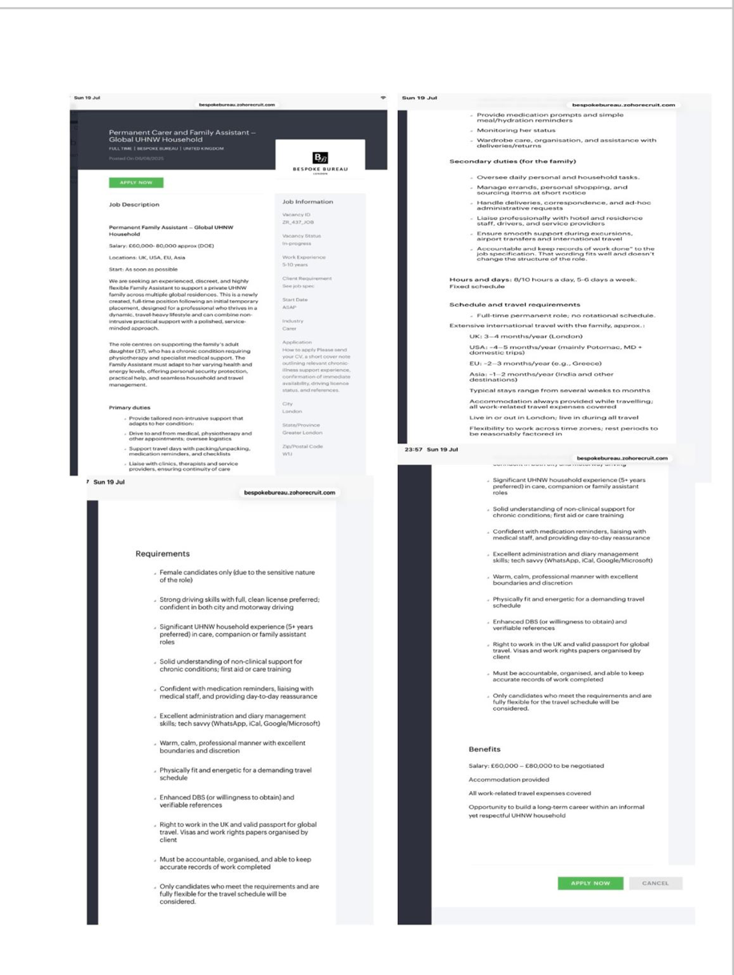
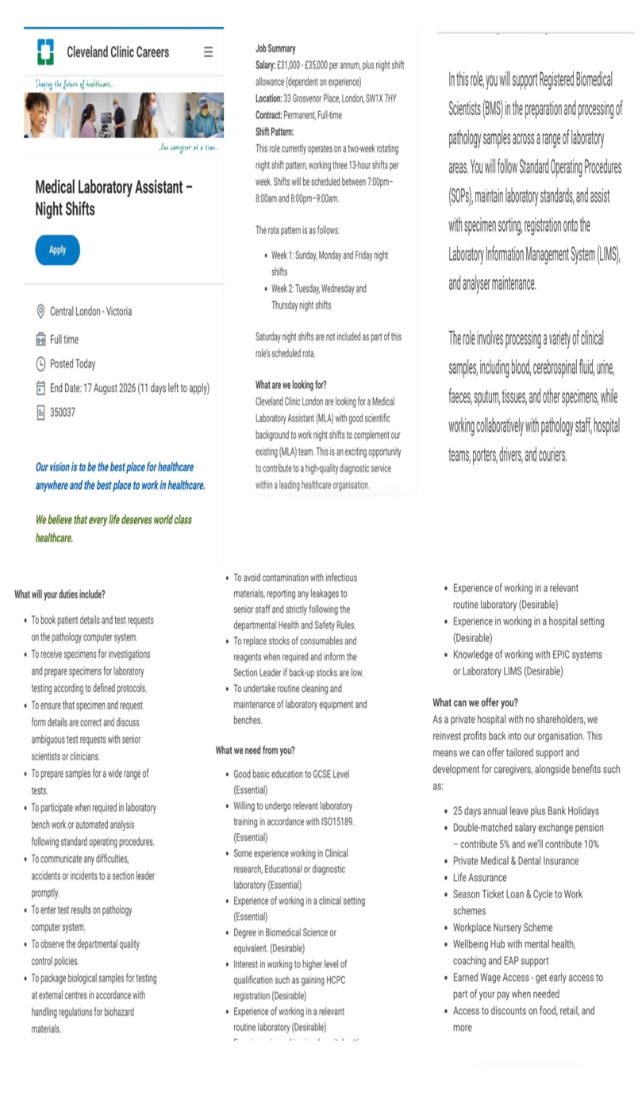

Task 1: Comparison of the two Job adverts and Identification of Key Skills

The two job advertisements are for a Family Assistant and a Medical Laboratory Assistant. The roles are different and they have several important skills and knowledge areas in common. Both positions required a high level of organisation, communication, attention to detail, professionalism, health and safety awareness, teamwork and ability to follow procedures or instructions. Also require employees to work responsibly and maintain confidentiality when dealing with sensitive information (NHS, 2023).
One key shared skill is attention to detail. In the family Assistant role, attention to detail is important when managing medication reminders, appointments, travel arrangements, household records and administrative tasks. The HCPC (2024) highlights the importance of maintaining full, clear and accurate records because accurate record keeping supports continuity of care and safe treatment. Example in my experience small mistakes in time management. Is when I forgot that my patient has GP appointment and that cause delay treatment and serious consequences for the client that I look after. Similarly, the Medical Laboratory Assistant must carefully check patient details, specimen information, test requests, and laboratory records. Incorrect information or specimen handling could affect the accuracy of test results and potentially impact a patient’s treatment. Attention to detail is essential for maintaining safety, accuracy and high-quality service to my clients.

Another important similarity is good communication skills. The Family Assistant is expected to communicate with medical staff, service providers, drivers and other professional's while providing reassurance to the family. The Medical Laboratory Assistant also needs to communicate effectively with scientists, clinicians, pathology staff, hospital team, porters, drivers and couriers. Good communication helps prevent misunderstandings, ensures information is passed on accurately and supports effective teamwork. Example when I am filling up a document for my patient and I put the wrong date of birth it causes confusion and delay for my patients test results.
Both advertisements also highlight Health and Safety. The Family Assistant requires knowledge of care, first aid and safe support for chronic conditions, while the laboratory role requires strict adherence to heath and safety procedures when handling biological and potentially infectious specimens. This demonstrates that healthcare related professionals must understand risk and follow establish procedures to protect themselves, patients and colleagues.
Overall, the two job advertisements demonstrate that, despite being different occupations, health care related roles require similar transferable skills. Attention to detail, communication, organisation, professionalism and health and safety awareness are valuable skills that can support my future career and improve the quality and safety of my work.

Task 2: Reflective Self-Assessment

As a student with ADHD and dyslexia and dyspraxia self-assessment is important because it allows me to identify my strengths, weakness, opportunities and threats and consider how these may affect my employability. Having these learning difficulties means that understanding how I learn and manage my time is important. The VARK model has helped me reflect on my learning preferences and consider strategies that support my academic development (Fleming, 2001).

Weakness: Time Management
One weakness I identified is managing multiple assignment deadlines alongside personal responsibilities. During busy periods, I sometimes leave tasks too late, which increases stress and affects the quality of my work. To improve this, I have started using the Pomodoro Technique, which involves working in focused 25-minute intervals followed by short breaks. This method helps improves concentration and productivity while reducing procrastination (Cirillo,2006). For example, when I am preparing for exams and coursework simultaneously, I used Pomodoro sessions to break large tasks into manageable sections enabling me to meet deadlines more effectively.

Strength : Reflective Learning
A key strength is my willingness to reflect on my experiences and learn from them. Gibbs Reflective Cycle suggests that reflection allows individuals to evaluate experiences, understand what went well, and identify areas for improvement (Gibbs,1988). For example, after receiving feedback from a tutor about improving my academic writing, I reviewed the feedback, identified weakness in referencing, and implemented the suggestions in the future assignments. As a result, my grades improved and become more confident in my academic abilities.

Opportunity : Professional Development and Equality.
An important opportunity for my future career is continuing professional development (CPD). CPD would allow me to keep my knowledge and skills up to date through relevant courses and training. For example, I could complete training in safeguarding, infection prevention and control, manual handling or basic life support. I could also learn a new healthcare technique from an expereicend professional during a placement. If I completed infection prevention training, for example, I could use the knowledge to improve my hand hygiene and follow correct procedures when support patients. I could then reflect on what I learned and identify further development needed.
I can also use VARK strategies during CPD. For example, when learning a new procedure, I could watch a practical demonstration, use a diagram to understand the steps and make short written notes. This would help me engage with new information in ways that suit my learning preferences. Developing new skills and completing relevant courses would demonstrate to employers that I am committed to lifelong learning and professional improvement.
An opportunity available to me is gaining healthcare experience through volunteering and work placements. According to Gibbs (1988) learning through experience supports professional growth and continuous improvement. For example, volunteering in a care home would allow me to develop communication, teamwork, and patient care skills that employers value within the healthcare sector.
Equality and inclusion are also important areas of professional development. The Equality Act 2010 provides protection from discrimination relating to protected characteristics. For example, if I were supporting a patient with a disability, I would consider whether reasonable adjustments were needed to help them access information or services. If a patient had a different cultural or religious background, I would listen to their preferences and communicate respectfully rather than making assumptions. NHS England (2023) highlights the importance of equality, diversity and inclusion in healthcare. Developing this understanding would help me provide respectful care focused on the individual.

Threat: Competition for Employment.

A potential threat to my employability is competition for healthcare positions. Employers may receive applications from candidates with similar qualifications but more recent experience. For example, another applicant may have completed relevant healthcare courses and have recent volunteering experience. I can reduce this threat by developing my CPD, gaining practical experience and reviewing job descriptions to identify skills employers require. If job advertisements repeatedly ask for strong communication and teamwork skills, I can seek volunteering or placement opportunities where I can demonstrate these abilities.
Evidence of Readiness for Employability and Personal Advancement

I have evidence that demonstrates my readiness for employment. My nursing and care experience has helped me develop professional responsibility and communication skills. I also hold a full UK drivers license, DBS clearance, First Aid certification and a Health and Safety certificate. For example, my First Aid and Health and Safety training have helped me understand the importance of recognising risks and responding appropriately to emergencies. My DBS clearance is relevant to roles involving vulnerable people.
My experience has also helped me understand confidentiality, professionalism and equality. For example, when supporting a patient, I would avoid discussing personal information with people who are not authorised to receive it. I would also communicate respectfully and consider the individual needs of each patient.

Overall, my self assessment has helped me recognise that reflective learning and willingness to develop are strengths. Time management remains an area for improvement, but Pomodoro and visual planning are helping me become more organised. CPD provides an opportunity to develop new skills, while competition for employment is a potential threat. By continuing to learn, reflect of feedback, gain experience and apply equality principles, I can improve my employability and prepare for future healthcare opportunities.

Reference List
Cirillo, F. (2006) The Pomodoro Technique
Equality Act 2010, c.15. London: The Stationery Office
Fleming, N.D. (2001) Teaching and Learning Styles: VARK Strategies. Christchurch, New Zealand: N.D. Fleming.
NHS England (2023) NHS equality, diversity and inclusion improvement plan. NHS England.

Task 3

Development area | Action | Timeline | Resources | Method of Measurement
Time Management | Use weekly visual planner and Pomodoro sessions; divide assignments into smaller tasks | Immediately and review monthly | Planner, Calendar reminder and Pomodoro timer | Submit assignments before deadline and record completed tasks
CPD | Complete relevant training such as safeguarding, infection prevention, moving and handing and resuscitation | Within 6-12 months | Online courses, university.NHS,  Healthcare training | Certificates and CPD(Continuing Professional Development) record
Healthcare Experiences | Apply Volunteering work or work placement opportunities | Within 6months | NHS,Care homes,charities university careers service | Number of application, interviews and hour of experience

My main short term employment goal is improving my time management, further develop my professional skills with professional development (CPD), and get more healthcare experience, these goals are based on my SWOT analysis. This is important because I want to get more organise and improve my employability within healthcare.

Time management is the main area for development as in previous experience I’ve had to manage several responsibilities at the same time, which can make it difficult to prioritise and organise my tasks. For example, there was a situation where I had forgotten that a patient had a GP appointment, leading to a delay in their care. This emphasised the importance of planning and responsibility. Over the next 6 months I will use a weekly planner, phone reminders and the Pomodoro technique to divide larger tasks into smaller activities. I will track my progress by checking how frequently I miss important tasks and assignments before their deadlines (Cirillo, 2006).

My second goal is to develop my CPD. I aim that in the next 12 months I complete relevant healthcare training, including safeguarding, infection prevention and control, moving and handling and basic life support. Skills for Health (2026) identifies these as important areas in healthcare training, and keeping their certificates and short reflections in a CPD portfolio will help keep track of what I’ve learned and how it improves my practice. CPD can help healthcare professionals keep and develop skills throughout their careers (HCPC, 2026).

My long term goal is to gain further healthcare experience through volunteering or work placements. In the next 12 months I will continue to apply for suitable opportunities in care or healthcare settings. This would help me develop my skills further in communication, team work and patient care. I will use the feedback from supervisors to reflect using Gibbs’ (1988) reflective cycle. This would improve my confidence, allow me to work on my weaknesses and strengthen my CV to prepare me for future healthcare employment.

Department of Health and Social Care (2023). NHS constitution for England. [online] GOV.UK. Available at: https://www.gov.uk/government/publications/the-nhs-constitution-for-england
Health and Care Professions Council (2024). Standards of Conduct, Performance and Ethics. [online] Health and Care Professions Council. Available at: https://www.hcpc-uk.org/standards/standards-of-conduct-performance-and-ethics/
Cirillo, F. (2018). The pomodoro technique: The acclaimed time-management system that has transformed how we work. [online] Google Books. Crown. Available at: https://books.google.co.uk/books/about/The_Pomodoro_Technique.html?id=rinKDQAAQBAJ&redir_esc=y
Skills for Health (2025). Mandatory training every healthcare professional needs | Skills for Health. [online] Skills for Health. Available at: https://www.skillsforhealth.org.uk/article/mandatory-training-every-healthcare-professional-needs/
HCPC (2019). Continuing professional development (CPD) . [online] HCPC. Available at: https://www.hcpc-uk.org/cpd/ [Accessed 17 Aug. 2026].
The University of Edinburgh (2024). Gibbs’ reflective cycle. [online] The University of Edinburgh. Available at: https://reflection.ed.ac.uk/reflectors-toolkit/reflecting-on-experience/gibbs-reflective-cycle [Accessed 17 Aug. 2026].

