Rethinking Business Conference and Database

George parker

Generating Business Data and Analysis (BMSP4004)

Dr Roisin Mullins

17th January 2018

Contents
Part 1- Introduction 3
The Future Generations Act 3
Rational for chosen locations 3
Role of a business analyst 5
Benefits of using a Database 5
Database Lifecycle 5
Data types, Queries, Forms and Reports used within Database 9
Part 2- Business intelligence 10
Sources of relative unstructured data generation 10
References 11

Part 1- Introduction

There will be a conference ran by the Carmarthen business school that will occur on a yearly basis, the conference will be known as the rethinking business conference. For the conference there will be a new database created for the collection of relevant data and locations to be considered as viable locations for the rethinking business conference, there will be specific consideration towards the most optimum time for the conference to be ran during the year as well as the ideal length of time for the conference to run for whether it is a day or a weekend or an entire week if it is optimum. The cost of the conference will demand specific focus so that a location can be decided upon that is as cost efficient as possible to be in line with the goals of the rethinking sustainability conference. There shall also be a high level of consideration towards the registration fees for the delegates to pay in order to gain access to the conference as well as any other fees that may be requires for the delegates to pay and as important the location for the conference with the only requirement being that the location be along the Wales Costal path.

The Future Generations Act

The Future Generations Act is in place so that public bodies in wales consider their long term impact from decisions that they make as well as how they impact on important and continues welsh issues such as poverty, climate change and health inequality. The future Generations Act is an individual act that is unique to wales and has interest globally from many other countries because it allows for positive changes to be made for the current and future generations of any country that implements the act ("Future Generations Act", 2018).
There are seven well-being goals that are clear for public bodies to understand can use for consideration when creating goals and decided on future achievements to work towards.
The first goal of the Future Generations Act is aims towards the prosperity of Wales and aims towards turning wales into a low carbon society that is also productive and highly innovative whilst also considering the limits of the global environment and in response act efficiently in the use of finite resources and the division of said resources in proportional way. This goal should also aim to increase the population’s skill level and intelligence to increase the economic wealth of Wales and in result provided more opportunities for employment so that workers are able to experience all of the benefits that are allowed from the securing of decent work ("Well-being of Future Generations (Wales) Act 2015", 2018).

Rational for chosen locations

When choosing a location to hold rethinking business conference there must be careful consideration towards whether or not the location in question is a viable representation of what the rethinking business conference wishes to represent and stand for. This meant that there had to have been a wide range of optional locations for the rethinking business conference to be held at, this was done using Wales’s unique and beautiful coastal bath as a starting point. From there twos decided that eight counties would be chosen to represent the wide range of heritage that wales has as well as Wales’s geography and natural beauty. So that each county could show off multiple aspects that make them unique to their individual area of wales two towns where chosen from each county and then within each town three locations where chosen to show variety of different options available across wales. This in total came to forty eight possible locations to choose from providing a large feel of data with many different options across Wales to choose from, when choosing a location it was important that each location resided upon if not very close to the coastal path so that the rethinking business conference will be adequately situated in relevant surroundings that inforce the massage that is being sent by the rethinking business conference.
After analysing all of the chosen location within the database there were two locations across Wales that are appropriate for use because these three locations that reach the standard that was required to be used as a location for the rethinking business conference.
The first location that is suitable for the rethinking business conference is Llansteffan Castle, the reason the this location is good for the rethinking business conference is that the castle is carbon efficient location staying in line with the purpose for the conference it is also less than five kilometres from a main road allowing easy access for the delegates. The castle also has parking facilities with more than enough space for the delegates as well as having suitable space to hold the conference whilst also being able to provide reassures such as meals for the delegates. Finally the total cost of the facility is £340.00 it total meaning that the financial impact of the rethinking business conference at this location will be low and efficient.
The second location that has been narrowed down for the rethinking business conference is a restaurant in the Mumbles called Verdis, this location is well known in the local area and across South Wales for its styling, quality of food and location. Verdis is located at the end of the bay and requires you to drive along the bay and experience the beauty of the area before you reach the restaurant. Verdis located beside a main road allowing for easy access with a car park also next to the road with more than enough space for the delegates, although the venue doesn’t have a specific conference area it is possible to use the restaurant to hold the conference this may be a better option as there are great views of the bay from the restaurant for a good backdrop for the rethinking business conference. The total cost will come to £2,102.00 whish is the middle between the other two options and this location is also a carbon efficient location to further reinforce he message of the rethinking business conference.
After looking and analysing both locations to find which location will be the best and most efficient option for the rethinking business conference, the best location to hold the rethinking business conference is Verdis as it meets all of the requirements for the conference to inforce its message as well as meet all the needs of the delegates. As the restaurant is open all year round it is possible to run the conference at any time of the year and is open from seven in the morning until midnight, this allows for the conference to be ran whenever is most convenient for all parties and this is the 6th of June. It is also most efficient to run the conference from 11am until 5pm meaning that costs can stay low without the need to pay for hotels and other overnight fees. This location also fits another criteria for the conference by linking with the future generations Wales act as the chosen location is carbon efficient and considerate of the environment surrounding its business location and works with rather than against it.

Role of a business analyst

Business analysts are integral to the creation and maintained of a business and its database, business analysts are usually involved in the creation from an early point and work towards finding ideas for development and dealing with problematic issues for the database. Business analysts have to find options for further ways forward for the company that is in line with their beliefs and goals and use the information that they find in the creation of cases for the recommendation the businesses. Business analyst also commonly work at senior levels inside organisations so that they can be efficient in their ability to advise the best course of action for their organisation to take (Cadle, Paul & Turner, 2017) (Villanova, 2018)
Analysts have ensure that any and all changes that are made are in line with the organisations strategy and use tactics that will also work to increase the rate that the organisation is able to deliver their business strategy.

Benefits of using a Database

The use of a database is ideal for an organisation as it allows for an organisation to efficiently manage all of their collected data and also for all users of the database to easily perform multiple tasks easily and in a short space of time. A database also allows for the storage of large amounts of information in an organized and easy to understand way, this can all be done within a single software application such as Access or Excel. These software programs also have a user friendly interface allowing new data to be added easily and the easy removal of redundant information (Roman, 2002) ("Benefits of database development", 2018).

Database Lifecycle

The first stage of the creation of the database was to identify the mission and goal that is to be achieved by the creation of the database, this is to deduce a suitable location to hold a rethinking business conference. During this stage there was time for the identification of restraints and limits for both the data analyst and the database ("Data Director Documentation Center", 2018) (Halpin, 2003).
The second stage is the design of the database where it was decided on what information was to be entered into the database and how the database should be structured. This was then implemented using access and the program SQL as it was cost efficient with a good level of usability for data analysis, implementation and maintenance (CORONEL, 2018).
The entity relationship diagram shows the relationships between all three of my tables that begin with the County table with the primary key set for the county code, there is then a one to many relationship liking this table to the town table. The town table has the primary key set as the town code then there is another one to many relationship connecting this table to the venue table with which has two primary keys one being venue code and the other being location code.
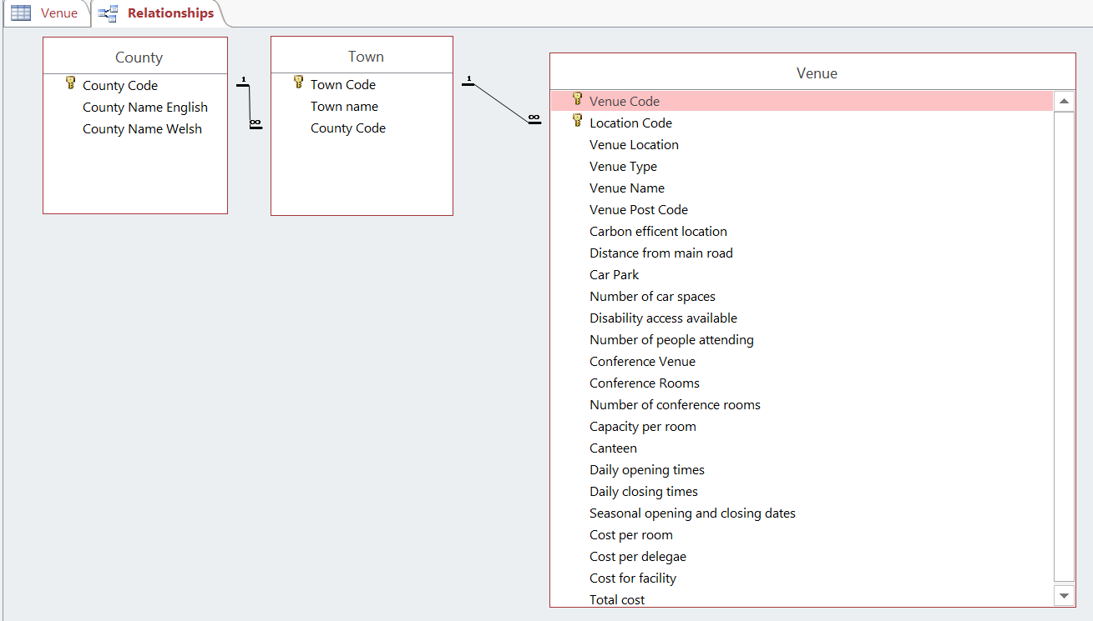

So that a viable business could be chosen to hold the conference many different pieces of data had to be collected. The first piece of data was the name of the county in both English and Welsh for ease on the user and then I created a county code ranging 1-8 so that the information transfer between tables is much easier and accurate.
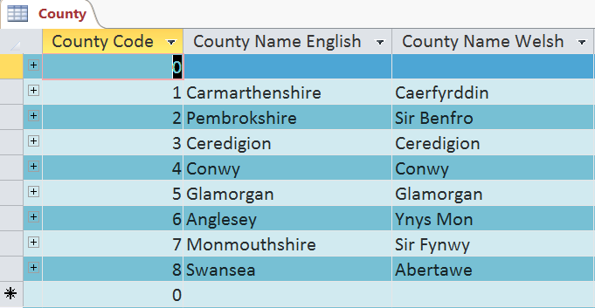

Then there is the information table for town which contains all sixteen town names for the eight counties and the town code 1-16 for again the easy and correct transfer of information.
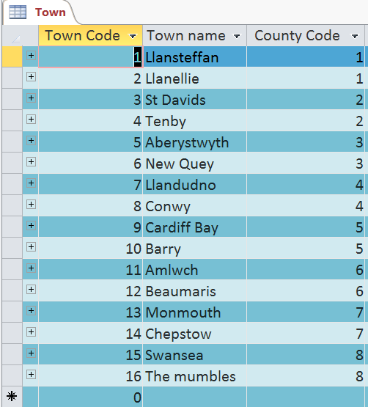

This data then joins the venue table, the table begins with venue code ranging 1-48 so that each location has an individual code then the next column contains the location code so that it is possible to know the county and town code as well as the town name. The next column contains venue location which shows where each venue is located then there is venue type which shows what type of venue the location is, then this is furthered in the next column venue name giving the used the specific name of the venue. They next column contains venue post code giving the user access to the exact location of the venue, carbon efficient location is the next column and shows the user if the location is suitable in terms of carbon usage for the conference location. The next is distance from main road showing how easy the location is to access and the next is car park so that the user knows if the venue has car parking access. They next column gives further information by showing the user the amount of space available within the car park after this here is disability access informing the user if the venue is suitable of a person with a disability following this there is number of people attending to show how many delegates are to attend the event in question. The next column shows if the venue has a dedicated conference room provided, the next is conference rooms to show the names of conference rooms the venture has if there are conference rooms are provided the following column shows the number of conference room that the venue has available. Next is capacity per room to show the maximum numbers allowed to attend safely for each room and following this is a column showing if a canteen or any catering facilities are provided by the venue. In order the next three columns show daily opening times then daily closing times and then seasonal opening and closing times for each venue all year round, following this the next four columns show cost per room, cost per delegate, cost for facility and total cost allowing the user to see individual prices that they may require.
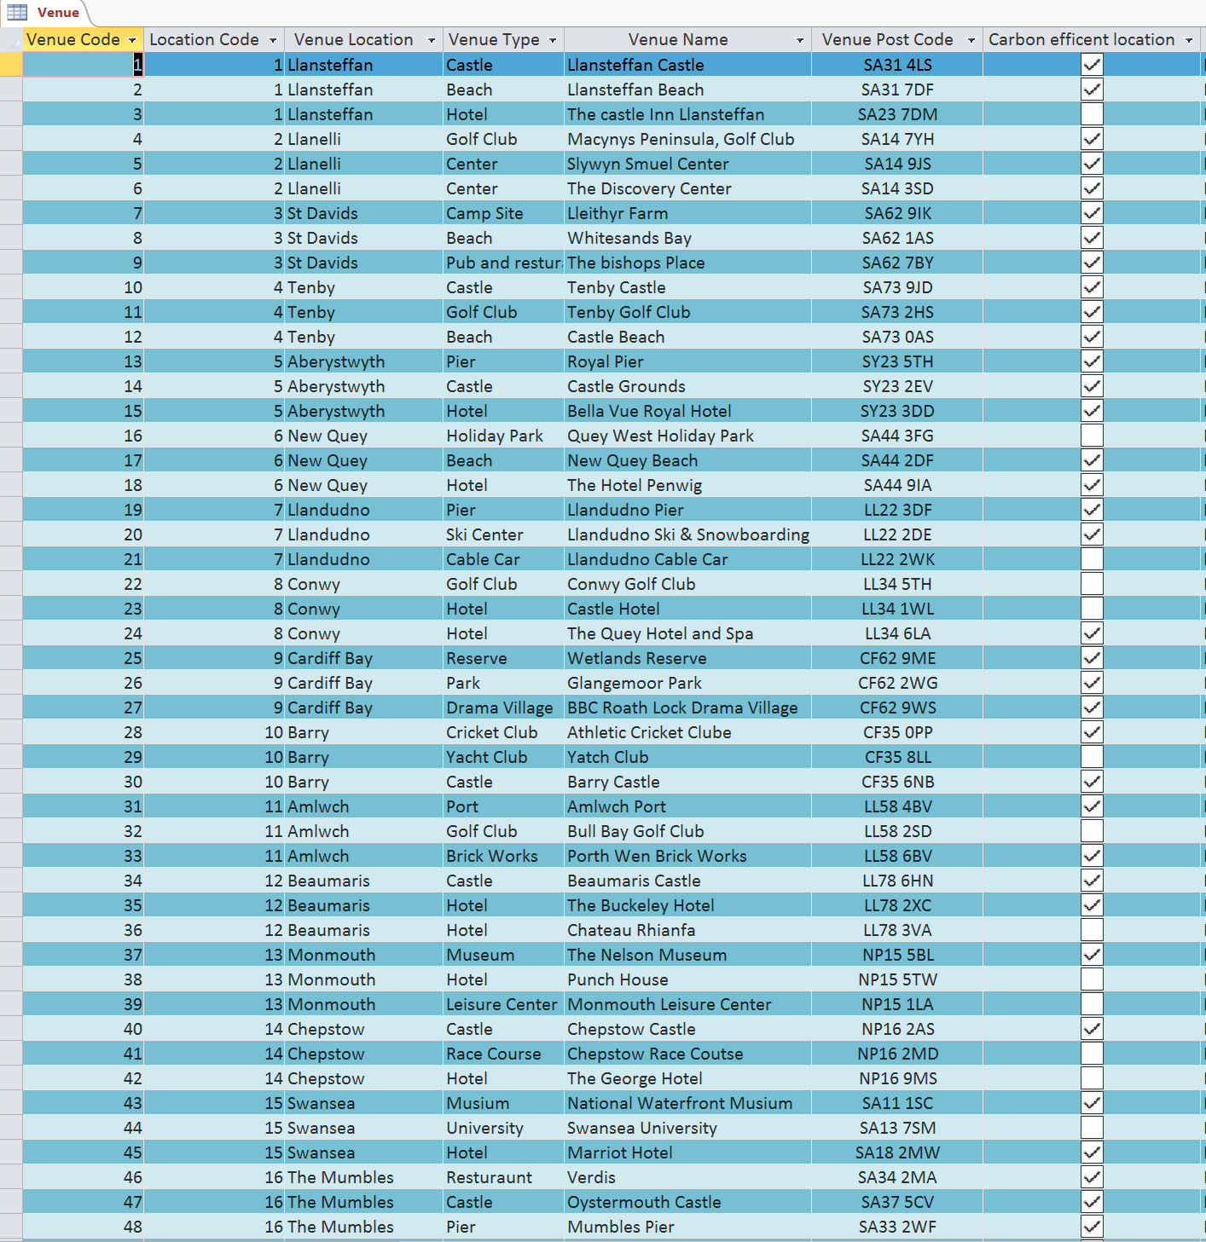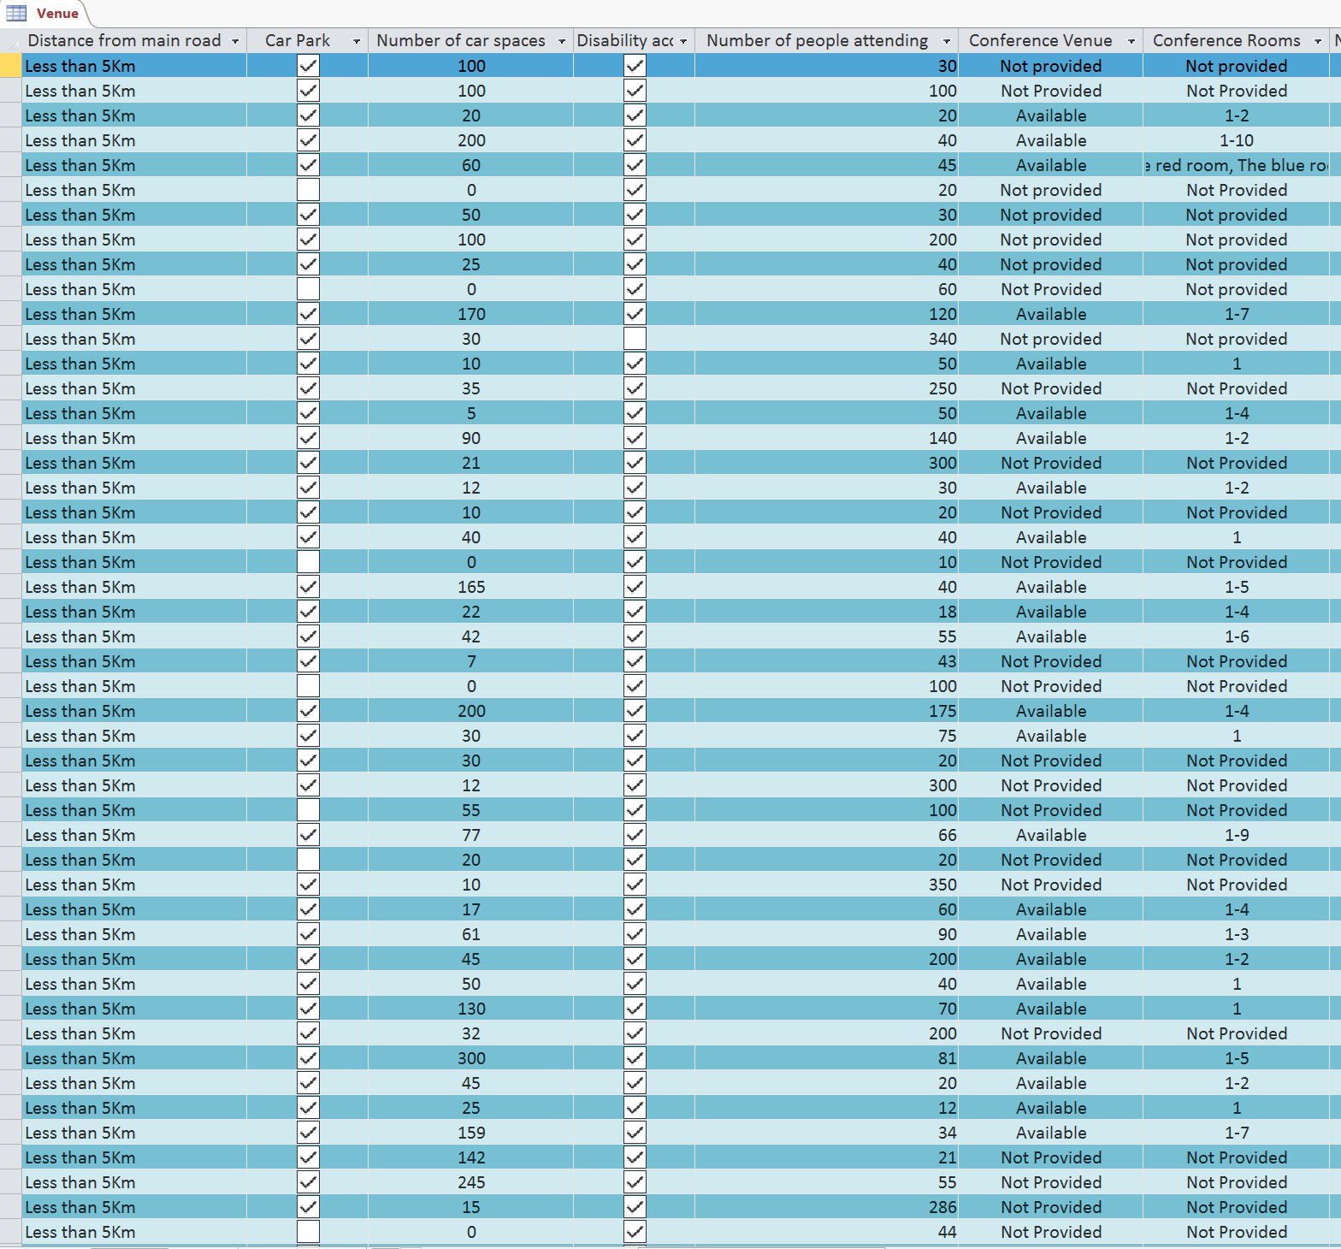
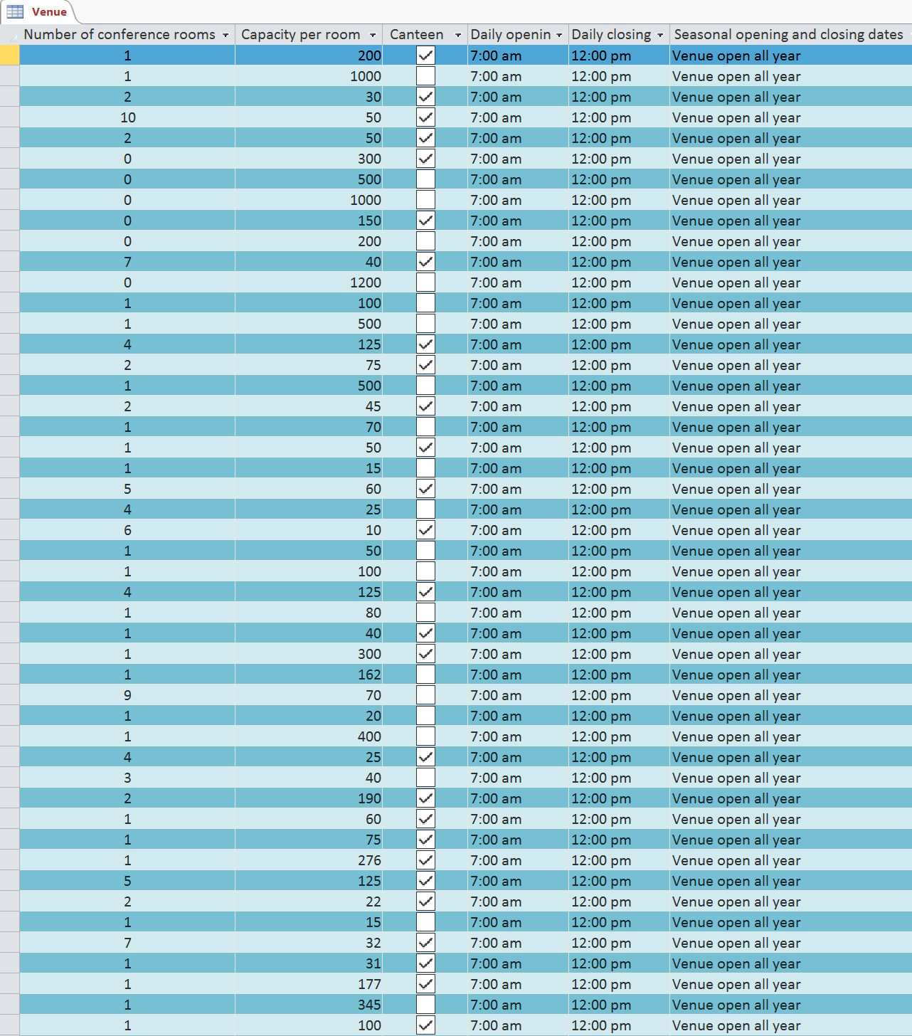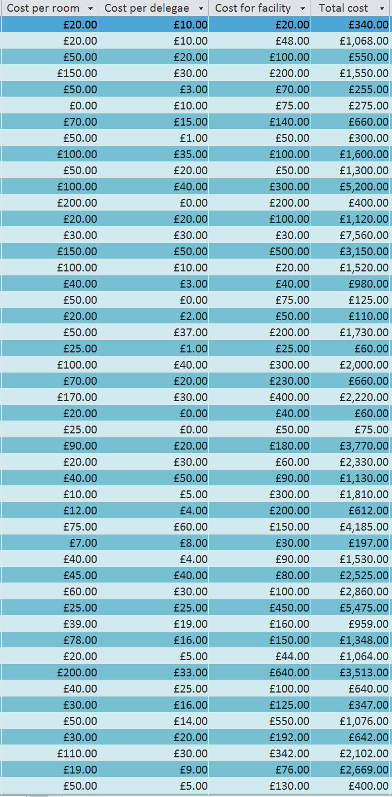

Data types, Queries, Forms and Reports used within Database

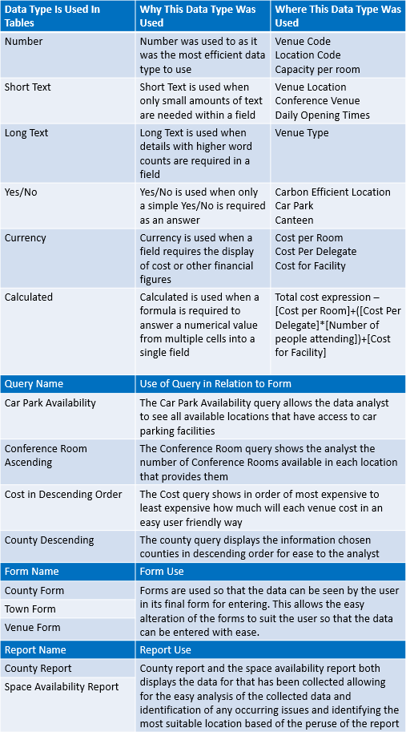

Part 2- Business intelligence

There is a large range of ways that you can capture data from unstructured sources and when using rescues it is useful to consider the original form of the document to see if they can be updated to increase the amount of useful and relative data captured.
Optical character recognition allows the identification of machine generated characters in either low or high volumes from devices such as typewriters and other printed characters. Intelligent character recognition (ICR) is a computerised translation of manually written characters, the information must be scanned then transferred to the ICR system where it is translated. Intelligent document recognition(IDR) capture rates is dependent upon individual products and capture data such as codes, key words and other recognition numbers this is used on high volume data and ideally capture data from semi structured documents such as letters and is highly used in digital mailrooms ("business systems data with online data collected", 2018) ("The rise of the ‘data generation’", 2018).
Manual keying is used for low volumes of data and results small amounts of recognition from intelligent data capture products, intelligent document recognition (IDR) and intelligent character recognition (ICR). Nearshore keying is used appropriately when high volume data has low recognition from intelligent data capture documents such documents can be handwritten data. Bar code recognition provides high amounts of data and high levels of recognition, this is used for a wide range of uses such as gifs, deliveries and may other products ("The rise of the ‘data generation’", 2018).

Sources of relative unstructured data generation

There are many websites that collect unstructured data, the key in digital tending sites is usability and a simple user interface (UI). The largest data collector is Facebook with 1.59 billion users per month, ten there is WhatsApp which is also owned by Facebook. Other unstructured data sources include tumbler, Instagram, twitter, google pulse, skype, viber, snapchat, Pinterest, LinkedIn, reddit, YouTube and flicker ("Social Networking Sites", 2018).
Unstructured data can be scrubbed together from these social media sources on a daily basis to be placed into a database. This can also be done for accurate structured data, then both they structured and unstructured data can be placed into the database to collect large quantities of various and relative data for future use within the database.

References
60+ Social Networking Sites You Need to Know About in 2018 - Make A Website Hub. (2018). Make A Website Hub. Retrieved 17 January 2018, from https://makeawebsitehub.com/social-media-sites/
The rise of the ‘data generation’. (2018). MyCustomer. Retrieved 17 January 2018, from https://www.mycustomer.com/marketing/data/marketing-trends-the-rise-of-the-data-generation
CORONEL, C. (2018). DATABASE SYSTEMS. [S.l.]: CENGAGE LEARNING.
Cadle, J., Paul, D., & Turner, P. (2017). Business analysis techniques. Swindon (UK): BCS, The Chartered Institute for IT.

Roman, S. (2002). Access database design and programming. Sebastopol [CA]: O'Reilly.
Future Generations Act. (2018). The Future Generations Commissioner for Wales. Retrieved 17 January 2018, from https://futuregenerations.wales/about-us/future-generations-act/
Well-being of Future Generations (Wales) Act 2015. (2018). Gov.wales. Retrieved 17 January 2018, from http://gov.wales/topics/people-and-communities/people/future-generations-act/?lang=en
Benefits of database development. (2018). nibusinessinfo.co.uk. Retrieved 17 January 2018, from https://www.nibusinessinfo.co.uk/content/benefits-database-development
Villanovau, 2018. (2018). Villanovau.com. Retrieved 17 January 2018, from https://www.villanovau.com/resources/business-analysis/business-analyst-job-description/#.Wl97l-S7JNY
Data Director Documentation Center. (2018). Pubs.vmware.com. Retrieved 17 January 2018, from http://pubs.vmware.com/datadirector/index.jsp?topic=%2Fcom.vmware.datadirector.admin.doc%2FGUID-05B0D472-276B-4C55-BD41-63E67C101B43.html
business systems data with online data collected. (2018). Google Adwords and Analytics Exam Latest Question and Answers. Retrieved 17 January 2018, from http://school4seo.com/google-analytics-certification-answersheet/which-of-these-can-join-offline-business-systems-data-with-online-data-collected-by-google-analytics/
Halpin, T. (2003). Database modeling with Microsoft Visio for Enterprise Architects. San Francisco: Morgan Kaufmann Publishers.

