

Geographical information system: Assignment Two
By: Ricky Jenkins

submitted as part of the requirements for the award of BSc (Hons) Applied Computing

May 2019

Table of Contents
1 Introduction 2
2 Can the use of LBS and GIS provide public service information? 2
3 Local health Board 2
4 MapInfo - Addon 3
5 Addon / Web Page 6

1 Introduction
I will be focusing on Swansea immunization rate to inform parents and healthcare professionals of areas that need to be warned of as possible outbreak of the prior case study of meningitis. Using MapInfo as geographical example and creating an LBS or Location based service to provide the location of Comprehensive schools and hospitals, and using an add-on feature, I will create a web page to show a way to inform parents and healthcare professionals of the danger areas of low immunization. This report will contain understanding of LBS and GIS with its uses for the health board by showing a web page result, Steps taken are to retrieve location and information of each school and hospital, drawing a graphical example of each location so it can be used on add on, and lastly speaking about the web implementation.

2 Can the use of LBS and GIS provide public service information?
[1] Location based services (LBS) uses Realtime geographical data from devices to provide information. [2]LBS is used throughout several software and applications, this allows providers of the application to gather information from the device and supply the user with useful information. [3]For example, this would be used to tell users where the nearest shop is to them using their GPS. LBS is mainly used within mobile devices due to most people carrying their mobile around with them and services these days allow access to the internet and GPS tracking.

2.1 Integration between LBS and the current system
After the workspace is complete and website is produced, the local health board can create LBS to collect user’s data around wales and possibly show them the immunization rates of the area, or if they have children. Show if the school they are currently attending has high enough immunization for them to be safe.

3 Local health Board
Health board goal is the concern of local populations safety and wellbeing, one task is to ensure and prevent any outbreaks that may or could occur. By having more information about their area, it can make the difference from stopping or preventing an outbreak, so they have turned to using more GIS systems to see about how their local areas are handled, so in my case "immunization rate" in Swansea. Immunization is the process where a person is made immune or more resilient to a or many infectious diseases for example a vaccine. Spoken about in my previous case study, anywhere with low immunization rate (so where people haven’t had their injections) are at risk of getting minor to major diseases, so in my case Meningitis. So as meningitis targets more during the "Teen" faze, comprehensive schools need to be informed, especially if the school containe high number of pupils have a local low immunization rate.
I have been tasked in gathering geographical information to provide public service information about immunization and areas of threat. So, by using LBS information with school and hospital data, the public service information results being an addon web page created using the GIS software, can and will be used to illustrate the information my gathered data from this case study/report.
Location based services is real time geo data that can be used in a multiple ways, therefore in are instance, it will be used to retrieve the latest information about immunization rate as this is kept up to date, so using are previous case study, and the location of schools and hospitals we can look and analysis crucial data that could help stop any outbreak from occurring. So, the main advantages of a location-based information are that dynamic change of information, is mobile GIS and internet mapping will provide the most updated geospatial information for multiple GIS applications, so in my case, MapInfo application.

4 MapInfo - Addon
[4], [5]Using MapInfo and a web page to illustrated its uses on a fully functional website, to inform those in Swansea area about low immunization rates and to make sure parents have their children vaccinated if they haven’t already encase of an outbreak of meningitis especially as its most prominent to effect people during their teens, so I'll be showing schools and hospitals in Swansea with immunization rate to show areas of concern, perhaps to focus on.
Using the layers and themes from first case study, I built upon the workspace with the data collected from the sources above, the map also contains a Bing map layer to make it easier to visualize and understand. First points were created on the map where school and hospitals exist within the GIS space. I did this by using the input tools within MapInfo creating Points, image below.
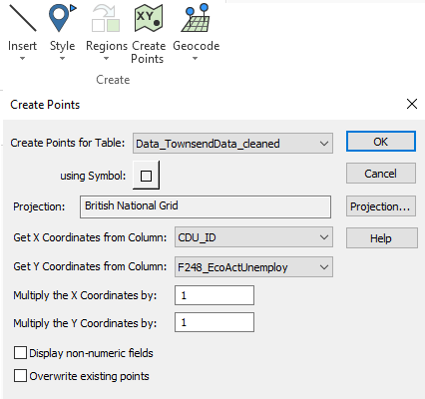
Another tool that was used for the creation of the map layer was to use the insert tool to create a physical drawing on the map using polygons. This was to create an visual aspect to allow people to easily see the schools locations and what is the school within the map, Image below.
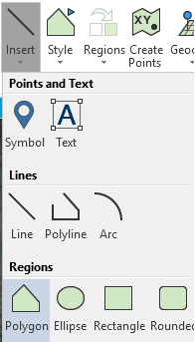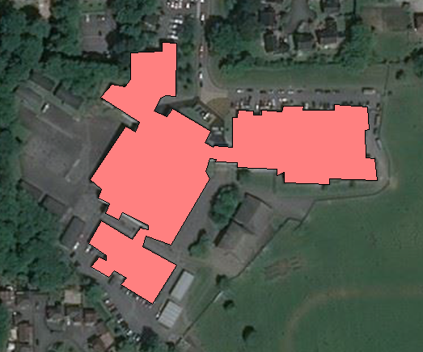

Using previous case Study/report, I have already gathered the immunization rate using [6]ukdataservice and Swansea boarders "Town and Index" table. So, by using this alongside the school locations and hospital data, therefore we can state areas with low immunization while informing parents and health professionals which areas / schools are likely to be affected the most and to act before the devastation of meningitis could take place. Below is a few screenshots of the layer theme built within the last case study and will be used to better visualize with the school and hospitals.
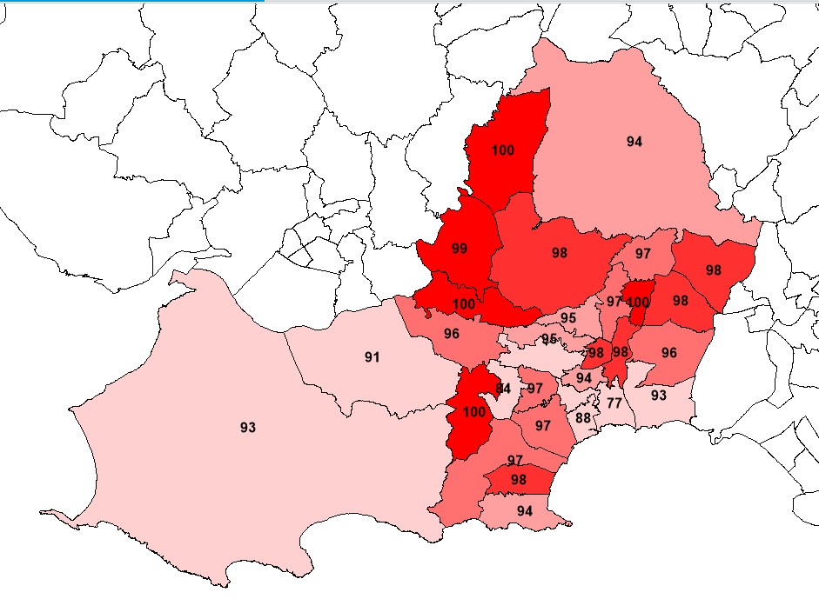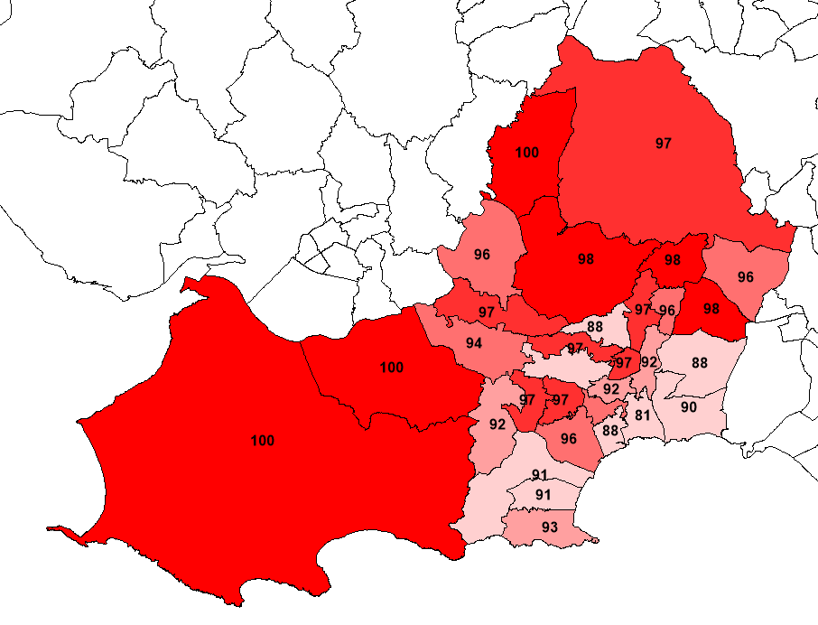
_{PNP_1_2018} _{PNP_2_2018}

Hospitals and school locations was gathered via [7]www.swansea.gov.uk/schoolcontactdetails which any relevant information about them was stored in the same table. I have had to assume a few comprehensive school’s student count due to there being no information on [7]www.swansea.gov.uk/schoolcontactdetails and on their own home school pages no continuing this, I have made these assumes by using the size of the area and my own experience of seeing the school sizes. From using MapInfo to create theses tables, I have used the "edit" tool alongside "point and test" drawing tool to draw an outline around each school and hospital to show their locations on the map, theses will become links or information pop ups when highlighted, showing their necessary information about it to show its relevant for example their address and or pupil size. Once complete, I was able to add a style to both schools and hospitals to ensure the user knows the difference, made labels to show which is school or hospital and could use the "Bing" map or "towns or index" background to show the areas of which they are in. Below are a few examples with a "Bing" map background and the others with "Towns and index" with immunization levels to give an idea of how it will look when on a working website:

Map_Original PNP_2_2018
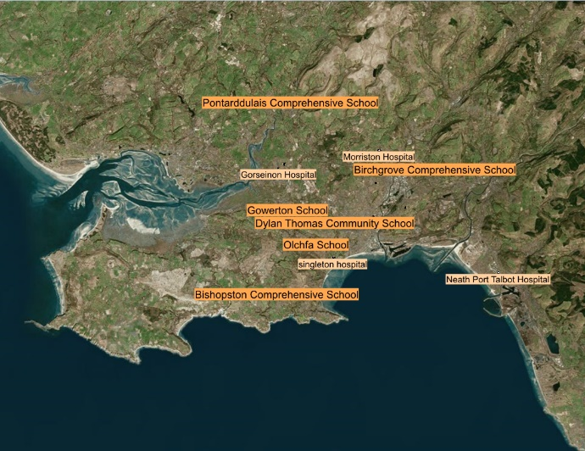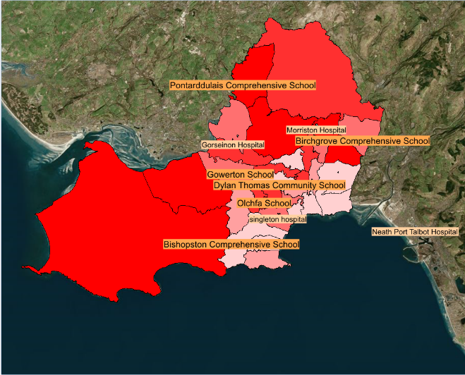
PNP_2_2017 PNP_2_2016
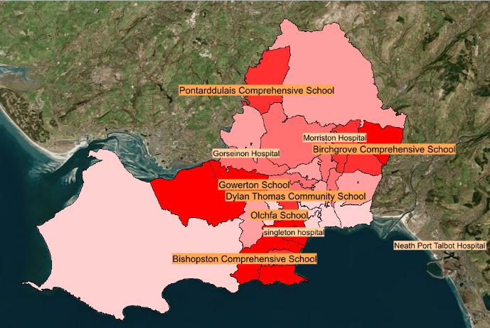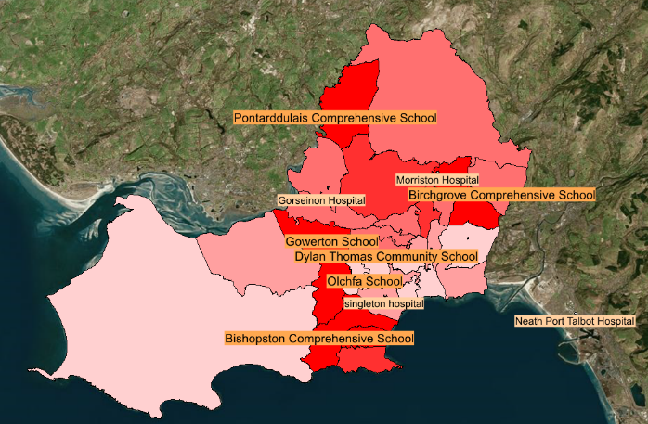
Key
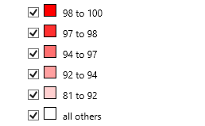
Within the images above, we can asses the data and create assumptions from the data. For example, from 2016 to 2018, immunizations have been getting better due to more red being shown. This shows more people are being influenced by the medical research and services such as the NHS.
The images above show that big city’s and towns had high immunization rate in 2016 however throughout the 2 years, it seems to have switched were big city’s and towns are lacking immunization.
Some schools within the photo Is at risk of low immunization and the research shown today should allow services such as the NHS target these area’s better and provide better knowledge and education. For example;
Pontarddulais Comprehensive school from 2016 to 2018 has been in a high immunization rate and therefore this school shouldn’t have a out break and between 2016 to 2018 more area’s around Pontarddulais has been getting higher immunization so the NHS shouldn’t need to focus on this school however others such as;

Dylan Thomas Community School should need attention by NHS due to the rates from 2016-2018 not improving not that and is not as high as other schools, this could lead to risks such as out breaks and people getting infected by viruses.
Overall most schools are within a location where the immunization is high enough and this is possibly due to the NHS doing their job correctly, however there is still improvements shown that the NHS could be doing.

5 Addon / Web Page
Using the addon that was supplied by the lecturer (HTML Image Map V3), this allowed us to provide a image of the current visible layer and have ‘hotspots’ that link to different pages. The image below is the plugin for MapInfo;
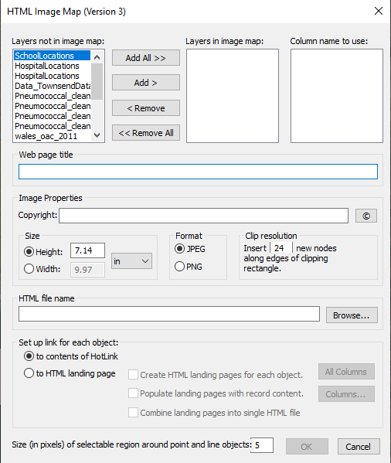
With the pages created and data exported from the selected tables (Hospitals and Schools). The pages were cleaned up and the hotspots were fixed.

5.1 Website
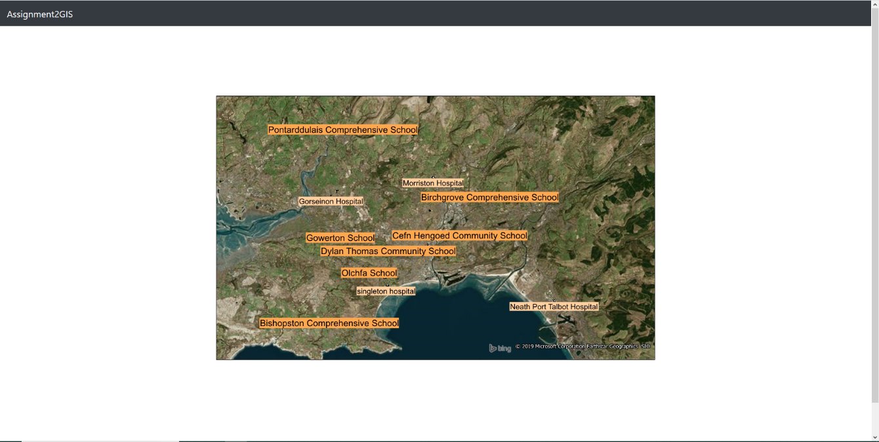
This is the main page of the website that allows users to see school and hospital name tags and can click on the tags to take them page specifically for the selected item. This allows users to navigate between schools and hospitals to get information of the selected hotspot. Using the MapInfo plugin exported everything, however the waypoint hotspots were broken so I used https://www.image-map.net/ To fix the current hotspots to work correctly with the map.

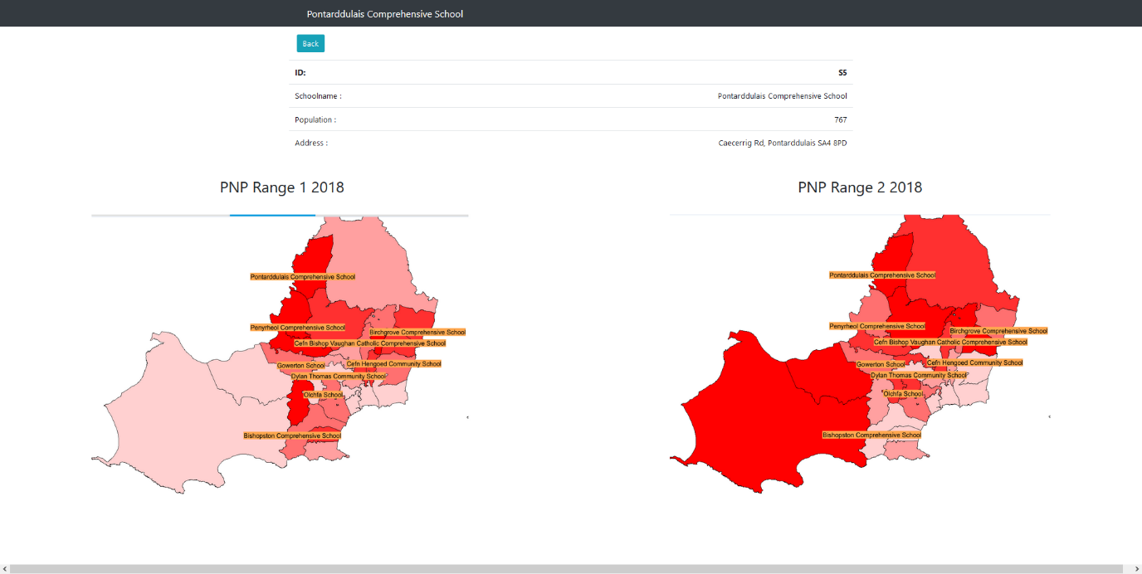
In the image above, this shows a selected hotspot ‘Pontarddulais Comprehensive school’. There is several information for this school such as the name, population and address. In this page, it also shows the current ranges for PNP ranges 1-2. This shows the all schools and the current one selected. This allows users accessing this website to see the immunization rate for the selected area.

[1] Ryan Goodrich, “Location-Based Services: Examples and Uses,” https://www.businessnewsdaily.com, 2013. [Online]. Available: https://www.businessnewsdaily.com/5386-location-based-services.html. [Accessed: 24-May-2019].
[2] techopedia, “What are Location Based Services (LBS)? - Definition from Techopedia,” techopedia.com. [Online]. Available: https://www.techopedia.com/definition/12888/location-based-services-lbs. [Accessed: 24-May-2019].
[3] The Manifest, “7 Examples of Location-Based Services Apps – The Manifest – Medium,” https://medium.com, 2018. [Online]. Available: https://medium.com/@the_manifest/7-examples-of-location-based-services-apps-82b8be3bdcac. [Accessed: 24-May-2019].
[4] “MapInfo® Pro - Desktop GIS | GIS Mapping | Pitney Bowes.” [Online]. Available: https://www.pitneybowes.com/us/location-intelligence/geographic-information-systems/mapinfo-pro.html. [Accessed: 26-Jan-2019].
[5] Map Info, “MapInfo® Pro - Desktop GIS | GIS Mapping | Pitney Bowes,” pitneybowes.com, 2019. [Online]. Available: https://www.pitneybowes.com/us/location-intelligence/geographic-information-systems/mapinfo-pro.html. [Accessed: 26-Jan-2019].
[6] uk dataservice, “UK Data Service,” ukdataservice.ac.uk, 2019. [Online]. Available: https://www.ukdataservice.ac.uk/. [Accessed: 26-Jan-2019].
[7] Gov, “Swansea - School contact details,” https://www.swansea.gov.uk, 2019. [Online]. Available: https://www.swansea.gov.uk/schoolcontactdetails. [Accessed: 24-May-2019].

