
COMMUNICATIoN AND MODELS
WRITING REPORT

ANDREA FERNANDEZ IGLESIAS
TEACHER: LLOYD

COMMUNICATION AND MODELS
The communication. It is a fascinating journey back in time, that began when a man blew animal horns, as my teacher said. It is an interesting topic because he shows me also how it started. Everything began with Electrical Technology in communication. When one of the biggest developments in communication came in 1831 when the electric telegraph was invented.

THE TELEGRAPH (Invented in 1831 by Henry Morse)
(He developed a code: Morse code in 1835)
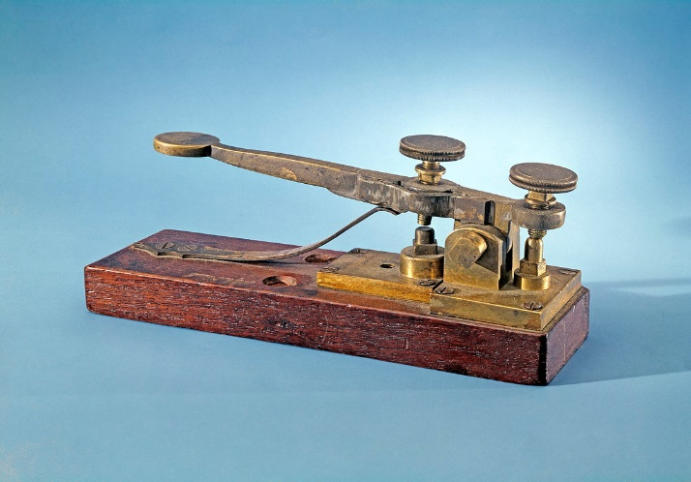

THE TELEPHONE (Invented in 1876 by Alexander Graham Bell)
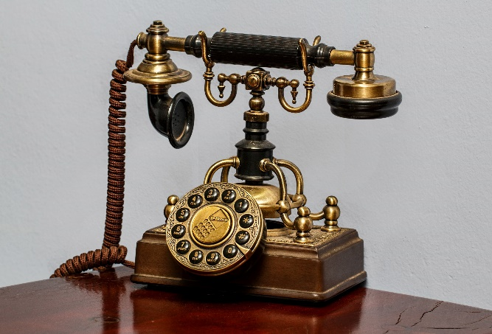

THE MOVILE PHONE (Invented in 1973 by Motorola)
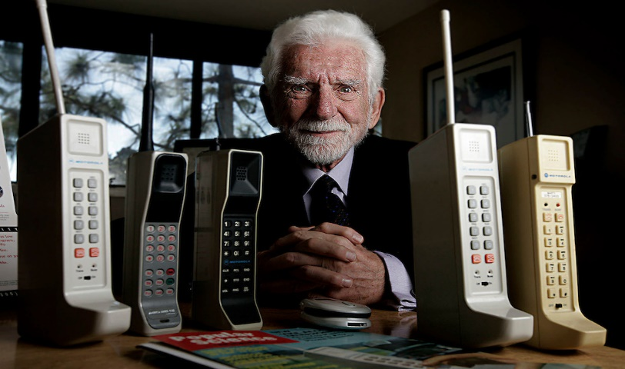

(In 2007 Steven Jobs revelated the first iPhone, “flip tones”, and phones with a split keyboard and screen were the norm)
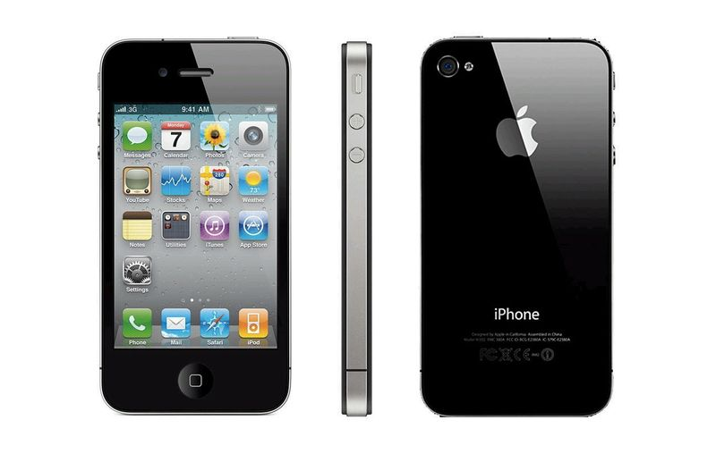
Esta foto de Autor desconocido está bajo licencia CC BY

MODELS
- The Shannon – Weaver mathematical model ( Invented in 1949)
- Schramm´s model of communication (Invented in 1954)
- Berlo´s model of communication (Invented in 1960)O HOW ARE Y
Hello my friend, how can I help you? Just tell me and I will do my best for you

THEORY
Information Source Transmitter Chanel Receiver Destination
Message
Receiver Signal
Message

SMCR
THE SHANNAN – WEAVER MATHEMATICAL MODEL (1949)
- SENDER
- MESSAGE
- CHANEL
- RECEIVER

THEORY
MESSAGE

THE SCHRAMM´S MODEL OF COMMUNICATION (1954)
MESSAGE
DECODER INTERPRETER & ENCODER
ENCODER INTERPRETER & DECODER

THEORY

SOURCE | MESSAGE | CHANNEL | RECEIVER
Communication skills | Content | Hearing | Communication skills
Attitudes | Elements | Seeing | Attitudes
knowledge | Treatments | Touching | Knowledge
Social system | Structure | Smelling | Social system
Culture | Code | Tasting | Culture
ENCODES
DECODES

THE BERLO´S MODEL OF COMMUNICATION (1960)

A communication model is a simplified representation of the communication process. Most models attempt to describe both verbal and nonverbal communication, often understanding it as an exchange of messages. Its function is to provide a compact overview of the complex process of communication. It helps researchers formulate hypotheses, apply communication-related concepts to real cases, and test predictions.
Despite their usefulness, many models have been criticized for being too simplistic because they omit essential aspects. The various components and their interactions are usually shown in diagram form. increase. Many models recreate some basic components and interactions. They involve the idea that a sender encodes information in the form of a message and sends it over a channel to a receiver. The recipient must decipher the message to understand the original idea and provide some feedback. In both cases, noise can interrupt and corrupt messages.

NONVERBAL COMMUNICATION SKILLS
Nonverbal communication skills are cues that transmit different types of information or express certain attitudes and emotions without apply to written or spoken language. It includes the use of body language to send specific messages and may include gestures, facial expressions, eye contact, etc. Nonverbal communication provides additional information, meaning, and cues beyond verbal communication.
NONVERBAL COMMUNICATION SKILLS
Nonverbal communication skills are cues that transmit different types of information or express certain attitudes and emotions without apply to written or spoken language. It includes the use of body language to send specific messages and may include gestures, facial expressions, eye contact, etc. Nonverbal communication provides additional information, meaning, and cues beyond verbal communication.
SEND A MESSAGE
Non-verbal communication helps us send messages without using verbal cues. For example, you can nod your head to show that you agree with what someone said.
MESSAGE OF SUPPORT
You can rely on your nonverbal communication skills to underline and emphasize what you say. For example, if you use hand gestures, you might indicate that you want your audience to remember a certain key point.
CONVEY INTENT
Nonverbal communication allows your audience to learn certain things about your emotions, whether intentional or not. For example, your audience may think you're excited when you keep smiling or annoyed when you make a serious frown.
PROVIDE HELP
Actions speak louder than words, and certain actions can help provide support. This can include a pat on the back or a simple nod.
CONVEY FEELINGS
Non-verbal communication skills allow us to express a wide range of emotions such as disappointment, sadness, happiness, contentment and relief.
INDICATES PREFERRED ACTION
Certain nonverbal cues, such as approaching a door to indicate a desire to leave or raising a hand to offer an idea, can help indicate desired behaviour. show individuality Nonverbal communication skills help you express who you are. For example, if you regularly offer a kind gesture or smile, it could indicate that you are kind and cheerful.
SHOWCASING PERSONALITY
Nonverbal communication skills help you express who you are. For example, if you regularly offer a kind gesture or smile, it could indicate that you are kind and cheerful.
DE-ESCALATING TENSION
Open body language, a friendly smile, a calm tone of voice, and any other direct gestures are some of the nonverbal communication skills that help resolve conflicts.

FORMS OF NONVERBAL COMMUNICATION SKILLS
- Movement
This includes how you move your legs, arms, or whole body to convey a specific kind of message. It may include anxious, sitting, standing, and walking slowly or quickly.
Example: Sit still and pay attention during the meeting to show that you are respectful.

- Emotional language
Emotional language includes different ways of positioning different body parts to suit emotions, environments, and situations.
Example: Cross your arms to show that you are scared or angry.

- Posture
This includes how you stand and sit. This reflects their professionalism, level of comfort, and general attitude towards conversations and people.
Example: Drop your shoulders to show that you are frustrated, tired, or disappointed.

- Space
Closing or extending the distance between you and others can help others point out a variety of things, such as B. The importance of the conversation, your feelings for them, your well-being, or even your desire to connect with or support them.
Example: Show your new contact that you respect their personal distance by standing a few feet away from them.

- Gestures
Gestures, both intentional and unintentional, can send different kinds of messages. They vary by community and culture.
Example: Give someone in the UK a 'thumbs up and tell them you agree with what they just did

- Eye contact
Using (or not using) eye contact is an effective way to show interest and attention.
Example: Make eye contact during the meeting, pay attention to what the other person is saying, and show that you are interested.

- Facial expressions
Facial expressions are very common and mostly unintentional, but they help convey certain information and emotions. This includes using eyebrows, facial muscles, mouth, and eyes.
Example: Open your eyes wide and raise your eyebrows to show your excitement.

- Touch
Touch is a powerful and helpful method of communication and is most often used to indicate comfort or support. However, it should only work if the other person agrees and should not be used to express negative emotions such as frustration or anger.
Example: Put your hand on your friend's shoulder to show empathy and support.
(Indeed, 2021)

VERBAL COMMUNICATION SKILLS

MARIA and PEDRO
Pedro works on a building site and Maria is his wife. One day Maria phoned Pedro.
‘Hello, Pedro, when you’re coming home, see if you can get me a chicken.’
‘Okay,’ replied Pedro.
When he got home, Pedro took off his boots and coat and went into the kitchen.
‘Maria, where are you?’ He spoke.
‘Here – in the sitting room,’ she said.
When Pedro went into the sitting room, Maria said, ‘Where is the chicken?’
‘What Chicken?’ Asked Pedro.
The one I asked you to get on your way home.’
Oh, no! I thought you said I will see you in the kitchen when I come home!
In this case, you can see how important is the step of “communication” and what happens when you do not work on it.

- Verbal communication occurs whenever words are used to convey information. This includes both written and spoken language, as well as sign language. Strong oral communication skills help you build confidence and build meaningful personal and professional relationships.

- The main purpose of verbal communication is to use words to convey information clearly and concisely.
2.1. The three most commonly used situations are:
Interpersonal communication, group discussion, and public speaking.
    - Interpersonal communication refers to people communicating directly with other people.
    - Group speaking refers to conversations between a relatively small number of people.
    - Public speaking involves one person presenting information to a large number of people.

HOW TO IMPROVE VERBAL COMMUNICATION SKILLS?
- Consider your message
- Recognize your audience
- Be mindful of your nonverbal communication
- Speak clearly
- Choose your written words carefully
- Practice active listening
- Think before you hit “reply”

POOR COMMUNICATION IN THE WORKPLACE
How to address it: Poor communication often occurs when there is a discrepancy between what is said and what is heard. In other words, the other person misunderstands what you are saying and understanding is no longer mutual.

WHAT CAUSES POOR COMMUNICATION IN THE WORKPLACE?
- Unconfirmed understanding: Ask questions to make sure they understand you clearly
- Poor communication skills: Good written communication in the workplace is grammatically correct, clear, concise, and professional.
- Lack of clear goals: Employee expectations should be communicated clearly and in detail. If your employees have specific goals, you can easily measure their performance and ask for improvement if necessary.
- Insufficient leadership: Great leaders confidently answer questions and seek out the resources they need when they do not know the answer.
- Remote communication: Without an in-person conversation, sometimes what is being communicated can get lost in translation.

EFFECTS OF POOR COMMUNICATION
Poor communication can have a lasting impact on productivity and performance at work.
- Unpredictable work environment
- Low morale
- Missed deadlines
- Workplace conflict

USE COMMUNICATION THEORY TO IMPROVE SUCCESS
Communication theory is a division of information theory that studies how information is transmitted between two groups of people. As with any scientific study, the process is simplistic, with only two people involved: the sender and the receiver. They send single messages to each other and travel through the medium. In reality, communication is much more complicated, but the basics obtained using this simplified mode are still valid.

- Air for verbal communication.
- Paper for written communication.
- Email for electronic communication.
COMMUNICATION THEORY STUDIES THE VERBAL FORMAL AND VERBAL INFORMAL TYPES OF COMMUNICATION EVER SINCE

Hello my friend how can I help you I do not even know how to name it
EXAMPLES OF BUSINESS COMMUNICATION
- Internal communication between colleagues 4. Customer relations
- Marketing communication 5. Advertising
- Marketing communication 6. Public relations
Hello I do not know what else put in here

COMMUNICATION ELEMENTS
- Source: This is what the sending side is trying to communicate.
- Message: The information, concept, or generally any communication.
- Sender: The person who encodes the source into a signal. Usually, this happens using a language, accepted by both parties. However, this is not necessary.
- Signal: This is what the Sender sends to the Receiver.
- Medium: This is where the Signal travels. It could be air, paper, the Internet, and so on.
- Noise: This is any interference over the Medium, which might cause the Signal to be distorted.
- Received signal: This is what the Receiver ultimately receives (potentially changed by Noise).
- Receiver: The person who decodes the signal into the Received message.
- Received message: This is how the Receiver decodes the received signal.
- Destination: Where the message is intended.

(Herrity, 2022)
(Quintanilla, 2020)
(duck, steve, 2021)

References
duck, steve, 2021. Communication in everyday life: a survey of communication. Fourth ed. Los Angeles: SAGE.
Herrity, J., 2022. Verbal Communication Skills: Examples and 7 Tips. s.l.:indeed .
Indeed, 2021. Nonverbal Communication Skills: Definition and Examples. s.l.:Indeed.
Quintanilla, K. M., 2020. Business and professional communication: KEYS for workplace excellence. Fourth ed. s.l.: SAGE.

