Kiri Smyllie 1908930,
Academic and Employability skills, BMSW4001
20 April 2020.

Title of Your Report
In this report I will be analysing my academic progression through term 1 to term 2. In this report i will be including any in class work i have produced, any skills i have learnt and how i would go on to apply them in a real life situation. I will include time management, analytical thinking, critical thinking, a personal development plan and a cv, I will then go on to explain how each mentioned topic can help build my skills and impact my future.

Time Management equals

Less stress,
Better solutions.

Better quality results.
Smyllie K, 2020.

What is time management and how is it effective?:
Time management is when you break your time down into sections to reach a stable goal in a set deadline. It is a key factor in any form of life. ‘Good time management enables you to work smarter – not harder – so that you get more done in less time.’ (What is time management?). When you learn how to time manage you instantly have a calmer way of life as many things aren’t rushed and you have time to edit or recreate your idea without failing your deadline. Many people use time management inside of the workplace as well as outside.

What is analytical thinking?
‘Analytical thinking is a critical component of visual thinking that gives one the ability to solve problems quickly and effectively. It involves a methodical step-by-step approach to thinking that allows you to break down complex problems into single and manageable components.’ (IQ Doodle). This is a skill I was personally glad to acquire. This skill is often confused with critical thinking and although similar they are two different types of thought process’.

Analytical thinking involves breaking down complex information into smaller parts while critical thinking involves taking outside knowledge into account while evaluating information. (The peak)

Smyllie K, 2020.

CRITICAL THINKING

ANALYTICAL THINKING

As i would like to own a nursery i find these skills to be crucial as i will be able to figure out any pros or cons that can arise. This also helps me when it comes to the planning side of my business as this will be able to help me think about all the internal and external factors I would need to open my business.

Analytical thinking would have me thinking about things such as costs, equipment needed, target audience, competition and how many staff members I would need to keep a nursery a float and legal. These are some of the key factors that would need to be identified when trying to own any business, by identifying and making a fully structured plan your business is more likely to go to plan and any inconveniences would have been thought about and can be reconstructed.
So what is critical thinking?
Critical thinking is a broader scale of thinking. It is an extra self assistance skill. It helps exclude irrelevant factors as assistance is sometimes questionable.
‘you don't simply accept all arguments and conclusions you are exposed to but rather have an attitude involving questioning.’ ( Study.com )
‘It requires wanting to see what evidence is involved to support a particular argument or conclusion.(Study.com)
This is a very diverse skill and can be used in many aspects of life. During life many unfortunate situations happen which are out of a person's control, critical thinking is something that is taught and not many people take it upon themselves to learn this skill.
‘A person with a good memory and who knows a lot of facts is not necessarily good at critical thinking. A critical thinker is able to deduce consequences from what he knows, and he knows how to make use of information to solve problems, and to seek relevant sources of information to inform himself.’ (C01)

I have learnt that critical thinking is a very reliable source when it comes to planning for future reference, for current situations and to help resolve any issues.
What is a cover letter?
A cover letter is a letter that will come be

What is a curriculum vitae?
A curriculum vitae (CV) is a page of content containing relevant background information to help an employer have an understanding of a future employee. This page will contain information such as your name, your phone number, email, any past job titles and character references that you may have acquired along the way. In a cv it is good to include any occasional hobbies, awards or extra information you may feel is relevant in a work environment. In a lecture we were asked to either create or recreate an updated version of a cv that met all of the current requirements. I found this task to be a very humbling experience and it is also an inspiring skill to have as you are putting yourself on display for another person to create a perception of you that should represent you accurately if executed correctly.

If you create an untrue perception for yourself for employers to see, it is important to understand these people will test your stated abilities and if you can not perform to certain demands then you will have a higher chance of having to restart your goals.
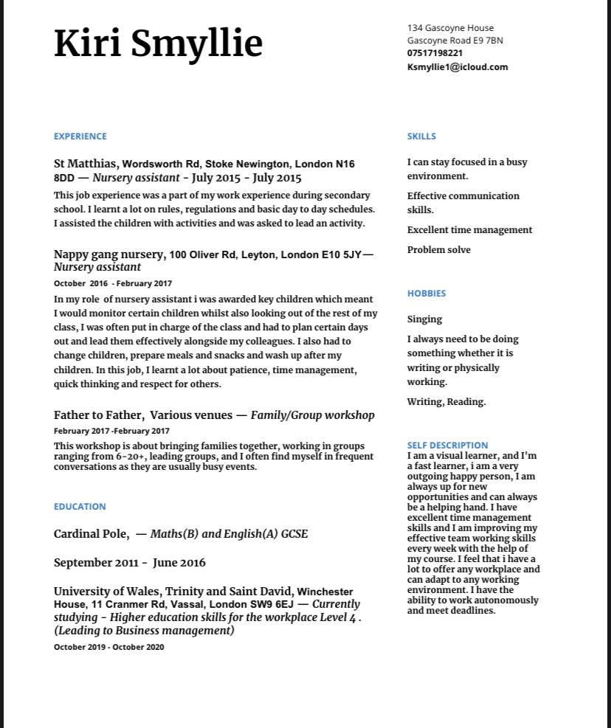

This is my current cv to date,in this cv i have expressed my skills and hobbies in hope to make my future employee have a grasp on my personality, my background, my main field of work and the area i am based in.

What is a personal development plan?
A personal development plan (also known as PDP) is very much what it says. It is a plan in which you acknowledge both strengths and weaknesses of an individual and aim to develop a plan of action which either consolidates strengths or reinforces weakness’. The aim of the plan is to help with progression in an individual's career, help with self reformations and help get a better understanding of how to progress.

Area of development:
Confidence: In the beginning of term 1 i felt very uncomfortable, i had no idea what to expect, how hard the work would be and how much time it would take to present my ideas.

How to achieve my goal:
Try to speak out more, when i am in lecture try to engage in the group conversations, which will help when it comes to the group work. Ask questions. What i do not understand: make sure it is understood to the best of my knowledge before leaving that current session.

Deadline for goal:
Mid of second term, i would like to be able to understand how the university
Operates and how I can adapt to my current environment to make it easier for me to stay focused and on track.

Reason for goal: I find it hard to concentrate when i'm constantly hiding away from things in a setting im trying to work in so by having confidence and speaking out i’m able to build relationships with people in my surroundings, making it one less thing to worry about and making it an easier work environment to produce high quality assignments.

Whilst doing this PDP I identified my weaknesses and found ways in which I can operate around them, whilst indirectly dealing with the issues at hand by not making them a priority. These will also help with my employability skills as I am able to identify and adapt to my current circumstances.

So what are employability skills?
Employability skills are the skills needed when trying to apply for a job, they are the skills that employers look for when they are contemplating hiring you and they also help them know what to expect. There are multiple types of employability skills.

Types of employability skills:

Problem solving: Problem solving is one of the main skills needed in any aspect of life. Without it, it would be very hard to get through day to day life. When you have the ability to problem solve as an individual or a group means that you are able to come up with many solutions to problems, which can also lead to new ideas.

Adaptability in this world is crucial, adaptability means you are able to compromise with any given situation handed to you and can still produce good results. In a workplace such as a childcare setting, being able to adapt is a main part of your job as children are constantly doing spontaneous things and it is a constant battle against drawing the line with safety and fun. I learnt that adaptability is walking into a classroom knowing nothing and leaving with a broad idea.

Written communication:
Written communication is a form of communication that is used across the world, it is important because many people use this type of communication to record a lot of things such as records, health information, secret data many people don’t even know about. For some people who can not speak written communication is one of the only ways to be heard. In a workplace it is important to have this skill because data that is incorrectly recorded can lead to incorrect conclusions, leaving a wide opportunity for a problem to arise.
By focusing on gaining employability skills and taking out time to understand the full structure behind what goes in to knowing oneself, you automatically learn how to productively turn a situation from good to bad, adaptation is always going to be one of the key skills I take from term 1 of my course until my end of time.

In my time of studying my academic and employability module I have realised a lot of life is about understanding certain concepts in timely matters, breaking down the situation carefully, analysing every single piece that has been taken apart, risk assessing everything and then slowly putting everything back together and adding your own adjustments. I have gained confidence by speaking out during lectures and receiving feedback and support from either my lectures or peers. I felt as if I did not fully understand what it took to present myself as someone who could confidently talk in front of anyone and feel like I was heard. I have learnt that a true team member is fair, and being able to work in a group is priority as many workplaces include working as a team. I was able to work on my written communication skills and I produced a curriculum vitae which was up to a standard I felt comfortable enough to now use as my personal go to cv.

Overall this module was very effective in teaching me what it takes to become an ideal team leader, team mate and a normal person. It helped me grow more into a person as I am presenting myself differently on a whole to feel more like the woman I grow to be everyday. This module was effective in making sure I knew how to understand the misunderstood, change my thought process and helped me become a better person in and out of the workplace.

Works Cited

https://www.mindtools.com/pages/article/newHTE_00.htm (What is time management.)
https://school.iqdoodle.com/framework/competencies/analytical-think/ (IQ Doodle)
https://thepeakperformancecenter.com/educational-learning/thinking/critical-thinking/analytical-thinking-critical-thinking/ - The Peak.
https://philosophy.hku.hk/think/critical/ct.php (C01).
https://study.com/academy/lesson/what-is-critical-thinking-definition-skills-meaning.html (Study.com)

