

Student name: Seletta Loreen Munroe
Student ID: 2332439
Module name: Changemakers: Building your Personal Brand for Sustainable Employment
Module code: BMHP5015
Lecturer name: Christopher Mafuva

Acknowledgement of AI tool use
I acknowledge the use of Grammarly (https://www.grammarly.com/) on 1st May 2026 to support to check my work using the prompt(s):
I confirm that I have not presented any AI generated text as my own work. I confirm I have copies of my drafts, notes, and other resources I used before, and after the use of AI tools which I may be asked to provide in evidence.

Introduction

A career in social work at Family Help requires a dedication to helping children, youth, and families as soon as they are in need. Early assistance is an essential component of the larger safeguarding system since the position focuses on offering both practical and emotional support to keep issues from getting worse and requiring statutory involvement. Through counselling, advocacy, and coordinated multi-agency support, Family Help practitioners collaborate with families to develop resilience, fortify connections, and encourage positive change. Strong communication skills, empathy, and the capacity to build trustworthy, nonjudgmental connections with people who could be going through stressful, uncertain, or vulnerable times are all necessary for this line of work. It also necessitates a thorough comprehension of child development, safety, and the societal determinants of family well-being. I am prepared for this role by expanding my knowledge, honing critical abilities, and participating in reflective practice as I advance in my academic studies and professional growth. My goal is to make a significant impact on families' lives by providing caring, empowering, and professionally grounded support.

- Job description: Social worker – Family Help

Report overview: This report will include skills analysis, self-evaluation, action plan, personal branding, my unique values.

Job description: Social worker (family Help/ support).
This is an exciting opportunity to make a genuine impact on the lives of children and families, while developing your career in a supportive, forward-thinking environment. You will be based in a dynamic community known for its cultural vibrancy, excellent facilities, and strong sense of belonging (Indeed, n.d).

Person specification analysis:
- Qualified Social Worker degree (BA/MA Social Work, Diploma in Social Work, or equivalent).
- Social Work England registration.
- Excellent communication, assessment, and report-writing skills.
- Ability to work effectively both independently and as part of a multi-agency team.
- Work in partnership with local agencies, schools, and healthcare professionals to safeguard children and promote positive change.
- Strong knowledge of relevant legislation, statutory guidance, and best practice in safeguarding.
- UK family/children Social Work: 2 years (required). (Indeed, n.d).

Skill requirement for the position:

Assessment and Intervention: Carry out comprehensive assessments to identify the needs of children and families, ensuring their safety and wellbeing.
Develop, implement, and review care plans in collaboration with children, families, and partner professionals.
Therapeutic Communication: Provide therapeutic interventions and support to children and families to achieve positive outcomes.
Previous experience: Working with children, young people, and families in a statutory setting.
Interpersonal and Communication Skills: Offer advice, guidance, and practical support to families and carers, connecting them with community resources. Indeed, (n.d)

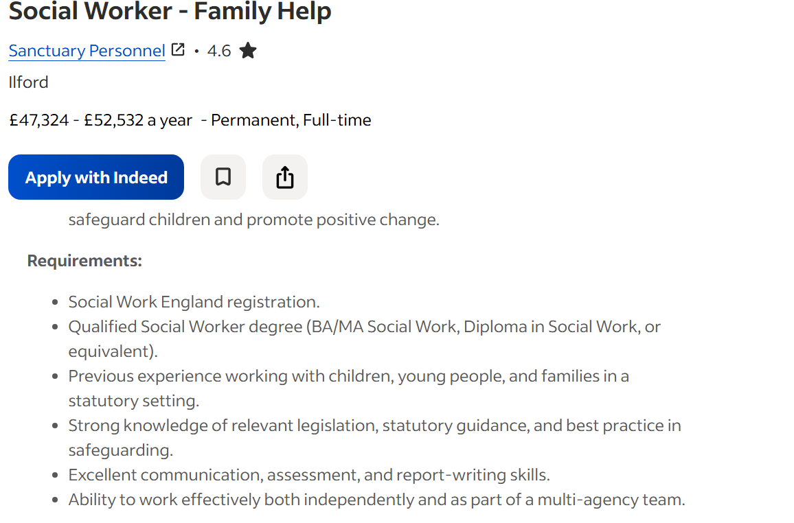

- Analyse the skills needed for the job and assess your skills and experience

The key employability skills, for the role the role of Social Worker in Family Help includes.

Since communication skills have a direct impact on the quality of interactions and results in child protection and family social work contexts, they are crucial for social workers who help families. Effective communication requires empathy because it lowers client resistance and enhances information sharing without sacrificing the clarity of social workers' concerns (Forrester, D. et al. 2008).

Ethical practice & professionalism:

A thorough understanding of pertinent laws, statutory guidelines, and safeguarding best practices.
For social workers assisting families, professionalism and ethical practice are crucial because they enable them to resolve difficult moral dilemmas that arise during professional interactions. (Gómez-García, R., Lucas-García, J. and Bayón-Calvo, S. 2022).

Self-Reflection of My Own Skills

I used a SWOT analysis reflection as a self-assessment method to evaluate my own abilities. To direct professional development, I had to conduct a structured reflection on my strengths, shortcomings, opportunities, and threats in my prior personal development plan, class term 3, level 4. I was able to determine my present competencies and areas for development with the aid of this method. (Hopen, D, 2019).

Strengths:

I greatly improved both my academic writing and communication skills during my Level 4 and 5 Health and Social Care courses. I was able to improve my capacity to communicate ideas effectively, coherently, and professionally by working on challenging assignments, case studies, and reflection exercises. I gained knowledge about how to utilise correct vocabulary, organise reports, and modify my writing style for various audiences.

Weaknesses:

It is difficult for me to continue my education to finish my degree because it calls for juggling the demands of my studies with my personal obligations and professional growth. Managing deadlines, difficult academic material, and consistent motivation can occasionally feel overwhelming. particularly in areas like reflective analysis, report writing, and assessment.

Opportunities:

My Level 4 and Level 5 courses helped me enhance my writing and communication abilities, which opened several options for me to advance professionally in social care. My ability to create excellent evaluations, case notes, and reports is supported by my strong written communication skills. This improves my chances to take on increasingly challenging coursework, finish my degree, and advance into placements.

Threats:

Several outside obstacles could hinder my growth as I continue to strive for a career in social work and family assistance. As I juggle university work, jobs, and personal obligations, one possible threat is the rising academic and professional requirements put on social care students.

Health and social care related experience and qualifications

Disability Awareness Course (Completed)

My comprehension of equality, inclusiveness, and the many needs of people with physical, learning, and sensory disabilities has improved after completing a disability awareness course. This experience encourages person-centred practice and helps me work with service users in a sensitive manner.

Level 4 Certificate in Health and Social Care

My Level 4 qualification gave me a solid understanding of professional values, regulation, communication, safeguarding, and reflective practice. Additionally, it improved my critical thinking, academic writing, and comprehension of the ethical obligations in care settings.

Safeguarding Training Certificate

This credential attests to my knowledge of safeguarding obligations, which include identifying abuse indicators, comprehending reporting protocols, and upholding professional boundaries. Roles involving children, families, and vulnerable adults require it.

Completion of Level 5 Module(s)

Completing Level 5 courses demonstrates advancement into more challenging coursework, such as evidence-based practice, leadership, complicated case analysis, and evaluation techniques.

- Development of personal skills and resources

Building my personal brand

Through the lens of professional identity, which includes how people view themselves and are viewed by others in their professional positions, the idea of personal brand for social workers in family assistance may be comprehended. Personal characteristics, ethics, ideals, and the social environment in which a professional works are all part of professional identity. The incentives, rewards, and tactics that sustain social workers' long-term involvement and contentment in the field of child and family services are likely to be reflected in their personal brand. (Thoburn, J. et al. 2021).
- LinkedIn.
- Skills for Care Learning Hub
- Webinars, conferences, and industry events
- Professional forums and networks. (Royal college of nursing, 2026).
Brand elements: My empathetic approach, my enthusiasm, and my interest in child advocacy are the main components of my brand that I wish to highlight. Empathy allows me to comprehend the lived experiences, feelings, and viewpoints of children, families, and individuals, empathy is a key component of both my professional identity and personal growth.
My dedication to advancing justice, rights, and favourable results for the individuals I work with is reflected in my advocacy.

My unique selling point (USP)

Strong communication skills, specialised training, and consistent academic success all contribute to my USP. I can clearly convey information, establish rapport, and modify my communication style to suit the requirements of kids, families, and professionals because I am a skilled writer and communicator. My capacity to operate inclusively and recognise the various needs of people with physical, learning, or sensory disabilities is strengthened by completing disability awareness training. While my safeguarding training certificate attests to my ability to identify and address concerns about danger or abuse, my level 4 certificate in health and social care offers a strong foundation in safeguarding, legislation, professional principles, and reflective practice. Furthermore, finishing Level 5 modules demonstrates my advancement into more challenging coursework.

Resources needed to attain the skills required for the job role of social worker family help.

- Financial resources: University course fees
- Time commitments
- Access to mentors, and experienced professionals
- Practical experience: Volunteering roles
- Information resources: Academic journals, professional body publications.

Communicating my skills to potential employers

I show how my Level 4 and 5 Health and Social Care training, knowledge of safety, and awareness of disabilities enable me to work with children and families with confidence. I have strong verbal and writing communication skills, and I can modify my style to establish credibility and effectively convey information. My ability to build strong relationships and comprehend the needs of families is aided by my abilities in empathy, approachability, and advocacy. All these abilities and traits make me a good fit for the position of social worker or family helper.
- Action Plan and Timeline

Action Plan and Timeline for Developing My Skills (1‑Year Plan + Long‑Term Milestones)
Safeguarding Training Renewal (Ongoing Professional Requirement)
Action: Maintain up‑to‑date safeguarding knowledge by renewing training every three years.
Purpose: Ensures safe, lawful, and ethical practice when working with children, families, and vulnerable adults.
Specific: Renew safeguarding training every three years to meet professional standards in social work and family help.
Measurable: Renewal years: 2025 → 2028 → 2031 → 2034 → 2037, continuing in three‑year cycles.
Achievable: Only one accredited course is required every three years, widely available through approved providers.
Relevant: Safeguarding is essential for anyone working with vulnerable individuals and is central to safe practice.
Time‑Bound: Each renewal must be completed by June of the renewal year (2028, 2031, 2034, etc.) (Ochieng and Ward, 2018).

Projected Timeline for Completing My Degree (2026–2027)

Action: Complete all remaining undergraduate modules, assessments, and placement requirements.
Specific: Finish all remaining academic and placement components between 2026 and 2027, progressing through each semester without resits or extensions.

Measurable:

- Passing all modules
- Submitting assignments on time
- Completing placements
- Receiving regular feedback from tutors
- Tracking progress through a study planner
Achievable: I already have strong foundations from Level 4 and Level 5 studies, including communication, safeguarding, disability awareness, and academic writing. Time‑management strategies and structured study plans will support this goal.
Relevant: Completing my degree is essential for progressing to a master’s programme and achieving my long‑term goal of becoming a qualified social worker or family help practitioner.
Time‑Bound: Degree: Completion planned for mid‑2027. (Ochieng and Ward, 2018).

- Communication of skills to potential employers
Curriculum vitae:
I will customise my resume by emphasising the abilities, expertise, and experiences that are most pertinent to the position of family help practitioner or social worker. To accomplish this, I will carefully go over the job description and determine the essential talents that employers are seeking, such as communication skills, knowledge of child development, awareness of safeguarding, and the capacity to cultivate strong relationships with families. After that, I'll make sure these abilities are prominently displayed in the "Key Skills" section at the top of my resume.

Cover letter:

I have a strong desire to encourage families and children to make positive changes by providing early intervention help. My Level 4 and 5 Health and Social Care training equipped me with good communication skills, awareness of safeguarding, and inclusive practice. I can establish trust and collaborate with families because of my talents in advocacy, empathy, and approachability. I am dedicated to enhancing outcomes for children who are at risk and providing a professional, person-centred approach.

Interviews:

By outlining a situation I was in, the task I had to finish, the actions I took, and the outcomes I attained, I will use the STAR method to clearly demonstrate my abilities. Employers can see how I use my problem-solving, communication, empathy, and safeguarding awareness abilities in practical settings thanks to this methodical approach.

Professional platforms

My enthusiasm for helping children and families, my Level 4 and 5 Health and Social Care training, and my main abilities in empathy, communication, and advocacy will all be highlighted in my professional LinkedIn profile, which will represent my personal brand.
- Conclusion
In conclusion, early intervention, protection, and helping families develop resilience and effect good change are the main goals of the social worker's role in Family Help. Social workers analyse needs, establish trusted connections, and collaborate with multi-agency partners using evidence-based practice, professional curiosity, and excellent communication skills. This position is based on ethical decision-making, child-centred practice, and a dedication to advancing safety and wellness. All things considered, Family Help social workers are essential to improve outcomes for children and families and reduce escalation into statutory services. (Turney, D. and Ruch, G. et al. (2018).
Excellent writing and verbal communication, knowledge of safeguarding, awareness of disabilities, and successful completion of Level 4 and Level 5 courses are just a few of my strong professional capabilities. These abilities provide a strong basis for my future job in family assistance and social work. At the same time, I'm determined to address my areas for improvement by aggressively seeking out regular input from supervisors, mentors, and peers.

References
Department for Education (2023) Stable Homes, Built on Love: Implementation Strategy and Consultation Response. Available at: https://www.gov.uk/government/publications/childrens-social-care-stable-homes-built-on-love (Accessed: 30 April 2026).
Forrester, D. et al. (2008) “Communication skills in child protection: how do social workers talk to parents?” Child & family social work, 13(1), pp. 41–51. Available at: https://doi.org/10.1111/j.1365-2206.2007.00513.x. Accessed 30 May 2026
Gómez-García, R., Lucas-García, J. and Bayón-Calvo, S. (2022) “Social workers’ approaches to ethical dilemmas,” Journal of social work: JSW, 22(3), pp. 804–823. Available at: https://doi.org/10.1177/14680173211010251. Accessed 30 May 2026
Hopen, D. (2019) “A Tool for Competency Identification and Development,” The Journal for quality and participation, 42(2), pp. S1–S3. Accessed 30 May 2026
Indeed, (n.d). Social Worker - Family Help; Available at: https://uk.indeed.com/viewjob?jk=7297e4b62140463e&from=shareddesktop_email Accessed 27 April 2026
Motlhaka, H. (2020) “Blackboard Collaborated‑Based Instruction in an Academic Writing Class: Sociocultural Perspectives of Learning,” Electronic journal of e-Learning, 18(4), pp. 337–346. Available at: https://doi.org/10.34190/EJEL.20.18.4.006. Accessed 30 May 2026
Ochieng, B. and Ward, K. (2018) “Safeguarding of vulnerable adults training: assessing the effect of continuing professional development,” Nursing management (Harrow, London, England), 25(4), pp. 30–35. Available at: https://doi.org/10.7748/nm.2018.e1781.
Royal college of nursing (2026) “Networking” Available at: https://www.rcn.org.uk/professional-development/your-career/networking
Social Work England (2023) Professional Standards. Available at: https://www.socialworkengland.org.uk/standards/professional-standards (Accessed: 30 April 2026).
Thoburn, J. et al. (2021) “LOOKING BACK- LOOKING FORWARD: MESSAGES FROM EXPERIENCED SOCIAL WORKERS FOR THE RECENTLY QUALIFIED,” Pedagogía social, (38), pp. 151–163. Available at: https://doi.org/10.7179/PSRL2021.38.10. Accessed 30 May 2026
Turney, D. and Ruch, G. (2018) ‘Thinking about thinking: Using theory to support reflective practice’, Child & Family Social Work, 23(1), pp. 1–9. Available at: https://onlinelibrary.wiley.com/doi/full/10.1111/cfs.12397 (Accessed: 30 April 2026).

