DS1: My Digital Life
Student Name: Kristyna Demeterova
Student ID: 2619528

Screenshot/Photo 1
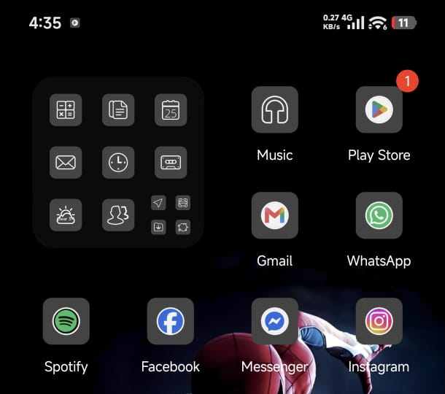
These are my phone apps for daily communication and learning. All of these apps help me to improve my digital skills and communicate with others.

Screenshot/Photo 2
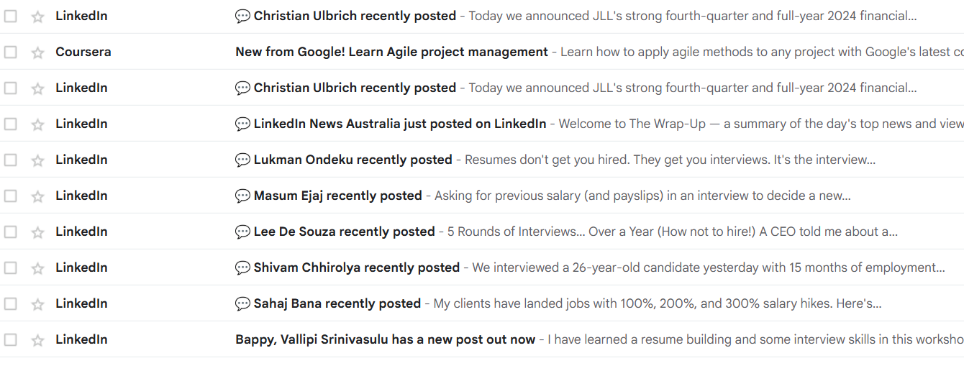
I use email for my academic and personal purposes regularly. For example, I use email to communicate formally with my teachers.

Screenshot/Photo 3
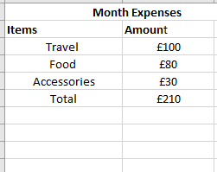
I use Excel sheets to calculate and monitor my monthly expenses. I frequently use the SUM function in Excel to calculate my expenses.

Screenshot/Photo 4
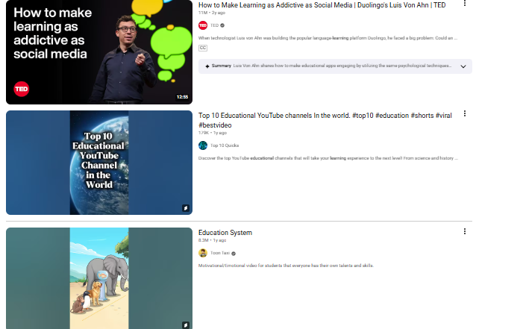
I watch YouTube videos and reels to enhance my academic knowledge and skills. For example, I learned the basic functions of Excel through YouTube. This improved my digital skills.

My Short Reflection
In my daily life, I use different digital tools and software services to improve my knowledge and communicate with others.
I am confident in using my phone to communicate with others and search for different information to develop academic knowledge.
I use WhatsApp and Email to communicate with my teachers, and it makes me more engaged in learning.
I feel it is challenging to do advanced functions in the MS Excel sheet and I need to improve it.
I use YouTube to learn different learning skills, and I visit channels of famous academic YouTubers to gain knowledge.
Sometimes I visit my Email account to know about promotional campaigns, and it improves my purchasing decisions.
I have a chat group on WhatsApp with my friends and family.
Sometimes I feel confused and tense about using different digital tools due to concerns about data leakage and misuse.
So, I sought support from my teacher about digital tools and technology to use them in proper ways for better security and accessibility.
As a student of higher level, digital tools and platforms make me more flexible and engaged in learning. They help me improve my digital skills.

Submission Checklist
Before you submit, please check:
​​​ ☒ I added 4–6 screenshots
☒ I wrote short sentences for each screenshot
☒ I wrote my short reflection
☒ My work is my own
☒ My file opens correctly
​​☒ My file opens correctly

