Title – Driving change and building business cases.

Research Tile - The aim of the research project is to analyse the relationship between sickness absence and mental health related sickness absence in Natural Resources Wales (NRW) and to provide solutions to any trends or areas of concern.

Name – Charlotte Morgan

Student number - 2217650

CIPD number - 85352796

Word count- 3,163

Introduction
The management of sickness absence in any organisation, is essential to the monitoring of trends and to address any areas of concern. Natural Resources Wales (NRW) are no different to other companies, in that the review and analysis of sickness absence has to be undertaken. It must be viewed as a positive way to monitor data and improve the health of the business and assist staff in their working life.
It is essential to have correct and current sickness absence data to ensure NRW have the ability to recognise and highlight any areas of concern, so that effective resolutions can be taken to support the employee and the business service provision. (CIPD, 2023)
17.0 million days were lost in the UK due to employees suffering with stress, depression or anxiety due to work related reasons. (HSE, no date)
Self-reported work-related ill health which covers stress, depression or anxiety has seen an increase in recent years, this was also noted prior to the Covid pandemic.(HSE, no date)
Every organisation has to be ensured that the sickness absence process that has been implemented is fit for purpose and must care and assist with any employees that have any health concerns which may require increased absence from work. For employees who have long term health issues, NRW must comply with numerous legislative requirements in order protect those staff who are at risk due to long term health conditions and disabilities. The Equality Act 2010 covers the rights of employees and was made law to avoid all the different types of unlawful discrimination towards an individual. The Health and Safety at Work etc Act 1974, also ensures that the employee is protected under their health, safety and welfare, so providing as far as possible with risk they might incur in their job. (HSE, no date)

Literature review
Sickness absence remains a concern for most organisations, especially in the public sector. The Covid pandemic will have had an impact on the data, which was understandable due to the symptoms and legal restrictions that were in place. (ONS, 2022)
There are many legal aspects that must be adhered to for the organisation to be legally compliant, if this is not fulfilled, there could be serious consequences, in terms of financial and reputational damages. (HSE, no date)
Mental health related sickness absence has been increasing overtime in NRW and in the public sector with this being the largest cause of days lost. (GOV, 2022)
The Health & Safety Executive (HSE) focuses on work related mental health and there is a legal duty to protect employees if they are affected by the work they undertake. The HSE requires organisations to undertake a stress related risk assessment, if an employee shows signs of stress at work, which covers 6 management standards that can contribute to the work-related issues. (HSE, no date)\
Mental health is about how we reason, reflect and perform in our personal and working lives. It can be as a result of an incident that has happened such as bereavement but can be caused by actions at work. These could be the workload, the relationships in the team or with the line manager, however they must be assessed and actions implemented to support the employee. (HSE, no date)
In 2021, it was reported that 76% of businesses have recorded staff that have been away from work due to stress in that past year and that organisations need to expand and progress their offering for the wellbeing of their staff. (Mental health at work, 2021)
It is important that organisations do as much as possible to reduce the stigma associated with mental health, in their workplace. If an organisation fosters a positive approach to mental health, then it will improve their own business performance. (Davies, 2020, p 1)
An independent review requested by the prime minister in 2016, highlights the importance for organisations to manage the mental health in the workplace. It gathers data on the current situation, but also looks forward to what organisations can do to better understand the issues with mental health. It illustrates what organisations can do to better support staff who are struggling at work and those who are absent from work and focuses on the human cost of mental health and the impacts on those around the individual. (GOV, 2017).
Organisations that raise awareness of mental health, whether it be work related or personal and introduce tools and supporting information to both management and staff will reap the rewards of their proactive approach. This can be in the form of increased morale between employees, showing due care towards their employees which will improve the image of the organisation to attract more staff. (IOSH 2023).

Businesses that encourage openness and a safe place for employees to be honest about their mental health is important, these environments do not happen overnight but are build over time and the organisation will benefit in many ways. (Hasson and Bulter, 2020, p.35)
One area where the management of mental health in the workplace can be improved, is investing in the training of managers in mental health awareness. This training will provide managers with the skills and knowledge to address any concerns and to support the employee at an early stage, rather than the employee becoming absent from work due to mental health reasons. (NICE, 2021).
Businesses that positively acknowledge how employees’ mental health within the business can be supported, will be in a far more confident and advanced state to assist employees and in turn will reduce the associated costs of the management of mental health related sickness absence. (Hennekam, 2021, p.2).
The introduction of additional tools to support team leaders/line mangers can incur additional costs of the organisation especially at a time when the cost-of-living crisis is hitting business and may be seen as an added pressure that cannot be supported. However, the cost of sickness absence in term of mental health will outweigh this expense. (Deloitte, 2022).

Methodology
For the research project, a questionnaire was developed to gather the primary data that was needed to complete the aim of the assignment. The questionnaire was designed via the Microsoft forms. This a web- based application to enable questionnaires to be developed and sent out in an electronic way. Questionnaires via this method are easy to produce and manage and with the use of the on-line system to gather to the data, it is a simple and effective method. (Hannington and Martin, 2018, p.136).
The Microsoft forms are widely used in NRW and team leaders/line managers are aware of the use of these forms and these are utilised as part of their daily work.
The sheer nature of the work activities that NRW undertake, requires site working across a wide geographical area. With over half the team leaders/line mangers working on site for a vast amount of their working week, the questionnaire has to be in an electronic format. NRW, even prior to the Covid pandemic, issued all staff with laptops, tablets and or smart phones. All team leaders/line managers have laptops, tablets and a smart phone, so the ability to access the questionnaire was not an issue as the electronic devices were available.
The Microsoft forms facility will have made it easier and quicker for those team leaders/line managers who are on site to take part in the survey and feel they are being included.
The use of the questionnaire was by far the most effective method to gather information rather than arranging interviews/group sessions, as some team leaders/ line managers do not have the time to attend due to working off site, so this would be more time consuming for them. Also, as the interviews sessions would result in the team leader/line manager being absent from day-to-day work duties, this has a cost implication to the business. (Oltmann, 2016, p.3)
Thus, they are more likely to participate in the project research. Also, as the research project was undertaken during the summer months, many team leaders/line managers will be trying to fulfil their working tasks as well as covering other areas due to annual leave commitments and would not be able to attend workshops to provide the information needed, so the Microsoft forms was the best option for this project at this time.
A negative point of the use of the questionnaire, is that some team leaders/line managers will ignore the email and then not complete the questionnaire. (Business Research Methodology, no date). In order to reduce that happening, an email was sent prior to the questionnaire explaining the purpose of the survey and requesting their support to improve the situation.
The Health and Safety manager at NRW receives the sickness absence data on a monthly basis and is part of the Executive Board quarterly meetings where sickness absence is discussed.

viewer context are time and financial.
costs. Several authors note that face-to-face interviewing can accrue substantial.
time and financial expenses, due to the need to travel to respondents, as the
universal advice is to make the respondent comfortable by conducting the
viewer context are time and financial.
costs. Several authors note that face-to-face interviewing can accrue substantial.
time and financial expenses, due to the need to travel to respondents, as the
universal advice is to make the respondent comfortable by conducting the
Findings
NRW Top 5 Absences Reason for Rolling Year | Number of days | Absence days %
Stress, anxiety & mental health | 4788 | 36.46%
Coughs, Cold & Flu | 1912 | 14.56%
Infections, viruses, and diseases | 1156 | 8.80%
Musculoskeletal, function of joints and bones | 923 | 7.03%
Stomach, intestinal and digestive conditions | 839 | 6.39%
No Reason Entered | 207 | 1.58%
All Other Reasons | 3307 | 25.18%
Total | 13132

NRW Top 5 Absences Reason for Rolling Year | Number of days | Absence days %
Stress, anxiety & mental health | 4788 | 36.46%
Coughs, Cold & Flu | 1912 | 14.56%
Infections, viruses, and diseases | 1156 | 8.80%
Musculoskeletal, function of joints and bones | 923 | 7.03%
Stomach, intestinal and digestive conditions | 839 | 6.39%
No Reason Entered | 207 | 1.58%
All Other Reasons | 3307 | 25.18%
Total | 13132
NRW Top 5 Absences Reason for Rolling Year | Number of days | Absence days %
Stress, anxiety & mental health | 4788 | 36.46%
Coughs, Cold & Flu | 1912 | 14.56%
Infections, viruses, and diseases | 1156 | 8.80%
Musculoskeletal, function of joints and bones | 923 | 7.03%
Stomach, intestinal and digestive conditions | 839 | 6.39%
No Reason Entered | 207 | 1.58%
All Other Reasons | 3307 | 25.18%
Total | 13132
NRW’s absence data is collected, recorded and stored on an internal human resource system – MY NRW. To record sickness, the line manager has to search for the staff member who has reported sick, in MY NRW and then input the requested information regarding the absence, as in the first day of sickness and choose from a drop-down list for the reason for the sickness, e, g flu/mental health/ stomach related. Then the employee completes their return date once back at work.
The below graph illustrates the sickness absence percentage rate for NRW for the years - April 2020 – March 2021 - April 2021 – March 2022 and March 2022 – April 2023.

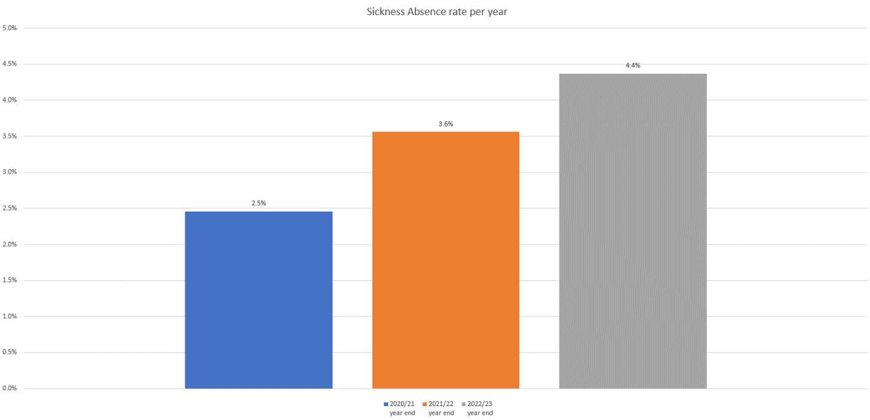

NRW sickness rate percentage is rising year on year, whilst COVID will have impacted 2021/2022, it is unlikely that this will have impacted 2022/2023.
In 3 years, there has been a 1.9% increase in the sickness absence rate from 2020/2021 to 2022/2023.
Data shows that the UK labour market’s sickness absence has risen to 2.2% in UK, compared to a recorded low of 1.8% in 2020. (ONS, 2021).
Public sector sickness rates still remain higher than those in the private sector, with 3% whilst the private sector recorded 1.9%. (People Management, 2022).
At some point 1 in 4 people will be affected by mental health issues and will undoubtedly have an effect on their working lives and that of the organisations they work for. It can be noted that mental health is the main reason for long term sickness absence from work and so businesses need to manage this concern and provide effective methods for their employees’ wellbeing. (CIPD, 2023).
There is a category for mental health sickness absence data on MY NRW, which is grouped as stress/mental health/depression.
NRW Top 5 Absences Reason for Rolling Year | Number of days | Absence days %
Stress, anxiety & mental health | 4788 | 36.46%
Coughs, Cold & Flu | 1912 | 14.56%
Infections, viruses, and diseases | 1156 | 8.80%
Musculoskeletal, function of joints and bones | 923 | 7.03%
Stomach, intestinal and digestive conditions | 839 | 6.39%
No Reason Entered | 207 | 1.58%
All Other Reasons | 3307 | 25.18%
Total | 13132

NRW Top 5 Absences Reason for Rolling Year | Number of days | Absence days %
Stress, anxiety & mental health | 4788 | 36.46%
Coughs, Cold & Flu | 1912 | 14.56%
Infections, viruses, and diseases | 1156 | 8.80%
Musculoskeletal, function of joints and bones | 923 | 7.03%
Stomach, intestinal and digestive conditions | 839 | 6.39%
No Reason Entered | 207 | 1.58%
All Other Reasons | 3307 | 25.18%
Total | 13132
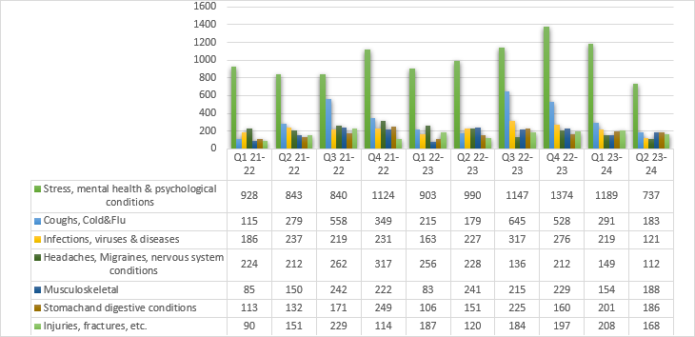
The breakdown of sickness absence in NRW as illustrated above, shows the total days lost per quarter, but only covers the period 2021/2022 and 2022/2023, as this is when the reason for sickness absence was being assessed.
Mental health related sickness absence has been the highest and main cause of sickness absence in NRW since the breakdown assessment started. The highest peak of mental health related sickness absence can be noted in quarter 4 in 2022/2023, with a slight decrease in the first quarter of 2023/2024. It can be viewed that quarter 4 in 2021/2022 was also high with a slight decline in the next quarter. This is in line with the Civil Service absence data for 2021, with 40.8% being the main cause of the sickness. (GOV, 2022).
There is no sub-section functionality on MY NRW for a line manager to indicate if the mental health sickness absence is personal, work related or a combination of both. The data produced via the system will show the figures of mental health sickness as a whole.
Therefore, no reports can be generated from the system to provide the breakdown of the reason for the mental health sickness absence, so NRW cannot use this information and therefore unable to highlight any trends nor can any areas of concern be addressed, such as workload, burnout, etc.

The following questions were asked via the Microsoft forms.
Q1: As a team leader/line manager have you managed sickness absence in relation to mental health (Personal or work related or both).
146 team leaders/line managers responded to the questionnaire that was emailed out to gather information for the research project. There are 210 team leaders/line managers in total employed in NRW. This resulted in a 69.5% response to the questionnaire.

80% of the respondents acknowledged that as a team leader/line manager has dealt with sickness absence within their teams in relation to mental health. This shows that a vast number of team leaders/line managers in NRW have had experience in managing mental health sickness absence.

Q2: If you have dealt with managing mental health sickness absence in your team, are you aware of the different policies and procedures in place?

NRW have developed, reaserched, launched and communicated numerous polices and procedures to support and assist the team leaders/line managers in managing mental health sickness absence. 98 % of those who responded noted they were aware of the NRW coporate sickness absence procedure and that 94% noted they were knew about the reasonable adjustment procedure that had been launched in recent years. There is corporate mental health and wellbeing policy and procedure, as well as signposting to helpful tools, that in place and these are able to viewed by all employees.

Q3 – Awareness of the tools currently in place at NRW.

From the results of the questionnaire, it is pleasing the note that is high level of awareness of the array of tools that NRW have provided for team leaders/line managers.
As in 98%, of those who responded had awareness of the occupational health referral that are in place for staff to help them in supporting their absence from work. NRW have a contract with an external Employee Assistance Programme (EAP) to provide all staff with 24-hour 365 days support and assistance. 91% of the team leaders/line managers noted awareness of this tool and this is a positive response in the management of sickness absence. However, only 22% of respondents were aware of the MIND wellness action plans. (Mind, 2023).
The action plans are a way of proactively managing the wellbeing of staff, and that it aids the discussion around mental health and how to support the employee. This tool is used as it has positive benefits for both the employee and team leaders/line managers, so this low awareness percentage rate needs to be addressed.

Q4: As a team leader/line manager do you feel confident and competent in managing mental health sickness absences in your Team?

61% of the team leaders/ line managers, that is 89 of those who kindly responded to the questionnaire stated that they felt confident and competent to manage mental health sickness absence in their team. This is positive response, however, there has to be work undertaken on improving the team leaders/line managers who at 39% noted that they were not confident in this area of sickness absence. It is a concern that 57 of 146 of team leaders/managers who responded, felt they do not have the self- assurance and skills to be able to manage mental health sickness absence. This may mean staff within those teams are not being given the support, care and help that they may need to manage their mental health.

Q5: What further support would help you feel more confident and competent in managing mental health sickness absences?

From the questionnaire, the highest response, 71%, can be noted that team leaders/line managers wish to have mental health awareness training for managers. NRW did run a series of externally delivered mental health awareness training for managers which had been made bespoke to NRW, in that our polices and procedure were mentioned as well as the EAP and occupational health referral process. However, not all team leaders/line managers would have attended and some will feel they need a refresher course as these were run a few years ago.
Just over half the respondents, 51%, wish to receive stress risk assessment training to assist their ability to manage mental health related sickness absence. These sessions will provide team leaders/line managers with the skill to complete the corporate stress risk assessment form. The stress risk assessment form can be used for both work related and personal stress reasons. This will determine why the staff member is off from work due to work related stress, as there is a legal requirement for the HSE for this to be undertaken. The aim is to ascertain the reason for the stress, e.g., lack of understanding of the role they undertake, the amount of workload – can be too much or too little, the relationship with a fellow colleague, etc. Then control measures can be agreed and implemented to ensure areas of concern are addressed by both the employee and team leader /line manager.

Conclusion
NRW has accurate and reliable data to manage sickness absence and can provide the information to undertake a comparison to similar organisations. It can be noted that the sickness absence rate is increasing in NRW and has continued to do year on year since 2021/2022.
Stress, mental health and psychological sickness absence is currently the top reason for staff being off work at NRW, which is a worrying, and more so for management this has been the case since the statistics were being gather and assessed. The breakdown data for the reasons for sickness absence can only be sourced back to 2021/2022. So, for the past 3 years, stress, mental health and psychological sickness has been the reason staff are unable to attend work.
There is no capability on NRW’s sickness absence system to breakdown the reason why staff are off work with stress, mental health and psychological sickness, as in work related or personal. This is worrying for NRW as the sickness rate is increasing year on year and mental health is the top reason for absence, but there is no way at the moment that further data can be gathered via the system.
The questionnaire findings, proved in some areas to have a positive response, in that a high percentage of the team leaders/line managers who responded had awareness of the many policies and procedures in place for them in managing mental health related sickness absence. A pleasing note was that again a high percentage of team leaders/line mangers were aware of the numerous tools available to assist and support in this area. It was also a positive, that over half of the team leaders/line managers felt confident to be able to deal with managing mental health sickness in their teams, that is a good sign that staff are having the assistance and aid to help them.
There is a clear message from the respondents that further support could be given in the area of managing mental health related sickness absence, in providing them with mental health awareness training for managers and also delivering stress risk assessment training. It is positive that the team leaders/line managers are willing to either learn new or further enhance their existing skills to help to support their team.

References

Business Research Methodology, (no date), Questionnaires. Available at Questionnaires (research-methodology.net) (Accessed 3rd April 2023).
CIPD (2023), Absence Measurement & Management. Available at Absence Measurement & Management | Factsheets | CIPD (Accessed 20th March 2023).
CIPD, (2023), Mental health in the workplace. Available at Mental health in the workplace | CIPD (Accessed 2nd April 2023)
Davies, G. (2020) Reducing stigma and increasing workplace productivity due to mental health difficulties in a large government organization in the UK: a protocol for a randomised control treatment trial (RCT) of a low intensity psychological intervention and stigma reduction programme for common mental disorder (Prevail), 20(1) pp.1-9.
Deloitte, (2022), Poor mental health costs UK employers up to £56 billion a year. Available at Poor mental health costs UK employers up to £56 billion a year | Deloitte UK (Accessed 2nd April 2023)
GOV (2017), Thriving at Work: the Stevenson/Farmer review on mental health and employers. Available at Thriving at Work: the Stevenson/Farmer review on mental health and employers (publishing.service.gov.uk) (Accessed 21st March 2023)
GOV (2022), Civil Service sickness absence, 2021: report. Available at Civil Service sickness absence, 2021: report - GOV.UK (www.gov.uk) (Accessed 21st March 2023).
Hannington, B and Martin, B. (2018), The pocket universal methods of design:100 ways to research complex problems, develop innovative ideas and design effective solutions. Reading: Rockport.
Hasson, G and Bulter, D. (2020) Mental health and wellbeing in the workplace. Reading Capstone.
Hennekam, S. (2021), Exploring mental illness in the workplace: the role of HR professionals and processes. International journal of resource management. 32, (15), pp.1-23. DOI.org/10.1080/09585192.2021.1960751
HSE (No date), HSE Statistics: Historical picture statistics in Great Britain – trends in work-related ill health and workplace injury. Available at HSE Statistics: Historical picture statistics in Great Britain – trends in work-related ill health and workplace injury (Accessed 20th March 2023).
HSE (No date), Managing sick leave and return to work. Available at Managing sick leave and return to work - HSE (Accessed 20th March 2023).
HSE (No date), Statistics – Working days lost in Great Britian. Available at Statistics - Working days lost in Great Britain (hse.gov.uk) (Accessed 21st March 2023).
HSE (No date), Stress at work - Mental health conditions, work and the workplace. Available at Stress at work - Mental health conditions, work and the workplace - HSE (Accessed 31st March 2023)
HSE (No date), The law - Principles to support disabled workers and workers with long-term health conditions. Available at The law - Principles to support disabled workers and workers with long-term health conditions - HSE (Accessed 23rd March 2023).
HSE (No date), Work-related stress and how to manage it: overview. Available at Work-related stress and how to manage it: overview - HSE (Accessed 22nd March 2023)
IOSH (2023), Managing mental health. Available at Mental health | Managing mental health | IOSH (Accessed 21st March 2023).
Mental health at work (2021), Your first stop better for mental health at work. Available at www.mentalhealthatwork.org.uk (Accessed 4th April 2023)
Mind, (2023), Mind-guide-for-employees-wellness-action-plans_final.pdf. Available at mind-guide-for-employees-wellness-action-plans_final.pdf (Accessed 2nd April, 2023).
NICE (2021), NICE and PHE recommend all employers give mental health training for managers. Available at NICE and PHE recommend all employers give mental health training for managers | News | News | NICE (Accessed 2nd April 2023).
Oltmann, S. (2016) ‘Qualitative Interviews: A Methodological Discussion of the Interviewer and Respondent Contexts’, Scholarly Journal, 17(2), p1-17.

ONS (2022), Sickness absence in the UK labour market - Office for National Statistics. Available at Sickness absence in the UK labour market - Office for National Statistics (ons.gov.uk) (Accessed 23rd March 2023).
People Management, (2022), Sickness absence rate highest in over a decade, ONS data shows. Available at Sickness absence rate highest in over a decade, ONS data shows (peoplemanagement.co.uk) (Accessed 2nd April 2023)

