

Human Resource Management
- LCMB7000 Assessment 1 -
Student ID:- 2123558

Table of Contents
Introduction 3
The emerging changes in labour market conditions in a post-Covid/post Brexit environment in the UK 3
Are there changes needed in the human resourcing strategies in the current scenario if so, what are they and how would you implement them as an HR Manager 6
Conclusion and Recommendation 8
Reference List 10

Introduction :-
In this contemporary business environment, Human Resource Management (HRM) is a new way of managing people that focuses on hiring, training, maximizing the potential of, and retaining employees. HRM is a field that emphasis growth and improvement. Employee involvement, performance, and growth can be fostered by managers at all levels. Alongside, HRM is increasingly being preferred over traditional methods of personnel administration by many businesses, owing to the critical role it plays in ensuring the continuity of a high-quality workforce. This report depicts the emerging transformations in the UK labour market concerning the Covid-19 and post-Brexit situations. Simultaneously, the impact of post-Brexit and Covid-19 on human resource strategies is also incorporated in this report. Furthermore, HRM theoretical perspectives are also discussed to analyze the strategies that are feasible in the existing business environment.

The emerging changes in labour market conditions in a post-Covid/post Brexit environment in the UK
Global labour markets have been severely affected by the COVID-19 crisis, with young people bearing the brunt of the burden. There is an 8.7% drop in the number of young people employed globally in 2020, compared to only a 3.7% drop in the number of adults employed (Office for National Statistics, 2022). These figures suggest that the UK labour market is continuing to recover, with some indicators of the labour market returning to levels prior to the pandemic. In recent months, employment levels have risen, and unemployment has fallen to levels not seen since before the pandemic. However, economic inactivity is still well above pre-pandemic levels, and rampant inflation means that real wages continue to decline.
With the corona virus (COVID-19) pandemic restricting some businesses' opportunity to trade, the labour market has been affected. According to the most recent data on the labour market, the number of job openings increased dramatically to a record 1.2 million in the three months leading up to November 2021, after dropping to a record low of 340,000 in the three months leading up to June 2020 (Office for National Statistics, 2022). In the three months ending in October 2021, the unemployment rate fell to 1.4 million (4.2%), the lowest level since the first three months of 2017. There is still an increase in joblessness, but it is now lower than it was five years ago, just prior to the pandemic (1.5 million). However, it was encountered that the unemployment rate increased from 1.5% in March 2019 to 4.1% in June 2020 (Office for National Statistics, 2022).
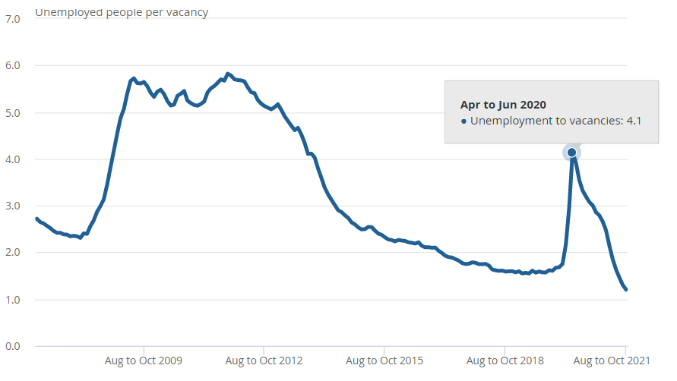
Figure 1: Unemployment rate during the pandemic
(Source: Extracted from Office for National Statistics, 2022)
Due to the lack of available workers and the high demand for labour, many companies have increased wages and increased work flexibility in an attempt to attract and retain more employees. A year after the Brexit vote, employment levels have remained relatively sharply higher than they were before the EU referendum in 2016 (CIPD, 2022). Despite a decrease in employment growth in 2019, the labour market is still extremely competitive and the number of job openings is at an all-time high, corresponding to this, the percentage of employers reporting difficulties in recruiting has risen. It is because the increase in EU workers who have come to work in the UK has not kept pace with the overall increase in employment in recent years that this is happening. More than three-fifths (61%) of organizations said they were having difficulty filling vacancies in the Spring 2019 report, up from 56% in the Spring 2017 report (CIPD, 2022). As a result, many companies have raised salaries, particularly for key employees and new hires.
Given the shortage of skilled workers and workers, it doesn't appear that Brexit has diminished employers' interest in hiring EU migrants. About two-thirds of organizations declared at the start of 2018 that they would continue to hire EU citizens. According to many employers, nationality does not play a role in hiring, but rather the ability to perform the task at hand. Employers cited a lack of qualified domestic candidates as the primary reason for not filling open positions for moderately skilled or unskilled workers (CIPD, 2022). Following last quarter's record high of +38, the net employment balance (the disparity between organizations expecting to increase staff levels and those expecting to decline staff levels) held steady at +37. This is the second-highest result since the survey's current methods were first used in winter 2012/13. The private sector's net employment intentions remain at +40. This represents that there is still a positive trend in the UK's employment figures, even if it is relatively low in the voluntary sector (+31) and public sector (+24) (CIPD, 2022). Correspondingly, it can be mentioned that in spite of the fact that Covid-19 hit the workforce of different organizations due to lock-down measures, these organizations have efficiently been able to attain a better workforce for accomplishing their organizational objectives and mission.
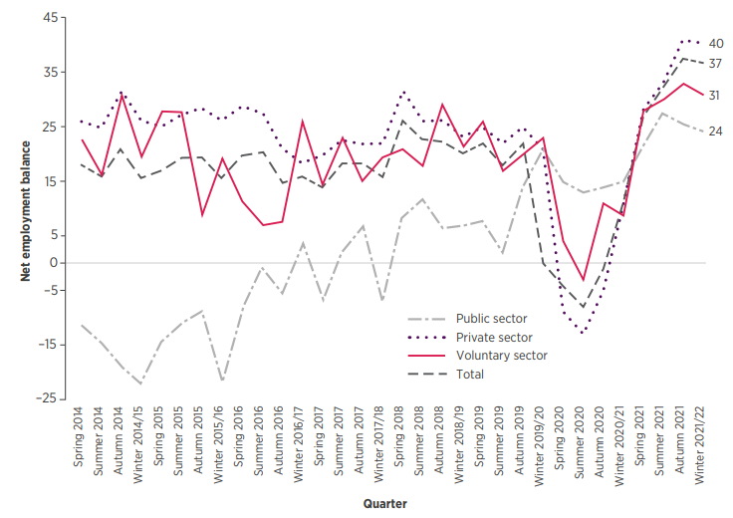
Figure 2: Net employment rate in different types of sectors
(Source: Taken from CIPD, 2022)
The year, 2021 saw a remarkable recovery of the UK workforce following the pandemic. With the aid of the government's furlough programme, the unemployment rate has remained low, but the demand for new workers has surged to new records in recent months (Karpman et al., 2021). Near the end of the year, the UK labour market is at its tightest in decades, contrary to expectations that it would loosen. Instead, a shortage of workers is the most pressing issue. The tightening of candidate availability in lower-paid industries can be seen in the shifts in relative job-seeker involvement over the course of the pandemic. In contrast, job seekers are increasingly interested in higher-paying positions. Construction, cleaning, warehousing, and hospitality have seen the biggest drops in relative job seeker interest in recent years. After the relaunching road-map was declared on February 22, 2021, many of the dwindles in these areas occurred (Karpman et al., 2021). In this respect, it might be stated that the industries with high employee turnover rates need to be more concerned regarding their HRM strategies to influence the perception of their employees.

Are there changes needed in the human resourcing strategies in the current scenario if so, what are they and how would you implement them as an HR Manager
The Brexit vote has had a significant impact on companies' attracting and retaining workers. Specifically, restrictions on immigration from the European Economic Area necessitate significant changes in the design of job positions. Individuals coming from the European Economic Area are restricted from entering the UK, which necessitates significant job design changes (e.g. reskilling roles or embracing flexible work arrangements). On the other hand, residents of the EU who currently reside in the UK have until June 30th, 2021, to apply to remain in the country after the UK officially exited the EU on January 31, 2020 (assets.publishing.service.gov.uk, 2022). There were 6,015,400 applications as of 30 June 2021, with more than half a million still awaiting at the time of this writing, according to Home Office data. Uncertainty weighs heavily on an HR professional's shoulders on behalf of the company, and we understand that.
There may be a need for European Union (EU) citizens and UK-based businesses to look outside the E.U. to fill gaps in their work-forces, as well. Brexit has been considered to pose a significant impact on both the migration patterns of skilled and unskilled workers, as well as on the labour market (assets.publishing.service.gov.uk, 2022). Many practical considerations are involved, and we understand that they can be overwhelming. As a result, dealing with the here and now is critical before considering the future. As a result of Brexit's impact on the economy, things like bonuses, financial incentives, and pensions have been affected. With the new trade agreement, businesses that previously relied on EU funding may see a decrease in funding due to a rise in the prices of doing business with the EU. In addition, the UK is no longer bound by EU law, meaning that rules and regulations governing areas like pensions could be changed or repealed.
In order to continue working in another EU country, UK citizens who are currently based there must apply for a permit from the country in which they currently reside. However, different EU countries require different paperwork corresponding to their respective employment contractual policies and agreements (Bussolo et al., 2018). Affected workers needs to be supported in their efforts to obtain necessary visas and other permits to remain in their current country of residence.
Even so, the HR department is still in charge of ensuring that employees perform at their best in terms of output, productivity, and efficiency. Gordon et al. (2018) claimed that the well-being of employees improves when they feel supported at work. Employees who are happy and healthy contribute to the success of the company. On the other hand, Peltz et al. (2021) contradicted that when it comes to their mental health, physical health, sleep, and financial well-being, they are more likely than their peers at other companies to say that their employer has had a positive impact. In the aftermath of a pandemic, HR professionals are taking a more proactive approach to ensure the health and well-being of their employees (López-Cabarcos et al., 2020). A pandemic situation, for example, may have prevented new employees from ever setting foot in the office or meeting their boss and coworkers. In this respect, the HR managers of business organizations are required to be well-aware of the physical and mental well-being of their employees in critical situations like the pandemic. This strategy by HR managers might have helped them to deal with their people efficiently and retain them for the long term.
- Strategic Contingency Theory
A contingency is a situation in which a sub-unit of an organisation is required to perform a variety of tasks that have an impact on the work of other sub-units. It becomes a strategic contingency in an organisation when another sub-unit has control over more contingencies and becomes powerful (Akintelu et al., 2018). An organization's leader becomes an important part of the organisation because of their unique ability to solve issues and problems that other members of the organisation cannot solve. Therefore, because of the high degree of reliance on a leader, it is difficult to bring in a new leader.
The main focus of the Strategic Contingency Model was on the influence of external variables on an organization's power. An organization's power is determined by both the relationships between departments and the differences between individuals. Because people are unique in their abilities, skills, and more, departmental relationships and individual differences also play a role in shaping power decisions (Jiang and Li, 2019). Hickson also dismisses the Great Man theory, which held that a person with charisma or leadership skills by birth could only be an effective leader. The author believes that even if someone lacks charisma, they can still be an effective leader if they possess problem-solving skills. It can be stated that with the appropriate application of strategic contingency theory the management of an organisation can capable to describe the overall department and align them in order to cope up with the uncertainty. Instead of reacting to the problem itself, contingency management helps managers focus on the root causes of individual issues (Armstrong and Brown, 2019). Managers who understand the importance of contingency theory instead of focusing on the results of the problem will seek to understand all of the influences that led to it. For example, with regard to loading and unloading goods, a warehouse manager may look closer and realize that the lack of proper ventilation is making workers fatigued and needing to take frequent breaks. Hence, rather looking for the root cause of the productivity decline, the manager should have turned to motivation theories as a quick fix.
- Standard Causal Model of HRM
In terms of Human Resource Management, the Standard Causal Model is the best. The model depicts a causal chain that starts with a business procedure and ends with HR forms and a better budgetary display. HR activities that are aligned with the organization's strategy are depicted and shown in the model (Kaufman, 2020). Based on the best-fit theory, HR can only be effective if it is aligned to business strategy in accordance with its own strategy. As a result, an organization's HR strategy is derived from its overall strategy in order to maximize financial performance. Correspondingly, the HR strategy dictates how the HR practices are implemented. Some examples of these include hiring and training, evaluation and payoffs. Certain outcomes can be expected as a result of these HR practices. Commitment, quality output, and engagement are all examples of the different HR practices. These HRM outcomes, in turn, lead to an increase in internal efficiency. For example, productivity, quality, and innovation are considered as the practices of the HR department in order to enhance the employee’s motivation. These results lead to financial success and the unmediated HRM effect, which shows that some HR practices can directly improve internal performance, is another interesting relationship (Cheng and Hackett, 2021). For example, a well-trained employee is more likely to perform at a higher level, even if this does not have an impact on HR outcomes. Therefore, increased financial performance can lead to increased investment in human resources, as the model's reversal of the normal causality shows.

Conclusion and Recommendation
From the above discussion, it can be concluded that human resource department plays an essential role in managing the business success along with the employee’s job satisfaction. In the recent scenario, it has been seen UK labour market have taken a tremendous change and the global market have been affected with the impact of pandemic. The other reason for the change is because of the huge rate of job cuts and low-income ratio among the common people. During that time, in an organisation HR manager plays the vital role in managing the employees job security. In the wake of the Brexit vote, companies have struggled to attract and retain employees. Significant alterations to job descriptions are required as a result of the new restrictions on immigration from the European Economic Area (EEA). As a result of the UK's ban on people from the European Economic Area entering the country, job design has to change significantly. It can be recommended that the management and the HR department of the different organisation needs to adopt the following strategies to maintain the employees job satisfaction level that are as follows:
- The HR managers needs to provide the different facilities to every employees such as work from home and medical facilities so that they can be on the line with their productivity. Additionally, it is the responsibility of the HR department that they need to create an emergency response team.
- The HR department also needs to reconsider the leaves and policies so that every employee can able to work as per their feasibility. With the help of that strategy’s employees can feel safe and at the same time they will also able to give time to their family members.

Reference List
- Akintelu, S.O., Oladele, W.O. and Akinpelu, S.S., 2018 CHAPTER THREE STRATEGIC HUMAN RESOURCE MANAGEMENT PRACTICE AS A TOOL FOR COMPETITIVE STRATEGY IN INFORMATION TECHNOLOGY (IT) FIRMS IN LAGOS STATE, NIGERIA. Multidimensional Approaches to Sustainable Development in Nigeria, p.29.
- Armstrong, M. and Brown, D., 2019. Strategic Human Resource Management: back to the future. Institute for Employment Studies reports, pp.1-36.
- assets.publishing.service.gov.uk, 2022 EU Settlement Scheme: EU, other EEA and Swiss citizens and their family members Available at: https://assets.publishing.service.gov.uk/government/uploads/system/uploads/attachment_data/file/1069096/EU_Settlement_Scheme_EU_other_EEA_Swiss_citizens_and_family_members.pdf [Accessed 19 April 2022]
- Bussolo, M., Davalos, M.E., Peragine, V. and Sundaram, R., 2018. Toward a new social contract: Taking on distributional tensions in Europe and Central Asia. World Bank Publications.
- Cheng, M.M. and Hackett, R.D., 2021. A critical review of algorithms in HRM: Definition, theory, and practice. Human Resource Management Review, 31(1), p.100698.
- CPID, 2022 Labour Market Outlook [Online] Available at: https://www.cipd.co.uk/Images/labour-market-outlook-summer-2021_tcm18-99641.pdf [Accessed 19 April 2022]
- Gordon, S., Tang, C.H.H., Day, J. and Adler, H., 2018. Supervisor support and turnover in hotels: does subjective well-being mediate the relationship. International Journal of Contemporary Hospitality Management.
- Jiang, K. and Li, P., 2019. Models of strategic human resource management. Sage handbook of human resource management, pp.23-40.
- Karpman, M., Zuckerman, S., Gonzalez, D. and Kenney, G.M., 2020. The COVID-19 pandemic is straining families’ abilities to afford basic needs. Washington, DC: Urban Institute, 500.
- Kaufman, B.E., 2020. The real problem: The deadly combination of psychologisation, scientism, and normative promotionalism takes strategic human resource management down a 30‐year dead end. Human Resource Management Journal, 30(1), pp.49-72.
- López-Cabarcos, M.Á., López-Carballeira, A. and Ferro-Soto, C., 2020. New ways of working and public healthcare professionals’ well-being: the response to face the covid-19 pandemic. Sustainability, 12(19), p.8087.
- Office for National Statistics, 2022Labour market overview, UK: March 2022 [Online] Available at: https://www.ons.gov.uk/employmentandlabourmarket/peopleinwork/employmentandemployeetypes/bulletins/uklabourmarket/march2022 [Accessed 19 April 2022]
- Peltz, J.S., Bodenlos, J.S., Kingery, J.N. and Rogge, R.D., 2021. The role of financial strain in college students’ work hours, sleep, and mental health. Journal of American college health, 69(6), pp.577-584.

