Module Name: Digital Skills and Research Methods
Student Name: Martin Andrei Iancu
Student ID: 2530102

Table of Contents
Introduction 3
Group Member 1: Microsoft 365 Productivity Application 4
Group Member 2: Microsoft 365 Communication or Collaboration Tool 8
Group Member 3: Digital Safety Action Plan for Greenfield 11
Conclusion 15
References 17

Slide:
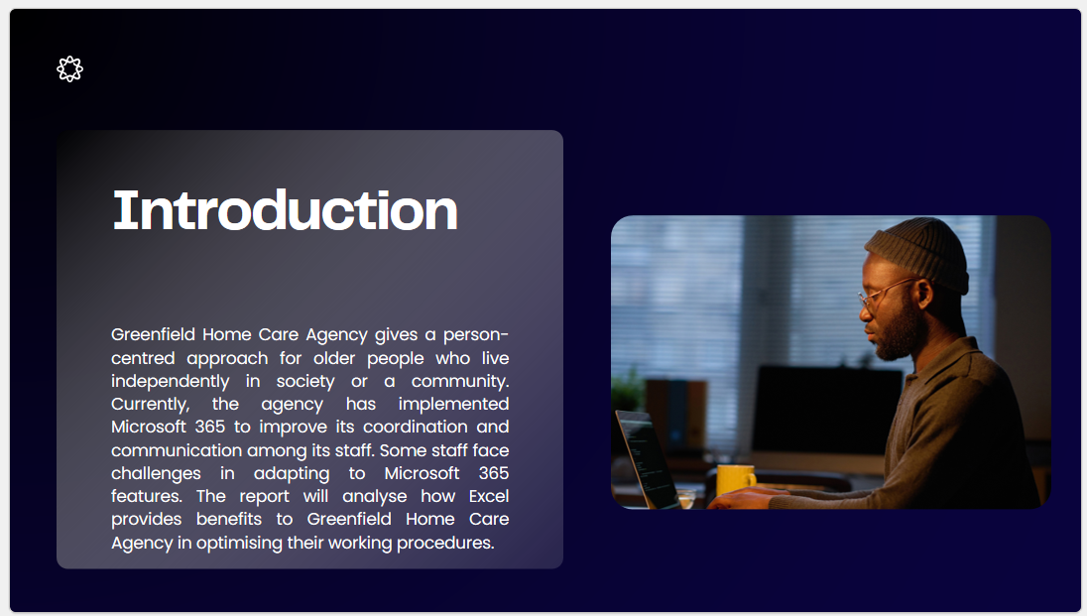
Notes:

Introduction
Greenfield Home Care Agency gives a person-centred approach for older people who live independently in society or a community. Currently, the agency has implemented Microsoft 365 to improve its coordination and communication among its staff. Some staff face challenges in adapting to Microsoft 365 features. The report will analyse how Excel provides benefits to Greenfield Home Care Agency in optimising their working procedures. Moreover, the report will explain the role of OneDrive to improve communication among its staff across different locations. Furthermore, the report will explain the action plan to improve data security and data protection at Greenfield.

Slide:
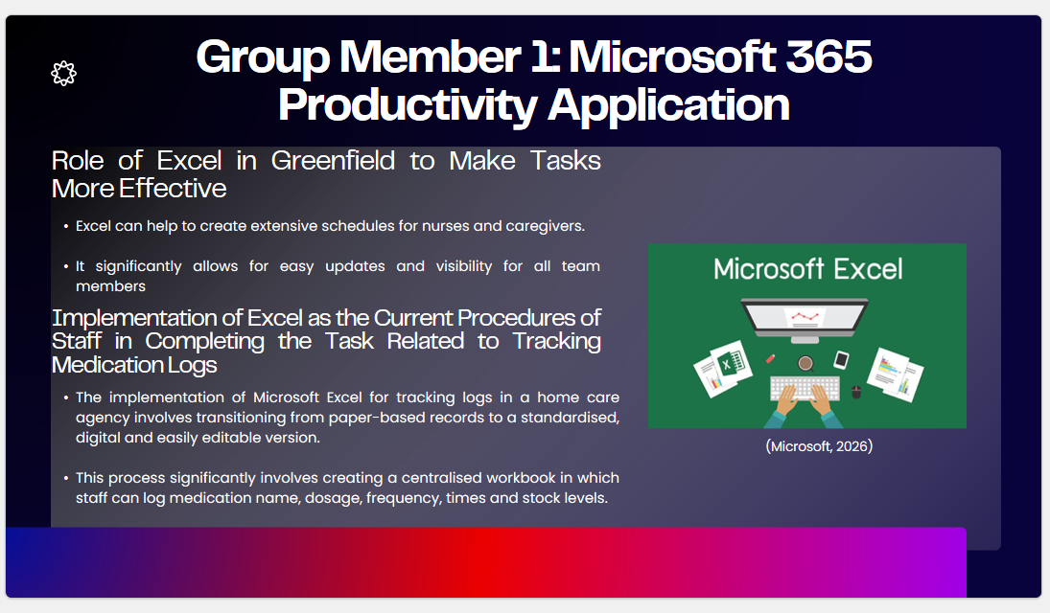
Notes:

Group Member 1: Microsoft 365 Productivity Application
Role of Excel in Greenfield to Make Tasks More Effective
Microsoft Excel can play a vital role in improving the operational effectiveness of this home care agency by transforming raw patient and employee information into structured, actionable insights. Moreover, it specifically serves as a flexible, cost-effective tool for maintaining scheduling, tracking patient information, optimising resources and ensuring compliance. Excel can help to create extensive schedules for nurses and caregivers. It significantly allows for easy updates and visibility for all team members (Moorhead, 2022). Excel allows agencies to build a single repository for patient demographic information, clinical timelines and care plans. Therefore, Excel is a powerful, flexible and accessible digital lifesaver for effectively structuring operations and driving effectiveness.
Implementation of Excel as the Current Procedures of Staff in Completing the Task Related to Tracking Medication Logs
The implementation of Microsoft Excel for tracking logs in a home care agency involves transitioning from paper-based records to a standardised, digital and easily editable version. This process significantly involves creating a centralised workbook in which staff can log medication name, dosage, frequency, times and stock levels. It generally uses conditional formatting for automotive visual alerts (Diamant, 2024). However, some staff face challenges in managing their work with Microsoft Excel. Working with Excel always seems to be difficult at first. Slow adaptation to this tool will make it easy to track all kinds of medication logs. It will help the staff of this agency to make a smooth implementation of the working procedures of Excel (Marks, 2026).
Slide:
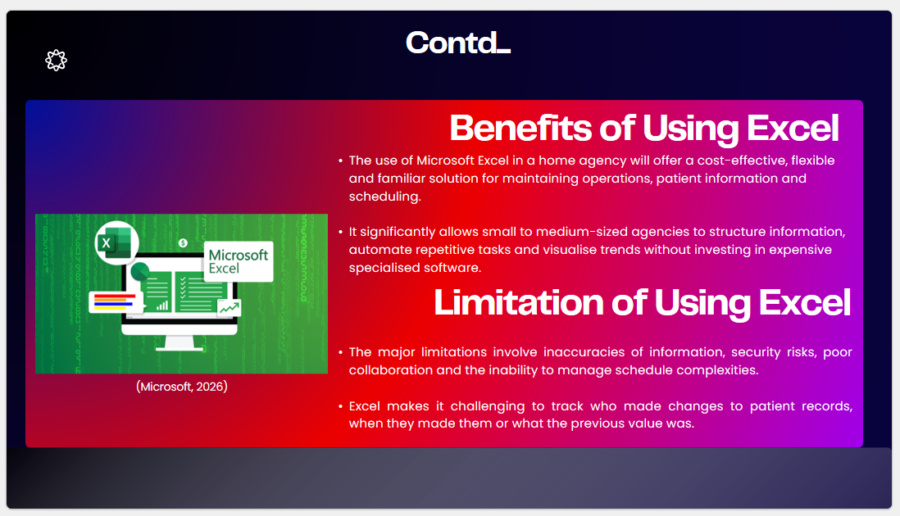
Notes:
Benefits of Using Excel
The use of Microsoft Excel in a home agency will offer a cost-effective, flexible and familiar solution for maintaining operations, patient information and scheduling (Rosener, 2024). It significantly allows small to medium-sized agencies to structure information, automate repetitive tasks and visualise trends without investing in expensive specialised software. Excel can provide a structured, tabular format to effectively store information, caregiver schedules and inventory needs, which makes information easy to locate and update (Lenovo, 2026).
Limitations of Using Excel
The use of Excel for this home care agency is common in the early stages, but it quickly introduces significant operational, security and compliance risks as the agency grows. The major limitations involve inaccuracies of information, security risks, poor collaboration and the inability to manage schedule complexities. Excel makes it challenging to track who made changes to patient records, when they made them or what the previous value was. This general lack of accountability is a major problem for audits and regulatory compliance. Staff spend hours performing manual data entry, cleaning data and fixing broken formulas, which takes time away from client care (Microsoft, 2026).

Slides:
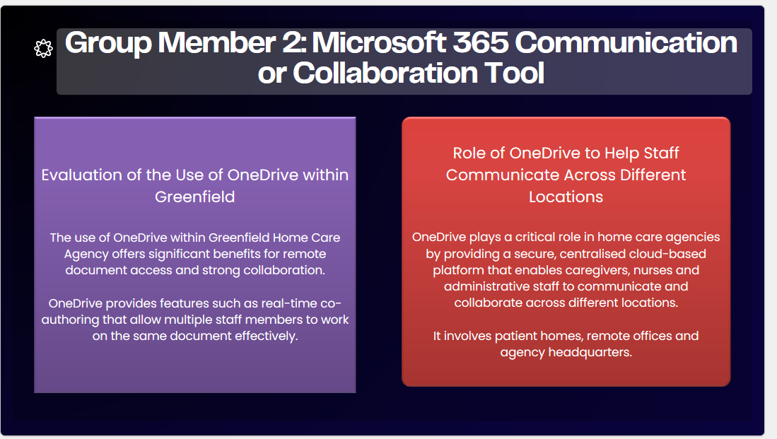
Notes:

Group Member 2: Microsoft 365 Communication or Collaboration Tool
Evaluation of the Use of OneDrive within Greenfield
The use of OneDrive within Greenfield Home Care Agency offers significant benefits for remote document access and strong collaboration. With OneDrive, caregivers can access, update and share patient records from anywhere on any device, which significantly supports an extensive workforce to manage their working procedures (McFedries and Weverka, 2025). OneDrive provides features such as real-time co-authoring that allow multiple staff members to work on the same document effectively. It significantly eliminates issues with several versions. OneDrive also offers smooth access to real-time information that requires an active internet connection, which can be a limitation in rural areas or in patient homes with poor connectivity (Microsoft, 2026).
Role of OneDrive to Help Staff Communicate Across Different Locations
OneDrive plays a critical role in home care agencies by providing a secure, centralised cloud-based platform that enables caregivers, nurses and administrative staff to communicate and collaborate across different locations. It involves patient homes, remote offices and agency headquarters. With the use of OneDrive, staff can access patient care plans, schedules and clinical documentation from any device in the field. This anywhere, anytime access significantly ensures that field workers have up-to-date information before and during visits to patients. Multiple users can effectively edit documents such as care plans in a simultaneous manner. This helps to eliminate the need for sending multiple versions of documents, which ensures everyone works from the most current file (Microsoft, 2026).
Slides:
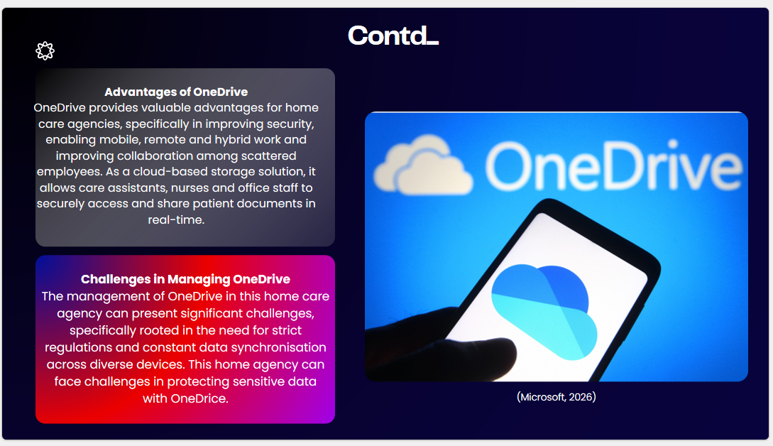
Notes:
Advantages of OneDrive
OneDrive provides valuable advantages for home care agencies, specifically in improving security, enabling mobile, remote and hybrid work and improving collaboration among scattered employees. As a cloud-based storage solution, it allows care assistants, nurses and office staff to securely access and share patient documents in real-time. OneDrive provides encrypted storage, which is essential for effectively protecting sensitive patient data. Administrators can set granular permissions which specifically ensure employees only access the files essential for their role, which protects confidential records of patients (Ramsac, 2026).
Challenges in Managing OneDrive
The management of OneDrive in this home care agency can present significant challenges, specifically rooted in the need for strict regulations and constant data synchronisation across diverse devices. This home agency can face challenges in protecting sensitive data with OneDrice. Specifically, improper file sharing or incorrect permissions settings on OneDrive can lead to security breaches (Demiliani and Tacconi, 2024). Caregivers generally use various devices to access information, which can lead to data leaks if those devices are lost and stolen. Remote caregivers generally work in areas with poor internet connectivity, which also leads to persistent file synchronisation failures. A deep reliance on OneDrive for total data protection is not adequate, as it does not provide extensive disaster recovery in the way dedicated backup solutions do (Microsoft, 2026).

Slide:
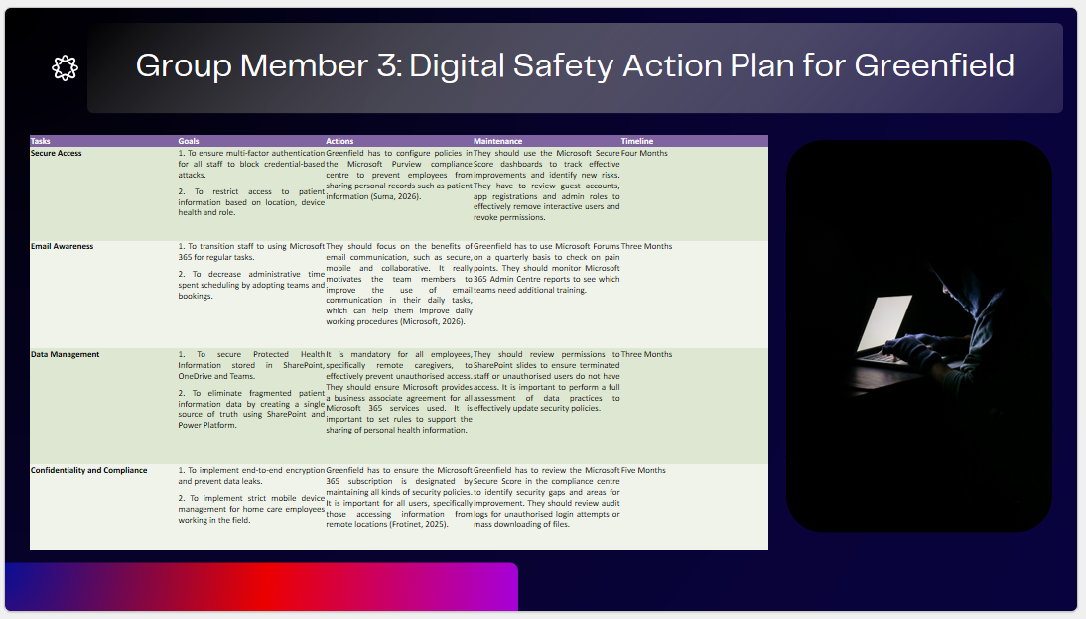
Notes:

Group Member 3: Digital Safety Action Plan for Greenfield
Action Plan to Improve Data Security and Data Protection
Tasks | Goals | Actions | Maintenance | Timeline
Secure Access | 1. To ensure multi-factor authentication for all staff to block credential-based attacks.  2. To restrict access to patient information based on location, device health and role. | Greenfield has to configure policies in the Microsoft Purview compliance centre to prevent employees from sharing personal records such as patient information (Suma, 2026). | They should use the Microsoft Secure Score dashboards to track effective improvements and identify new risks. They have to review guest accounts, app registrations and admin roles to effectively remove interactive users and revoke permissions. | Four Months
Email Awareness | 1. To transition staff to using Microsoft 365 for regular tasks.  2. To decrease administrative time spent scheduling by adopting teams and bookings. | They should focus on the benefits of email communication, such as secure, mobile and collaborative. It really motivates the team members to improve the use of email communication in their daily tasks, which can help them improve daily working procedures (Microsoft, 2026). | Greenfield has to use Microsoft Forums on a quarterly basis to check on pain points. They should monitor Microsoft 365 Admin Centre reports to see which teams need additional training. | Three Months
Data Management | 1. To secure Protected Health Information stored in SharePoint, OneDrive and Teams.  2. To eliminate fragmented patient information data by creating a single source of truth using SharePoint and Power Platform. | It is mandatory for all employees, specifically remote caregivers, to effectively prevent unauthorised access. They should ensure Microsoft provides a business associate agreement for all Microsoft 365 services used. It is important to set rules to support the sharing of personal health information. | They should review permissions to SharePoint slides to ensure terminated staff or unauthorised users do not have access. It is important to perform a full assessment of data practices to effectively update security policies. | Three Months
Confidentiality and Compliance | 1. To implement end-to-end encryption and prevent data leaks.  2. To implement strict mobile device management for home care employees working in the field. | Greenfield has to ensure the Microsoft 365 subscription is designated by maintaining all kinds of security policies. It is important for all users, specifically those accessing information from remote locations (Frotinet, 2025). | Greenfield has to review the Microsoft Secure Score in the compliance centre to identify security gaps and areas for improvement. They should review audit logs for unauthorised login attempts or mass downloading of files. | Five Months

Slides:
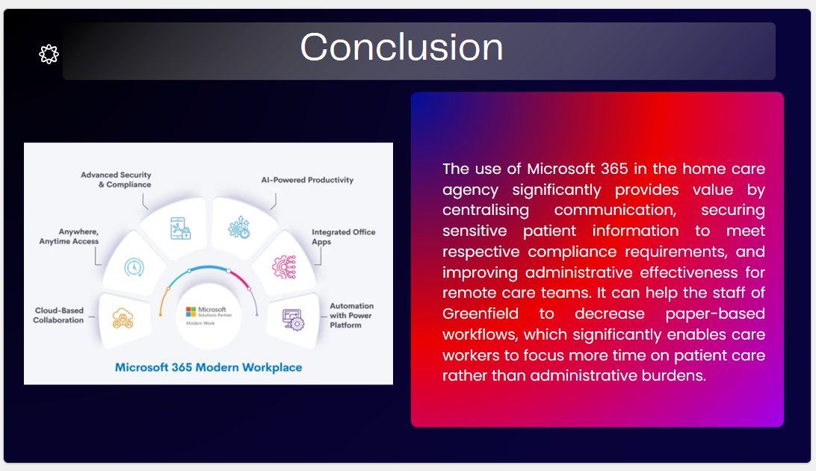
Notes:

Conclusion
The use of Microsoft 365 in the home care agency significantly provides value by centralising communication, securing sensitive patient information to meet respective compliance requirements, and improving administrative effectiveness for remote care teams. It can help the staff of Greenfield to decrease paper-based workflows, which significantly enables care workers to focus more time on patient care rather than administrative burdens. Agencies can set granular user permissions based on document sensitivity, which also ensures only authorised staff have access to specific patient records. Care managers can use teams to manage patient observation records, procedures and appointments seamlessly. The home care agency has to save on administrative costs and decrease human errors by replacing manual tracking and spreadsheets with digital automation.

Slide:
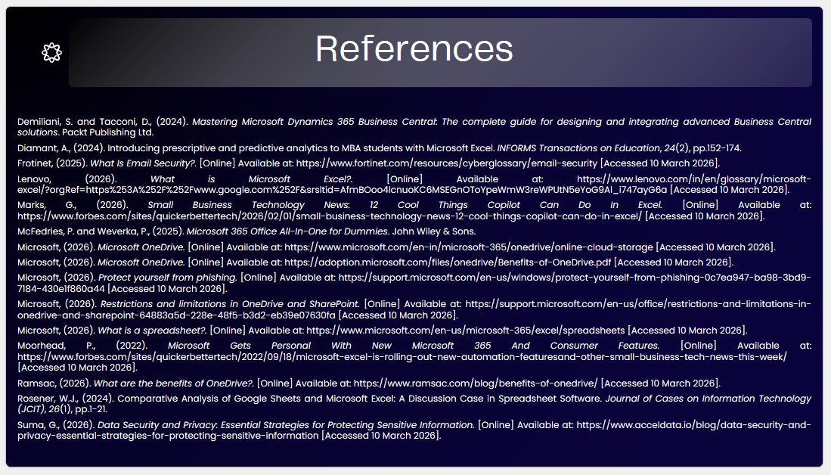
Notes:

References
Demiliani, S. and Tacconi, D., (2024). Mastering Microsoft Dynamics 365 Business Central: The complete guide for designing and integrating advanced Business Central solutions. Packt Publishing Ltd.
Diamant, A., (2024). Introducing prescriptive and predictive analytics to MBA students with Microsoft Excel. INFORMS Transactions on Education, 24(2), pp.152-174.
Frotinet, (2025). What Is Email Security?. [Online] Available at: https://www.fortinet.com/resources/cyberglossary/email-security [Accessed 10 March 2026].
Lenovo, (2026). What is Microsoft Excel?. [Online] Available at: https://www.lenovo.com/in/en/glossary/microsoft-excel/?orgRef=https%253A%252F%252Fwww.google.com%252F&srsltid=AfmBOoo4lcnuoKC6MSEGnOToYpeWmW3reWPUtN5eYoG9Al_i747ayG6a [Accessed 10 March 2026].
Marks, G., (2026). Small Business Technology News: 12 Cool Things Copilot Can Do In Excel. [Online] Available at: https://www.forbes.com/sites/quickerbettertech/2026/02/01/small-business-technology-news-12-cool-things-copilot-can-do-in-excel/ [Accessed 10 March 2026].
McFedries, P. and Weverka, P., (2025). Microsoft 365 Office All-In-One for Dummies. John Wiley & Sons.
Microsoft, (2026). Microsoft OneDrive. [Online] Available at: https://www.microsoft.com/en-in/microsoft-365/onedrive/online-cloud-storage [Accessed 10 March 2026].
Microsoft, (2026). Microsoft OneDrive. [Online] Available at: https://adoption.microsoft.com/files/onedrive/Benefits-of-OneDrive.pdf [Accessed 10 March 2026].
Microsoft, (2026). Protect yourself from phishing. [Online] Available at: https://support.microsoft.com/en-us/windows/protect-yourself-from-phishing-0c7ea947-ba98-3bd9-7184-430e1f860a44 [Accessed 10 March 2026].
Microsoft, (2026). Restrictions and limitations in OneDrive and SharePoint. [Online] Available at: https://support.microsoft.com/en-us/office/restrictions-and-limitations-in-onedrive-and-sharepoint-64883a5d-228e-48f5-b3d2-eb39e07630fa [Accessed 10 March 2026].
Microsoft, (2026). What is a spreadsheet?. [Online] Available at: https://www.microsoft.com/en-us/microsoft-365/excel/spreadsheets [Accessed 10 March 2026].
Moorhead, P., (2022). Microsoft Gets Personal With New Microsoft 365 And Consumer Features. [Online] Available at: https://www.forbes.com/sites/quickerbettertech/2022/09/18/microsoft-excel-is-rolling-out-new-automation-featuresand-other-small-business-tech-news-this-week/ [Accessed 10 March 2026].
Ramsac, (2026). What are the benefits of OneDrive?. [Online] Available at: https://www.ramsac.com/blog/benefits-of-onedrive/ [Accessed 10 March 2026].
Rosener, W.J., (2024). Comparative Analysis of Google Sheets and Microsoft Excel: A Discussion Case in Spreadsheet Software. Journal of Cases on Information Technology (JCIT), 26(1), pp.1-21.
Suma, G., (2026). Data Security and Privacy: Essential Strategies for Protecting Sensitive Information. [Online] Available at: https://www.acceldata.io/blog/data-security-and-privacy-essential-strategies-for-protecting-sensitive-information [Accessed 10 March 2026].

