Aida Lamer
1706552
Introduction to Web Development
04/01/2018

Contents
Introduction 3
Requirements 3
Implementation 5
Evaluation 9
References 12

Introduction
In the following report, I will be highlighting several key factors regarding my website that I created for the following assignment.

Requirements
One of my favourite hobbies is horse riding, and this is my I chose to make a website based off the farm that I keep my horses at. While making the website, I made sure to highlight all the different services we offer for the horses, owners and riders. My main target audience were children. I was hoping to encourage children to take part in an outdoor activity that would improve their social life and health as well as learning to be responsible for an animal. My other target audience were adults who have an interest in showing horses. The farm is focused on breeding top quality showing horses and producing young horses with high potential. I was hoping to encourage adults to bring their horses to our farm for schooling or breaking in order to bring out their full potentials.
The following image will show the site map:
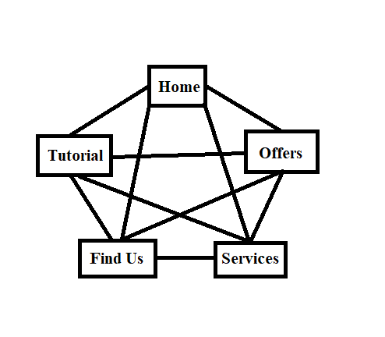
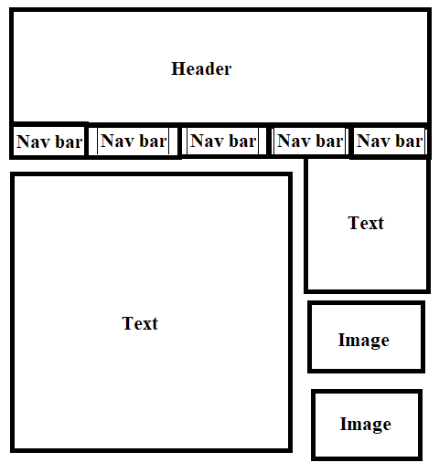

Implementation
In the following section I will be providing number of screen shots of my completed website:
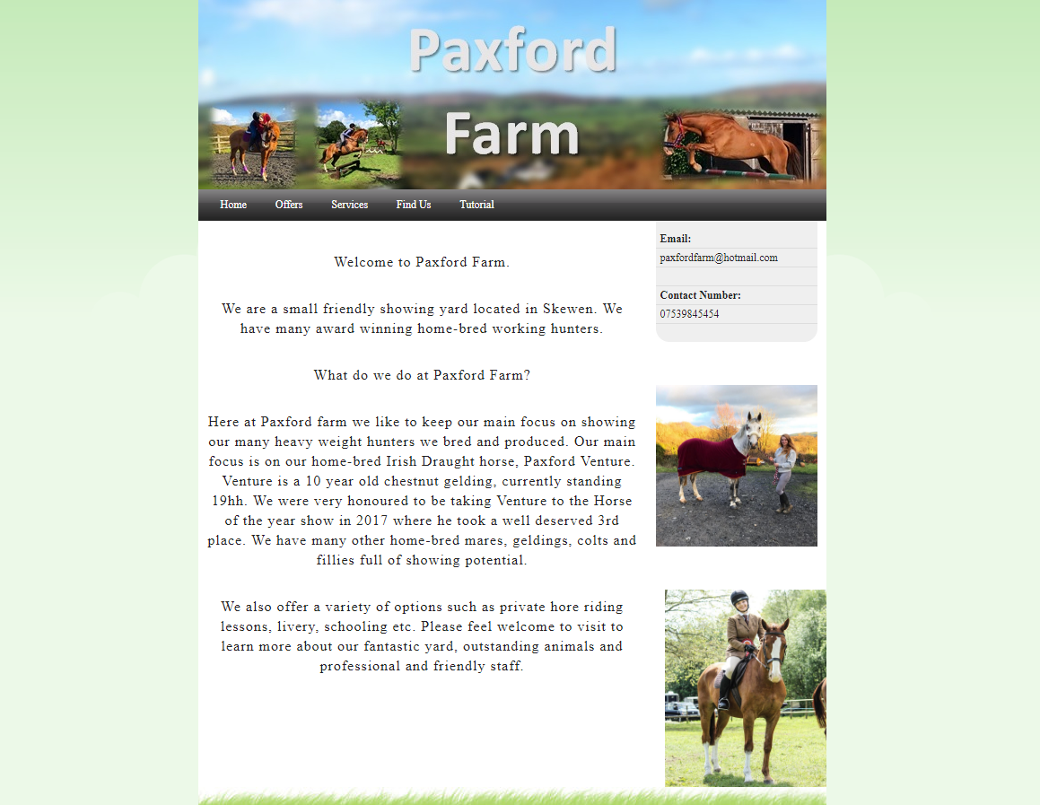
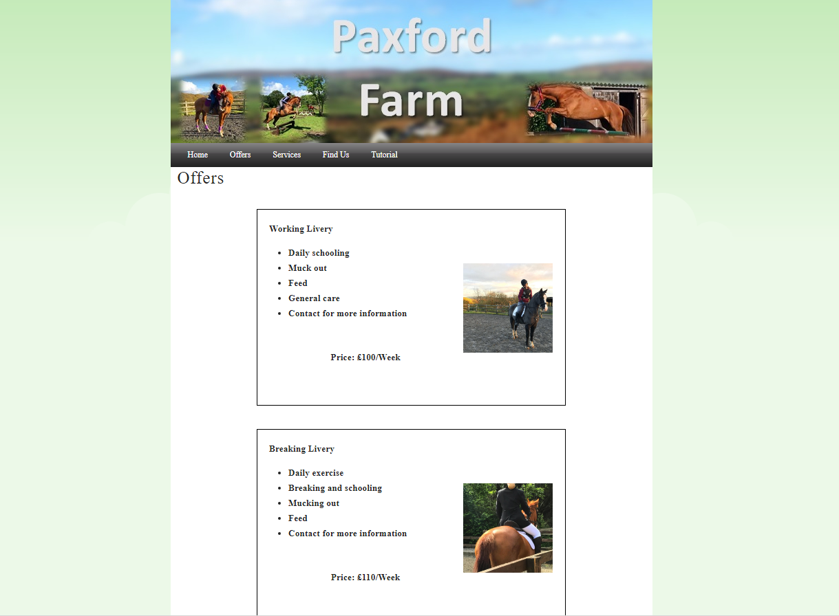
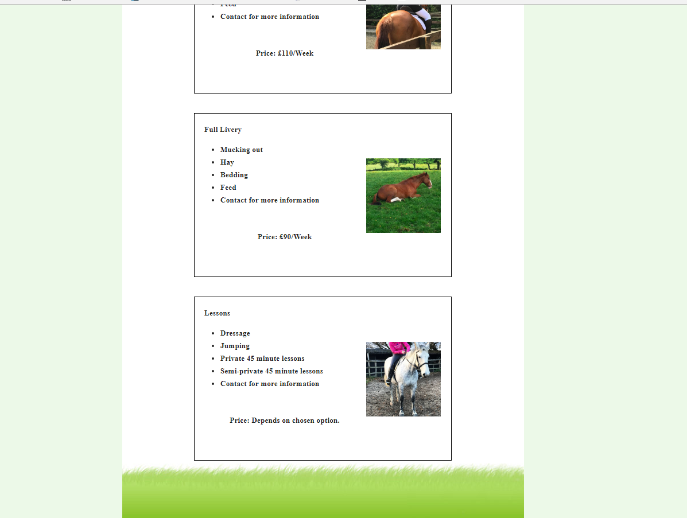
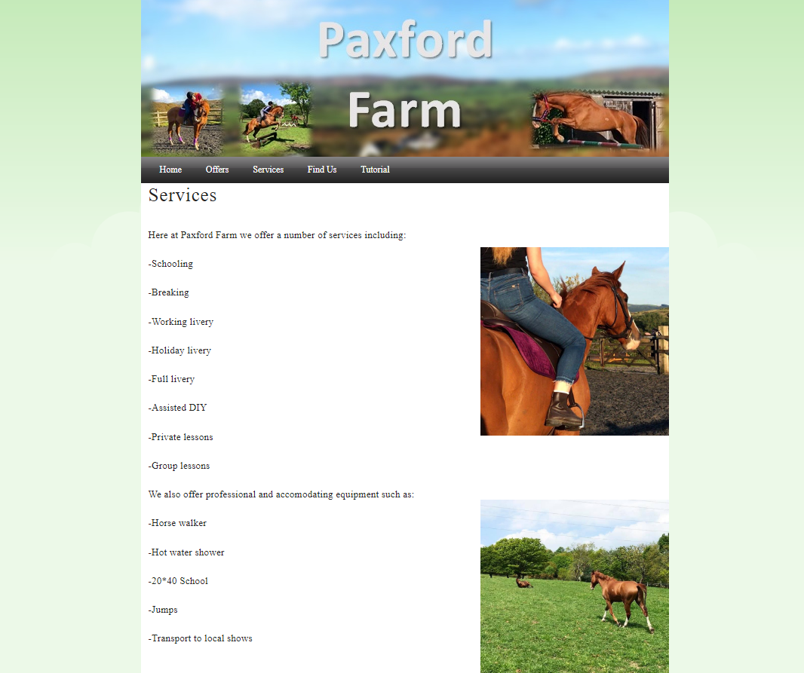
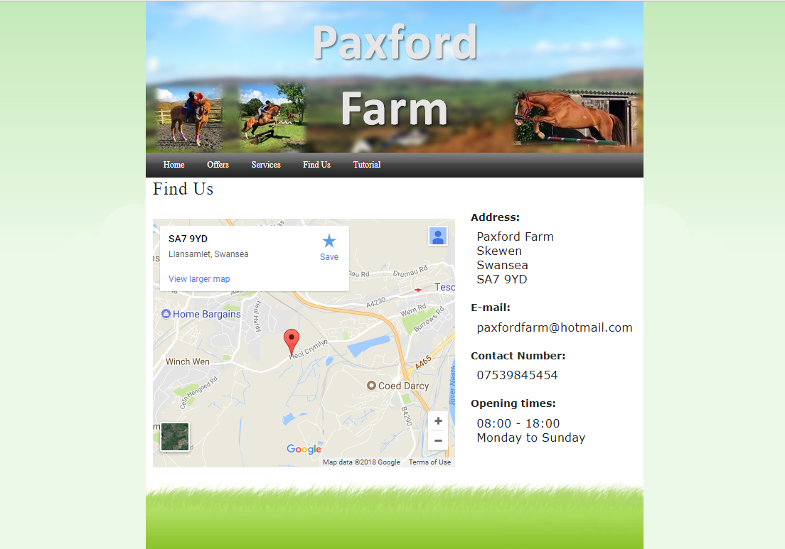
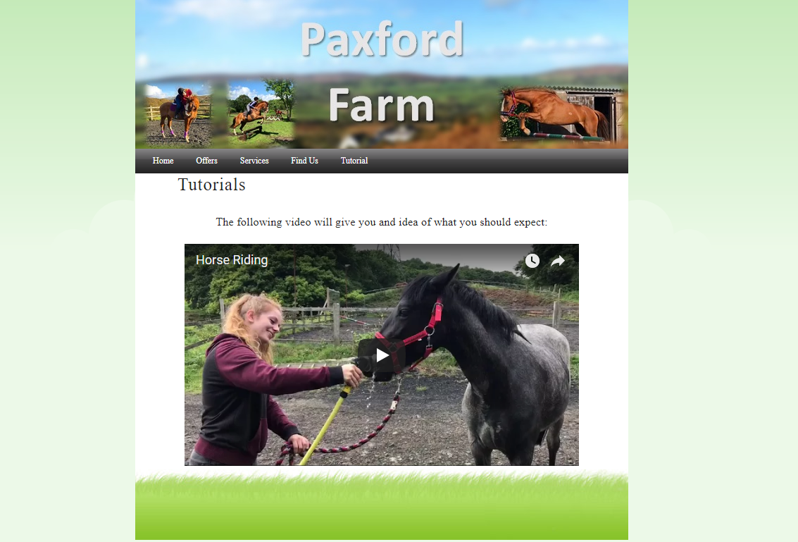
In the following section I will be validating my HTML code:
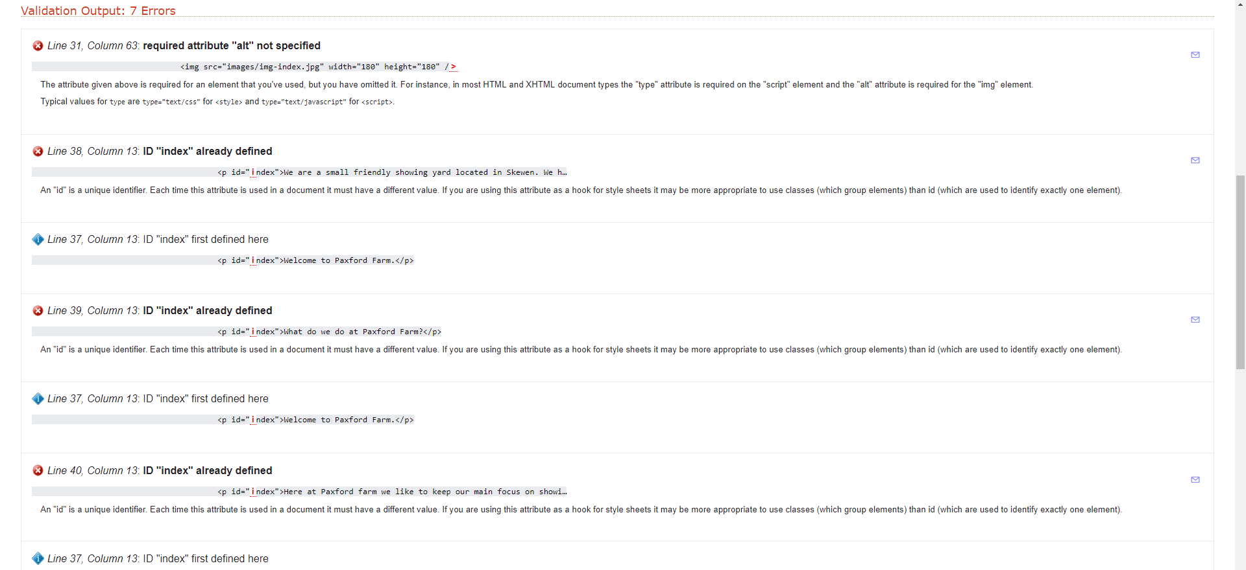
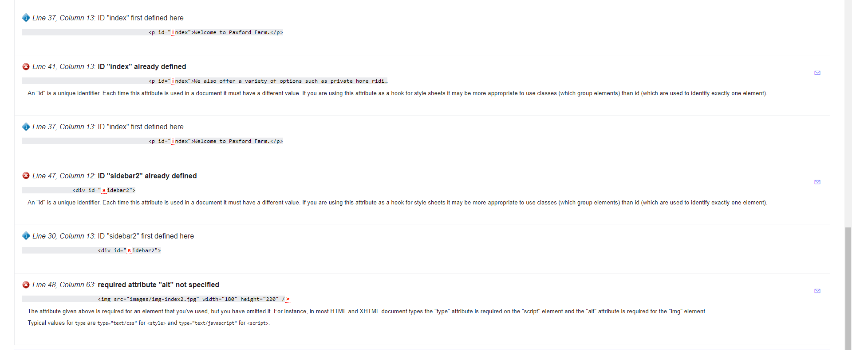
In general, I had very few errors. An error that often occurred was ‘required attribute “alt” not specified’. This occurred due to not adding ‘alt’ and naming the image. Another error was ‘ID “index” already defined’ which occurred due to duplicating ID throughout the website. These were the two errors that showed up after evaluating my html. ^{[1]}
The following image will show the validation of my CSS code:
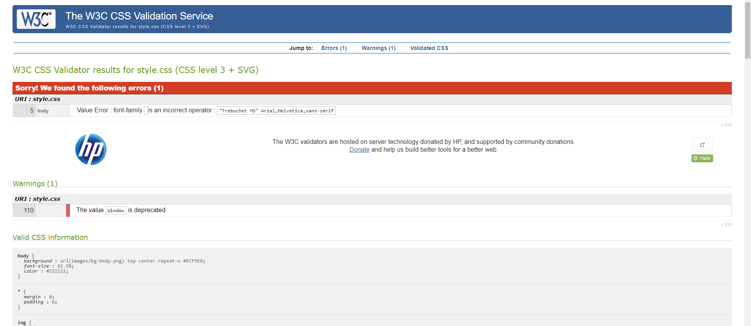
This shows that there was only one error with my CSS code and it was a value error. I used an incorrect operator. ^{[2]}

Evaluation
In the following section I will be writing an evaluation on the accessibility on my website.
With the use of WCAG you’re able to cover a side range of people with disabilities such as, blindness, loss of hearing, learning disabilities, photosensitive etc.
Headings- The heading of the website contains the farms name, ‘Paxford Farm’ with suitable images containing different activities the farm provides. You can sere the heading on every page of the website. The headings should be h1, h2, h3, h4, h5 or h6 in order for the user to identify the heading easily. ^{[3]}
Information structure and relationships conveyed throughout my HTML code- With the use of the navigation bar you can see the contents of each pages on the website. An example would be, on ‘Services’ the website gives a brief description of all the different services the farm offers. This section also gives a list of equipment the farm contains.
Images and media content- I used helpful and relevant images on every page of the website. All the images show different activities the participants could take place in. The tutorial page includes a video to give the audience a good idea of all the facilities the farm has to offer as well as all the different activities they will be taking part in. Alt also helps with the description of the image. If the image failed to load, they would still be able to see a description of the image. ^{[4]}
Scalable text- All text should be easy read by people with visual disabilities without the use of any alternative technology such as screen magnifier. The text on my website was a bold colour with a regular size font. ^{[5]}
Main colours on website- the background colour for the website was white. The foreground on the white background was black. This way it was clear and easy to read as well as giving the website a professional look. Another background colour was dark grey. On this background we used a white foreground for the text. This way the text was very bold and clear for the user to read. We used this background and foreground choice for the navigation bar. The background and foreground should have a 4:5:1 ratio. ^{[6]}
Navigation- On every page the user will have access to the navigation bar in order to give them a guidance on the website. Almost every page fits onto the screen without having to scroll down. Due to the navigation bar being on top, the user will have a constant access to it. This is helpful for people with disabilities who would struggle to find their location or wished to go somewhere else. ^{[7]}

On my complete website, for all the pages I used a green background located on both sides of the website. This gives it a professional look that the user would associate with nature. The main background was white. I chose this colour as it’s very clear, suitable for colour blind people or people with vision disabilities to see. The text on the white background was black. I chose this colour as it’s very bold, easy to see on white background and suitable for people with vision disabilities. For the navigation bar, I used a dark grey background with white text. I chose this colour combination as it makes it very clear and easy for someone with disabilities to locate the information bar in order to find the page that they are looking for. For my header I decided to user a blurred image of the landscape of the farm, with multiple clear images of activities people can take part in at the farm. I chose a very bold and clear font and colour for the name of the farm/website. This header looks appealing for the user, and it is also full of information of what the website is about.
On ‘Home’ page, the user can find the contact details of the farm, as well as a brief description of what the farm has to offer for the audience. On the right hand side of the website, the user can view two images. Both of these images are to show the user an idea of what the farm is about. Both images I chose were very high quality in order to give the website a professional look.
On the page ‘Offers’ the user can find a number of different packages the farm offers. These include a short list of details as well as price of the packages. A relevant image is located at the right hand side of each package. This is to show the user a clear idea of what each package includes.
On the page ‘Services’ the user can find a list of services they offer at the farm. This is to give the user a more detailed description of what the farm offers. This also includes number of options that were not included in ‘Offers’. This page also includes a list of equipment’s the farm is equipped with. This is to give the user an clear idea of what the farm has to offer for their costumers. This way they will have a more clear view of the farm without having to visit. On this page you can also view number of images of different facilities of the farm such as fields and riding school. Both images are very clear and look appealing for the audience.
On the page ‘Find Us’ the user can have full access to the farm’s address as well as contact details. I used a larger sized font for the address, email, contact number and opening times. This was to ensure that no spelling mistakes were made if the user wished to contact. This also suits people with visual disabilities. On this page you can also find an embedded map of the location of the farm. This map also allows the user to zoom in, zoom out, scroll and give them the option to view with the use of satellite view without leaving the website.
On the page ‘Tutorial’ the user can find a video clip of multiple activities they can take place up the farm. The video is very clear with the option to make it full screen to suit people with vision disabilities. The video doesn’t include any speaking so people with hearing disabilities would be able to understand it very clearly.
Overall, I’m happy with my completed website. However, there are multiple recommendations for future improvements that I could make. For the images, I could have used alt in order to let the audience read what each image is. This way if the images failed to load, the user would still had a clear idea of what the image was. Another improvement that I could make in the future is to make the ‘Email’ and ‘Contact number’ larger. The font is relatively smaller than the rest, and it could cause potential problems for people with vision difficulties. Another improvement would be to include all the services the farm offers on the ‘Offers’ page. This way the audience would have a clear understanding of what each service consists of and how much it costs. Another improvement would be to make a ‘Contact Us’ section where the audience could fill out a form to be able to send an email to the owner of the farm. In future I would also like to include a ‘Gallery’ page in order to give the audience the option to view images taken at the farm that would include all activities, services, equipment’s and animals.

References
[1]"The W3C Markup Validation Service", Validator.w3.org, 2018. [Online]. Available: http://validator.w3.org/. [Accessed: 07- Jan- 2018].
[2]"The W3C CSS Validation Service", Jigsaw.w3.org, 2018. [Online]. Available: http://jigsaw.w3.org/css-validator/. [Accessed: 07- Jan- 2018].
[3]"G141: Organizing a page using headings | Techniques for WCAG 2.0", W3.org, 2018. [Online]. Available: https://www.w3.org/TR/WCAG20-TECHS/G141.html. [Accessed: 07- Jan- 2018].
[4]"Images Concepts • Images • WAI Web Accessibility Tutorials", W3.org, 2018. [Online]. Available: https://www.w3.org/WAI/tutorials/images/. [Accessed: 07- Jan- 2018].
[5]"Understanding Success Criterion 1.4.4 | Understanding WCAG 2.0", W3.org, 2018. [Online]. Available: https://www.w3.org/TR/UNDERSTANDING-WCAG20/visual-audio-contrast-scale.html. [Accessed: 07- Jan- 2018].
[6]"WebAIM: WCAG 2.0 and Link Colors", Webaim.org, 2018. [Online]. Available: https://webaim.org/blog/wcag-2-0-and-link-colors/. [Accessed: 07- Jan- 2018].
[7]"Understanding Guideline 2.4 | Understanding WCAG 2.0", W3.org, 2018. [Online]. Available: https://www.w3.org/TR/UNDERSTANDING-WCAG20/navigation-mechanisms.html. [Accessed: 07- Jan- 2018].

