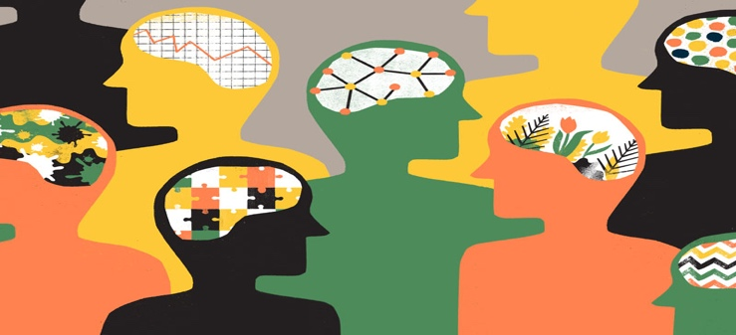

Cultural Awareness (Ex.1) - Exercise taken from Sewell, Hári (2009). Working with ethnicity, race and culture in mental health: A handbook for practitioners. Jessica Kingsley Publishers: London.
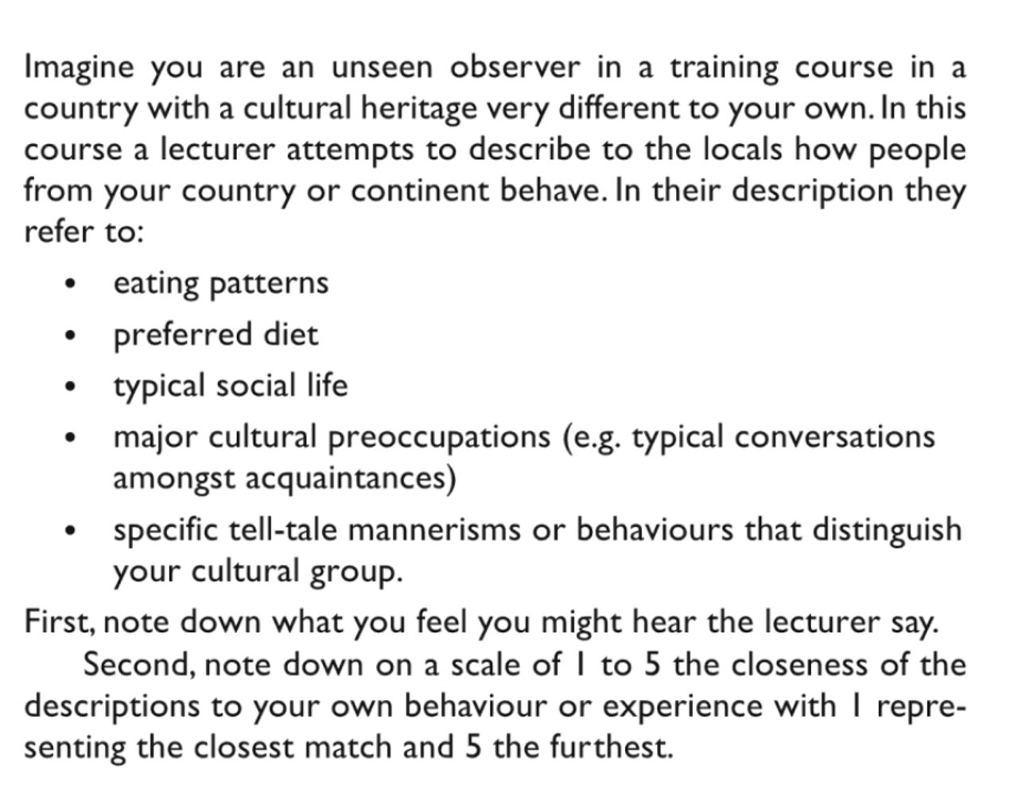

Intersectionality (Ex. 2)

Draw in your own “intersectionality map”.

Reflecting on Cultural Biases - Exercise taken from Sewell, Hári (2009). Working with ethnicity, race and culture in mental health: A handbook for practitioners. Jessica Kingsley Publishers: London.



