Thomas Reynolds (2305662)
(ACCA4024)
Network And Cyber security assignment

Table of Contents

Abstract: 1
Introduction: 1
Part 1: 1
Part 2: 6
References: 10

Abstract:
In this assignment much research was done into different cyber attacks and how they can affect a network and its users. Strategies on how to identify such threats and get rid of them were also explored. With this knowledge I then created my own network.

Introduction:
In this assignment I will be discussing measures put in place to make networks secure against cyber threats. The different types of threats will also be explored. With this knowledge a network will be created.

Part 1:
a)
The NIST cybersecurity framework consists of five key components. Identify, protect, detect, respond, recover. [1]
In the identify section risk assessments are done to identify flaws in the system, also you can identify what assets need the most protection. Then you can implement security measures to ensure safety. These measures consist of password management, dns filtering, firewalls, data encryption, security policies, employee training and more.
Detecting threats is very crucial as if you are not aware of a potential threat on a network it is open for attacks. Also, there may already be malicious software on one of the devices and no one has realized yet. The longer it is undetected the more damage it can cause, for example stealing data and duplicating itself to other devices. So you must regularly scan and analyze the network using tools such as NMAP and Wireshark.
[2] This source goes into detail on how NMAP can provide great insight on how it can identify security risks.
This helps detect suspicious traffic on a network. You should also keep track of unusual staff activity. There’s no guarantee that they aren’t causing harm to the network, for example opening an entrance for unwanted traffic to enter. Even if their motives are unclear you should keep tabs on their activity.
If an attack on the network has taken place it is important you respond in the correct way. For example notifying the users whose data may be at risk. If you do not inform those users they are at risk of another attack as their data may have been stolen. Data such as passwords and emails. When informed they can quickly change any passwords that may have been jeopardized which can minimize damage. Another plan to have is how you are going to keep the business running and operational while the attack is being dealt with. If you can keep the business operational while dealing with such an attack, it again minimizes damage to the business. Update cyber security plans with lessons learnt from the attack.
Then as a business you must recover from the attack. This includes repairing/restoring any equipment that was affected from the attack. If the damage was too bad replace the equipment with proper security measures installed. Then you must keep everyone informed about what happened and how you plan on making sure this won’t happen again. As you need to be a reliable business.
This framework is very important when it comes to keeping data safe. Whether its the data of employees or customers. It does this by finding potential threats in the network then if found improving the strength of the network. Providing plans on how to continuously check potential threats and vulnerabilities. Which as stated before improves security as you can deal with the fault before it becomes too much of an issue. However, if an attack does happen plans are put in place to minimize damage such as data loss. With these plans in place the likelihood of an attack happening is decreased. And the time taken to come back from an attack decreases as well.

b) Wireshark – This is a tool that allows you to analyze packets. [3]
The user can see who sent the packet, where it was sent to, the protocol used and other info. Attackers can use this tool to gather as much information about their target as possible. They can also find potential threats to exploit such as unsecure protocols being used. The attacker may also find misconfigurations to exploit.
NMAP – This is a network scanning tool used to analyze network exploration and host discovery. It does this by sending packets and looking at the responses then relaying this data to the user. This information could be very useful to attackers as they will be able to discover devices on a network they didn’t know existed. Attackers can also identify open ports, all this information allows attackers to form an attack.
As stated in the background section the first stage in the cyber kill chain is the reconnaissance. This makes sense as attackers need knowledge of the network layout to start planning an attack. While understanding what devices are on the network and how they communicate, attackers can start scanning for vulnerabilities. For example, are unsecure protocols being used. Tools such as nmap can identify if IOT devices are being used on the network. Which introduces more vulnerabilities such as use of default passwords, IOT devices are given default passwords, and some businesses may forget to change them. This means attackers can get into the network through the IOT device. There may be no vulnerabilities to exploit when first analyzing the network but as new devices get introduced attackers will be quick to notice any misconfigurations.

c)
WannaCry – This was a ransomware attack that targeted computers using Microsoft Windows.
[4] This ransomware had a worm component meaning that it replicates itself rapidly and tries to send itself to other hosts. The aim of the attack was to extort money. If it took control of system it would encrypt your file and demand a payment for them to be returned. The attack used an exploit in the Windows operating system, Microsoft had made a patch two months before the attack. However, many users do not regularly update their software. This means many people were still affected by the attack. This was one of the main reasons the attack was so successful, there were many people using outdated software that did not have up to date security. This means if you want to keep your network secure having all devices up to date is very necessary. Attackers are always finding flaws in software which means the manufacturers must keep improving them to ensure any faults aren’t exploited. If the attack was successful against a business, there could be a lot of downtime as you would not be able to see crucial files. So it is important to update devices regularly to avoid such attacks.

TeleRat – This malicious software uses telegram to send commands to a victim's device. They also send and receive data from the victim’s device. It is a trojan named ‘TeleRat’ that uses telegrams bot API to extract data from its victim. A trojan is malware that disguises itself as legitimate software. This malware would supposedly tell you how many views your telegram account had received which is what alerted some people that this app could be dangerous. This is because “Telegram doesn’t allow for populating any such information” according to paloalto networks [5] The malware would send commands in the background using Telegrams bot API, it did this to communicate with victims devices. If an employee from a business cannot spot a trojan, they may give the malicious software access to the network. RAT malware allows the attacker to remotely control the victim's device. If this goes on for a long period of time without the victim noticing, there may be extreme data loss or damage to the network. So, it is important to identify suspicious malware on your device. There is anti-malware software out there that will help you identify this type of software's identify the trojan and can help remove them from your device. You can also use task manager to see if there’s any unusual activity.

cii)
Whaling –
[6] This attack is like a phishing attack but the targets have high ranking positions within an organization. The goal being to steal information from the organization or gain access to parts of the organization only high-ranking individuals have access to. It goes without saying if this attack is successful it could be detrimental to the organization as even client's information could be at risk. The high-ranking individual will receive an email posing as a legitimate person or company. In the email they will make up a scenario that typically involves the high-ranking individual making a payment or giving information away. It is important that the high ranking individual knows with confidence who they are communicating with. This decreases the impact an attack like this can have.
Pharming –
[7] This is when a user is directed to a website that is disguising itself as a legitimate one. For example, a website posing to be a bank but is not. If the user does not realize they are on a fraudulent website information such as credit card details are at risk. They will try to trick you by having a similar URL to the one they are posing to be. However, it will be different but most people will not notice the slight change. The layout of the site will look trustworthy in order to trick its victims. The link to the fake website may be sent to the user through email which is when you can start to see if the website is fake or not. Nowadays those type of emails appear in the spam folder, so if they are pretending to be a legitimate bank or retailer you know it's a scam. Also as said previously the URL will be different, it may be similar, but you should always check if it's the legitimate URL. Especially if you are going to enter credit card details. One of the main ways to check if its a fake website or not is to see if it uses HTTPS or HTTP. The difference being HTTPS is secure, so a bank or trusted retailer would not use a HTTP for their website. A lot of these attacks use money as an incentive. They may say you have won a contest and the reward is money, even if you have not entered any competition. Then to get the reward it directs you to the fake site.
To stop the chances of these attacks from happening its important to teach yourself how to spot these attacks. It is also important to teach others around you how to spot these things as well.

Part 2:

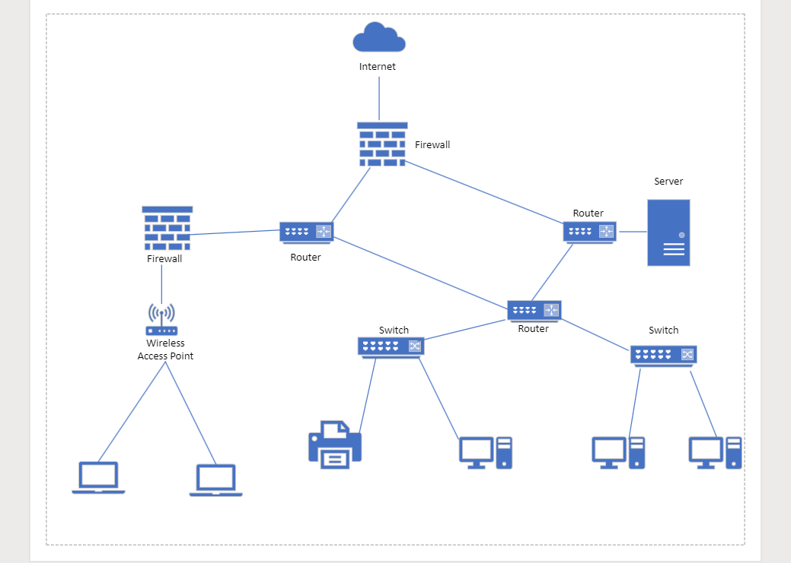

To eliminate single points of failure I introduced multiple routers. The single point of failure is a part of the network that if it failed the entire network would fail. Originally, I had one router in the diagram that all parts of the network were connected to. So, if an error occurred with that router the entire network would suffer. I introduced multiple routers to avoid this issue. For example, if the router that the Wireless access point is connected to fails, the other devices are still able to communicate with each other and access the internet. This makes the network reliable and more stable; downtime is minimized as only a portion of the network needs to be repaired. The firewalls improve security of the network as the traffic that can access the server is limited. As many people can access the Wireless access Point it's important to have a fully configured firewall connected to the router that gives it access to the network. This is because not all users should have access to parts of the network such as the server. This again improves security.

2b)
Tools such as WireShark are useful to analyze activity on the network. You can see if there are any unusual IP addresses accessing the network. It is also a great tool for troubleshooting network errors. Another tool like WireShark that was mentioned earlier was NMAP. This tool scans the network and relays the feedback information to the user. As mentioned previously, discovering vulnerabilities is very important. This is because you can solve the problem before it gets exploited. A tool such as NMAP is great for making such discoveries. If the network is being used for a business, you need a configured firewall to ensure safety for your network. Firewalls monitor incoming and outgoing network traffic. It then decides whether to block certain traffic based on set security rules. Firewalls are common practice in networks today. Not all traffic should have access to all parts of the network especially the server, as user data may be stored on there. So, the firewall makes sure that the traffic on the network can only go where they are supposed to.

Bi)

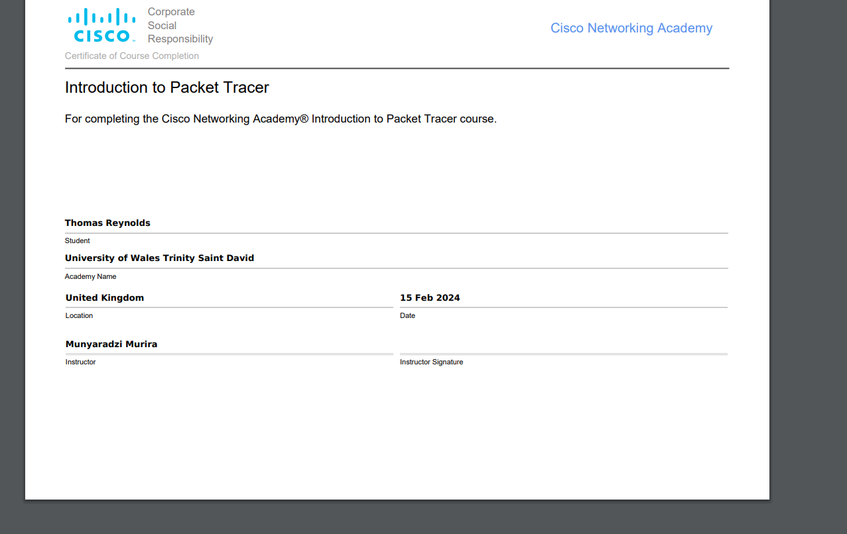

Bii)
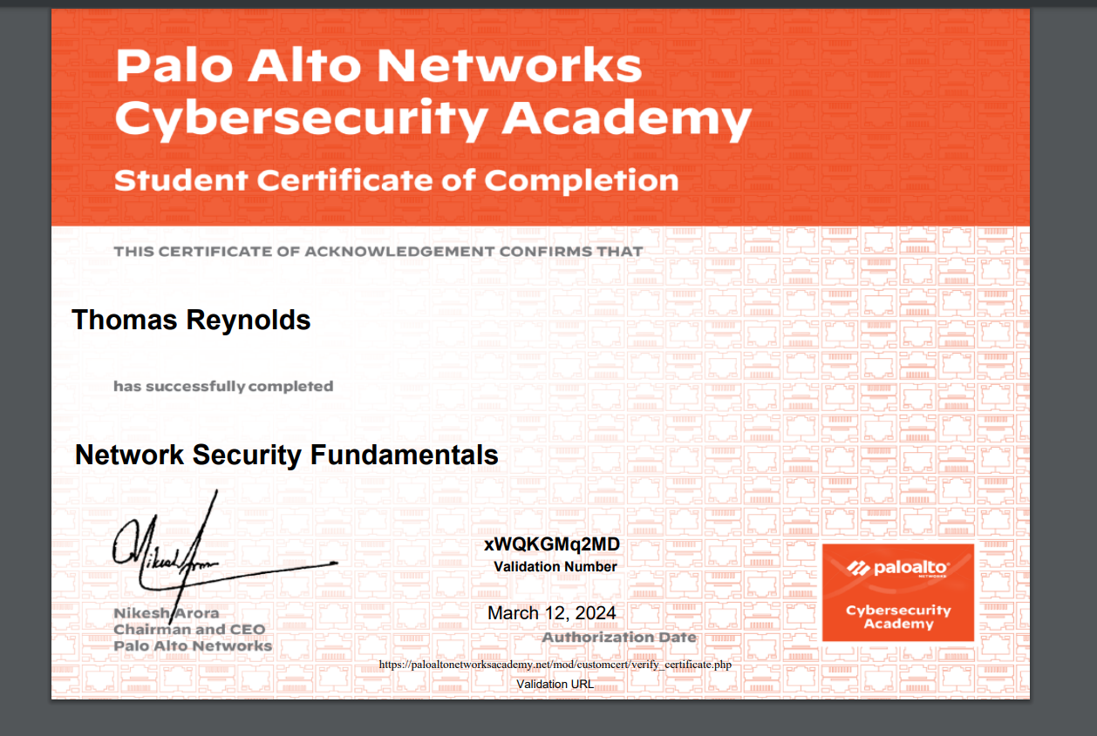
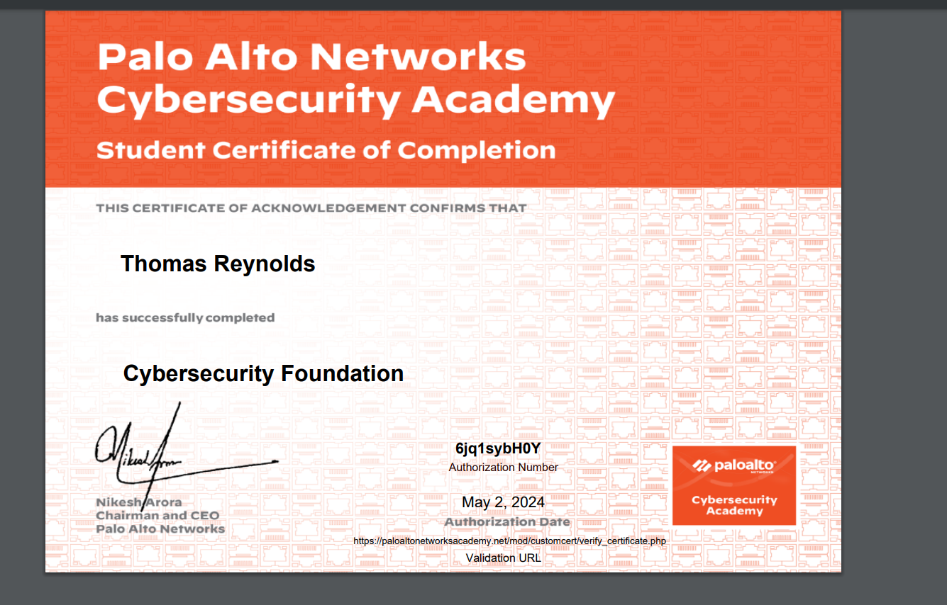

References:
[1] Understanding the NIST cybersecurity framework, Federal Trade Commission, 2024
https://www.ftc.gov/business-guidance/small-businesses/cybersecurity/nist-framework
[2] Leon Yen, Nmap Vulnerability Scan: How To Easily Run And Assess Risk, Datamation, February 26, 2024
https://www.datamation.com/security/how-to-easily-run-a-vulnerability-scan-using-nmap/#:~:text=At%20the%20most%20basic%20level,risks%20present%20within%20the%20network.
[3] Katie Terrel Hannah, Wireshark, techtarget, 2024 https://www.techtarget.com/whatis/definition/Wireshark#:~:text=Wireshark%20is%20a%20widely%20used,ensure%20smooth%20operations%20and%20security.
[4] What was the WannaCry ransomware attack?, cloudflare, 2024
https://www.cloudflare.com/learning/security/ransomware/wannacry-ransomware/
[5] Ruchna Nigam and Kyle Wilhoit, TeleRAT: Another Android Trojan Leveraging Telegram’s Bot API to Target Iranian Users, unit 42, March 20th 2018

https://unit42.paloaltonetworks.com/unit42-telerat-another-android-trojan-leveraging-telegrams-bot-api-to-target-iranian-users/.
[6] Business email compromise: defending your organization, National Cyber Security Centre,
https://www.ncsc.gov.uk/guidance/business-email-compromise-defending-your-organisation
[7] What is Pharming?, fortinet,
https://www.fortinet.com/resources/cyberglossary/pharming#:~:text=Pharming%20is%20online%20fraud%20that,a%20victim's%20computer%20or%20server.

