

Individual Report -
Information Systems Improvements

BA (Hons) Leadership and Management Skills for the Workplace Managing Business Information
Module Code: LCLM5004

Student Name: Tamara Sofia Sanches Tavares
Student Number: 2336849
Lecturer Name: Dr. Amer Kareem
Table of Content
1. Introduction 3
2. Evaluation of Existing Systems 4
2.1 Manual Inventory System and Customer Data 4
2.2 Operational Challenges in Reporting, Security, and Integration 4
3. Recommended Solution: Implementation of a Cloud-Based ERP System 5
3.1 Rationale for a Cloud-Based ERP System 5
3.1.1 Comparative analysis of ERP options 6
3.2 Functional Modules and Organisational Benefits 6
4. Implementation Plan 7
4.1 Step-by-Step Implementation 7
4.2 Potential Challenges and Mitigation Strategies 8
5. Conclusion 9
References 10

1. Introduction
AKPerog Ltd. is an electronics retailer operating in 30 physical stores alongside an expanding e-commerce platform company which is rapidly growing. While the company has experienced substantial increases in sales, the internal information systems have not been upgraded or modernised to match the scale and complexity of the company recent growth. Consequently, the company is now facing several operational challenges associated with outdated and inefficient information practices, particularly in the areas of inventory management, customer relationship management (CRM), decision-making, and data security. According to Laudon and Laudon (2022), organisations that fail to align information systems with business growth often experience reduced visibility, slower decision-making, and increased operational risk, all of which are evident within AKPerog Ltd.
The organisation remains heavily dependent on manual procedures, including spreadsheet-based reporting and manual stock checks. These outdated practices contribute to frequent stock discrepancies, delayed administrative processes, and limited real-time visibility, which directly impacts customer satisfaction and operational control. Modern retail organisations increasingly rely on integrated Transaction Processing Systems (TPS) and Management Information Systems (MIS) to ensure accuracy, speed, and consistency of operational data, particularly across multi-channel environments (Laudon and Laudon, 2022).
The purpose of this report is to critically evaluate AKPerog Ltd.’s existing information systems and recommend an updated and integrated solution capable of supporting the company’s continued expansion. The report analyses current system limitations, evaluates their impact on organisational performance, and proposes the implementation of a cloud-based Enterprise Resource Planning (ERP) system. An implementation plan supported by recognised information systems models is presented to ensure successful adoption and long-term value creation.

2. Evaluation of Existing Systems

2.1 Manual Inventory System and Customer Data
AKPerog Ltd. most significant operational challenge is the manual inventory management system, where stock levels are updated independently across physical stores and are not synchronised with the online sales platform. This lack of real-time integration results in inaccurate stock visibility, order cancellations, and reduced customer trust, particularly during periods of high demand. Real-time TPS and integrated ERP inventory modules reduce human error and improve fulfilment accuracy. Research by Gartner (2023) highlights that retailers without integrated inventory systems face higher fulfilment errors and lower customer retention, reinforcing the urgency for system modernisation.
In modern retail companies where generally utilise real-time Transaction Processing Systems (TPS) enable real-time updates across all sales channels, significantly reducing human error and improving operational efficiency (Laudon and Laudon, 2022). AKPerog Ltd.’s reliance on manual processes not only increases administrative workload but also limits management’s ability to forecast demand accurately and respond proactively to market fluctuations.
In other hand, customer data management presents a further challenge, as information is fragmented across point-of-sale systems, e-commerce databases, marketing tools, and customer support platforms. This fragmentation has a several impact to the company, which unable the organisation from developing a single, unified customer view, which is essential for personalised marketing and consistent service delivery. According to Salesforce (2023), organisations that centralise customer data through integrated CRM systems achieve higher customer satisfaction and improved decision-making, a capability currently lacking at AKPerog Ltd.

2.2 Operational Challenges in Reporting, Security, and Integration
AKPerog Ltd. faces several operational inefficiencies that hinder performance and growth. Management currently relies on manually compiled spreadsheet reports, which are often inconsistent, outdated, or inaccurate due to human error. This lack of real-time visibility delays critical decisions such as demand forecasting, pricing adjustments, and supply planning. Modern businesses typically use Management Information Systems (MIS) and Business Intelligence (BI) tools to support strategic and operational decision-making, but AKPerog Ltd.’s manual processes limit competitive responsiveness.
In addition, fragmented systems and weak access controls create data security vulnerabilities. Sensitive customer information is at risk of unauthorised access, and key GDPR requirements—such as data minimisation, restricted access, and audit trails—are not adequately met. Non-compliance exposes the company to legal penalties, reputational damage, and loss of customer trust.
Finally, the lack of system integration across sales, finance, inventory, and marketing forces employees to manually transfer data between platforms. This process is time-consuming, error-prone, and creates inconsistencies across the organisation. Integrated information systems are essential for modern retail operations, and AKPerog Ltd.’s current approach limits efficiency, causes data duplication, and restricts scalability.

3. Recommended Solution: Implementation of a Cloud-Based ERP System
To overcome the operational inefficiencies previously identified, AKPerog Ltd. should implement a comprehensive and integrated information system that facilitates scalability and supports real-time decision-making. The proposed solution is the adoption of a cloud-based Enterprise Resource Planning (ERP) system incorporating key modules such as Inventory Management, Customer Relationship Management (CRM), Finance, and Business Intelligence. This approach will enable the organisation to streamline processes, enhance data accuracy, and improve overall operational efficiency.

3.1 Rationale for a Cloud-Based ERP System
An ERP system provides a centralised database that is accessible across all departments, thereby eliminating data duplication and ensuring consistency and accuracy in real time. For a multi-store retailer, the ability to synchronise physical and online stock is particularly critical. A cloud-based ERP solution offers significant advantages over traditional on-premises systems. It reduces upfront infrastructure costs, as the need for physical servers and hardware is eliminated. Furthermore, maintenance, updates, and security are managed by the vendor, which minimises the burden on internal IT resources. The system is inherently scalable, allowing the organisation to adapt seamlessly as it grows, and it provides remote accessibility, enabling staff to access the platform from multiple locations. Well-established ERP solutions suitable for medium-sized retailers include Microsoft Dynamics 365, Oracle NetSuite, and SAP Business One.
To strengthen the justification for adopting the cloud‑based ERP system, the Technology Acceptance Model (TAM) can be used to explain how employees are likely to accept and use the new technology. According to TAM, two key factors influence user adoption: Perceived Usefulness (PU) and Perceived Ease of Use (PEOU). In the case of AKPerog Ltd., the ERP system increases usefulness by providing real‑time inventory visibility, integrated customer data, and automated reporting, all of which directly address the company’s current operational challenges. In addition, modern cloud‑based ERP systems are designed with user‑friendly interfaces and simplified workflows, which improve ease of use and reduce the amount of training required. By ensuring the system is both useful and easy to use, TAM indicates that employees are more likely to accept and adopt the ERP system, which is essential for successful implementation

3.1.1 Comparative analysis of ERP options
To support the selection of the most appropriate ERP system for AKPerog Ltd., a comparative analysis of leading cloud-based ERP solutions was conducted. This analysis draws on industry trends highlighted the importance of cloud-based ERP, integration capabilities, AI-driven automation, and business intelligence as core differentiators in modern ERP systems. The graph below provides a visual comparison of three widely adopted ERP systems based on key selection criteria aligned with these trends.
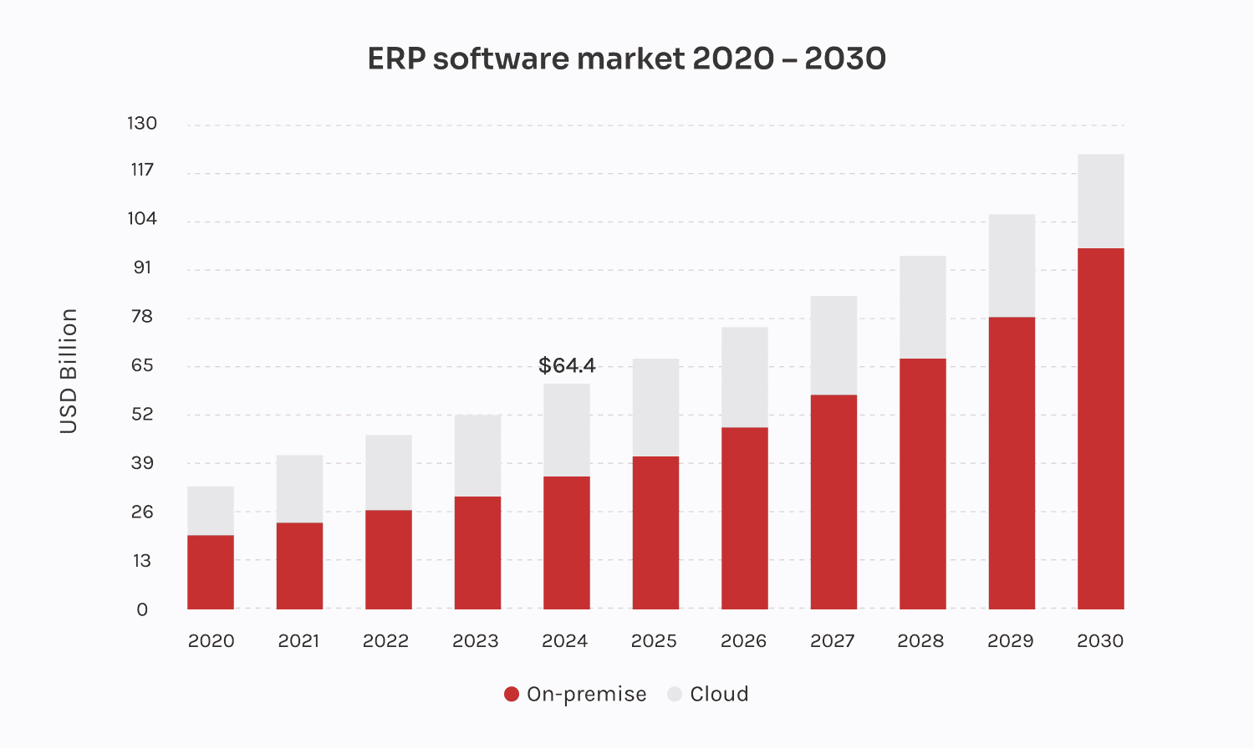
This comparison supports evidence-based decision-making by demonstrating which ERP solution best aligns with AKPerog Ltd.’s operational and strategic requirements

3.2 Functional Modules and Organisational Benefits
The ERP system will incorporate several functional modules, each addressing specific operational challenges. The Inventory Management module will synchronise stock levels across physical stores and online platforms, automatically update inventory following sales or returns, and issue alerts when stock reaches reorder thresholds. By leveraging historical sales data, it will also enable more accurate demand forecasting. These capabilities will reduce discrepancies, prevent overstocking or understocking, and improve customer satisfaction.
The Customer Relationship Management (CRM) module will centralise customer data, creating unified profiles accessible across all channels. This will facilitate personalised marketing campaigns, loyalty programmes, and targeted promotions. Additionally, it will enhance customer service by providing staff with access to order histories and previous support interactions, thereby strengthening customer relationships and encouraging repeat purchases.
Integration between finance and sales will eliminate the need for manual data entry, reducing accounting errors and improving the accuracy of budgeting, invoicing, and financial reporting. The Business Intelligence component will provide real-time dashboards and visual analytics, enabling trend analysis, demand forecasting, and automated reporting. These tools will significantly enhance strategic decision-making and give management greater control over business performance.
Finally, the ERP system will strengthen data security and ensure compliance with GDPR requirements. Features such as role-based access control, data encryption, and audit trails will protect sensitive information and mitigate legal and reputational risks. By implementing these measures, AKPerog Ltd. will safeguard customer trust and maintain regulatory compliance.

4. Implementation Plan
The successful implementation of an Enterprise Resource Planning (ERP) system requires a structured and phased approach to minimize operational disruptions and ensure a smooth transition. A gradual rollout allows for effective risk management, stakeholder engagement, and system optimization before full deployment.

4.1 Step-by-Step Implementation
The first stage involves requirements analysis, which is critical for aligning the ERP system with organizational needs. This process begins with comprehensive interviews across all departments to capture diverse operational perspectives. Existing workflows are documented to identify inefficiencies and pain points, enabling the definition of essential system features that address these challenges.
Following requirements gathering, the next phase is vendor selection. This entails soliciting proposals from multiple ERP providers and conducting a comparative evaluation of costs, functionality, scalability, and technical support. The chosen solution must be tailored to the specific demands of retail operations, ensuring compatibility with both physical and digital sales channels.
Once a vendor is selected, system configuration is undertaken. This includes customizing workflows, data fields, and user interfaces to reflect organizational processes. Integration with existing Point-of-Sale (POS) systems and e-commerce platforms is essential to maintain operational continuity. Additionally, user roles and permissions are established to safeguard data integrity and enforce access controls.
The subsequent stage is data migration, which requires meticulous preparation. Existing datasets are cleaned to eliminate duplicates and inconsistencies, ensuring accuracy and reliability. Core data—such as customer profiles, inventory records, and historical sales information—is then transferred into the new system through controlled migration protocols.
To facilitate adoption, staff training is implemented across all departments. Training programs combine interactive sessions with comprehensive user manuals and video tutorials. Furthermore, designated “super users” are trained to provide ongoing support within their respective teams, fostering internal expertise and reducing dependency on external assistance.
Before full-scale deployment, pilot testing is conducted in a limited number of stores. This controlled environment allows for the identification and resolution of technical or operational issues. Feedback from staff during this phase is invaluable for refining system performance and user experience.
Upon successful testing, the ERP system proceeds to full deployment across all retail outlets and the online platform. Continuous monitoring during this transition ensures prompt detection of anomalies and facilitates corrective measures. Finally, a post-implementation review evaluates the system’s impact on operational efficiency, customer experience, and overall business performance. Insights from this review inform future enhancements and optimization strategies.

4.2 Potential Challenges and Mitigation Strategies
Despite careful planning, several challenges may arise during implementation. Staff resistance is a common obstacle, often stemming from apprehension about change. This can be mitigated through early involvement of employees in the planning process, transparent communication of benefits, and comprehensive training programs. System downtime poses another risk, which can be minimized by adopting a phased rollout and maintaining robust backup processes. Data migration issues, such as inaccuracies or loss, are addressed through thorough data cleansing and test migrations prior to final transfer. Lastly, cost concerns can be alleviated by opting for a cloud-based subscription model, which reduces upfront investment and offers scalable pricing.

5. Conclusion
AKPerog Ltd. is facing significant operational challenges due to outdated and disconnected information systems. Manual processes, fragmented customer data, inconsistent reporting, and weak security measures are holding back the company’s ability to operate efficiently and grow sustainably.
The recommended cloud-based ERP system offers an integrated solution that will streamline workflows, improve stock management, enhance customer experience, and support better decision-making. By synchronising data across all departments and implementing strong security features, the system will help AKPerog Ltd. achieve long-term operational excellence.
A structured implementation plan will ensure a smooth transition, mitigate risks, and support employees in adapting to the new system. Overall, the proposed ERP system will significantly strengthen AKPerog Ltd.’s performance and prepare the company for future expansion.

References
Gartner (2023) Market Guide for ERP Platforms. Gartner Research. Available at: https://www.gartner.com, (Accessed: 8 December 2025).
ICO (Information Commissioner’s Office) (2023) Guide to the UK General Data Protection Regulation (UK GDPR). Available at: https://ico.org.uk, (Accessed: 8 December 2025).
ERP trends 2025: innovations and strategies for business growth. Available at: https://innowise.com/blog/erp-trends/ (Accessed: 14 December 2025).
Laudon, K.C. and Laudon, J.P. (2022) Management Information Systems: Managing the Digital Firm. 17th edition. Harlow: Pearson Education.
McKinsey & Company (2023) The Future of Retail Technology and Digital Operations. McKinsey Digital Insights. Available at: https://www.mckinsey.com, (Accessed: 8 December 2025).
Microsoft (2024) Dynamics 365 Business Central for Retail. Available at: https://learn.microsoft.com, (Accessed: 8 December 2025).
Oracle (2024) Cloud ERP for Retail: Improving Agility and Performance. Oracle White Paper. Available at: https://www.oracle.com, (Accessed: 8 December 2025).
Salesforce (2023) State of the Connected Customer. Available at: https://www.salesforce.com, (Accessed: 8 December 2025).
Stair, R. and Reynolds, G. (2021) Principles of Information Systems. 14th edition. Boston: Cengage Learning.
Venkatesh, V., Thong, J.Y.L. and Xu, X. (2022) ‘Consumer acceptance and use of information technology’, MIS Quarterly, 46(1), pp. 1–27.

