

Ethical Hacking
(ACCA7033)

End of Semester Assignment

By
Talwinder Kaur (2227879)

October, 2023

Table of Contents
ABSTRACT 3
1.0. Introduction 4
2. RECENT CYBERSECURITY ATTACKS 5
2.1 Ransomware attack on Toyota manufacturing plant in Japan 5
2.1.1. How the attack occurred 5
2.1.2. How could have this been prevented? 6
2.1.3. Countermeasures 6
2.2. The Guardian Cyberattack 6
2.2.1. How did it occur? 6
2.2.2. How could this have been prevented? 7
2.2.3. Countermeasures 7
2.3. Rhysida Ransomware attack on Prospect Medical Holdings 7
2.3.1 Mode of attack 7
2.3.2. How could have this been prevented? 8
2.3.3. Countermeasures 8
3. CYBERATTACK SETUP SIMULATION DETAILS 9
3.1. Flowchart diagram for proposed CPC network simulation environment 9
3.2. Details of the Setup plan 10
3.3. PENTEST FRAMEWORKS 11
3.4. COBOLT Strike 11
3.4.1 Features of this framework include 12
3.5. Metasploit Framework 12
3.5.1. Key components of this framework include: 12
3.6. Penetration Testing Execution Standard (PTES) 13
3.7. The Open-Source Security Testing Methodology Manual (OSSTMM) 13
NIST Cybersecurity Framework 14
3.8. MITTRE ATT&CK TACTICS 15
4. SIMULATION PROCEDURES 16
4.1. Planning and Scoping: 16
4.2. Reconnaissance (MITRE ATT&CK Tactics: Discovery): 16
4.3. Vulnerability Analysis (MITRE ATT&CK Tactics: Initial Access): 16
4.4. Social Engineering (MITRE ATT&CK Tactics: Initial Access): 16
4.5. Exploitation (MITRE ATT&CK Tactics: Execution): 16
4.6. ATTACKS 16
4.6.1. Malware Attacks (MITRE ATT&CK Tactics: Execution, Defense Evasion): 16
4.6.2. Insider Attacks (MITRE ATT&CK Tactics: Credential Access, Privilege Escalation): 17
4.6.3 DDoS Attacks (MITRE ATT&CK Tactics: Impact): 17
4.6.4. Data Breaches (MITRE ATT&CK Tactics: Exfiltration): 17
4.7. Reporting: 17
4.8. Mitigations: 17
4.9. Continuous Improvement 17
5. SIMULATION REPORT 18
5.1. Executive Summary: 18
5.2. Scope: 18
5.3. Vulnerability Assessment: 18
5.3.3. Misconfigured Firewalls: 19
5.3.4. Malware Vulnerabilities: 19
5.4. Exploitation and post-exploitation: 19
5.5. Recommendations: 20
5.6. Conclusion: 20
6. SOLUTION IMPLEMENTATION 21
6.1 INVOICE 21
6.2 Security Configuration Settings: 22
6.2.1 Network Segmentation: 22
6.3. Timetable for Execution: 22
7. CONCLUSION 23
8. REFERENCES 24

ABSTRACT
Ethical hacking is a proactive approach adopted by organisations in an attempt to identify and mitigate vulnerabilities in computer systems and networks. This paper discusses the significance of ethical hacking in enhancing cybersecurity measures. It explores the importance of ethical hacking, emphasizing identifying and mitigating potential threats before malicious actors can exploit them. The impact of ethical hacking on cybersecurity is examined, highlighting its crucial role in safeguarding digital assets and maintaining the integrity of information systems.
The first part of this work discusses the recent cybersecurity attacks that occurred in different organisations at different times, how these attacks occurred, how they could have been avoided, and the countermeasures to adopt.
The second part of it is a cyber-attack simulation of a computer that wants to check the vulnerability state of its network infrastructure. Different tools and methodologies were adopted in performing the test.

Introduction

In the rapidly evolving cybersecurity landscape, the prevalence of cyber threats necessitates proactive measures to safeguard sensitive information and critical infrastructure. Ethical hacking, or penetration testing, has emerged as a vital strategy to identify and rectify vulnerabilities within computer systems. This paper aims to provide an overview of ethical hacking, its principles, and its role in bolstering cybersecurity defenses. By simulating real-world cyber-attacks, ethical hacking allows organizations to fortify their digital fortresses against potential adversaries.
The impact of ethical hacking on cybersecurity is quite profound, as it ensures organisations always stay one step ahead of malicious actors. By identifying weaknesses in systems and networks, ethical hackers contribute to the creation of a more robust defense mechanism. This proactive approach reduces the risk of data breaches, financial losses, and reputational damage. The continuous cycle of ethical hacking and security enhancement ensures that organizations maintain resilience in the face of evolving cyber threats, ultimately fostering a safer digital environment.

2. RECENT CYBERSECURITY ATTACKS

Ransomware attack on Toyota manufacturing plant in Japan
Between February and March of 2022, a Toyota manufacturing plant in Japan experienced an attack, it was termed a Toyota hack. It was a ransomware attack. This attack was targeted at Toyota's key suppliers, which led to a fall in the productivity of the car company. Over 28 of its production lines and 14 factories were forced to shut down production until the attack was contained. The details of the attackers were unknown as of when the report was made, but it was clear the attack intended to steal sensitive data of the company.

2.1.1. How the attack occurred
The attack first hit their plastic parts supplier (Kojima Industries), after which it was extended to their network systems. These attacks spread across to other subsidiaries of Toyota, like Hino Motors and Daihatsu Motor. The attackers gained access to the company's network through network devices that were left on default configuration settings, according to one of the company's top officials, he says the factory IT and operational devices are exposed to attacks due to the inability to update most of the outdated software patches. Their manufacturing plant Kojima Industries has thousands of connected devices within the site, and each one is a potential point of attack. Most of these devices are old machines that no longer have security patch fixes, and these machines can't be easily replaced because of how expensive they are. Most times during critical manufacturing and production sessions, we can’t shut down or restart these machines else the production process will be halted causing huge losses for the company
However, the Cyber security terms were able to prevent the attack from spreading further, but the extent of damage done wasn't disclosed to the public.

2.1.2. How could have this been prevented?
As a security expert, after considering the situation surrounding this company and the nature of its infrastructure, I will recommend that those of its production machines that can't be updated with security fixes should probably be run on a separate LAN network, that is hosted locally within the site. Other devices connected to the enterprise network should be protected with a firewall and security updates settings should be set on auto-update. Each production site should have its separate backup server that is separated from the main enterprise server [Toyota hault].

2.1.3. Countermeasures
Multi-factor authentication: I recommend that multi-factor authentication be enabled on every device on the network.
- Routing patching: all software running on the production machines must be updated regularly, and any outdated software or system must be upgraded to newer versions.
- Staff education and training. Every staff must be trained on the risk of ransomware attacks, and how it can be avoided if security measures are observed.
- Vulnerability scanning: frequent vulnerability scanning must be done to check for easy target points on the system.

The Guardian Cyberattack
It was reported that on 20 December, the Guardian newspaper experienced a cyber-attack on some parts of its systems. It was suspected to be a ransomware attack, but after investigation, it was discovered that it was a phishing attack. This attack aimed to cause the company to shut down operations which forced the staff to work remotely, this means the internal systems will be discounted, and the networks can become easy targets for the attackers to penetrate.

How did it occur?
From the investigation, it was discovered that the attack vector was a phishing email. The attacker had access to one of the staff pieces of information, which led to a system compromise. The staff probably demanded a ransom, but no official details on that. The company reported the incident to the office of the UK information commissioner within 72 hours of the attack. This was like a case of social engineering and misconfiguration.

How could this have been prevented?
If the staff had reported the incident the moment their information was compromised, the company security team would've probably intercepted the attack by isolating the victim's office systems or probably removing the victim's credentials from the entire company's network or server. If IDS and IPS were implemented, and the threat would've been detected and deactivated.

Countermeasures
- Multi-factor authentication: I recommend that multi-factor authentication be enabled on every device on the network.
- Staff education and training. Cybersecurity awareness training with top priority on social engineering attack patterns, must be conducted frequently for every staff, including the least person like the cleaning staff.
- Access control. users must only give access based on their job specifications. Any staff who is on work leave or out of the company must disabled or deleted from the system.
- Implementation of IDS and IPS.

Rhysida Ransomware attack on Prospect Medical Holdings
A ransomware gang launched an attack on a medical facility in August 2023. leading to a disruption of services in Prospect Medical and the closure of other healthcare services. The attackers stole over 500,000 social security numbers, confidential documents, patients' medical records, and corporate research files. They demanded 50 Bitcoins which amounted to over $1.3 million. To prove that they have access to these files, they posted screenshots of some of the documents online.

2.3.1 Mode of attack
During an investigation, it was discovered that a third-party agent gained unauthorized access to the organization's system, and was able to access and exfiltrate files with confidential and sensitive documents. These stolen confidential documents contained employment details of all employees, old and recently admitted patients, medical lab research documents, and other sensitive files. Prospects Medical Holding was faced with a 94-page lawsuit as a result of this attack.

2.3.2. How could have this been prevented?
Firstly, the company contravenes the Data Protection Act of 2018, which controls how personal information is used by organizations.
On no account should users' confidential data be shared with a third-party agent without the knowledge of the users. If an IDS and IPS were implemented, the attacks could've likely been detected and contained.

2.3.3. Countermeasures
- The organization must implement IDS and IPS systems.
- Access control must be regulated.
- Users' confidential details must never be shared with a third party.
- Data Protection Act must be implemented

CYBERATTACK SETUP SIMULATION DETAILS

3.1. Flowchart diagram for proposed CPC network simulation environment

Flow chat d
Start

Virtual Environment
(VIRTUAL BOX)

Virtual Machines
(Kali linux, Windows 10, beebox)

ATTACKER MACHINE
(KALI LINUX)
VICTIM MACHINE
(Windows 10)
VICTIM MACHINE 2
(Metasploitable2)

Figure 1. Flowchart indicating the infrastructural setup of CPC Company

Details of the Setup plan

The following are the steps I will be taking in setting up the infrastructure
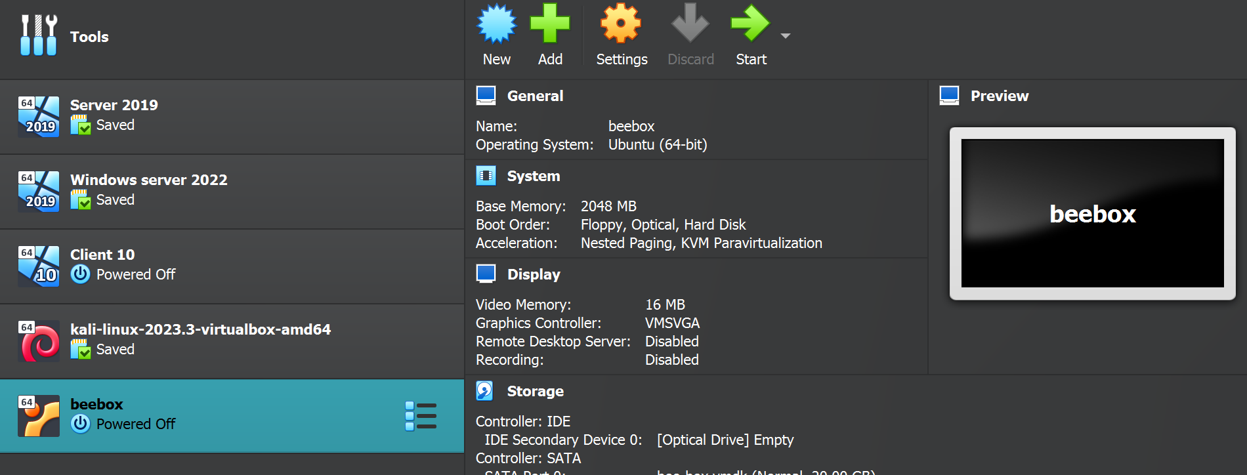
- Infrastructure requirements: For this setup, I used a virtual box as my virtual environment

- Virtualization Platform: Kalil Linux, Windows 10, beebox
- Virtual Machines: Kali Linux is the attacker machine, Windows 10 machine, metasploit2, and bbox, are the victim machines.

- Setting up Virtual machines: Installed and configured all virtual machines with operating systems
- Configure operating system: Kali Linux was assigned 4GB RAM, 2CPU, and 100GB HDD. This version of Linux always comes with pre-configured tools, but I will install more tools like Nessus, OpenVAS, Nexpose, Metasploit, and Burp Suite will be installed and configured.
- Test connectivity: ensuring there’s connectivity among all Virtual machines.
- Implementation of security measures: Conduct a vulnerability assessment to check the level of vulnerabilities in the system.
- Documentation: All steps of this vulnerability testing will be documented, and an executive summary report will be presented to the Executives of the company.

PENTEST FRAMEWORKS

I have adopted the OWAPS Top 10 standards and MITRE ATT&CK framework for this testing. It explains different security risks and vulnerabilities in web applications
The following weaknesses are known vulnerabilities in web applications

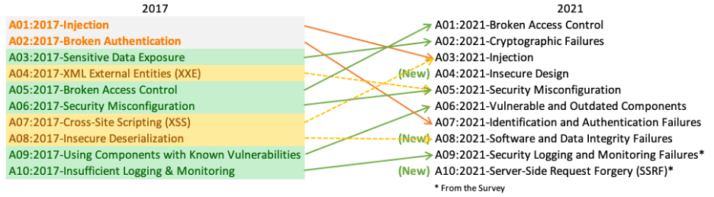

Figure 1. OWAPS Top 1o web application risk framework

COBOLT Strike
Cobalt Strike: is a command and operations framework often used by the red team for testing vulnerabilities in a network. Features of this framework include adversary simulations, incident response guidance, and social engineering capabilities. This framework helps the red team to understand the behaviors of cyber attackers.
The difference between the Cobalt strike framework and other frameworks is that it provides more in-depth insights between the attack tools and the targeted systems, this is why cobalt strike is often preferred by pen-testers who want to do a full scope testing and assessment of a system.

3.4.1 Features of this framework include
- Reconnaissance: Finding information about the target client-side application and version information
- Post Exploitation: analyzing different payloads on the target system using PowerShell scripts, logs keystrokes, etc.
- Spear phishing: cobalt strike can generate a phishing link from an imported message, and help create a convincing phishing attack. It sends the email and tracks who clicks the link.
- Attack Packages: A cobalt strike can host a web drive-by attack or can convert any file into a trojan horse.
- Convert Communication: it uses HTTP, HTTPS, and DNS to egress a network, it can replicate another actor or system.
- Browser Pivoting: uses a pivot on its browser to breach a two-factor authentication to access sites as a target.

Metasploit Framework
Metasploit Framework (Metasploit Pro) is a framework developed by Rapid7 containing over 1,500 exploits, with Network data discovery, scan imports, and advanced automation features if you're using the Pro version. It also has a free and open-source version. It is used mainly by ethical hackers, penetration testers, and cybersecurity professionals to identify and exploit vulnerabilities in a system.

Key components of this framework include:
Structured modular framework: users can easily extend their capabilities by developing new modules or by using existing ones.
- Exploits: a piece of scripts that affect the behavior of vulnerabilities in target systems.
- Payloads: code that is executed on the target system after a successful exploit
- Auxiliary Modules: supports the pen testing processing starting from information gathering, scanning, and vulnerability detection.
- Post-Exploitation: it indicates the necessary actions to be taken after a successful exploitation.

Figure 2. Metasploit architectural models

Penetration Testing Execution Standard (PTES)
It is a collection of information security experts from different organisations. It provides a well-structured approach to performing penetration testing, ensuring consistency and completeness in the testing process. This framework aims to provide a standard methodology that supports cybersecurity experts in conducting effective penetration testing
It has features like Intelligence gathering and threat modeling, Vulnerability research, Exploitation, and post-exploitation support.

The Open-Source Security Testing Methodology Manual (OSSTMM)
It is a framework owned by the Institute for Security and Open Methodologies (ISECOME).
Features include Security test scoping, Rules of engagement and error handling, and Support for results disclosures.

NIST Cybersecurity Framework
This framework focuses on best practices, standards, and guidelines for cybersecurity risks. It adopts the Identify, Protect, Detect, Respond, and Recover approach. Because of its broadness, it can be a guideline for different cybersecurity tests and compliance audits.

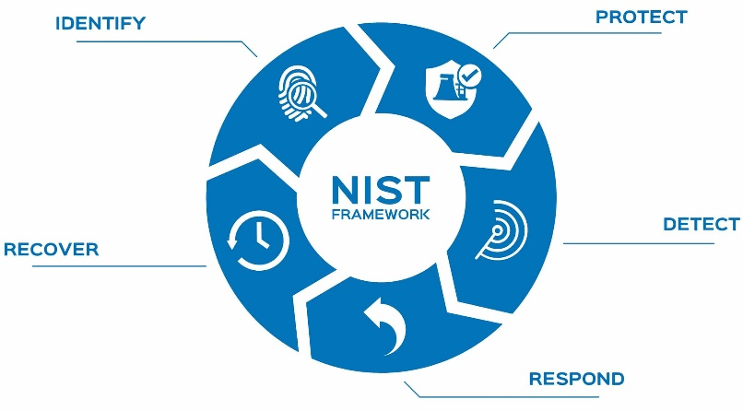

Figure 3. NIST Cybersecurity framework approach

MITTRE ATT&CK TACTICS
MITTRE ATT&CK is a security framework adopted by security experts and organisations to enhance their threat intelligence, improve detection and response capabilities, and to further strengthen their security defense capacity. It consists of Tactics, Techniques, Procedures, and Mitigations.
Below is a screenshot taken from the MITTRE ATT&CK website, showing the different attack tactics implored by attackers to exploit network infrastructures, all over the world.

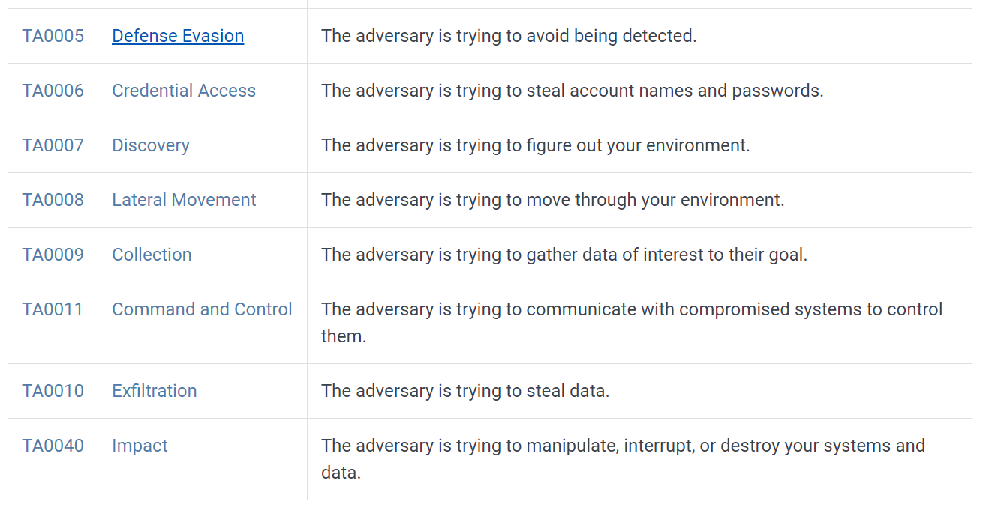
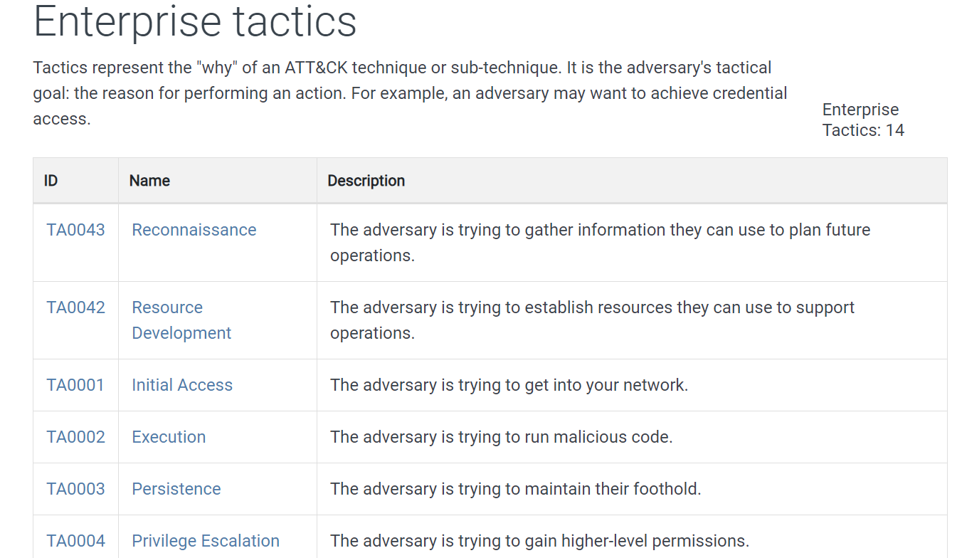

Figure 4. MITTRE ATT&CK Enterprise attack techniques

SIMULATION PROCEDURES
As the Red Team Engineer, my objective is to conduct a full-scope cybersecurity attack and vulnerability assessment of CPC network infrastructures.
The following phases will be adapted to meet the goals of this simulation

4.1. Planning and Scoping:
The scope of this simulation is to conduct a multi-layered, full-scope cyberattack simulation on CPC’s systems and infrastructure. The goal is to implement a virtualized replica of the production environment and actively analyse for design weaknesses, technical flaws, and vulnerabilities, Identifying target systems and critical assets.

4.2. Reconnaissance (MITRE ATT&CK Tactics: Discovery):
I Gathered information about the target organization using open-source intelligence (OSINT) and identified potential targets, employees, technologies in use, and public-facing information. Information on the company's website, social media, blogs, etc will be considered. (T1119). I was to develop a password combination from their birthdays, social posts, family reunions, place of birth, etc,

4.3. Vulnerability Analysis (MITRE ATT&CK Tactics: Initial Access):
I identified and analyzed vulnerabilities using tools like Nessus or OpenVAS.

4.4. Social Engineering (MITRE ATT&CK Tactics: Initial Access):
I performed a phishing campaign and my target was the employees (T1566).
I implored the MITRE ATT&CK technique Spear phishing Attachment (T1566.001) to deliver malicious payloads.
4.5. Exploitation (MITRE ATT&CK Tactics: Execution): from the information gathered and the vulnerabilities discovered, I utilized different tools to exploit the vulnerabilities, using tools like Metasploit or Cobalt Strike to gain access (T1204).

4.6. ATTACKS

4.6.1. Malware Attacks (MITRE ATT&CK Tactics: Execution, Defense Evasion):
I deployed malware using MITRE ATT&CK techniques such as PowerShell (T1086) or Scripting (T1064). Testing the organization's ability to detect and respond to malicious activities (T1553).

4.6.2. Insider Attacks (MITRE ATT&CK Tactics: Credential Access, Privilege Escalation):
Simulated attacks from within the network, using compromised credentials identified from the system(T1110). I tested the effectiveness of internal security controls and monitoring (T1550).

4.6.3 DDoS Attacks (MITRE ATT&CK Tactics: Impact):
I simulated a DDoS attack using tools like LOIC or Hping, this determined the company's ability to detect and mitigate DDoS attacks (T1498).

4.6.4. Data Breaches (MITRE ATT&CK Tactics: Exfiltration):
Attempted to exfiltrate sensitive data using techniques like Data Exfiltration Over Command-and-Control Channel (T1041). Evaluating data loss prevention (DLP) tools and incident response procedures (T1565).
4.7. Reporting: A detailed report will be developed, explaining all findings processes, attacks, and vulnerabilities discovered in the system, indicating necessary recommendations for mitigations and improvements based on the assessment.
4.8. Mitigations: necessary mitigations will be implemented based on MITRE ATT&CK recommendations. Adopting more sophisticated security controls, patches, and software updates and educating employees on security best practices.
4.9. Continuous Improvement: Iterate and refine security practices based on MITRE ATT&CK knowledge.

SIMULATION REPORT

5.1. Executive Summary:
This penetration testing engagement was aimed at simulating a multi-layered, full-scope cyberattack on Curetor Pharmaceutical Company's systems and infrastructure. From the assessment, I was able to identify several vulnerabilities, including phishing attacks, web application vulnerabilities, misconfigured firewalls, and malware vulnerabilities. The findings and recommendations presented in this report are intended to support Curetor Pharmaceutical Company in strengthening and hardening its cybersecurity defenses.

5.2. Scope:
The scope of this penetration test covered Curator CPC and infrastructure, including Web servers, network devices, web applications, and endpoints.

5.3. Vulnerability Assessment:

5.3.1. Phishing Attacks:
Techniques: conducted social engineering attacks to simulate phishing attempts. By utilizing a tool called SET (Social-Engineer Toolkit) for crafting and sending phishing emails.
Outcome: I was able to perform a phishing attack by sending a phishing email to one of the employees of the company, and successfully identified employees susceptible to phishing attacks.
Gathered sensitive information through simulated phishing campaigns.

5.3.2. Web Application Vulnerabilities:
Techniques: Employed OWASP ZAP (Zed Attack Proxy) for automated scanning of web applications, and conducted manual testing for identifying injection and cross-site scripting (XSS) vulnerabilities.
Outcome: I discovered SQL injection vulnerabilities in the login page. Detected multiple instances of XSS vulnerabilities in user input fields.

5.3.3. Misconfigured Firewalls:
Techniques: conducted port scanning using Nmap to identify open ports, and employed automated tools like Nessus for firewall rule analysis.
Outcome: Identified several open ports with misconfigured firewall rules, allowing unnecessary access. Detected default configurations on critical network devices.

5.3.4. Malware Vulnerabilities:
Techniques: Employed Metasploit framework for exploiting known malware vulnerabilities, and utilized YARA rules to identify potential malware signatures.
Outcome: Successfully exploited outdated software on endpoints, and Identified systems with malware-like behavior through YARA rule matches.

5.4. Exploitation and post-exploitation:

5.4.1 Exploiting Phishing Attacks:
Commands and Tools: SET commands for crafting and sending phishing emails.
Credential harvesting with captured credentials stored securely.

5.4.2 Exploiting Web Application Vulnerabilities:
Commands and Tools:
ZAP automated scans and manual testing using SQLmap.
Exploitation using SQL injection techniques, gaining unauthorized access.

5.4.3 Exploiting Misconfigured Firewalls:
Commands and Tools: Nmap for port scanning.
Nessus for firewall rule analysis. Exploitation using identified open ports for unauthorized access.

5.4.4 Exploiting Malware Vulnerabilities:
Commands and Tools:
Metasploit framework for exploiting known vulnerabilities.
YARA rules for malware signature identification.
Exploitation leads to unauthorized access and data exfiltration.

5.5. Recommendations:
- CPU must Implement regular cybersecurity awareness training for employees to recognize and report phishing attempts.
- Conduct a comprehensive review of web applications for security vulnerabilities, applying necessary patches and secure coding practices.
- Conduct a thorough firewall configuration review, closing unnecessary ports and tightening rules to minimize attack surfaces.
- Keep software and systems up to date, regularly patching and updating to mitigate known vulnerabilities.
- Deploy and maintain advanced threat detection and prevention solutions to identify and stop potential malware attacks.

5.6. Conclusion:
This penetration testing engagement revealed critical vulnerabilities in Curetor Pharmaceutical Company's systems, emphasizing the importance of implementing robust cybersecurity measures. The recommendations provided aim to enhance the overall security posture and resilience against potential cyber threats. Regular testing and proactive security measures are essential to safeguarding the organization's sensitive data and maintaining a secure environment.

SOLUTION IMPLEMENTATION

6.1 INVOICE

Delta Pen-Test Security
Professional Service Invoice
Invoice Number: DPST-2024-009
Date: 04/01/2024
Due Date:20/01/2024
Currency: British Pounds (GBP)

Address: 20 Bank Hall Road, Manchester
Phone: 0754678902
Email: deltap@gmail.com

S/N | Service Description | Quantity | Unit Price | Total
1. | Red Team Security Assessment  exploitation, and post-exploitation) | 1 | [£100/hrs.]  [10 hours] | £1000
2. | Mitigation Tools and Software (Snort) | 2 | £5000 | £10000
3. | Firewall Solutions (Cisco Firepower) | 1 | £7,000 | £7,000
4. | Intrusion Detection and Prevention (IDPS) CrowdStrike Falcon | 2 | £10,000/Year | £20,000
5. | Intrusion Prevention System (IPS)  CrowdStrike Falcon | 1 | £5000 | £5000
6. | Patch Management Tools  (Microsoft WSUS) | 2 | £2000 | £4000
7. | Endpoint Protection Tools  (Symantec Endpoint Protection) | 1 | £2500 | £2500
8. | Training and Consultation | 1 | £1500 | £1500
9. | Security Awareness Training  (4 hours) | 1 | £2000 | £2000
10. | Cost of Implementation | 1 | £3000 | £3000
11. | Security Configurations Setup  (5 hours) | 1 | £1000 | £1000
 | Subtotal  VAT (20%)  Total |  |  | £57000.00  £11400  £68400.00

6.2 Security Configuration Settings:

6.2.1 Network Segmentation:
- Configuration Setting: I will Implement VLANs and Access Control Lists (ACLs).
Description: Segregate the network into segments to limit lateral movement in case of a breach.
Mitigation Technique: Isolate critical systems, and control communication between segments.
- Least Privilege Access:
Configuration Setting: I will enforce the principle of least privilege.
Description: Limit user and system access rights to the minimum necessary for performing job functions.
Mitigation Technique: Reduce the attack surface, and prevent unauthorized access.
- Regular Security Audits:
Configuration Setting: Schedule routine security audits.
Description: Regularly assess and audit configurations, policies, and access controls.
Mitigation Technique: Identify and remediate misconfigurations and vulnerabilities

6.3. Timetable for Execution:
TASK DESCRIPTION | DURATION | DATE AND TIME OF EXECUTION
Vulnerability Assessment | 10 hours | 10/01/2024
Configuration | 9 hours | 10/01/2024
Implementation | 15 hours | 11/01/2024
Testing | 5 hours | 12/01/2024
Training | 4 hours | 13/01/2024
Review report | 2 hours | 14/01/2024

Each vulnerability identified will be analysed and mitigated according to the exploitation level
Implementation Schedule: The implementation will involve configuration, software patch, firewall rules setup, and Endpoint management implementation
Testing: Each fix will be thoroughly tested in a controlled environment before applying to the production network.
Training: Training sessions for IT staff and end-users on the new security measures will be done in batches.

CONCLUSION
An essential component of cybersecurity is ethical hacking, which gives organizations a proactive way to find and fix vulnerabilities before bad actors can take advantage of them. There are many advantages to ethical hacking, from thorough vulnerability assessments to encouraging a culture of ongoing cybersecurity measure improvement. Beyond just reducing immediate threats, ethical hacking affects how resilient organizations are overall to the constantly changing world of cyberattacks. Ethical hacking continues to be a vital weapon in the toolbox of cybersecurity experts as technology develops, greatly assisting in the preservation of a safe online environment and the safeguarding of digital assets.

REFERENCES

G. Jayasuryapal, P. M. Pranay, H. Kaur and Swati, "A Survey on Network Penetration Testing," 2021 2nd International Conference on Intelligent Engineering and Management (ICIEM), London, United Kingdom, 2021, pp. 373-378, doi: 10.1109/ICIEM51511.2021.9445321.
G. R. K. Rao, V. V. Battu, V. Anupama, A. Allada, S. V. R. Krishna and C. Hema, "Modern Progressive Pitfalls of Cyber Attacks on the Digital World," 2023 2nd International Conference on Edge Computing and Applications (ICECAA), Namakkal, India, 2023, pp. 244-248, doi: 10.1109/ICECAA58104.2023.10212303.
H. M. Z. A. Shebli and B. D. Beheshti, "A study on penetration testing process and tools," 2018 IEEE Long Island Systems, Applications and Technology Conference (LISAT), Farmingdale, NY, USA, 2018, pp. 1-7, doi: 10.1109/LISAT.2018.8378035.
Johnson, M. B. (Year). "Securing Digital Assets: The Role of Ethical Hacking." International Journal of Information Security, Volume(Issue), Page Range. DOI/Publisher.
Smith, J. A. (Year). "Ethical Hacking: Enhancing Cybersecurity Defenses." Journal of Cybersecurity Research, Volume(Issue), Page Range. DOI/Publisher.
“2022’S 4 Most Common Cyberattack Patterns.” Security Intelligence, securityintelligence.com/articles/most-common-cyberattack-patterns-2022/.
“Foresiet | Secure the Future.” Foresiet - Digital Risk Protection Platfrom | Artificial Intelligence Based Cybersecurity, foresiet.com. Accessed 5 Jan. 2024.
Jayasuryapal, G, et al. “A Survey on Network Penetration Testing.” 2021 2nd International Conference on Intelligent Engineering and Management (ICIEM), 28 Apr. 2021, https://doi.org/10.1109/iciem51511.2021.9445321.

- Kandasamy, Kamalanathan, et al. “Digital Healthcare - Cyberattacks in Asian Organizations: An Analysis of Vulnerabilities, Risks, NIST Perspectives, and Recommendations.” IEEE Access, 2022, pp. 1–1, https://doi.org/10.1109/access.2022.3145372.
- Kaspersky. “LockBit Ransomware — What You Need to Know.” Www.kaspersky.com, 13 Jan. 2021, www.kaspersky.com/resource-center/threats/lockbit-ransomware.
- McCroskey, Kelsey . “Prospect Medical Holdings Failed to Protect Private Data from Hackers, Class Action Says.” Www.classaction.org, 19 Oct. 2023, www.classaction.org/news/prospect-medical-holdings-failed-to-protect-private-data-from-hackers-class-action-says#:~:text=As%20the%20case%20tells%20it%2C%20a%20ransomware%20group. Accessed 4 Jan. 2024.
- MITRE. “MITRE ATT&CK^{TM.}” Mitre.org, 2023, attack.mitre.org/.
- Muncaster, Phil. “Toyota Halts Production across Japan after Ransomware Attack.” Infosecurity Magazine, 1 Mar. 2022, www.infosecurity-magazine.com/news/toyota-production-japan-ransomware/.
- OWASP. “OWASP Top Ten.” Owasp.org, OWASP, 2021, owasp.org/www-project-top-ten/.
- “Royal Mail Cyberattack Linked to LockBit Ransomware Operation.” BleepingComputer, www.bleepingcomputer.com/news/security/royal-mail-cyberattack-linked-to-lockbit-ransomware-operation/.
- Shi, P., et al. “The Penetration Testing Framework for Large-Scale Network Based on Network Fingerprint.” IEEE Xplore, 1 July 2019, ieeexplore.ieee.org/document/8805839.

