

Postgraduate/Distance Learning
Assignment coversheet & feedback form

THIS SHEET MUST BE THE FIRST PAGE OF THE ASSIGNMENT YOU ARE SUBMITTING (DO NOT SEND AS A SEPARATE FILE)

For completion by the student:
Student Name:
Danielle Marie Goldstein
Module code: HPCA7009  Module title: Skyscapes, Cosmology and Archaeology | Student ID number: 1710933 |  |  | Educational support needs:  No
Module tutor: Bernadette Brady

Assignment due date: July 20th, 2020
If your module has multiple submissions, please indicate which piece of work this is.

1st 2nd X 3rd 4th 5th 6th
I confirm that this is my original work and that I have adhered to the University policy on plagiarism.
Signed Danielle Marie Goldstein
Email submission: if you are submitting this form via email, please tick this box X
(as a substitute for your signature) to confirm that you agree to the above declaration.
Assignment Mark
1st Marker’s Provisional mark
2nd Marker’s/Moderator’s provisional mark
Agreed Internal Mark:

External Examiner’s mark (if relevant)
Final Mark

NB. All marks are provisional until confirmed by the Final Examination Board.

For completion by Marker 1:
Comments:

Marker’s signature: |  |  | Date:
For completion by Marker 2/Moderator:

Comments:

Marker’s Signature: |  | Date:
AGREED INTERNAL MARK (where necessary):

Comment on process of arriving at agreed mark:

External Examiner’s comments (if relevant)

External Examiner’s Signature: |  | Date:

Astronomical Iconography at Temple of Khnum
Introduction
The aim of this research project was to examine the astronomical iconography at the Temple of Khnum while conducting simple measurements with the Egyptian skyscapes in mind. A comparison will be offered through considering the northern and southern locations of the temple, discussing the lunar and solar journeys depicted on the ceiling, as well as the significance of the four winds. Through an observation of the sky, people have been able to find their place in time and space, and their relationship to the cosmos. Cosmos comes from the Greek word kosmos, meaning an intelligible order demonstrating beautiful harmony. Nicholas Campion defined the Egyptian religious system as a cosmothesism, suggesting that the cosmos itself was the object of worship, as each deity had a function and a place in the cosmic order, where the movements of the sun, moon, and stars were the focus of ritual, and the basis of the sacred Egyptian calendar. The rhythm of death and rebirth was daily, in preparation for the great transition into the afterlife as noted in The Ancient Egyptian Pyramid Texts, which contain the oldest body of Egyptian religious writings. Through the study of archaeoastronomy scholars have been able to learn how the Ancient Egyptians measured time, how they created their calendars, how they orientated their sacred structures according to religious regulations, and how they mapped the sky for guidance. Skyscapes, which was termed by Fabio Silva in response to the field of archaeoastronomy, was defined as an indigenous conceptual framework that constitutes a people’s understanding of the sky and those that live within it, including how they related to their culture’s beliefs and practices with consideration of time and space, and to their structure and material culture.

Locating Temple of Khnum: physically, temporally, and cosmically
Temple of Khnum is located within Upper Egypt, about fifty-five kilometres south of modern day Luxor, and lies just west of the Nile River in the town of Esna. Ancient Egyptians called Esna Lunyt, also known as Iunyt, or Ta-senet, sourced from the Arabic Isna and the Coptic Sne. This temple contains archaeological evidence dated from as early as the Middle Kingdom of Ancient Egypt, however it was well known as an important cultural centre in the Ptolemaic Period; and what exists of the temple in modernity was built during the Graeco-Roman period of Egypt. Neugebauer and Parker dated this temple as Vespasian-Domitian from about 100 CE. A unique characteristic of this temple is that it is approximately nine meters below sea level, therefore remains of this ancient site lie beneath the houses and businesses of Esna, and these establishments have yet to be excavated. The hypostyle hall was built from red sandstone.
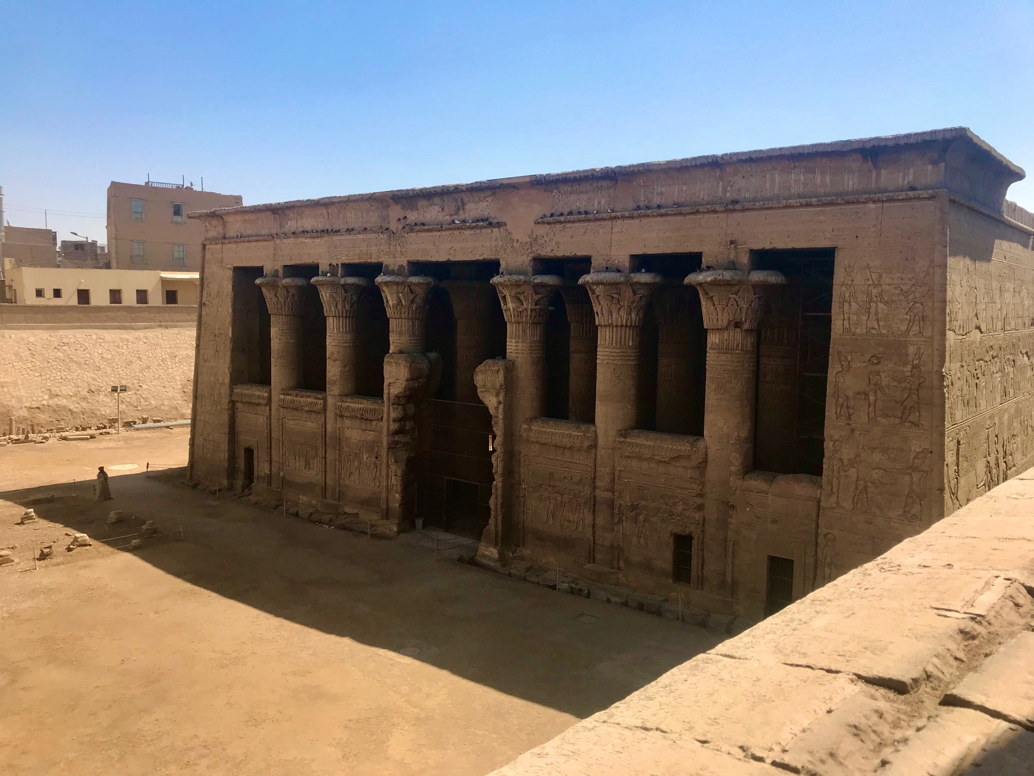
Figure 1 Danielle Marie Goldstein, Temple of Khnum view from street, 18 April 2019, Digital Photograph
Temples in Ancient Egypt were manifestations of the divine, a defined space where the sacred took form, symbolizing a beautiful organization of the cosmos. The layout of any given temple was a map of the divine origins of creation, and rarely varied, although slight modifications would take form to honour local cults. From the New Kingdom onwards, the temple was an icon of the primordial mound from which creation rose; the floor represented the earth from which vegetation blossomed, and the ceiling was decorated with stars or astronomical images. Hypostyle halls were a common theme that were designed to be positioned directly after the temple’s open court, which were quite often deep, and filled with columns. Like other features of the temple, these columns were created for symbolic purposes, perhaps representing cosmic pillars holding up creation on earth to extend to the heavens, or the marshland vegetation sourced from the primordial waters. During the Roman occupation of Egypt, there was a clear attempt to control Egyptian culture both politically and economically, however the religion was free to flourish. Some scholars have agreed that what remains of the Temple of Khnum was similar to other Ptolemaic temples; that these temples may serve as some of the best evidence for the whole tradition of temple decoration and worship in Ancient Egypt, as the majority of the temples built in earlier periods disappeared, and that a temple that was built during Roman times was not much different from one built in the peak of Egyptian rulership. Temple of Khnum displays layers upon layers of creation mythology and cosmology that includes texts on the walls, calendars on the pillars, and astronomical iconography on the ceiling. It was dedicated to the ram god Khnum, who was a creator god known for giving form to both gods and men on his potter’s wheel. The theme of creation was also symbolized through the ‘seven creative words’ of Neith, Khnum’s consort and a creator goddess. The texts on the walls found at Esna pointed to Khnum as creator of the world, one who kept the cosmos in order, ‘He places the four sides of heaven’.

Looking Up: Lunar and Solar Journeys
The iconography dedicated the northern ceiling to the lunar night-sky, meanwhile the southern part of the ceiling was devoted to the solar day-sky. For the Ancient Egyptians, the lunar cycle was very significant, as the early calendar began with the lunar month when the old crescent of the waning moon could no longer be seen just before sunrise in the east. More specifically, the new month was marked by the completely blacked out moon when the sun and moon married. The lunar year was divided into three four month seasons based around the flooding of the Nile, which influenced the planting and harvest of crops. Thoth, the god of knowledge, wisdom, and writing was associated with the lunar cycle, sourced from the Coffin Texts Spell 156, ‘I know, O souls of Hermopolis, what is small on the 2nd day and what is great on the 15th day; it is Thoth’. Priskin noted Thoth’s ties to the moon as being the preeminent lunar god. Temples like Edfu, Dendera, and Esna contain aspects or portions of the lunar cycle, however according to Priskin’s study of these temples, there was a complexity of the lunar cycles, as they contradicted from temple to temple. He found connections between the evening sun and the what the Egyptians considered as the first half of the lunar cycle, which would depict the moon waxing from new to full, deeming this cycle as an ‘evening event’ that was primarily tied to the direction of the west, as the waxing moon sets on the west. Therefore the waning of the moon was a ‘morning event’ connected to the solar cycle, an eastern phenomenon, as the waning crescent moon would rise in the east.

The most northern section of the seventh strip of the ceiling, as shown in figure two is three strips north of the centre strip, containing fourteen figures on lunar circles, depicting the moon waxing, with the wedjat eye growing on the side of the disk, finally showing completion as the wedjat eye is in a full lunar circle over the sun. Thoth is also seated, holding the wedjat eye over the full moon symbol. The wedjat was the lunar eye that Thoth restored to wholeness. Just below the waxing phase is the second part of the lunar cycle, the waning moon with the focus to the east. This most northern register of the ceiling depicted the lunar cycle in its entirety, combining the elements of lunar processions, lunar staircases, the barques of lunar opposition and conjunction. Just one strip below this was what Neugebauer and Parker termed Esna C, which contains the southern constellations of Orion and Sirius located in the southern part of this register, meanwhile the Hippo and other northern constellations are located on the northern part of this strip. When considering the appearance of Thoth, the location of the waxing phase of the moon in the very northern section of the ceiling, and Esna C’s location of night-time constellations, one may conclude that the Ancient Egyptians defined the northern ceiling of this temple as being dedicated to the moon’s journey through the phases and the evening sky.

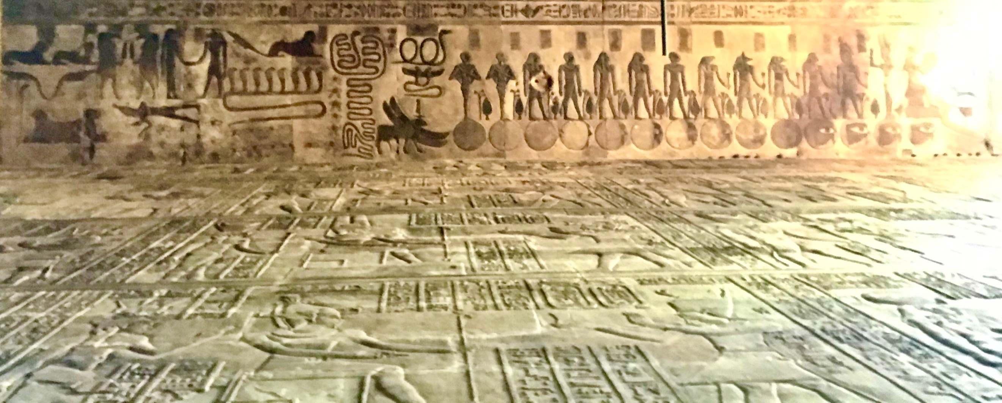
Figure 2 Danielle Marie Goldstein, Ceiling of Temple of Khnum (most northern strip), 15 February 2020, Digital Photograph
The southern section of the ceiling was decorated with the zodiac and representations of the star vault, planets, and constellations. Zodiac could be defined as a belt of stars in the path of the sun, as the word originates from Greek, meaning figures of animals. Although it was sourced from Babylonian culture, the zodiac on the ceiling of Esna contained specific Egyptian artistic renditions. Zodiacs were found from the Ptolemaic period onward, occurring alone, or in association with the planets, constellations, decans, and other mythological figures including the four winds. The decans were a division of the sphere of fixed stars that subdivided the zodiac signs, that were hour regulating, and that the decans at this temple were quite significant. As one looks up, two strips south of the centre register Neugebauer and Parker termed Esna B is framed at either end by the bending figure of Nut, the sky goddess. The register below this one, at the very southern section of the ceiling also depicts two images of goddess Nut. In Esna B the full zodiac is denoted, ranging from Aries to a Taurus bull running, Gemini represented as a man wearing an animal tail and a woman both looking toward the bull, the lion of Leo, Virgo as a woman wearing a while crown with an ear of corn, Libra as a woman holding scales, Scorpio as a scorpion, Sagittarius symbolized as the archer, Aquarius features a standing man pouring water from two vessels, and the two fish of Pisces. The Cancer crab sits to the left, essentially to the east of a four-winged wind creature. While Cancer, the zodiacal sign that marks Summer Solstice sits in the southeastern section of Esna B, the Capricorn seagoat, the zodiacal sign that marks the Winter Solstice is in the northwestern part of this register. The location of these solstice points further defines the emphasis that every image placed on the temple was done with cosmology in mind. Each year the sun reaches its zenith at the Summer Solstice. For the Egyptians the significance of this time of year may be traced back to approximately 3000 BCE to the remains of Nabta Playa, when this solstice point marked the arrival of necessary summer rains for livestock and plants gathered. The latitude of Egypt marked that Re, the sun god of Ancient Egypt was reborn annually each year at Winter Solstice.

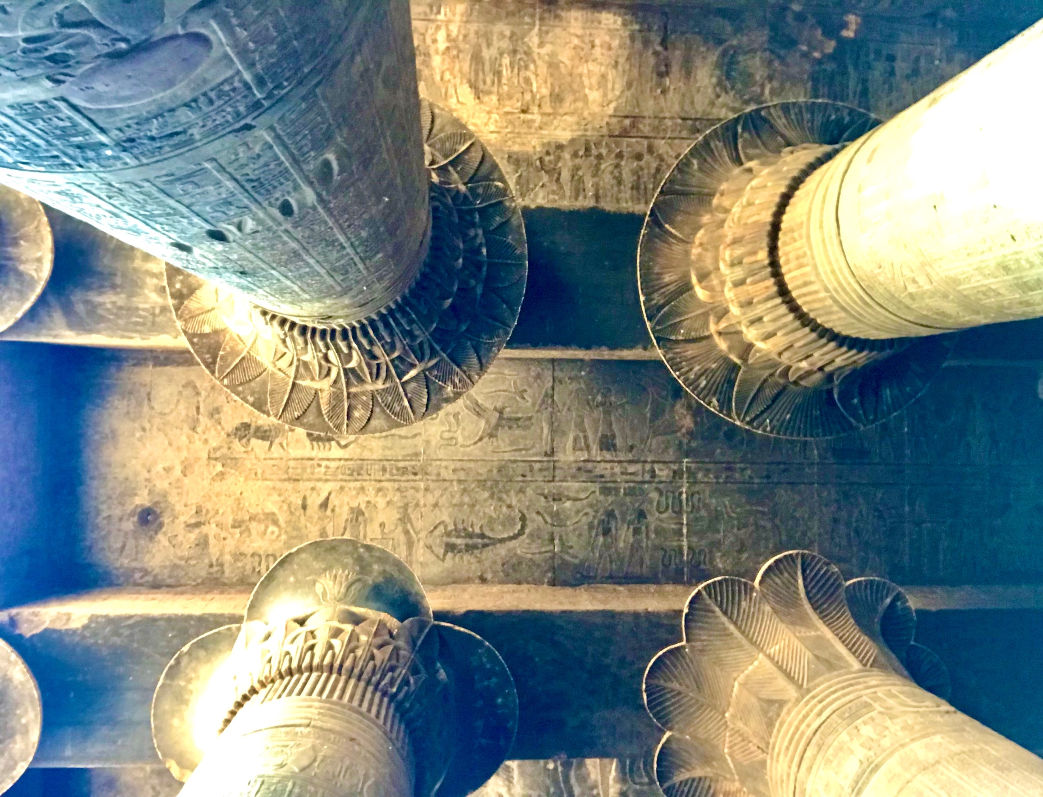
Figure 3 Danielle Marie Goldstein, Temple of Khnum, Esna B Ceiling (2nd register from South), 18 April 2019, Digital Photograph
The western half of Esna B has an expanded decan list, some constellations or mythological figures interspersed, and in addition to the luminaries, the Sun and the Moon, three planets were carved and displayed in their exhaltations, namely Jupiter in Cancer, Saturn in Libra, and Mars in Capricorn. With the knowledge that the southern section of the ceiling contains the zodiac, the planets in their exhaltations, the decans, the solstice points marking the rebirth and zenith of the Sun, and goddess Nut whom marked the journey of the sun being birthed each sunrise from her womb and swallowed each sunset through her mouth, one may conclude this imagery was placed in these locations to symbolize the daily journey of the Sun, with Re traveling upon his Solar Bark, which contrasted with the northern section of the ceiling’s imagery dedicated Thoth, and the nightly journey of the Moon.

The Four Winds at Esna
In the Graeco-Roman period fantastic creatures coined the four winds appeared to mark the orientation of scenes by their location, particularly at Esna A (a destroyed temple north of Khnum Temple which was also dedicated to the god Khnum), Armant, Dendera, and Heter. As discussed previously, the texts on the walls found at Temple of Khnum were quite extensive, and in addition to the mythology of Khnum they contained specific writings about the four pillars of the sky, invoking the significance of the four sides or four corners referring to the symbolic nature of the four cardinal points, which denoted the universal power of creation. The concept of four sides, four corners, four directions, and the four cardinal points equates to the imagery of the four winds. Scott Noegel found that for the Ancient Egyptians the four winds were personified as winged beings that brought the four cardinal directions to life, referenced in the Pyramid Text in Spell 340, and that winds and wings were interconnected in their importance, as the wings represented birds taking flight by utilizing the force of wind, while the flapping of the wings created wind. The Coffin Texts declared that the four winds were under the dominion of Shu, the god of wind and light, who was often connected with an image of a feather, or at times depicted with a symbol that represented the four pillars that stood on the four corners of earth. Sourced from Spell 161 of the Book of the Dead, each wind originated from a separate opening of the sky. Christian Jacq outlined in the text Egyptian Magic that to pass through the four frontiers of the sky, the seeker must recite the words of those who dwelt in secret places to the guardians. In Egyptian cosmology, each wind could be connected to a deity. A secret incantation that was to only be performed in private ritual, from the Book of the Dead Spell 161 scribed an incantation for breaking an opening into the sky, one for each direction; the Northwind for Osiris, the Southwind for Re, the Eastwind for Nephthys, and the Westwind for Isis. Noegel noted that the inherent creative power of the four winds allowed priests to invoke them to resuscitate the deceased in the afterlife, thereby the winds were healing, protective, and enlivening, a pure force that drew down order. These four winds were like supergods that worked with heka. Heka known as magic, was beyond any single event, as it was anchored in the creation cycle being re-enacted each morning at sunrise, both life affirming and destructive; this force animated and permeated the cosmos, was buried within gods, humans, animals, plants, and stones.

The Northwind, kbwy was represented with four ram heads, the Southwind, shb.wy was represented with a lion’s head, the Eastwind, hnw-szs.wy was represented with a ram head or the body of a scarab, and Westwind, hdy.wy was represented with a snake’s head. According to Noegel, the winds would appear having the body of a man, the head of animal, and bearing four wings. At Temple of Khnum four winds do indeed appear in the four corners of the ceiling, however, they do not take human form. An image of the Northwind was crafted as shown in figure two, looking up in the northwest corner behind the dark moon a four-winged animal body with what appears to be a ram’s head carrying a feather on top was crafted, perhaps offering a connection to Shu. Figure four shows the northeast corner depicting a scarab with four wings, an image of the Eastwind.

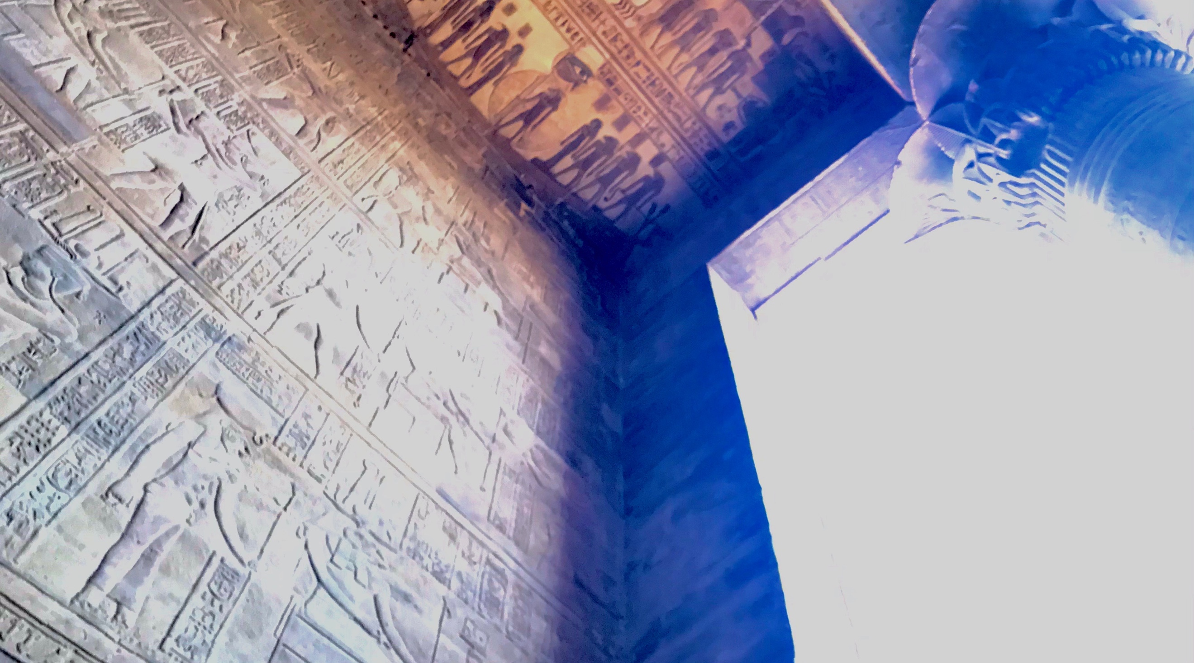
Figure 4 Danielle Marie Goldstein, Temple of Khnum, Northeast corner of ceiling, 15 February 2020, Digital Photograph
The southeast corner depicts a four-winged animal body with what appears to be a lion’s head as the Southwind makes the most logical sense, however it is unclear. Just above this wind is a human figure with four ram heads as seen in figure five. The southwest corner hosts an avian creature with four wings, as shown in figure six representing most likely the Westwind. In figure three, between the zodiacs of Gemini and Cancer is another wind surrounded by a number of serpents, which Neugebauer and Parker named the Westwind. Both serpents and birds were connected to goddess Isis, who had dominion over the Westwind. The four winds were a primordial power that when combined represented the totality of divine forces that enlivened one in the afterlife. Through a division of the earth from the heaven, these four winds united to create the universe. As one became identified with the four cardinal points, they became the cosmos—knowing the laws of creation with the ability to capture invisible powers and direct them at will. The presence of the winds at this temple enforces the creation mythology, and perhaps is also offering an allegory of power as to how to navigate the cosmos.

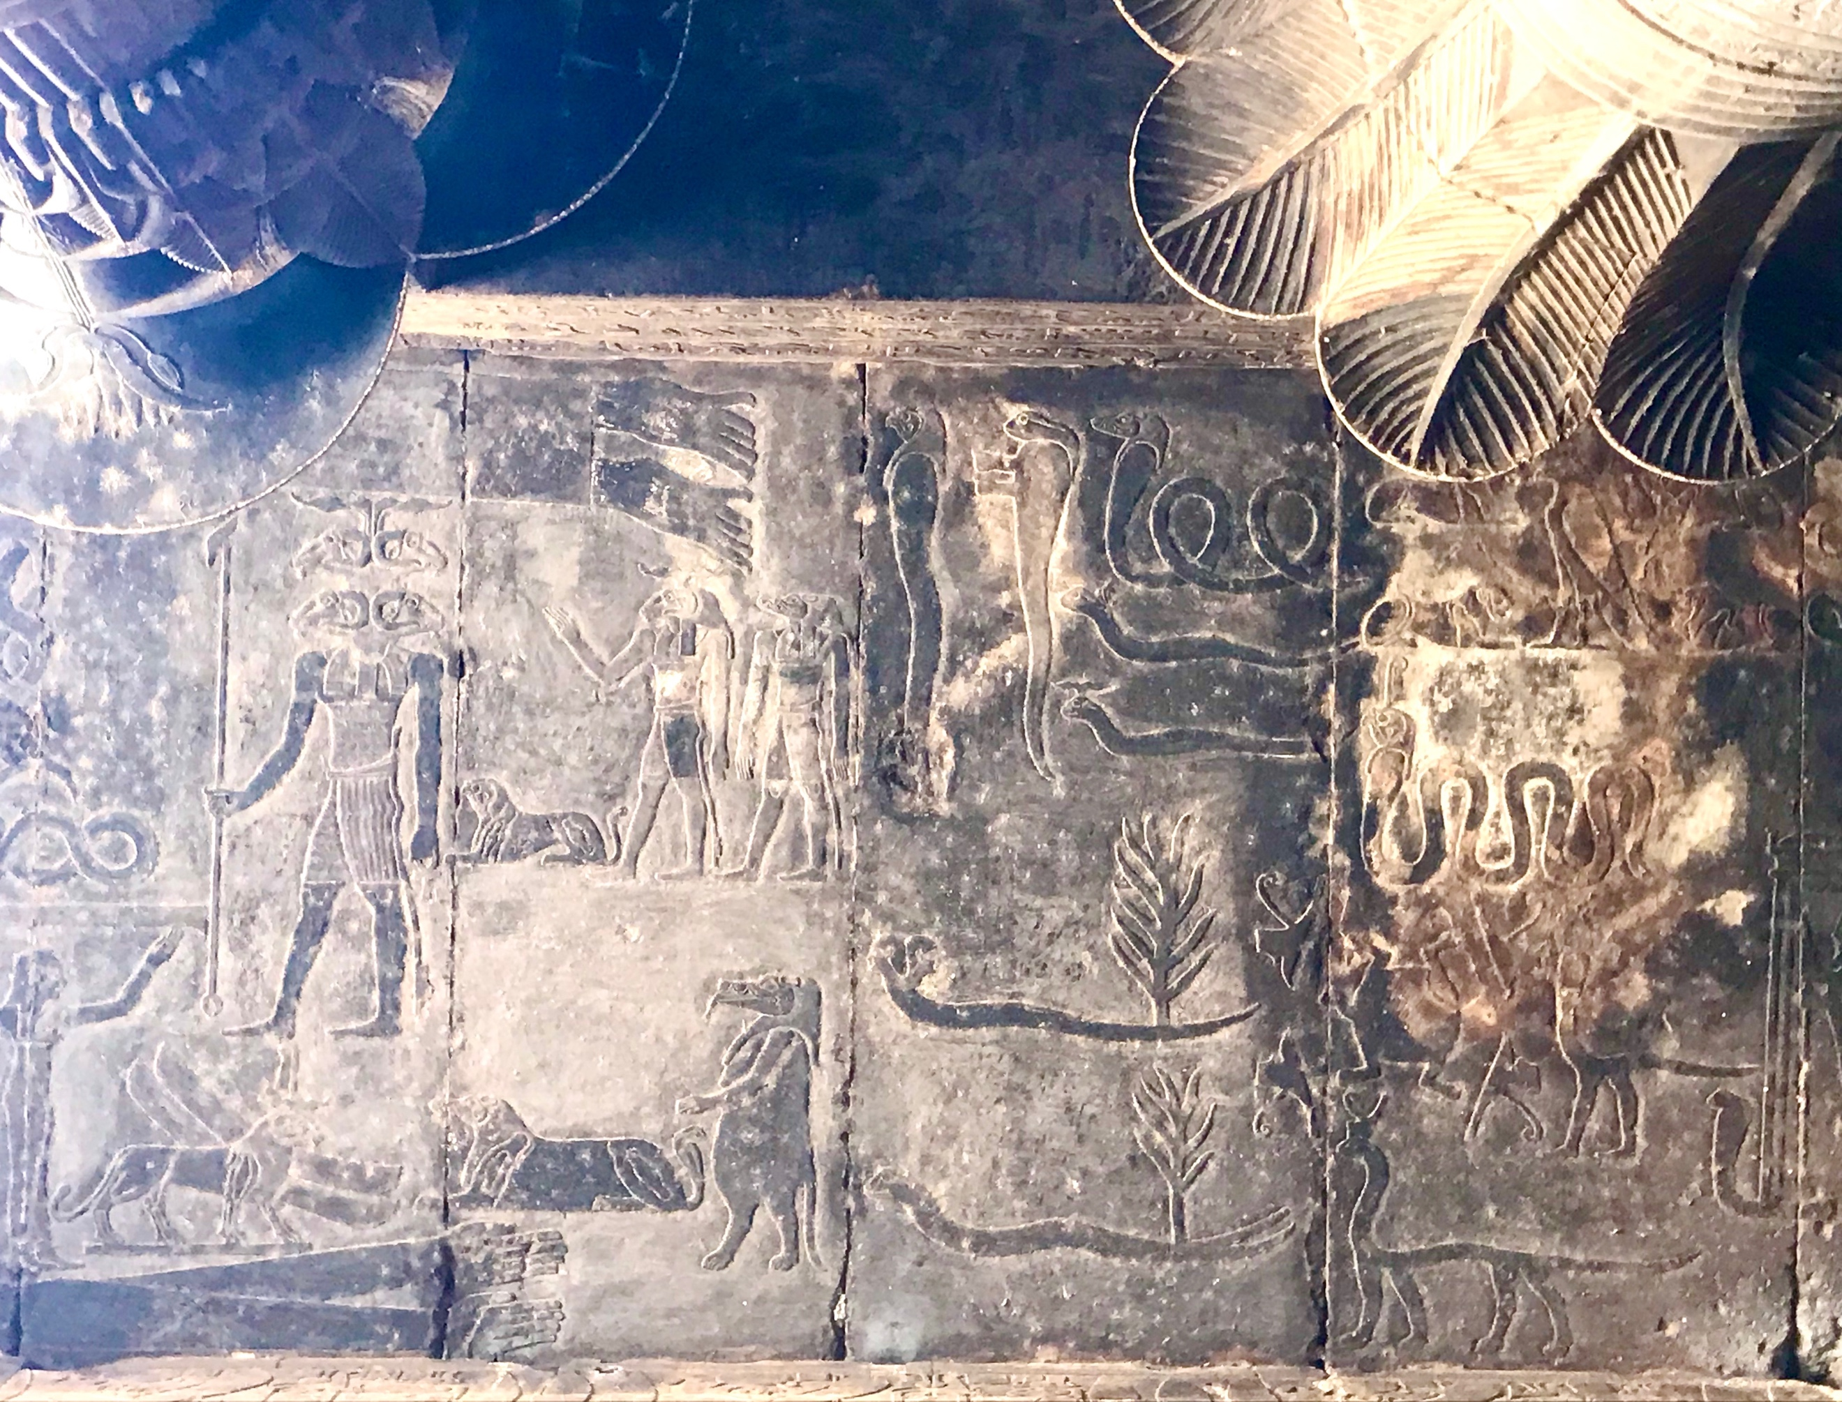
Figure 5 Danielle Marie Goldstein, Temple of Khnum, Southeast corner of ceiling, 18 April 2019, Digital Photograph

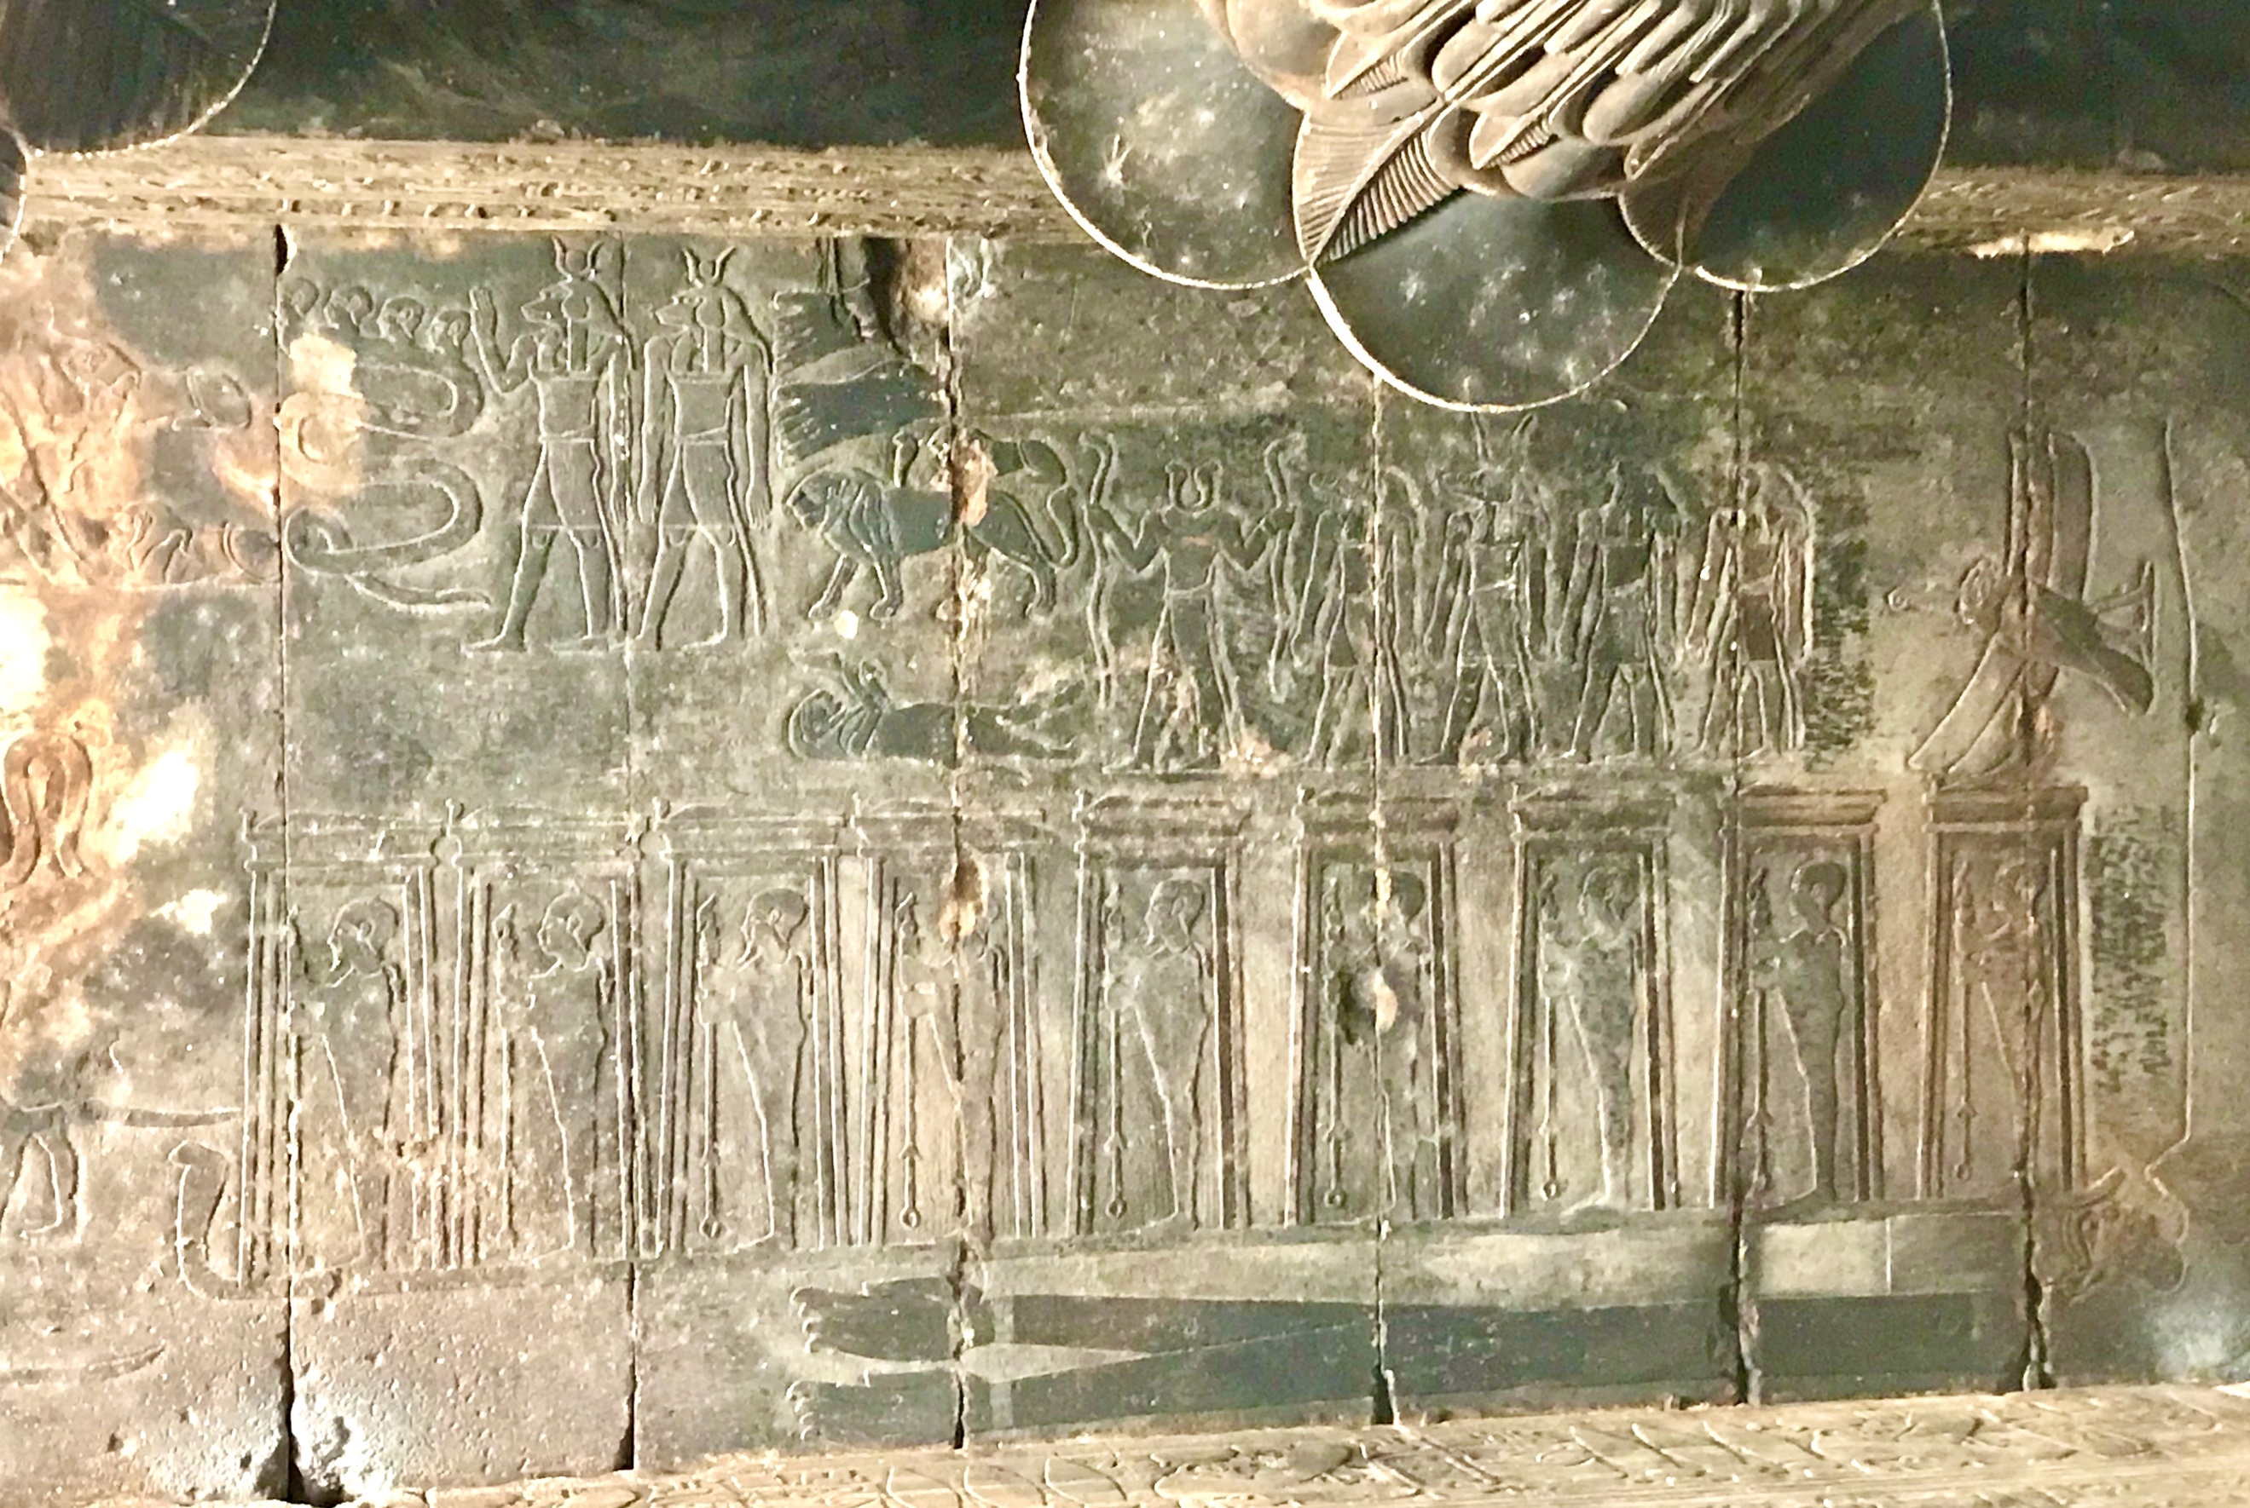
Figure 6 Danielle Marie Goldstein, Temple of Khnum, Southwest corner of ceiling, 18 April 2019, Digital Photograph
Scholarly Background
Belmonte and Shaltout measured over three hundred and thirty ancient temples and shrines in Egypt to define if there was a relationship to the orientation of these sites. They created the term Nile hypothesis, proposing that the Nile River was the main source of inspiration for the orientation of the temples in Upper Egypt, however they also attempted to disprove this theory, by taking measurements of temples in areas out into the Western Desert where they discovered that at times, astronomical orientations dominated the alignment of the temples and other sacred sites. They claimed that the temples in Egypt were oriented with consideration to the cardinal directions, solar directions, and star alignments. Their research utilized a high-precision compass, which corrected for local magnetic declination, and a clinometer, but they stated the goal was not about extremely precise alignments, instead, it was to measure as many of the buildings as possible, giving equal weight to each temple. In their calculations of the azimuth and angular height, a mean error of in the determination of the corresponding declination was slight, described as plus or minus three fourths of a degree. Belmonte and Shaltout went on to explain that magnetic declination was not likely to suffer alterations in Egypt, as it is mainly limestone and sandstone land. As stated previously, Temple of Khnum was made of sandstone. Neugebauer and Parker noted that when considering temples in Egypt, the term “orientation” was to not be an exact astronomical sense, however generally the temples were usually directed with their main axis perpendicular to the Nile, thus generally east-west or west-east.

Research Methodology and Findings
Due to extraordinary circumstances, it was impossible to capture live data for this research project. A clinometer would not have been useful for this research project as the modern town of Esna was built up around the temple, therefore any measurements around elevation would not be accurate. Since the town of Esna was not built up around 100 CE, one may assume that there was a flat horizon as the area was on the Nile flood plain. The axis of this temple’s orientation is roughly east-west, and the ceiling of the Hypostyle Hall has seven strips or registers that run from the east to the west. The length of each ceiling strip of the Hypostyle Hall of the temple is fifty-four feet, and the width of Esna B is nine and a half feet. Belmonte and Shaltout captured the following data of the Temple of Khnum: latitude of 25°19’, longitude of 32°34’, an azimuth of 56° and a declination of 30°. Considering this knowledge, Google Earth Pro was utilized to capture measurements virtually. The azimuth was measured across the temple, finding a true azimuth of 56°. The latitude found was 25°17’34.40 north and the longitude was 32°33’22.33 east. With the four winds at the four corners of the temple in mind, a diagonal was captured from the northeast corner to the southwest corner of the temple measuring 42.36 meters ground length and a true azimuth of 172°, and another diagonal was captured from the northwest corner to the southeast corner of the temple with 42.95 meters ground length and a true azimuth of 117°. The declination of 31+ defines that this temple is outside of the solar range, and it is unlikely there was a star orientation.

Conclusion
This research project set out to explore the significance of the imagery on the ceiling at Temple of Khnum, as celestial alignments were gathered with an intention to understand how this specific temple fits into the greater conversation of Egyptian cosmology. Timothy Darvill wrote of the challenges within the field of skyscapes, ‘Among the most intractable difficulties are the well-known hurdles of dealing with partial data, heavily damaged sites, inaccurate surveys, poor reconstructions, understanding the capabilities of technologies available to ancient cultures, and a poor or non-existent knowledge of the physical environment to inform questions of visibility and invisibility.’ Although there was not a solar or stellar alignment to the Temple of Khnum, it is clear that this temple was crafted to be full mapping of creation mythology and iconography, from the columns, to the walls and the ceiling. The northern half of the temple offered a visual lunar night-time journey, while the southern half of the temple displayed the daytime solar journey. A journey that for the Ancient Egyptians was deeply significant in their mythology; the sun was said to exist in the south-eastern sky, ‘behind Punt’, located at the most southern point on the horizon of an observer and eastwards, and each evening the sun went into complete darkness, entered the duat, the realm of the dead, when the decanal hours were operating, when birds were cooing to Egypt from the northwestern horizon down to the southeastern. At this temple the iconography of the four winds marked the four cardinal directions, protecting the space with the presence of these superdeities. The four winds were transport for these deities to fly in all directions laterally and vertically to and from the heavens, ultimately representing a totality of cosmological power.’ Ptolemaic temples were a compilation, as the ancients placed an archive of their culture for great remembrance. Thereby, the Temple of Khnum was crafted to be a self-contained cosmos displaying interwoven creation iconography.

Bibliography
Primary Sources
The Ancient Egyptian Book of the Dead, translated by R. O. Faulkner (New York: Macmillan Publishing Company, 1985)

The Ancient Egyptian Pyramid Texts, translated by James P. Allen (Atlanta: Society of Biblical Literature, 2005)

Neugebauer, O. and Richard A. Parker, Egyptian Astronomical Texts: III. Decans, Planets, Constellations and Zodiacs (Plates), (London: Percy Lund, Humphries and Company Limited, 1969)

Neugebauer, O. and Richard A. Parker, Egyptian Astronomical Texts: III. Decans, Planets, Constellations and Zodiacs (Text), (London: Percy Lund, Humphries and Company Limited, 1969)

Secondary Sources
Abdel-Rady, Radwan S. A., ‘Goddesses of the Four Pillars of the Sky at the Temple of Esna’, sourced from Academia.edu, <https://www.academia.edu/35002621/GODDESSES_OF_THE_FOUR_PILLARS_OF_THE_SKYAT_THE_TEMPLE_OF_ESNA_Radwan_ABD_EL-RADY>, [accessed 1-20 July 2019], pp. 46-58

Campion, Nicholas Astrology and Cosmology In The World’s Religions (London: New York University Press, 2012)

Darvill, Timothy ‘Afterword: Dances Beneath a Diamond Sky,’ in Skyscapes The Role and Importance of the Sky in Archaeology, ed. by Fabio Silva and Nicholas Campion (Oxford: Oxbow Books, 2015)

Dunand, Françoise and Christiane Zivie-Coche, Gods and Men in Egypt: 3000 BCE to 395 CE Translated by David Lorton (Ithaca: Cornell University Press, 2004)

Dundas, Gregory S., ‘Augustus and the Kingship of Egypt’, Historia. 4th Qtr. (2002), pp. 433-448

Famous Historic Buildings, ‘Esna Temple’ < http://www.famous-historic-buildings.org.uk/esna.html> [accessed 15 July 2019]

Greenbaum, Dorian Gieseler, and Micah T. Ross, ‘The Role of Egypt in the Development of the Horoscope’, in Egypt in Transition Social and Religious Development of Egypt in the First Millennium BCE, ed. by Ladislav Bares, Filip Coppens and Kveta Smolarikova, (Prague: Charles University in Prague, 2010)

Hallof, Jochen, ‘Esna’, UCLA Encyclopedia of Egyptology, 1602 Version 1 (October 2011), pp. 1-15, https://escholarship.org/uc/item/6k78t4w9

In Search of Cosmic Order: Selected Essays on Egyptian Archaeoastronomy, ed. by Juan Antonio Belmonte and Mosalam Shaltout (Cairo: Supreme Council of Antiquities Press, 2009)

Jacq, Christian, Egyptian Magic (Wiltshire: Aris & Phillips Ltd., 1985)

Noegel, Scott. B, ‘On the Wings of the Winds: Towards an Understanding of Winged Mischwesen in the Ancient Near East’, Kaskal, Volume 14 (2017), 15-54

Parker, Richard A., ‘Ancient Egyptian Astronomy’, Philosophical Transactions of the Royal Society of London. Series A, Mathematical and Physical Sciences, Vol. 276, No. 1257 (1974), pp.51-65

Pinch, Geraldine, Magic in Ancient Egypt (London: British Museum Press, 1994)

Priskin, Gyula ‘The Depictions of the Entire Lunar Cycle in Graeco-Roman Temples’, The Journal of Egyptian Archaeology, Vol.102 (2016), pp. 111-144

Priskin, Gyula, ‘The Spells’, in The Ancient Egyptian Book of the Moon: Coffin Text Spells 154-160, (United Kingdom: Archaeopress, 2019)

Ritner, Robert Kriech, The Mechanics of Ancient Egyptian Magical Practice (Chicago: The University of Chicago, 1993)

Silva, Fabio, Defining skyscapes, Sophia Centre Press Blog (2017)

Spalinger, Anthony J., ‘Nut and the Egyptologists’, Studien zur Altagyptischen Kultur, Bd. 41 (2012), pp. 353-377

Soliman, Wael Sayed , ‘Dwellers of the Sky: Serpent in the Greco-Roman Zodiac’, <https://jguaa.journals.ekb.eg/article_3176_7379d35e3f5f5050cf2428935b08e23e.pdf>, [accessed 15, March, 2020]

Wilkinson, Richard H., The Complete Temples of Ancient Egypt, (New York: Thames & Hudson, 2017)

In Search of Cosmic Order: Selected Essays on Egyptian Archaeoastronomy, ed. by Juan Antonio Belmonte and Mosalam Shaltout (Cairo: Supreme Council of Antiquities Press, 2009), p. 13.
Nicholas Campion, Astrology and Cosmology In The World’s Religions (London: New York University Press, 2012), pp. 83-84.
The Ancient Egyptian Pyramid Texts, translated by James P. Allen (Atlanta: Society of Biblical Literature, 2005), p. 1.
In Search of Cosmic Order, ed. by Belmonte and Shaltout, p. 13.
Fabio Silva, Defining skyscape Sophia Centre Press Blog (2017).
Richard H. Wilkinson, The Complete Temples of Ancient Egypt, (New York: Thames & Hudson, 2017), p. 201.
Wilkinson, The Complete Temples of Ancient Egypt, p. 201.
Jochen Hallof, ‘Esna’, UCLA Encyclopaedia of Egyptology, 1602 Version 1 (October 2011), pp. 1-15, https://escholarship.org/uc/item/6k78t4w9, p. 1.
O. Neugebauer and Richard A. Parker, Egyptian Astronomical Texts: III. Decans, Planets, Constellations and Zodiacs (Text), (London: Percy Lund, Humphries and Company Limited, 1969), p. 82.
Wilkinson, The Complete Temples of Ancient Egypt, p. 201.
Famous Historic Buildings, ‘Esna Temple’ < http://www.famous-historic-buildings.org.uk/esna.html> [accessed 15 July 2019].
Françoise Dunand and Christiane Zivie-Coche, Gods and Men in Egypt: 3000 BCE to 395 CE Translated by David Lorton (Ithaca: Cornell University Press, 2004), pp. 88-89.
Dunand and Zivie-Coche, Gods and Men in Egypt, pp.225-226.
Dunand and Zivie-Coche, Gods and Men in Egypt, pp. 88-89.
Wilkinson, The Complete Temples of Ancient Egypt, p. 65.
Wilkinson, The Complete Temples of Ancient Egypt, pp. 65-66.
Gregory S. Dundas, ‘Augustus and the Kingship of Egypt’, Historia. 4th Qtr. (2002), pp. 433-448, p. 447.
Dundas, ‘Augustus and the Kingship of Egypt’, p. 447 and Dunand and Zivie-Coche, Gods and Men in Egypt, p. 225.
Dunand and Zivie-Coche, Gods and Men in Egypt, p. 227.
Dunand and Zivie-Coche, Gods and Men in Egypt, p 227.
Radwan S. A. Abdel-Rady, ‘Goddesses of the Four Pillars of the Sky at the Temple of Esna’, sourced from Academia.edu,<https://www.academia.edu/35002621/GODDESSES_OF_THE_FOUR_PILLARS_OF_THE_SKYAT_THE_TEMPLE_OF_ESNA_Radwan_ABD_EL-RADY>, [accessed 1-20 July 2019], pp. 46-58, p. 49.
Richard A. Parker, ‘Ancient Egyptian Astronomy’, Philosophical Transactions of the Royal Society of London. Series A, Mathematical and Physical Sciences, Vol. 276, No. 1257 (1974), pp.51-65, p. 52.
Gyula Priskin, ‘The Spells’, in The Ancient Egyptian Book of the Moon: Coffin Text Spells 154-160, (United Kingdom: Archaeopress, 2019), p. 27.
Parker, ‘Ancient Egyptian Astronomy’, p. 52.
In Search of Cosmic Order, ed. by Belmonte and Shaltout, p.136.
Priskin, ‘The Spells’, p. 25.
Gyula Priskin, ‘The Depictions of the Entire Lunar Cycle in Graeco-Roman Temples’, The Journal of Egyptian Archaeology, Vol.102 (2016), pp. 111-144, p. 112.
Priskin, ‘The Depictions of the Entire Lunar Cycle in Graeco-Roman Temples’, p. 116.
Priskin, ‘The Depictions of the Entire Lunar Cycle in Graeco-Roman Temples’, p. 116.
Geraldine Pinch, Magic in Ancient Egypt (London: British Museum Press, 1994), p. 27.
Priskin, ‘The Depictions of the Entire Lunar Cycle in Graeco-Roman Temples’, p. 141.
Priskin, ‘The Depictions of the Entire Lunar Cycle in Graeco-Roman Temples’, p. 143.
Neugebauer and Parker, Egyptian Astronomical Texts: III. Decans, Planets, Constellations and Zodiacs (Text), p. 84.
Hallof, ‘Esna’, p. 4.
Wael Sayed Soliman, ‘Dwellers of the Sky: Serpent in the Greco-Roman Zodiac’, <https://jguaa.journals.ekb.eg/article_3176_7379d35e3f5f5050cf2428935b08e23e.pdf>, [accessed 15, March, 2020], p. 56.
Richard A. Parker, ‘Ancient Egyptian Astronomy’, Philosophical Transactions of the Royal Society of London. Series A, Mathematical and Physical Sciences, Vol. 276, No. 1257 (1974), pp.51-65, p. 61.
Neugebauer and Parker, Egyptian Astronomical Texts: III. Decans, Planets, Constellations and Zodiacs (Text), p. 4.
Greenbaum, Dorian Gieseler, and Micah T. Ross, ‘The Role of Egypt in the Development of the Horoscope’, in Egypt in Transition Social and Religious Development of Egypt in the First Millennium BCE, ed. by Ladislav Bares, Filip Coppens and Kveta Smolarikova, (Prague: Charles University in Prague, 2010), pp. 156-157.
Neugebauer and Parker, Egyptian Astronomical Texts: III. Decans, Planets, Constellations and Zodiacs (Text), p. 82.
Neugebauer and Parker, Egyptian Astronomical Texts: III. Decans, Planets, Constellations and Zodiacs (Text), p. 207.
In Search of Cosmic Order, ed. by Belmonte and Shaltout, p. 15.
Anthony J. Spalinger, ‘Nut and the Egyptologists’, Studien zur Altagyptischen Kultur, Bd. 41 (2012), pp. 353-377, p. 365-6.
Neugebauer and Parker, Egyptian Astronomical Texts: III. Decans, Planets, Constellations and Zodiacs (Text), pp. 82-84.
Neugebauer and Parker, Egyptian Astronomical Texts: III. Decans, Planets, Constellations and Zodiacs (Text), pp. 4, 256.
Abdel-Rady, ‘Goddesses of the Four Pillars of the Sky at the Temple of Esna’, p. 60.
Scott. B Noegel, ‘On the Wings of the Winds: Towards an Understanding of Winged Mischwesen in the Ancient Near East’, Kaskal, Volume 14 (2017), 15-54, pp. 17-18.
Noegel, ‘On the Wings of the Winds’, pp 18-19.
Noegel, ‘On the Wings of the Winds’, p. 18.
Christian Jacq, Egyptian Magic (Wiltshire: Aris & Phillips Ltd., 1985), p. 38.
The Ancient Egyptian Book of the Dead, translated by R. O. Faulkner (New York: Macmillan Publishing Company, 1985), p. 156.
The Ancient Egyptian Book of the Dead, translated Faulkner, p. 156.
Noegel, ‘On the Wings of the Winds’, p. 37.
Ritner, Robert Kriech, The Mechanics of Ancient Egyptian Magical Practice (Chicago: The University of Chicago, 1993), pp. 18-23.
Noegel, ‘On the Wings of the Winds’, p. 18.
Noegel, ‘On the Wings of the Winds’, p. 18.
Neugebauer and Parker, Egyptian Astronomical Texts: III. Decans, Planets, Constellations and Zodiacs (Text), p. 257.
Noegel, ‘On the Wings of the Winds’, p. 18.
Noegel, ‘On the Wings of the Winds’, p. 37.
Christian Jacq, Egyptian Magic (Wiltshire: Aris & Phillips Ltd., 1985), p. 29.
In Search of Cosmic Order, ed. by Belmonte and Shaltout, p. 3.
In Search of Cosmic Order, ed. by Belmonte and Shaltout, p. 3.
In Search of Cosmic Order, ed. by Belmonte and Shaltout, p. 8.
In Search of Cosmic Order, ed. by Belmonte and Shaltout, p. 2.
In Search of Cosmic Order, ed. by Belmonte and Shaltout, p. 220.
In Search of Cosmic Order, ed. by Belmonte and Shaltout, p. 2.
Neugebauer and Parker, Egyptian Astronomical Texts: III. Decans, Planets, Constellations and Zodiacs (Text), p. 4.
Neugebauer and Parker, Egyptian Astronomical Texts: III. Decans, Planets, Constellations and Zodiacs (Text), p. 82.
Neugebauer and Parker, Egyptian Astronomical Texts: III. Decans, Planets, Constellations and Zodiacs (Text), p. 83.
In Search of Cosmic Order, ed. by Belmonte and Shaltout, p. 350.
Timothy Darvill, ‘Afterword: Dances Beneath a Diamond Sky,’ in Skyscapes The Role and Importance of the Sky in Archaeology, ed. by Fabio Silva and Nicholas Campion (Oxford: Oxbow Books, 2015), pp. 140-148, p. 147.
Spalinger, ‘Nut and the Egyptologists’, p. 364.
Noegel, ‘On the Wings of the Winds’, p. 39.

