

Skills for the Workplace
Module Assignment Submission

Student Name: | Arfana Akhtar
Student Number: | 1715085
Module No: | BMSK4004_LON
Module Title: | Problem Solving and Decision Making
Lecturer: | Yajesh Kumar

Statement of Confirmation of Authenticity
By the act of making this submission, the student declares that this is the work of the student named above. The work has not, in whole or in part, been knowingly presented elsewhere for assessment, or where assessment has been built on a previous assessment, this has been identified. Where materials have been used from other sources it has been properly acknowledged. If this statement is untrue, the student acknowledges that an assessment offence has been committed.
Attention is drawn to the plagiarism and unfair practice policies of both the University and of ILM.

Contents
Executive Summary/Abstract 3
Introduction 3
Aims and objectives of business? 4
How was it formed? 7
Financial situation; 8
Number of staffs; 10
Organisational Structure of McDonalds; 10
Discussions 11
Analysis 16
STP strategy and MCD achieving sustainable success 17
Ishikawa Analysis; 19
http://dawnscustomdesigns.com/fishbone-diagram-template/ 20
Forcefield Analyses; 21
Swot Analyses 21
PESTLE Analyses; 22
Recommendations/Suggestions 23
Conclusions 24
References 24

Executive Summary/Abstract

McDonalds is a known international fast food restaurant. They have also expanded their businesses on the global scale. It’s obvious and proven that the fast food outlet, McDonalds has exceeded a lot more than other fast food outlet businesses, in terms of sale and fame on an international level. However, McDonalds being the largest worldwide fast food restaurant in India KFC performs much better than McDonalds.
The aim of this study is to find out what this company is and research the background of the company. To also find out problems the company has. By then identifying the problems of which the company is facing, but to also show techniques of solving the issues.
In this study of report, I will be using qualitive findings to help find the issues raised in the company.

Introduction

This report will be focusing on the restaurant called McDonalds and applying the recognized problem-solving tools and techniques to identify problems and solutions to a work-based problem. I will also include an evaluation of possible solutions.
McDonalds is a fast food known outlet which is worldwide and growing at a rapid speed worldwide.
McDonalds is an American company which was founded in 1940 as a restaurant operated by a couple named Richard and Maurice McDonald, in San Bernardino, California, United States
The company McDonalds is primarily a franchiser with more than 90% restaurants currently owned as well as operated by independent franchises.
It enables an individual to be their own employer and maintain their control over all the employment related matters. The matters are the pricing decisions and marketing while also benefiting from the strengths of McDonalds global band and their financial resources and the operating system too.
The company term for a company’s typical franchise is 20 years. It requires franchises to meet certain standards and sometimes it does not work with passive investors.
The relationship with the franchisees business is designed to make sure there is a consistency and a very high quality in all the McDonalds restaurant worldwide at all times.
The McDonalds franchisees that are predictable they contribute to the company’s income through the payment of the rent and the royalties, based upon a percentage of sales, but with specified minimum rent payments.
McDonald has a strict policy of initially all fees are to be paid upon the opening of any new restaurant or upon a grant of a new franchise.

Aims and objectives of business?
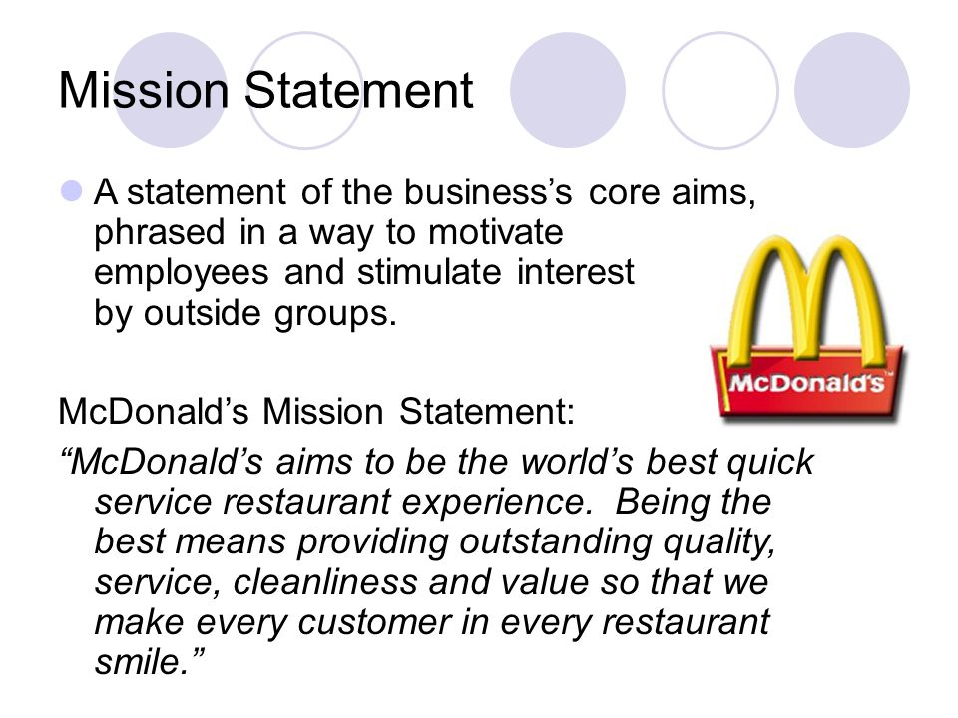

From the table above which you can see is a mission statement of McDonalds which clearly states what their mission is and how they will maintain their abilities by sticking to there very own mission statement.
The aim and objective for McDonalds is to serve quality food to customers that they can rely on. McDonalds is always striving to maintain an outstanding excellent customer service to the community and customers and to continually improve customer skills and serve food in a clean and welcoming environment worldwide, has they known restaurant has a high reputation to maintain always.
The goal of McDonalds is to be the world’s fastest quick service restaurant to be experienced always by customers.
To commit in maintaining and developing the best food products in the quick service, in order to maintain or deliver this requirement, the restaurants has made several commitments to food safety and nutritional issues which has been and still a continuing problem with McDonalds restaurant.
McDonalds must lead the quick service market by a program of site development and profitable restaurant openings, also by attracting new customers.
McDonald must also increase the sales via promotion which will enable them to continue their expansion program.
McDonalds has an objective to improve the menu, which will help the restaurant benefit and the customers, which will give them more reason to come back and visit again.
McDonalds many ideas come from the franchisees whom respond to the customer demands quickly.
The restaurants consumer taste changes over time and its vital McDonalds respond to these changes quickly.

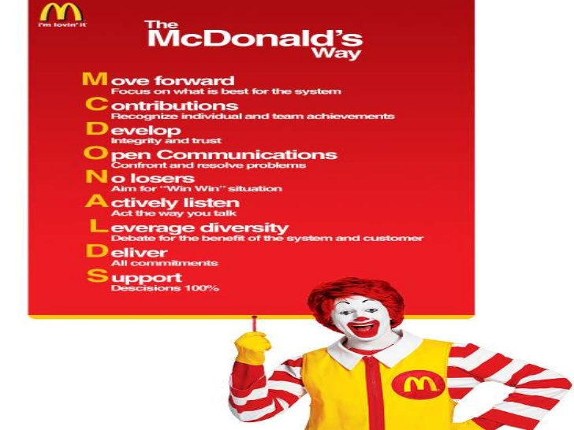
(McDonalds.com, 2019)

As shown from the table above McDonalds in the name itself has its very own meaning to it. The table also shows how all McDonalds strategy of employment should be, and how it should also be maintained.
- M – move forward
- C – contributions
- D – develop
- O – open communications
- N – no losers
- A – actively listen
- L – leverage diversity
- D – deliver
- S - supply

The McDonalds restaurant focuses on their employees, their franchise businesses and their suppliers whom all are working together to always provide excellent customer’s service and maintain the speed too, as that is very important for McDonalds to deliver on time.
The restaurant, McDonalds holds a high reputation to maintain and has a consistency of trying to provide quality outstanding quality food for their customers, which also always needs to be in a clean and welcoming environment for the customers and the workers.

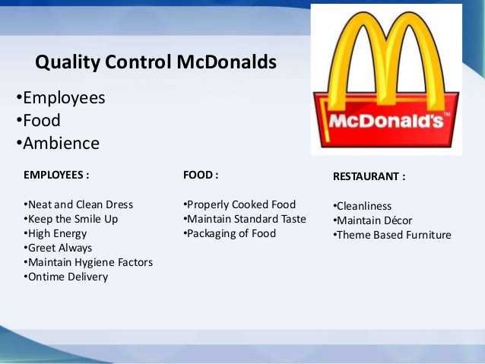
(McDonalds. 2019)
McDonalds have a control of quality as shown in the table above the three points are the employees, food and ambience. It also shows clearly what is expected from the employees, food and the ambience in bullet points.
They aim their best to provide quality food in a clean and welcoming environment. The restaurant global initiative is to always be providing exceptional customer service experience.
The owners, the suppliers, the operators and employers are the areas of interest that McDonalds strives to balance and maintain an outstanding reputation with.

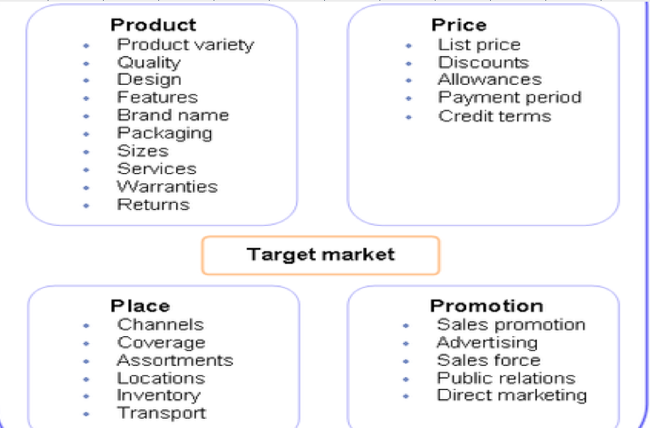
(Technology with Sweeney, 2019)
The table above shows the target market of McDonalds restaurant.
According to McDonalds.com their plan to win strategy focuses on people, products, place, price and promotion.
They are dedicated to always improve their business and how it operates. Looking at the fours P’s above also shows how serious they are for a successful business.

How was it formed?

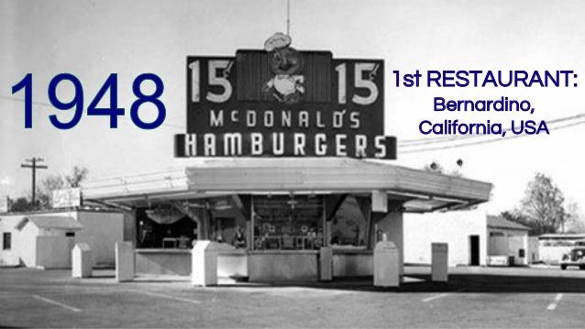
(McDonalds, 2019)
From research I found the first ever McDonalds restaurant was opened in 1948 by two brothers named Mac and Dick McDonald which was originally as a barbecue which was established in San Bernardino; California, USA.
As shown in the picture above the very first McDonalds and how it was.

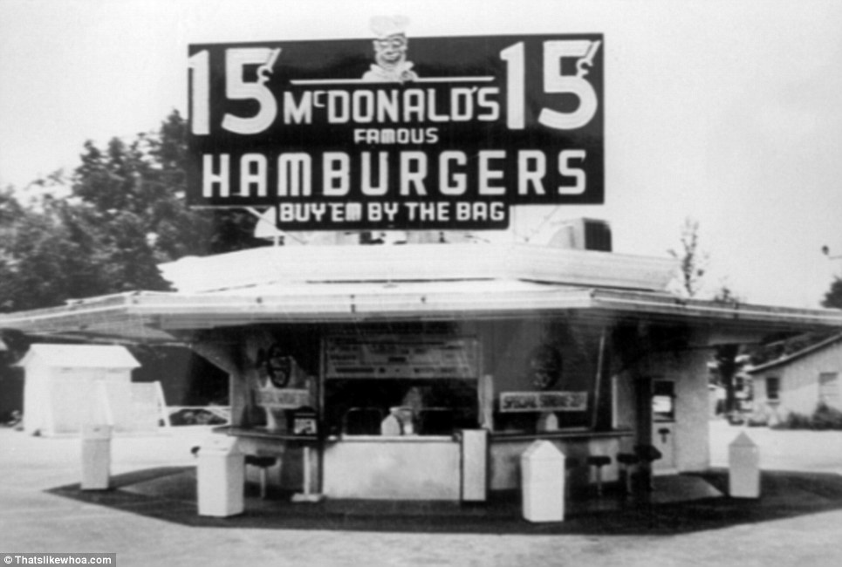

McDonalds then shortly after decided that the restaurant should opened a drive-through with featuring a much larger menu.
The first McDonalds with a drive-through was opened as shown the picture above which is one of the very first drive through to be opened.

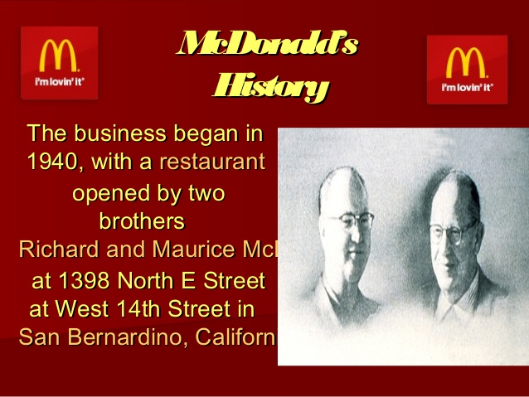

McDonalds has a story about the two brothers named Dick and Mac McDonald moved to California where they fought together to seek more opportunities which they both felt was unavailable in New England.
After both brothers failing in the movie business, they both soon after proved to be a successful operating drive-in restaurant.
In 1948 the both brothers decided to take a big risk in streamlining their operations and introducing their very own speedy service system which started with a big bang featuring with the hamburgers being at only fifteen cents.
The restaurants success also had led the two brothers to begin franchising their concept, which within those businesses were also nine more becoming operating restaurant’s.

Financial situation;

The financial situation at McDonalds;

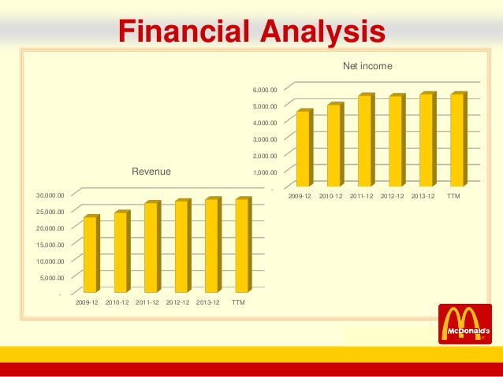
(McDonalds, 2019)
The table above shows a financial analysis of McDonalds revenue and the net income which is from 2009-2013.
It clearly shows the net n revenue income starts low from 2009 then rises but from 2011-2013 it has shown to stay the same place which shows something need to be introduced for the figures to go up.
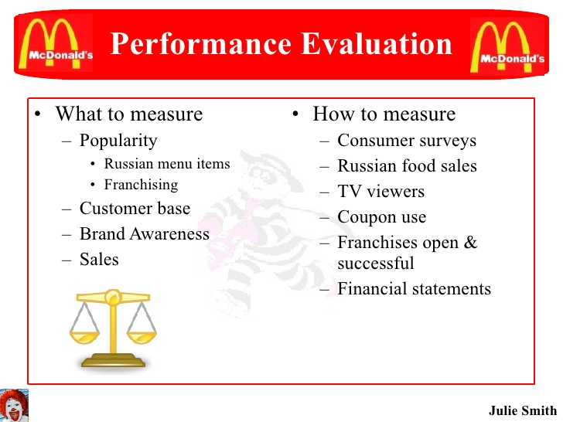

The picture above shows McDonalds performance, an evaluation of what to measure, which is broken down to popularity, customer base, brand awareness and of course the sales of the business.
It also shows exactly what to measure which are the consumers surveys, Russian food sales, TV viewers, coupon use, franchises opening and the successful financial statements of McDonalds restaurant.

Number of staffs;

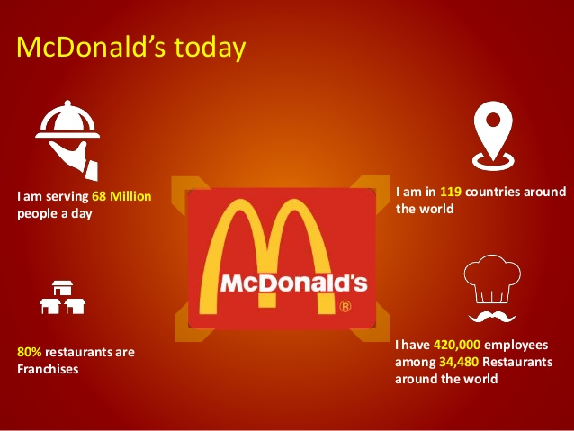(McDonalds, 2019)
The picture above shows a breakdown of the inside of McDonalds of today.
- Currently the number of employees there are in McDonalds is 420,000 employees up to date to 2019 which all employees are among the 34,480 restaurants around the worldwide.
- There is currently McDonalds restaurants in approximately 119 countries around the world and still growing.
- 80% of the restaurants are franchises.
- McDonalds is serving up to 68 million people each day and counting.

Organisational Structure of McDonalds;

The table below shows in more detail of the organisational structure of McDonalds which can also be called the career chart.
It shows exactly how the employee first starts and when the employee can finish up to.
An employee can first start form being a crew member to ending all the way up to be a restaurant manager.
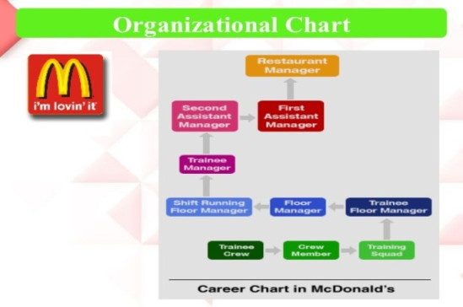
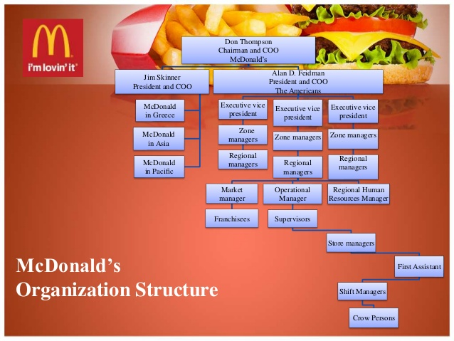
The table above shows a more detailed organization structure of McDonalds which also includes the CEO of the restaurant too.

Discussions

McDonalds as any business has flaws and problems which can be resolved when recognized when using solving tools and methods.
Here I will elaborate more in details some of the few problems within the McDonalds restaurant.
- There are no ingredients written anywhere for customers to read or see because they might need to check for personal reasons like being allergic to certain ingredients, or not liking a certain ingredient.
- A lot of the employees don’t even know what’s in the burgers when customers ask.
- Hygiene is a big issue in McDonalds.
- Toilets are in such a mess most times.
- Not enough sitting areas.
- Not enough staff on dining area to keep area clean and hazard free at a rapid speed.
- Not enough bins in restaurants.
- Need more CCTV cameras in place for safety precautions.
- McDonalds should consider that oil should be separate when frying food and not using one oil for everything.
- Shouldn’t leave ready made food in food warmer for too long.
- Machines should be washed toughly and not just around the machine especially milkshake tubes and drinks tubes should be jet washed.
- Kitchen should have more space with fan as its very hot, humid and stuffy which makes it hard when washing equipment’s.
- Gloves should always be worn when handling customers food.
- Hair net should always be worn too.
- McDonalds should think about making menu a slight heathier to avoid the mass obesity that is going in the UK.
- Employees should always stock up well in advance to avoid rush hour.
- Train stuff to work rapidly to avoid long ques.
- Have play areas in more McDonalds in different areas.

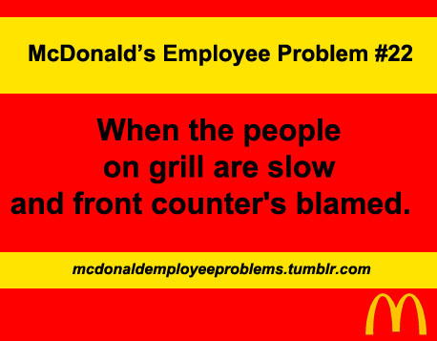

McDonalds face employee problems when basically the employees in the kitchen are slow and not moving at a fast pace the front counters are always the first hand to be blamed and must deal with unhappy customers which at times gets of hand.

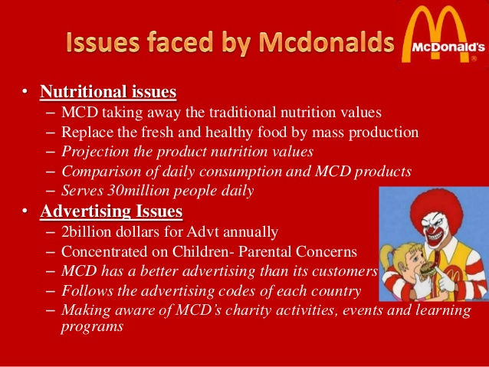
McDonalds a shown above picture faced nutritional issues and shows you the breakdown of the problems.
It is stating McDonalds taking away the traditional nutrition values and replacing the fresh and healthy food by mass production. McDonalds should plan the product nutrition values and should be comparing daily consumption of MCD products.
McDonalds has also had advertising issues like having two billion dollars for adverts, trying to concentrate on children which is parental concerns due to the unhealthy menu and leading to a mass production of obesity in children.
Researchers show McDonalds has a better reputation at advertising then its customers health needs. McDonalds follows rules and regulations for each country and McDonalds has a reputation of making aware of charity activities, learning programmes and maintaining charity events.

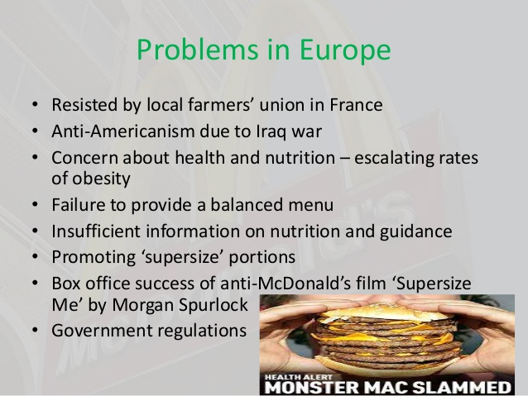

As shown in the picture above McDonalds has had problems in Europe. The problems are listed in bullet points above in picture.
McDonalds has a big concern of health and nutrition issues which escalates the rates of a mass of obesity.
It’s also states clearly McDonalds fails to provide a balanced menu, as well as not giving information on nutrition and guidance.
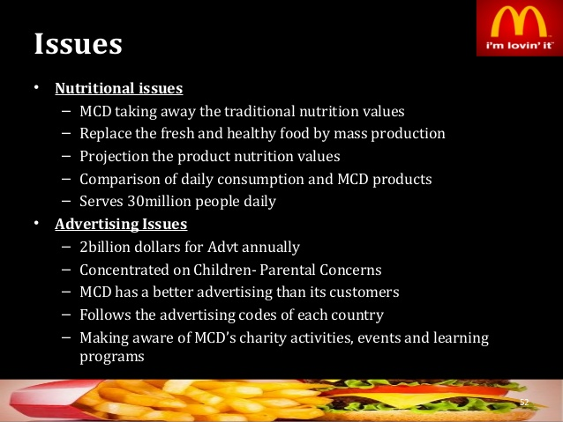
The above picture shows a few more issues again MCD should look at the fish bone diagram and try to resolve these matters, like the replacing the fresh and healthy food by mass production so its more of a balanced diet and not a threat in everyone lives. They should also investigate how to now change the food to avoid obesity has kids are already a big fan of McDonalds and can help the parents from stressing.

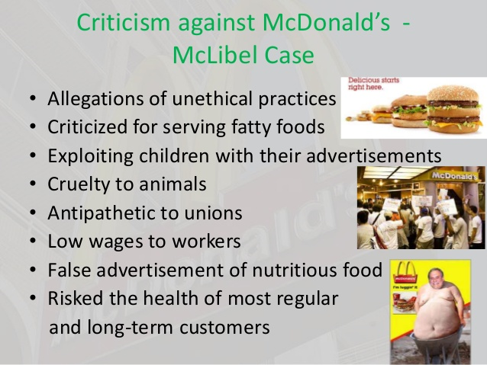

As shown in the picture above labelled criticism against McDonalds McLibel case. It states there were allegations of unethical repetitions, McDonalds were criticized for serving fatty food which leads to mass population of obesity.
It also shows that McDonalds were exploiting children with their adverts and proved McDonalds’s cruelty towards animals.
Employees were getting low wages which initially that what was the cause that made the workers go on a strike to be heard and to make a stand that low wages will not be accepted, and something should be done about it promptly.
McDonalds had and still facing but has improved a lot better now whereas before McDonalds menu was a high risk to the health of most regular and long-term customers.
After the McLibel case McDonalds were forced to look at the issues and make changes promptly to avoid such case in the future again.

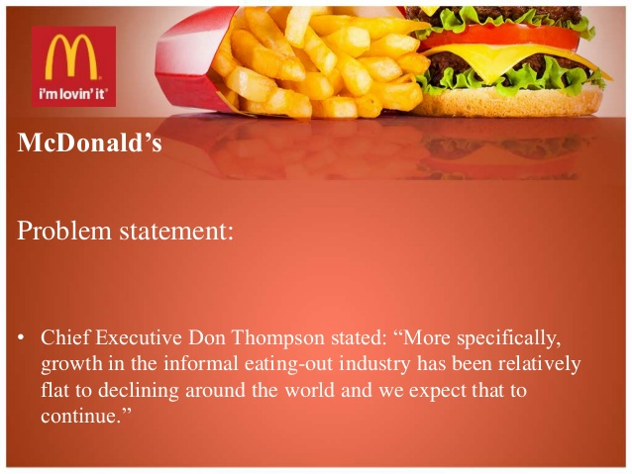

In the above picture the chief executive Don Thompson has stated that
“more specifically growth in the informal eating out industry has been relatively flat to declining around the world and we expect that to continue”
He made the statement when McDonalds were facing issues with the obesity levels of the public, and with parent worrying for their children health issues.
The adults were also facing major health problem from constantly having McDonalds has the fat is quite bad and even though there are healthier option to choose from a lot of people still choose a big mac over a veggie burger or even a salad.
McDonalds are famous for their burgers especially their big mac and their famous 99p menu of cheeseburgers and chicken mayo’s.
McDonalds has also introduced a breakfast menu but still even then a lot of the food is still quite fatty but there are healthy options of porridge and fruits. But a lot avoid being healthy and go for fatty breakfast.
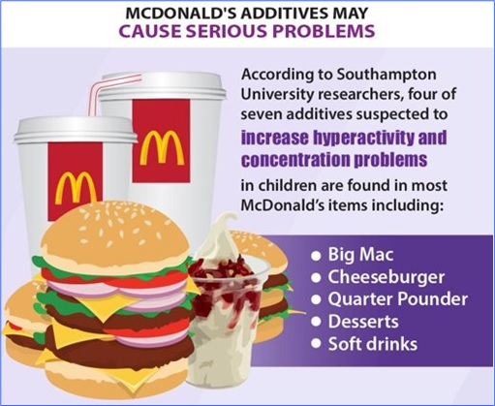
The picture above clearly states McDonalds is addictive and may cause serious health problems.
According to the research in the university of Southampton it shows that four of seven addictive are suspected to increase hyperactivity and have an increase in concentration problems, which are all in found mostly in children.
Most McDonalds food including the big mac, cheeseburger, quarter pounder, desserts and all the soft drinks have been tested and proved those items are highly rated by children hence why the increase of hyper activeness and concentrating problems due to the sugar levels being so high.
There are a few unknown facts about McDonalds which are;
- McDonalds is the largest toy distributor in the world.
- McDonalds real business is real estate.
- McDonalds first food listed on the menu was hot dogs not hamburgers.
- McDonalds opens a new restaurant every 14.5 hours.
- McDonalds feed over 68 million people every day and counting.
- McDonalds golden arches are recognised by more people than the cross.
- McDonalds has a unique menu listed in every country.

Analysis

McDonalds has a lot of problems as seen from the above and I wrote and backed the problems with evidence showing the problems.
Here I will write about how to solve the problem and write about the techniques of problem solving.
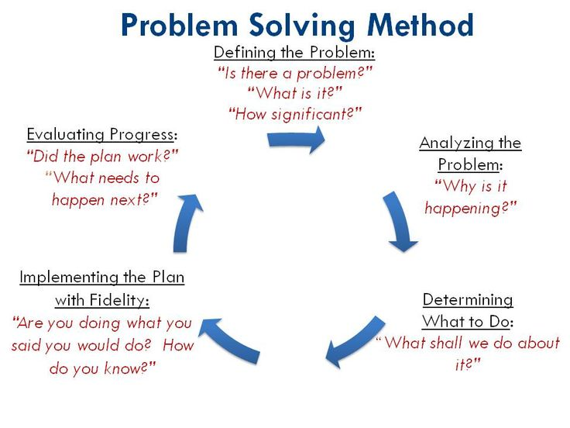

The above diagram shows a way of solving a problem and shows a breakdown starting from;
- Defining the problem
- Analysing the problem
- Determine what to do
- Implement the plan with fidelity
- Evaluating the process
By using this theory which will help in tackling the problems out or dealing with any issues in a working environment will be very easy to resolve and the problem will end with a clear understanding.
It will also avoid escalation in future preferences if the problem is resolved promptly.

STP strategy and MCD achieving sustainable success.
The table below shows the STP strategy and the breakdown of it to. The meaning of STP is;
- Segmenting
- Targeting
- Position process
It is a three-way approach in building a marketing plan for the businesses. Using and following the three steps of STP will allow the business owners and consultants or even the employees of the business to come up with a plan to formulate marketing strategy that draws the brands, company and product benefit to customers marketing segments.
Following through the three-way approach will help establish a creative and promising marketing plan.
The three breakdown which will help even more is;
- Define the market
- Create market segment
- Evaluate the segment on the set criteria
In the picture below shows a more in-depth breakdown of the STP of McDonalds.
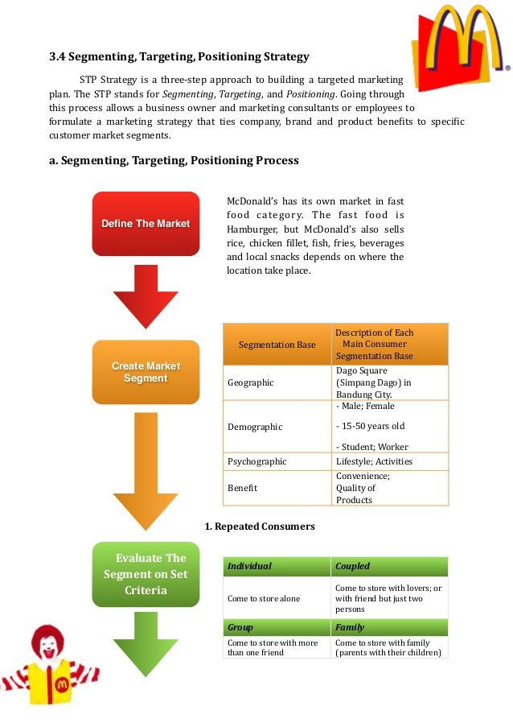

The table of McDonalds sustainable achieving success is shown below;
McDonalds values are;
- Sustainable supply chain
- Environmental Responsibility
- Community
- Employees experience
- Nutrition and Well-being

These are all the things McDonalds values.
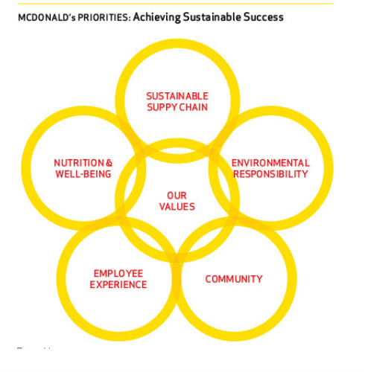

Ishikawa Analysis;

Ishikawa diagrams also called the fish bone diagram, herringbone diagram, which are all casual diagrams created by Kaoru Ishikawa that shows a breakdown of the causes of a specific event.
As shown below one problem McDonalds faced with the contract ending with the famous Heinz company.
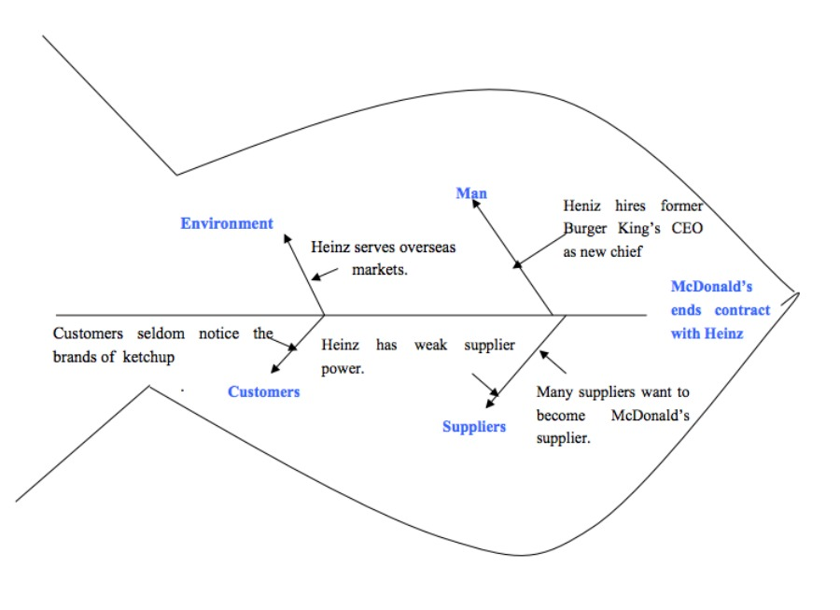(Zhang’s, Y. 2019)

This diagram below shows another problem within McDonalds which is based on Obesity. I used the fish bone to show the cause of problem.

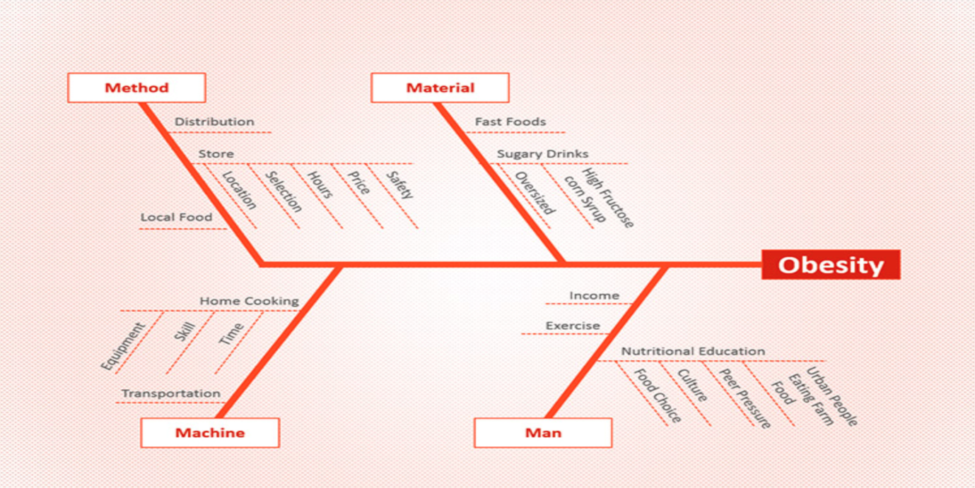

The diagram below is another problem with low customer satisfaction with McDonalds which I also use to identify the specific cause using the fish bone diagram.
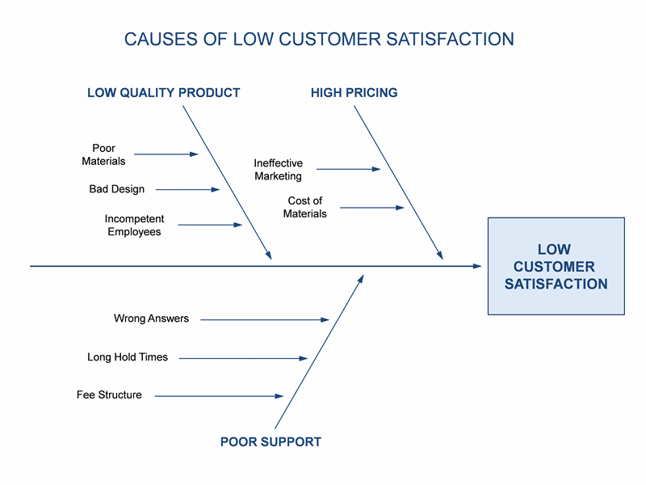

Forcefield Analyses;
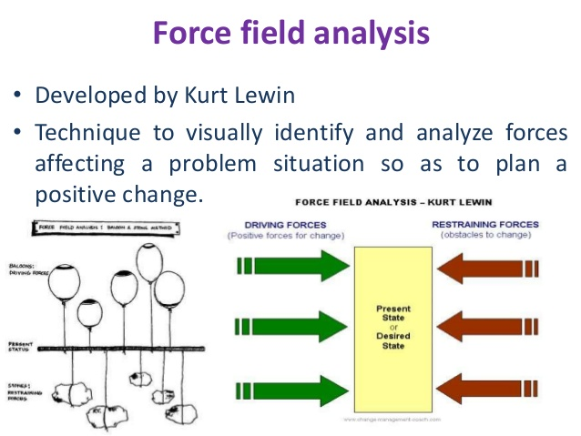
(Lewin, K. 2019)

The diagram above is a force field analysis which was developed by Kurt Lewin. Kurt Lewin use this technique to visually identify and analyse the forces which were affecting a certain situation or problems in order to plan a positive change using this forcefield technique.

Swot Analyses

SWOT is an abbreviation for Strengths, weakness, opportunities and threats which are related to the organisations. The following table illustrates McDonalds SWOT analysis;

Strengths  - Market leadership in US  - Brand Awareness & Brand Value  - High level of Profitability  - Global Presence  - High Level of Profitability | Weakness  - Declining Brand Image  - Negative Publicity  - High Employee Turnover  - Low Differentiation  - Unhealthy Food on Menu
Opportunities  - Home Delivery of Foods  - Product Differentiation  - Focusing on Nutritional Menu  - Improving CSR Aspect of the Business  - Increase the extent of localization in the international market | Threats  - Lawsuits Against the Company  - Food Safety Concerns  - Fast Food saturation in Developed Countries  - Currency Infatuations  - Competitions from Quality burger chains

PESTLE Analyses;

Here I will write about the PESTLE of McDonalds, and the meaning of PESTLE as well.
Political;
- Health and safety
- Stability of the government
- Potential change to the legislation
- Global influences
Environmental;
- Economic growth
- Employment rates
- Inflation rates
- Monetary polices
- Consumer confidence
Social;
- Income distribution
- Demographic influences
- Lifestyle factors
Technological;
- International influences
- Changes in technology information
- Take up rates
Legal;
- Taxation polices
- Employment laws
- Industry regulations
Environment;
- Energy change
- Environment restrictions
- Climate change
- Workforce health

Recommendations/Suggestions

Here I would like to talk about what recommendations I feel should or could be used for McDonalds.
I think the presence of McDonalds in Asian countries could be very good as it is already in China and has made a huge impact to being there. When it was first opened in Beijing the big mac was closely observed and the population of people were taking pictures with the infamous Ronald McDonald.
It has been clearly stated McDonalds in China is growing faster than it is in America. So, opening more in different Asian countries could have the same impact as China or have even better impact.
I also think a health issue is a big problem with McDonalds which is why I recommend for McDonalds to have more healthier selection of food.
McDonalds should have a menu with promoting far more healthy option and ones with were customers enjoy and that also fits the original ‘speedy service’ model which the company initially introduced in the 1950’s.
McDonalds should also consider using local food sources where possible which will decrease the time to market and decrease the of fuel used for travel.
I also recommend McDonalds using these techniques below to help adjust issues in the future.
Here is one example for when having business meeting;
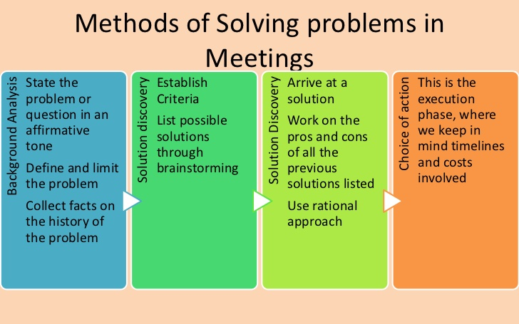

Another technique is the steps to solve a problem as shown below which has five steps.
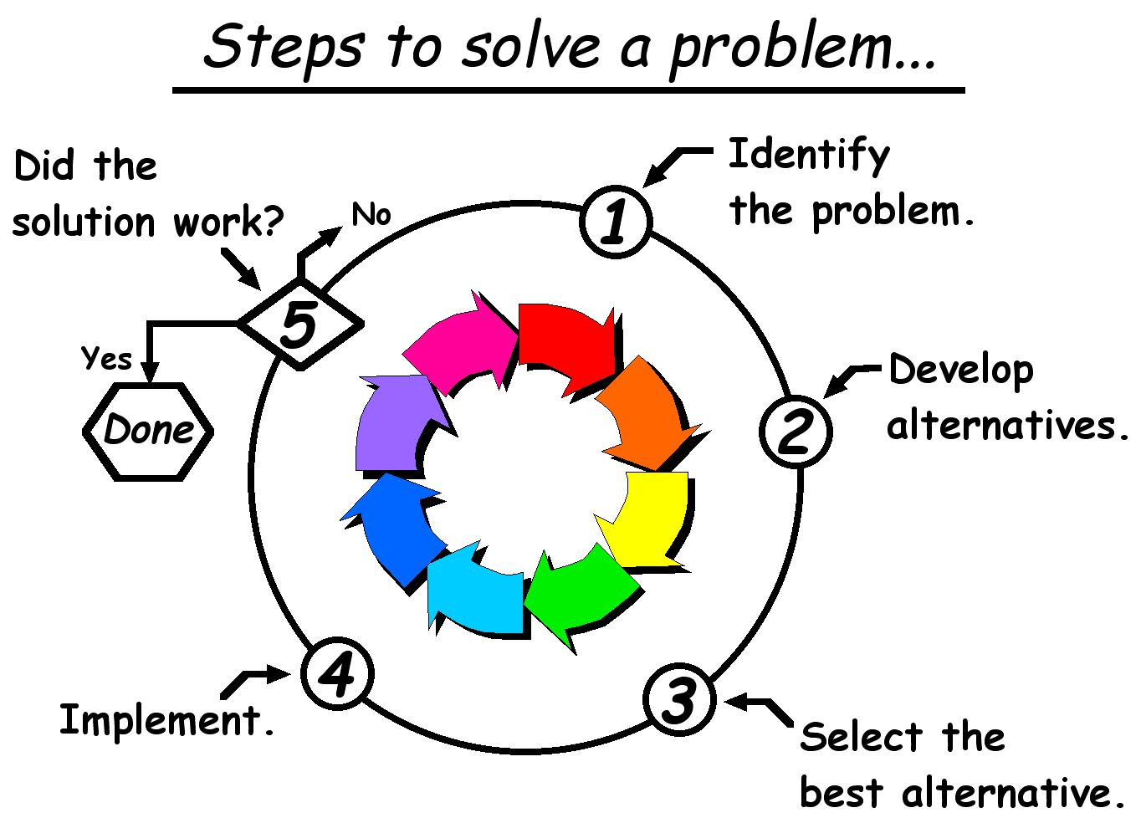
The five steps are;
- Identify the problem
- Develop alternatives
- Select the best alternative
- Implement ideas
- Conclude if the solution worked or not

Conclusions

This report I have done is based on a business which I choose a worldwide known fast food outlet named McDonalds’s. I have had to introduce my chosen restaurant, write about the background of the restaurant in as much detail as possible.
I had to write about the McDonalds restaurant problems and how the problems were raised but identifying the problems I then looked at certain tools like the Ishikawa fish bone diagram to sort out why there is a problem and how it is has led there.
I have also shown some solving tools to use for future preferences.
By doing this report I have now actually realised McDonalds does have issues just like any other businesses but as a customer you don’t seem to see it unless you’re working or researching about the company.
I have now for my own knowledge also learnt how to identify problems and how to resolve them use the certain techniques I wrote about earlier in report.
I have also learnt how to back up my theory using tools and while doing that I have now had more knowledge in looking at many theories.
I have also learnt by doing this report to be able to solve and make good decisions at any working environment, to also be able to manage and implement change in the workplace.
The most important skill I have benefited by doing this report is being able to plan, monitor and review the implementation and the communication of decisions. Also learnt how to evaluate my options to decide a decision at work.
These theories and techniques are also very helpful in your own personal life style to.

References

Reference. (2019). Where Was the First McDonald’s? [online] Available at: https://www.reference.com/business-finance/first-mcdonald-s-f53c7d4498813ef1 [Accessed 29 Apr. 2019].
Slideplayer.com. (2019). 1.3 Organizational Objectives - ppt video online download. [online] Available at: http://slideplayer.com/slide/7256272/ [Accessed 29 Apr. 2019].
Dua (2019). Quality Management and Implementation. [online] Slideshare.net. Available at: http://www.slideshare.net/rythamatics/quality-management-and-implementation [Accessed 29 Apr. 2019].
Technology with Sweeney. (2019). The 4 P’s Simplified. [online] Available at: http://mrsweeneyblog.wordpress.com/2013/02/04/the-4-ps-simplified/ [Accessed 30 Apr. 2019].
みんカラ. (2019). スクリーンの背景2 The Founder マクドナルド帝国を築いた男・・. [online] Available at: http://minkara.carview.co.jp/userid/1095234/blog/39880921/ [Accessed 30 Apr. 2019].
Mail Online. (2019). Retro photos of the first McDonald's show the quaint burger joint before its glory days as a booming global franchise. [online] Available at: https://www.dailymail.co.uk/news/article-2213917/Retro-photos-McDonalds-quaint-burger-joint-glory-days-booming-global-franchise.html [Accessed 30 Apr. 2019].
Mail Online. (2019). Retro photos of the first McDonald's show the quaint burger joint before its glory days as a booming global franchise. [online] Available at: https://www.dailymail.co.uk/news/article-2213917/Retro-photos-McDonalds-quaint-burger-joint-glory-days-booming-global-franchise.html [Accessed 30 Apr. 2019].
Jiang (2019). McDonald's Company Analysis. [online] Slideshare.net. Available at: https://www.slideshare.net/YanxinJiang/mcdonalds-company-analysis-33306069 [Accessed 30 Apr. 2019].
jm_smith_211 (2019). McDonalds-Case Study. [online] Slideshare.net. Available at: https://www.slideshare.net/jm_smith_211/mcdonalds-1746308 [Accessed 30 Apr. 2019].
Literaturereviews.web.fc2.com. (2019). What is McDonald's business structure? [online] Available at: http://literaturereviews.web.fc2.com/free-essays/paper-20168639/ [Accessed 31 Apr. 2019].
satyashanker (2019). McDonalds. [online] Slideshare.net. Available at: https://www.slideshare.net/satyashanker/mcdonalds-72544124 [Accessed 1 May 2019].
Mcdonaldemployeeproblems.tumblr.com. (2019). Tumblr. [online] Available at: http://mcdonaldemployeeproblems.tumblr.com/ [Accessed 1 May 2019].
Aydrose (2019). McDonalds UAE- PESTLE, Porter's 5, SWOT, Issues & Recommendations. [online] Slideshare.net. Available at: http://www.slideshare.net/ArshedAydrose/mcdonalds-uae-pestle [Accessed 2 May 2019].
DEEPANKAR (2019). McDonalds Case on Ethics. [online] Slideshare.net. Available at: http://www.slideshare.net/BUDEEPANKAR/mc-donalds-27139267 [Accessed 3 May 2019].
Slideshare.net. (2019). McDonalds Corporation Strategic Management Analysis. [online] Available at: http://www.slideshare.net/TahminaSharmin/mc-donalds-strategic-management-analysis [Accessed 3 May 2019].
Slideshare.net. (2019). McDonald presentation. [online] Available at: https://www.slideshare.net/phamkhoa52/mcdonald-presentation [Accessed 6 May 2019].
Financetwitter.com. (2019). 20 Awesome Fast Facts About McDonald’s That You May Not Know. [online] Available at: https://www.financetwitter.com/2014/10/twenty-awesome-fast-facts-about-mcdonalds-that-you-may-not-know.html [Accessed 7 May 2019].
Solicha (2019). Shopper Behaviour McDonald's Simpang Dago Bandung Indonesia. [online] Slideshare.net. Available at: https://www.slideshare.net/nindut1/shopper-behaviour-mcdonalds-simpang-dago-bandung-indonesia [Accessed 8 May 2019].
Pre-sustainability.com. (2019). Measuring Sustainability Part III: How a Sustainability Index Can Optimize Decision-Making | PRé Sustainability. [online] Available at: https://www.pre-sustainability.com/measuring-sustainability-part-iii-optimize-decision-making [Accessed 8 May 2019].
Blogs.ubc.ca. (2019). McDonald’s squeezes Heinz | Yuwei Zhang's Blog. [online] Available at: http://blogs.ubc.ca/yuweizhang/2013/10/28/mcdonalds-squeezes-heinz/ [Accessed 8 May 2019].

Data Viz Project. (2019). Fishbone Diagram | Data Viz Project. [online] Available at: http://datavizproject.com/data-type/fishbone-diagram/ [Accessed 8 May 2019].

DC Design. (2019). Fishbone Diagram Template - DC Design. [online] Available at: http://dawnscustomdesigns.com/fishbone-diagram-template/ [Accessed 8 May 2019].
Slideshare.net. (2019). community participation and techniques ofr it oct 2014. [online] Available at: http://www.slideshare.net/chauhan25/community-participation-and-techniques-ofr-it-oct-2014 [Accessed 8 May 2019].
Pre-sustainability.com. (2019). Measuring Sustainability Part III: How a Sustainability Index Can Optimize Decision-Making | PRé Sustainability. [online] Available at: https://www.pre-sustainability.com/measuring-sustainability-part-iii-optimize-decision-making [Accessed 8 May 2019].

