BA International Hotel Management
Student name: Sebastian Garbaty
Student Number: 2211131
Module: Foreign Languages and Cultural Awareness
Module code: BMIH5003
Word count: 1023

Executive Summary

The official opening of Diversity Hotel and Spa's latest Polish location represents a milestone in hotel life and its global cultural enrichment. Before the ribbon-cutting ceremony, the hotel's devoted general manager travels abroad to guarantee every detail is perfect. The general manager will prepare meticulously for a smooth launch overseas. Discussions with the hotel's core crew are key to this project. These discussions include aligning the property with the brand's high standards and coordinating chain operations. First and foremost, the manager must guarantee the hotel embodies Diversity Hotel and Spa. But this is no ordinary task. Poland's cultural distinctions must be considered by the manager. The language barrier is a unique hurdle, but they are ready to cross it via efficient communication tactics. The management must also focus on the local culture's most important beliefs and customs. Diversity Hotel and Spa's methods honour Poland's rich heritage and culture. As the general manager travels overseas, they prepare the Diversity Hotel and Spa in Poland to combine worldwide standards with local character.

Contents
Executive Summary 2
Introduction 4
Main Body 4
Cultural sensitivity 4
Culture Overview 4
Globe Project analysis 5
Challenges 6
Conclusion 7
Recommendation 7
References 8

Intercultural Competence Report

Introduction

The inauguration of a new hotel in Poland contributes to the expansion of the cultural tapestry; nevertheless, in order to be successful, the team must be introduced to the brand standards and management expectations prior to the grand opening. To ensure the hotel's success and to retain the Diversity Hotel and Spa's reputation as a multicultural and diversity-advocate hotel brand, all talks must be conducted while keeping cultural differences in mind and engaging Polish staff members in employment. Keeping the county's cultural values in mind, a GLOBE project analysis reflects a general examination of the country.

Main Body

Cultural sensitivity

Hotel staff must be culturally informed and sensitive due to the global hospitality sector. Guests from different cultures have distinct beliefs and expectations; therefore, culturally intelligent staff may customise services, which boosts client satisfaction. Understanding cultural differences may affect food, housing, and social behavior. However, critical thinking must be applied; otherwise, stereotyping guests by overemphasising cultural standards can disrespect them. Cultural sensitivity may also help deliver. Wan and Goh (2020) visitor preferences, although reducing misunderstandings For instance, assuming a guest's eating preference is based on culture is wrong. Peterson (2010) Cultural knowledge is important, but it must be paired with individualised care to avoid generalisations and meet each guest's needs.

Culture Overview

Poland's rich history and strong identity shape its culture and customs. Roman Catholicism dominates the country's culture, with holidays and rituals related to religious events (Leszcynska, 2017). While becoming increasingly cosmopolitan, Poland plays a big role not just in attracting tourists but in attracting responsible tourists (Debicka, Oniszczuk-Jastrabek, 2017). In their society, the Polish language remains crucial, making learning fundamental phrases a sign of respect. Polish hostesses are known for generously serving food and drinks. Visitors to someone's house are urged to bring a small gift in return. Soup and bread are common meals, including pierogi, kielbasa, and bigos (Olszanka, 2022). Christmas and Easter traditions include decorating Easter eggs and making intricate nativity displays (Rudawska, 2017). Polish etiquette includes handshakes and formal titles, unless invited to use personal names. When entering a home, remove shoes out of respect. Poland's complex history of independence and foreign occupation shapes its customs, monuments, and pride, where a comprehensive education emphasises academic accomplishment and is highly appreciated (Sikora, Kaczocha, and Wartecka-Ważyńska, 2015).

Globe Project analysis
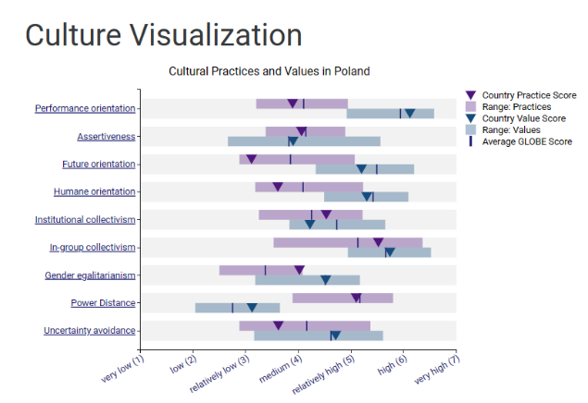
The GLOBE Project's (2023) graphic study portrays Polish cultural practises and beliefs across various dimensions. Suggests that performance orientation is highly valued in Poland. The ratings are more balanced, showing a more balanced view of assertiveness in Polish culture. Future orientation denotes a society that values planning and forward thinking. Humane Orientation demonstrates that in Polish society, compassion, selflessness, and charity are valued. While in-group loyalty and pride are more typically exhibited, the value or ideal may be lower in Polish culture.
Although Polish society supports equal rights and opportunities for men and women, there may be some discrepancies between aspirations and practise. The ratings for Power Distance show a moderate acceptance of hierarchical orders, and the Polish culture values norms, structure, and clear expectations to reduce uncertainty.
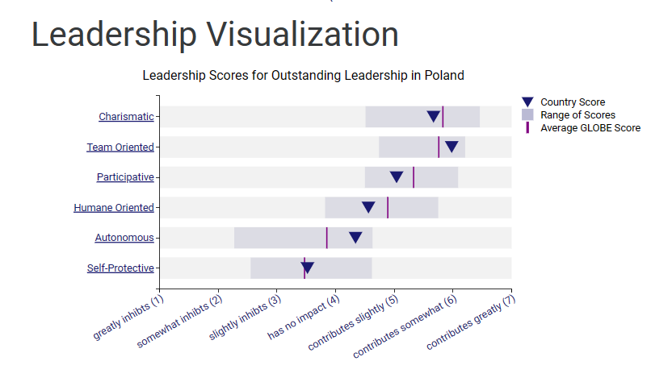
The Ledership Visualization GLOBE Project Chart (2023) displays the following information: The Country Score for its leadership attribute is positioned to significantly contribute, underscoring the importance of charm in Polish leadership as well as teamwork and collaboration in leadership roles. While the participatory score leans slightly towards "contributes," this indicates that a participative leadership style is important but may not be the dominant leadership strategy. Although the score tends toward "contributes considerably," compassion, humanity, and ideals in leaders may not be the most prominent characteristics. Autonomy score is closer to having little impact, implying that autonomy in leadership is not a fundamental value in Poland's leadership culture, and self-protection may be viewed as a less desirable trait for leadership in Poland.

Challenges

Polish society places a high value on structure and clear expectations, which suggests that clear guidelines, training, and standard operating procedures must be provided to avoid uncertainty (Wilczynska et al. 2004). Especially given the introduction of new brand standards and the need for the Polish team to adapt to a new work environment and a new brand. While teamwork is highly appreciated, autonomy is given less weight; consequently, it is necessary to strike a balance between distributing responsibilities and promoting joint decision-making. Keeping in mind the dominance of Roman Catholicism in Poland, management must be aware of religious holidays, customs, and practises, taking care not to schedule crucial activities or meetings on key religious days. Adapting leadership style to the changing team environment is essential for the management team in order to engage employees (Baytok, 2023).

Conclusion

Before the grand opening, the team must become familiar with brand standards and management requirements. To maintain the Diversity Hotel and Spa's reputation as a multicultural and diversity advocate, it must take cultural differences into account and utilise Polish staff. The GLOBE project demonstrates that Polish culture and customs are dominated by Roman Catholicism due to the country's rich history and strong identity. The nation prioritises performance, the future, and a humane perspective, with in-group loyalty and pride being more prevalent. Hierarchical orders are moderately accepted in the GLOBE project, and structure and clear expectations are valued. Challenges include clear guidelines, training, and standard operating procedures; teamwork appreciation; and balancing autonomy and responsibility distribution. Because guests from different cultures have differing beliefs and expectations, global hospitality requires culturally aware and sensitive staff. As important as cultural knowledge is, it must be combined with individualised care to avoid generalisations and meet the needs of guests.

Recommendation

- Polish language learning course for all non-Polish speakers, who may work in Poland on a temporary or permanent basis.
- The same is being offered to Polish employees who are visiting London for in-house training.
- A city tour can help you learn more about the culture and become more acquainted with the layout of the city.
- Taste of traditional Polish cuisine Poland is proud of they traditional food.
- Learn some basic polish words people will appreciate it.
- Respect they culture.
- Avoid stereotypes such as polish people can hold, they alcohol some may found it offensive.

References

Baytok, A., Zorlu, Ö., Avan, A., & Bayraktaroğlu, E. (Eds.). (2023) Leadership Approaches in Global Hospitality and Tourism. IGI Global. https://doi-org.ezproxy.uwtsd.ac.uk/10.4018/978-1-6684-6713-8 Accessed on (25th Oct 2023).
Debicka, O., & Oniszczuk-Jastrzabek, A. (2014) Responsible tourism in Poland. In Faculty of Tourism and Hospitality Management in Opatija. Biennial International Congress. Tourism & Hospitality Industry (p. 189). University of Rijeka, Faculty of Tourism & Hospitality Management.
Dorota Rudawska, E. (2014) ‘Customer loyalty towards traditional products–Polish market experience’. British Food Journal, 116(11), 1710-1725. PDF Download Google Scholar. Available on (27th Oct 2027).
GLOBE Project (2023) Results - Poland GLOBE Project. [online] www.globeproject.com. Available at: https://www.globeproject.com/results/countries/POL?menu=country#country [Accessed 25 Oct. 2023].
Leszczyńska, K. (2017) The roman catholic church in poland vis-à-vis europe and the processes of european integration. Three pictures of europe. In: S.P. Ramet and I. Borowik, eds. [online] Palgrave Macmillan US, pp.61–84. doi:https://doi.org/10.1057/978-1-137-43751-8%E2%82%84 Accessed on (25th Oct 2023).
Olszanka, P. (2022) Eating Our Way to Authenticity: Polish Food Culture & the Post-Socialist ‘Transformation’. Social Sciences, 11(2), 44. https://doi.org/10.3390/socsci11020044. Accessed on (25th Oct 2023).
Peterson, B. (2010) What is cultural intelligence? (p. 104). FrancoAngeli. PDF Download Google Scholar. Available on (27th Oct 2027).
Sikora, J., Kaczocha, W., & Wartecka-Ważyńska, A. (2015) Values and professional and ethical norms in rural tourism in Poland. Agricultural Economics, 61(8), 377-392. PDF Download Google Scholar. Accessed on (26th Oct 2023).
Wang, K. T., & Goh, M. (2020) Cultural intelligence. The Wiley Encyclopedia of Personality and Individual Differences: Clinical, Applied, and Cross‐Cultural Research, 269-273.
Wilczyńska, W., Liskova, L., Eðvarðsdóttir, S., & Speitz, H. (2004) Hospitality in intercultural teacher training. Cultural mediation in language learning and teaching, 133. PDF Download Google Scholar. Available on (27th Oct 2027).

