

Rhys Ratner (1803424)
Project Planning for Construction
Assignment 2

You are to assume that NPTCBC has received planning consent for a bridge to link two halves of an industrial estate. [See attached drawings. Further drawings available on Moodle].
NPTCBC want to build it to provide access from one industrial estate to another over a small railway line. This is to improve the economic viability of the area.
The proposed foundations are piles as described in the drawing. The piers are reinforced concrete and the
Deck is to be manufactured off site.
Work is proposed to start on 6th May 2020.
The following tasks are allocated a percentage to emphasise the suggested time you should spend on each individual task. Marks will be allocated against the set Marking Criteria indicated on page 6.

- Produce a detailed work breakdown structure for all the major activities related to the construction of this project – from start until completion. (25%)
- Produce Construction Method Statements for three of the major activities related to this project. (25%)
- Produce a Gannt chart utilising suitable software showing the critical path. (25%)
- Develop, evaluate and produce site specific reports for time, cost and resources of the work activities. (25%)

Table of contents
- – Introduction…………………………………………………………3
- – Work Breakdown structure……………………….………...4-5
- – Method Statement……………………………………………….6-8
- – Gantt Chart…………………………………………………………..9
- – Site Specific Report…………………………………………10-12
- – Conclusion……………………………………………………………13
- – References………………………………………………………….14

1.0 - Introduction
In this assignment it is required that several tasks are to be undertaken to complete the assignment. It is required to complete the tasks specifically to a bridge job in Neath that links two industrial estates. One of the tasks was to create a work breakdown structure using Microsoft project and excel outlining the works that needs to be undertaken to complete the bridge construction. Another one of tasks is to complete a method statement for three major tasks. The tasks used for the assignment were piling, pier construction and road surfacing construction. The final two tasks were to produce a Gannt chart using the appropriate software and to produce site specific reports regarding cost, time and resources. The appropriate software used was Microsoft teams.

- - Work breakdown structure.
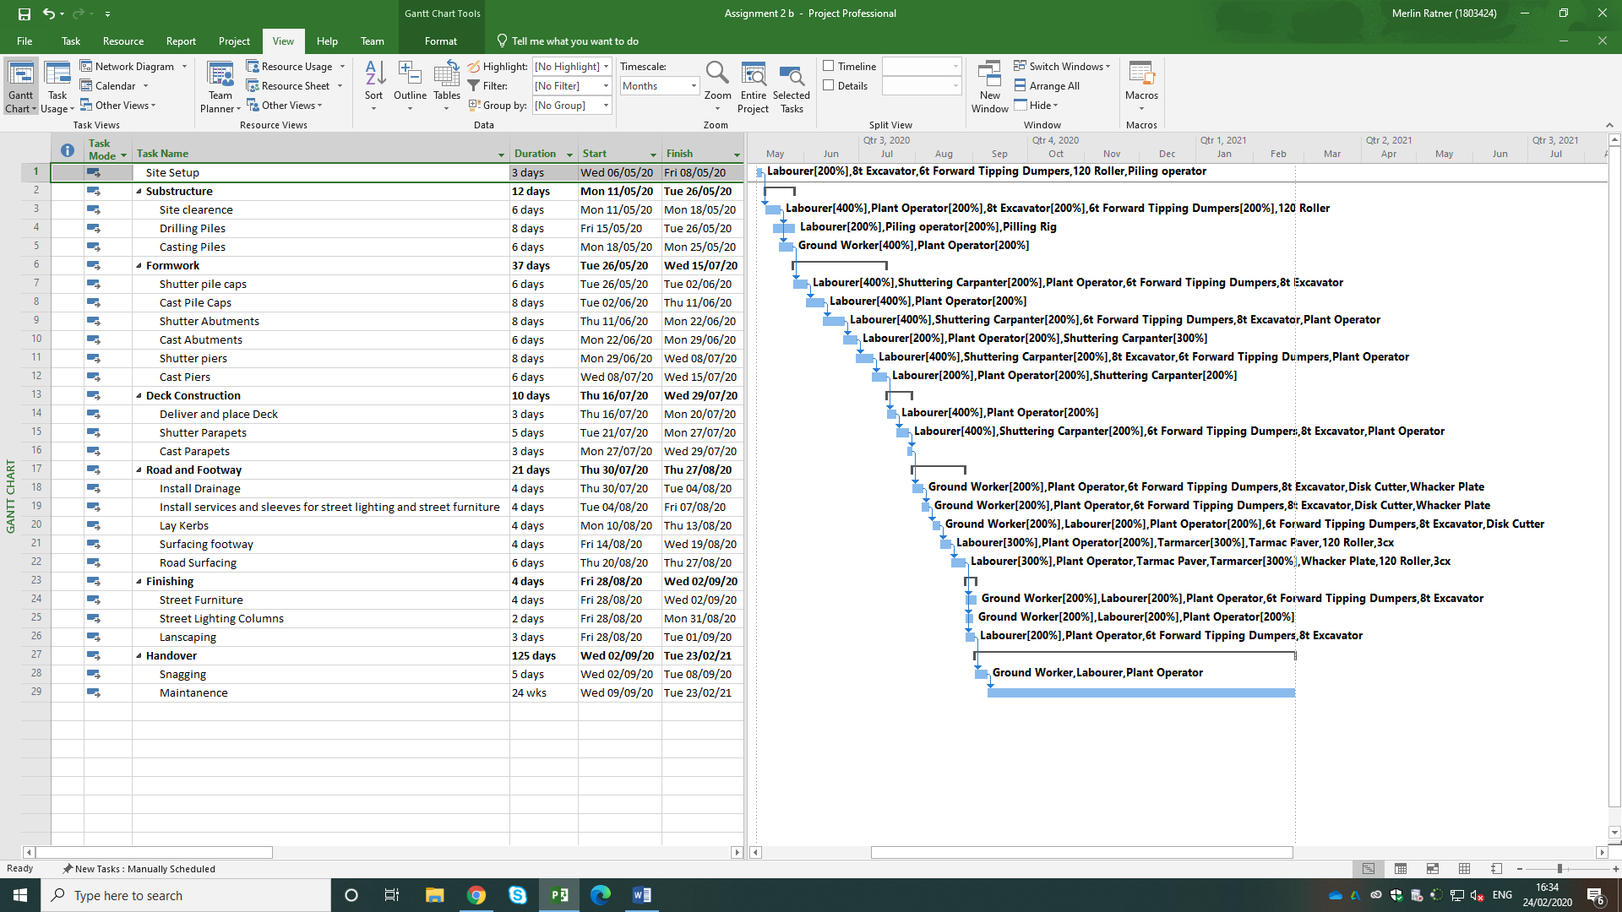
Figure 1 - Schedule of works (Microsoft Projects)

The above image is the work breakdown structure for the major activities related to the construction of the bridge. The work breakdown has been developed from experience of bridge construction and asking colleagues on site regarding the sequence and tasks that occur whilst construction the bridge. In constructing a bridge, it needs to begin from the ground and work its way up.
Table 1- Work breakdown structure (Microsoft Excel)
Above is a graph to showing the work structure completed on excel. The graph shows the work
breakdown structure, the task, duration and what task proceeds the other. This was completed on
two different types of software.

3.0 – Method Statements for Construction
Construction method statements are in place so that works on construction site can be planned and completed safely. Construction method statements clearly set out a step by step way to carry out a task.
The method statements below are associated with the NPTCBC bridge link project. The method statements written below are for three major tasks involved with this bridge construction.
  - – Method statement for Piling
Pre-Construction
- Before any work can commence it is crucial that all staff have been briefed about the daily activity and have been inducted to site.
- Firstly, the area will need to be made secure and segregated from the public.
- The work area will be kept tidy throughout the task to minimise the likelihood of any hazards and accidents.
- All mechanical tools and plant used will have been checked and in good working order.
- All plant to be used by trained and competent people only.
(Alun Griffiths Contractors, 2019)
Construction
- The piles would need to be set out by a competent surveyor/engineer using spray and steel/timber pegs.
- After the piles have been set out, appropriate measures can be taken to ensure the piling rig has room and a secure platform to work on.
- Then, works should begin constructing a piling platform for the rig to sit on. Appropriate material like type 1 sub-base.
- The sub base should be spread out evenly and level, and should also be compacted in layers to allow for stability.
- After the piling platform is complete the guide casing can begin to form.
- Before the drilling can commence a steel casing with the same internal diameter as the pile diameter will be installed to the pile centre which will be marked out.
- The steel casting consists of a series of lengths which will be extended and welded together where necessary.
- The verticality of the casing will be checked throughout the task.
- After the casing has been correctly assembled the drilling can commence.
- The first step is to set up the rig on a working platform so that it is stable and safe during the drilling.
- throughout the drilling, all the excess material will be stored on site until a lorry can offload it from site.
- After the rig has bored several holes another gang can fall back and begin to install the steel.
- After the drilling has been completed and most of the steel has been completed, the pouring can begin.
- After all the piles have bee poured and cast and have set, they can be cut off to the required level, marked out by a competent person, ready for the pile caps and base.
(World, 2018)

3.2 – Construction Bridge Piers

Pre – Construction
- Before any work can commence it is crucial that all staff have been briefed about the daily activity and have been inducted to site.
- The first activity that needs to be done before anything can commence is to cordon off the site and make the area secure from the public.
- During the task it is imperative that the area is kept tidy to avoid any hazards or falls.
- All mechanical tools and plant are to be checked and made sure they are in good working order.
- All mechanical tools and plant are to be used by competent and qualified people only.
Construction
- After the concrete base for the piers are cast and set the construction of the piers can begin.
- The first step in this phase is to get the steel delivered to site and put near the working area so that there is less transport of materials on site.
- The next step is for the engineer to set out the location of the shutters so the steel fixers can begin to tie steel.
- All offcuts and bits of steel are to be put in a skip or kept in a pile outside the working area to keep the area clean and tidy.
- Prior to the shuttering any debris will need to be blown out of the cages to ensure the structural integrity of the concrete isn’t reduced.
- After the steel has been tied, put in place and secured, the shuttering can begin.
- Peri shutters will be used for the formwork.
- When the shutters have been properly assembled and strutted the pour can begin.
- After the concrete has gone off the shutters can be removed.
- The shutters will need to be cleaned so that they can be used for the next pier ad other future purposes.
Observed the above activity during a bridge project in Henllan, Lampeter during June 2018 – November 2018.

3.3 – Road Construction
Pre – Construction
- Prior to any works commencing it is important for all workers to have been briefed and inducted to site so that all appropriate health and safety information has been forwarded.
- The first activity that needs to be completed is to segregate the work area from the public so that they aren’t in any danger.
- During the work activity it is crucial that the area is kept tidy to reduce and/or remove dangers of slips, trips and falls.
- All mechanical tools and plant are to be visually checked before use to ensure that the equipment is in good working order.
- All mechanical tools and plant are only to be used by qualified competent people.
Construction
- The first activity for constructing a road is to obtain the sub-base on site.
- The sub base should be delivered in the working area to make the activity more efficient as there is no need to transport it again
- After the sub-base has been delivered there is a need to level the sub base to the correct level with an excavator.
- Enough compaction is needed therefore the number of passes by a roller will be that of the specification.
- After the sub-base has been checked for level and properly compacted the tarmac paver can be delivered to site.
- After the sub-base has been completed the surface will need to be jet washed or swept clean.
- Then the bituminous emulsion adhesive will need to be applied to the clean surface.
- Materials will be tipped directly into the tarmac paving machine from the supply lorry.
- The materials are to be laid to the required levels which will have been marked out by a competent person i.e an engineer.
- All debris and waste tar are to be cleared and disposed of correctly.
- This process is to be repeated for every layer of tarmac.
(LTD, 2016)

4.0 – Gantt Chart
Gannt chart are used in construction projects as a work programme. Gannt charts assist construction teams in tracking the project and at the beginning of the project to estimate the duration of a project.
Figure 2 - Gannt Chart (Microsoft Projects)

Above is the Gantt chart has been produced and developed from the work breakdown structure using Microsoft Projects. The Gantt chart shows the activities that need to be carried out sequentially. The Gannt chart also shows how long each activity would take, how many workers are needed and what plant/machinery are needed. The information for the gannt chart was collected from my own experience and questioning my colleagues on site that have had vast experience in constructing bridges.

- – Site Specific Report
  - – Cost

The screenshot adjacent to the text shows the total cost of each task for the whole project. The total cost of the project is £69,960,00 over 17 weeks. This cost is a total of resources (staff and plant) and is an estimate. The most expensive resource across the whole job is a plant operator and they are the most used resource on the job not including the maintenance period. In order to reduce the cost of the job, a reduction in resources could save money but would make the length of the job longer which would come with more costs, if for example the job runs over the deadline. A daily/weekly cost would apply. Another way to make the total cost less is to use a smaller excavator or dumper. This again may also affect the time and still come with its own costs. This cost is also not including any unforeseen circumstances and is assuming there is no issue. This work is high risk work therefore when materials and other aspects of the work such as scaffolding, shutter etc. will increase the cost considerably.
Figure 3- Task Cost Overview (Microsoft Projects)


  - – Resources
Figure 4 - Resource overview (Microsoft Projects)
The screenshot adjacent to the text shows each resource throughout the project and for how long they are used in total for the project. For this project, only ground staff have been considered. I have considered,
- Plant Operators
- Shuttering Carpenters
- Labourers
- Groundworkers
- Pilling Operator
- Tarmarcers
In order to be more detailed and have a greater understanding on the resources, cost and time of the project office staff such as,
- Site Manager
- Quantity Surveyor
- Site engineer
- Project Manager
- Works Manager/Foreman
Would’ve been included. Resources also included in this project was,
- 8 tonne Excavator
- 6 tonne Forward tipping dumper
- Modular Transporter
- 120 Roller
- Tarmac Paver
- Disc Cutter
- Whacker Plate
- Pilling Rig
- 3CX
Above is the plant machinery believed to be appropriate to complete the assigned project. The resources total to a cost of £69,960.00 which is the total cost of the project because raw materials and scaffolding etc have been considered.

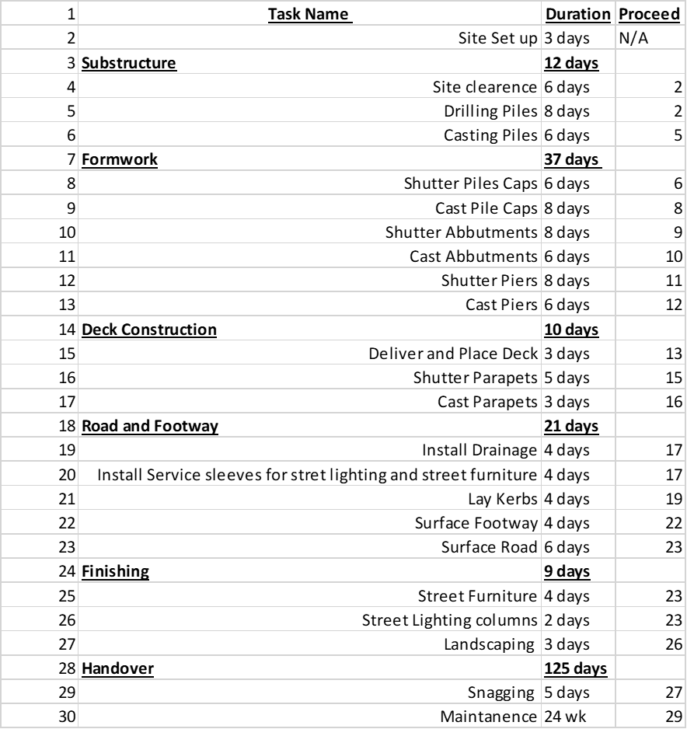
  - – Time
The chart adjacent shows an approximate time scale on how long the tasks will take. The estimations of time scales have been made from onsite experience and estimating from the amount of resources used. The total time for the project from site set up to 18.5 weeks. This estimation is assuming all works runs smoothly and that nothing goes wrong. The time could be increased if unforeseen instances occur such as a machine breaking down, locating something in the ground like old footings or structures etc. However, in order to decrease the time, more resources could be added such as another gang and more plant to increase work activity which would decrease the total time of the project. The snagging and maintenance period are assumed. Snagging will happen at the end of a project and depending on the issues at the end of the project this may be. The Maintenance period is also estimated. This time period cannot be defined until the contract has been completed. Though, the period in the contract is generally 24-26 weeks on a project.
Table 2 - Work breakdown structure (Microsoft Excel)
- – Conclusion
In conclusion, the above report includes a detailed work breakdown structure, 3 construction method statements, a Gannt chart and site-specific reports have been produced, in relation to the NPTCBC bridge construction project. The first part of the report, it includes a work breakdown structure detailing all the major activities related to the construction project throughout. This was achieved using excel and Microsoft projects to show versatility. The second part of the report contains three method statements for three major activities during the construction project. These activities are pilling, pier construction and road construction. The next part of the report was to produce a Gannt chart using suitable software. The software used was Microsoft project. This software was also used to assist throughout the report. The last part of the report includes site specific reports for time, cost and resources. These reports were developed and evaluated using the assistance of Microsoft projects and personal on-site experience.

7.0 - References
Alun Griffiths Contractors, 2019. BIT MAC SURFACING (HAND LAY), Swansea: Alun Griffiths Contractors.
LTD, G. F. (., 2016. Health & Safety Documentation Method Statement. [Online]
Available at: http://www.garyfletchersurfacing.co.uk/docs/Method%20Statement.pdf
[Accessed 03 March 2020].
World, T. S., 2018. Method Statement for the Construction of Bored Pile. [Online]
Available at: https://www.thestructuralworld.com/2018/09/04/method-statement-for-the-construction-of-bored-pile/
[Accessed 24 02 2020].

Table 1- Work breakdown structure 5
Table 2 - Work breakdown structure 11

Figure 1 - Schedule of works 4
Figure 2 - Gannt Chart 9
Figure 3- Task Cost Overview 10
Figure 4 - Resource overview 10

