UWTSD
Understanding and Engaging in the Customer Experience Mohammad Rahman, 1709543, UWTSD
BMSK5003
Mohammad Rahman, 1709543 dATED: 9TH jULY, 2019.

Executive Summary:

World becomes so completive in business. In business customer is the mitochondria of business and related actives. Understanding customer is a great deal so that it need to know the customer experiences. Engagement and understanding of customer experience provide the advantage to any business. This is the management report where the researcher gain knowledge about customer experience and engagement and explain to reader. In order to do that the researcher critically evaluate quality process in the work environment and analyse the customers’ experience of different organisation. Different evidence, model, theories such as Principles of Quality Management, CRM value chain method, Fish bone analysis, Management By walking Around (MBWA) approach been discussed. Unethical Practise, its impact to customer experience been explain with the example of different organisation. How importance is sustainability at workplace also discuss with help of example mentioning specific organisation. To explain sustainability and good quality of product and service Customer Relationship Management (CRM) has been scrutinised. This report investigate the customer experience of business based on ethical and sustainability policies and tasks have been supported by academic theory and citations with the example of different organisation in different sector such as retail banking, manufacturing and service sector regarding problems such as Tax avoidance, discrimination at work, poor working environment and facilities etc. Finally recommendation has given at the basis of findings. The researcher used secondary research method to finish this management report successfully. Readers are highly recommended to go for further research considering the limitation of time, depth and volume of this Management Report.

Table of Contents:
Particulars | Page Number.
Introduction | 3
Findings | (4-14)
conclusion | 15
Recommendation | 16
Appendix | 17
References | (18-20)

Introduction:
Ethics at work involves a series of recognition regarding identifying problems and improved working conditions considering labour right such as health and safety, freedom of association, wages, working hours over time to time. According to Ethical Trading Initiative (2019) ethical trading is believe where service and product have not been made at the outflow of workers in worldwide resource chains enjoying their rights. NIBUSINESS.CO.UK. (2019) explains that ethical trading in business not only implementing societal responsibilities but also good for wider community and work environment benefited business by building sales, attract investment, boost revenue, enhance trust and save money that make business more competitive and therefore more successful. As per Investopedia. (2019) Ethics in business sets the tendency for entire company how to run daily basis so that employees are guided by leaders and follow their footsteps . When employees feel they are valued and have integrity at work result in increases productivity and overall employee morale. Then it grasps far beyond worker loyalty and morale or the strength of a management team bond. To preserve a positive image, trades must be dedicated to operating on a virtuous foundation as it relates to treatment of workers, fair market practices and valuing the surrounding environment while treatment of consumer. Customer relationship Management also link with strong ethics. In regards to data collection storage and maintenance CRM involves with ethic as the information is confidential. According to Markgraf, B. (2017) ethical companies have to keep sensitive customer data for CRM private and confidential to the maximum level and have detailed policies and procedures for collecting, maintain, tracking even to destroy data and retain precise records of such events.

Findings:
Task 1: There are many companies having unethical practice in their businesses despite their popularity. Barclays, amazon, Walmart these big names are not out of the list.
Amazon: Amazon is a multinational technology company incorporated in USA- the second largest private employers in USA. The popularity of Amazon for their service in sky high. Though Amazon principles are customer mania rather than competitor focus, commitment to operational excellence and passion for invention but there is some unethical issues in the business. Ethical unicorn (2019) shows and describes many areas such as Tax avoidance, warehouse abuses, gig economic system for delivery drivers, worker exploitation where Amazon doing unethically.
Ethical Problems of Amazon: Government collected tax and use it for development and improvement of society especially for healthcare and education. In fact Amazon was avoiding tax. Research found that from it start its business until 2015 Amazon USA, would have been paid 20.4 billion US dollar in sales taxes. Amazon got incentives from government for their good jobs estimation worth 1.6 billion US dollar but avoid federal tax of USA. On other hand, by routing sales to Luxembourg Amazon UK only paid 4.6 million pounds as a tax in 2017. As per Ethical unicorn (2019) The European Commission ordered that Luxembourg had incorrectly allowed Amazon to dodge taxes on about 75% of its European profits, and well-ordered Luxembourg to recuperate $250 million plus interest from Amazon in October 2017. Even with being a massive establishment, with huge numbers of warehouse employees are experiencing abuses. Wages in Amazon warehouse employees is lower than the average wages elsewhere. Institute for Local Self Reliance, (2015) analysed Amazon’s fulfilment centres paid wages about 9% less than the industry average. Multiple reports revealed that staffs struggling to meet enormous high target under poor working conditions causes records of increased anxiety, depression even suicidal thoughts in workers, alongside bullying and harassment. In peak season Amazon hires staffs by external companies and let them go by short notice, on a sudden forcing to work in long hours, with low wages under poor conditions. Inadequate fire safety facilities, lack of sufficient protective equipment, absence of a functioning labour union at the factory, and strict management causes high rate of employee turnover. Amazon also occupies its delivery drivers through a gig economy scheme known as Amazon Flex can’t be used to make a living.

Walmart: An US based offshore retail company that operates a chain of hypermarkets, grocery stores and discount department stores. Walmart first store opened in USA in 1965 is a result of Sam Walton’s far-sighted leadership. As per Walmart (2019) Walmart moto to work together to keep the cost low and living for everyone and give opportunity to all. Their strategy to build on an unshakeable base: lowest prices anywhere anytime. The company employs 2.3 million associates globally and assists more than 800 million customers each month at more than 11,000 stores in 27 countries. They introduced Walmart pay that is secure, easy and fast way for customers to pay by their smart phones, becomes a popular method of instore payment.

Ethical problems of Walmart: One of the biggest company in the world Walmart is a non-union organisation. Employees can not allowed to join or communicate with union. NewYorkEssays. (2017), reveals according to Moore (2005) The PSS accused the policy of Walmart acts little to assist its staffs but gives the company the control they need to terminate unwanted non-compliant employees. Walmart using cash to bribe the employees to prohibit them to form union and encouraged dishonest behaviour. The wages of its employee is so minimum that it hard to maintain their living and force to leave the job before the completion of first year and make them eligible for public assistance, such as food stamps. Professor Richard Drogin from California State University studied and found there were a discrimination in the workplace at Walmart as male hourly workers earn up to 37 percent more per hour than female counterparts; women make up to 72 percent of total labour force but only 33 percent having managerial position. These statics shows how unjust, unfair and unethical Wal-Mart is when it comes to discriminating against females. Walmart factories in third work countries such as Bangladesh, Sri Lanka and Cambodia having poor workplace conditions, health and safety issues is not standard as per labour act which is against the slogan of International Labour Organisation for advancing social justice and promoting decent work.

Barclays Bank Plc: Today, Barclays is a major global financial services provider engaged in retail banking, credit cards, corporate and investment banking and wealth management. Barclays moves, lends, invests and protects money for 48 million customers and clients worldwide. Barclays is a financial service provider now a days famous for retail banking initially starting business as goldsmith banker in 1690 in London and later on 1736 it named Barclays. Since Barclays acted as a leader of innovation such as First lady Branch manager, introducing first ATM machine, invest the first industrial steam railway. They engage with 48 million customer worldwide serving them though wealth management, investment banking, credit cards, loan, mortgage etc. Barclays (2019) claims their values towards customer are respect, integrity, service, excellence and stewardship.

Ethical Problem of Barclays: In spite of their values Poor ethical business by Barclays Bank Plc has revealed during their progression over many years. Rivershaw, K. (2017) discussed unethical practices by Barclays mentioning that Barclays current & savings accounts receive a very poor score of 2 out of 20. Tax avoidance, maintaining political lobbying, Activities against climate chance issues and reducing carbon footprint- these are the areas where Barclays practise unethically.

In order to solve the ethical problem first of all it requires desire and create and maintain policies with honesty with enthusiasm. Create happy environment, respect for all in the workplace irrespective of race, colour, culture, religion or gender. Comply with acts or laws such as labour law, Employment rights act, health and safety act, equality and diversity laws etc. Be transparent, avoiding unethical activities, engage people and making relationship can ensure happy environment at workplace. Maintaining up graded CRM system provides more opportunities as well as build relationship ensure growth and sustainability.

Sustainability:
Sustainability is a business strategy has a positive impact on business. When a business is sustainable it enjoys relationship with all stakeholders ensuring productivity and growth and it creates a fruitful effect on environment as well as on society. Able to facing challenges, sustainability can drive business success. Spiliakos, A. (2018) describes that equity and sustainability creativities can help progress financial performance while adopting public support. Strongest motivating aspects to adopt a sustainable mind set such as align with a company’s goals, missions or values, expand reputation; meet customer’s expectations; and cultivate new growth opportunities. According to Haanaes, K. (2016) sustainability is a business approach to create a long-term value considering social, ecological and economic environment in business. Sustainability is becoming more important so that across all industries 62% of administrators consider a sustainability strategy essential to be competitive in the present day, and another 22% think it will be in the imminent. Effective communication and intentions without sustainability no longer enough in competitive present market. Earnestly Nike and Adidas have both stepped up. Nike has dedicated on reducing waste whereas Adidas has produced a greener supply chain Walmart also focused on sustainable retailing increasing resource productivity and reducing waste. Financial services like ANZ bank advance native populations with good sustainability practices and by entrenching sustainability in their business processes and culture. BMW has made strides on energy efficiency and pollution reduction in the point of practising strong ethic and making relationship with customer and society becomes sustainable.
Amazon: Recent years Amazon has set goals on renewable energy, making their voice heard on smooth environmental policies, and leveraging their knowledge in technology to initiative innovation that can benefit the globe – and enhancement of profits. As per Forbes. (2018) Amazon Sustainability Question Bank and largest wind farm in US launched by Amazon to add over one million megawatt hours of clean energy to the national grid to support green economy. Under the Amazon Career Choice Program, Amazon pre-pays 95 percent of tuition and fees. Transparency at amazon is one of the big opportunities in sustainability. Amazon has built software to implement packaging initiatives, Valuing employees in workshop communicate to them directly. BBC news (2019) reveals that Amazon is building relationship using Amazon Prime providing two hours delivery window to its customer.

Walmart: It taken strategies for its sustainability focused on endowing its associates and refining the public lives globally. Quartz at Work. (2019) revealed in order to transform future retail and commerce forward Walmart launches a tech incubator, Store Nº 8. They declare to reduce greenhouse gas emissions from its supply chain by 1 gigaton. Walmart leveraging new technologies and presented new innovation aiding customers and associates. The organisation also announces plans to expand maternity and parental leave, increased hourly rate, provide one time cash bonus for eligible associates.

Barclays: Barclays becomes Official UK Consultation for the Principles for Responsible Banking. The Principles for Responsible Banking deliver a sole framework for the global banking industry to implant sustainability at strategic, portfolio and transactional levels in business. It also helps align banks with society’s goals as conveyed in the Paris Climate Agreement and the United Nations’ Sustainable Development Goals – a set of objectives keen to undertaking climate change, ending poverty and safeguarding global peace and prosperity. Barclays (2019) describes that Barclays uses cookies on website helps to engage customer improves the browsing experience and marketing. Barclays’ green product portfolio to embrace things such as UK first-to-market green mortgage product, or aiming to double the bank’s green bond investment to £4bn over time. Barclay’s new commitment is to facilitate £150bn of social and environmental financing by 2025 sector include clean technology, renewable energy, affordable housing, education and national and supranational development institutions.

Task 2:

Quality: Quality in business where customer want quality in order to get value for money and satisfaction with appropriate price to pay. According to Tutor2u. (2019) quality is about to meet the requirements and expectations of customers. For customer the key features of quality include good design and functionality, reliability, consistency, durability and value for money. Business success rely on quality in many ways such as customer loyalty, strong brand status for quality, vendors need to stock the product, fewer returns and replacements result in reduce cost and inviting and holding good staff.

Quality Management: It is an act controlled many tasks to ensure steady delivery of services and products. Key components of quality management consist of quality planning, improvement, control and assurance. The main purpose of quality management to develop the company’s processes, services, products and culture to gain long term success derives from customer satisfaction. Principles of Quality Management embrace customer focus, leadership, engagement of people, process approach, steady development, Evidence-based Decision Making and Relationship Management

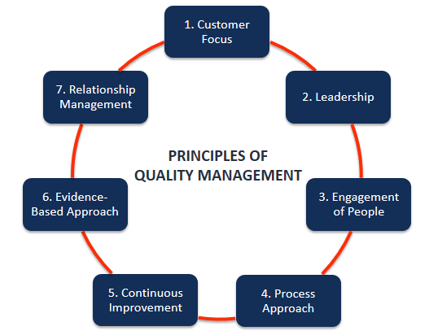

Fig.: Principles of Quality management.
CFI (2019) urges that achieving greater consistency for product and service, increased efficiency in processes reduces wastage and develop the use of time and resources, improve customer satisfaction are the main benefits of Quality Management.

Customer Relationship Management (CRM): CRM stands for Customer Relationship Management where technology is being used to manage, interact with existing and potential customer assists to build customer relationships while increased sales, profitability and improved customer service.

Salesforce. (2019), describes CRM benefits users emphasis on their business and build relationships with different people comprising colleagues, customers, service users or suppliers. CRM refers technology, strategy and process. CRM software records customer details such as address, email, telephone and media profile website as well as details of news, company activities, client’s personal preferences and communications. Generating a 360° view, seizing interactions and by developing the information CRM can make a relationship with customer with business, backings sales management, integrates with social media and facilitates team communicating. Complete mobility and access to an ecosystem of bespoke apps. Offered by Cloud based CRM systems. File and content sharing, lead management, sales forecasting, instant messaging, email tracking are the key features of CRM system.

Preact (2019) show the benefit of CRM system to support a business in engaging its customers. Grow efficiently, discover new Insights from Business Data, do Business Anywhere and safeguarding Business.

But NIBUSINESSINFO (2019) explains that in implementing a CRM can cause key difficulties for business. Such as CRM costs, software subscription or purchase fees, specific IT resources required, hard and software requirements, business culture, staff training, poor communication, lack of leadership etc. Ninja Outreach (2019) show different CRM model include IDIC Model, QCI Model and CRM Value Chain Model.
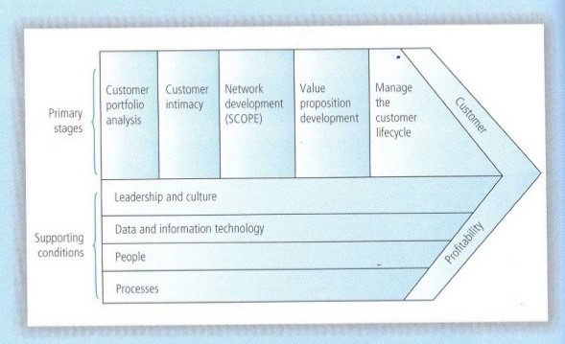

Fig: CRM Value Chain Model

One of the established model such as The CRM value chain model that can easily followed by any organisation while developing and applying their CRM strategies based on strong theoretical principles and practical requirements of the business. It is suitable for business to business and business to consumer settings in the field of IT, software, retail, media, telecoms, construction , manufacturing company irrespective of its size small or large ensuring long-term mutually-valued relationships is being built with its tactically important customers. Customer portfolio analysis, customer intimacy, network development, value proposition development and managing the relationship are the five steps in the CRM value chain model. Culture and leadership, Procurement processes, Human resource management processes, IT/Data management processes and Organization design are some fundamental settings that a company even must reflect while dealing with CRM.

Fishbone Analysis: It is also called a cause and effect diagram and/ or Ishikawa diagram. It is an imagining tool for classifying the potential cause of a problem in order to identify it root causes internally and maintain quality. As per WhatIs.com. (2019) A fishbone analysis is beneficial in brainstorming sessions to focus discussion. When the possible causes for a problem has identified, the organiser comforts the group to rate the potential reasons in accordance with their level of rank and diagram a hierarchy. Fishbone diagrams are used in the ‘analyse’ stage of define, measure, analyse, improve, control approach to problem solving.
McDonald: McDonald's having more than 1200 restaurant in UK. It has 97000 employees working as a team and deliver high quality of food and service to the customer. According to m.mcdonalds.co.uk (2019), McDonald’s is the world largest chain restaurant having 1.8 million employees globally. In the UK, McDonald’s invested over £40million on training and development every year.
McDonald and its CRM: McDonald’s successfully integrated CRM effectively in their business. According to Market (2019) method used by McDonald’s which provides improved data capture, reporting in real time and fastest respond to resolve issues. Program called Power centre supplied by Astute solutions monitor and measure the customer relationship throughout the brand by using captured data.
McDonald’s Fishbone analysis: to maintain McDonald’s reputation, business growth, retain good quality food and service McDonald’s using its talent and internally reviewed their operation by analysing and applying different methods. Fish bone analysis provides internal facts, problems, given chance for brainstorming and decision making against different issues. Besides many stakeholders their employees and customer holds great deal regarding quality issues and services. In order to create and maintain happy workplace environment management has been providing good service but still there is some customer dissatisfaction regarding customer service has been seen. By using fishbone analysis of McDonald’s case study the researcher has found that there is still low wages and lack of training made employee less motivated result in the giant restaurant constantly got high rate of employee turnover.

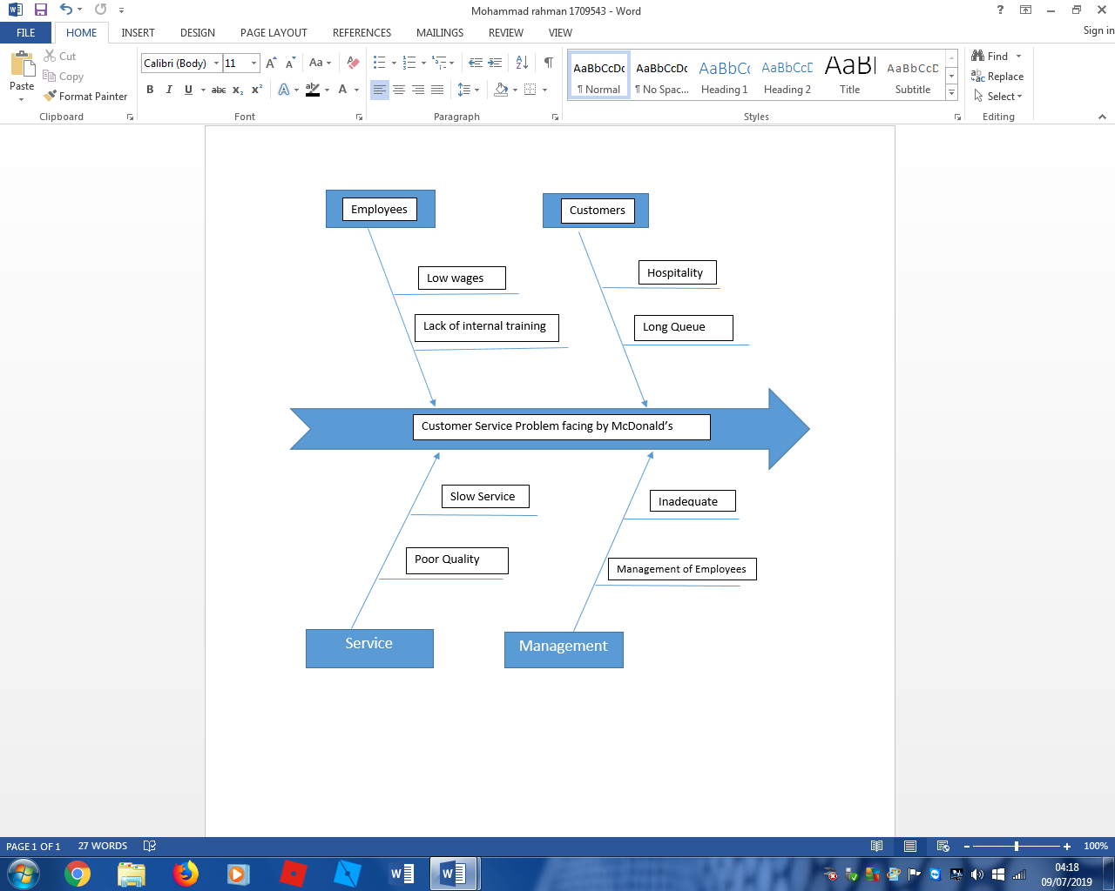
Fig: Fishbone analysis of McDonald’s.

For the lack of training staffs remain unskilled so that they remain unengaged result in long queue and customer feel uncomfortable about the hospitality given. Unhealthy and jerk food, lack of understanding of different cultures and custom also having bad impact on customer service problem facing by McDonald’s now a days.

Management Approach or Style: MBWA (Management By walking Around).
Management by working around is an effective model in order to staying touch with team and engage them effectively into workplace. According to Leadership Thoughts (2019) Management by walking around can alter relationship with employees to send a positive message to the staffs and demonstrated and engage the staff at work genuinely. To apply this model management needs to be observant, take time and meet staffs regularly, listen to them passionately. Besides asking the questions need to share own vision as well. Avoid criticizing publicly and deal with any performance issue during supervision. Positive feedback and recognise achievements encouraged team members to approach with ideas.
Clear Concept. (2019) describes that MBWA helps to address issues in earlier stage, increase team productivities, engaged more people and reduced interruptions. It talks to all stakeholder by spreading net far and wide. Despite these advantages MBWA approach has some disadvantages. As per Linked in (2014) MWBA limits the geography and employee. It also relies upon candid insight. Considering nature and style of business it is not always possible to apply MBWA but now a days it is possible to engage the worker and making relationship with them by the use of technology such as using email, talk via mobile phones and networking software like Google doc.
IKEA is a great example of implementing and successfully used the unique style of management approach, MBWA. Team management work with employee at workplace. They have talked and listen to staffs, given feedback, engaged them into work so that employees feel they are valued and relationship building-up.

Conclusion:
To conclude this Management Report the researcher successfully stated and showed the impact of ethical and sustainable policies on the quality matter Of CRM in business. The researcher uses different model and theories as well as technics to give the readers the idea about implication of ethic, sustainability and quality in business. This report identify problems and improved working conditions and explain how ethical trading implementing societal responsibilities while doing business. In order to give readers proper ideas about unethical trading the researcher specifically not only mention the unethical practise doing by specific companies but also describes how sustainably matters in the business explaining different activities practise by different organisation. To provide and retain quality of products and services especially in this completive business world principles of quality management has been discussed that gives reader the proper understanding of quality of CRM, its importance and how vital the engagement and relationship in today’s business that ensures business growth and happy and safer environment in any organisation. Though recommendation is also provided on development points highlighted within finding but reader will be recommended to go for more research about understanding and engaging in the customer experiences.

Recommendations:

Amazon and Barclays should select quality people who works with ethics. They should create supporting policies and make sure an appropriate practise also taken place against unethical activities such as tax avoidances. Identify the case of unethical behaviours and establish procedures ensure ethical behaviours. They should have transparent financial accounts, making culture of it and control system should be developed. Also need to develop people understanding relevant matters. Make sure leadership must walk and talk. Prise good ethics publicly. Reward system could be implemented for work ethics practise by employees and management, support better public policies and motivated ethics and create a culture to respect the values within organisation. Amazon should release the workload from its worker especially for pick time or seasons and make balance between work pressure and working hours. Standard wages should be given so that the employee ensures at least standard of living. Workplace environment need to be improved by training and through learning process, ensuring safety equipment and work condition. Dismiss the gig economy scheme for its delivery driver changing good, standard friendly and happy system.

Walmart should allow their employee to create a union ensuring employees as well as management equal rights will be there. Discrimination against women has to be removed and ensure women empowerment by getting more lady managers. Safety and security of workplace must be ensured by Walmart’s associates especially at third-world countries. Culture of respect and friendly policies has to be implemented and practises for employee better engagement and relationship with each other and management.

Barclays should make balance and somewhere make compromise issued relate to political lobbying and climate chance. For sustainability and better quality product and service any organisations such as Walmart or McDonald’s has to review their CRM system regularly. Strategy and sustainability efforts should be aligned while making any decision by Management. Need to discover new insight to ensure quality so more research need to be carried out.

Appendix
Secondary Research method has been used by researcher. Google engine search, books, you tube, and journals are also used for completion of this management report. Highly grateful to the lecturer to make the lectures relevant and having full of learning elements and overall joyful environment.
References:
Barclays. (2019), Our History Barclays [Online] Available: https://www.banking.barclaysus.com/our-history.html [Accessed 7 July 2019].

Backlays. (2019), How Barclys is Building a Sustainable Banking system [Online]. Available: https://home.barclays/news/2019/3/how-barclays-is-building-a-sustainable-banking-system/. [Accessed 07July 2019]
BBCNews. (2019), Amazon [Online] Available: https://www.bbc.co.uk/news/topics/c50znx8v8y4t/amazon. [Accessed 8July 2019]
CFI. (2019), Quality Management-Understanding How Quality Management Works [Online]. Available: https://corporatefinanceinstitute.com/resources/knowledge/strategy/quality-management/ [Accessed 8 Jul. 2019].
Chron. (2019), How to Change Unethical Behavior in Business. [Online] Available: https://smallbusiness.chron.com/change-unethical-behavior-business-19175.html [Accessed 7 Jul. 2019].

Clear Concept. (2019), 5 Reasons why MBWA could be your best management strategy yet [Online]. Available: https://clearconceptinc.ca/5-reasons-why-mbwa-could-be-your-best-management-strategy-yet/. [Accessed 9th July 2019].
Digital.wings.uk.barclays. (2019), CRM and cloud computing in association with Salesforce [online] Available https://digital.wings.uk.barclays/for-everyone/milestone/what-is-crm/ [Accessed 7 Jul. 2019].

Douglas, E. (2019), 7 Practices to Prevent Unethical Behavior. [Online] Available: https://blogs.edweek.org/topschooljobs/k12_talent_manager/2012/10/7_practices_to_prevent_unethical_behavior.html [Accessed 7 Jul. 2019].
Ethical Trading Initiative. (2019), What is Ethical Trade? [Online]. Available: https://www.ethicaltrade.org/faq/what-ethical-trade. [Accessed 3rd July 2019].
Ethical Unicorn. (2019), The Ethical Issues in amazon [Online]. Available: https://ethicalunicorn.com/2019/01/12/how-ethical-is-amazon/. [Accessed 6th July 2019].
Expert Market. (2019), McDonald’s CRM Case Study [Online]. Available: https://www.expertmarket.co.uk/crm-systems/mcdonalds-crm-case-study. [Accessed 9th July 2019].
Forbes. (2018), Amazon's Big Opportunity: Transparency In Sustainability [online]. Available: https://www.forbes.com/sites/edfenergyexchange/2018/04/02/amazons-big-opportunity-transparency-in-sustainability/#474a6d3a7c50 [Accessed 7 Jul. 2019].

Haanaes, K. (2016), Why all Businesses should Embrace Sustainability [Online]. Available: https://www.imd.org/research-knowledge/articles/why-all-businesses-should-embrace-sustainability/ [Accessed 7th July 2019]
Investopedia. (2019), Why is Business Ethics Important? [Online]. Available: https://www.investopodia.com/ask/answers/040815/why-are-business-ethics-important.asp. [Accessed 3rd July 2019].
Leadership Thoughts. (2019), Management By Walking Around Transforms Employee Relationships [Online]. Available: https://www.leadershipthoughts.com/management-by-walking-around/. [Accessed 9th July 2019]

Linked in. (2014), Management by walking around in a social world [Online]. Available: https://www.linkedin.com/pulse/20141008081707-789783-management-by-walking-around-in-a-social-world. [Accessed 9th July 2019].
M.mcdonalds.co.uk. (2019), About MacDonald’s [Online]. Available: https://m.mcdonalds.co.uk/ukhome/Aboutus/Newsroom/facts_and_stats0.html. [Accessed 9th July 2019]

Markgraf, B. (2017), Ethical Issues in CRM, [Online].Available:https://bizfluent.com/info-8384284-ethical-issues-crm.html. [Accessed 4th June 2019].
NewYorkEssays. (2017), Unethical Business Practice of Walmart [Online]. Available: https://newyorkessays.com/essay-unethical-business-practice-of-walmart/. [Accessed 6th July 2019].

NIBUSINESS.CO.UK. (2019), Ethical Trading [Online]. Available: https://www.nibusinessinfo.co.uk/content/benefits-ethical-trading. [Accessed 3rd Jul 2019].

NIBUSINESSINFO.CO.UK. (2019), Potential Drawbacks CRM System [Online]. Available: https://www.nibusinessinfo.co.uk/content/potential-drawbacks-crm-systems. [Accessed 9th July 2019].
Ninja Outreach. (2019), CRM Models [Online]. Available: https://ninjaoutreach.com/crm-models/. [Accessed 9th July 2019].
Preact. (2019), What Are the Top 5 Benefits of CRM? [Online]. Available at: https://www.preact.co.uk/why-crm/how-businesses-benefit-from-crm [Accessed 9 Jul. 2019].
Quartz at Work. (2019), Walmart tried to Make Sustainability Affordable. Here’s what happened [online]. Available: https://qz.com/work/1354706/walmart-tried-to-make-sustainability-affordable-heres-what-happened/ . [Accessed 7th Jul. 2019].

Rivershaw, K. (2017), Making an ethical choice: why I stopped banking with Barclays [Online]. Available:https://medium.com/@k.n.burke/making-an-ethical-choice-why-i-stopped-banking-with-barclays-b69533c3d897. [Accessed 4th July 2019].

Salesforce. (2019), A Beginner's Guide to CRM Systems [Online]. Available: https://www.salesforce.com/uk/learning-centre/crm/crm-systems/. [Accessed 8th July 2019]

Salesforce. (2019), The B2B Sales Funnel and the Role of CRM Systems [Online]. Available: https://www.salesforce.com/uk/learning-centre/crm/b2b-crm/. [Accessed 8th July 2019]
Salesforce. (2019), What is CRM [Online] Available: https://www.salesforce.com/uk/learning-centre/crm/what-is-crm/. [Accessed 8th July 2019]
Spiliakos. A, (2008), What Does "Sustainability" Mean in Business? [Online]. Available: https://online.hbs.edu/blog/post/what-is-sustainability-in-business [Accessed 7 Jul. 2019].
Tutor2u. (2019), Quality –Introduction [Online]. Available: https://www.tutor2u.net/business/reference/quality-introduction. [Accessed 9th July 2019]
Walmart. (2019), Our History [Online]. Available: https://corporate.walmart.com/our-story/our-history [Accessed 7th July 2019]
WhatIs.com. (2019), What is Fishbone Diagram?[Online]. Available: https://whatis.techtarget.com/definition/fishbone-diagram. [Accessed 9th July 2019].

