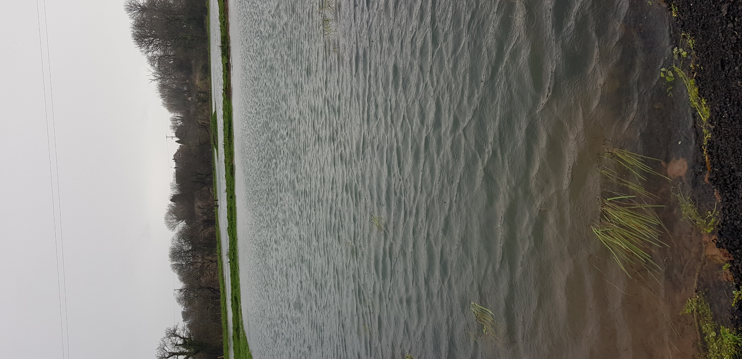  Is size of farmland ponds related to plant species biodiversity in the early years of natural colonisation? | Simon Richards  BSc Environmental Conservation. University of Wales Trinity St David

Table of Contents
Introduction 2
Aims and Objectives. 6
Literature review 7
Methodology 8
Measuring instruments 8
Analysis and Discussion 10
Conclusion 11
References 12

Introduction

Ponds are widespread across the globe and although much study has been focused on larger bodies of freshwater such as streams, rivers and lakes, until recently, the study of ponds and their associated pond biota had received much less attention. (Biggs et al; 2005)
A pond has no clear definition but are small bodies of shallow water < 10 ha surface area either man-made or formed by natural processes.Historically created by various forces of nature, activity of glaciers scraping out hollows leaving behind impervious material, sea level changes leaving pools that with the inflow of fresh water become brackish and river courses meandering and leaving small and larger areas of still fresh water and trees uprooting and creating sunken areas from their root plates (Oldham & Swan, 1997).
Man has created thousands of ponds particulary in farmland particulary up to early 1800’s, marl pits were dug for clay and lime soil to improve soil fertility, as reservoirs to provide drinking water for livestock, as fish breeding areas for angling and for aesthetics (Williams, Whitfield and Biggs 2007). With the early 1800’s being a high point with approximately 800,000 ponds (Bradbury, R.B. and Kirby, W.B., 2006) current pond numbers are hard to quantify accurately especially as some surveys disregard ponds of less than 0.2 ha but studies have provided regional estimates and distribution in England and Wales are estimated at 220,000 with recent decades seeing the fastest decline. (Halls, 1997) (Boothby and Hull, 1997) (Wood et al., 2003). However, several thousand new ponds are also created each year in England and Wales and recognized as providing a valuable resource in terms of landscape quality and biodiversity improvement. (Williams; Whitfield; Biggs 2007)

Hypothesis
Does the smaller pond attract similar numbers of aquatic plant species as the larger pond?
Do individual macrophyte species exhibit preferences for larger or smaller ponds?
The purpose of this study is to record the colonisation of different flora species present in the two varying sized ponds, both constructed in the same location during late summer 2019 to see whether there is a significant difference between the two ponds. The results could advance understanding of how pond size benefits aquatic plant biodiversity and may influence future policy on how sizing of ponds is undertaken when creating new ponds for biodiversity.
The focus is on plant colonisation as plants are the primary producer gaining energy from sunlight through photosynthesis and providing both oxygen into the pond water enabling fauna communities to develop and providing a food source for many species including molluscs, larvae of many invertebrates, tadpoles of amphibians and important habitat for hunting and shelter for a wider range of fauna.
The study will be conducted over two years and will be looking at the early colonisation of Dewslake Pond A and Pond B, previous studies have shown that newly created ponds are often very quick to attract flora and that they often reach maximum diversity within three to five years.

Site description.
The ponds are in Dewslake meadow in Lamphey, Pembrokeshire, Wales SA71 5PB (UK national grid coordinates SN 022006) and lie in an area of floodplain beside the Ridgeway road from Lamphey to Tenby in semi improved grassland adjacent to a stream that is a tributary of the Pembroke river. The Dewslake meadow is small (approximately 5.25ha) and has a private footpath running along the North side of the ponds for guests at the adjoining campsite to use.
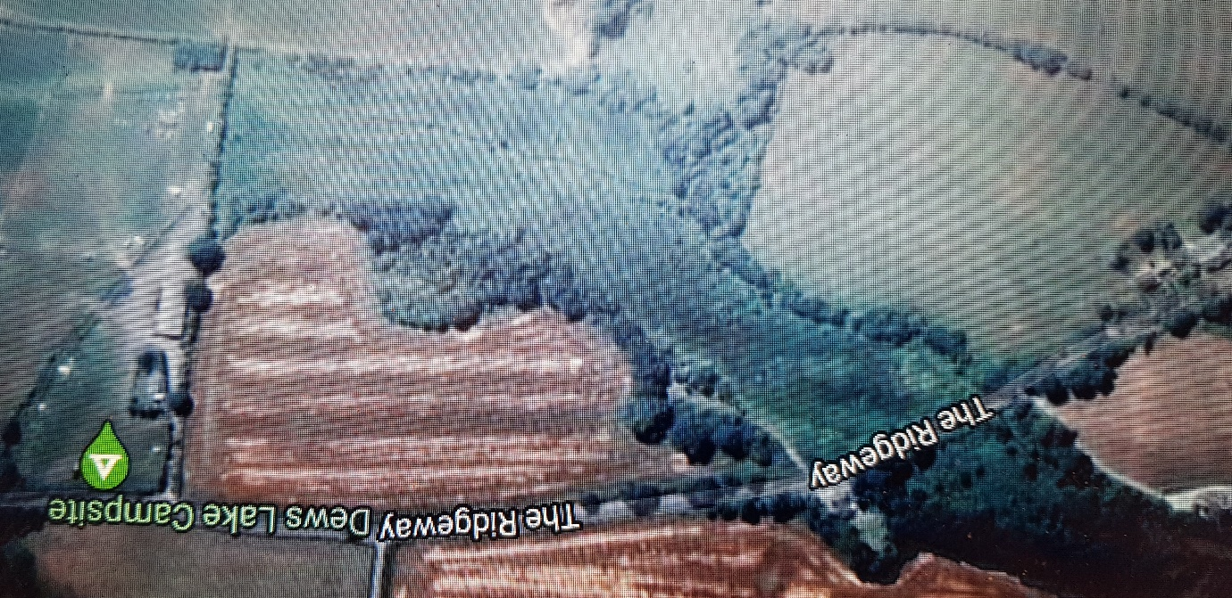

Map curtesy of google maps
Fig 1. Site of Dewslake ponds Grid N 

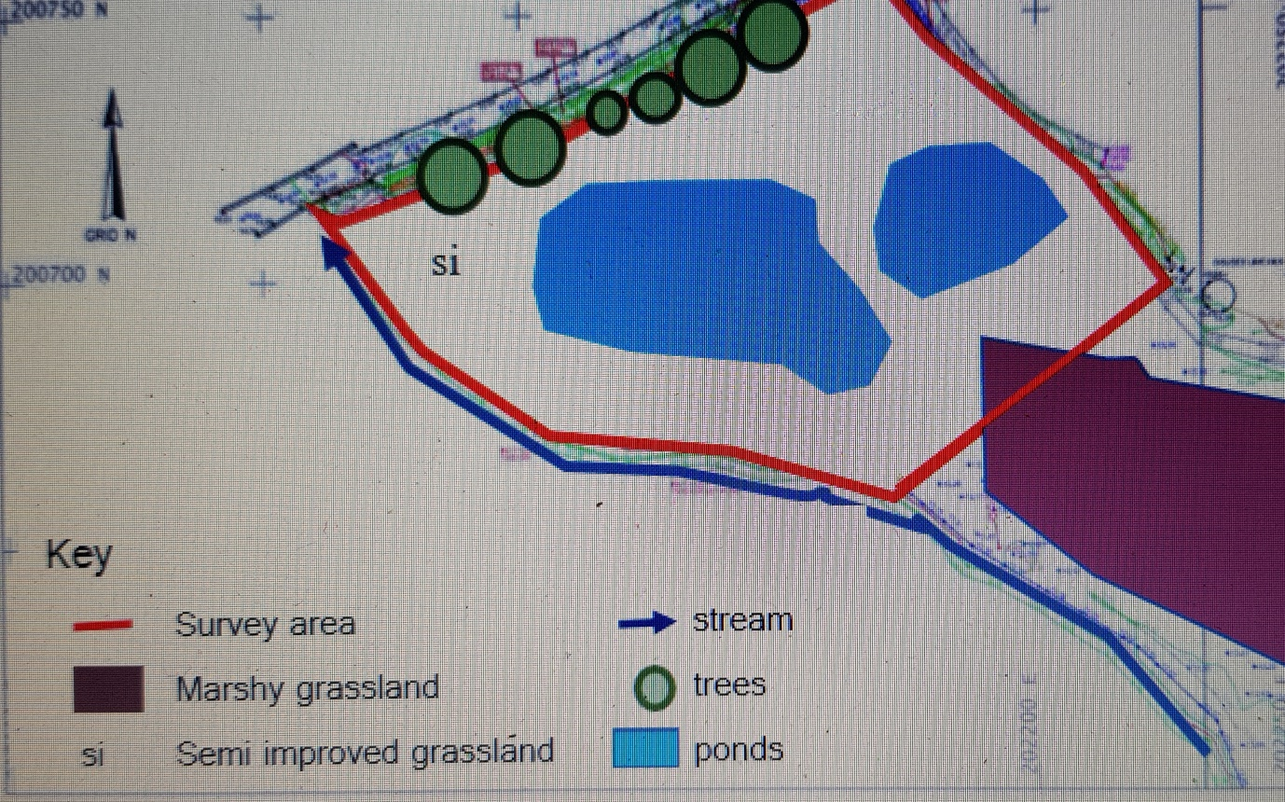
Map curtesy of Kite Ecology
Fig 2. Both Dewslake ponds with marshy grassland to south-east and stream to the south.

Aims and Objectives.

Aims

Whether size of pond surface area has an impact on early colonisation of aquatic flora.
Whether there is a species preference to smaller or larger pond areas.

Objectives

To study two ponds constructed at the same time in the same area
To ensure there are as few variables between the two ponds except size
Samples are taken over two consecutive years three times each growing season
To compare the aquatic plant species in each pond.
Many recent studies have shown that the creation of new ponds benefit a wide range of fauna and flora with recommendations on the design of a pond with its depth, amount of slope on the sides, degree of sunlight or shade, difference between high water levels in early spring and low water levels in late autumn. (Gee et al 1997) (Williams et al 1997).
Previous studies appear to conflict one another on whether size matters, some state that biodiversity does increase with pond size (Hill, M.J., Mathers, K.L. and Wood, P.J., 2015).
Although studies have shown that very shallow ponds or hollows only 5cm deep are beneficial to biodiversity, no studies appear to have looked at the comparative merits of two distinct pond sizes in the same location, both fed by the same water source but discreet from each other.

Literature review

The rapid decline in pond numbers in the UK has caused a decline in biodiversity, particulary in those species such as amphibians that rely on still areas of freshwater to feed and breed. Historical theory ( MacArthur and Wilson, 1967) would suggest that pond size should be large (“the bigger the pond, the better”), but information about ecology of ponds (Biggs et al., 1994,) is sparse and contradictory.

Indicator Species
Some taxa are referred to as ‘indicator species within a studied habitat but there is actually no consensus on what they are supposed to indicate. Some amphibians including the species great crested newt have been promoted as bioindicators indicating a healthy habitat if found in a pond. However, care needs to be taken with the use of bioindicators as research has indicated that individual species evidence alone is not a sufficient indicator of biodiversity. (Sewell, D. and Griffiths, R.A., 2009) Other terms such as ‘umbrella species’ (where the protection of one species and its habitat is presumed to protect many other species sharing the same habitat) are often not research based but more an expectation and is often used where funds or time is insufficient for full research. (Simberloff, 1998; Sewell, 2009). Therefore, it is important to complete reliable data collection and analysis to support these claims.

Number of ponds

Estimates by (Downing et al 2006) suggested that the area of ponds > 10 ha may be as high as 30% of the global total standing water area; although recent evidence suggests this is not accurate (Seekell et al 2013; Verpoorter et al 2014). Satellite imagery omit ponds smaller than 0.2 ha in size (2000 m²) (Verpoorter et al 2014) however even the smallest of these (less than 0.1 ha) have important roles in ecosystems (Holgerson and Raymond, 2016).
Small still waterbodies are often hotspots for biogeochemical activity and therefore may be among the most important ecosystems in the world (Downing 2010). Permanent or temporary ponds are valuable to wildlife as they often have their entire water column within the photic zone enabling macrophyte growth to flourish given the right conditions.(Oertli et al 2005) We still need to find ways of better assessing the environmental value of ponds (Biggs et al. 2005; Oertli et al. 2005b). It is essential that we also include in any biodiversity assessment, adjacent habitats such as wetlands and streams as well as the ponds. (Declerck et al. 2006).

Fauna in ponds
Pond-dependent species, especially amphibians have seen a serious decline in numbers as habitat quality has been falling(Oldham & Swan, 1997) Back garden pond habitats, whilst small in surface area have become a valuable habitat and are enormous value for the taxa both in rural and particulary in urban gardens. (Beja and Akazar 2003; Knutson et al 2004; Soomets et al 2016). Avian diversity in aquatic habitats is an important feature, many declining farmland species rely on wetland habitats including ponds to breed and survive including lapwing, snipe, woodcock, yellow wagtail, reed bunting and bittern. Many feed on aquatic macroinvertebrates, particulary adult aerial stages which also provide essential food for rearing young. (Newton 1998; Baxter 2005; Ruggiero et al 2008; Richardson 2010; Schummer et al 2012; Matuszak 2014; Soinien et al 2015; Stenroth et al 2015;)

European context
The European Pond Conservation Network has held five conferences aimed at increasing knowledge and appreciation of ponds in our ecosystems (Oertlietal 2005). In the UK in the past ten years the ecological significance of ponds has been more prominent with a 4 million-pound National Pondlife Centre developed, supported by the Millennium commission and the Heritage Ponds Project plus many local initives around the UK. Shown to be valuable habitats for common and scarce fauna and flora, peer reviewed studies have shown the positive benefits of ponds, particulary when situated near existing watercourses or wetland areas. (Semlitsch, R. D 2015). The habitat between ponds can be as important as the ponds themselves and artificial water features may act as complementary steppingstones for functional connectivity. (Conrad et al 1999)
During the fifth conference of the European Pond Conservation Network (Luxemburg June 2012) it was recognized that ponds are vital in this period of climate change as habitat for the northern migration of species. They also provide sustainable solutions for carbon capture, flooding mitigation and nutrient runoff and retention. (Céréghino, et al 2014)

Size of ponds
A positive relationship between pond size and species has been demonstrated in studies. ( Møller and Rørdam, 1985)( Gee et al., 1997) (Jeffries, 1998) (Pond-Action, 1994) although other studies provide exceptions (Friday 1987) and (Linton and Goulder 2000).
Recent evidence has been provided from scientists that small ponds are important around the world by providing carbon sequestering before the water moves to other moving water bodies and onto the sea. Glastir Land Management Scheme for Wales 2015 has provided funding for landowners to maintain farm ponds with grants from the Welsh government. (https://gov.wales/glastir) The new Agriculture Bill is still to be ratified but is expected to provide more funding and encouragement for these types of environmentally important schemes.

Importance of new ponds for biodiversity
Many studies have looked at pond design, pond numbers and the relationship with biodiversity but no studies have a direct comparison between differing pond size and biological diversity within the same location, fed by the same water source and of the same age.
Ponds have been shown to attract flora and fauna in a very short space of time with significant numbers of species within the initial two or three years, a particular benefit of new ponds is they are in open farmland without overhanging trees casting shade, therefore no detrimental effect causing reduced numbers of aquatic plants. As the primary producers supplying the food source for many of the taxa that later colonize the pond this is an important factor. Ponds improve the functional connectivity across the landscape which further increases biodiversity including invertebrates. (Biggs, Williams 2005) Extensive construction of new ponds is needed to ensure a high diversity of habitat and species and it is important to have accurate data to inform farmers and other interested parties of optimum options on size and shape (Williams et al 1997).

Carbon sequestration

With global warming becoming an ever more pressing topic in science, recent studies have shown ponds are important sites for long-term burial of carbon in pond sediments that may be very significant in terms of the global carbon cycle (Cole et al 2017). Small lentic bodies of water including ponds (Downing et al 2006; Smith et al 2002) may prove to be extremely significant in biogeochemical cycles (Downing et al 2008; Mullins 2019).

Methodology

Permissions and health and safety
The study site is owned by Martin Jones who has given permission to access and remove samples from his Dewslake site 24/7 throughout the period of study.
Under the Health and Safety at Work Act (1974) any lone working beside open ponds will mean the wearing of a buoyancy aid whilst data collecting. In addition, a safety line has been attached across both ponds

Activity
Over a period of two years longitudinal studies of the aquatic flora will be recorded in the growing season over two ponds on A (750m²) and B (3500m²). Data will be collected during the growing season in April, June and September 2020 and again in April, June and September 2021.
Measurements of the water pH, conductivity, nitrate and phosphate will be sampled at each survey.

Measuring instruments
Peer reviewed methodology is being used for collecting data but has been adjusted from 5m measuring points to allow for varying size of both ponds and to ensure that 30 records for each individual site were available for reliable statistical integrity (Oertli et al 2005).Transects using (0.5x0.5M) quadrats perpendicular to the longest side of both ponds every 4m length for pond A and 8m for the larger pond B and identify and record each plant species. Tables of expected plant species and % plant cover will be produced and taken to site at each survey to assist in recording.
Photographs of each plant unrecognized plant will be taken for later identification of species along with the quadrat number. Samples immediately above the water shoreline edge and a second set of samples at the same measured points along the pond in the water immediately away from the shoreline, in water that is no more than 3m deep. (Bried et al 2012,2015) Alternative methods of collection of data include collecting plant samples for identification later in the office but I chose my methods as they were less intrusive on the habitat. Therefore, these methods are the most valid for this study.

The statistical analysis using an unpaired T test will be used to compare the number of species in each pond sample.
A Venn diagram will show the species that were only found in pond A and only found in pond B and the shared species between the two pond habitats.
A ranked percentage species presence curve graph will show the plant species monitored on both ponds.

Results

If the study results show that the smaller pond will attract the same or a similar number of species as the larger pond, then this will add to existing knowledge about pond design and will help inform any interested parties about sizing of a new pond construction for optimal use of land, time and capital. A potential impact of determining that smaller pond size is equally valuable to biodiversity to a much larger pond could result in more ponds being created.

Analysis and Discussion

There are limitations in this study. Due to the data collection over a period, recording will inevitably mean even with reliable data recording, some species may have been missed. However longitudinal study over a two-year period with both pond sites recorded at same time periods, the data provided will be valid. Using the same methods of observation and sampling should provide reliability.
Triangulation of data will help support my findings and it will be further analysed and verified following discussion with qualified groups and individuals, along with the extensive use of relevant articles, websites and published reports.
Observation on site has been used in collecting data which can present a bias due to its difficulty in accurately interpreting.

Conclusion

If my hypothesis is proved, then expected results will show that smaller ponds are as valuable as larger ponds for plant biodiversity in their early years and this can be used to inform future design and construction of ponds for environmental purposes.

A further period studying the changing biodiversity of the Dewslake ponds would provide more descriptive data on which to base a longer-term analysis.

Also, further research on a greater number of variously sized new ponds within a catchment and landscape would be valuable as it would provide a more statistically sound basis on which to draw firmer conclusions.
If funds allowed, further research on fauna colonisation, particulary molluscs, beetles, dragonflies and amphibians during the same two-year period would be very useful as it ould have provide a better understanding of the wider biodiversity value of the two ponds.

References

Biggs, J., Williams, P., Whitfield, M., Nicolet, P. and Weatherby, A., 2005. 15 years of pond assessment in Britain: results and lessons learned from the work of Pond Conservation. Aquatic Conservation: Marine and Freshwater Ecosystems, 15(6), pp.693-714.
Briers, R.A. and Biggs, J., 2005. Spatial patterns in pond invertebrate communities: separating environmental and distance effects. Aquatic Conservation: Marine and Freshwater Ecosystems, 15(6), pp.549-557.
Boothby J, Hull AP. 1997. A census of ponds in Cheshire, North West England. Aquatic Conservation: Marine and Freshwater Ecosystems 7: 75– 79.
Boothby, J., 1999. Framing a strategy for pond landscape conservation aims, objectives and issues. Landscape Research, 24(1), pp.67-83.
Bradbury, R.B. and Kirby, W.B., 2006. Farmland birds and resource protection in the UK: Cross-cutting solutions for multi-functional farming? Biological Conservation, 129(4), pp.530-542.
Céréghino, R., Boix, D., Cauchie, H.M., Martens, K. and Oertli, B., 2014. The ecological role of ponds in a changing world. Hydrobiologia, 723(1), pp.1-6.
Gee, J.H., Smith, B.D., Lee, K.M. and Griffiths, S.W., 1997. The ecological basis of freshwater pond management for biodiversity. Aquatic Conservation: Marine and Freshwater Ecosystems, 7(2), pp.91-104.
Halls A.J. (Ed.) (1997). Wetlands, biodiversity and the Ramsar convention: the role of the convention on wetlands in the conservation and wise use of biodiversity. Gland, Ramsar Convention Bureau
Hassall, C., 2014. The ecology and biodiversity of urban ponds. Wiley Interdisciplinary Reviews: Water, 1(2), pp.187-206.
Hill, M.J., Mathers, K.L. and Wood, P.J., 2015. The aquatic macroinvertebrate biodiversity of urban ponds in a medium-sized European town (Loughborough, UK). Hydrobiologia, 760(1), pp.225-238.
(https://gov.wales/glastir) Accessed 15/02/2020

Mullins, M.L. and Doyle, R.D., 2019. Big things come in small packages: why limnologists should care about small ponds. Acta Limnologica Brasiliensia, 31.
Oertli, B., J. Biggs, R. Céréghino, P. Grillas, P. Joly & J. B. Lachavanne, 2005. Conservation and monitoring of pond biodiversity: introduction. Aquatic Conservation: Marine and Freshwater Ecosystems 15: 535–540
Semlitsch, R.D., Peterman, W.E., Anderson, T.L., Drake, D.L. and Ousterhout, B.H., 2015. Intermediate pond sizes contain the highest density, richness, and diversity of pond-breeding amphibians. PLoS One, 10(4).
Sewell, D. and Griffiths, R.A., 2009. Can a single amphibian species be a good biodiversity indicator? Diversity, 1(2), pp.102-117.)
Simberloff, D., 1998. Flagships, umbrellas, and keystones is single-species management passé in the landscape era. Biological conservation, 83(3), pp.247-257.
Williams, P., Biggs, J., Corfield, A., Fox, G., Walker, D. and Whitfield, M., 1997. Designing new ponds for wildlife. British Wildlife, 8(3), pp.137-150.
Williams, P., Whitfield, M. and Biggs, J., 2007. How can we make new ponds biodiverse? A case study monitored over 7 years. In Pond Conservation in Europe (pp. 137-148). Springer, Dordrecht.
Wood PJ, Greenwood MT, Agnew MD. 2003. Pond biodiversity and habitat loss in the UK. Area 35: 206– 216.

