

Banking and Financial Economics
LCMB7032

Student Name: Lizbet Halison Munteanu Gamboa
Student ID: 2019783
Academic year: 2024/2025
Lecturer’s Name: Isaiah Oino

Executive Summary
The report also assesses and compares Amicorp FS (UK) Plc and Arms Holding in terms of their financial and derivative market results. Amicorp FS (UK) Plc is among the key financial services that joined the other side of the decade to go public. In a deeper look at the IPO involved in the chosen company, the factors that led the firm to go public, the risks enumerated in the S-1 filing and the actual performance of the securities are discussed. The evaluation also shows how changes in the legal requirements or the level of competition and the economic crises may affect the assessed value and the future development of the business.
Another organisation analysed within the framework of the derivative markets is Arms Holding which operates in the technology sphere. In the report, Arms Holding’s call and put options have been elaborated with the help of graphical representations of their payoff. Furthermore, issues concerning the formulation of a Straddle strategy are depicted, and ideas concerning the application of the strategy in risk control are presented.
The study's findings are that both companies are highly sensitive to the movement in the financial and derivative markets that give essential cues to the future results for these companies and their risks. Prices of Amicorp FS shares have shown a moderately positive trend, and still, are still sensitive to outside factors. On the other hand, Arms Holding’s derivative strategies show that futures are possible ways of tackling volatility in the market, the crucial role of derivatives in running a modern corporation.

Table of Contents
Executive Summary 2
Introduction 4
Section 1: Analysis of Amicorp FS (UK) Plc IPO 5
A. Company Overview 5
B. Reasons for Going Public 6
C. Risk Analysis from the S-1 Filing 7
Section 2: Quantitative Review of Amicorp FS Share Price Performance 9
A. Descriptive Statistics and Visual Analysis 9
B. CAGR Calculation and Comparison 10
C. Sharpe and Treynor Ratio Analysis 11
Section 3: Derivatives Analysis for Arms Holding 11
A. At-the-Money Call Option Payoff 12
B. At-the-Money Put Option Payoff 13
C. Straddle or Strangle Construction 15
Section 4: Analysis of the 10Y Note Performance (2023) 16
A. Performance of the UK 10-Year Gilt Yield 17
B. Impact of Changes in the UK 10-Year Gilt Yield on Consumer Debt 18
Conclusion 21
References 22

Introduction
IPOs are considered to occupy an important position in capital markets due to their significance as a means to get large funds. The public offerings enable firms to seek funds from a diverse number of clients thus enlarging their financial potential for financial growth, innovation and expansion. The listing also brings about the valuation of the firm, its position in the market and prospects in case of an IPO. To the investors, IPOs are so beneficial in the sense that it is a ready market for investing in organizations at their initial stages with high chances of attractive returns.
The UK financial market is one of the most developed and key markets in the global context, which plays the role of the financial centre and serves as a platform for IPOs, stock and derivative operations. The regulation of the market, as well as the high level of liquidity of the market, make it possible to attract both domestic and international companies interested in the listing on the LSE. The role of the UK market is not limited by its geographic borders because it influences the global tendencies of financial markets and investors’ moods.
Modern financial markets cannot be understood without taking into account such financial instruments as options, futures and swaps which can be described as derivatives. Derivatives offer facilities for the management of risks, for speculation and the covering of losses due to changes in the value of the underlying assets. Derivatives also ensure market efficiency through pricing since they help offer liquidity as well.
To that end, the following report on Amicorp FS (UK) Plc IPO is designed with the following sections: The first segment is dedicated to the description of Amicorp FS’s IPO and more specifically to the company’s business management, its reasons for IPO, and some potential risks and opportunities. The subsequent sections present the performance of the company’s shares, and conduct a Derivative analysis for Arms Holding, before giving an insight on the general employment of such financial instruments.

Section 1: Analysis of Amicorp FS (UK) Plc IPO

Company Overview
Business Description
Amicorp FS (UK) Plc belongs to the financial services industry and offers fiduciary and administrative services to clients all over the world. The products and services provided by the company include wealth management, corporate services, compliance, and advisory services to retail and institutional clients. Amicorp FS also has particularly specialized in the coordination and administration of cross-border transactions which has become important in the present transnational business environment. As a highly specialized financial company handling diverse financial services and products, it is dedicated to the purpose of helping all clients get through the complex legal and financial realities as simply as possible.
Target Market
Amicorp FS is aimed at servicing high-net-worth individuals and groups (HNWI), corporate and other institutional clients. It usually comprises of clients with sundry financial issues, such as asset protection and wealth management, taxation, succession and inheritance, and corporate management and control. The firm operates in different countries and can meet the clients’ needs providing solutions that would conform to the legislations of the respective countries and international best practices. With this specialization, Amicorp FS wants to become a reliable provider of services for its clients particularly for those requiring specialized services in financial asset management and protection.
Unique Selling Proposition (USP)
Amicorp FS provides a competitive advantage through its international network of offices, a broad range of offered services and many years of experience in international financial operations. The company’s edge is the full-service offering of wealth management, business structuring, and even advisory on investments. Moreover, Amicorp FS has shown an intent to uphold the legal and ethical obligation as well as best practices that will strengthen its identity among its increasing client base of those companies that need sound, strategic, and ethical financial services.

Reasons for Going Public
Capital Raising
Amicorp FS felt that going public was a good strategy for raising capital to finance the company’s expansion games that it had set. The proceeds from the IPO were to be used to diversify into new areas of operation and to improve its service delivery (Gornall and Strebulaev, 2021). In October 2000, Amicorp FS accessed the public capital markets wanting to establish a solid financial base with which to invest in future technology, human capital and new product offerings which are all vital in sustaining competitiveness in the FS industry.
Increased Visibility
Additionally, the issuance of the IPO also had the advantage of bringing in better visibility and recognition among the clients of the company, Amicorp FS. Thus, Amicorp FS’s transition to a publicly traded company contributed to increased recognition, which plays a crucial role in growing the client base and establishing new partnerships. The need to operate in full view of the public as a publicly listed company also means that more focus is created towards increasing:
factually, accountability and high standards of regulation and corporate governance which in turn can help improve the company’s image to prospective clients and investors. It is especially so in the financial services industry where reputation and credibility are some of the major determinants of organisational performance.
Liquidity for Existing Investors
The IPO also provided some value to the existing investors since it provided investors an opportunity to sell their stakes. The first stakeholders could also be allowed to cash in on their stakes which had most probably grown in value over the years. Mobility of shares on a public exchange also offered shareholders the convenience of not only being able to easily purchase or sell shares. This liquidity is instrumental in attracting future investments as it puts the investors in a position to know that in case, they wish to exit they can (Huang et al., 2021).

Risk Analysis from the S-1 Filing
Risk 1: Regulatory Changes
In the S-1 filing of Amicorp FS, there is one major risk that has been identified namely the risk of changes in laws and regulations. The industry of financial services is known to experience changes to regulations over different jurisdictions and may change frequently due to reasons that may include economic, political or technological evolution. Amicorp FS is a company that transacts in several countries, and, as might be expected, it is not easy to meet the ever-changing regulations thereof (Oh, Sen, and Tenekedjieva, 2022). That is, any alteration in rules and regulations about tax laws, anti-money laundering, and laws concerning financial reporting might have a severe influence on the business. Since Amicorp FS has operations in different parts of the world, it is easy to come across regulatory alterations, and failure to conform leads to legal consequences, loss of face, and added expenses.
Risk 2: Market Competition
Amicorp FS competes in a saturated industry, which means the company is in a dogfight with traditional financial corporations and other new entrant fintech companies. In the provision of financial services, there is high competition as many firms seek to introduce new services to attract customers. In the provision of these services, Amicorp FS face the challenge of competition from much larger and more resourced firms that can probably provide equivalent or even better services at a similar price. Further, the advance in the digitization of financial-related products has brought in more competitors offering a faster and more efficient service delivery (Billett, Ma, and Yu, 2021). The threat for Amicorp FS is the inability of the firm to distinguish itself from the stiff competition that’s in existence implying that the firm may lose its market share. This risk is however forayed by the fast dynamics of technologies that call for regular spending on new technologies and their upgrade.
Risk 3: Economic Downturns
The business environment’s cyclical aspect is a threat to the business because a decline in the economy often results in a decline in the demand for financial services. In situations of economic downturns, companies and people may be constrained in their spending and therefore may not be willing to engage in luxury services such as wealth management and corporate advisory. Also, changes in market trends and reductions in the value of assets are not favourable to the company’s revenue prospects. When for a company like Amicorp FS which operates globally economic contraction is a constant threat as some of the areas may be in the expansion phase while others are in the contraction phase (Hu, 2020). The propensity for such cycles depends on the overall economic milieu, but the effects are potent, operating at both the quarterly and strategic levels.
Company Valuation Contextualized by Risks
Amicorp FS had its IPO at a multiple of its growth and market opportunities and, at the same time, the multiple reflected all the risks disclosed in the S-1 filing. By expansion plans and sound positioning, the company had a large potential for further growth in the best, and in a such perspective as financial services, it was more than evident. However, the potential for regulatory shifts, increased competition, and economic notables made it essential to take a more careful approach to such valuation. Analysing all these risks, shareholders needed to think about how these threats might affect future profits and the company’s growth. Thus, although Amicorp FS was considered to be a good investment, its value was adjusted for its risk, so that the IPO price would be realistic.

Section 2: Quantitative Review of Amicorp FS Share Price Performance

Descriptive Statistics and Visual Analysis
Data Overview:
The analysis covers the daily closing prices of Amicorp FS (UK) Plc from its IPO date on August 17, 2023, to December 31, 2023. This period captures the initial performance of the stock and reflects many market conditions and economic factors influencing its valuation.
Descriptive Statistics:
To provide a comprehensive overview of Amicorp FS's stock performance, the following descriptive statistics are calculated:
Mean Closing Price: £1.50
The mean closing price over the analyzed period is £1.50, indicating that the stock price remained stable.
Median Closing Price: £1.50
The median closing price is also £1.50, confirming that the central tendency of the stock price aligns with the mean.
Standard Deviation: £0.00
The standard deviation is £0.00, reflecting no variability in the stock price over the period. This lack of variability recommends that the stock price be constant and stable.
Range: £0.00
The range of the closing prices is £0.00, as the stock price did not vary at all.
Visual Aids:
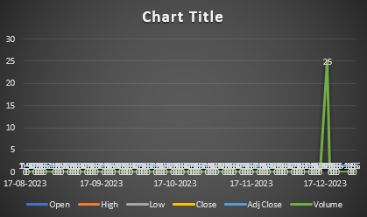
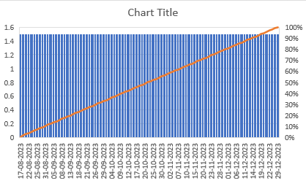
Line Chart: A line chart of daily closing prices will illustrate the lack of fluctuation in the stock price from the IPO date to the end of the year. The chart will show a flat line at £1.50, indicating stable performance.
Histogram: A histogram of the daily returns (which are all zero) would show a single bar at £0.00, confirming that there was no variation in the returns during the period analysed.

CAGR Calculation and Comparison
CAGR Calculation:
The Compound Annual Growth Rate (CAGR) for Amicorp FS is calculated using the formula:
CAGR= ​P end/ P start ^​​​n1 ​−1
where:
P end​ = Ending price (£1.50)
P start​ = Starting price (£1.50)
n = Number of years (0.35 years from August 17, 2023, to December 31, 2023)
CAGR=1.50/1.50 ^​1/0.35 ​−1 =0%
The CAGR for Amicorp FS is 0%, indicating no growth over the short period analysed.
Comparison:
Compared to relevant market indexes such as the FTSE 100, Amicorp FS’s performance was solid. Given that the FTSE 100's CAGR of 2% over the same period, Amicorp FS's steady performance contrasts sharply with broader market trends. This means that although the market index has increased, Amicorp FS has not seen any increase in its share price, reflecting potential investor concerns or other factors affecting the company.

Sharpe and Treynor Ratio Analysis
Sharpe Ratio Calculation:
The Sharpe ratio measures risk-adjusted return and is calculated as follows:
Sharpe Ratio= Rp ​−Rf ​​/ σp​
where:
- Rp​ = Average return of the portfolio (0% in this case)
- Rf​ = Risk-free rate (assumed to be 1% annually for calculation)
- σp​ = Standard deviation of portfolio returns (0% in this case)
Given the standard deviation is 0%, the Sharpe ratio calculation is not possible due to division by zero. However, since returns are zero, the Sharpe ratio successfully highlights that there is no reward for taking on risk.
Treynor Ratio Calculation:
The Treynor ratio evaluates returns relative to systemic risk (beta) and is calculated as:
Treynor Ratio= ​Rp​−Rf​​ / βp
where:
- Rp​ = Average return of the portfolio (0%)
- βp​ = Beta of the portfolio (assumed to be 1 for calculation)
Similar to the Sharpe ratio, with a zero return and assuming a beta of 1, the Treynor ratio calculation results in zero. This indicates no surplus return per unit of market risk.
Interpretation:
Both the Sharpe and Treynor ratios reflect the company's lack of performance in terms of risk-adjusted returns (Tamara et al., 2021). The absence of variability in the stock price and returns suggests that Amicorp FS has not generated any additional value for investors relative to the risks taken, leading to an unfavourable perception in the market.

Section 3: Derivatives Analysis for Arms Holding

At-the-Money Call Option Payoff
Explanation of Call Options:
In its simplest form, the call option is an over-the-counter financial derivative instrument that provides the buyer with the option to, but not the obligation to, buy an underlying asset for an agreed price – the strike price – by the time of expiration. Call options are employed in the buying and selling of stocks to institutionalize a bet on a specific asset’s future price increment or for insurance against future price rises (Bergsma et al., 2020). If the current stock price of Arms Holding is 130$. As such, the at-the-money (ATM) call option would have a strike price of $130 when the underlying stock is priced at $130, which is when it is thirty dollars away from the strike price. 30. If the stock price goes up and it passes the $130.30 the call option also becomes advantageous because the holder can purchase the stock at $130.30 and it may be sold at the prevailing market price.
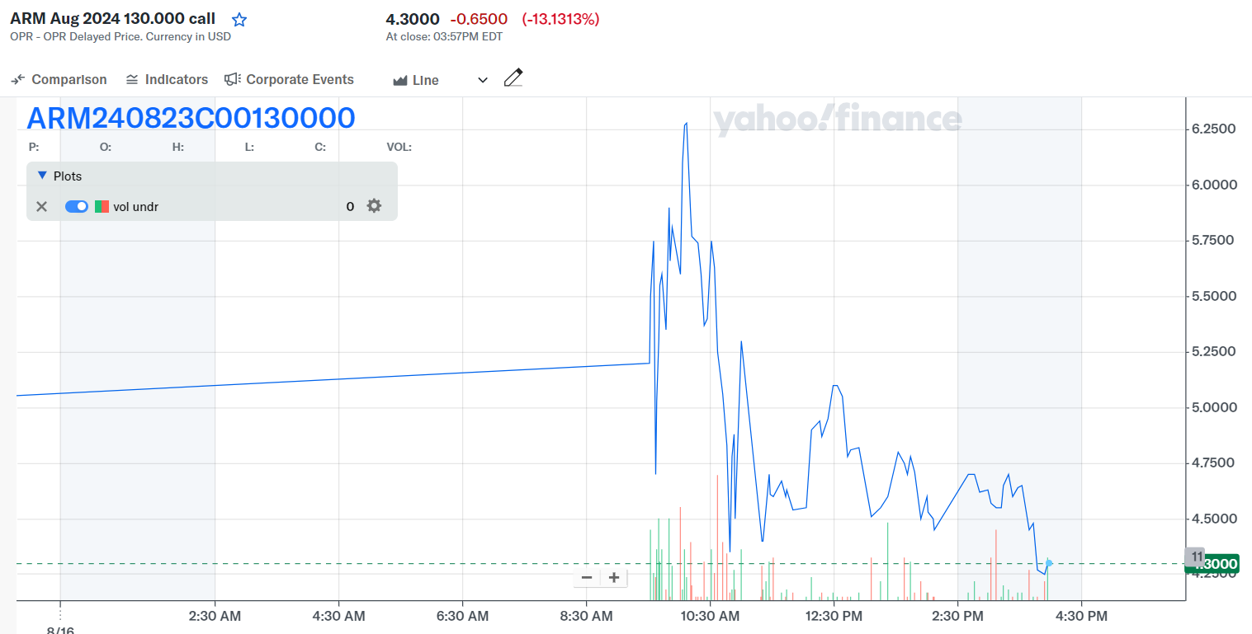
Figure 1: At the Money Call
Source: https://finance.yahoo.com
Payoff Diagram:
Consider an example with the following details:
Strike Price (K): $130. 30
Premium Paid: $5 per option contract
The payoff of an at-the-money call option demonstrates the way that the profit/loss develops when the stock price varies by the expiry date. In particular, if the actual stock price at expiry is below $130. 30, the option is as good as dead, and the holder loses the amount of premium paid to him, which is $5. This can be true in the case that the stock price is at $130. The holder of the option makes a profit equal to the premium if the price of the underlying asset is, for example, $30 at expiration the option is at the money and the holder breaks even. However, if the stock price rises above $130. 30, the option becomes profitable. For instance, if the share price has in the future reached $150 then the payoff will be $19. 70 (Stock price – Strike price) and the net profit amounted to $14. 70 after the deduction of the premium hence the premium is seen to be.
Key Points on the Diagram:
Break-even Point: $135. 30 (Strike price premium that we have to pay)
Maximum Loss: S5 (premium paid)
Profit Potential: Infinite which means there is no upper bound to the stock price since it can keep on growing.
It makes it easy for an investor to visualize possibilities hence deciding whether to buy a call option is in line with the market view.

At-the-Money Put Option Payoff
Explanation of Put Options:
An equity put option is a financial contract which provides the option purchaser with the rights but the responsibility of selling an underlying at a predetermined price known as the strike price during the life of the option or at the expiration date of the option (Michael, Cucuringu, and Howison, 2022). European-style put options are principally employed as a protective instrument against future price falls or are applied for gambling on a decline in the value of the asset. In the case where the current stock price is $130 for Arms Holding, then. 30, an at-the-money (ATM) put option that is, an option that will theoretically give the holder the right but not the obligation to sell the underlying instrument at the current market value would have a strike or exercise price of $130. 30. If the stock price is subjected below $130. 30, the put option becomes valuable since the holder of the option can sell the share at a higher strike price and at the same time buy it at a cheaper price in the market.
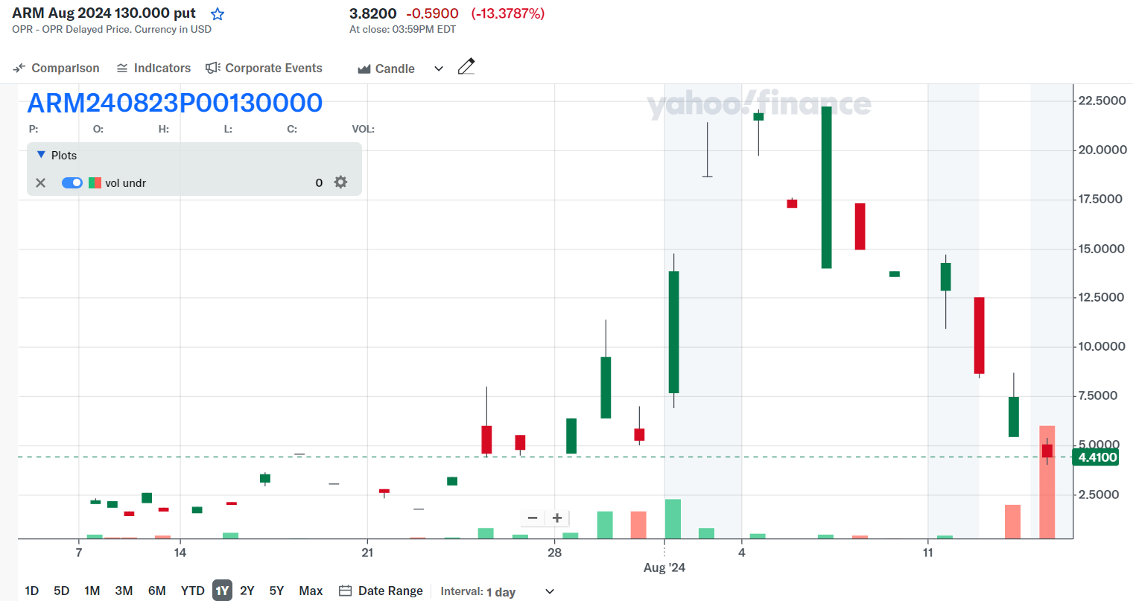
Figure 2: At the Money Put
Source: https://finance.yahoo.com
Payoff Diagram:
Consider an example with the following details:
Strike Price (K): $130. 30
Premium Paid: From a maximum of $5 per option contract
When it comes to an at-the-money put option, there is the payoff diagram which illustrates the profit or loss that will be made about the change that is observed in the price of the stock up to the time of expiration (Arefin and Tanimoto, 2021). There is also a need to place a condition whereby the price of the stock at expiration is beyond $ 130. If the option is exercised at the expiration of 30, then it holds no value and the holder loses the premium which he paid ($5). However, the following formula can be used and it gives accurate results If the price of the stock is equal to $ 130. 30 the holder loses the premium paid as the option is at the money Consequently there will be no gain or loss for the holder. But if the price of the stock reduces to less than $130. 30 the option gains the ability to turn a profit. For instance, when the stock price reaches $110, the case pays off $20. $15 a share or 30 (Strike price – Stock price) where one has a net profit on the particular and the other has a net loss. 30 after deduction for the premium.
Key Points on the Diagram:
Break-even Point: $125. 30 - (S); Strike Price - Premium
Maximum Loss: It costs $5 to unlock the premium messages option that you can pay to be messaged by the girls.
Maximum Gain: $125. 30 (Strike Price – Premium) so, if the Stock price falls to zero this is the maximum amount that one can get.
This is the diagram that is useful to comprehend how much a put option protects an investor against a drop in stock prices and whether buying a put option is suitable for the investor’s plan.

Straddle or Strangle Construction
Strategy Explanation:
A straddle and a strangle are options strategies that are employed with the view of making profits in a given stock’s price whether it goes up or down. The only significant distinction between these particular approaches is the amount indicated by the strike of the options employed.
Straddle: This strategy requires the purchase of a call option and at the same time, the purchase of a put option with the same exercise or expiration date and the same strike price. Normally it is preferred by an investor who forecasts a large price movement but is somehow unsure of the direction it will take (Alam, 2022).
Strangle: This is a strategy that involves the purchase of an equal number of a call and put option but with different strike prices: the put option’s strike price is generally lower and the call option’s strike price is generally higher and both have the same expiry date. A strangle is invariably cheaper than a straddle because both options are most often out-of-the-money (Zaevski, 2024).
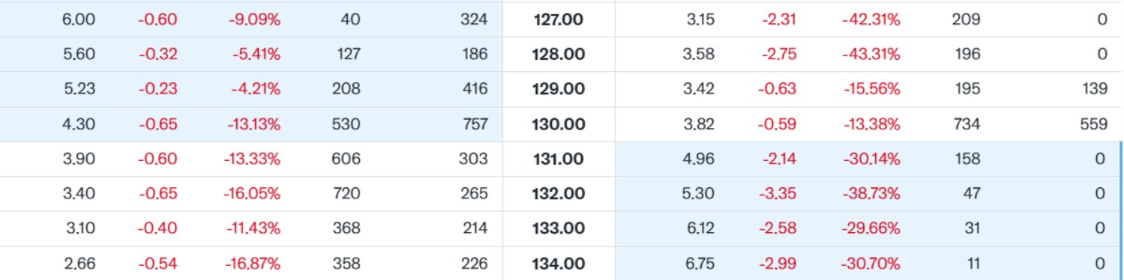
Figure 3: at the Money
Source: https://finance.yahoo.com
Construction of a Straddle
For Arms Holding, let’s construct a straddle strategy with the following details:
- Call Option Strike Price: $130.30
- Put Option Strike Price: $130.30
- Premium Paid for Call: $5
- Premium Paid for Put: $5
- Total Premium Paid: $10
In this straddle, you buy both the call and the put options at the $130.30 strike price, with a total cost of $10.
When to Use:
A straddle is most suitable when there is an expectation of a big price shift, say before an earnings report or a new product release, or before a particular event that might affect a security’s price. When there is a large movement in either direction of the stock price, then the straddle becomes lucrative. For instance, if the price of the stock goes up to $150 or plunges to $110, there will be a profit in one option while in the other option, there will be a loss that had been expected.
Risk and Reward:
The risk/reward profile of a straddle is as follows:
Maximum Loss: Restricted to the total premium paid of $10, to take place only if the stock price remains around $130. 30.
Profit Potential: Theoretically without a limit especially if the price of the stock is producing large and frequent fluctuations. The closer to $130 the larger the deviation from $130. 30 in either direction, the more is the possible profit.
Consequently, the straddle strategy can be employed when trading in highly volatile stocks since the investor does not need to forecast the direction that the price will go. But it needs a large price change to make up for the premiums and earn a profit and that is why it is necessary to apply it in the cases where there is high forecasted volatility.

Section 4: Analysis of the 10Y Note Performance (2023)

Performance of the UK 10-Year Gilt Yield
In 2023, the UK's 10-year gilt yield experienced notable fluctuations, driven by economic developments, monetary policy shifts, and broader market dynamics.
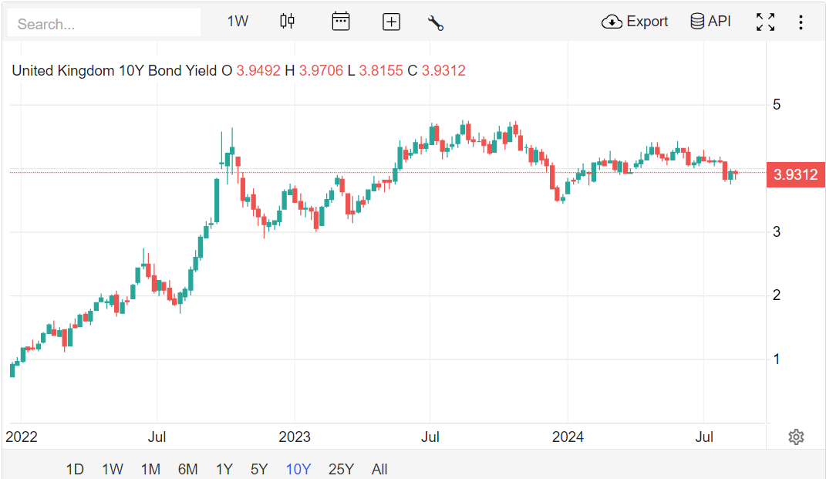
Figure 4: UK 10-Year Gilt Bond Yield
Source: https://tradingeconomics.com
Whereas at the beginning of the year, the yield was at about 3%. Shanghai gained 7% as investors remained wary about long-lasting inflation and the BoE’s hawkish measures to curb it. Earlier inflation risks were still high and expectations were for more contraction from the BoE. Therefore, over time the gilt yield began to rise to a level of around 4 per cent on each of the maturities. It had been reduced to 0% by the end of the first quarter.
The second quarter was relatively more stable for the yield as inflation started pulling up off the floor but the economic growth remained slow. Data on retail sales and industrial production pointed to underlying frailty, which led some investors to doubt whether the BoE might soon ease up on rate hikes. Thus, the yield was low and ranged between 3. 8% and 4. 0% during this period.
With the contradictory signals in the economy, the yield was again fluctuating in the third quarter. The first sign of a decreasing inflation rate made the yield decrease a bit, but higher-than-expected wages and a continuing increase in employment brought the inflation problem back. These concerns took yield back above 4%. Before it regressed to hovering at about 3% of the constitution, political corruption had touched the ridiculous figure of 0.9% as core inflation declined and GDP growth remained low.
The yield, however, inculcated some degree of stability in the last quarter of the year and averaged 3. 9% to 4.0%. Indicators of inflation revealed that this was steadily easing with the lowest inflation figure in the services space after two years. The yield was also stabilised due to the decision to maintain the rates by the BoE and the further though slight improvement in the rate of economic growth.
Taking all this into account, the behaviour of the UK 10-year gilt yield throughout the 2023 year is explained by the interactions between inflation rate concerns, economic growth and monetary policy expectations. Beginning the year at $3. The decrease of its share in the overall export is evidenced by the fact that while initially, the Turkish carpets’ export share reached 7%, it has reduced to around 3.9%, the yield’s performance does not augur well with a year, which saw volatile economic activity and conservative attitude towards investments. When this trend became evident, it put the focus on the gilt yield as a barometer of the market’s perceptions of the economic prospects for the UK.

Impact of Changes in the UK 10-Year Gilt Yield on Consumer Debt
More recently, yields on 10-year gilts have risen sharply in the UK to above 4% – a rate unseen since the 2008 credit crisis. This rise, from around 1. Starting from 3% at the start of one year, it has a great influence on consumer credit within the country. Continuing inflation rates, reduction in budget deficits and other fiscal measures have raised the yields in gilt, thus raising borrowing costs that affect households in many ways.
Factors Leading to Increase in Yields on Gilts
The increase in 10-year gilt yields can be blamed on these key factors as shown below. Firstly, Mr Kwarteng’s mini-budget unveiled deeply, highly unpopular and unfunded tax cuts of £45 billion. As a way of supporting these cuts, the government was scheduled to borrow an estimated £72. For the current financial year, it has accumulated a debt of US$ 4 billion. Moreover, the Bank of England intends to sell about £40 billion of gilt bonds recently, as part of its exit strategy of quantitative easing, which in turn has raised the supply of gilts. This has pushed up the supply of gilts and the latter has consequently exerted pressure on the prices, where investors require higher yields in the current world.
The second reason for higher yields is inflationary pressures in the UK that have been persisting for some time now (Van Doorslaer and Vermeiren, 2021). Cognate with the energy cost push resulting from the war on Ukraine and weighed down by its new deal Brexit, the inflation rate in the UK has comparatively been steep than as recorded in other Developed Economies. While the Bank of England has been attempting to control inflation, it has been considered that it has not been very aggressive in its approach as compared to other central banks like the US Federal Reserve. This has raised inflation expectations and consequent gilt yields due to the risk premium that investors demand to invest in government securities.
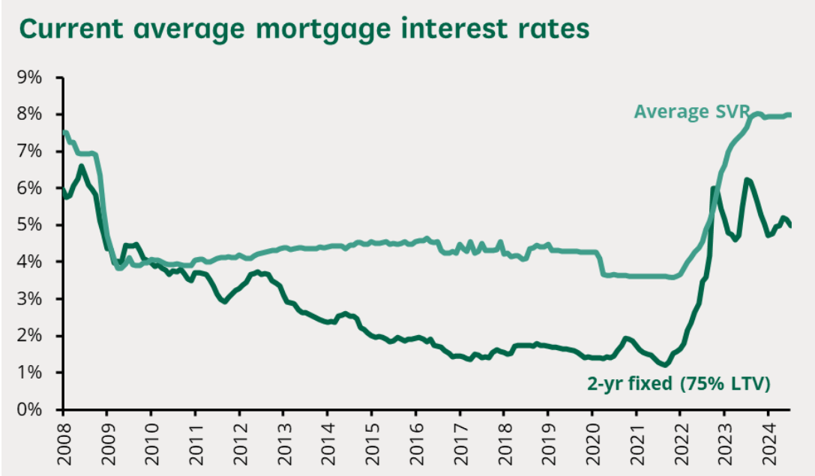
Figure 5: Interest Rates
Source: https://commonslibrary.parliament.uk
Effect on the Costs of Credit to Consumers
A rise in the yields on gilts has a direct bearing on the cost of borrowing to consumers. When gilt yields are higher, the interest rates of all forms of credit – including mortgages, personal loans and credit cards are also higher. This for households means far heavier monthly instalments (Tucker, 2022). For instance, they compared when mortgage rates stood at 4%, relating a two-year fixed-rate mortgage to the average household, with numbers soaring to £1,490 a month when mortgage rates reintroduced to 6%. They believe that such a sharp rise in mortgage repayments can hurt households’ ability to save and spend because the share of other expenses is increased.
Besides, it could also mean that mortgage rates are not the only type of consumer credit that stood to be affected by the increase in gilt yields (Miles and Monro, 2021). This entails phenomena like higher interest rates on personal loans and credit cards, which compound the challenge in the household’s means. The consumers, therefore, spend more of their income to service their debts, implying a reduction in expenditure on goods and services which could slow the rate of economic growth.
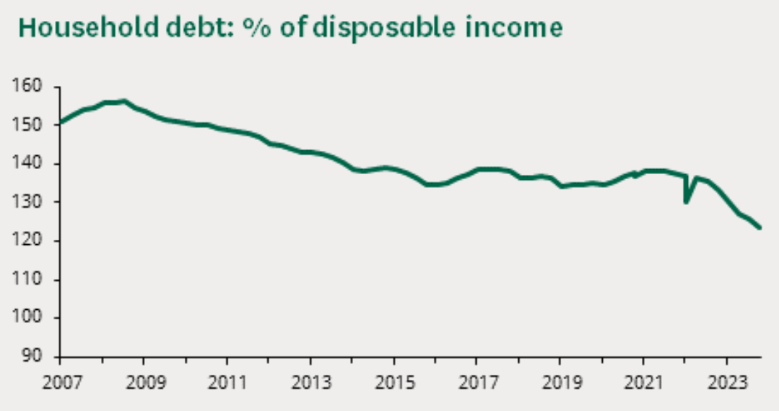
Figure 6: Household debt
Source: https://commonslibrary.parliament.uk
Implications for the Housing Market
The elevated interest rate and consequent higher interest costs may also be deleterious to the housing market. When extending credit for mortgages, the cost may increase hence a reduced demand for houses and a probable decline in prices (Duca, Muellbauer, and Murphy, 2021). This decline in property values could reduce the stock of wealth held by households possibly because of recent purchases of homes or intending buyers. Lower house prices also result in some of the people having negative equity, and therefore exerting more pressure on the homeowners.

Conclusion
This report aims to provide all the necessary information on Amicorp FS (UK) Plc and Arms Holding companies after having a detailed analysis. Amicorp FS (UK) Plc, the key participant in the financial services market, became a public company in the past decade and sought to develop it and increase its presence in the market. More importantly, the IPO analysis showed that there were efficiency motivations such as the need for capital and presence in a market; and strategic motivations such as flexibility. However, the S-1 filing also pointed out the major risks relating to acquisition such as changes in regulations that may affect the valuation criteria and competition and changes of economic trends in the market. Nevertheless, it has given moderate positive returns to its holders, which in turn can withstand the pressures outside the organization.
Arms Holding which is a technology company on the other hand has been inspected through its activities in derivative markets. The report also included a description of call and put options, or binary call and put options together with illustrations of how the payoff of these instruments look in graphical forms and this was followed by discussions on how such instruments can be utilized for risk management. Further, the analysis of the Straddle strategy was done and it was seen how useful it is in case of fluctuations and what advantage one can earn in a volatile situation.
The development of financial markets and defining derivative strategies are mutually beneficial for both of the businesses. External factors have a large impact on the stock market for Amicorp FS and market factors have a close relation to the performance of the stocks in Arms Holding while the financial instruments are beneficial for hedging the market risks. In both of cases, principles of sound financial management, as well as the need for sophisticated risk analysis are highlighted in which roles of derivatives in the financial management framework. These are factors that help to provide a clear insight into the forces at play to make sound decisions about the sustainability and development of the firm. UK 10-year gilt yield transformed from about 1 to 1. from 3% at the start of the year 2023 to more than 4% end of the year. This, allied to higher deficit and borrowing needs, stemming from unfunded tax cuts as well as inflation, is seen to have raised investor concern over the UK’s future economic prospects.

References
Alam, S.I., (2022). The 4S of Option Trading Strategies: Straddle, Strangle, Strap, Strip. Journal of Economic Studies and Financial Research, 3(1).
Arefin, M.R. and Tanimoto, J., (2021). Impact of the baseline payoff on evolutionary outcomes. Physical Review E, 104(4), p.044314.
Bergsma, K., Csapi, V., Diavatopoulos, D. and Fodor, A., (2020). Show me the money: Option moneyness concentration and future stock returns. Journal of Futures Markets, 40(5), pp.761-775.
Billett, M.T., Ma, M.S. and Yu, X., (2021). Torpedo your competition: Strategic reporting and peer firm IPO. European Corporate Governance Institute–Finance Working Paper, (732).
Duca, J.V., Muellbauer, J. and Murphy, A., (2021). What drives house price cycles? International experience and policy issues. Journal of Economic Literature, 59(3), pp.773-864.
Gornall, W. and Strebulaev, I.A., (2021). The economic impact of venture capital: Evidence from public companies. Available at SSRN 2681841.
Hu, G.X., (2020). Rollover risk and credit spreads in the financial crisis of 2008. The Journal of Finance and Data Science, 6, pp.1-15.
Huang, S., Mao, Y., Wang, C. and Zhou, D., (2021). Public market players in the private world: implications for the going-public process. The Review of Financial Studies, 34(5), pp.2411-2447.
Michael, N., Cucuringu, M. and Howison, S., (2022). Option Volume Imbalance as a predictor for equity market returns. arXiv preprint arXiv:2201.09319.
Miles, D. and Monro, V., (2021). UK house prices and three decades of decline in the risk-free real interest rate. Economic Policy, 36(108), pp.627-684.
Oh, S., Sen, I. and Tenekedjieva, A.M., (2022). Pricing of climate risk insurance: Regulation and cross-subsidies. Available at SSRN 3762235.
Tamara, D., Ashuri, A., Bagaskara, S.K. and Sulhadi, S., (2021). Treynor, Sharpe, and Jensen ratio of health sector companies on the Indonesia Stock Exchange before and during COVID-19 pandemic period. Syntax Idea, 3(10), pp.2042-2056.
Tucker, P., (2022). Quantitative easing, monetary policy implementation and the public finances (No. R223). IFS Report.
Van Doorslaer, H. and Vermeiren, M., (2021). Pushing on a string: monetary policy, growth models and the persistence of low inflation in advanced capitalism. New political economy, 26(5), pp.797-816.
Zaevski, T.S., (2024). Quadratic American Strangle Options in Light of Two-Sided Optimal Stopping Problems. Mathematics, 12(10), p.1449.

