BREXIT REPORT

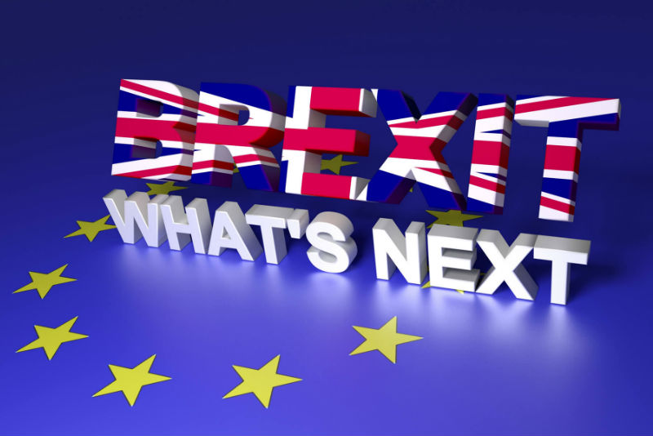
Table Contents

BREXIT REPORT 1
Title:Tourism Travel Planning for Brexit. 3
1.0 Introduction 3
2.0 Air Transport: 3
2.1 Outbound and Inbound Travellers: 3.4
2.2 Airlines: 4.5
2.3 Exchange rate impacts: 5
3.0 Transport to Northern Ireland via Land: 6
3.1 Outbound and Inbound Travellers: 6
4.0 Travel Documents: 8
4.1 Passport: 8
4.2 Visa Control: 8
5.0 International Tourism: 9
5.1 Inbound Tourism: 9
5.2 Outbound Tourism: 9
5.3 Domestic Tourism: 10
6.0 Recommendations 10
7.0 Conclusion: 11
8.0 Appendices 11
8.1 Appendix 1 11
8.2 Appendix 2 12
8.3 Appendix 3 12
8.4 Appendix 4 13
Bibliography: 13.14.15.16

Title: Tourism Travel Planning for Brexit.

Introduction

On the 23rd June 2016 the EU referendum and the Brexit referendum took place. A vote which decided if the UK, should stay or leave the EU. Leave won by 51.9% to 48.1% the referendum turnout was 71.8% with more than 30 million people voting (BBC News, 2018: p.2). As the EU- is an economic and political partnership it has grown to become a “single market” allowing goods and people to move around, as if the member states are one country (BBC News, 2018: p.2).
For the UK to leave the EU, Article 50 of the Lisbon Treaty had to be invoked which has given the two sides two years to come to an agreement for the split (BBC News, 2018: p.3). The Prime Minister Theresa May triggered this process on the 29th March 2017, this will mean the UK is scheduled to leave at 11pm UK time on Friday, 29th March 2019 (BBC News, 2018: p.). What does the future hold for the UK, and how will the UK, prepare for a “No Deal Brexit”? How will travel and tourism be affected? What major impacts will it have on tourists traveling to and from the UK, via air transport, or travelling to Northern Ireland via land?

2.0 Air Transport:

2.1 Outbound and Inbound Travellers:

Tourism industry within the UK and that of the other EU members state are heavily dependent on each other. With the UK air market being dominated by outbound traffic there are over 53.9 million visits overseas by UK residents each year (IATA, 2016: p.2). Trips taken by UK residents to EU stands at 76% while there are 67% of visitors to the UK coming from EU destinations (Tourism Alliance, 2016: p.2).
The EU aviation sector makes up one third of the world market and is one of the best performing parts of the European economy (European Commission, 2018) There are over 900 million air passengers who travel each year to, and from the UK and within the European Union (European Commission, 2018). The air market largely comes from the UK, which has more than double since 2015, compared to non – UK

residents flying to the nation (Business Travel News, 2016). While the EU agreement is in place people can move around freely. With a no deal prospect looming the immediate impact on air traffic will be governed by the effects of Brexit (IATA, 2016 p.1). which could mean custom checks, tariffs on goods and longer border checks for travellers (BBC News, 2018 p.12).
The Egate is currently used by all EU members it enables visitors to bypass standard passport control. Without a deal in place passport control would be tighter making airports congested. Airports are engines of economic growth within the aviation sector generating over £338billion across the EU (European Commission, 2018). With problems such as capacity and congestion air traffic management cannot be met creating major problems across all flights with a disruption to all passengers traveling to and from the UK. (Look at Appendix 1).

2.2 Airlines:

Airlines would be dramatically affected if there is no agreement in place this would result in reduced investment in both route development and aviation infrastructure (Tourism Alliance, 2016 p.3). This would be a catastrophic disaster as all British and European licensed airlines would lose the automatic right to operate air services between the UK and the EU without seeking advance permission (The Guardian, 2018). Budget airlines for (e.g. easyJet) have boomed since 1995 this is due to the removals of air – service agreements within the EU a no deal will obliterate any agreements that are in place affecting the low-cost budget airlines (Tourism Alliance, 2016: p. 3).
American airlines will also be affected whilst connecting to Europe though British partner airlines such as British Airways (The Guardian, 2018). All “EU -licenced airlines would lose the ability to operate wholly within the UK (The Guardian, 2018). UK – licenced airlines would also lose the ability to operate intra-EU air services (The Guardian, 2018). The UK faces the prospect of having to determine its future access to the EU market and renegotiate its own bilateral agreements (Business and Economics, 2017: p.1).

This could revert to the 1944 Chicago convention severely limiting the number of access points in both the EU and worldwide, as well as the number of airlines allowed to fly to any given city pairing (European Commission, 2018). All flights could come to a standstill this would have a dramatic effect on employment as the aviation sector directly employs 2million people and supports over 5.5million jobs (European Commission, 2018). (Look at Appendix 2)

2.3 Exchange rate impacts:

With the pound slumping the day after the referendum inflation rose after June 2016 and currently stands at 2.7% (BBC News, 2018: p.8). The weakness of the pound has immediately made outbound trips from the UK more expensive (IATA,2016: p.2). For overseas visitors to the UK, their local-currency will now stretch further than it did previously making it more affordable when visiting the UK (IATA,2016: p.2). With the movement of sterling this will affect purchasing power and, overtime, will serve to discourage outbound travel by UK residents and encourage inbound travel by foreigners (IATA,2016: pg.2). With the weaker exchange rate price elasticities would be affected this would see a net reduction in traffic of around 3% (IATA, 2016: p.2).
The price of overseas travel would be affected seeing a 10% increase in fares (IATA, 2016: p.2). This could reduce the outbound traffic from the UK by 7% (IATA, 2016: p.2). Inbound travellers to the UK could rise by 2.8% in this case inbound demand is encouraged more than outbound is deterred (IATA, 2016: p2). By 2020 the direct economic impact is likely to see the UK air passenger market be as low as 3-5% (IATA, 2016: p.2).
There would also be additional costs to inbound and outbound visitors this would include travel insurance, European Health Insurance and an increase in mobile phone roaming fees as the UK would not have a cap on roaming charges (Tourism Alliance, 2016: p.4). With inbound visitors to the UK the impacts are marginal compared to Air Passenger Duty and the imposition of VAT on accommodation, attractions and eating out (Tourism Alliance, 2016: p.4). Airlines would also be affected when buying fuel as airlines buy their fuel in dollars and with the slump in the pound fuel will be more expensive to buy increasing flight costs (Abta, 2018).

3.0 Transport to Northern Ireland via Land:

3.1 Outbound and Inbound Travellers:

Northern Ireland is the smallest UK region with only (1.5%) of UK citizens (Policy engagement at Queen`s, 2015: p.2). It is the only part of the UK that shares a land border with another EU member state and is heavily involved in a range of cross – border cultural, economic, and political initiatives (Policy engagements at Queen`s, 2015: p.2). Several issues have been raised about Northern Ireland since Brexit this not only involves this cross-border dimension but also its links to the continent (Policy engagements at Queen`s, 2015: p.2). The land border between Northern Ireland and EU member the Republic of Ireland has been a key part of Brexit talks (BBC News, 2018: p.16).
With a no deal Brexit this could see the return of the “hard border” – this would mean the return of physical infrastructure, such as customs posts or a network of surveillance cameras (BBC News, 2018: p.16). There are more than 180 formal roads cross the border and many more counting the tractor trails and foot paths (The Washington Post, 2016). They are used daily by tourists, farmers, anglers, and for the transportation of goods, but after Brexit the border will become a frontier of the EU (The Economist, 2016: p.20). This raises the prospect of tighter controls on people and goods travelling between north and south-and even between Northern Ireland and mainland Britain (The Economist, 2016: p.20).
Northern Ireland could become a back door into Britain for undocumented migrants and untaxed goods, unless checks are imposed (The Economist, 2016: p.20). Travel would be affected with the recreation of a physical international border between Northern Ireland and the Republic of Ireland. There would be tighter controls and could result with an EU, traveller driving from Dublin having to show their passport on the way to Belfast (Belfast Telegraph, 2018). Travelling by car to Northern Ireland would become extremely difficult resulting in long delays.

Drivers would need international Driving Permits if the EU does not recognise UK licences (Belfast Telegraph, 2018). There are two types of IDP required by EU countries, depending on whether they have raifed the 1949 or 1968 conventions on road traffic (Belfast Telegraph, 2018). This will mean some itinerates will require the two permits. This would be disastrous for those UK citizens living in Londonderry who may have to cross the border to commute to work (Belfast Telegraph, 2018). Parents driving their children to school would also be affected as children go to school on either side of the border.
Drivers could be turned away at the border or face enforcement action if they have not obtained the right documents (Belfast Telegraph, 2018). The UK department for Transport believes up to 7 million permits could be requested in the first 12 months after Brexit (Belfast Telegraph, 2018). This would result in lengthy border delays if permits are to be checked (Belfast Telegraph, 2018). This imposition of passport checks and custom posts will have a major impact on trade and tourism. Giving Northern Ireland one of the hardest borders in Europe if there is a no deal Brexit (Belfast Telegraph, 2018).
If the border issue remains unresolved between the UK and the EU this would represent a grievous and undermine the 1998 Good Friday Agreement, which delivered peace to Northern Ireland (The Guardian, 2018). With the British government rejecting EU`s proposal Northern Ireland will not be split from UK and will encounter a hard border. Driving to Northern Ireland could result in an armed presence of the past being reinforced. (Look at Appendix 3).

4.0 Travel Documents:

4.1 Passport:

British Citizens are currently classed as EU nationals and are currently able to enter the Schengen area if the traveller has a valid passport. There is no requirement for the British passport to have a minimum or maximined validity period remaining when entering or leaving the Schengen area (Gov, UK, 2018). As we get nearer to March 29th, 2019, if there is a no deal scenario British passport holders will be considered as a third world country national – under the Schengen Border Code and will need to comply with different rules to enter and travel around Schengen area (Gov, UK, 2018).
British passport holders will require 6 months validity remaining on the date of arrival (Gov, Uk, 2018). For countries that are in the EU but not in the Schengen area, travellers will be required to check the requirements for the county that they are travelling to (Gov, UK, 2018). Ireland are not part of the Schengen area as a result travel to Ireland is subject to separate Common Travel Area arrangements which will be maintained after the UK leaves the EU (Gov, UK, 2018). Passports will have a new design with a blue passport being issued late 2019.

4.2 Visa Control:

The Uk government wants to keep visa- free travel to the UK for EU visitors after Brexit with the hope that the EU agrees to this for UK travellers visiting the EU (BBC News, 2018 p.15). Without a deal in place both the UK and EU visitors would have to seek official permission to travel.

5.0 International Tourism:

5.1 Inbound Tourism:

There were over 10 million visits to the UK by inbound tourists between April – June 2018 (National Statistics, 2018). £5.8 billion was spent on inbound visits to the UK between these months inbound travellers spent on average £411 and staying on average 6.1 days (Tourism Alliance, 2016 p.1). This economic activity provides the UK with a new source of income enhancing tourism (David. L, et al., 2013:). The impact that tourism has on the economy can be tremendous for e.g. creates jobs, lowers unemployment, and contributes to a better understanding of the local area (David. L, et al., 2013).
Brexit has seen the value of sterling falling against the Euro, making the UK a more attractive destination for visitors from EU destinations (Tourism Alliance, 2016). The impact on the UK tourism industry is likely to be positive for city destinations rather than rural and seaside towns (Tourism Alliance, 2016: p.3). However, the UK tourism industry depends on expenditure by EU visitors this is increasly low due to the short length of stay (Tourism Alliance, 2016). Inbound business travel will decrease with a no deal businesses will look to relocate their European headquarters to an EU country (Tourism Alliance, 2016). (Look at Appendix 4)

5.2 Outbound Tourism:

There were over 19.9 million visits abroad made by UK residents during the period between April-June 2018 (National Statistics, 2018: p.10). Spending 11.6 billion visiting other countries (National Statistics, 2018: p.10). Visits to European countries increased by 1% to 16.2 million (National Statistics, 2018: pg.10). Holiday visits increased by 3% compared with the same period a year earlier (National Statistics, 2018: p.10). Business visits decreasing by 9% and visits to friends and relatives decreased by 1% (National Statistics, 2018). With a decrease in certain areas the effects of Brexit and a no deal on air-space will affect outbound tourism and will rapidly decline to an even bigger extent. This will have a huge economic impact on tourism as many EU countries depend on tourism from the UK. For tourism to be sustainable in the future, it is vital that effective policy and planning take place today (David. L, et al., 2013).

5.3 Domestic Tourism:

There are over 120.7 million trips taken within the UK each year (GB Report, 2017: p.6). There are over 59.1 million holidays taken by UK residents in Great Britain each year (GB Report, 2017: p.6). Business trips taken stand at 16.5 million and the VFR stands at 41.8% (GB Report, 2017: p.6). The economic expenditure within the UK on tourism stands at £23.7 billion (GB Report, 2017: p.6). Tourism boards across the county have seen an increase of 25% in bookings within the UK since Brexit as more Brits look to spend their cash at home (Travel Intelligence, 2018). Holidaying within the UK will hugely boost the economy however there are concerns of overcrowding as domestic tourism tends to be seaside resorts and rural destinations which in turn may not have the facilities to cope with such a huge drive in tourism (Tourism Alliance, 2016).

6.0 Recommendations
Airlines need clear guidance and want the UK Government to negotiate continued access to this liberalised regime. It is essential to remain a member of the ECAA, post- Brexit. Many of the existing airline routes are secured through EU negotiated agreements (Abta, 2018). The Government need to retain these agreements so that UK airlines can continue to operate established air routes (Abta, 2018). There is no fall-back option for the aviation sector such as World Trade Organisation rules, with a reduction in the number of routes this would impact holidaymakers, business travel and visitors to the UK(Abta, 2018). Lowering Air Passenger Duty would reduce the cost of air travel, making the UK a more attractive global trade partner (Abta, 2018).
Government need to reach a future customs arrangement with the EU: current arrangements have cut down on bureaucracy for tax and border issues. Agreements on tariffs and trade need to remain in place. It is critical that the Government maintain the benefits of the Customs Union (Abta, 2018). As Northern Ireland is a border economy, interruptions to the free flow of goods and labour will have negative impacts on the Northern Irish economy. Northern Ireland should be granted a referendum on whether they remain with UK or join with the Republic of Ireland to avoid a hard border. With over 72% of car journeys to Northern Ireland each year it is essential that such journeys can continue to operate freely, with minimal changes to current arrangements.

7.0 Conclusion:

Travel will be majorly affected if there is a no deal Brexit creating major disruption via land and air. Outbound and inbound travellers will have to face long boarder checks and may have to carry permits to get to certain parts of the UK. Politicians need a leader who will guide them through Brexit as without a deal there will be no transition period. New trade deals need to be negotiated this means building new relationships with different countries and with the EU members state. A no deal could mean that the UK becomes a third world country when exiting the European Union.

8.0 Appendices

8.1 Appendix 1

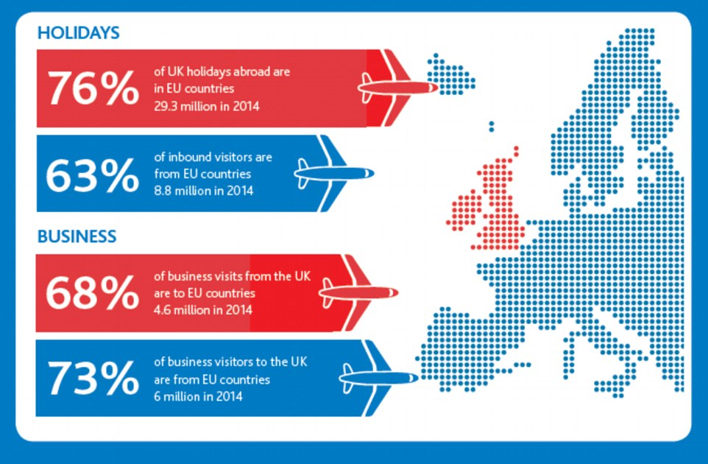
http://www.dailymail.co.uk/travel/travel_news/article-3490062/Brexit-disaster-tourism-warn-leading-travel-industry-firms-Abta-produces-report-ahead-June-referendum.html.

8.2 Appendix 2

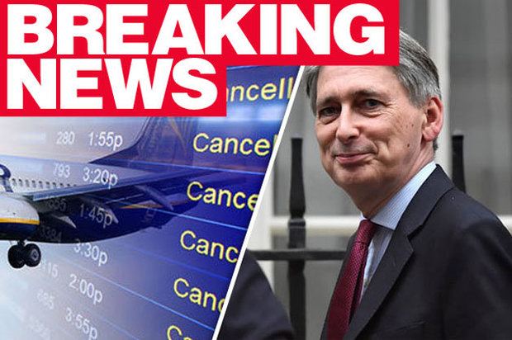
http://www.dailystar.co.uk/news/latest-news/651478/Brexit-news-no-flights-UK-EU-Philip-Hammond-Theresa-May

8.3 Appendix 3
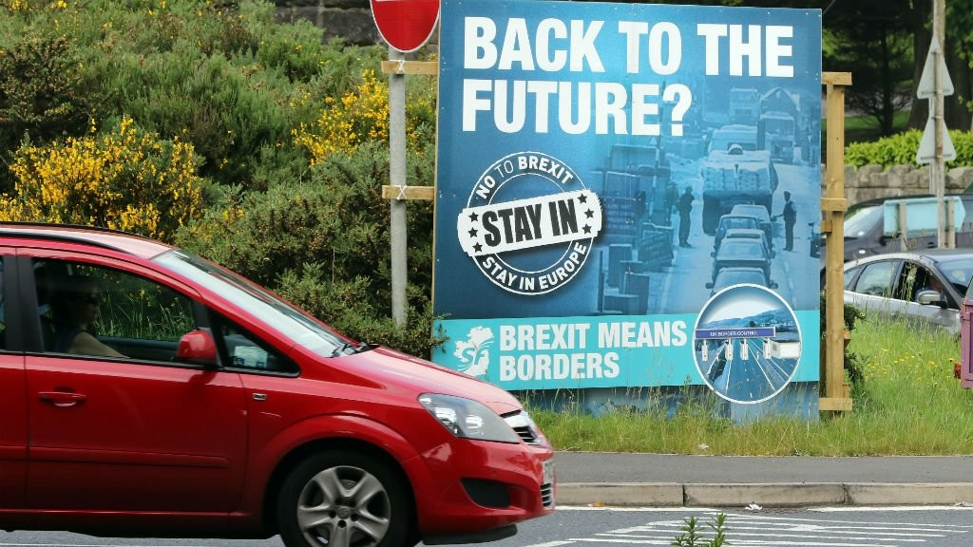

http://www.france24.com/en/20160622-video-brexit-northern-ireland-vote-stirs-old-political-divides

8.4 Appendix 4

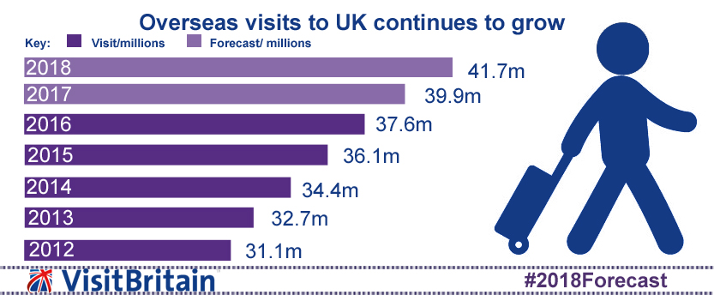
http://www.visitbritain.org/forecast

Bibliography:
(Hunt, (2018)) (Commission., (2018).) (Horsfield, (2018). ) (Analytica., (2017). ) (Jiaying, (2009). ) (Sims, (2016). ) (Mason, (2016). ) (Peeters, (2018).) (ICAO., (1944).) (Oxley, (2015).) (Economics, (2016). ) (Alliance., (2016). ) (O`Carroll & Sabbagh, (2018).) (Boffey, (2018).) (Ferguson, (2018). ) (Simpson, (2018).) (Anon., (2016).) (McGowan, (2015). ) (Murray, (2018).) (Booth, (2016).) (Kellner, (2018).) (Commision., (2018). ) (Elsevier., (2015).) (Appleman, (2017).) (UK., (2018).) (O`Carroll, (2018). ) (Intelligence., (2016). ) (West, (2016).) (David, (2013).) (Cooper, (2013). ) (Abta, (2018).
Abta., (2018) ... Travel Trends: Travel industry Reports & Publications.
[Online] Available at: https: www.abata.com
{Accessed Tuesday 20th November (2018).].
Alliance., T., (2016). . EU Referendum: Impacts on the UK Tourism Industry.. [Online]
Available at: https:www.tourismalliance.com
[Accessed Tuesday 6th November (2018).].
Analytica., O., (2017). . EU/UK: Airlines face uncertainty after Brexit.. [Online]
Available at: https://search.proquest.com/docview/1891100688
[Accessed Tuesday 6th November (2018). ].
Anon., (2016).. Frontier spirit: Northern Ireland after Brexit.. The Economist., 420(9000), p. 20.
Appleman, B. &. Leiden., (2017).. Immigration Policy.. [Online]
Available at: https://www.balglobal.com
[Accessed Monday 12th November (2018).].
Boffey, D., (2018).. May`s plan to give Stormont a backstop veto enrages EU envoys.. [Online]
Available at: https://www.theguardian.com
[Accessed Thursday 8th November (2018).].
Booth, W., (2016).. The Brexit wild card? Ireland.. [Online]
Available at: https;//www.washingtonpost.com
[Accessed Sunday 11th November (2018).].
Commision., E., (2018). . EU Avisation: 25 years of reaching new heights.. [Online]
Available at: https://ec.europa.eu/index_en.htm
[Accessed Monday 12th November (2018).].
Commission., E., (2018).. Mobility and Transport.. [Online]
Available at: https://www.ec.europa.eu/index_en.htm
[Accessed Thursday 1st November (2018). ].
Cooper, C. & Hall. C., (2013). . Contemporary Tourism: An International Approach.. 2nd (Ed). ed. Oxford: Goodfellow Publishers Limited. .
David, L. Edgell. S. & Swanson. J., (2013).. Tourism Policy and Planning.. 2nd (Ed). ed. New York: Routledge.
Economics, I., (2016). . The impact of ¬Brexit` on UK Air Transport.. [Online]
Available at: https://www.iata.org/economics
[Accessed Tuesday 6th November (2018). ].
Elsevier., (2015).. Special issue of papers selected by the air transport research society- Selected topics on applied air transport economics.. Transport Policy., 43(1), pp. 1-3.
Ferguson, K., (2018). . Irish citizens will continue to be allowed to live, work and travel to Britain as they do now even if there is a no deal Brexit, ministers promise.. [Online]
Available at: https://www.dailymail.co.uk>news>irish
[Accessed Friday 9th Novemeber (2018).].
Horsfield, G., (2018). . Overseas travel and tourism: April, May and June 2018 provisional results.. [Online]
Available at: https://www.ons.gov.uk/peoplepopulationandcommunity/leisureandtourism
[Accessed Monday 5th November (2018).].
Hunt, A. &. Wheeler, B., (2018). Brexit: All you nedd to know about the Uk leaving the EU.. [Online]
Available at: https://www.bbc.co.uk/news/uk-politics-32810887
[Accessed Monday 5th November (2018)].
ICAO., (1944).. Conventions on International Civil Aviation.. [Online]
Available at: https://www.ICAO.int>publication>pages
[Accessed Wednesday 31st October (2018).].
Intelligence., T., (2016). . Domestic Tourism in the UK set to rise following Brexit results.. [Online]
Available at: https://www.travelintelligence.net/tourism-in-the-UK
[Accessed Monday 12th November (2018).].
Jiaying, L. &. Sanjay, K. Nepal., (2009). . Sustainable tourism research.. Journal of Sustainable Tourism. , 17(1), pp. 5-16.
Kellner, P., (2018).. In January 2019 Britain will officially switch from a pro-Brexit to an anti-Brexit country, and this is how we know.. [Online]
Available at: https://www.independent.co.uk
[Accessed Sunday 11th Novemeber (2018). ].
Mason, R., (2016). . How did the UK end up voting to leave the European Union?. [Online]
Available at: https://www.theguardian.com
[Accessed Tuesday 30th October (2018). ].
McGowan, L., (2015). . Policy engagement at Queen`s.. [Online]
Available at: https://qpol.qub.ac.uk/category/europe/
[Accessed Saturday 10th November (2018).].
Murray, S., (2018).. Warning Northern Ireland drivers will nedd £5 permits to cross border in no-deal Brexit.. [Online]
Available at: https://www.belfasttelegraph.co.uk>news
[Accessed Sunday 11th November (2018).].
O`Carroll & Sabbagh, D., (2018).. No-deal Brexit could hit UK-EU flights, says Whitehall.. [Online]
Available at: https://www.theguardian.com
[Accessed Monday 5th November (2018). ].
O`Carroll, L., (2018). . How will a no-deal Brexit affect UK`S travel and exports?. [Online]
Available at: https://www.the guardain.com
[Accessed Monday 24th November (2018).].
Oxley, D. &. B. N., (2015).. Exchange rates and aviation: examining the links.. [Online]
Available at: https://www.iata.org/economics
[Accessed Monday 5th November (2018). ].
Peeters, P. Higham, J. Cohen, S. Eijgelaar,E. Gossling, S., (2018).. Desirable tourism transport futures.. [Online]
Available at: https://doi.org/10.1080/09669582.2018.1477785
[Accessed Tuesday 30th October (2018).].
Simpson, C. Doyle,S. & Graham, S., (2018).. What happens if no Brexit deal is agreed?. [Online]
Available at: https://www.IRISHNEWS.COM/NEWS/NORTHERNIRELANDNEWS
[Accessed Saturday 10th November (2018).].
Sims, A., (2016). . Independent. [Online]
Available at: https://www.independent.co.uk
[Accessed Thursday 8th November (2018). ].
UK., G., (2018).. Travelling to the EU with a UK passport if there`s no Brexit deal.. [Online]
Available at: https://www.gov.uk>publications>travel
[Accessed Tuesday 13th November (2018).].
West, E., (2016).. Uncertainty Rules as Business Travel Industry Sorts Through Brexit Implications.. Business Travel News. , 33(1), pp. 1-3.

.

