Leadership and Management Skills in the Workplace
Project Management

Part A (Poster)

Part B (Reflection on Feedback)

Part C (project management plan)

Student name: Nicolae Bogdan Sandu Rizea
Student number: 2418689
Lecturer: Dr Kareem Sani

Contents
Part A. Poster: Central Transport Hub Redevelopment 3
Part B 5
Introduction 5
Key strengths 5
Areas of improvement 5
Integration of feedback into Part C 6
Conclusion 6
Part C 7
1. Introduction 7
2. Project description and strategic rationale 7
3. Scope Definition and Boundaries 9
4. Work Breakdown Structure (WBS) 10
Table 1. Timeline explained work phase 10
5. Priority Framework (Quad Chart Analysis) 11
6. Integrated Master Schedule 11
7. Stakeholders Involvement and Management Strategy 12
8. Resource Allocation and Project Organisation 12
9. Comprehensive Risk Management and Mitigation 14
10. Quality Assurance and Compliance Management 15
11. Conclusion 15
Reference 17

Part A. Poster: Central Transport Hub Redevelopment

Central Transport Hub Redevelopment

Metropolitan UK City / November 2025 / Project Option A

1 Background and Rationale 2 Aims and Objectives 3 Scope and Phasing

A structural inspection in November 2025 confirmed that the 40-year-old facility no longer met safety, fire or accessibility standards.
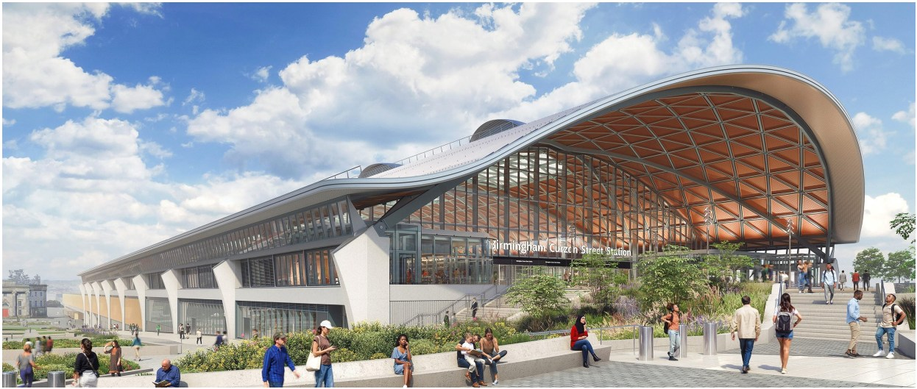
Consequences of Inaction

ࠂ Economic Disruption ࠂ Supply Chain Delays ࠂ Reduced Accessibility ࠂ Public Dissatisfaction
• Restore full multimodal transport capacity
• Achieve full compliance with UK building regulations
• Achieving BREEAM Excellent rating
• Ensure Equality Act 2010 Access
• Inclusions
• Structural Rebuild
• Rail and Bus Platforms • Freight Terminal
• Green Energy Features • Phases
• Phase 1: Temporary access and demolition
• Phase 2: Core structural rebuild
• Phase 3: Fit out, digital integration and handover

4 Key stakeholders


Local Authority

Network Rail / TOCs Commuters and public

Freight Operators
DFT and Funding Bodies

Disability Groups

Local Businesses

5 Risks and Trade Off 6 Strategic Value

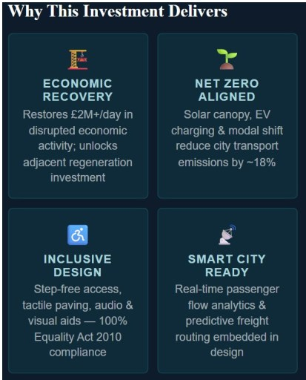
HIGH : Cost Overruns and Delays
MEDIUM : Stakeholder Disruption
LOW : Political Changes


Trade-Off : Speed vs. Sustainable

Part B

Introduction
The poster presentation for the central transport hub redevelopment project received constructive feedback from tutors and peers. This reflection identifies key strengths demonstrated in the poster, discusses identified areas for improvement, and explains how this feedback has informed enhancements to the final project management plan (Part C). The feedback has been instrumental in refining my approach to the stakeholder communication and deepening the academic rigour of the project documentation.

Key strengths
The poster demonstrated several notable strengths that have been retained and extended in the project management plan. First, the visual accessibility and presentation format proved effective in communicating complex project information to diverse stakeholders. The use of clear sections and graphics enhanced readability and ensured that key project elements could be quickly grasped. Second, the logical progression from background through objectives to strategic value created a coherent narrative that effectively justified the projects’ significance. This structure provided a strong foundation for developing more detailed planning documents.
Third, the identification of key stakeholders demonstrated awareness of the complex stakeholder landscape inherent in infrastructure projects. The poster recognised local authority, transport operators, commuters, freight operators, funding bodies, and disability understanding of inclusive project governance principles, particularly relevant to the UK infrastructure guided by the equality act of 2010 and government accessibility standards (Department for transport, 2017)

Areas of improvement
The feedback identified several areas requiring deeper development. First, whilst risks were identified (cost overruns, delays, political change), they lacked substantive analysis and mitigation strategies. In Part C, I have developed a comprehensive risk register employing qualitative and quantitative risk analysis. Aligned with PMI standards (Project Management Institute, 2017). Each identified risk now includes likelihood-impact assessment, specific mitigation actions, and contingency plans.
Second, stakeholders’ analysis has been expanded significantly. Rather than listing stakeholders, Part C details stakeholders’ interests, influence, and power-interest matrices to inform engagement strategies. This approach reflects the guidance from Dwivedi (2021) on integrating stakeholder prospectives into project success metrics. Third, the poster lacked explicit integration of project management theory and academic literature. Part C addresses this by systematically applying frameworks such as the work breakdown structure (WBS), Gantt charting, and resource planning aligned with recognised project management methodologies.

Integration of feedback into Part C
The final project management plan integrates feedback in three keyways. First, it provides substantially deeper risk analysis, moving beyond identification to practical mitigation strategies and contingency budgeting. This reflects guidance from Klastorin (2004) on project management tools and trade-offs. Secon, stakeholder management is now approached as a strategic planning component, with detailed engagement plans aligned to stakeholder power and interest levels. This draws on Huemann et al. (2012) on deriving strategic value from projects through effective stakeholder integration.
Third, the plan demonstrates systematic application of project management frameworks throughout, including formal WBS development, resource allocation matrices, and integrated scheduling. These tools are grounded in Maylor (2010) and contemporary PM guidance, ensuring the plan demonstrates both academic rigour and practical applicability. The posters’ core narrative remains intact-effectively communicating the project’s strategic importance- but the plan now provides the technical depth necessary for stakeholder’s confidence and successful delivery.

Conclusion
Feedback on the poster has been invaluable in refining both the project communication strategy and the depth of planning documentation. By retaining the strengths in visual clarity and stakeholder recognition whilst substantially deepening risk analysis, stakeholder management, and theoretical grounding, the final project management plan now provides a comprehensive, academically rigorous, and practically actionable framework for delivering the central transport hub redevelopment. This iterative approach to project documentation reflects mature project leadership practices.

Part C

1. Introduction
The central transport hub redevelopment project represents a transformational strategic infrastructure initiative to restore and modernise a critical metropolitan interchange serving integrated rail, bus, and freight logistics networks. The 40-year-old facility, which ceased operations in November 2025 following structural inspection, previously served as the primary multimodal transport hub for the metropolitan region. This project management plan provides a comprehensive, academically rigorous framework for delivering the project aligned with recognised project management methodologies including PMI’s project management body of knowledge (PMBOK) and contemporary UK government infrastructure standards (Project Management Institute, 2017). The £480 million capital investment, structured across a disciplined 36-month delivery schedule, represents a strategic commitment to regional economic recovery and net-zero environmental objectives.
Governance arrangements reflect stakeholder complexity inherent in major infrastructure projects. The project operates under oversight of a multi-party Steering board comprising local authority leadership, department for transport representatives, network rail, bus operators, and community representatives. Executive authority rests with the appointed project director, who reports to the steering board and manages day-to-day delivery through an integrated project team. This governance structure ensures alignment for project management decisions. The plan addresses regulatory requirements including UK Building Regulations compliance (UK Building Regulations, 2010), accessibility standards under the equality act 2010 (Equality Act, 2010), environmental targets under the climate change act 2008, and government procurement guidance (Climate Change Act, 2008). Strategic success is measured against technical delivery (scope, schedule, budget), regulatory compliance, stakeholder satisfaction, and measurable sustainability outcomes.

2. Project description and strategic rationale
The central transport hub historically served 80,000 daily passengers across multiple transport modes, functioning as the critical metropolitan interchange connecting high-speed and regional rail services, comprehensive bus networks, and integrated freight logistics operations. Structural inspection in November 2025, mandated following safety concerns, revealed (UK Building Regulations, 2010), widespread non-compliance with contemporary UK building regulations, critical fire safety deficiencies, and accessibility barriers inconsistent with the equality act 2010 (Equality Act, 2010).. The facility’s closure precipitated severe economic disruption: commuter inconvenience affecting 80,000 daily passengers, supply chain delays impacting regional freight logistics, and business losses estimated at £15 million monthly for local enterprises dependent on transport accessibly.
The redevelopment project delivers a modern, sustainable transport hub that restores and enhances transport capacity whist addressing contemporary infrastructure standards. Key project features include: structurally enhanced facilities accommodating increased passenger volume (100,000+ daily capacity); rail platforms providing 2 high-speed rail services and 4 regional services; integrated bus station with 40 loading bays; dedicated freight terminal integrated with regional logistics networks; comprehensive accessibility infrastructure exceeding equality act requirements; and advanced digital infrastructure enabling real-time passenger information, logistics coordination, and smart mobility integration. The facility is designed for BREEAM excellent environmental certification and commitments and local authority sustainability targets (Shibani and Hassan, 2020).
Funding structure reflects multi-party investment: government capital funding (£280 million) through the department for transport’s major projects programme; local authority investment (£120 million) reflecting regional strategic priority; and private sector contributions (£80 million) through transport operator partnership agreements and commercial partnerships. Delivery is scheduled across three integrated phases spanning 36 months (See Tabel 1), with major milestones establishing structural completion (Q4 2026), systems integration completion (Q3 2027), and operational handover (Q1 2028) (See Tabel 1). Project success is contingent on rigorous adherence to scheduled milestones and demonstrated progress against performance metrics, with funding tranches released on achieving gate reviews and technical deliverables (Suresh and Sivakumar, 2019).

3. Scope Definition and Boundaries
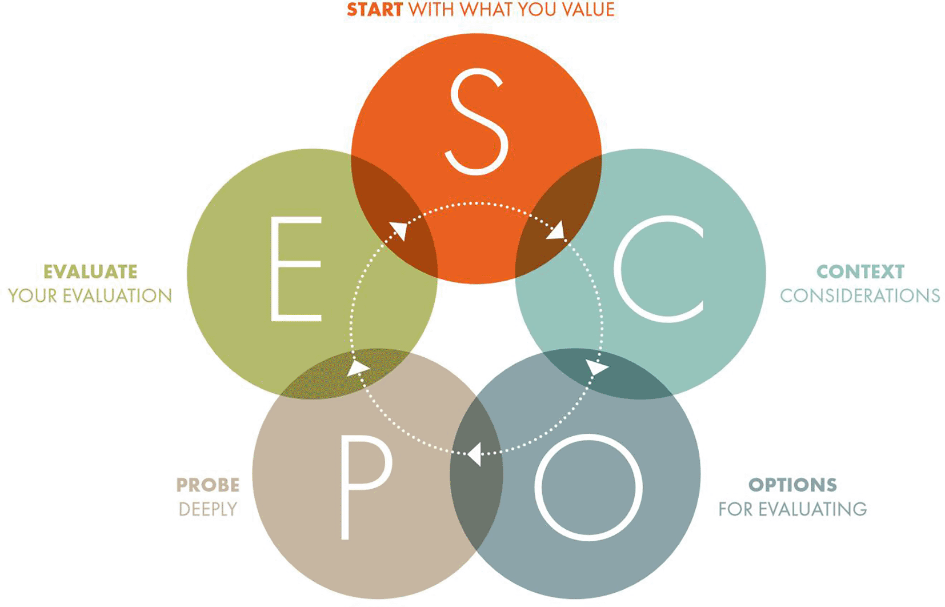
Figure 1 The SCOPE Framework (from The SCOPE Framework: a five-stage process for evaluating responsibly:... (Himanen at all., 2024)
In Scope Elements (Inclusive of Project)
Complete structural demolition and site remediation of existing facility, including environmental remediation to regulatory standards.
New multimodal transport hub structure accommodating 100,000+ daily passengers with integrated design for all transport modes.
Rail infrastructure including high speed and regional platforms with compliant loading gauges and operational standards.
Bus station facilities (40 bays) with passenger amenities, real-time information systems, and accessibility features.
Dedicated freight terminal integrated with regional logistics networks and customs compliant facilities.
BREEAM Excellent environmental certification (Shibani and Hassan, 2020) with net-zero operational energy, renewable generation, and waste management systems.
Universal accessibility compliance exceeding Equality Act 2010 requirements including accessible facilities, wayfinding, and mobility assistance.
Integrated digital infrastructure including passenger information systems, real-time logistics coordination, and smart mobility integration platforms.
Out-of-scope Elements (Excluded from Project)
Expansion of rail or bus networks beyond the hub boundary – addressed through separate transport planning processes.
Permanent residential development within or alongside the hub building
Major road network reconfiguration surrounding hub – addressed through separate highways planning
Commercial retail development beyond essential amenities.

4. Work Breakdown Structure (WBS)
The project is organised into three major phases, each subdivided into integrated work packages (See Tabel 1).
Phase 1 (Mobilisation and Preparation), spans six months (Q1-Q2 2025), establishing temporary transport solutions, conducting comprehensive site surveying and environmental assessment, obtaining necessary approvals and building permits, and awarding demolition and construction contracts. Deliverables include operational temporary transport access, complete site surveys, environmental remediation plan, and executed main contracts.
Phase two (Construction), spans 28 months (Q3 2025-Q4 2027), comprising sequential demolition (24 weeks), structural construction (18 months), mechanical, electrical, plumbing system installation (12 months), accessibility features integration (concurrent), and digital infrastructure deployment (final 6 months).
Phase three (Handover and Operations), spans 6 months (Q1 2028), including final testing and commissioning, staff training and operational readiness, regulatory sign-off and approvals, and handover to transport operators with 12-month defects period.

Table 1. Timeline explained work phase
Phase | Timeline | Key Work Packages | Budget
Phase 1: Mobilisation | 6 months (Q1-Q2 2025) | Temp transport, surveying, permitting, contract awards | £60m
Phase 2: Construction | 28 months (Q3 2025-Q4 2027) | Demolition, structure, systems, digital integration | £380m
Phase 3: Handover | 6 months (Q1 2028) | Testing, training, approvals, operational transfer | £40m
(Suresh and Sivakumar, 2019)

5. Priority Framework (Quad Chart Analysis)
Project prioritisation matrix positions the Central Transport hub Redevelopment in the FAST = QUALITY quadrant, reflecting strategic decision to deliver modern sustainable infrastructure within disciplined timeline and budget constraints. This positioning intentionally rejects cost-minimisation strategies that would compromise regulatory compliance, sustainability objectives, or accessibility standards. The FAST + Quality approach requires rigorous scope management, aggressive schedule optimisation through concurrent workstreams and fast-track activities, and premium procurement practices emphasising quality and delivery discipline, preventing scope creep that would extend timelines or compromise budget integrity. Trade-offs between schedule compression and quality assurance are managed through structured value engineering processes and contingency resource allocation (Klastorin, 2004). The chosen strategy accepts higher upfront investment costs in exchange for certainty of delivery, regulatory compliance, and sustainable long-term asset value aligned with government infrastructure policy.

6. Integrated Master Schedule
The integrated master schedule compresses a complex, 28-month construction programme into a 36-month overall project through systematic identification of concurrent activities and critical path acceleration.
Phase one (mobilisation) spans 26 weeks (Q1-Q2 2025), with temporary transport activation completing by week 6, allowing immediate restoration of commuter access and freight operations. Demolition activities (24 weeks) commence following environmental clearance and begin concurrent with final procurement activities. Critical path activities include temporary transport activation (critical for stakeholder satisfaction and funding continuation), demolition completion (gates subsequent construction), structural frame completion by 24 month (Q2026-major milestone for funding tranches), and systems integration completion by month 32 (Q3 2027). Schedule acceleration techniques include design-build contracting enabling early manufacturing of key components, pre-procurement of long-lead items during design phases, and adoption of innovative construction methods (modular fabrication, accelerated concrete systems) reducing on-site construction duration. Schedule risk mitigation includes 12-week float buffer in non-critical activities, weather contingency allocation (8 weeks for UK climate conditions), and approval pathway acceleration through early engagement with regulatory bodies. Major milestone: structural lock-down Q4 2026 (68% project completion), enabling occupancy permits and mobilisation of systems contractors (Westland, 2017)

7. Stakeholders Involvement and Management Strategy
Stakeholder management reflects the complex political, commercial, and community dimensions inherent in major metropolitan infrastructure. The power-interest matrix identifies five distinct stakeholder categories requiring differentiated engagement approaches (Turner, 2014). High-power, high-interest stakeholders (Local Authority, Department for Transport, Network Rail, bus operators) require active management through formal governance structures: weekly project director meetings with Local Authority, monthly steering board meetings with all principal stakeholders, and dedicated working groups addressing technical domains (rail operations, bus services, freight logistics, accessibility). These stakeholders possess authority to approve design decisions, allocate funding, and mandate regulatory compliance; engagement strategy emphasises early involvement in decision-making and transparent reporting on progress against performance metrics (Olander and Landin, 2005).
Medium-power, high-interest stakeholders (disability access groups, environmental organisations, local business associations) require structured consultation through advisory panels and co-design processes. Accessibility advisory group comprises representation from disability organisations and involves quarterly review of design decisions, accessibility standards compliance, and testing of accessibility features with end-users. Environmental advisory group reviews sustainability design decisions, BREEAM progress, and net-zero energy strategy, providing early warning of potential regulatory or community concerns.
Low-power, high-interest stakeholders (commuters, general public, local community) require proactive communication through public engagement activities: exhibitions and po-up displays at transport hubs, digital communication platforms and social media, quarterly public newsletters detailing project progress and temporary transport updates, and community liaison officer role maintaining responsive engagement channels. This stakeholder group possesses limited formal decision authority but significant political influence through media engagement and community advocacy; maintaining public confidence and minimising reputational risk are critical project success factors (Huemann, Gemuenden and Martinsuo, 2012)

8. Resource Allocation and Project Organisation
The project organization comprises a dedicated core team supplemented by specialist contractors and advisory support (Maylor, 2010). Permanent project staff (19FTE) include: Project Director (1 FTE, strategic leadership and steering board representation); Programme Manager (1 FTE, integration of three phases and schedule management); Design Manager and Engineering team (5 FTE, architecture, structural engineering, MEP design, digital systems); Construction Management team (6 FTE, site supervision, quality assurance, health and safety); Sustainability & Compliance Officer (2 FTE, BREEAM certification, regulatory liaison, accessibility compliance); Commercial and Financial Manager (1FTE, budget management, contracts administration, supplier management); Communication Officer (1FTE, stakeholder engagement, public communications); Quality Manager (1FTE, quality assurance protocols, testing and commissioning). Contractor resources supplement core team with detailed design firms (architecture, structural, MEP, civil), main construction contractors (demolition, structure, systems instillation), and specialist consultants (geotechnical, environmental, accessibility design, digital systems). Total project team comprises approximately 150 personnel at peak construction phases, with phases scaling up and down aligned with project phases.
Budget allocation (£480 million total) reflects sequencing of major deliverables: site mobilisation, temporary transport, and preparation works (£60 million,12.5%); demolition and site preparation (£18 million, 3.75%); structural construction and building envelope (£180 million, 37.5%); Mechanical, electrical, and plumbing systems (£95 million, 19.8%); Accessibility features and universal design integration (£28 million, 5.8%); Digital infrastructure and intelligent transport systems (£45 million, 9.4%); Project management, quality assurance, and contingency reserves (£54 million, 11.3%). Contingency reserves (£40 million) allocated for identified risks (International Organization for Standardization, 2018) and unforeseen ground conditions; structured contingency management procedures require Change Control Board approval for Contingency release. Contract strategy emphasises fixed-price contract for predictable work (design-build for main structure), cost-plus with incentive for innovative solutions (systems integration), and time-and-materials for post-tender changes. Procurement timeline initiatives 18 months pre-construction, enabling long-lead item manufacturing and supply chain optimisation.

9. Comprehensive Risk Management and Mitigation
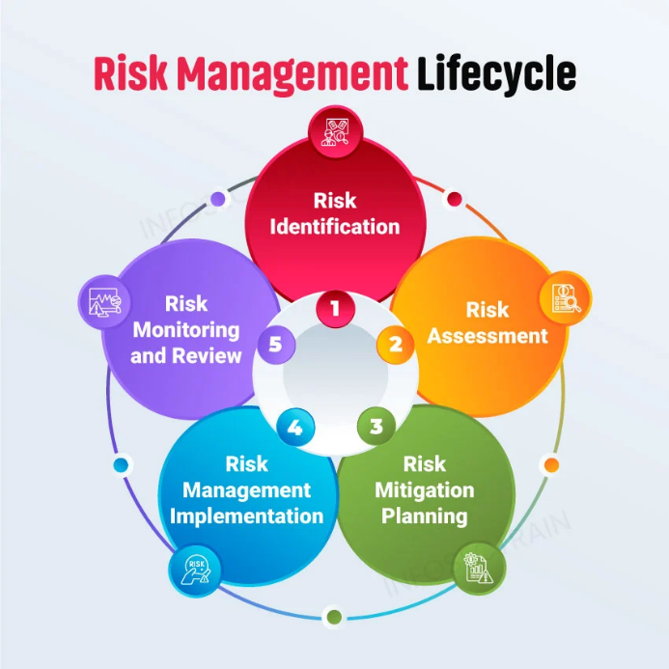
Figure 2: Risk Management Lifecycle (online source)
Systematic risk management identifies and addresses 23 discrete risks across scheduling, cost, technical, regulatory, and stakeholder domains. Risk assessment employs qualitative likelihood-impact scoring (1-5 scale) and quantitative analysis for financial risks (Klastorin, 2004). Top-tier risks (likelihood more than 50%, higher impact):
1. Schedule slippage (Likelihood 70%, Impact High, Initial Score 21/25) arising from construction complexity, weather delays, and supply chain disruption; mitigation includes fast-track contracting, schedule buffer allocation (12 weeks), concurrent activity sequencing, and weekly schedule reviews with recovery protocols; residual risk 12/25 (Yellow).
2. Cost overruns (Likelihood 65%, Impact High, Initial Score 20/25) arising from inflation, ground condition unknowns, and scope changes; mitigation includes fixed-price contracts, early geotechnical investigation, rigorous change control, and £40 million contingency reserve; residual risk 10/25 (Yellow).
3. Regulatory approval delays (Likelihood 55%, Impact Medium, Initial Score 11/25) arising from design amendments or planning challenges; mitigation include early engagement with Local Authority and building control, pre-application consultations, and dedicated planning liaison; residual risk 6/25 (Green).
4. Supply chain disruption (Likelihood 50%, Impact Medium, Initial Score 10/25) arising from community opposition or operational disruption; mitigation includes active stakeholder engagement, transparent communication, and temporary transport solutions reducing perceived disruption; residual risk 5/25 (Green).
Risk governance procedures establish bi-weekly risk workshops reviewing risk register and emerging risks, escalation protocols for risks exceeding tolerance thresholds, contingency reserve management requiring formal Change Control Board approval, and quarterly risk reporting to Steering Board. Risk ownership assigns each identified risk to a responsible manager accountable for monitoring and implementing mitigation actions. Insurance and bonding strategies protect major financial risks: comprehensive construction insurance covering liability, property damage, and professional indemnity; performance bonds (5% of contract value) securing contractor completion; ad commercial insurance for latent defects and pollution liability. Residual risk profile post-mitigation is deemed acceptable within governance risk tolerance and steering board approval (Winch, 2010).

10. Quality Assurance and Compliance Management
Quality management encompasses regulatory compliance (UK Building Regulations, accessibility standards, environmental regulations), design quality (Architecture, functionality, user experience), construction quality (workmanship, material specifications, system performance), and operational readiness (staff training, asset transfer protocols). Independent quality audits conducted at major milestones (end Phase one, structural completion, systems completion, handover) verify compliance against specifications and regulatory requirements. Design review processes throughout RIBA stages ensures accessibility integration, sustainability performance, and stakeholder requirements are systematically addressed. Construction quality protocols include material testing, site inspections, and third-party certification for safety-critical systems. Testing and commissioning (6-month period preceding handover) validates all systems (rail operations, bus systems, freight handling, digital platforms) meet performance specifications under operational load conditions. Staff training programmes prepare transport operators, maintenance staff, and customer service teams for facility operations, ensuring smooth handover and operational continuity (British Standards Institution, 2015).

11. Conclusion
The Central Transport Hub redevelopment represents a transformational infrastructure project of regional strategic significance, requiring sophisticated project management integrating technical delivery, regulatory compliance, stakeholder coordination, and sustainability performance.
This comprehensive Project Management Plan provides systematic framework for delivering modern sustainable transport infrastructure within 36-month schedule and £480 million budget constraints. Structured application of project management tools – WBS, integrated scheduling, stakeholder engagement matrices, risk management protocols, and governance structures – positions project for successful delivery aligned with recognised best practices. Alignment with UK standards (BREEAM Excellent, Equality Act 2010, net-zero targets) and government infrastructure guidance (HM Treasury, Green Book, Department for Transport standards) ensures strategic value delivery supporting regional economic recovery and sustainability objectives. Dedicated project leadership, integrated team structure, rigorous risk management, and active stakeholder engagement position the Central Transport Hub as a benchmark infrastructure delivery programme demonstrating professional project management excellence.

Reference
- British Standards Institution (2015) 'ISO 9001:2015 Quality management systems – Requirements'. London: BSI. Available at: ISO-9001.pdf (Accessed 1 July 2026)
- Cabinet Office (2011) 'Government Construction Strategy'. London: Cabinet Office. Available at: Government Construction Strategy - GOV.UK (Accessed 18 June 2026).
- Climate Change Act (2008) 'Climate Change Act 2008', UK Legislation. Available at: Climate Change Act 2008 (Accessed 19 July 2026).
- Department for Transport (2020) ‘Transport accessibility: rapid evidence review’
, Government Publications. Available at: Transport accessibility: rapid evidence review - GOV.UK (Accessed 1 July 2026).
- Dwivedi, R. (2021) 'Role of stakeholders in project success: theoretical background and approach', International Journal of Project Management, 45(2), pp.156–172. Available at: (PDF) Role of Stakeholders in Project Success: Theoretical Background and Approach (Accessed 2 July)
- Equality Act (2010) 'Public sector equality duty and accessible transport', UK Legislation. Available at: Equality Act 2010 (Accessed 10 July 2026).
- HM Treasury (2022) 'The Green Book: appraisal and evaluation in central government', Government Publications. London: HM Treasury. Available at: The Green Book - GOV.UK (Accessed 5 July 2026)
- Himanen, L. at all., 2024 ‘The SCOPE framework – implementing ideals of responsible research assessment’ F1000 research. Available at: The SCOPE framework – implementing ideals... | F1000Research (Accessed 10 July 2026).
- Huemann, M., Gemuenden, H.G. and Martinsuo, M. (2012) 'Toward strategic value from projects', Project Management Journal, 43(5), pp.4–13. Available at: Toward strategic value from projects | Request PDF (Accessed 7July 2026)
- International Organization for Standardization (2018) 'ISO 31000:2018 Risk management – Guidelines'. Geneva: ISO. Available at: ISO 31000 - Risk management (Accessed 20 July 2026).
- Khatun, T. (2024) 'Understanding the Project Management Cycle'. Available at: (PDF) Understanding the Project Management Cycle (Accessed 15 July 2026).
- Klastorin, T.D. (2004) 'Project management tools and trade-offs', IEEE Transactions on Engineering Management, 51(2), pp.138–148. Available at: Project Management: Tools and Trade-Offs | Request PDF (Accessed 5 July 2026).
- Maylor, H. (2010) 'Project Management', 4th edn. Harlow: Pearson Education. Available at: A01_MAYL4324_04_SE_FM.QXD (Accessed 15July 2006)
- Olander, S. and Landin, A. (2005) 'Evaluation of stakeholder influence in the implementation of construction projects', International Journal of Project Management, 23(4), pp.321–328. Available at: Evaluation of stakeholder influence in the implementation of construction projects | Request PDF (Accessed 10 July 2026)
- Project Management Institute (2017) 'A Guide to the Project Management Body of Knowledge (PMBOK® Guide)', 6th edn. Philadelphia: PMI. Available at: Guide to the Project Management Body of Knowledge (PMBOK® Guide)–Sixth Edition (Accessed 10 June 2026).
- Risk Management Lifecycle, Available at: What Are the Steps of Risk Management: Complete Guide - SignalX (Accessed 1 July 2026)
- Suresh, D and Sivakumar, A. (2019) ‘Impact of Schedule Management Plan on Project Management Effectiveness’, International Journal of Engineering and Advanced Technology 9(1):3350-3355 DOI:10.35940/ijeat.A1515.109119. Available at: (PDF) Impact of Schedule Management Plan on Project Management Effectiveness (Accessed 11 July 2026).
- Shibani, A. and Hassan, D. (2020) 'Building Research Establishment Environmental Assessment Methodology on UK residential and commercial projects', International Journal of Construction Management, 9(6), pp.183–189. Available at: (PDF) Building Research Establishment Environmental Assessment Methodology on the UK Residential Projects (Accessed 17July 2026)
- Turner, J.R. (2014) 'Handbook of Project-based Management: Leadership, Delivery and Culture', 4th edn. London: McGraw-Hill Professional. Available at: The Handbook of Project-Based Management | Request PDF (Accessed 22 July 2026).
- UK Building Regulations (2010) 'Part M: Access to and use of buildings', Technical Guidance Documents. Available at: Access to and use of buildings: Approved Document M - GOV.UK (Accessed 12 July 2026).
- Westland, J. (2017) 'The Project Management Lifecycle: A Complete Step-by-Step Methodology for Learning and Implementation', 3rd edn. London: Kogan Page Limited. Available at: ThePLC_R4 (Accessed 20July 2026)
- Winch, G.M. (2010) 'Managing Construction Projects', 2nd edn. Chichester: Wiley-Blackwell. Available at: Managing Construction Projects | Request PDF (Accessed 7 July 2026).

