Feasibility Plan
for an International Meeting

Bristol Winter Wonderland for Cancer Research UK
Diana Tanase
2210013
International Meetings Management for the Hotel Industry
Kathryn Flynn

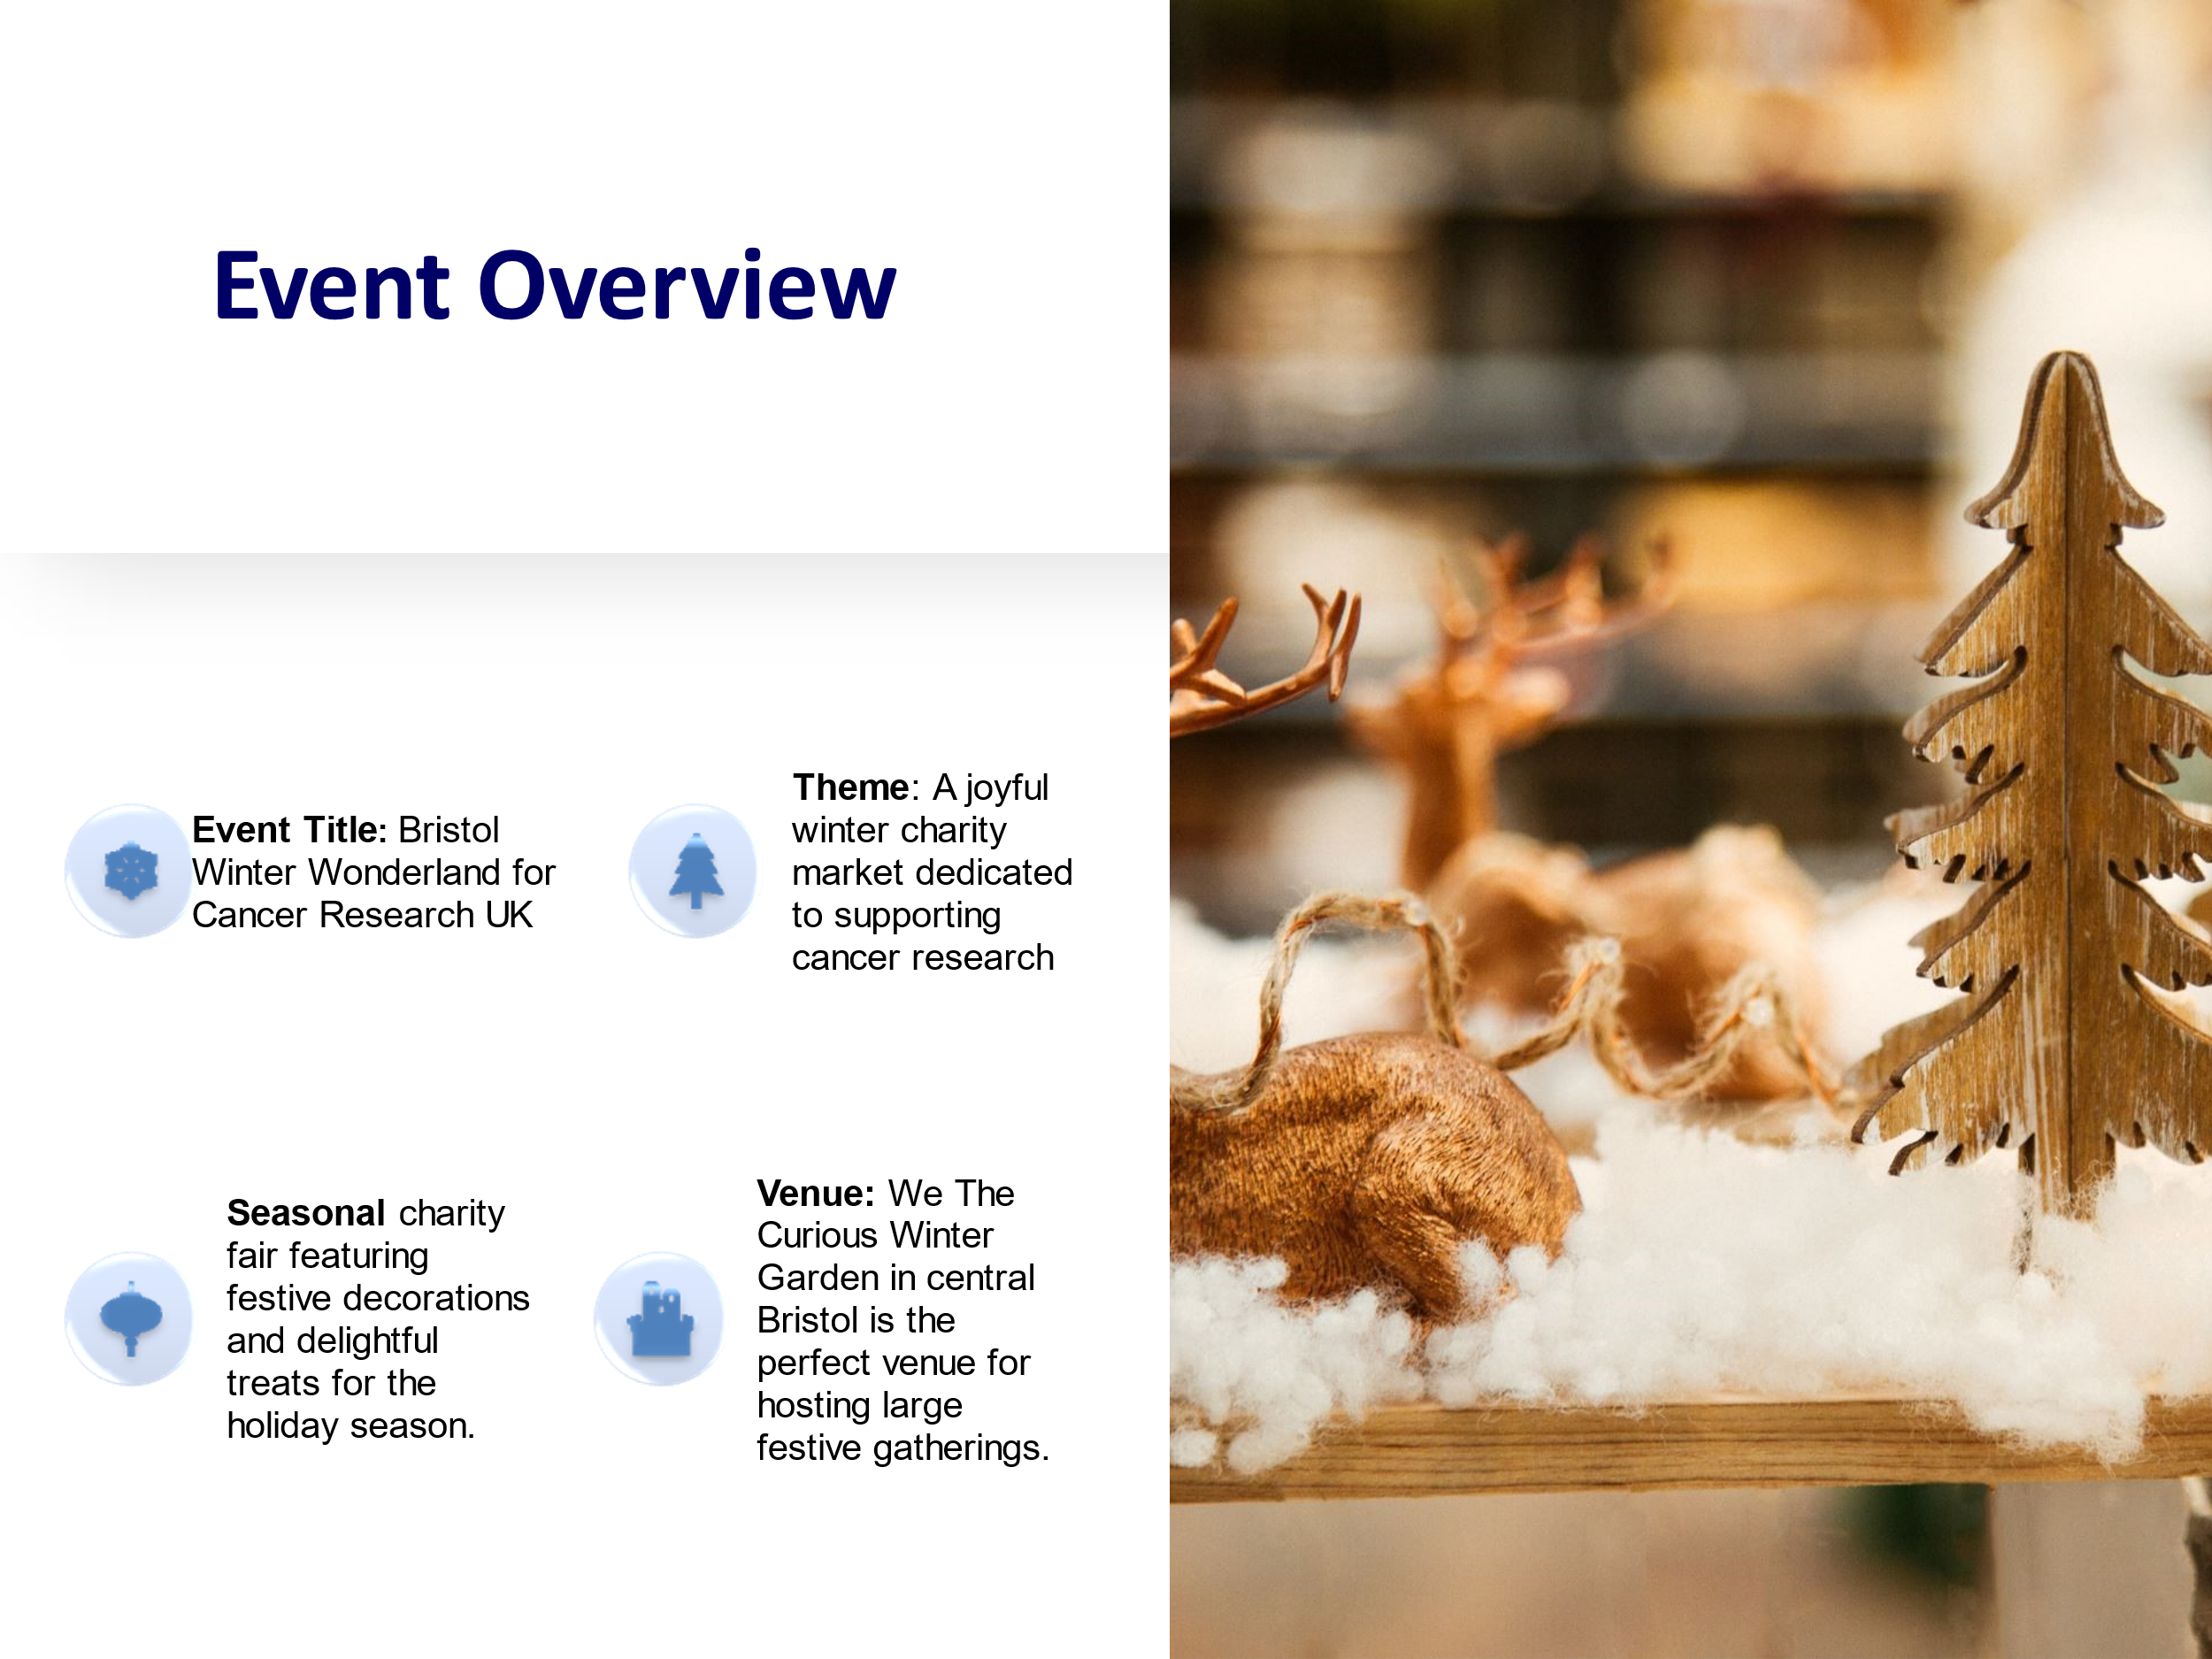



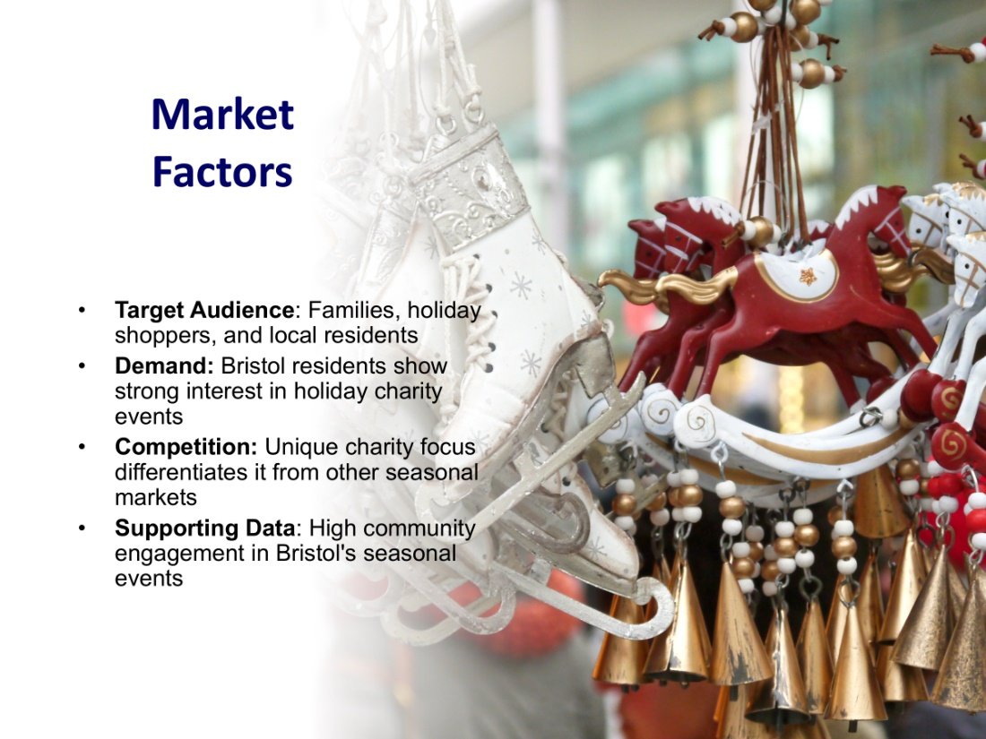

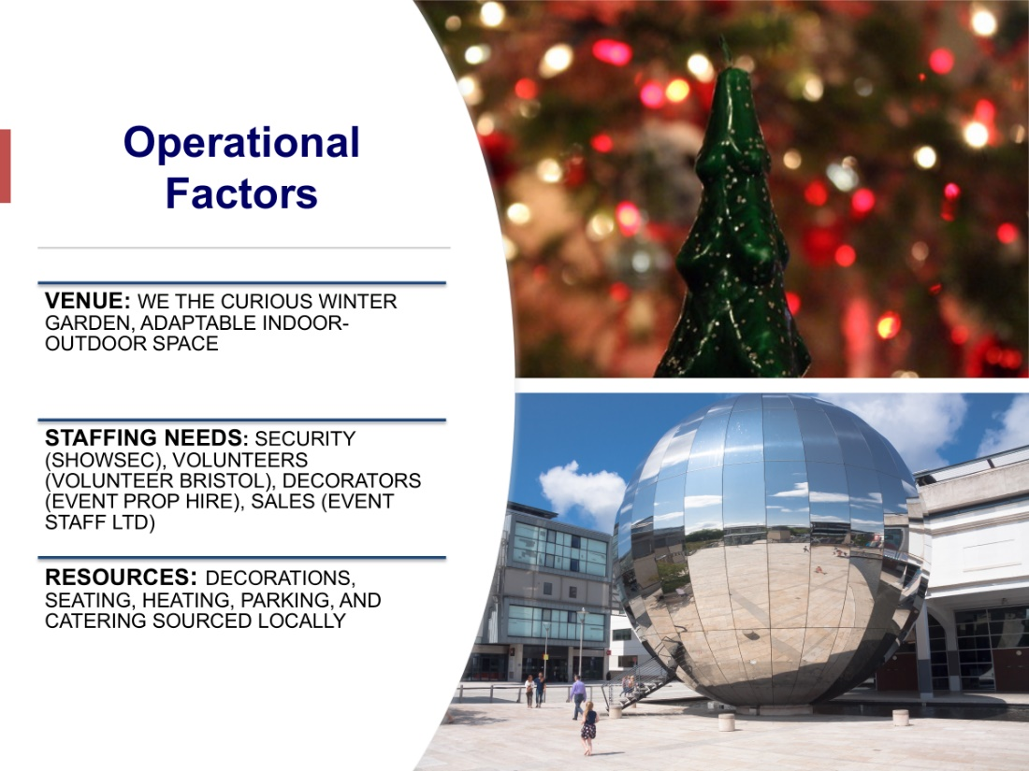

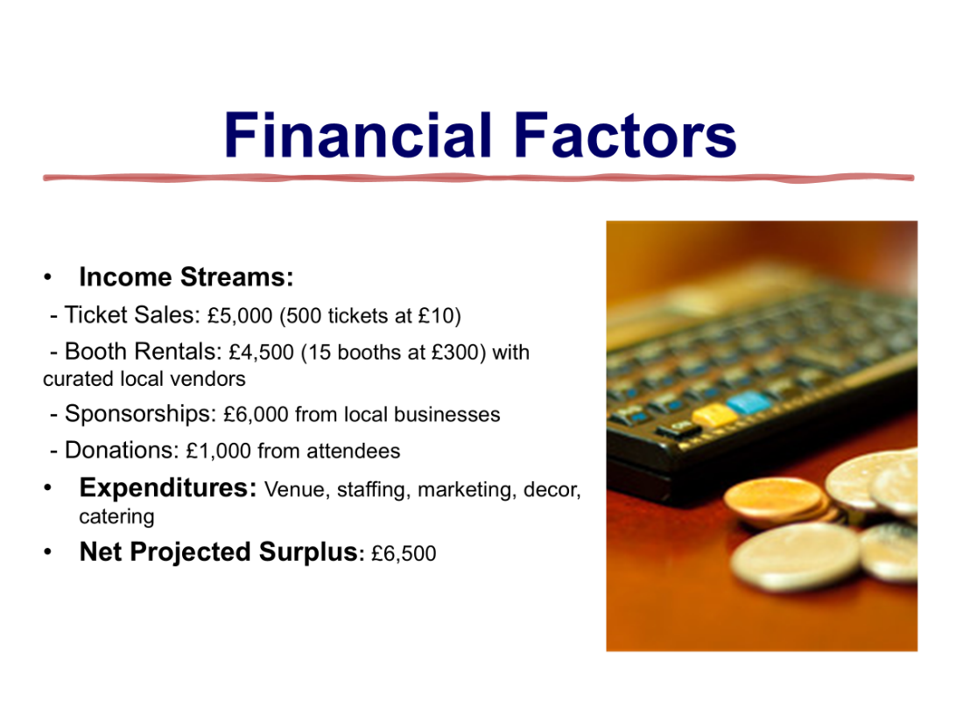



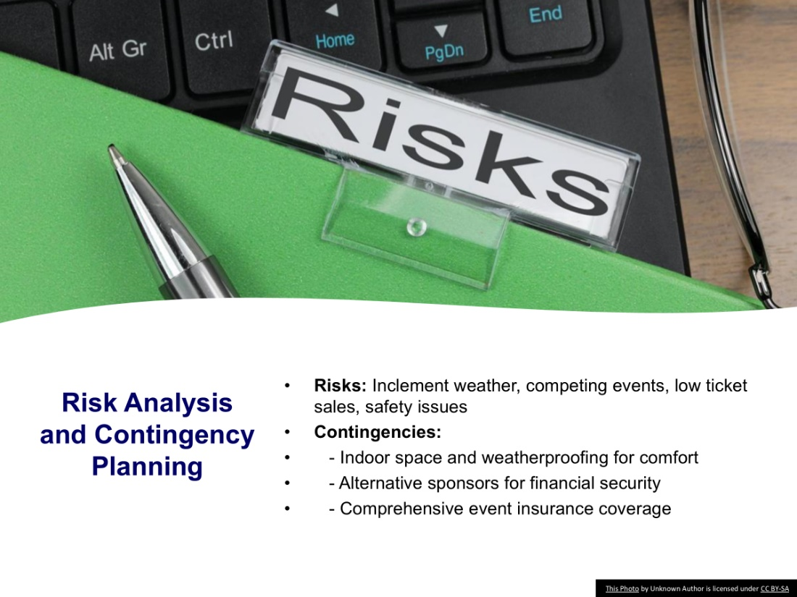



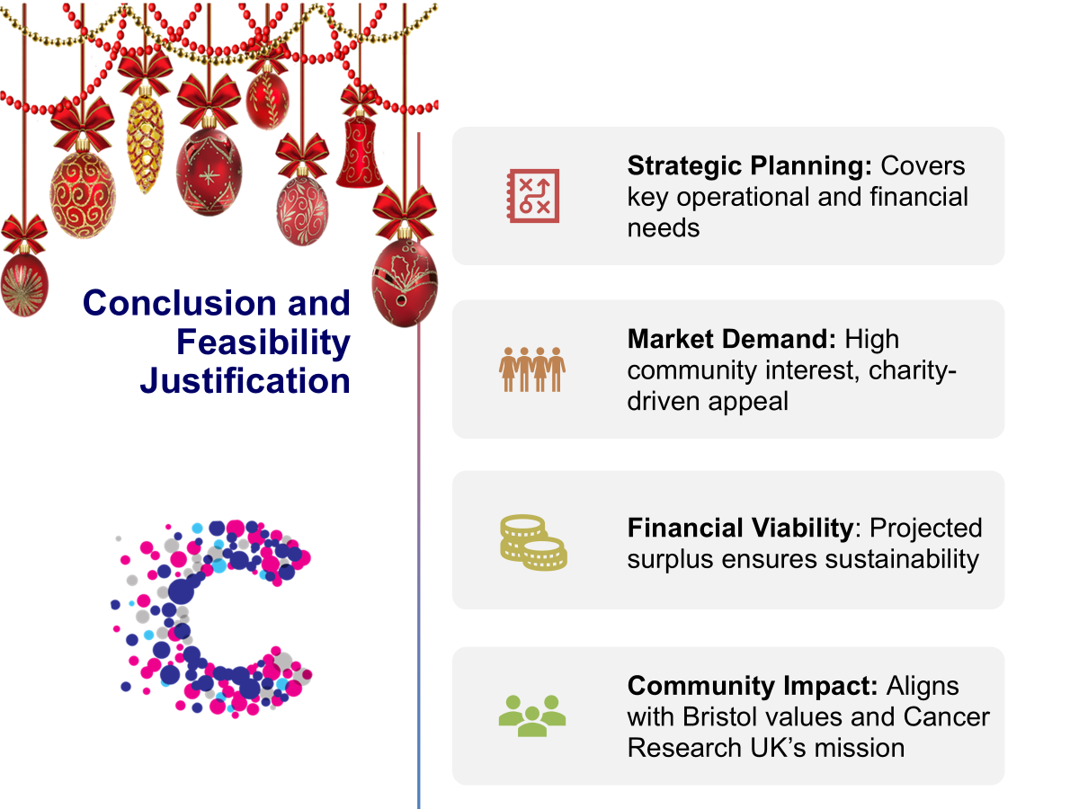

References:

BBC Radio Bristol (2023) Local Event Broadcasting and Announcements. Available at: https://www.bbc.co.uk/bristol (Accessed: 10 October 2024).
Bladen, C., Kennell, J., Abson, E., & Wilde, N. (2023) Events Management: An Introduction. 3rd ed. New York: Routledge.
Bristol 24/7 (2023) Media Support for Local Events. Available at: https://www.bristol247.com (Accessed: 10 October 2024).
Bristol City Council (2023) Bristol Park & Ride Options. Available at: https://www.bristol.gov.uk (Accessed: 10 October 2024).
Bristol Energy (2023) Sustainable Energy Solutions for Events. Available at: https://www.bristol-energy.co.uk (Accessed: 10 October 2024).
Bristol Sweet Co. (2023) Sponsorship and Gift Packages for Seasonal Events. Available at: https://www.bristolsweetco.co.uk (Accessed: 10 October 2024).
British Event Industry Survey (2023) Insights into UK Event Attendee Preferences. London: BEIS.
Cancer Research UK (2023) Charity Promotion and Support for Fundraising Events. Available at: https://www.cancerresearchuk.org (Accessed: 10 October 2024).
Charity Commission (2023) Fundraising Trends in UK Charity Events. London: Charity Commission.
Event Industry News (2023) Social Media Strategies for Charity Events. Available at: https://www.eventindustrynews.com (Accessed: 10 October 2024).
Event Management Safety Group (2023) Weather Preparedness in Winter Events. Available at: https://www.emsg.org.uk (Accessed: 10 October 2024).
Event Prop Hire (2023) Winter Decor and Lighting Rentals for Events. Available at: https://www.eventprophire.com (Accessed: 10 October 2024).
Event Safety Alliance (2022) Event Safety Best Practices. Available at: https://www.eventsafetyalliance.org (Accessed: 10 October 2024).
Event Staff Ltd (2023) Staffing Solutions for UK Events. Available at: https://www.eventstaffltd.co.uk (Accessed: 10 October 2024).
Eventbrite UK (2023) Booth Rentals and Vendor Management in Seasonal Events. Available at: https://www.eventbrite.co.uk (Accessed: 10 October 2024).
Getz, D. & Page, S. (2022) Event Studies: Theory, Research and Policy for Planned Events. 3rd ed. London: Routledge.
Heaters4Hire (2023) Temporary Heating for Outdoor Events. Available at: https://www.heaters4hire.co.uk (Accessed: 10 October 2024).
Hootsuite (2023) Increasing Engagement with Interactive Social Media Campaigns. Available at: https://www.hootsuite.com (Accessed: 10 October 2024).
Jones, M. & Baldwin, C. (2023) Events Management and Strategic Planning. London: Pearson Education.
Mailchimp (2023) Email Marketing Best Practices for Events. Available at: https://www.mailchimp.com (Accessed: 10 October 2024).
Masterman, G. (2022) Strategic Sports Event Management: Entertainment, Engagement, and Impact. 2nd ed. London: Routledge.
Mintel (2023) Holiday Market Trends and Competitive Analysis. Available at: https://www.mintel.com (Accessed: 10 October 2024).
Showsec (2023) Event Security Solutions. Available at: https://www.showsec.co.uk (Accessed: 10 October 2024).
Stokes Croft Brewery (2023) Sponsorship Opportunities for Community Events. Available at: https://www.stokescroftbrewery.co.uk (Accessed: 10 October 2024).
The Bristol Post (2023) Local Event Promotion and Community Engagement. Available at: https://www.bristolpost.co.uk (Accessed: 10 October 2024).
The Mall at Cribbs Causeway (2023) Community Sponsorship Initiatives. Available at: https://www.mallcribbs.com (Accessed: 10 October 2024).
Ticketmaster UK (2023) Ticketing and Entry Solutions for Charity Events. Available at: https://www.ticketmaster.co.uk (Accessed: 10 October 2024).
Visit Bristol (2023) Venue Options and Seasonal Events in Bristol. Available at: https://www.visitbristol.co.uk (Accessed: 10 October 2024).
Volunteer Bristol (2023) Volunteer Services for Events. Available at: https://www.volunteerbristol.org.uk (Accessed: 10 October 2024).
We The Curious (2023) Venue Hire Information. Available at: https://www.wethecurious.org/venue-hire (Accessed: 10 October 2024).

